
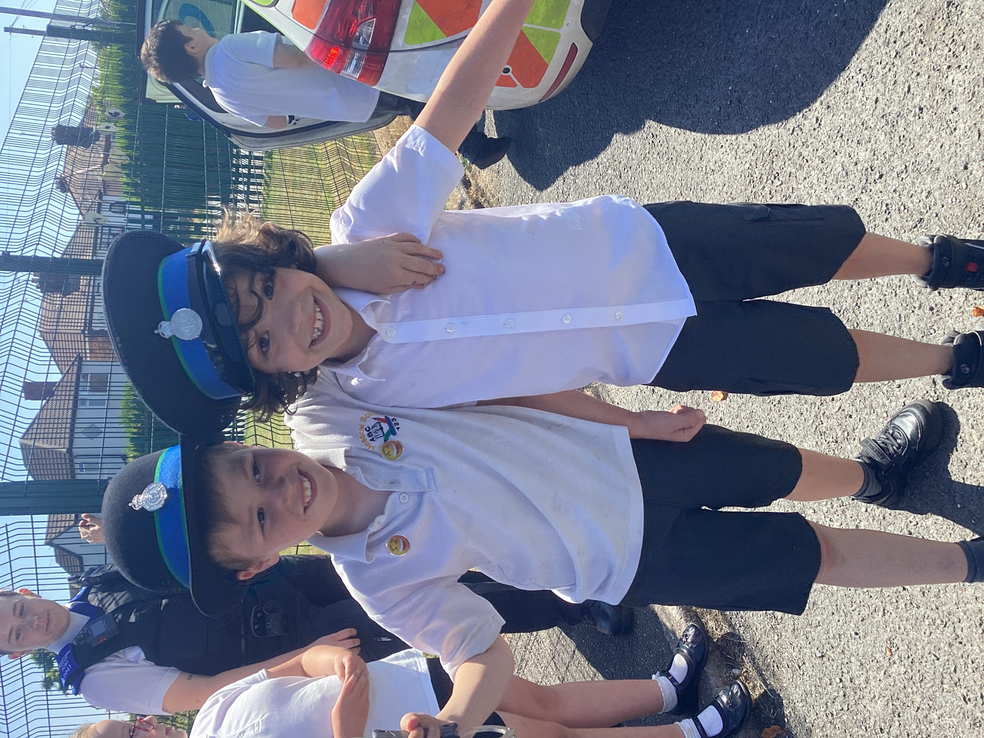
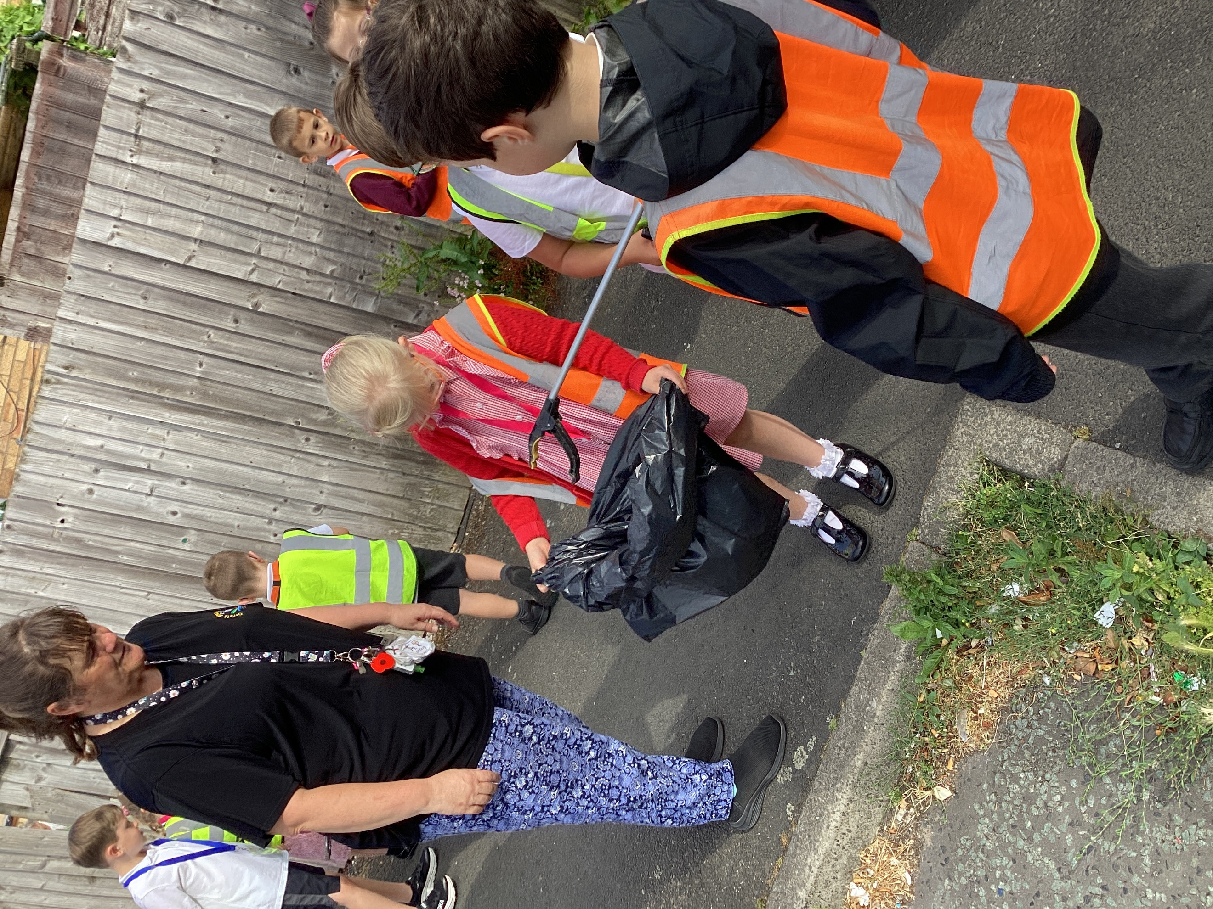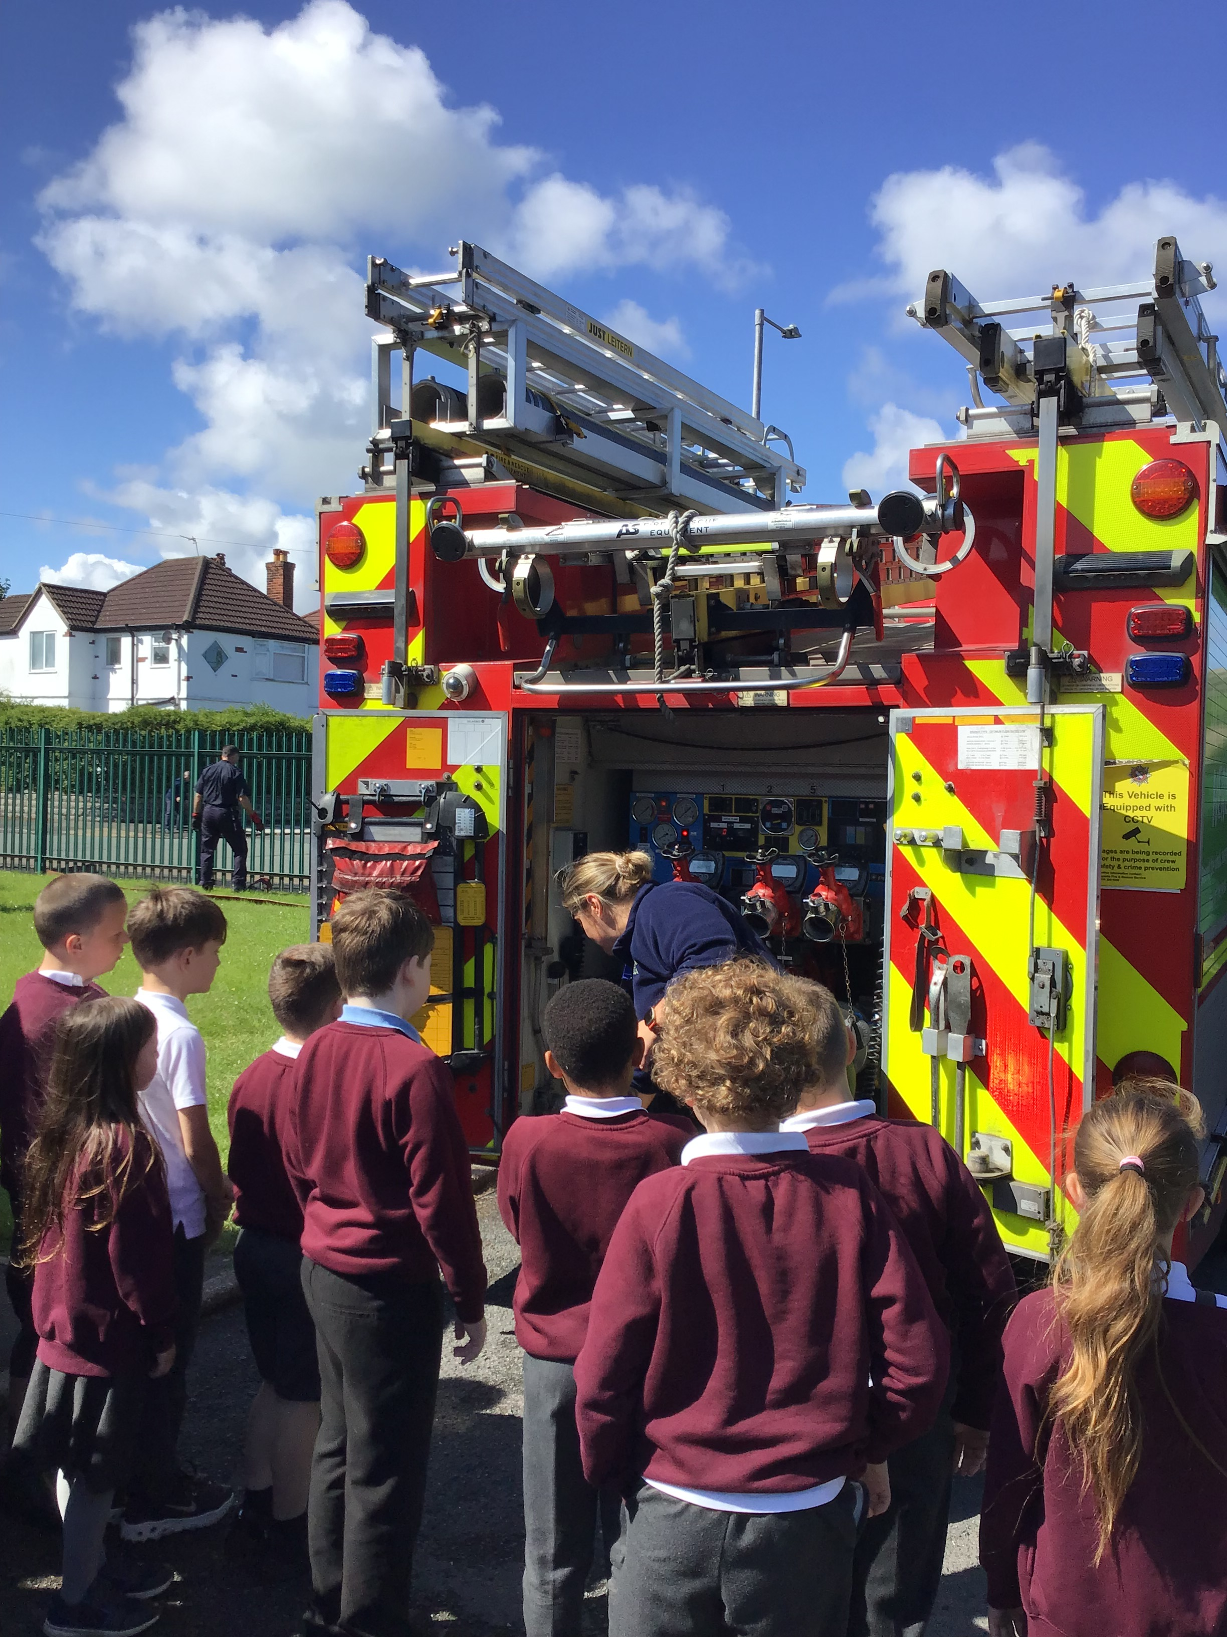

Governors Report – Summer 2026
PSHE
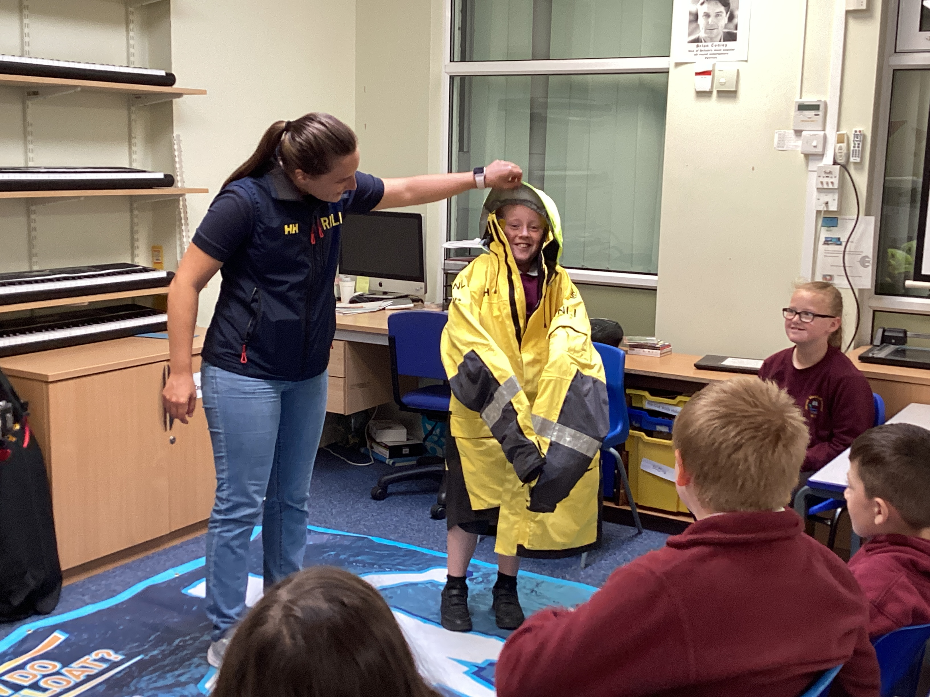
Roz Warren
Achievements
The ‘ways forward’ identified last year from this year’s school development plan and the actions taken:
To monitor the adapted independent section on the Autism Tracker to see if children attain more within this area.
The updated independence section of the Autism Tracker has successfully led to higher independence percentages among new children, as the targets are now more school-friendly and easier to practice within the daily school environment.
To use more external speakers to enhance the PSHE curriculum e.g. Police, Fire Fighters, Drug Awareness etc.
To enrich this year's PSHE curriculum, we hosted a range of external experts. Activities included mental health and transition workshops from Lesley (MHST), community safety visits from the police and fire brigade, drug education sessions for Years 5 and 6 with Lea (NHS), and class-by-class water safety talks from the lifeboat team.
To organise and deliver a Being Healthy and Safe week.
Our Being Healthy and Safe Week is in full swing! We have a fantastic line-up of exciting events for the children, including music with Matt Baker, specialised tag rugby coaching, yoga, and Super Soul Sanctuary sessions with Shazney. We are also welcoming vital safety visits from the lifeboat team, the fire brigade, and the police. To top it all off, classes are heading out on mindfulness trips to the local park, Little Gym, forest school and one class is attending a track and field event.
To keep up to date with the legal and current requirements of PSHE through the Liverpool School Improvement PSHE sessions.
R. Warren has maintained up-to-date knowledge of all legal and current PSHE requirements by attending all
Liverpool School Improvement sessions. In response to these updated statutory requirements, a new policy has
been drafted and is currently undergoing consultation on the school website for parents, staff, and governors.
The policy is scheduled for implementation in September 2026 and will be formally ratified at the first governors'
meeting of the academic year.

Staff Training
During staff meetings, R. Warren has effectively delivered PSHE updates, shared actionable feedback from book
scrutinise, and led collaborative discussions regarding necessary curriculum planning adaptations.

Quality of teaching and learning in PSHE
A comprehensive range of monitoring activities has been used throughout the year to evaluate the quality of teaching and learning in PSHE across the school. Evidence from regular learning walks demonstrates that lessons are consistently delivered within a safe, respectful, and inclusive environment. Observation during these visits highlighted strong pedagogical practices, including the effective use of ground rules, engaging activities and scaffolded discussion protocols that enable all pupils to engage confidently with sensitive topics. To triangulate these findings, pupil questionnaires were deployed school-wide. The data gathered was overwhelmingly positive, with children reporting high levels of enjoyment, a strong sense of personal safety, and an ability to articulate key concepts surrounding relationships, emotional literacy, and physical health.
ASD Framework
The ASD Framework continues to provide highly informative data on our pupils. All new children were baselined during the autumn term, and existing student profiles have been updated accordingly. Individual Education Plans (IEPs) consistently reflect this data, ensuring future targets are precisely tailored to each child's highlighted areas of need.
A whole-school data analysis revealed social interaction as a key area of strength this year, while independence and community continues to be identified as the primary area for development. In response, the Independence section of the ASD Framework tracker was strategically adapted to make targets more relevant to school-based practice. This targeted modification aims to directly foster pupil independence and improve the correlating tracking data moving forward. All children still need to be moved onto the new independence tracker so over time a positive impact potentially will be witnessed.
PSHE Book Scrutiny
PSHE books continue to showcase an excellent breadth of study, demonstrating a clear progression of skills and knowledge across all year groups, alongside the creative ways the subject is taught. Photographic evidence captures the practical nature of the lessons, while the books themselves display a rich variety of multi-sensory teaching approaches and high levels of pupil engagement. To ensure consistency, PSHE book scrutinies have taken place each term to moderate coverage and evaluate the quality of work produced. Crucially, this monitoring confirms that statutory RSE content is thoroughly embedded across all classes, explicitly demonstrating full compliance with legal requirements this will continue with the new regulations next year.

Learning Walk and Lesson Observations
This year R Warren completed several learning walks of PSHE. All children were engaged and on task. Children felt confident to answer questions and there was a lovely dialogue held between teachers and peers in several of the classrooms. It was obvious through this that PSHE is taught to a high standard and t was a pleasure to see PSHE being taught sequentially, using multisensory teaching and showing a high level of pupil engagement.
`

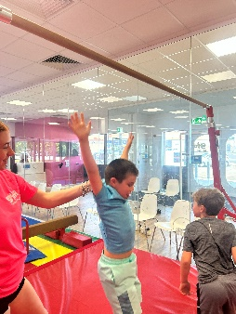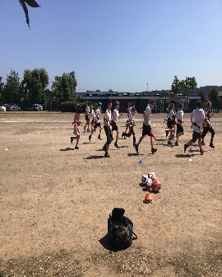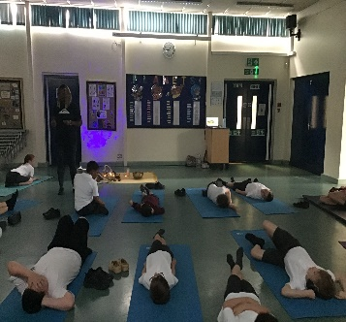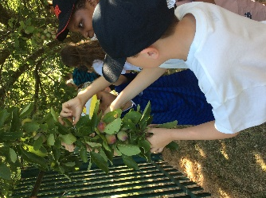

Pupil Voice

A cross section (2 per class) of pupil voice was taken from each class to find out pupil’s opinion about PSHE:

I enjoy PSHE lessons | 100% of pupil’s enjoy PSHE
I can tell my teacher some of the things I learn in PSHE (using book) | 100% of pupil’s could tell their teachers something they have learnt about in PSHE
My teacher teaches PSHE using lots of different activities | 100% of pupil’s feel that PSHE is taught through lots of different resources
My teacher teaches PSHE using lots of different activities | 100% of pupil’s find PSHE interesting and engaging.
The activities are interesting and engaging
I feel comfortable sharing my ideas, views and opinions in PSHE | 100% of pupils feel comfortable sharing their views

Some of the pupil comments:
‘I like keeping safe on the internet’
‘I love it’
‘It is fun’
‘I like the games’
‘It’s good’
‘I liked playing shop with money’
‘I enjoy all of it - I love it’
Staff Voice

Do you feel ready to teach the new PSHE content from September 2026? | 100% of teachers agreed
Do you feel the children can talk about their PSHE lessons? (Using the book if required). | 88% of teachers said their children can talk about PSHE
Is the simplified Independence section of the Autism Tracker easier to use? | 100% of teachers agreed that the simplified Independence section easier to use.
Do you feel confident in teaching the different areas of PSHE? | 100% of teachers feel confident teaching the different areas.
Do you need any support in PSHE? | 100% of teachers do not require support

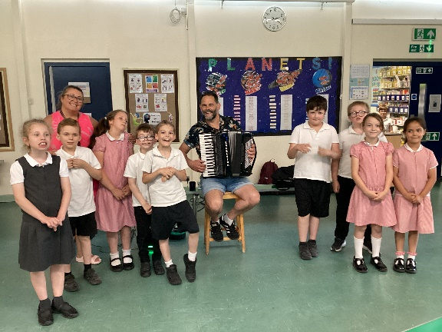

The Strengths of PSHE remain the same as last year:
- Being Healthy and safe week.
- The children’s engagement and enthusiasm for PSHE.
- Autism Tracker
- Visitors coming in to promote different area i.e. Firefighters, Police, Yoga, Nurse, Super soul sanctuary
- The enthusiasm for teaching PSHE and the children’s response
- Autism Accreditation Advanced status
- Independence afternoon

PSHE Ways forward 2026
- To successfully embed the updated PSHE policy and curriculum plans across all year groups from September 2026. Ensuring full compliance with the new statutory legislation. (Autumn 1)
- To organise and host a whole-school 'Water Safety Day' to ensure that pupils can identify key water safety rules which enhances the PSHE lessons taught through the year. (Summer 1)
- To plan a KS2 Careers Day, inviting at least 3 external speakers from various industries to broaden pupils' career horizons. (Spring 2)
- Maintain up-to-date subject knowledge and skills by regularly attending the Liverpool School Improvement PSHE sessions. (Ongoing)
- To organise and deliver a Being Healthy and Safe week. (Summer 2)

