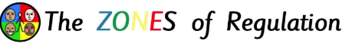

Helping Our Children Manage Their Feelings: The Zones of Regulation
At Orrets Meadow, we use an approach called The Zones of Regulation. It is a simple way to help children understand and manage their emotions—a skill we call "self-regulation." What is Self-Regulation?
Self-regulation is simply the ability to manage our energy and emotions so we can handle everyday stress. Whether it’s feeling calm enough to learn or energised enough to play, we all need tools to stay on track. We know that both children and adults sometimes find it hard to manage big feelings like anger, worry, or exhaustion. When these feelings take over, it’s hard to get through the day or focus on learning.

Our Goal
By using this approach across the school, we are helping your child to:
- Identify Feelings: Use better words to describe how they feel.
- Build a "Toolkit": Find personal "tools" (like deep breathing or a quick stretch) to help them calm down or wake up.
- Understand Others: Recognise how their friends might be feeling, which helps build empathy.
- Problem Solve: Learn how to bounce back when things get tough.
- Connect the Dots: See how things like lack of sleep or hunger can change their mood.

The Four Zones
To make emotions easier to talk about, we categorise them into four coloured zones. It is important to mention: There is no "bad" zone! We all experience every zone at different times. The goal is to help children recognise which zone they are in and use their toolkit to get back to the Green Zone when it’s time to learn. Below illustrates the emotions that we fell in the different zones:

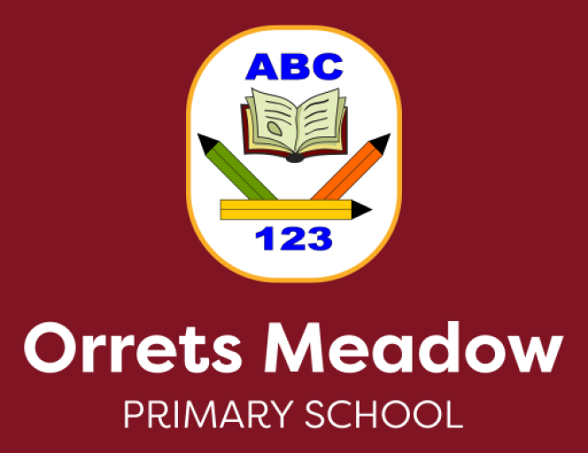

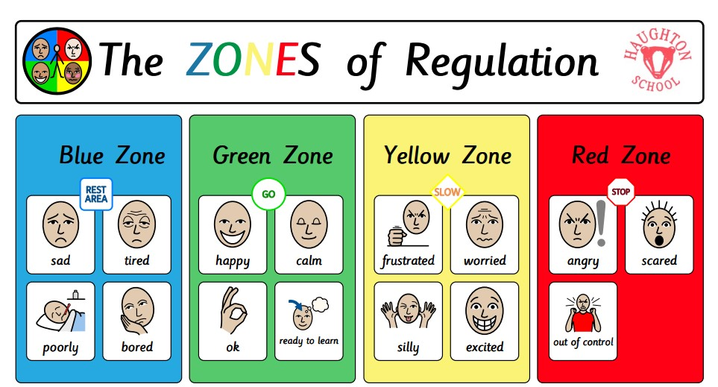

Tools and Strategies for Regulation
There are multiple tools and strategies that our children can use to self-regulate – and they will be individual to each child. However, it may be useful to think about the types of activities that will help our children to regulate in each zone. Here are some examples tools for each Zone:

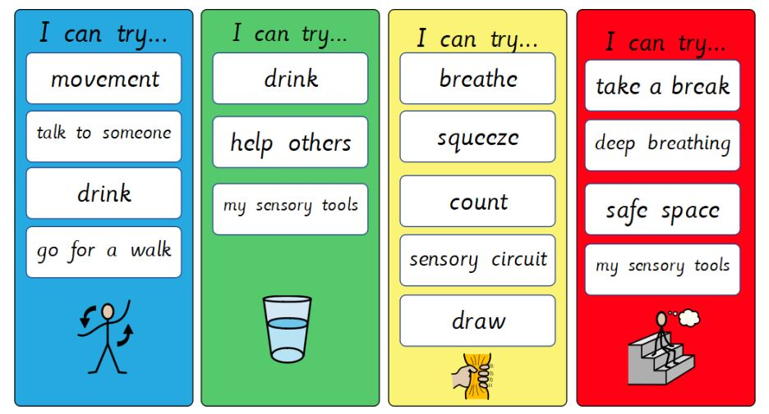

How can you help your child use The Zones of Regulation at home?

- Model and identify your own feelings using Zones language in front of your child (e.g. “I’m frustrated. I think I am in the Yellow Zone.”)
- Observe your child’s behaviour and try to use strategies when they are showing signs of being in the yellow zone, to catch it before they move to the red zone.
- Practice calming strategies when your child is in the green zone. This may include doing some deep breathing/meditation/heavy work and sensory activities throughout their day. They can then use these tools at other times.
- Talk about what tool you will use to be in the appropriate Zone (e.g. “I need to take four deep breaths to help get me back to the Green Zone.”)
- At times, wonder which Zone your child is in. Or discuss which Zone a character in a film/ book might be in. (e.g. “Peppa looks sleepy. I think she might be in the Blue Zone?”)
- Praise and encourage your child when they share which Zone they are in.
- Develop your child’s own zones of regulation toolbox.
- Have easy access to calming/sensory equipment at home.
- Remember to monitor your language: usually less is best (minimal in the red zone).
- Put up and reference the Zones visuals and tools in your home to consistently refer to and check in regularly with this. We will be creating different Zones visuals in our classes over the coming weeks. So please ask your child’s class teacher if you would like some Zones of Regulation visuals to use at home.

