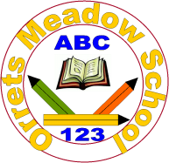
Governors Report – Summer 2023- 2024
Maths
Lorna Billington
Intent: To review and adapt our curriculum for maths to ensure our children are supported fully with their ever-changing range of co- morbidities and learning needs.
School Development Plan
Focused Priority 3 | Title | Review and adapt the Maths curriculum to ensure it meets the changing needs of OM pupils.

Why do we need to adapt our curriculum?

Due to our ever-changing cohorts our curriculum is always under review. Generally, pupils on entry are working well below age expectation and as a result of co- morbidities are working at lower levels for longer with a greater need for overlearning and revisiting of maths strands. As a result, we feel that this year it would support all pupils to amend the long- term plans to ensure that blocks are short to support the learning needs of our pupils.

Implementation
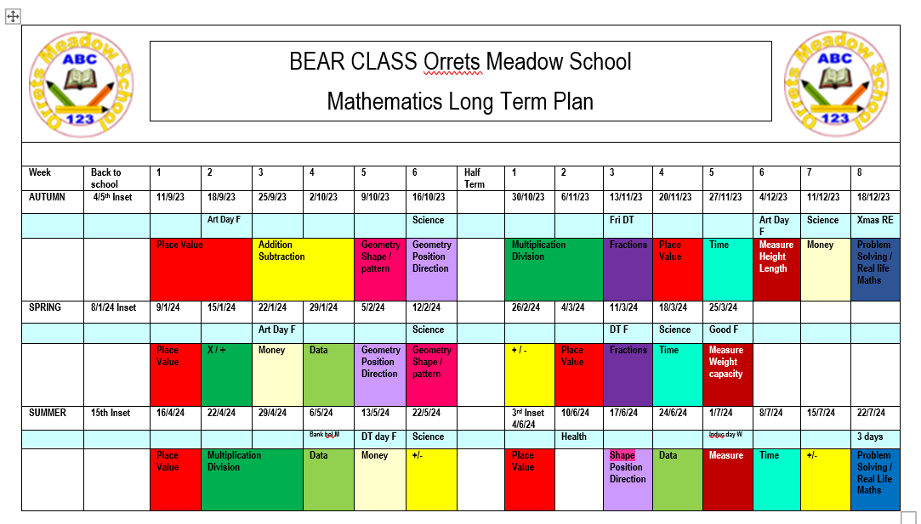
During the previous year as a result of discussions with staff and pupil voice it was agreed that we look to modify the curriculum plans to ensure more frequent visits to each block. As a result, the curriculum blocks have been made shorter to ensure that revisiting of each maths genre was more readily available to pupils. The maths curriculum long term plan has been modified and trialled this year. The plan ensured that all year groups visit each topic in maths more frequently in order to meet the needs of the pupils and
to support memory and retention. All staff continue to have access to follow the White Rose Hub resources which are used alongside other resources to provide a broad engaging maths curriculum. The ‘steps’ curriculum (pre – National Curriculum) has also been through a dynamic change.
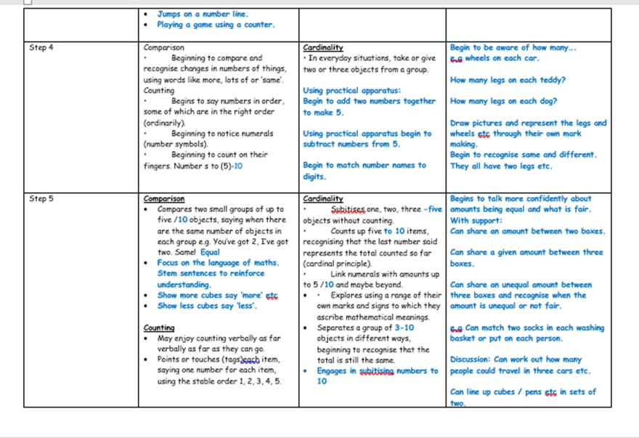
As some of our pupils are ‘older’ but still working pre-NC they are bringing with them more life. The steps are now set out to ensure that all topics in maths are available for study even at a ‘steps’ level.

(The above table is an example of the changes to steps. The black writing is the original step, with the blue writing setting out more detailed objectives where before ther wasn’t any).
Impact
During our recent OFSTED deep dive in maths the inspector commented on the curriculum plan and agreed that it was very inventive to adapt the plan to the extent it is, in order to meet pupils needs. He felt that the decision to ensure shorter blocks and more visits was the best way forward for our pupils and was very impressed. Pupil voice expressed that all the children enjoyed their maths lessons and felt that they were doing really well and making progress. Staff voice mirrored this with some discussion about extending one or two of the blocks for the more able pupils. (This has been acted upon for the following year as a trial).Pupil tracking also evidences the progress pupils make.
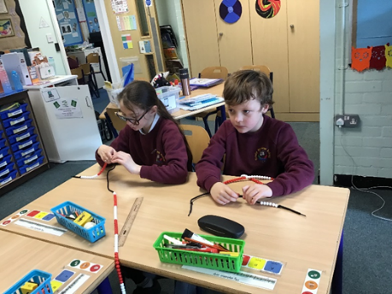
Fluency
Discrete fluency lessons have continued this year and been well received with staff stating that children are making observed progress as a result. Staff voice stated that having a discrete allocated time to focus on problem solving has supported progress effectively not just in maths but has transferred across other subjects.

Mental Maths Bonds Arithmetic Fluency 10:45-11am
Monday | Tuesday | Wednesday | Thursday | Friday
Multiplication/Division  Facts and relationships | Addition and subtraction  Relationships | Multiplication and Division  Recall Fluency | Number Bonds  Inverse relationships | Problem solving  Friday

Our school pedagogy for maths has played an integral part in our development of maths and continues to support our pupils through a multisensory approach.
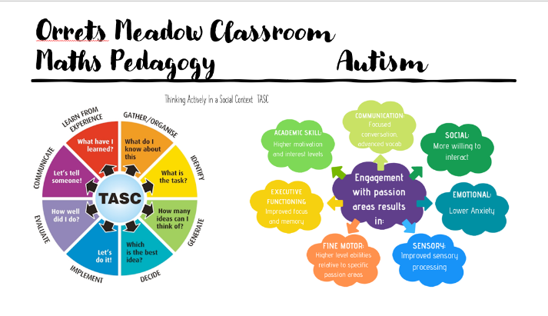
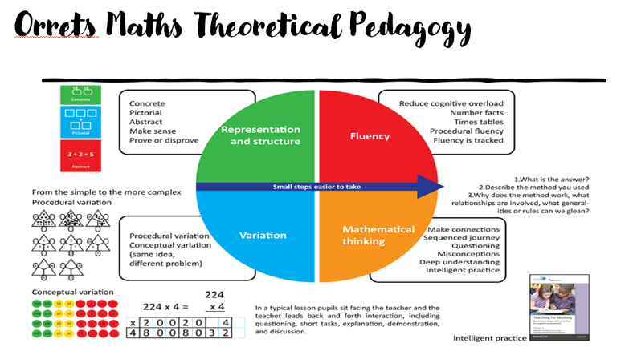
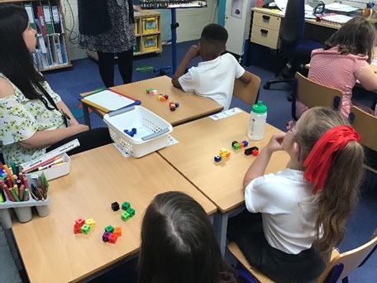
CPD: Staff Meeting: Staff meetings have concentrated on discussions related to the changes to the curriculum required in order to continue to meet the pupils needs.
Courses: I have continued to attended maths subject leader courses as facilitated through ‘Sarah Squared’. These include the latest findings, updates, advice and recommendations. Staff meeting reflect advice shared at these meetings.
Maths Moderation
Within School we carry out maths moderation. Here all teachers attend and bring with them work from their class to share and moderate according to the National Curriculum objectives. Teachers discuss the pupil as a whole and reflect on how the pupil has met the objectives and address any worries or concerns related to their additional needs.
Assessment
This continues to be made through Assertive mentoring and the White Rose Hub assessments at the end of each term. We also assess mental maths using ‘Animals Awards’.
Book Scrutiny
Focussed on the school marking approach, the implementation of the long- term plans. The books clearly evidenced hard work good progress and lots of approaches to work based on the new long-term plan.
Strengths:
- Pupils continue to make progress. (Assessment data raw scores/ Assessing pupil progress / Pupil progress/ observations/ book scrutiny/ staff voice/ pupil voice).
- Pupil’s abilities to retain information is being supported by more regular visits to topic areas.
- The staff continue to feel confident delivering a range of activities to meet the diverse needs of our pupils. The staff feel that the White Rose Hub programme of study along with extras from a range of sources supports teaching and learning.
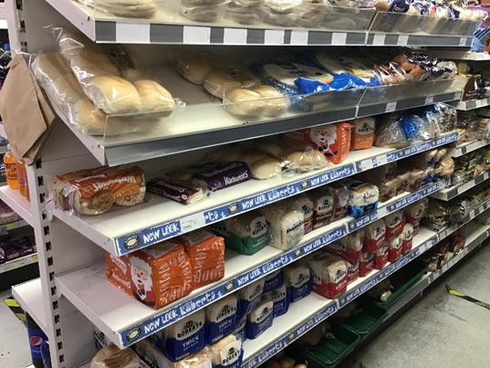
- Real life maths continues to be well supported through maths, social skills and life skills.

Talking Maths and Stem sentence support, continues to play an active role during maths lessons and has been well delivered and supported to ensure our pupils’ understanding and application of maths.
OFSTED
Ofsted visited this year and completed a four hour deep dive on maths. The inspector explored with myself what we teach why we teach it and what the outcomes are. We discussed the needs of the pupils and the effectiveness of CPD for all staff in line with support for the pupils. He completed an in depth book scrutiny. Checking that all marking policies where followed. We discuuses teaching and learning. We explored triangulation of the learning in school and mapped the planning against the pupils level of learning and the work in their books. He was extremely impressed with everything he saw. This is testemant to the hard work of all staff and that of the pupils as well as our links to the governors and the support that they give.
NEXT STEPS for 2024 2025:
Develop further the teaching and learning of shape, space, measure, position and direction through the Maths curriculum.
I would like to thank Cindy as the maths governor and for her continued support this year.
Lorna Billington

