Governor Report- Summer 2026
Science
Charlotte O’Brien
Achievements
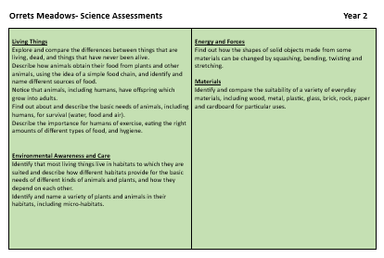
- As requested by the staff, APP Sheets for Science curriculum levels Y1-Y6 have been reviewed and streamlined. The repetitive statements have been removed and the presentation made visually more accessible by removing the unnecessary italics and different size fonts. The staff survey indicated that the staff preferred them to the old-style APP.
- Staff Meeting 1: Science Investigation
The updated APP sheets were shared with the staff in time for the February data drop. We watched part of a training video which encouraged active science investigations from School Improvement Liverpool and spent some time moderating science at the steps levels.
- Staff Meeting 2: Electricity


A progression of skills for electricity was shared with the staff which will help them back track objectives for electricity when it is being taught. They were introduced to new resources such as the energy sticks which buzz and glow when a whole circuit is completed and had time to explore the current resources and simple ideas for experiments.
- Staff Meeting 2: Data Loggers
Teachers had time to use the Data Logger resources available in school and were introduced to a new app called Arduino which allows allow measurements to be taken on an iPad.
- Monitor Art in Science-
Teachers have continued to include Art in the Science weeks and submitted a Pic Collage of the different art they have completed during the year.
- Create a Science Moderation Folder-
The moderation of Science provided a range of activities at different levels to help teachers make accurate assessments.
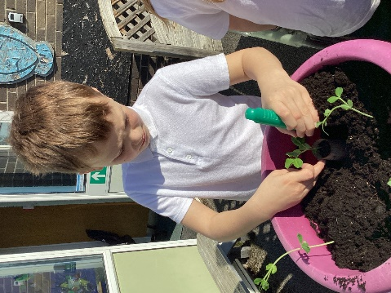
- Gardening Club- A gardening Club ran during the spring and summer terms for the children to sow seeds and nature them. The children managed to grow potatoes, mange tout and some soft fruit.
CPD
- Primary Science Subject Leader Briefing- Autumn Term 21/11/25
- School Improvement Liverpool- Working Scientifically 14/1/26
- Primary Science Subject Leader Briefing- Spring Term 13/03/26
- Primary Science Subject Leader Briefing- Summer Term 19/06/25
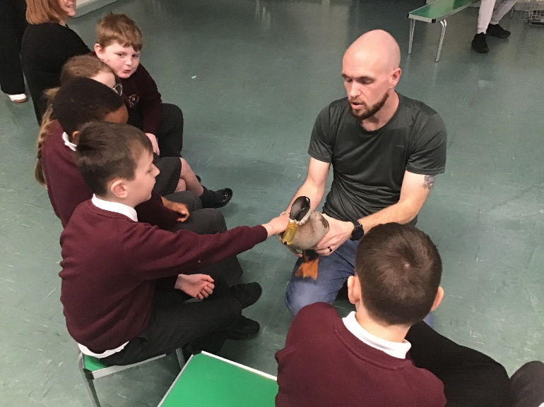
Quality of Teaching and Learning
- Science Subject Leaders Folder- To monitor the quality of teaching and learning in Science, a Science Leader’s file is kept updated. All the relevant policies and documents are kept in one central place. The Science policy has been updated to reflect Science teaching and learning at Orrets Meadow.
- Moderation- This year we met with teachers from Oak Trees Academy Schools to moderate our curricula and share best practice in science. This year we focussed on Pre curriculum Steps.
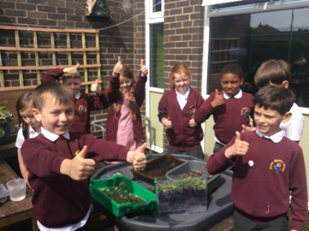
- A Learning Walk in the Summer Term demonstrated a wide range of activities adapted to for the needs of the children. Progression of skill and knowledge was evident across the school and all children were engaged in their learning.

- The Children’s Survey showed that Science is a popular subject across school with 100% of children saying they enjoy science. Most of the children (85%) knew they were doing well and making progress in science and could share fact they knew about science and could name an important scientist.

- The Teacher’s Surveys revealed that 66% of teachers ranked their confidence in teaching science as 9 or 10 at the top of the scale and 33% of the teachers ranked their confidence as 8. Teachers fed back positively about the updated APP for Science Y1-6. Some teachers requested a change around of topics in science to create more time for planting and growing in the spring term. Teacher’s requested a review of the investigation scaffold sheets.
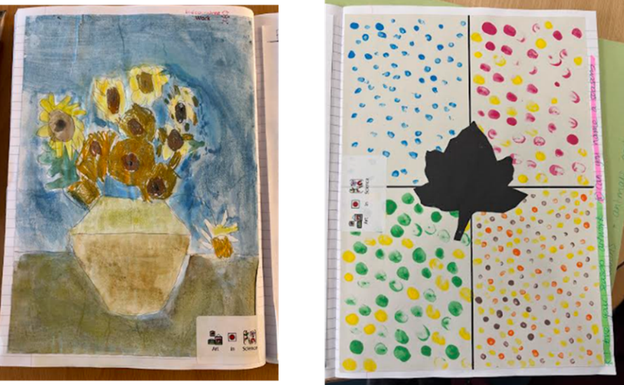
- Book Scrutiny- book scrutiny’s have shown creativity and progress through the curriculum. Teachers have maintained the high standards and range of curriculum enhancements. Teachers have continued to embraced Science in Art and created wonderful Scientific themed art to encourage long term recall of science knowledge.
Strengths
- We have a robust curriculum that meets all the demands of the National Curriculum and beyond.
- All staff have a clear understanding of the value of science and are confident teaching science.
- We have a wide range of multisensory resources to support skill and knowledge development across the school.
- Children enjoy science a lot at Orrets Meadow. (100%)
- All children can say who uses science in the real world with (85%) of children able to name a scientist.
- 85% of children know they are doing well in science.
Ways forwards
- Review Science Investigation Sheets for Pre-Y6 -Autumn Term
- Develop CPD ideas for staff meetings- Spring Term
  - Oracy in Science
- https://pstt.org.uk/events/oracy-in-primary-science/
- Review planning for Seasonal Change to support teaching at Year 1 level.
