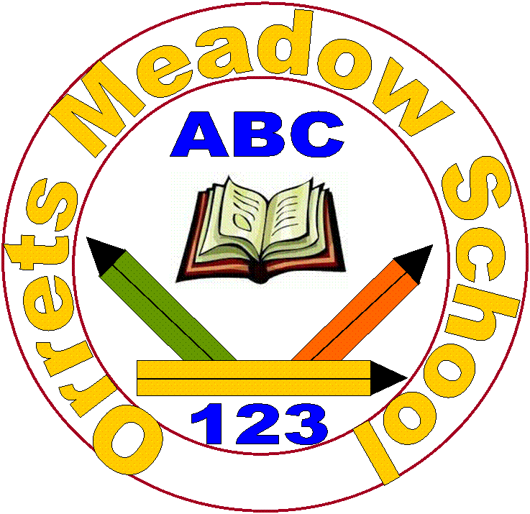
Orrets Meadow School
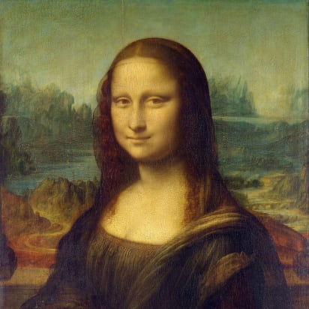
Art Policy

“To raise the aspirations of every child and give them confidence to fulfil their potential through positive experiences”

Orrets Meadow Curriculum Aims and Values
Aims
To ensure all our children are at the centre of a broad, varied and interesting learning experience that is enjoyable and relevant for the future. Our creative, multisensory curriculum will create a sense of awe and wonder and help to inspire a lifelong love of learning. The holistic nature of our practice will promote positive mental health and well-being and will enhance our children’s life skills, social skills and cultural awareness.
This subject is delivered through a trauma-informed approach. We prioritise safe relationships, understand behaviour as communication, and support pupils to regulate, engage, and achieve within a consistent and inclusive environment.
Values
Our curriculum will promote a range of values including:
- Respect
- Empathy
- Responsibility
- Equality
- Independence
- Happiness
- Resilience
- Gratitude
- Honesty
- Friendship
Intent
Art engages the senses by developing pupils’ handling experiences, moving and fine motor skills. Art develops curiosity, teaching pupils to observe the world thoroughly and carefully. Art allows pupils to express their feelings and ideas, both as a means of self-expression and to communicate with others. Art creates opportunities to explore different materials and develop their own ideas of how to use them effectively. Art allows pupils to learn more about how people lived in the past, by looking at art and artists. Art engages, inspires and challenges pupils, equipping them with the knowledge and skills to experiment and invent.
National Curriculum - Art
Purpose of study
Art embodies one of the highest forms of creativity. A high quality Art and Design education should engage and inspire pupils to develop a love of the Arts and World leaders in Design and Technology and their talent as artists, and so increase their self-confidence, creativity and sense of achievement. As pupils progress, they should develop a critical engagement with art, allowing them to create, and to adapt their work with a critical eye. Work should be celebrated by sharing with others either through an art display or presentation and discussion.

Aims
The national curriculum for Art aims to ensure that all pupils should be taught:
- to use a range of materials creatively to design and make products
- to use drawing, painting and sculpture to develop and share their ideas, experiences and imagination
- to develop a wide range of art and design techniques in using colour, pattern, texture, line, shape, form and space about the work of a range of artists, craft makers and designers, describing the differences and similarities between different practices and disciplines, and making links to their own work.
- to develop their techniques, including their control and their use of materials, with creativity, experimentation and an increasing awareness of different kinds of art, craft and design. Pupils should be taught:
- to create sketch books to record their observations and use them to review and revisit ideas to improve their mastery of art and design techniques, including drawing, painting and sculpture with a range of materials [for example, pencil, charcoal, paint, clay] about great artists, architects and designers in history.
Orrets Meadow’s Curriculum
We teach a Global Curriculum called 'Learning means the World' (LMTW) for all our afternoon subjects. This curriculum is innovative, forward-thinking and highly relevant to our pupils' needs and thoroughly engages them as they tackle challenging and inspiring topics and issues.
LMTW curriculum has been written with world issues in mind and is centred on 4Cs:-
- Communication
- Conflict
- Conservation
- Culture
Why did we choose 'Learning Means the World'?
As a school which is majority white British, we want our pupils to fully embrace cultural diversity, learning about, experiencing and celebrating a range of different cultural and faith heritages.
We believe that communication is key to accessing learning and securing pupils’ future success. As many of our pupils have Speech Language Communication Needs it is essential that opportunities are given to develop language for learning across the curriculum. With one of its 4 foci being on communication, this curriculum provides lots of opportunities for pupils to develop expressing themselves in discussion, debate and presentation, as well as enabling them to collaborate and exchange ideas.
We feel our pupils, as the future generation, need a greater awareness and appreciation of local, national and global conservation issues and initiatives. The need to learn that they have an important role to play in sustainability. This curriculum gives pupils opportunities to grow and develop spiritually, emotionally, physically and socially in the natural world around them. Our commitment to nurturing positive attitudes and values and developing life and social skills is promoted throughout the Learning Means The World (LMTW) curriculum.
It is theme based and broken down into the following phases:
- Explorers (foundation-pre curriculum)
- Pathfinders (KS1 level)
- Adventurers (Lower KS2 level)
We have the freedom to teach the National Curriculum in line with our pupils' specific needs and believe that our whole curriculum meets the values and aims which our stakeholders requested at the start of the consultation.
Why is Art Important?
Here is what the artists say:
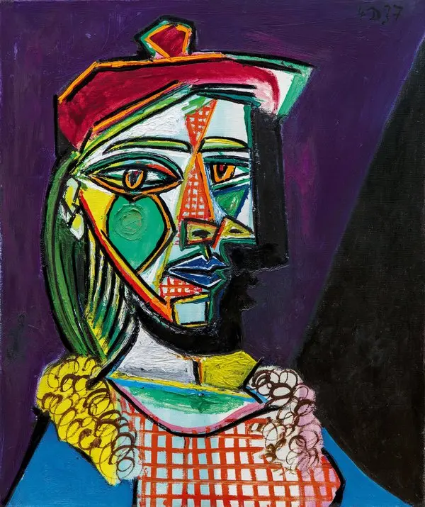
Pablo Picasso
“Painting is poetry that is seen rather than felt and poetry is painting that is felt rather than seen”
Every child is an artist. The problem is how to remain an artist when they grow up.
Pablo Picasso
"Art washes away from the soul the dust of everyday life”
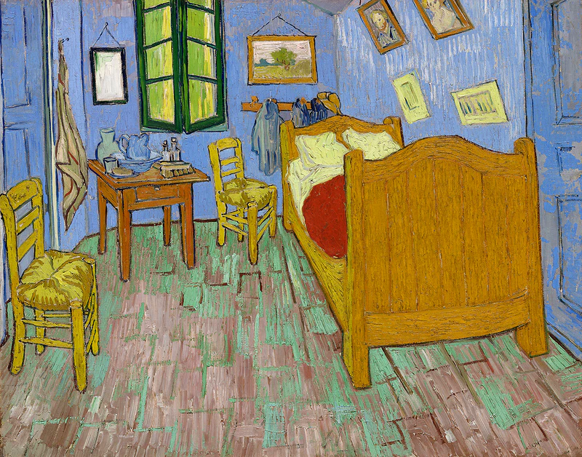

Vincent Van Gogh
“Great things are done by a series of small things brought together.”

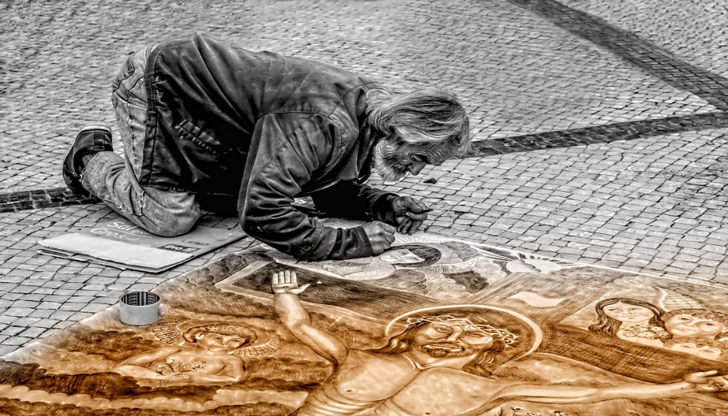

Leonardo Da Vinci
“Painting is poetry that is seen rather than felt, and poetry is painting that is felt rather than seen.”

Art education has proven to have remarkable impacts on academic, social and emotional outcomes, helping us develop empathy as we learn more about societies, cultures and history.
Engagement with Art helps us stretch our minds beyond the boundaries of the printed text or the rules of what is provable to encompass visual, spatial learning and develop motor skills. Through Art we learn to express ourselves confidently and creatively.
- Through Art people are allowed to be creative and express their inner thoughts and feelings.
- Through Art pupils produce their own original, creative work, exploring their ideas and recording their experiences.
- Art allows people to extend their imagination and reflect on their inner thoughts.
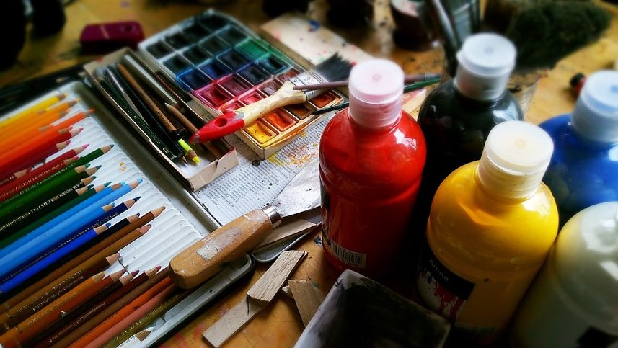
- Art creates opportunities to explore different materials and develop their own ideas and how to use them effectively.
- Art takes pupils to other worlds, cultures and times, as they explore ideas in the work of a variety of artists.
- Art helps pupils to begin to develop an understanding of how it reflects and shapes our society, contributing to a nature’s culture.
- Art engages, inspires and challenges pupils equipping them with the knowledge and skills to experiment and invent.
Learning through art develops pupils’ language skills, social skills, decision-making and risk-taking.

Implementation
When is Art taught?
Art is taught through thematic units. The attached overview maps set out which thematic units feature this subject and the Long-Term Plan clearly shows the progression of skills across the school. To further enhance our Art curriculum, we have days allocated specifically to Art. These ‘Art Days’ have enabled the pupils to focus on specific aspects of art, allowing an in depth study of artists and their work and also enabling pupils to tackle specific areas such as collage, painting, drawing and sculpture. These special days allow Orrets Meadow pupils to celebrate and share their achievements and show clear progression of skills across the school. Please find the art days rolling programme below:
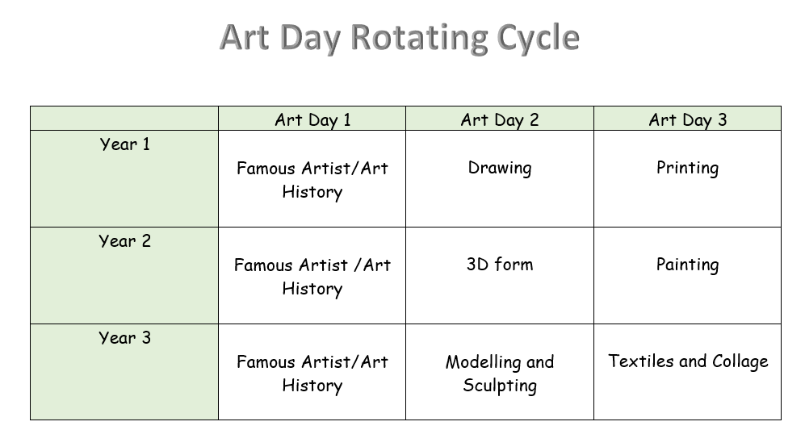
How is Art taught?
Art is taught through a combination of subject knowledge and skills. Learning takes place both inside and outside the classroom.
Art is taught through a wide variety of experiences which are initiated by truly inspirational artists. Children’s work is evaluated and developed throughout the lessons that are delivered. Children learn about famous artists and their techniques for producing aesthetic pieces, which are shared with others and discussed.
Sketchbooks are used as a way of recording, developing skills and reflecting on work of famous artists. It is important that children are exposed to the diversity of art that exists around the world. The sketchbook is used as an initial way of exploring responses to a variety of stimuli. A child can explore their initial ideas, write notes and collect photographs to include in their sketchbooks. Sketchbook work might lead to a final piece of work or may include references for future work.
The children at Orrets Meadow are encouraged to practise and develop their work.
- Techniques are practised such as shading, perspective and drawing from different viewpoints.
- Details are recorded.
- Working drawings are produced.
- Information gathered.
Access to the curriculum
The children at Orrets Meadow have a wide variety of special needs which include Spld, Adhd, Dyspraxia, Asd and Semh. Our pupils are primarily working extensively below their related age and consequently we provide a curriculum which ensures that the children are able to access and learn from it. The lessons are adapted to ensure children can engage at their own level but also experience an element of challenge which ensures that their learning grows.
The needs of our children are paramount and sensory issues that the children may have are considered before tackling new ideas. Many of our pupils have poor motor control and therefore tools have to be sourced or adapted to cater for their needs. Many also have sensory issues and this may prevent participation, so alternative activities are planned to ensure we have an inclusive classroom.
It is our aim at Orrets Meadow to engage all children in enjoyable learning experiences, delivered in stimulating ways, so children can feel achievement in what they have produced and so they can see how they have progressed in a variety of art skills.
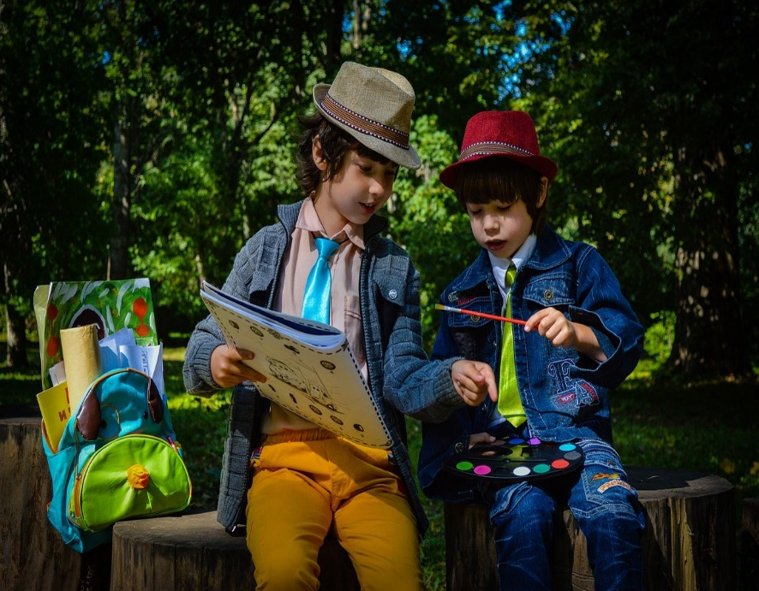

Art is an important part of developing pupils’ ability to express their individual creativity, working both individually and collaboratively with others.

What do we learn about in Art?
In Art we learn about:-
Different Media
- Drawing
- Painting
- Textiles and collage
- 3D form
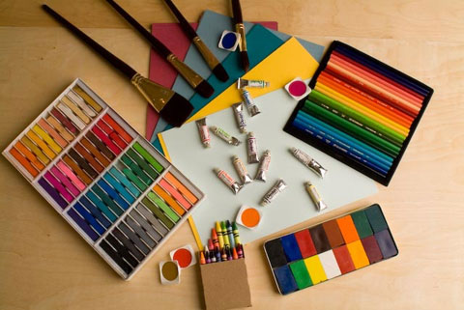
- Pattern
- Printing
- Photography
- Sculpture
- Mixed Media
- Textiles and Collage
Through art, pupils produce their own, original creative work, exploring their ideas and recording their experiences.

- Modelling

Different Skills

- Explore line, shape and colour
- Explore a variety of tools and techniques
- Make marks in print with a variety of objects
- Investigate using print on a wide range of media
- Explore malleable materials
- Respond to ideas
- Make changes to own work
- Experiment using a variety of tools, including pencils, crayons, pastels, felt tips, charcoal etc
- Use different brush sizes and shapes
- Build repeated patterns
- Work out ideas for drawings, using sketchbooks
- Find out about artists and architects and designers
- Draw independently for a sustained period
- Plan, refine and alter work as necessary

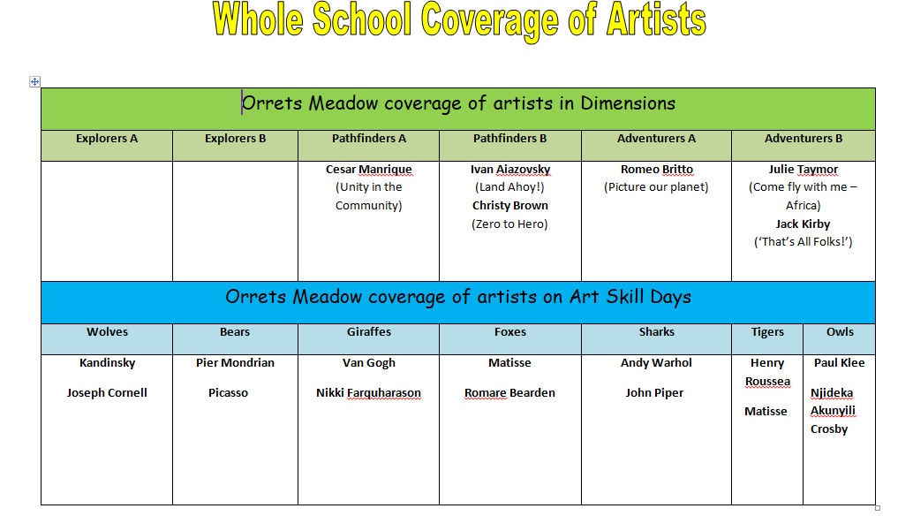
Who do we learn about in Art?

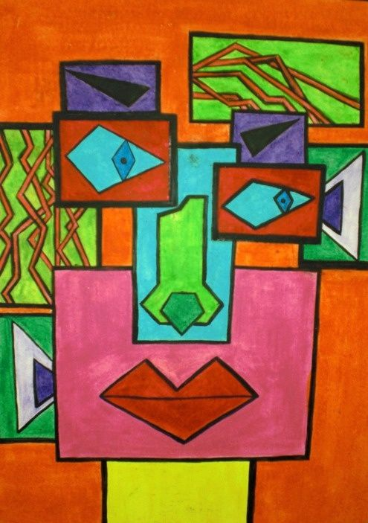

SMSC

Spiritual development in Art
Pupils have opportunities to communicate their ideas, meanings and feelings. Pupils use their imagination and creativity. Pupils will investigate visual, tactile and other sensory qualities of their own and the work of others. Pupils will develop independent thinking and develop their ideas.

Moral development in Art
Talk about how artists and designers represent moral issues.

Social Development in Art
Students work is celebrated by sharing with other classes and working collaboratively on Art projects. Recognise the need to consider the views of others. Respect each other’s ideas and opinions.

Cultural Development in Art
Children will develop knowledge and understanding of artists’ ideas and concepts identifying how meanings are conveyed. Pupils will learn about Art from around the world and how these present the variety of cultures.

Through art we explore a range of religious festivals and celebrations and how art is depicted through these.

Art takes pupils to other worlds, cultures and times, as they explore ideas in the work of a variety of artists.

Art Topic Overview
Knowledge Builder across the school
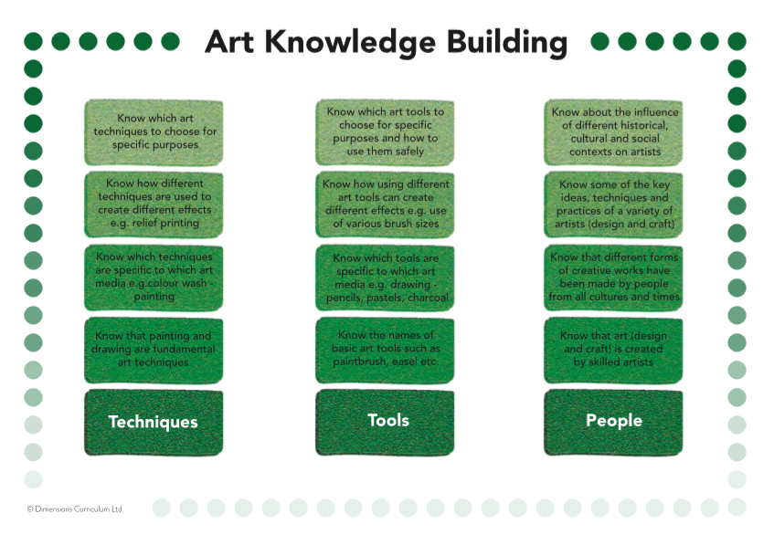

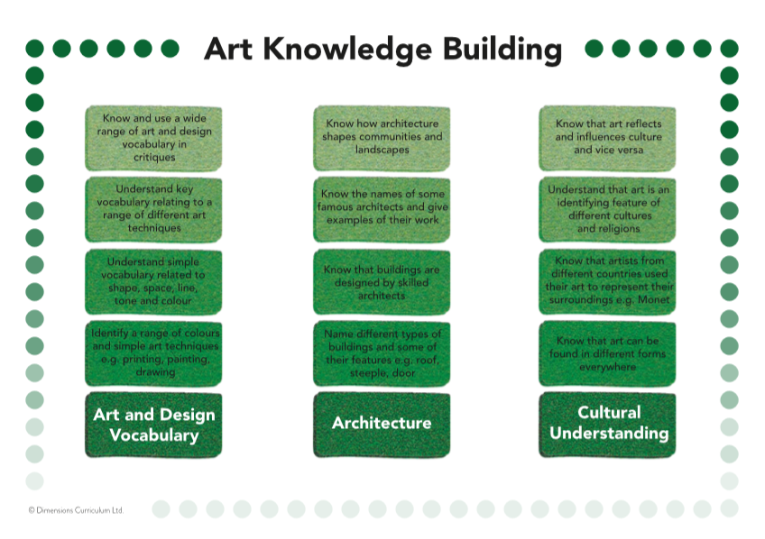

National Curriculum and how it is taught as objectives in Learning Means the World
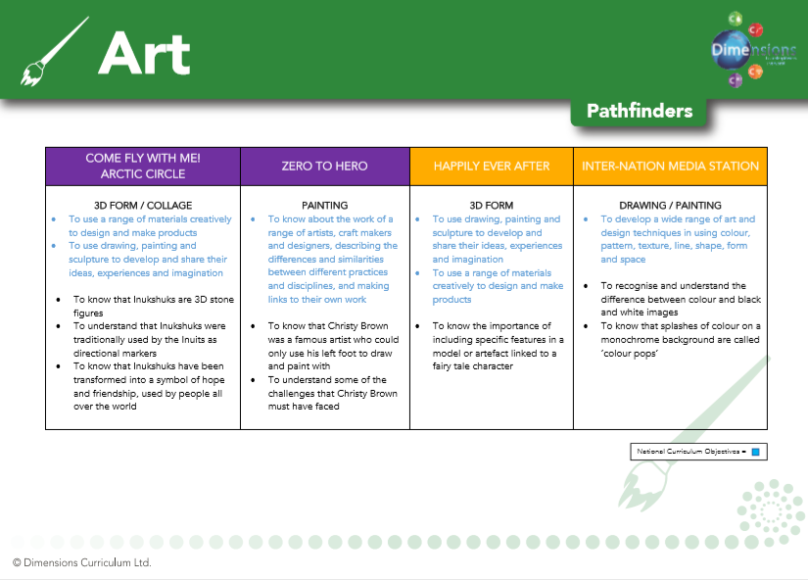

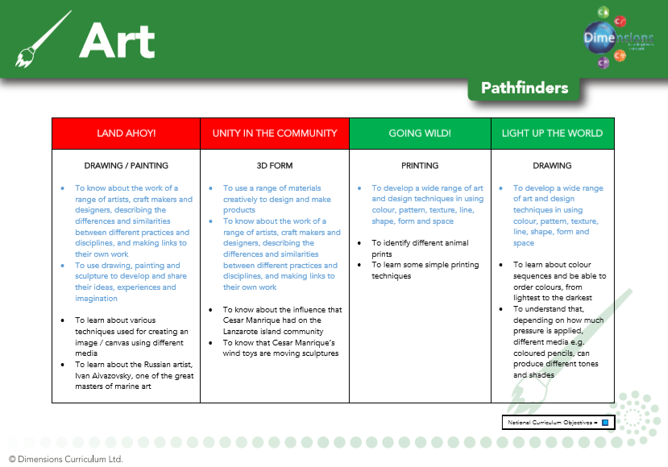

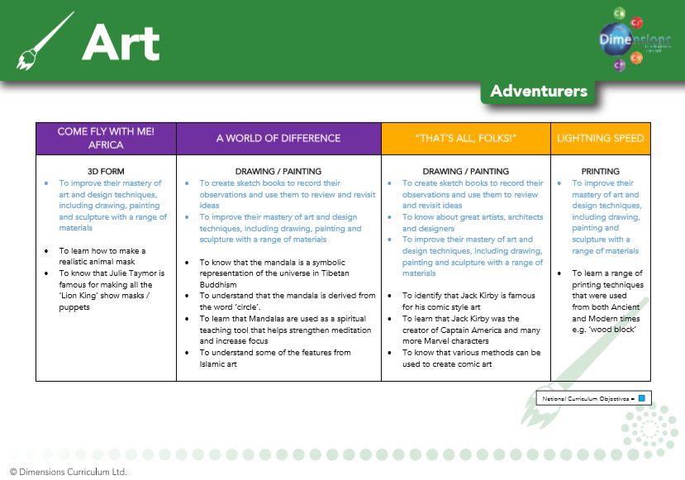

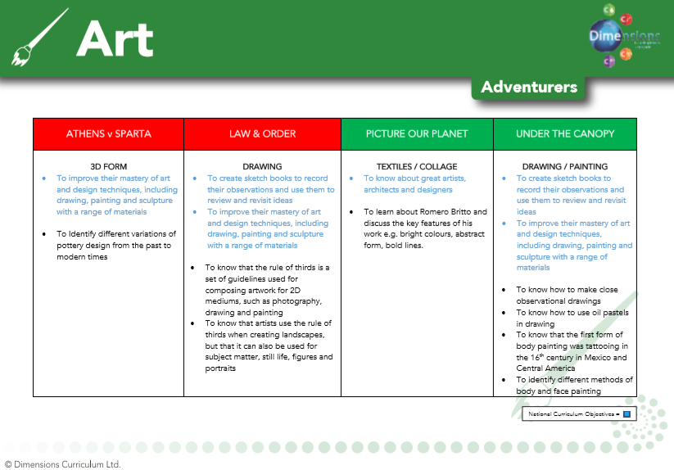

Long term plan - Progression of Skills
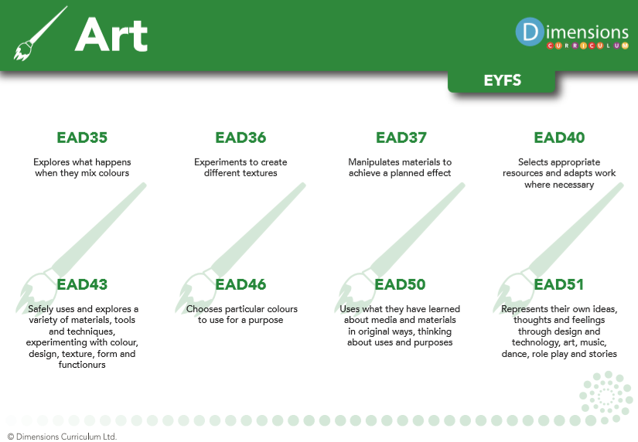

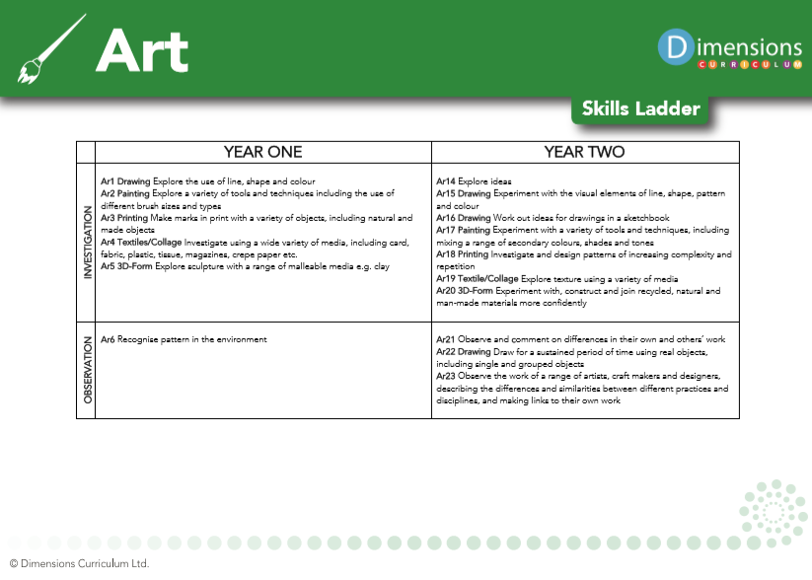

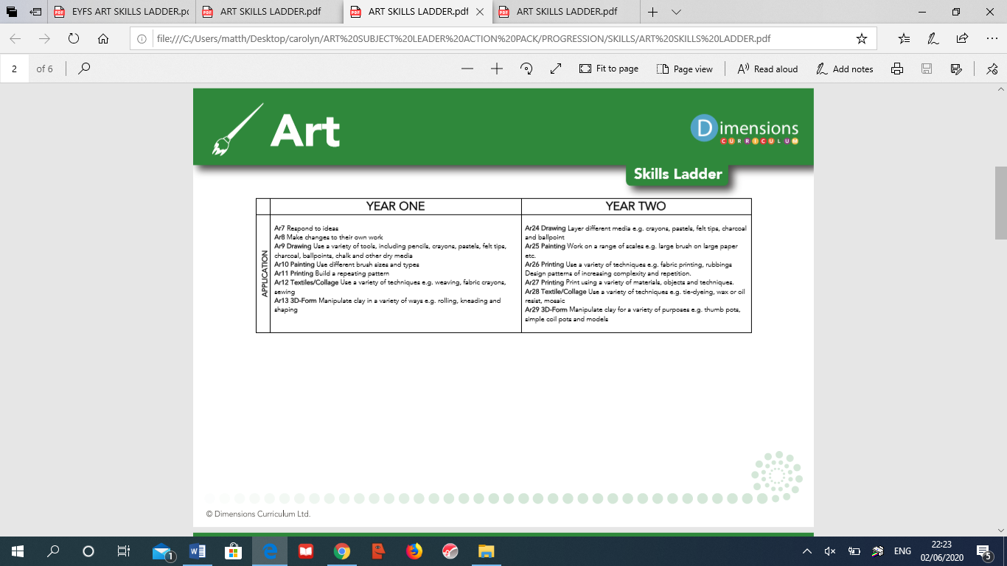

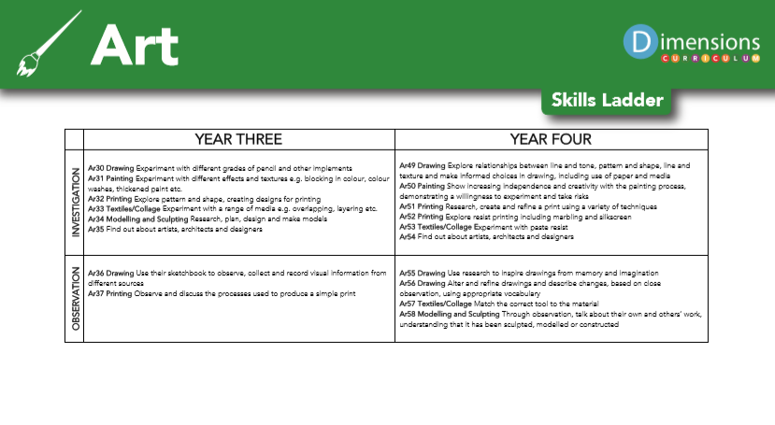

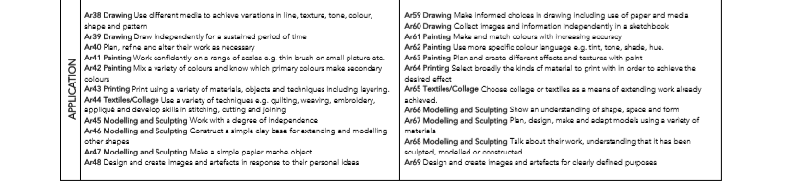

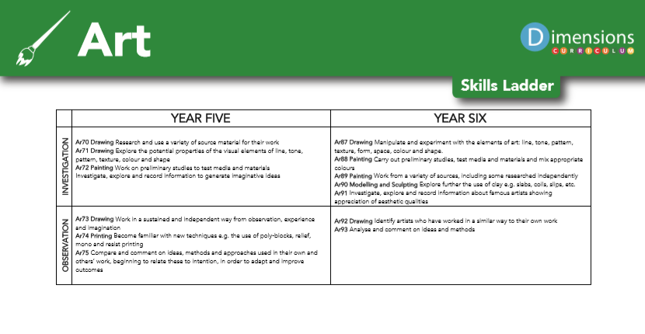

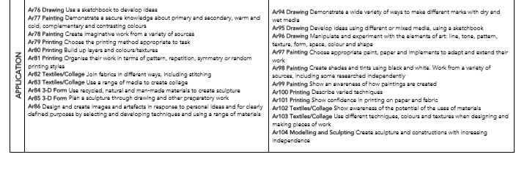

Skills in each art area:

Drawing:

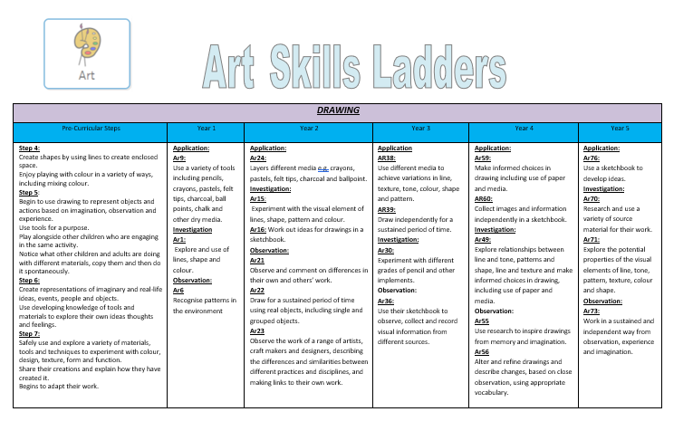

Textiles and Collage
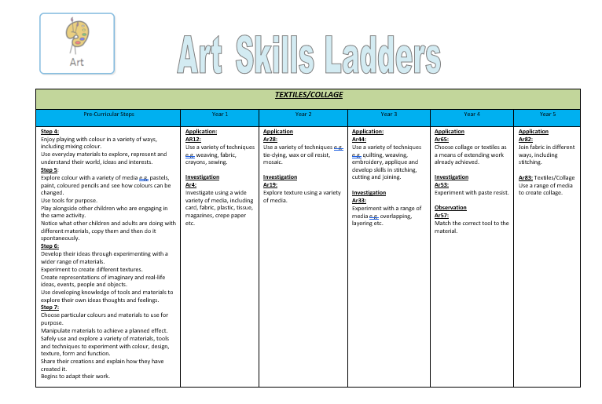
Printing 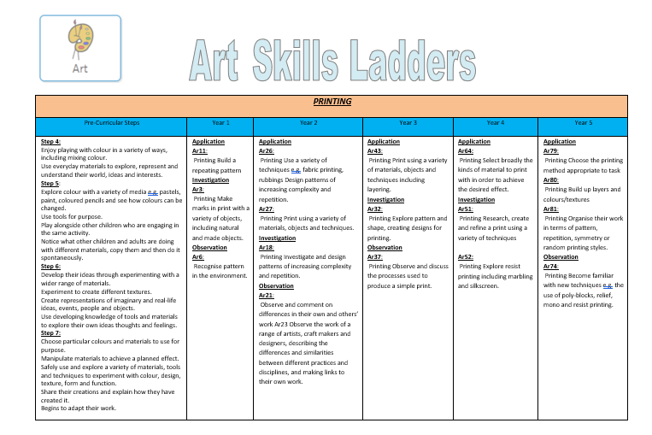
Modelling and Sculpting
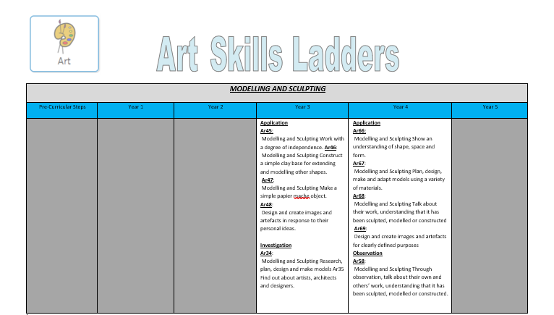

3D Form

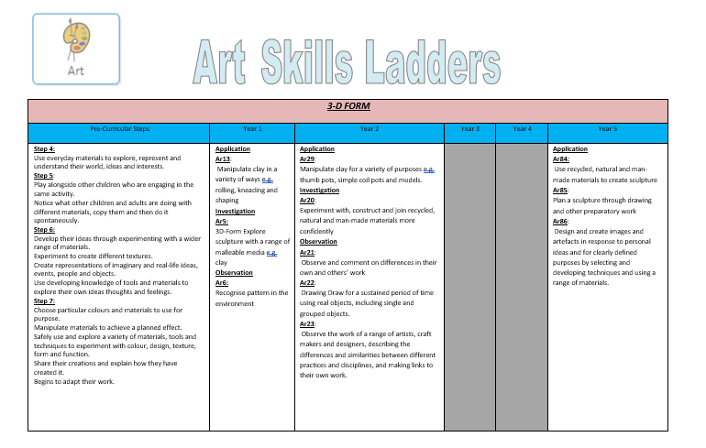

Painting
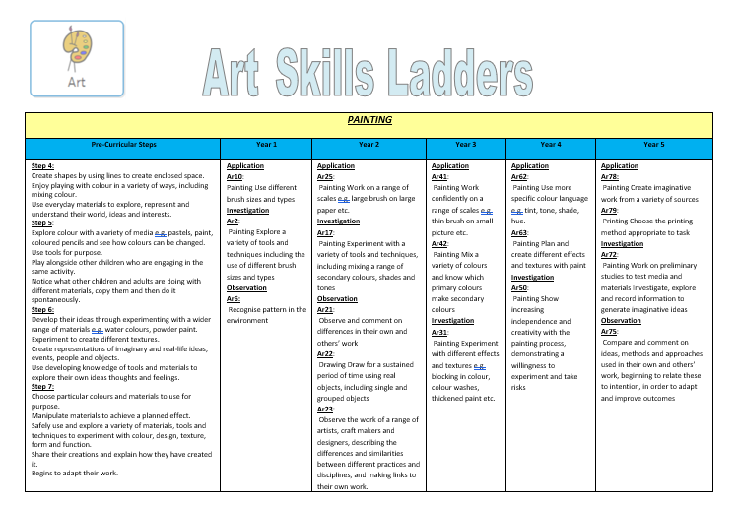

Impact

How do we assess and monitor Art?

All subjects are assessed through a programme called Trackzone. This enables teachers to record, monitor and update assessments in real time. It makes data analysis at pupil, class and subject level possible, helps identify gaps in learning and any areas for development.

Specific subject co-ordinators are able to view the children across the school and monitor their progress.

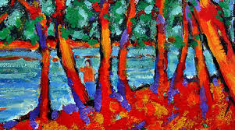
The programme uses a simple grading system 1-5. (U = Unassessed), teachers are able to make a judgement on each pupil’s progress, taking into account the overall evidence gathered through observation, conversation and examination, using their own professional judgement. Awarding a ‘4’ would indicate a pupil is working at age-related expectation, ‘5’ would be linked to mastery or exceeding expectation and 1-3 would be grades of partial knowledge / achievement.

As many of our pupils have short term memory difficulties, they find retaining knowledge especially difficult, so we use Kahoot quizzes throughout the units to support them remember ‘Sticky Knowledge’. These quizzes make learning fun, engaging and impactful. Teachers can use the ready-made quizzes created by Dimensions for each unit or they can create their own to introduce the topic, review and reinforce knowledge and use the information gained to help them identify which objectives have teaching and learning and CPD opportunities.

Art workshops are provided for staff to enable them to develop their skills and develop their ideas via hands on experiences.

SLT and subject leaders are continuously monitoring their subject to ensure it meets the needs of our pupils. They monitor using a variety of activities including:

- Learning walks
- Book scrutiny
- Lesson observations
- Pupil survey and discussions
- Staff survey and discussions

Pupils work towards the ‘Arts Award’. Each pupil collates samples of their art work within their own Arts Award book. They can include photographs, sketches, painting and also photos of themselves participating in expressive Arts like drama and dance. The work is monitored by the Art Co-ordinator. The children can gain a certificate once sufficient evidence is gathered. Achievements are celebrated during our end of term assembly.

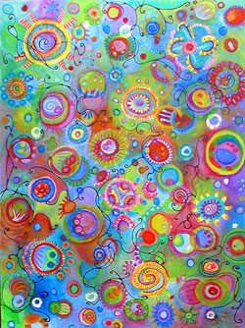
We are excited to teach our Learning Means the World curriculum and know it will positively impact on our pupils’ academic and whole well-being.
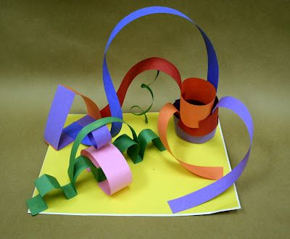
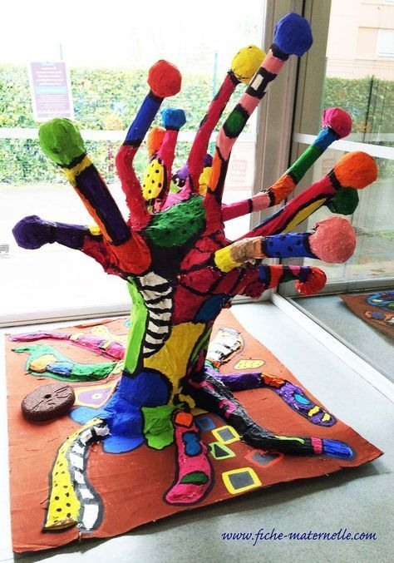

Art develops curiosity, teaching pupils to observe the world thoroughly and carefully.

Art develops pupils’ handling, moving and fine motor control skills.
Learning through art develops pupils’ language skills, social skills, decision-making and risk-taking.

