
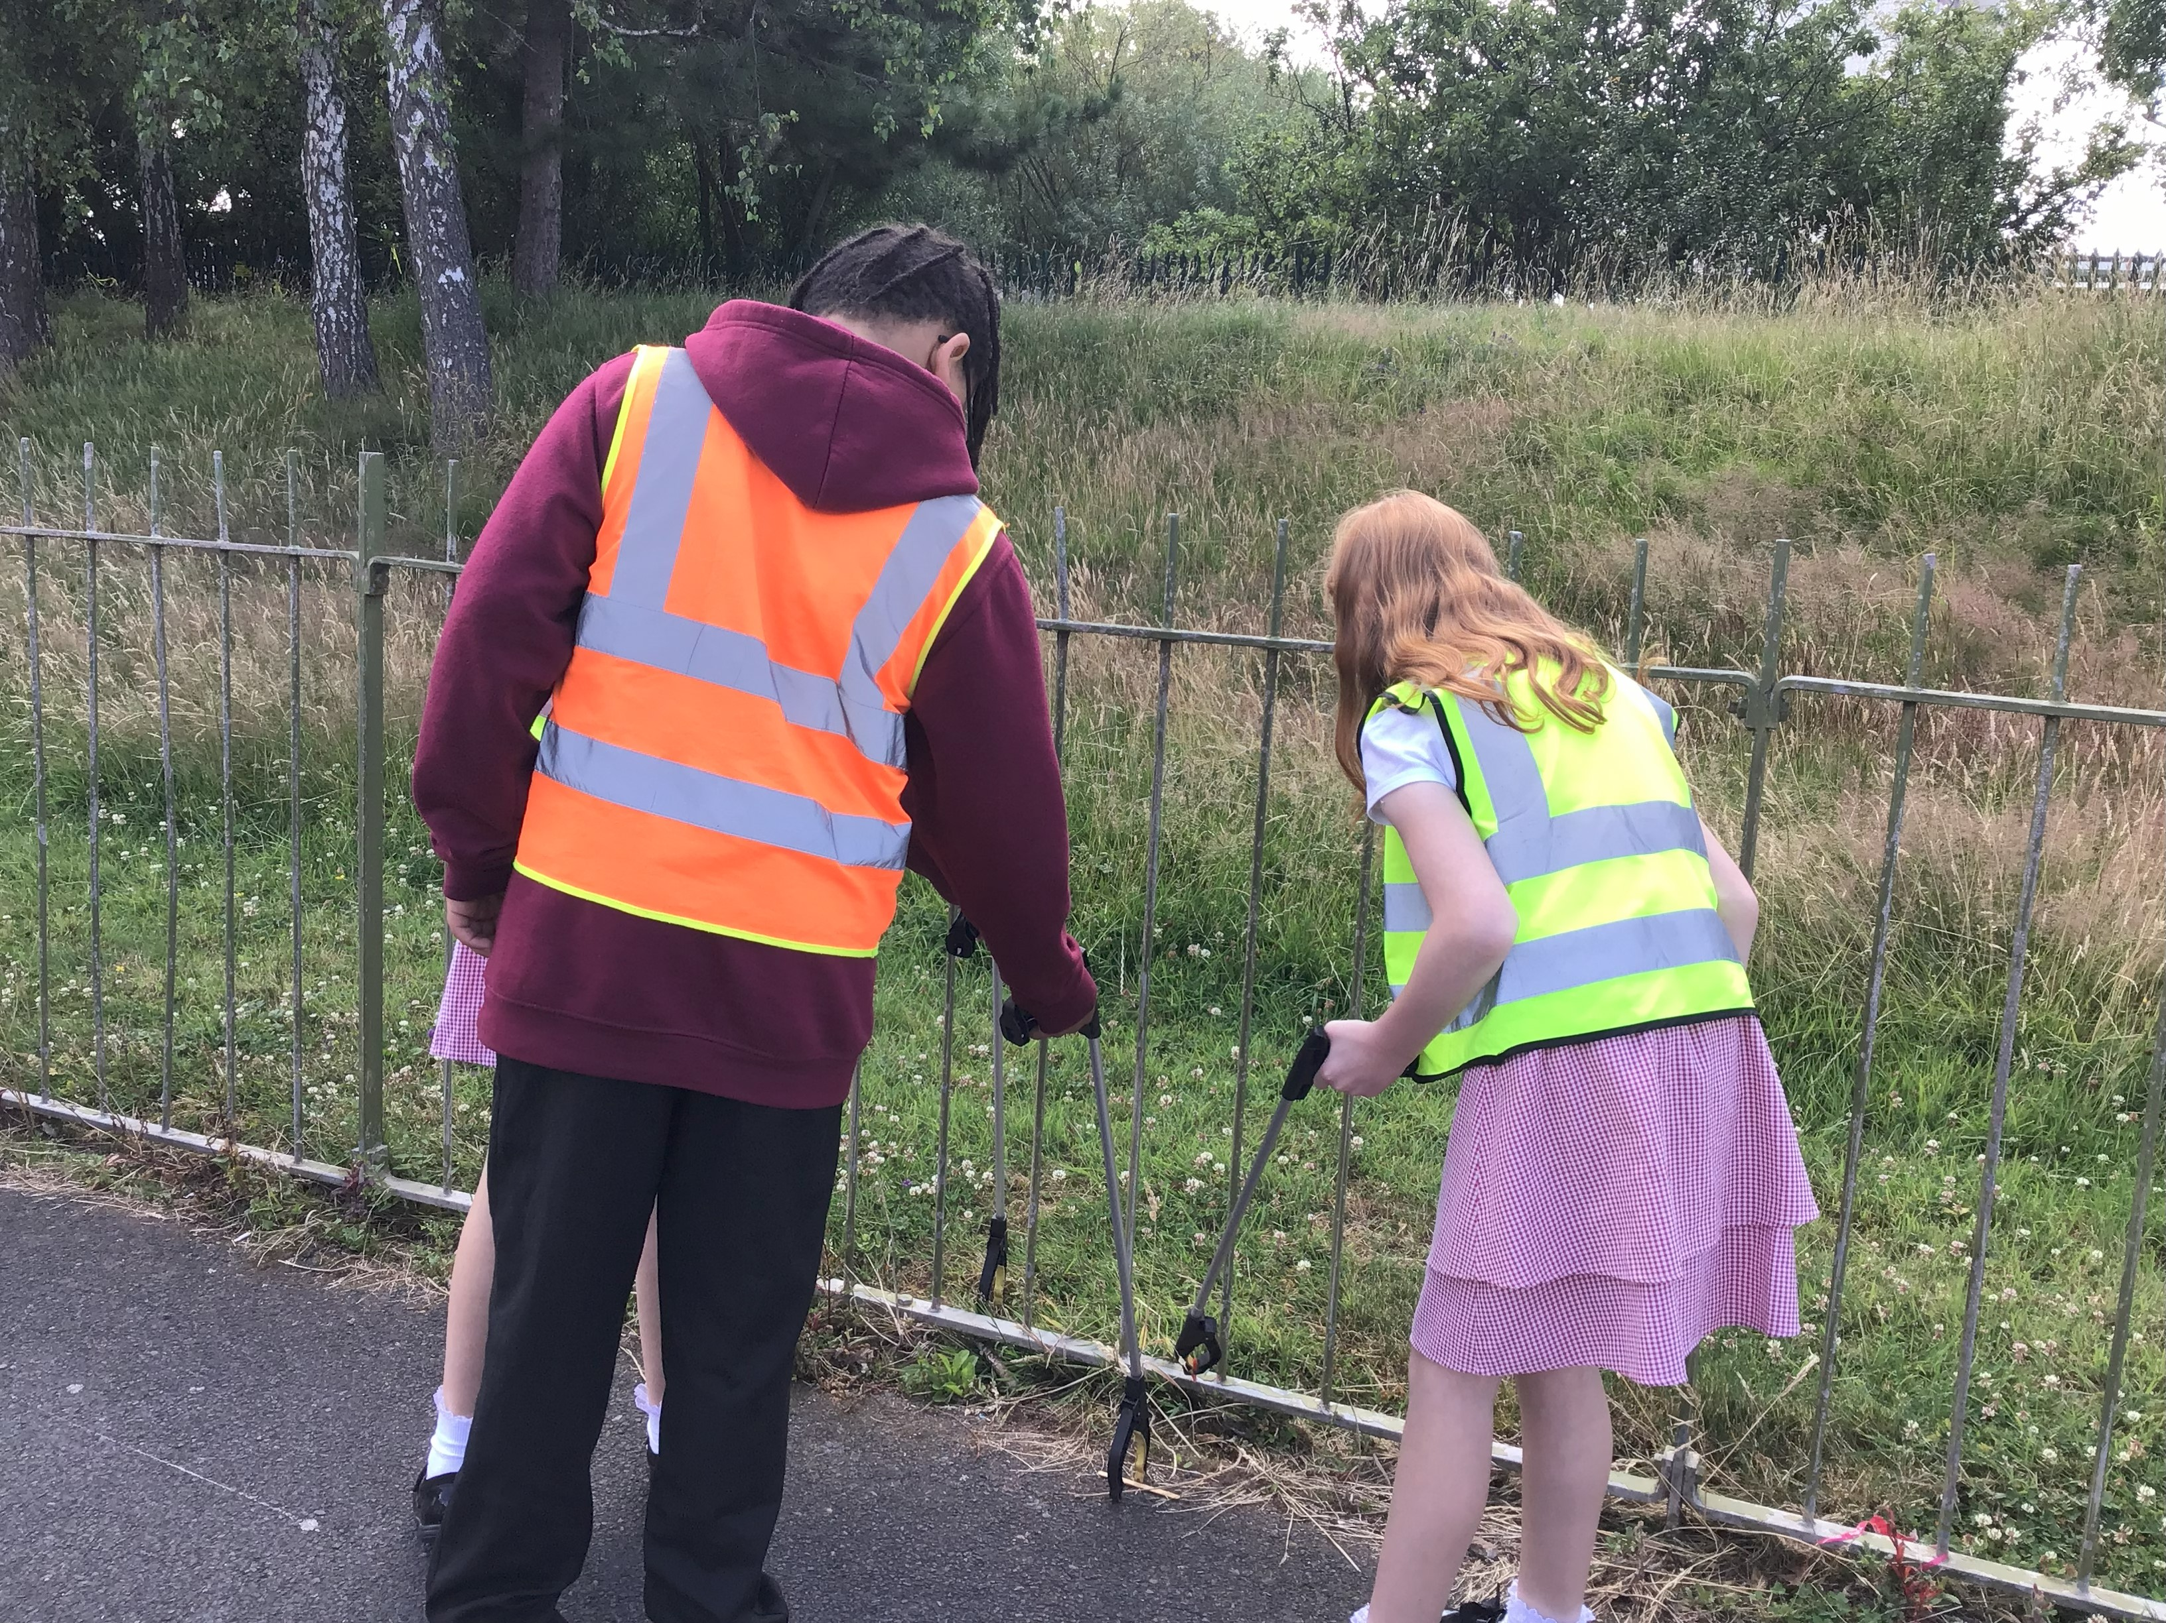
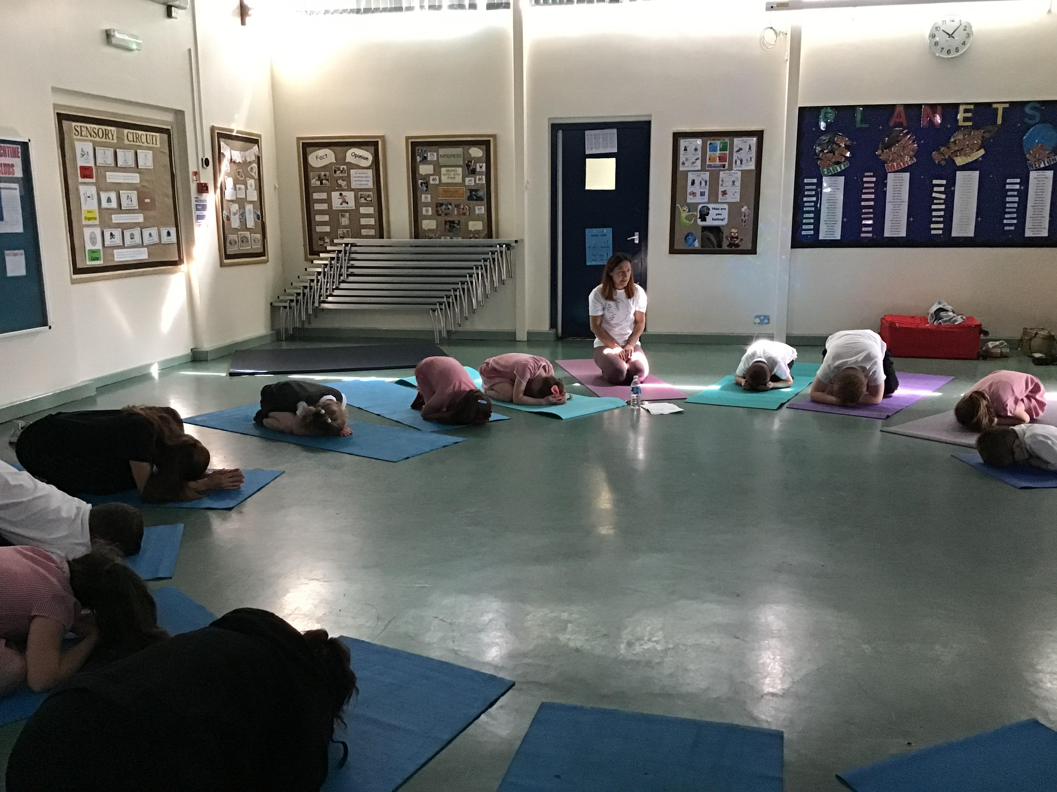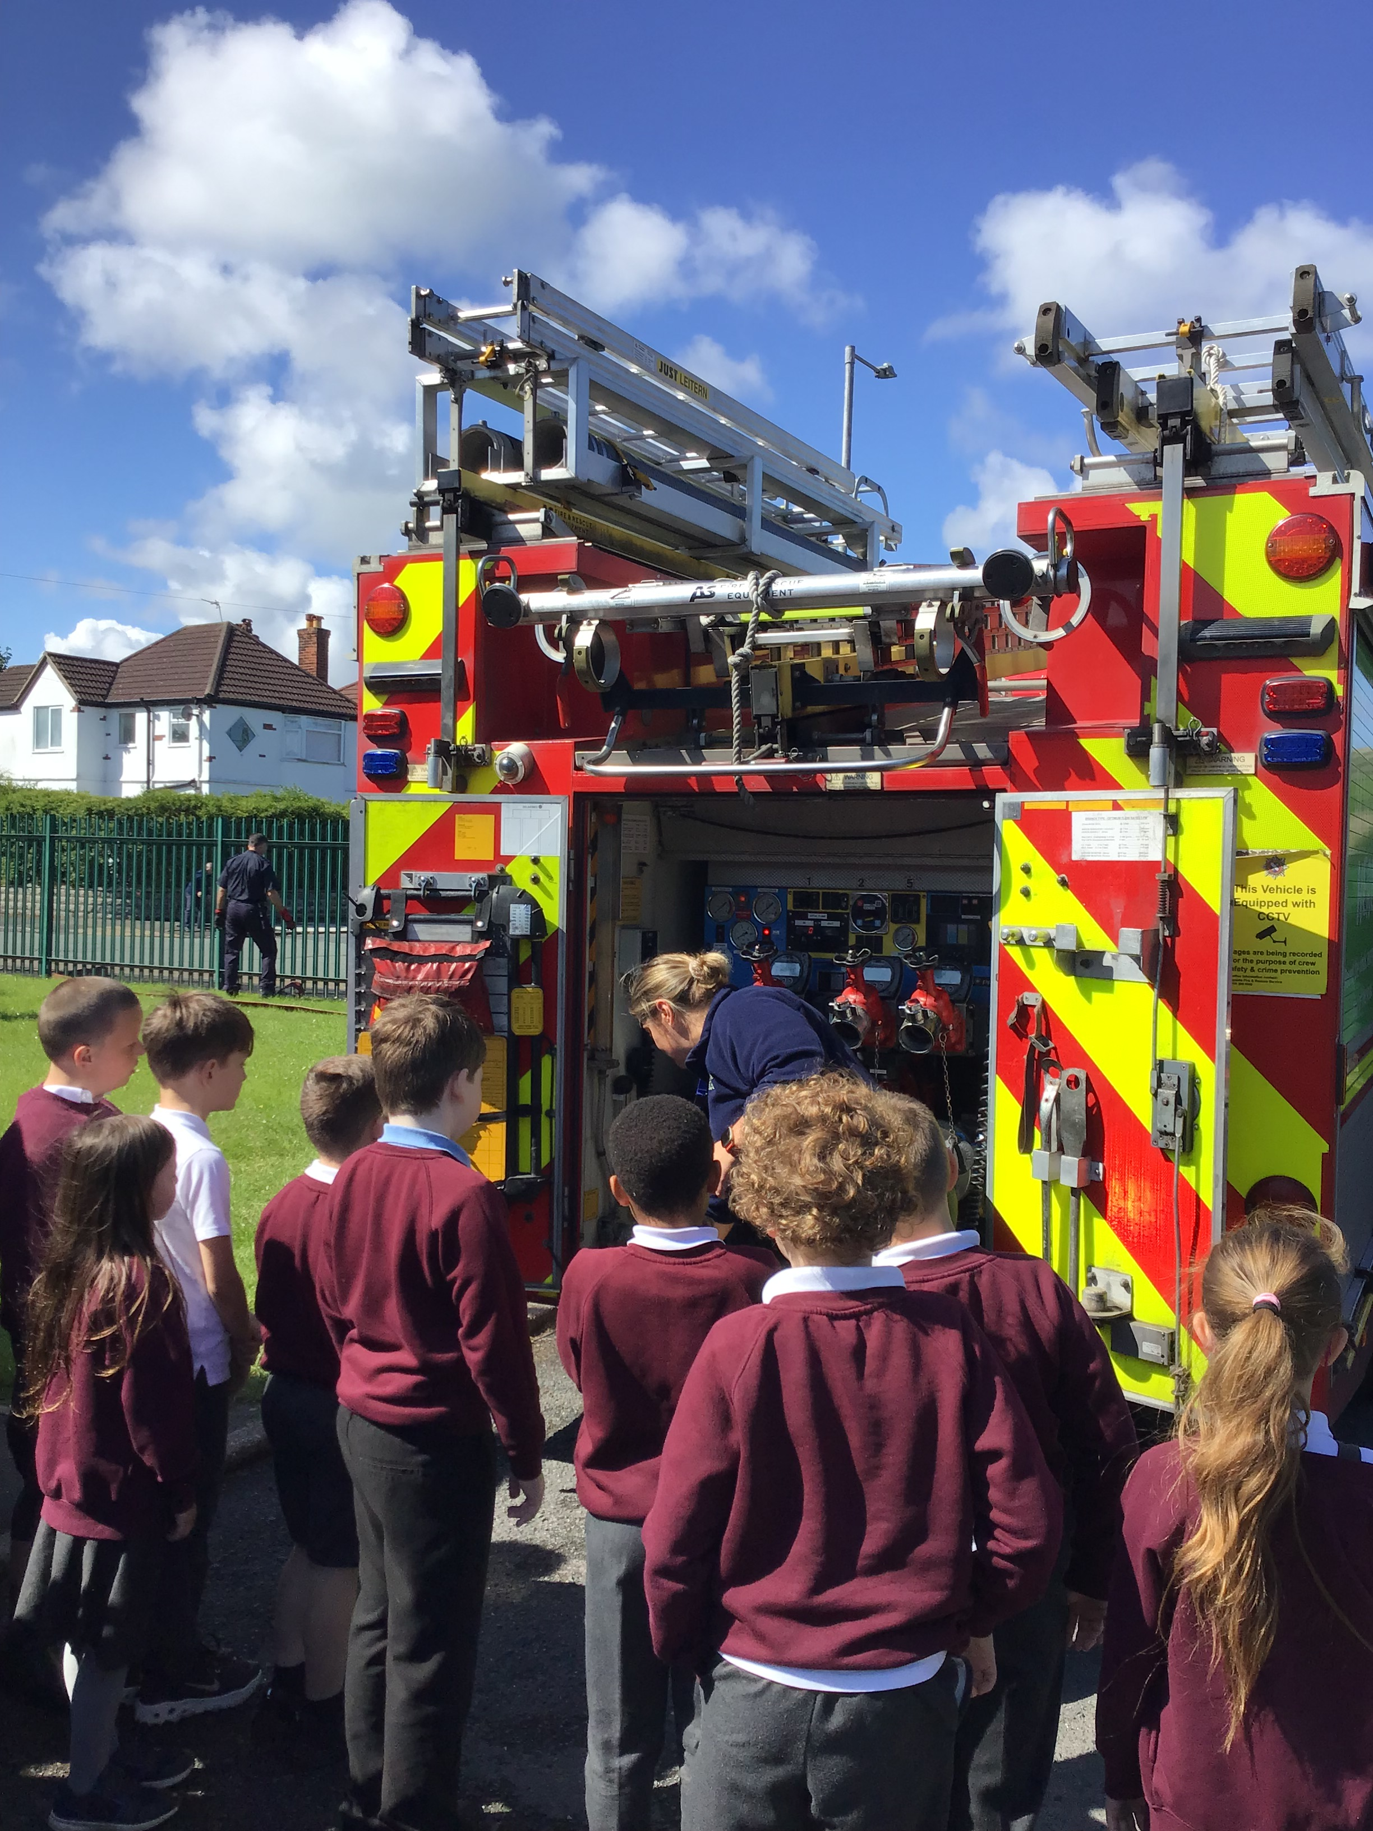

Governors Report – Summer 2025
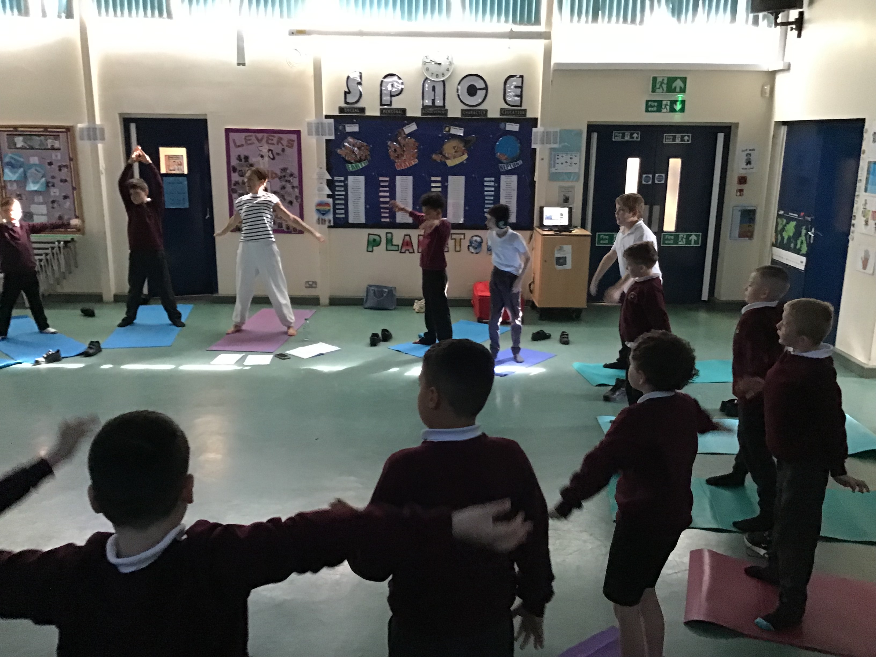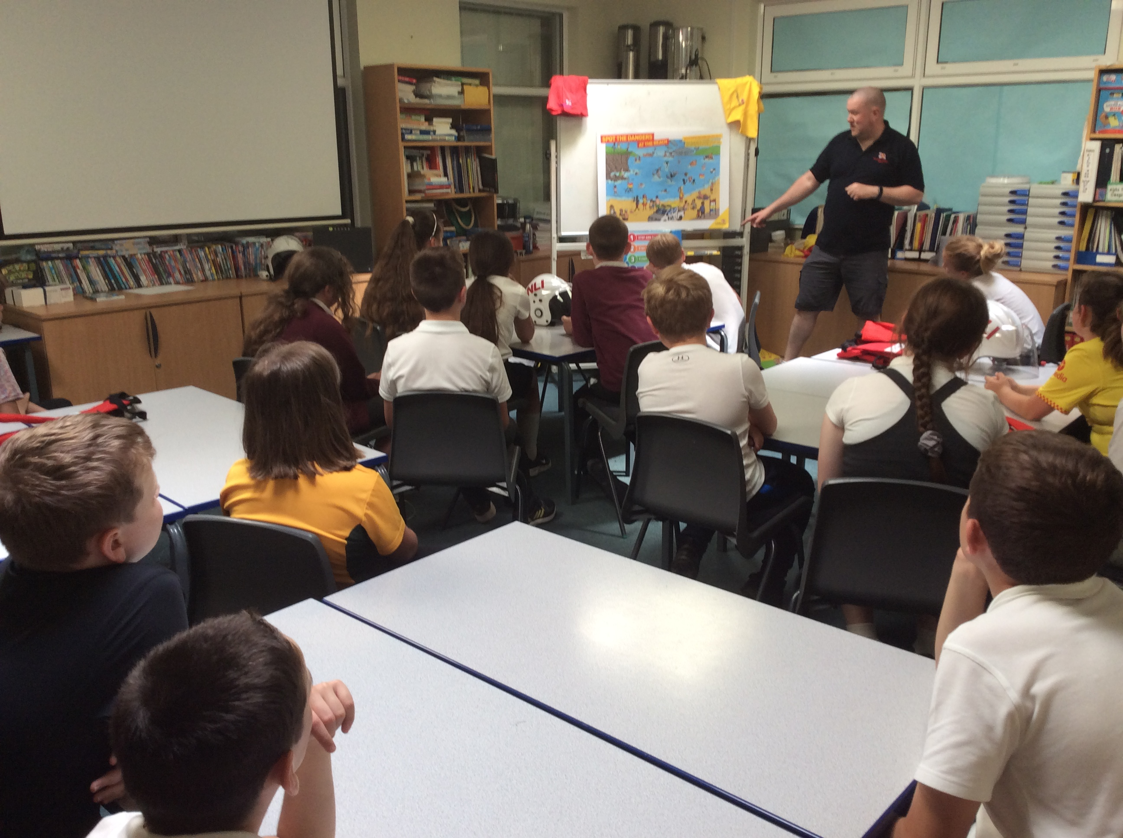
PSHE
Roz Warren
Achievements
The ‘ways forward’ identified last year from this year’s school development plan and the actions taken:
To keep up to date with the legal requirements of PSHE and ensure that Orrets Meadow curriculum adapts accordingly. (Autumn 1 ’24)
R Warren scrutinised and cross referenced the Dimensions PSHE against the legal requirements in PSHE. Additional content was added where required to ensure full coverage.
To adapt the Autism Tracker Independence Section to make it more school based rather than home based. (Autumn 1 ’24)
R Warren adapted the Independence planner so there were achievable school-based targets that can be practiced throughout the day or during our discrete life skill and social skill lessons. Hopefully this will be reflected in next years data and the independence data for whole school and individual classes will be higher.
To get outside speakers to give first-hand experience and expertise in different areas of the PSHE curriculum. (Ongoing)
During Being Healthy week, we have had an array of speakers including; the police, fire brigade, dental hygienist and life boat to name a few.
To arrange for the Police to come in and discuss e-safety and sending inappropriate images and the legalities of what you can do in and out of school (Y5/6). (Spring 1 ‘25)
The Police delivered an e-safety presentation in the hall for our whole year 6 about online usage and sending and receiving inappropriate images.
To organise and deliver an exceptional Being Healthy Week. (Summer 2 ‘25)
Our Being Healthy and Safe week is in full flow this week. We have many exciting events taking place for the children including; music by Matt Baker, A specialist rugby and cricket coach, yoga and Super Soul Sanctuary with Shazney. Classes are also going on mindfulness trips to Williamson art gallery, the beach, the farm and the park.

CPD for PSHE Lead
This year as subject lead R Warren has accessed the termly Liverpool School Improvement PSHE briefing. Claremount and Orrets had a face-to-face subject leader meeting, R Warren met with the PSHE lead to discuss processes, assessment and coverage. It was a fantastic opportunity to meet with another PSHE lead and discuss all aspects of PSHE.

Staff Training
During staff meetings R Warren has reflected on PSHE updates, given book scrutiny feedback and discussed any adaptation to the planning.
Quality of teaching and learning in PSHE
As the PSHE subject leader, R Warren completed a range of activities to oversee the teaching and learning of PSHE this academic year. Including collating and analysing the ASD Framework Data, Scrutinising the PSHE books against the planning, conducting learning walks, staff and pupil voice surveys and the Year 6 teachers on the Sex and Health Education lessons taught.
ASD Framework
The ASD Framework continues to give us informative data on the children. All new children were baselined during the autumn term and existing children’s ASD Frameworks have been updated accordingly. The IEP (Individual Education Plan) continue to reflect this and therefore gives future targets for children in the highlighted areas of need. The whole school area of strength this year came out a social interaction and the area for development came out as Independence and community. This year the Independence section in the Autism Framework tracker was adapted to make the targets more relevant to school-based practice in an attempt to improve Independence and the corelating data.

PSHE Book Scrutiny
PSHE books continue to showcase the excellent breathe of study, the progression of skills and knowledge across the year groups and the creative way it is taught. Photographs evidence the different lessons and the books demonstrate a variety of multisensory teaching it also evidences pupil engagement. PSHE book scrutinises have taken place each term to moderate coverage and work evidenced. The statutory RSE content is demonstrated for each class within their books and the coverage of legal requirements.

Learning Walk and Lesson Observations
This year R Warren completed several learning walks of PSHE. All children were engaged and on task. Children felt confident to answer questions and there was a lovely dialogue held between teachers and peers in several of the classrooms. It was obvious through this that PSHE is taught to a high standard and It was a pleasure to see PSHE being taught sequentially, using multisensory teaching and showing a high level of pupil engagement.

Autism Accreditation
This year we yet again received advanced status in the Autism Accreditation Award. We undertook a 3 day inspection and the outcome and feedback was amazing.

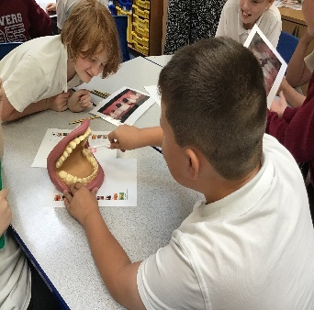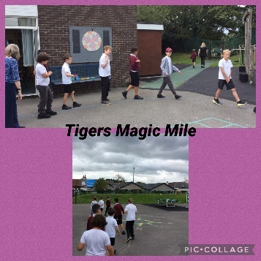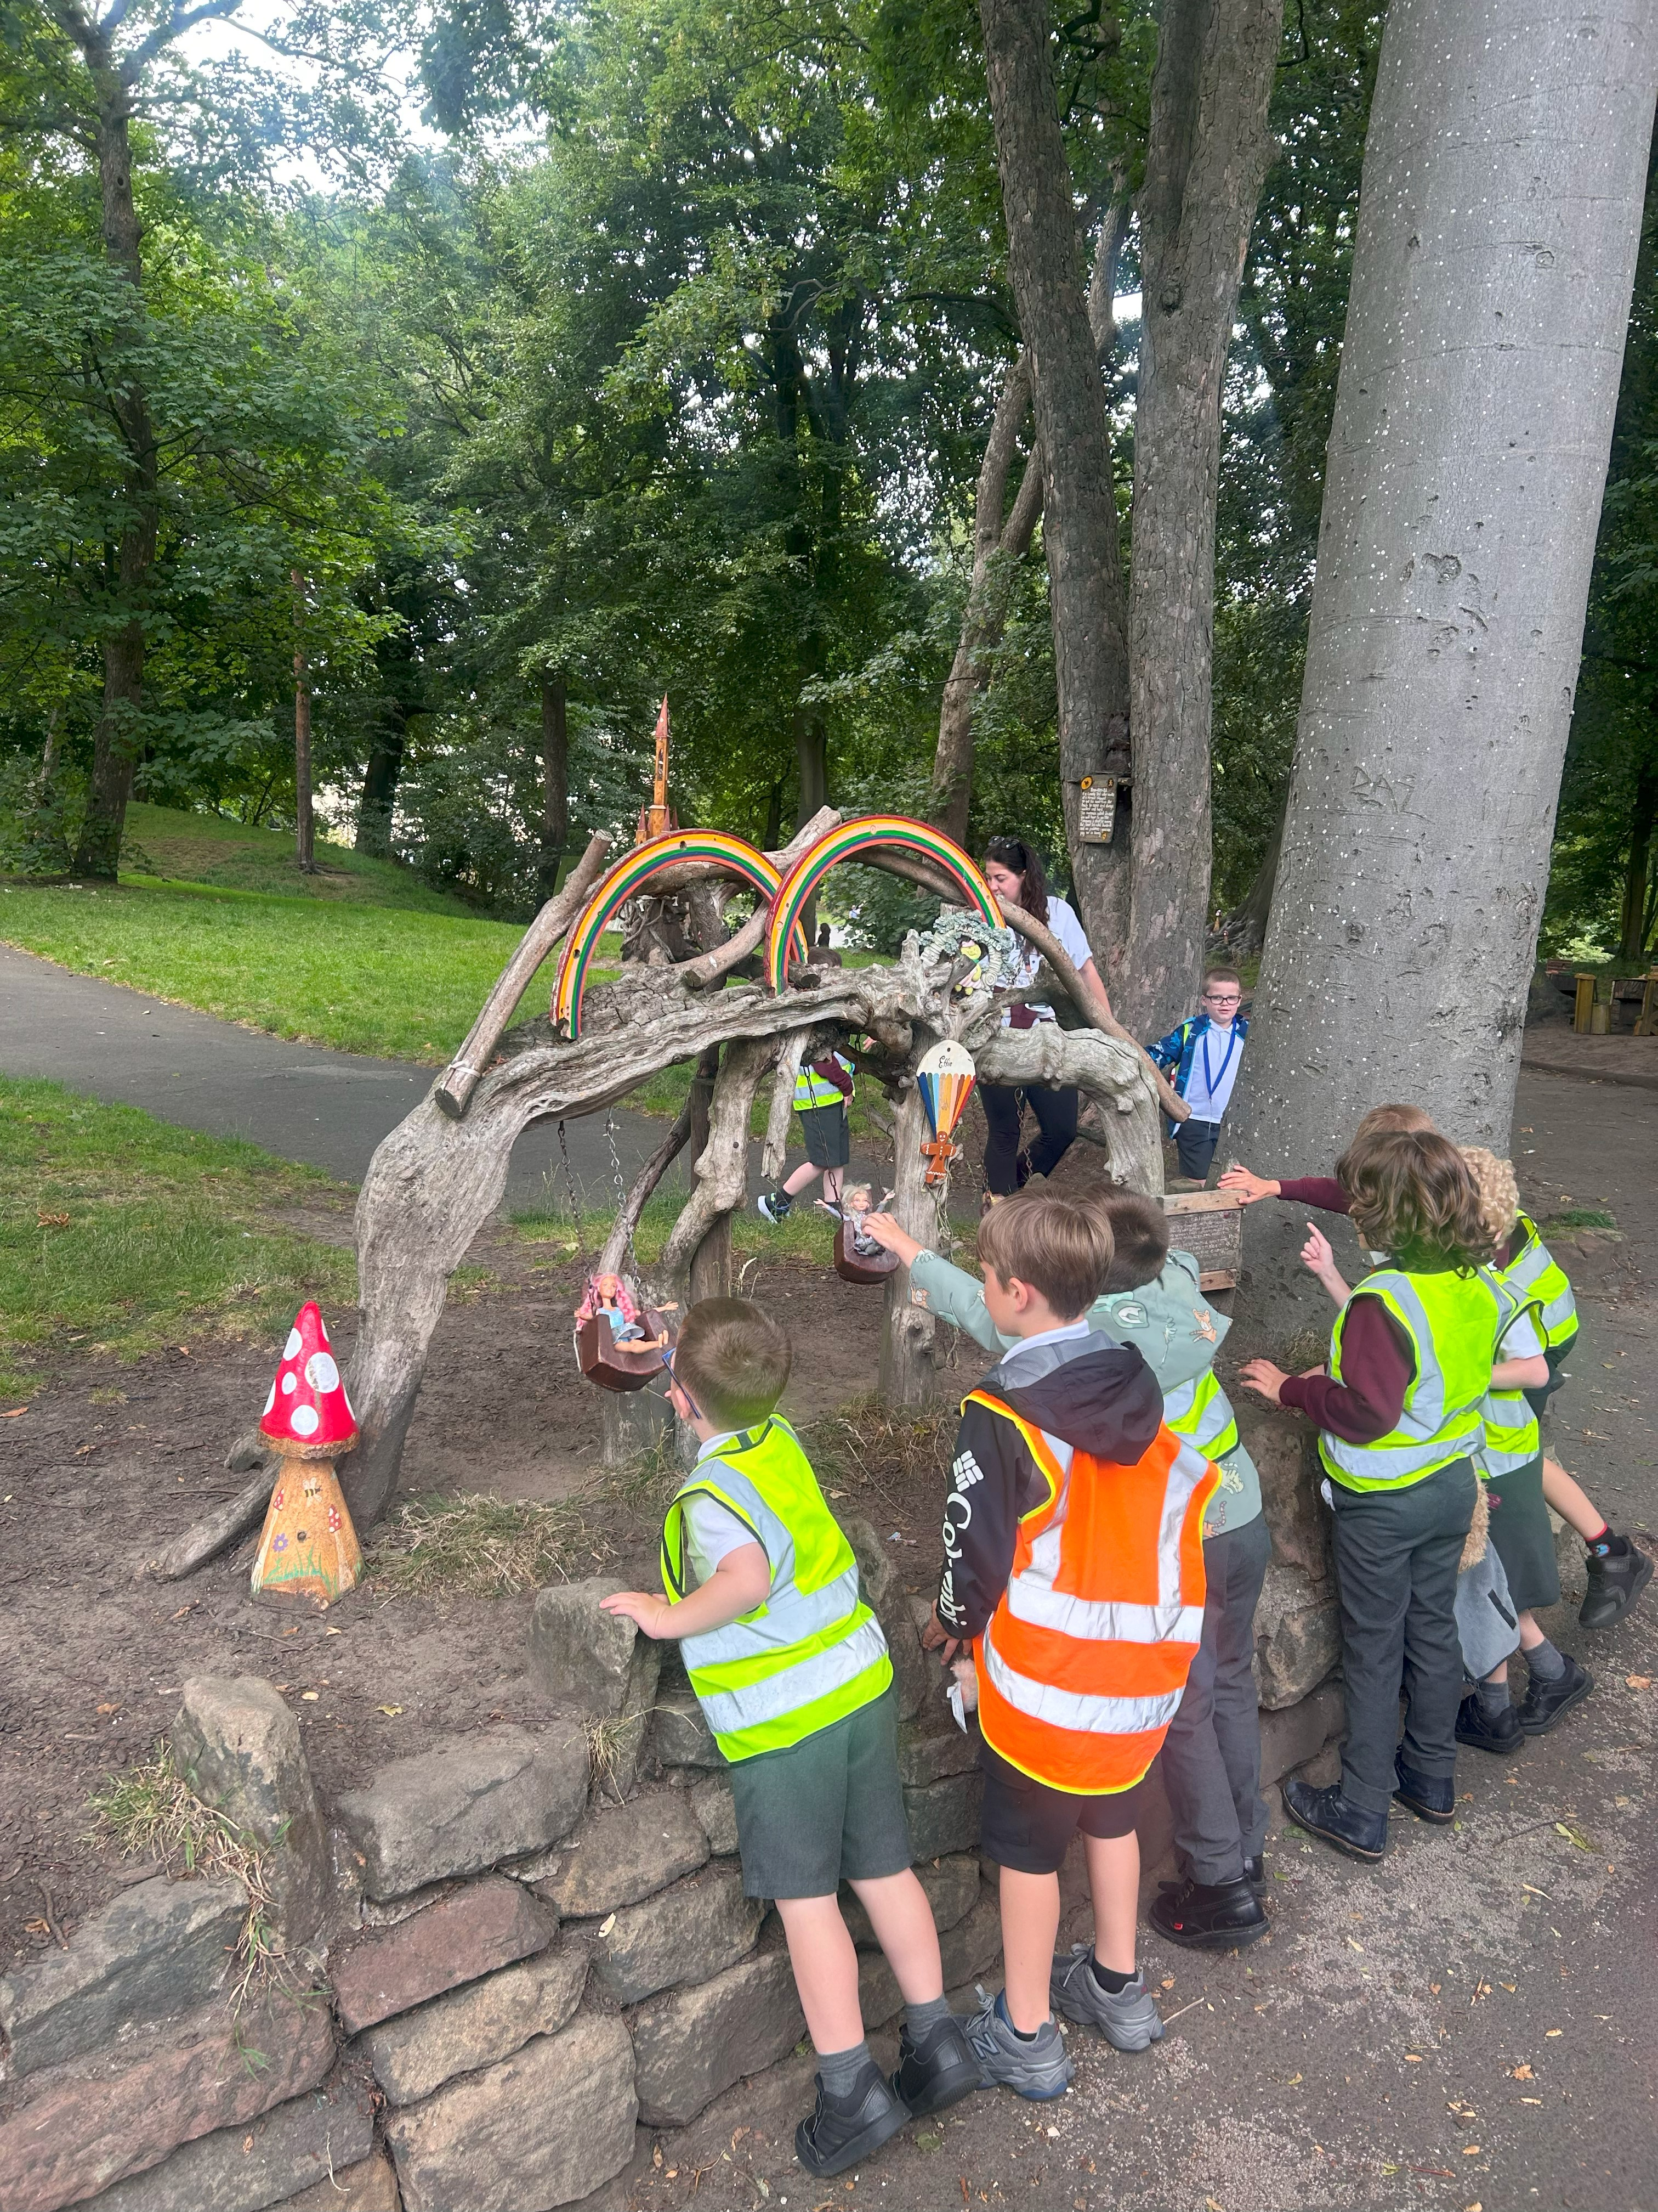

Pupil Voice

A cross section (2 per class) of pupil voice was taken from each class to find out pupil’s opinion about PSHE:

I enjoy PSHE lessons | 98% of pupil’s enjoy PSHE
I can tell my teacher some of the things I learn in PSHE (using book) | 100% of pupil’s could tell their teachers something they have learnt about in PSHE
My teacher teaches PSHE using lots of different activities | 100% of pupil’s feel that PSHE is taught through lots of different resources
The activities in PSHE are interesting and engaging | 94% of pupil’s find PSHE interesting and engaging.
I feel comfortable sharing my ideas, views and opinions in PSHE | 94% of pupils feel comfortable sharing their views

Some of the pupil comments:
‘I learnt how to share’
‘I enjoy Miss Baker’s lessons’
‘I find it fun’
‘It is calm and fun’
‘I like to share my ideas with my talking partner’
‘I like the different activities’
‘I love it’

Staff Voice

Does the Dimensions curriculum support you to teach the children in PSHE? | 100% of teachers agreed that Dimensions supported the teaching of RSE.
Do you feel confident teaching the revised RSE content? | 100% of teachers feel confident teaching RSE.
Are the majority of RSE lessons easy and straight forward to deliver? | 100% of teachers agreed that the RSE lessons were easy and straight forward to deliver.
Is it easy to resource your PSHE sessions? | 100% of teachers agreed it was easy to resource PSHE.
Do the children demonstrate a positive attitude and engagement with the PSHE curriculum? | 100% of teachers say that children demonstrate a positive attitude and engagement with the PSHE curriculum.
Do you feel the children generalise the knowledge and skills of their PSHE lessons overtime? (Autism Tracker) | 88% of teachers felt the children could generalise knowledge and skills of their PSHE lessons overtime.
Do you feel confident in teaching the different areas of PSHE? | 100% of teachers feel confident teaching the different areas.
Do you need any support in PSHE? | 100% of teachers do not require support

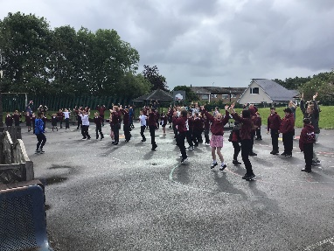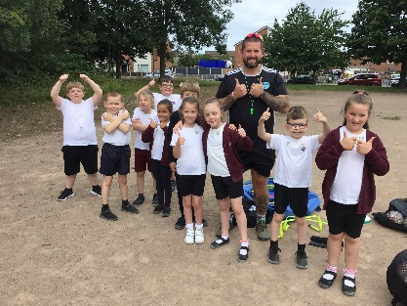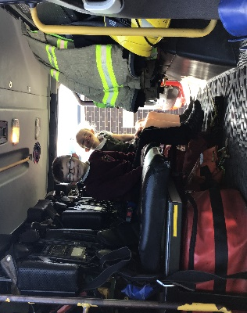

Strengths
- Being Healthy and safe week.
- The children’s engagement and enthusiasm for PSHE.
- Autism Tracker
- Visitors coming in to promote different area i.e. Firefighters, Police, Yoga, Nurse, Super soul sanctuary
- The enthusiasm for teaching PSHE and the children’s response
- Autism Accreditation Advanced status
- Independence afternoon

PSHE Ways forward 2025
- To monitor the adapted independent section on the Autism Tracker to see if children attain more within this area. (Autumn 2 ’25)
- To use more external speakers to enhance the PSHE curriculum e.g. Police, Fire Fighters, Drug Awareness etc. (Ongoing)
- To arrange for the Police to visit to discuss Halloween/Bonfire night and e-safety. (Autumn 1)
- To organise and deliver a Being Healthy and Safe week. (Summer 2)
- To keep up to date with the legal and current requirements of PSHE through the Liverpool School Improvement PSHE sessions. (Ongoing)

