
Orrets Meadow School

Design and Technology Policy

“To raise the aspirations of every child and give them confidence to fulfil their potential through positive experiences”

Orrets Meadow Curriculum Aims and Values
Aims
To ensure all our children are at the centre of a broad, varied and interesting learning experience that is enjoyable and relevant for the future. Our creative, multisensory curriculum will create a sense of awe and wonder and help to inspire a lifelong love of learning. The holistic nature of our practice will promote positive mental health and well-being and will enhance our children’s life skills, social skills and cultural awareness.
Values
Our curriculum will promote a range of values including:
- Respect
- Empathy
- Responsibility
- Equality
- Independence
- Happiness
- Resilience
- Gratitude
- Honesty
- Friendship
Intent
National Curriculum – Design and Technology
Purpose of study
Design and technology is an inspiring, rigorous and practical subject. Using creativity and imagination, pupils design and make products that solve real and relevant problems within a variety of contexts, considering their own and others’ needs, wants and values. They acquire a broad range of subject knowledge and draw on disciplines such as mathematics, science, engineering, computing and art. Pupils learn how to take risks, becoming resourceful, innovative, enterprising and capable citizens. Through the evaluation of past and present design and technology, they develop a critical understanding of its impact on daily life and the wider world. High-quality design and technology education makes an essential contribution to the creativity, culture, wealth and well-being of the nation.
Aims
The national curriculum for design and technology aims to ensure that all pupils:
- develop the creative, technical and practical expertise needed to perform everyday tasks confidently and to participate successfully in an increasingly technological world
- build and apply a repertoire of knowledge, understanding and skills in order to design and make high-quality prototypes and products for a wide range of users
- critique, evaluate and test their ideas and products and the work of others
- understand and apply the principles of nutrition and learn how to cook.
Orrets Meadow’s Curriculum
We teach a Global Curriculum called 'Learning means the World' (LMTW)for all our afternoon subjects. This curriculum is innovative, forward-thinking and highly relevant to our pupils' needs and thoroughly engages them as they tackle challenging and inspiring topics and issues.
LMTW curriculum has been written with world issues in mind and is centred on 4Cs:-
- Communication
History helps pupils gain a coherent knowledge and understanding of their country’s past and that of the wider world.

- Conflict
- Conservation
- Culture
Why did we choose 'Learning Means the World'?
As a school which is majority white British, we want our pupils to fully embrace cultural diversity, learning about, experiencing and celebrating a range of different cultural and faith heritages.
We believe that communication is key to accessing learning and securing pupils’ future success. As many of our pupils have Speech Language Communication Needs it is essential that opportunities are given to develop language for learning across the curriculum. With one of its 4 foci being on communication, this curriculum provides lots of opportunities for pupils to develop expressing themselves in discussion, debate and presentation, as well as enabling them to collaborate and exchange ideas.
We feel our pupils, as the future generation, need a greater awareness and appreciation of local, national and global conservation issues and initiatives. The need to learn that they have an important role to play in sustainability. This curriculum gives pupils opportunities to grow and develop spiritually, emotionally, physically and socially in the natural world around them. Our commitment to nurturing positive attitudes and values and developing life and social skills is promoted throughout the Learning Means The World (LMTW) curriculum.
It is theme based and broken down into the following phases:
- Explorers (Foundation level)
- Pathfinders (KS1 level)
- Adventurers (Lower KS2 level)
We have the freedom to teach the National Curriculum in line with our pupils' specific needs and believe that our whole curriculum meets the values and aims which our stakeholders requested at the start of the consultation.
SMSC

An important aspect of our curriculum at Orrets Meadow is the incorporation of all things SMSC. All staff in all subjects take any and every opportunity to humanise and contextualise aspects and issues of social, moral and other intrinsic events or concepts, be they past, present or potentially pending. We see the promotion of discussion and debate as a healthy part of life in school.

Design Technology gives pupils the opportunity to develop skills, knowledge and understanding of
designing and making
functional products.

Why is Design and Technology important?
Design Technology helps us to develop as reflective learners, as we work through the design process.

Through design technology, we are able to work collaboratively to solve problems and find solutions, teaching us to deal with uncertainty whilst developing communication, organisational and other practical life skills.

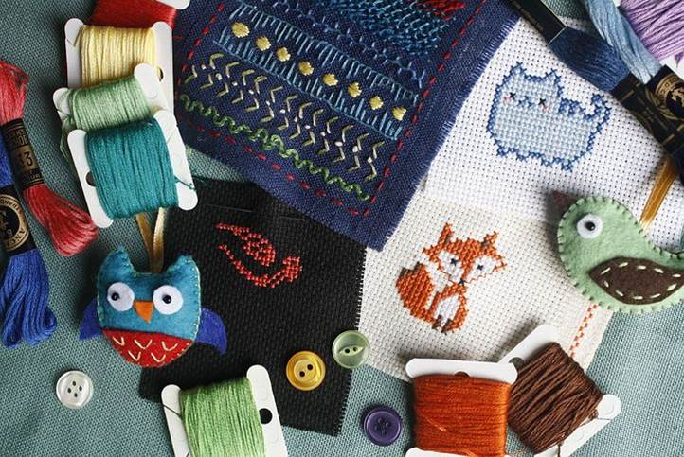
In design technology, we learn to appreciate the needs of others, the built environment and the likely impact of future technologies.


Pupils develop their
communication skills
through design technology, when they are sharing ideas and
explaining their thinking.
Design Technology teaches pupils to understand and apply the principles of nutrition and learn how to cook.

Implementation
Access to the Curriculum
Pupils at Orrets Meadow have a wide range of special needs, including ASD, SpLD, ADHD and SEMH. The majority of pupils are working at least two years behind their chronological age, some three or four years. The curriculum is therefore adapted to meet the stage the child is working at. Skills and knowledge are taught using strategies which help them learn effectively. Multi-sensory, over learning techniques are used to support pupils with their short- and long-term memory difficulties. Enrichment activities are used to bring the topics to life and make the learning more memorable.

When is Design Technology taught?
Design Technology is taught discreetly through thematic Dimensions units. The attached overview maps out which thematic units feature this subject. Focused tasks such as Mechanisms, Structures, Textiles and Cooking and Nutrition are planned in across each phase and taught during three whole school Design and Technology Days over the school year. The Long-Term Plan shows the skills taught through the Dimensions Curriculum.

How is Design Technology taught?

Design Technology is taught through a combination of subject knowledge, skill building and design and make projects. Food technology is taught through Life Skills, our 3D PSHE programme and through focused projects taught during the Cooking and Nutrition day. Learning takes place both inside and outside the classroom.

Pupils at Orrets Meadow have ASD and additional needs, so consideration needs to be given to how we teach DT. Many of our pupils have fine motor skills and sensory overload difficulties, so support is offered to these children to enable them to achieve. All of our pupils are working at least two years behind their chronological age and so the curriculum is adapted to meet the stage they are working at and strategies are used to best meet their needs.

What do we learn in Design Technology?

Through a variety of creative and practical activities, pupils are taught the knowledge, understanding and skills needed to engage in the process of designing, making, evaluating and gaining Technical Knowledge.


We complete design technology projects in each phase for specified clients in exciting contexts that do reflect real life situations. E.g. Designing a bag that is suitable for a Fairy to carry her things. A remote control for a Pirate who only has one hand. A communication device for an Evil Genius and a toy for a Tribal Child.
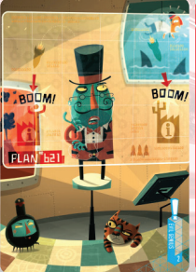



Design and Technology Topic Overview

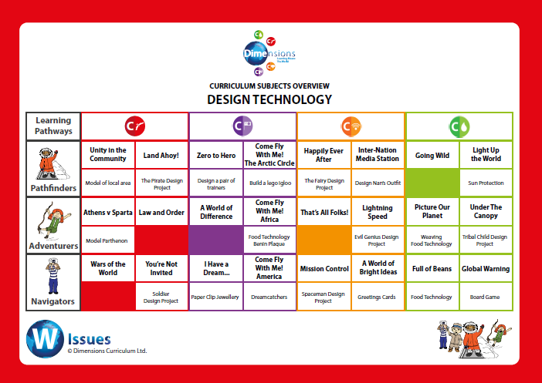


Design Technology helps children to problem-solve, making on-going changes and improvements during the design and make process.

Design Technology
teaches pupils how to
participate successfully in an increasingly
technological world.



Design and Technology knowledge builder across the school
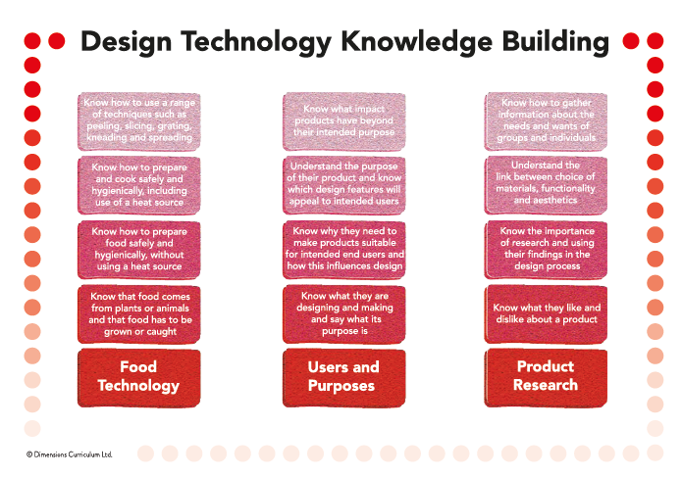

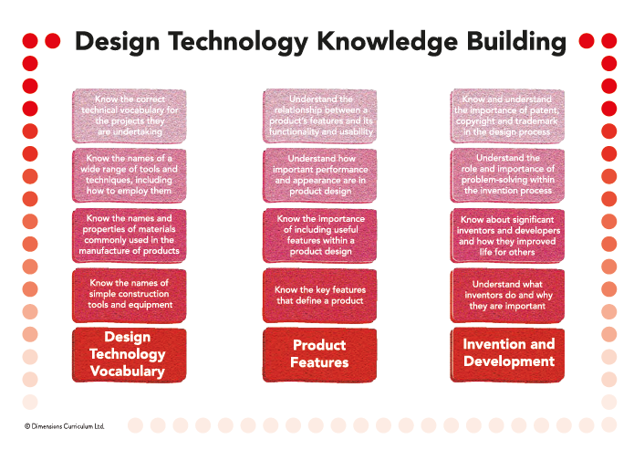

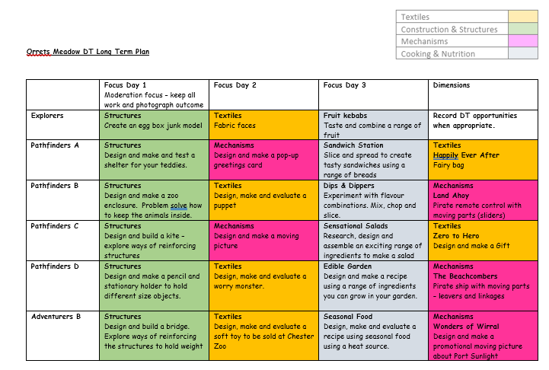

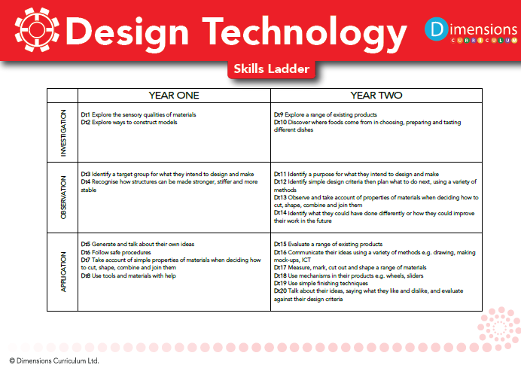

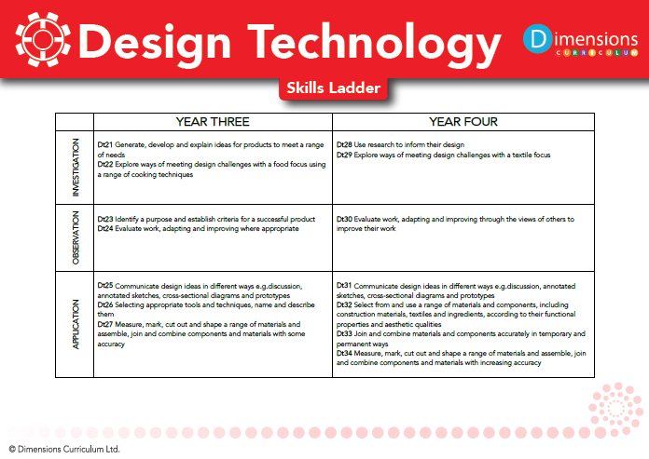
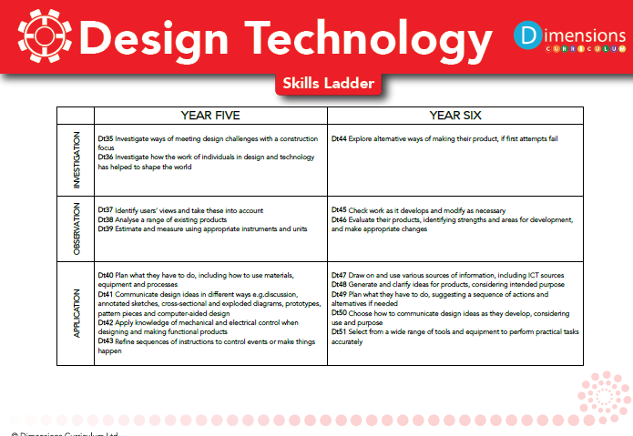

Impact

How do we assess and monitor DT

We use Trackzone which is an online tracking programme which enables teachers to easily record, monitor and update their assessments in real-time. It makes data analysis at pupil, class and subject level possible, helps identify gaps in learning and any areas for development.

Using a simple grading system of 1-5 (U = Unassessed), teachers are able to make a judgement on each pupil’s progress, taking into account the overall evidence gathered through observation, conversation and examination, using their own professional judgement. Awarding a '4' would indicate a pupil is working at age-related expectation, '5' would be linked to mastery or exceeding expectation and ‘1-3’ would be grades indicative of partial knowledge / achievement.

As many of our pupils have short term memory difficulties, they find retaining knowledge especially difficult, so we use Kahoot quizzes throughout the units to support them remember ‘Sticky Knowledge’. These quizzes make learning fun, engaging and impactful. Teachers can use the readymade quizzes created by Dimensions for each unit or they can create their own to introduce the topic, review and reinforce knowledge and use the information gained to help them identify which objectives have been achieved in Trackzone.

Twice yearly in March and July DT attainment can be assessed and analysed through the Foundation Subject Tracker where SLT, subject leaders and teachers can gain valuable knowledge on how the child, class and school are working in DT.

SLT, teachers and subject leaders use assessment for learning to inform planning, teaching and learning and CPD opportunities.

SLT and subject leaders are continuously monitoring their subject to ensure it meets the needs of our pupils. They monitor using a variety of activities, including:

- Learning walks
- Book scrutiny
- Lesson observations
- Pupil survey and discussions
- Staff survey and discussions

We are excited to teach our Learning Means the World curriculum and know it will positively impact on our pupils’ academic and whole well-being.

