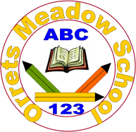**Governors Report – June 2024**

***English***

***Matthew Ferris-Rice***

**Overview & Priority Focus**

This academic year, the principal focus for English has been to **adapt the writing curriculum to ensure inclusive opportunities for all pupils,** with a particular emphasis on the **most complex learners**. This reflects Focused Priority 4 in the 2024–2025 School Development Plan (SDP). Our aim has been to revise the curriculum, assessment strategies, and pedagogical approaches to ensure that every child, regardless of developmental stage, has a clear and supported writing pathway.

Throughout the year, our strategic actions—ranging from CPD in colourful semantics to the redesign of assessment tools—have significantly strengthened our ability to support pupils working below national curriculum levels while still nurturing greater depth writers. Our curriculum is increasingly ambitious, better scaffolded, and more inclusive.

**Curriculum Development:**

In response to the SDP target, a complete **review and redevelopment of the writing curriculum** was undertaken. This included:

* Designing a **new writing APP assessment system** that now includes **pre-curriculum steps** and spans from emerging writers to Year 4 expectations.
* Reviewing and refining **pre-curriculum objectives**, which have been updated to reflect the needs of our changing pupil cohort.
* Beginning to reorganise the **literacy spine** to ensure a better match between texts, themes, and the developmental needs of each class. This work began with an autumn-term review and culminated in a final literacy spine update in summer term, for the Autumn Term, based on staff and pupil feedback.

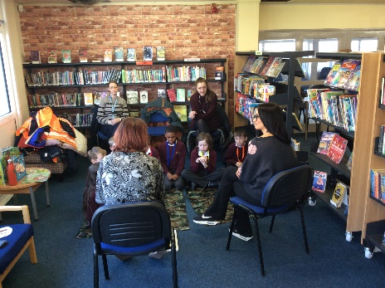Staff were invited to review and feedback on a **draft of the new writing curriculum** in early Summer 2. The curriculum was formally introduced at the **staff meeting on 25/6/25,** where both the **long-term** and **medium-term plans** were shared.

A particular strength of this redevelopment has been the **consultative process**, ensuring all voices—teachers, teaching assistants, pupils, and governors—have helped shape the final model. The English governor was kept informed throughout via regular updates, a learning walk, and book scrutiny.

**Staff Training and CPD**

Staff development has been central to this year's progress. Key training initiatives included:

* **Colourful Semantics Implementation**: All staff received CPD in autumn term and have since trialled these approaches within their classes. This visual approach to sentence construction has been especially valuable for our most complex pupils. While implementation is still ongoing, evidence from lesson observations and pupil work shows a marked increase in sentence-level independence.
* **Staff Meetings**:
  + Autumn 2: A whole-staff session focused on composition and sentence structure.
  + Spring 2: Staff explored a range of poets and how to integrate poetry more broadly.
  + Summer 2: A session was dedicated to curriculum mapping and planning.
* **External CPD**: I continued to attend termly **English Leaders Update sessions** through Sarah Squared and collaborated with **Wirral English Leads** to explore a variety of writing curricula from both mainstream and specialist settings.
* **Poetry CPD**: The staff meeting on 5/3/25 focused on teaching poetry more purposefully. This generated enthusiasm among staff and directly contributed to Foxes Class's outstanding poetry project (see below).

**Curriculum Enrichment & Pupil Achievements:**

We have continued to build a rich English culture across school this year, with notable highlights:

Young Writers Competition:

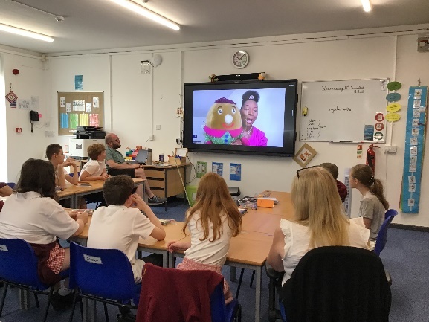Following our poetry CPD, Foxes Class created a stunning series of poems based on If I Were King by A.A. Milne. The work was submitted to a national poetry competition, and we are delighted that **the class's work has been published**. This has provided a major boost to pupil confidence and highlighted how creativity can flourish across the ability spectrum.

Zoom Call with Baroness Floella Benjamin – 11/6/25

Pupils had the rare opportunity to speak with Dame Floella Benjamin during a live Zoom call. Her message of resilience, diversity, and the power of storytelling had a powerful impact. Many pupils have since written reflective pieces inspired by the session, and the call has since been used in PSHE and English lessons.

Reading for Pleasure:

Our Reading Ambassadors have continued to thrive and innovate. Pupils:

* Organised author-themed book displays.
* Ran a “Recommend a Read” event during Book Week.
* Helped curate our expanding **Reading for Pleasure Scrapbooks**—which now serve as both reading records and creative journals.

Author visits (including collaboration with Linghams Bookshop), World Book Day events, and the regular book talk have all contributed to maintaining a reading-rich culture across the school.

**Assessment & Data**

To measure the impact of our curriculum changes, we introduced a **new English assessment map** in Autumn Term. This now allows staff to map pre-curriculum and curriculum objectives clearly and consistently.

Key improvements include:

* An updated **reading and writing tracker** with termly completion (Sept, Dec, March, July).
* More targeted **intervention identification**, using assessment outcomes and data analysis.
* Clear **progression mapping**, which supports accurate moderation and next-step planning.

As part of our revised model, we also integrated findings from **ACE and TALC assessments**, particularly for pupils not registering on conventional reading assessments. This has improved the way we scaffold both reading and writing instruction for complex learners.

**Monitoring and Evaluation:**

Throughout the year, a robust monitoring schedule has been maintained:

* **Learning Walks**: A Spring walk with the English Governor focused on phonics and writing. A joint learning walk was conducted again in Summer 1, showing strong evidence of implementation and impact.

**Book Scrutiny**: Conducted with the English Governor during Spring 1

* . Evidence showed improved transcriptional accuracy, broader use of genres, and increased evidence of independent sentence construction—especially from pupils using colourful semantics.
* **Pupil Voice**: Across all three terms, reading and writing voice surveys have shown:
  + 89% of pupils feel more confident in writing.
  + 92% of pupils can name a favourite author or book.
  + Increased engagement in book talk and peer recommendation.

These findings demonstrate strong alignment between staff practice and pupil experience.

**Speech and Language Integration:**

In collaboration with SALT professionals, we continued to integrate **communication targets** into daily English teaching. Pupils needing additional language support were identified early through **reading baselines** and subsequently assessed using speech and language frameworks.

This year’s cohort showed particularly strong gains in receptive and expressive language—likely influenced by the school-wide implementation of colourful semantics and the increase in **structured oral language activities.**

**Strengths:**

Orrets Meadow continues to have an **exceptionally inclusive and dynamic English curriculum**. Key strengths this year include:

* A **flexible and inclusive writing curriculum**, now in place from pre-curriculum to Year 4.
* Strong **staff engagement** in CPD and curriculum design.
* Pupil outcomes in reading and writing that reflect **accelerated progress**.
* **Cross-curricular literacy promotion**, including poetry, non-fiction, and oral storytelling.
* A vibrant **reading culture**, supported by ambassador leadership and community links.

**Next Steps:**

While this year has been highly successful, key priorities for 2025–2026 include:

1. **Embedding the new writing curriculum fully**, including formalising feedback mechanisms and refining assessment rubrics.
2. **Consolidating colourful semantics practice**, ensuring fidelity and consistency across all year groups.
3. Continuing to **explore writing opportunities for complex pupils**, including via oral storytelling, multimodal texts, and assisted technologies.
4. **Developing genre-specific writing goals**, particularly to extend more able writers and deepen writing for purpose and audience.
5. Further enhancing **author engagement and diversity in text selection**, ensuring texts reflect a wider range of voices and experiences.  
   (For full details please see the SDP 25-26)

**Conclusion:**

This year has been one of transformational growth in English at Orrets Meadow. With a clear focus on inclusivity, writing opportunity, and professional development, we are proud of the strides we have made to adapt and enrich our English provision. The high levels of pupil engagement, the impressive writing outcomes, and the consistent progress across cohorts reflect a deeply embedded culture of literacy that celebrates every learner.

As we move forward into 2025–26, we do so with a curriculum that is responsive, ambitious, and firmly rooted in the needs and strengths of our pupils.

