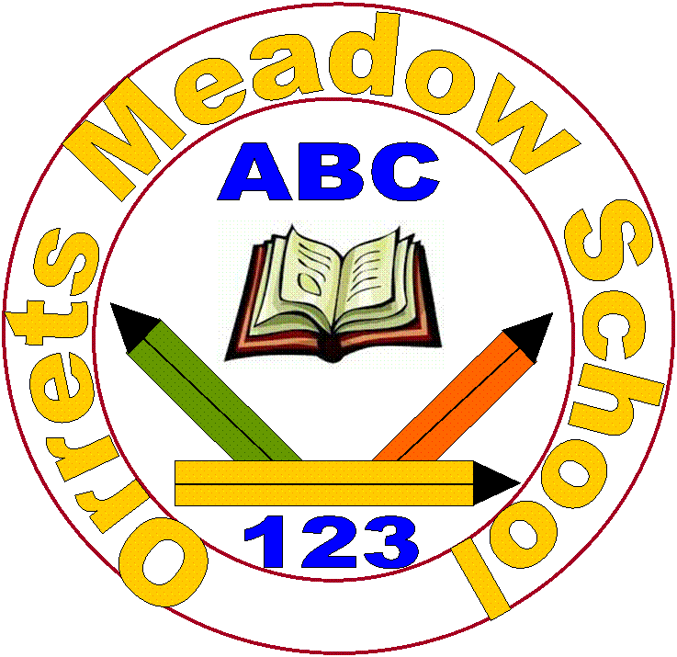
Orrets Meadow School
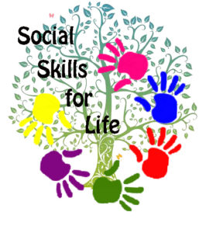
Life Skills and Social Skills Policy

“To raise the aspirations of every child and give them confidence to fulfil their potential through positive experiences”
Orrets Meadow Curriculum Aims and Values
Aims
To ensure all our children are at the centre of a broad, varied and interesting learning experience that is enjoyable and relevant for the future. Our creative, multisensory curriculum will create a sense of awe and wonder and help to inspire a lifelong love of learning. The holistic nature of our practice will promote positive mental health and well-being and will enhance our children’s life skills, social skills and cultural awareness.
This subject is delivered through a trauma-informed approach. We prioritise safe relationships, understand behaviour as communication, and support pupils to regulate, engage, and achieve within a consistent and inclusive environment.
Values
Our curriculum will promote a range of values including:
- Respect
- Empathy
- Responsibility
- Equality
- Independence
- Happiness
- Resilience
- Gratitude
- Honesty
- Friendship
Purpose of study
Essential life skills such as confidence, motivation, resilience and communication are associated with better academic outcomes and better prospects in the workplace, and there is an increasing emphasis on their value, given that future of the labour market trends towards automation.
The main focus for schools has been on developing children’s core academic knowledge and skills in literacy, numeracy, and range of curriculum subjects. However, there are other skills that are increasingly seen as important to children’s wider development: ‘essential life skills’ such as confidence, social skills, self-control, motivation, and resilience. These are the attitudes, skills and behaviours that are thought to underpin success in school and work and include the ability to respond to setbacks, work well with others, build relationships, communicate effectively, manage emotions, and cope with difficult situations. Such skills are often referred to as ‘social and emotional skills’, ‘soft skills’, ‘non-cognitive skills’ or ‘character’. Historically they have been seen as distinct from academic knowledge and skills; however this has begun to change. They are increasingly thought to play an important part in learning, as well as contributing to children’s wider development, well-being and readiness for life beyond school. When we refer to ‘life skills’ in this policy, we are referring to these essential life skills – and social skills (although taught discretely at Orrets Meadow) are a part of them. The umbrella of life skills also includes ‘functional’ life skills which our stakeholders have indicated as a high priority for the children at our school e.g. self-care, dressing skills, eating skills and etiquette, ability to tell the time and an understanding of how and why we use money.

Aims
Our life skills and social skills curriculum aims to ensure that all pupils improve:

- Self-perceptions and self-awareness. These relate to a child’s knowledge and perception of themselves and their value, their confidence in their current abilities and a belief in their efficacy in future tasks.
- Motivation. This can be characterised as the reasons for which individuals strive towards goals. It includes the belief that effort leads to achievement, distinguishes whether goals are set by other people or by oneself, and the value that is attached to the goal in question, aspiration and ambition.
- Self-control and self-regulation. These refer to how children manage and express emotions, and the extent to which they overcome short-term impulsivity in order to prioritise higher pursuits.
- Social skills. These describe a child’s ability and tendency to interact with others, forge and maintain relationships, and avoid socially unacceptable responses. They cover communication, empathy, kindness, sharing and cooperativeness. They are absent when a child is solitary, shy or withdrawn.
- Resilience and coping. These are demonstrated when an individual is able to adapt positively and purposefully in the face of stress and otherwise difficult circumstances. Resilience is not so much an aspect of character as a developmental process – the ability to summon strength when needed and ‘beat the odds’ of adversity.
- Independence and community participation. These include areas of life such as independent living, personal safety and self-care, knowledge and understanding of healthy lifestyles and engagement in community activities and leisure.

Why are life skills and social skills important?
There is growing evidence that life skills are associated with a range of positive outcomes at school and later in life (Sutton Trust, 2017). Many studies show that non-academic skills in childhood, (including self-control, self-perceptions and social skills), are strong predictors of adult outcomes - including employment, well-being, and physical and mental health. Research shows that having belief in their ability to influence events appears important in shaping a broad range of outcomes such as educational attainment, employment success, socioeconomic status, mental health and wellbeing, and some physical health outcomes. Young children’s self-control skills, such as conscientiousness, self-discipline and perseverance can predict their health, wealth and criminal history in later life regardless of IQ or social background. Indeed, some argue that these skills are as important, or more important, than academic skills – and that their importance in the future jobs market is growing. For example, recent research from the United States has argued that there are clear benefits to life skills in the workplace, arguing that jobs requiring high levels of social interaction have grown substantially. A recent report from the Sutton Trust points out that technological trends in the labour market affecting routine occupations mean that the value of interpersonal skills is likely to be even greater as automation takes further hold, and those with the educational background to take advantage will benefit the most. Reinforcing this message, the Confederation for British Industry’s (CBI) most recent survey of employers on education and skills found that “businesses are clear that first and foremost they want to recruit young people with attitudes and attributes such as resilience, enthusiasm and creativity. They are not selecting simply on the basis of academic ability.” The CBI emphasises the central importance to employers of young people having a positive attitude and resilience, demonstrated for example by a readiness to take part, openness to new ideas and activities, a desire to achieve, and an understanding that hard work and effort yields results.
Due to the context of our school (SEN with social-communication difficulties) and that our children typically find it more difficult to acquire and develop these skills naturally or at the same pace as neurotypical children, it is perhaps even more important that life skills and social skills are placed amongst our highest priorities.
When are life skills and social skills taught?
Music helps pupils to appreciate and understand a wide range of traditions and cultures.

Each class in school receives one life skills lesson (minimum of 30 minutes) and one social skills lesson (minimum of 40 minutes) per week. The attached overview maps out topics and content and the long-term plan clearly shows the progression of skills across the school. The children experience two independent skill days each year, where they have the opportunity to learn new life skills, such as washing dishes, using a knife and fork. Real life skills are promoted across all subjects, including trips to the local shop, going on public transport, riding a bike and writing cards. Each year we hold a ‘Being healthy and keeping safe’ week, where the children engage in a wide range of life and social activities and have visits from the emergency services etc. Every child attends forest school sessions, where they experience an outdoor life and social curriculum, while taking risks in a safe environment. Our cultural capital pledge ensures every child has the opportunity of key life experiences while they are at Orrets Meadow.
Our pledge to you while you attend our school…. you will;
Learn outdoors
Learn first aid
Visit a museum
Visit the local library
Visit a historical place
Visit a gallery
Learn to ride a bike
Learn to swim
Go on a residential trip
Visit a place of worship
Enjoy and express yourself through music
Eat foods from different cultures
Contribute to raising money for charity
Take part in a wide range of sports
Visit a farm
Visit the beach
Do something for the community
Listen to visitors who will widen your understanding of the world
Experience a range of different cultures and festivals
Read a wide range of texts and novels by various authors.

How are life skills and social skills taught?
Learning is multi-sensory, varied and adaptable and lessons takes place both inside and outside the classroom. There is a focus on making learning fun, practical and relevant. We use a range of reputable evidence-based resources to help deliver the programmes.
Social Skills
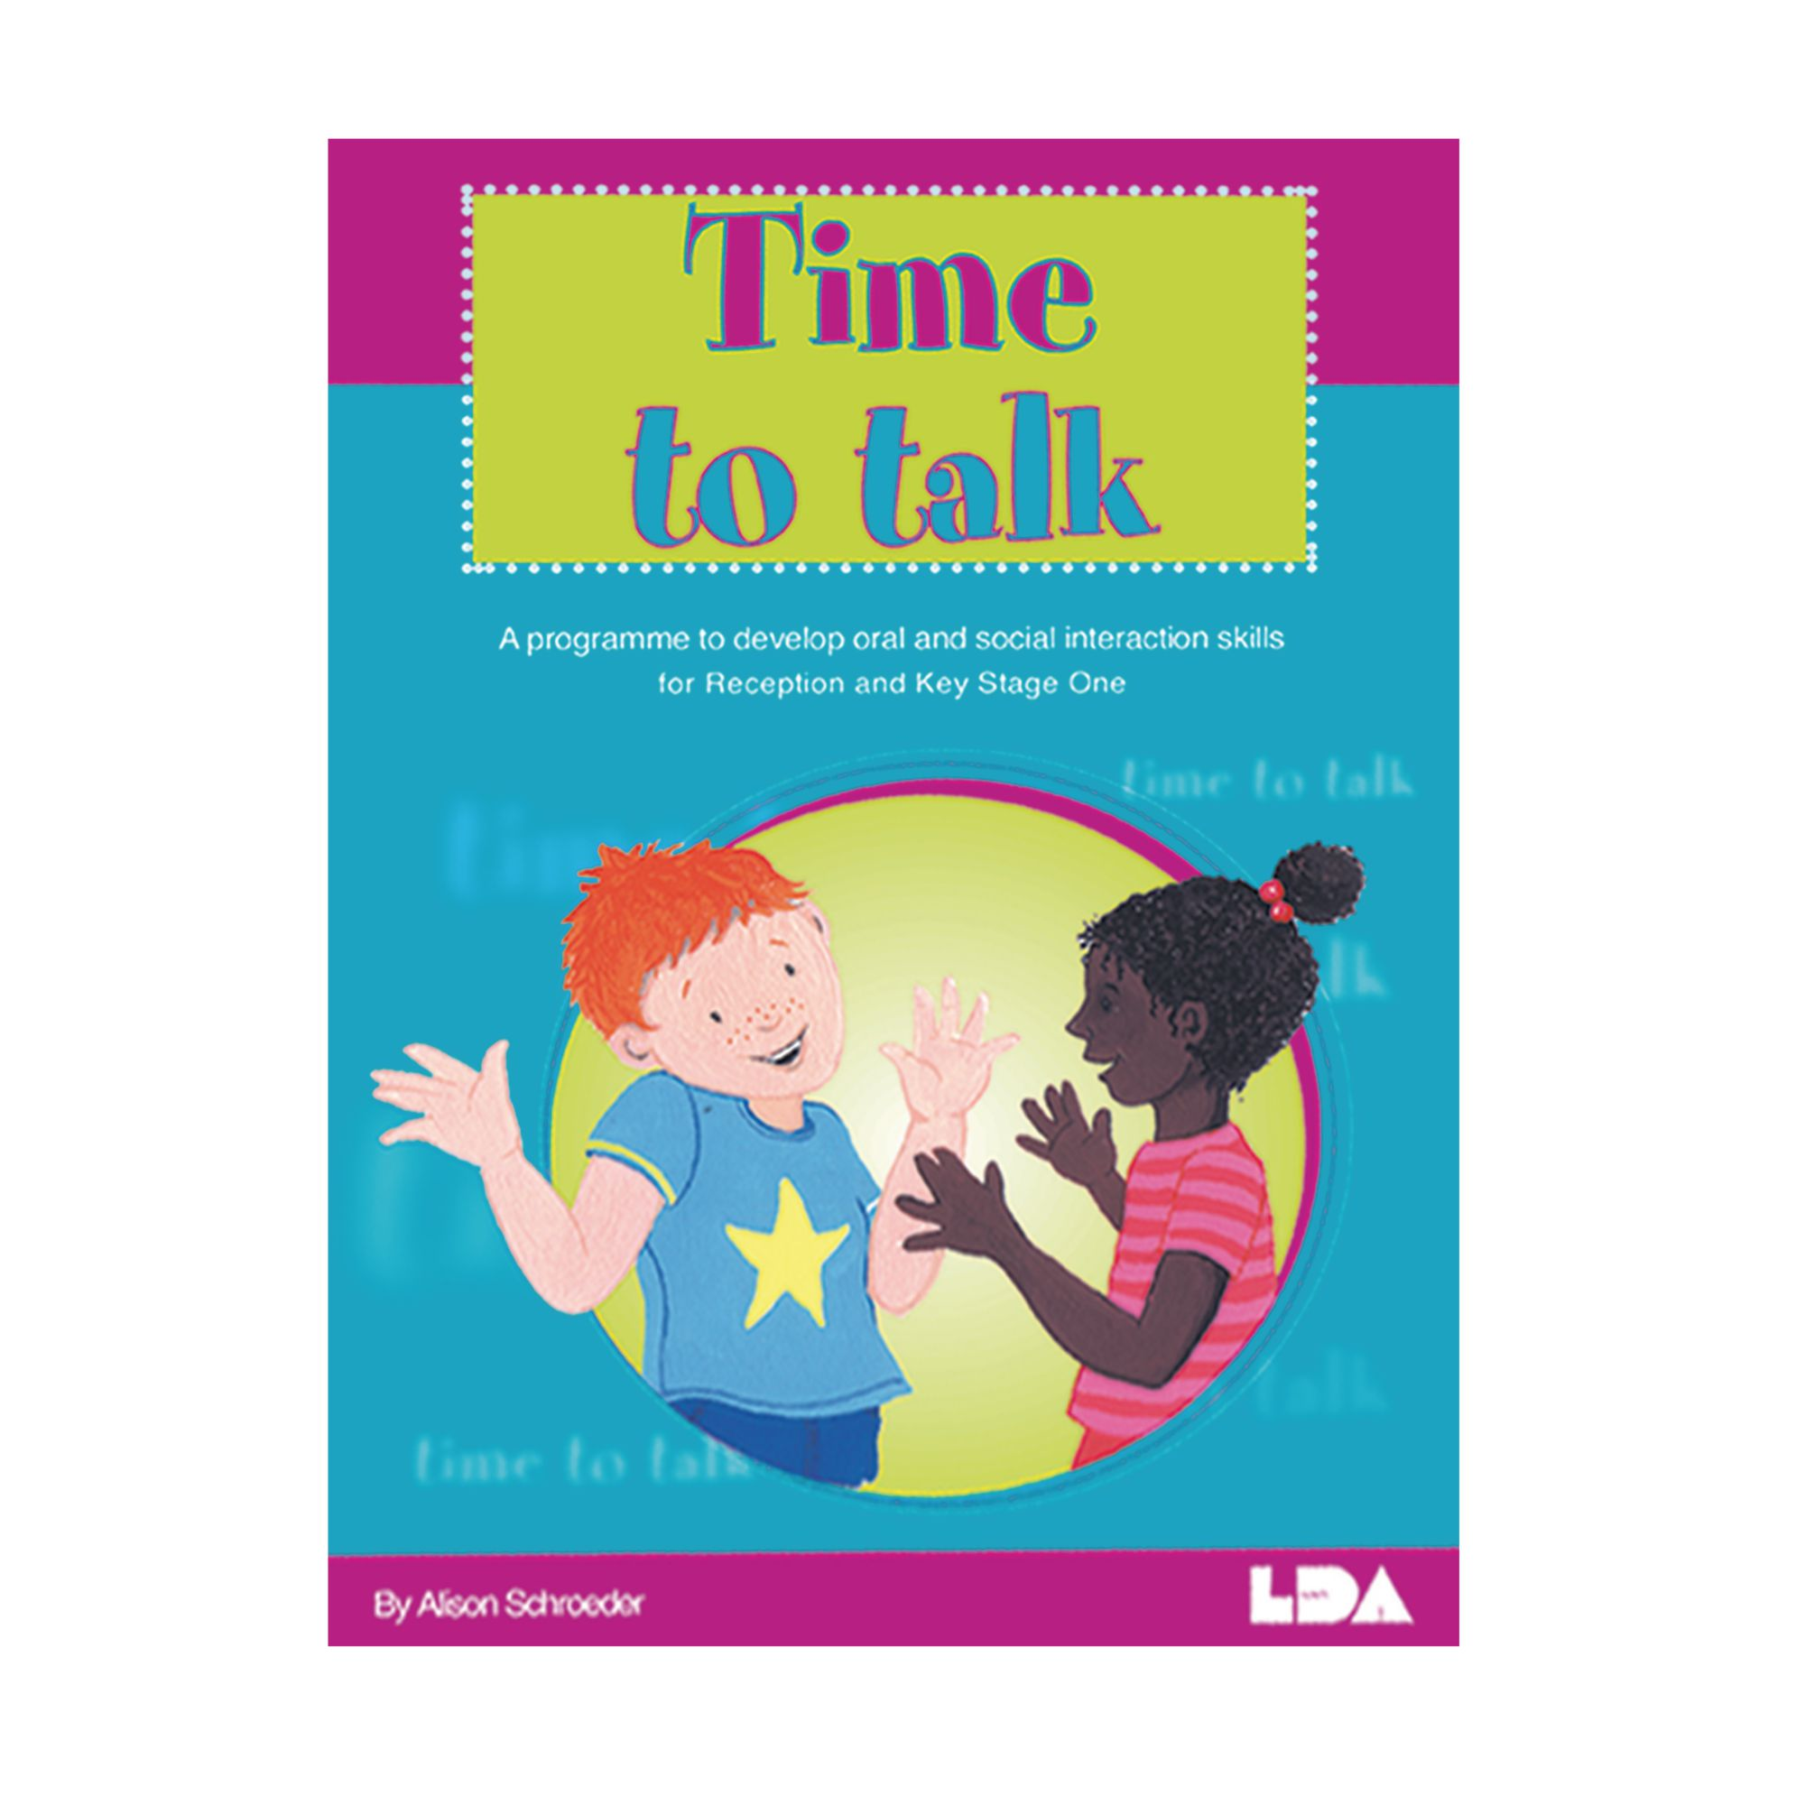
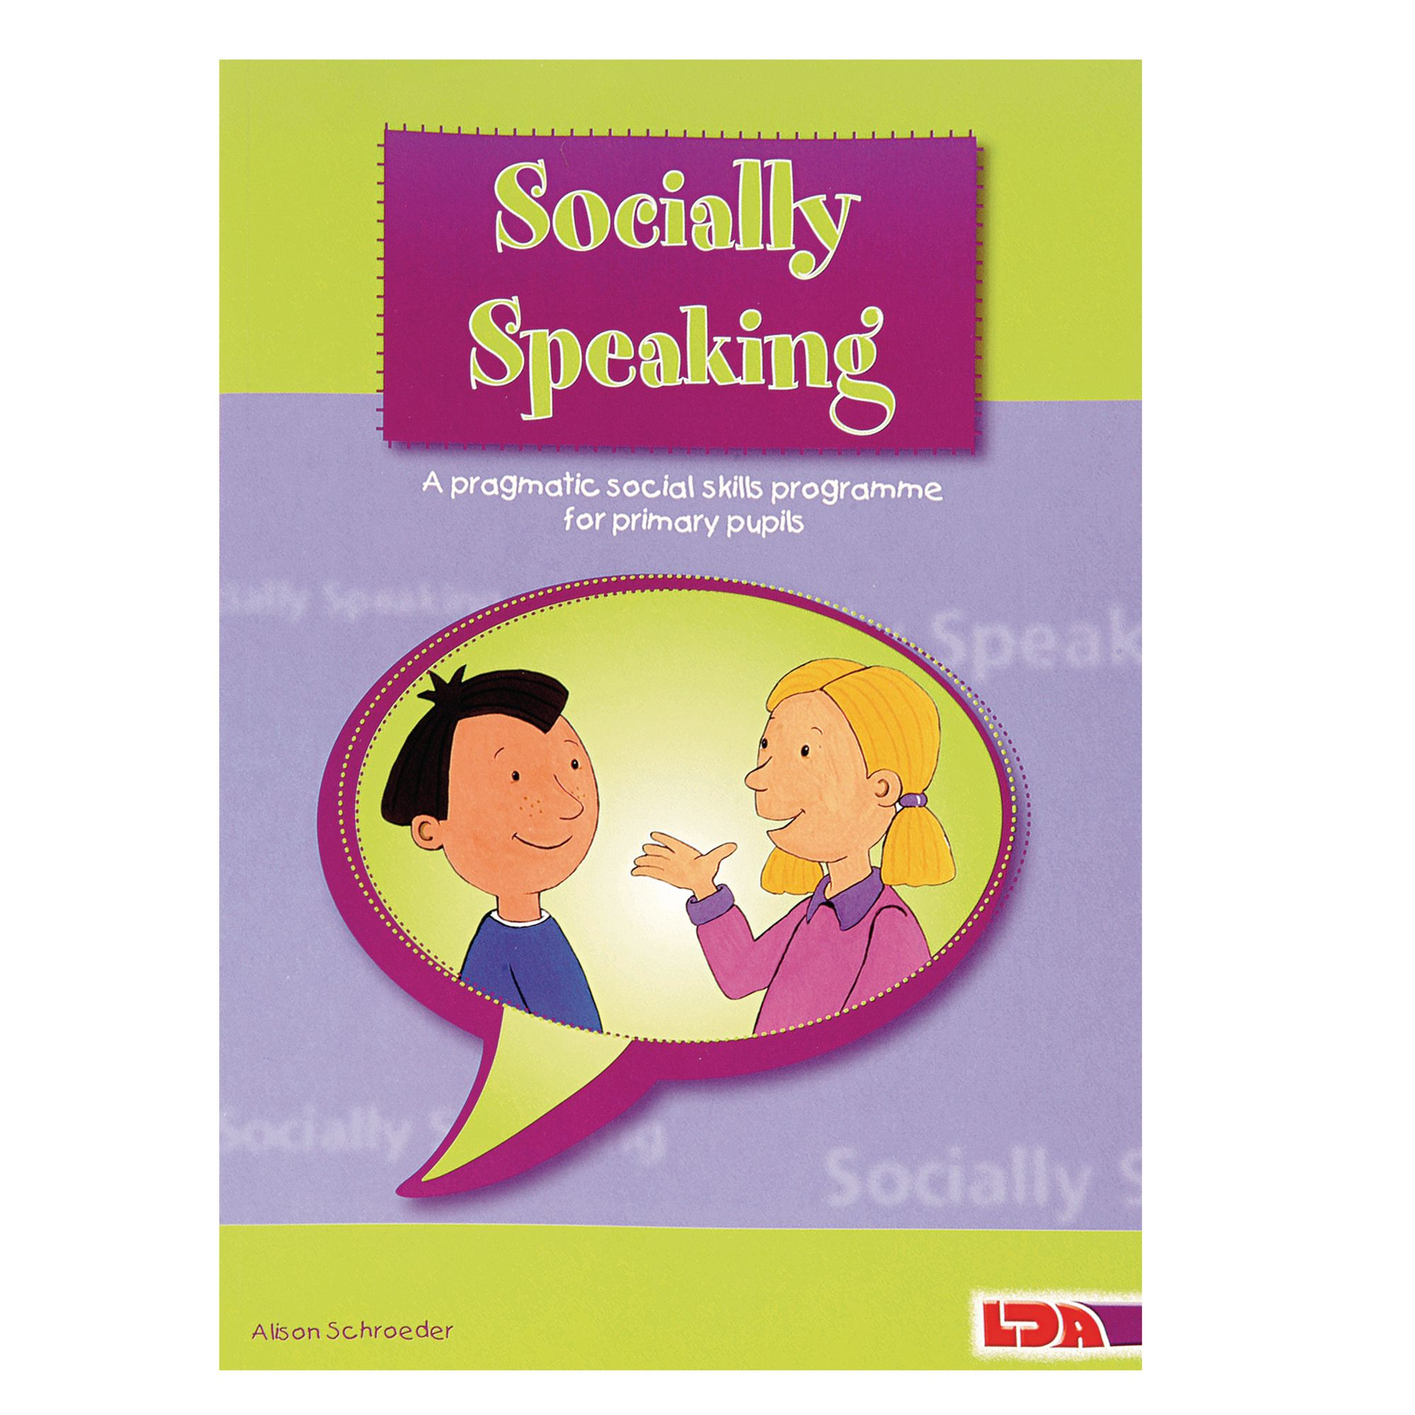

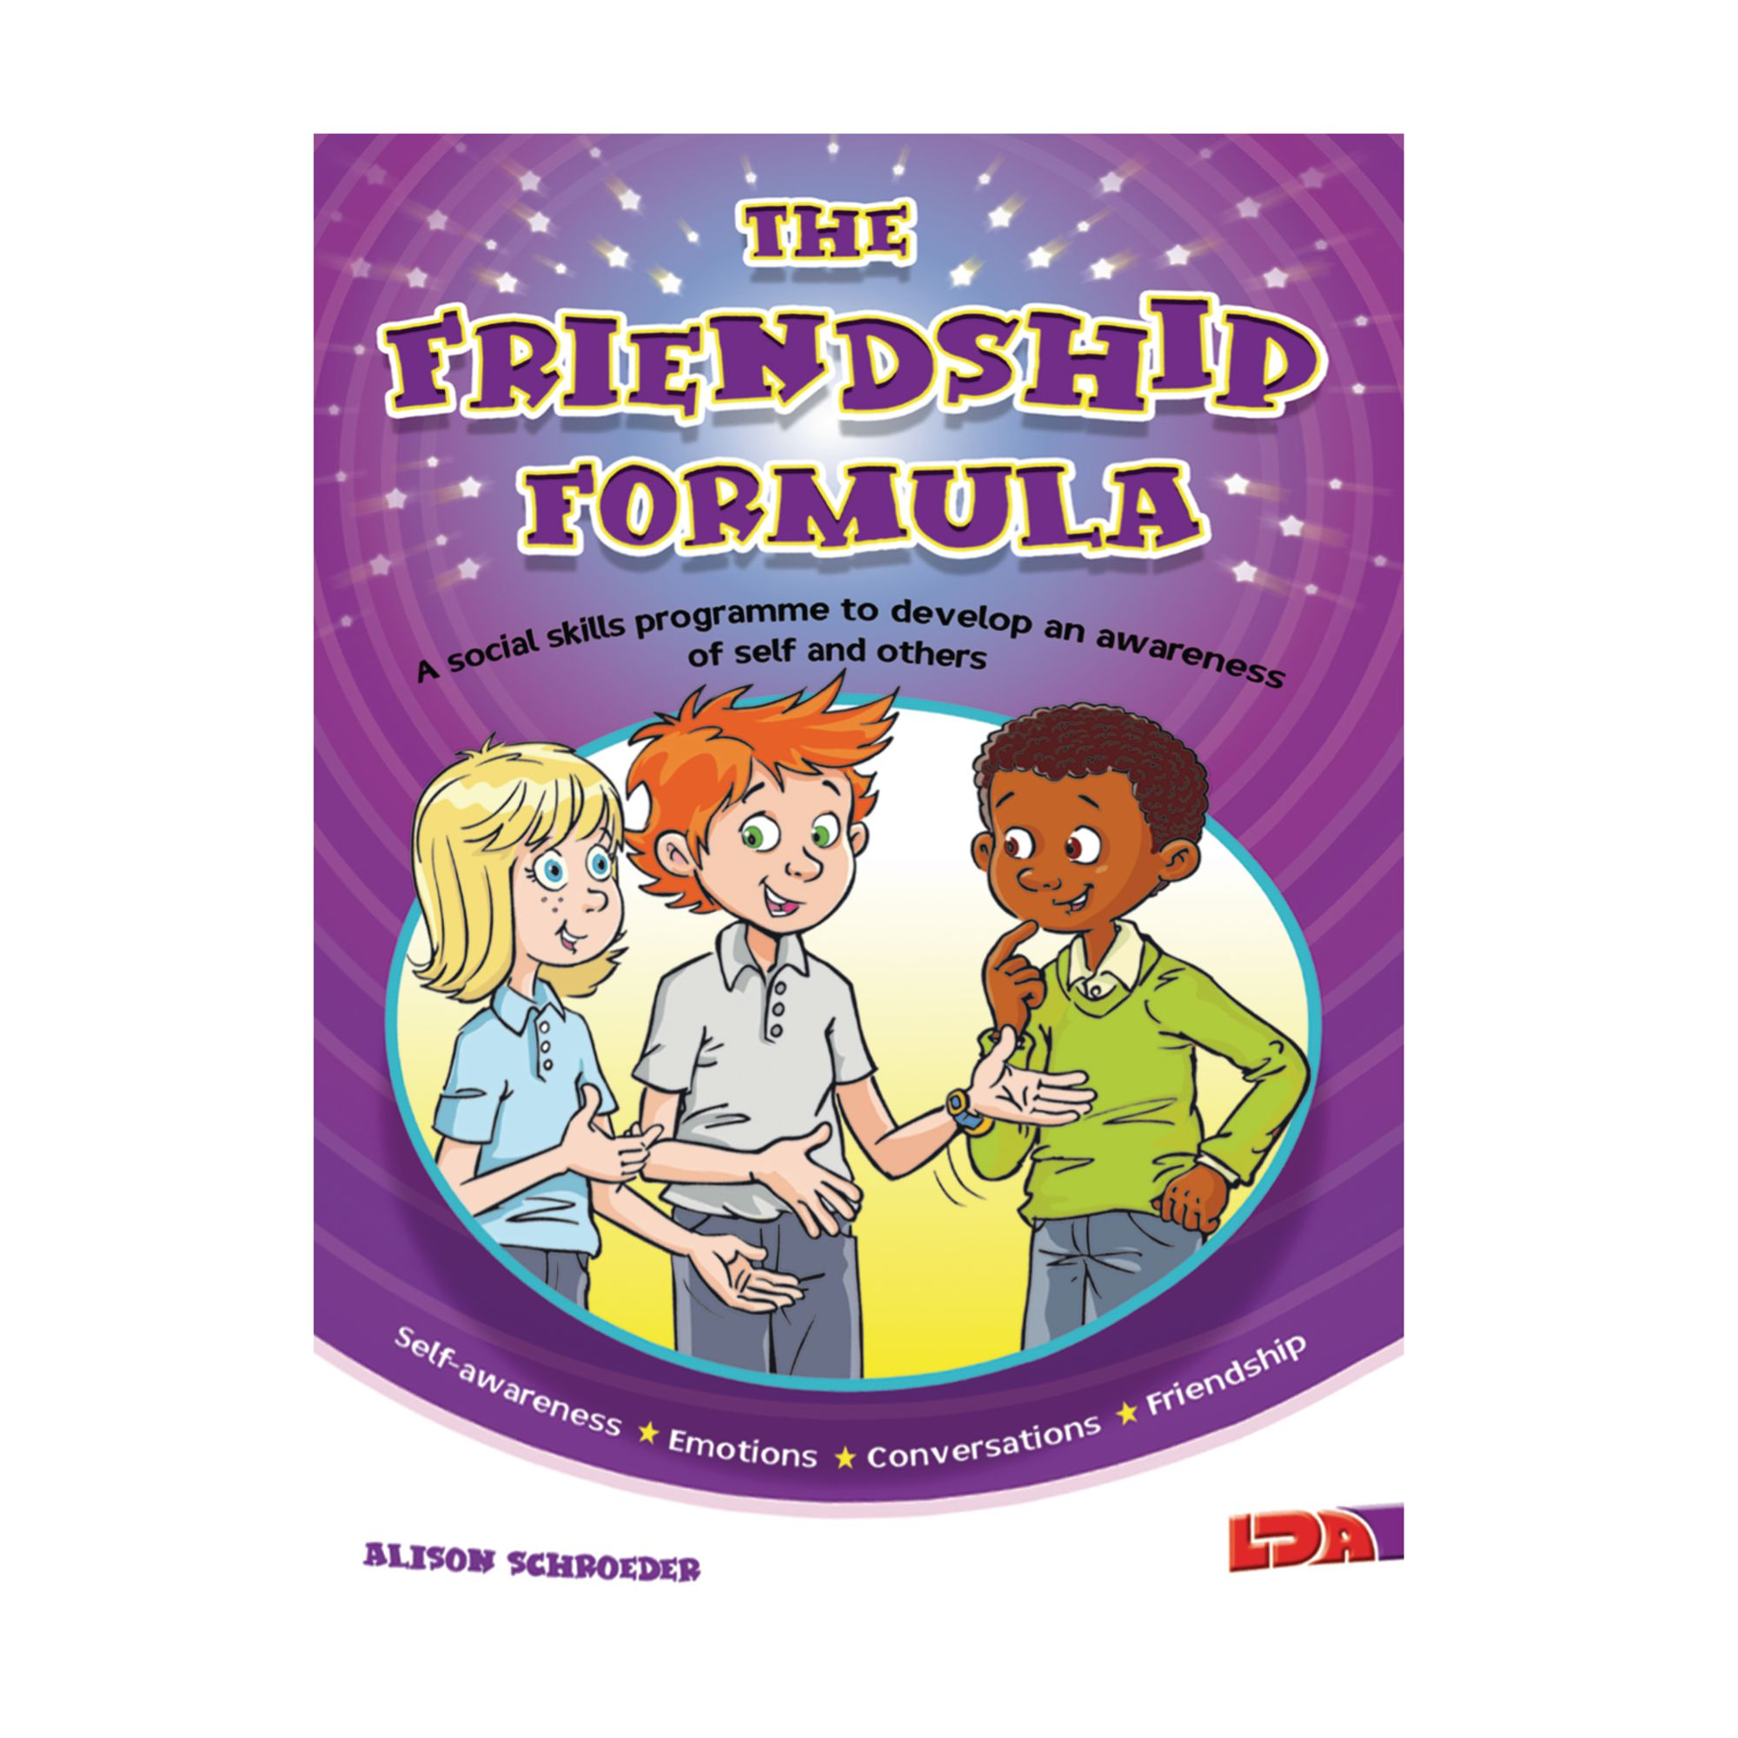
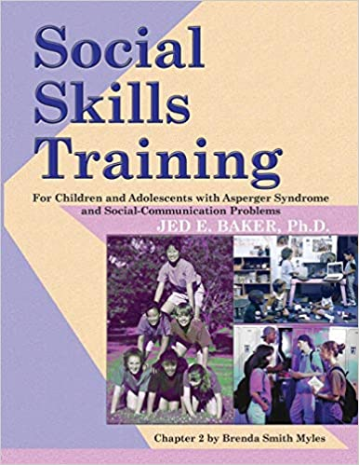

Staff use the above programmes as a basis for planning and delivery but are very much encouraged to adapt and innovate to meet the needs of their children. Although most classes will follow progression of skills similar to their curriculum learning pathways (Explorers, Pathfinders, Adventurers), if children are developing at different rates to their classmates then there is flexibility to adapt teaching for individuals or small groups. Lessons are usually scheduled for the start of a week, which allows the class teacher and support staff to bait the skills taught across a range of contexts and evaluate progress throughout the week. The lessons have some common features running through their basic structure e.g. meet and greet, circle time, game, skill development and social skills activity time. Although discrete taught skills are the main focus, the ethos of social skills lessons encourages enjoyment and building positive relationships between children and staff.
Life skills
Due to the incredibly varied nature of life skills, we use a wide range of resources from trusted sources including:



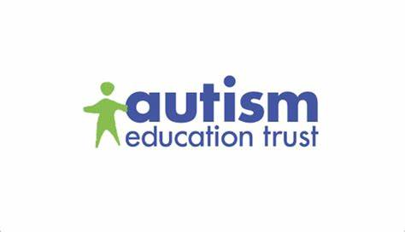

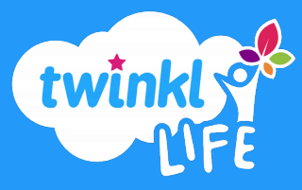
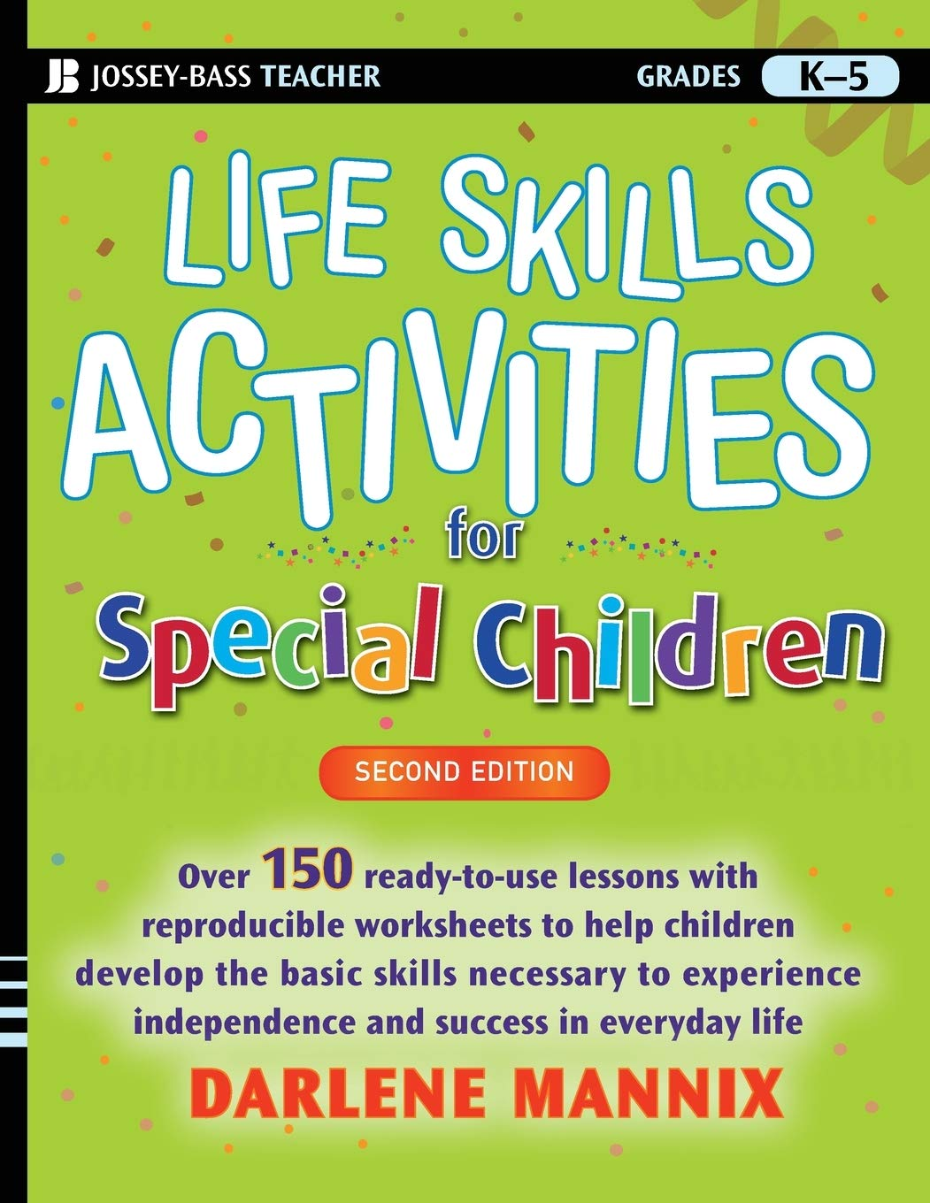

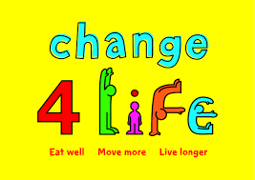



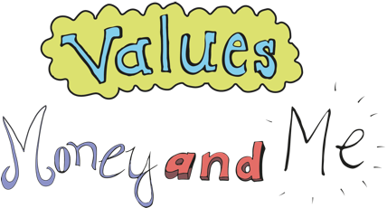
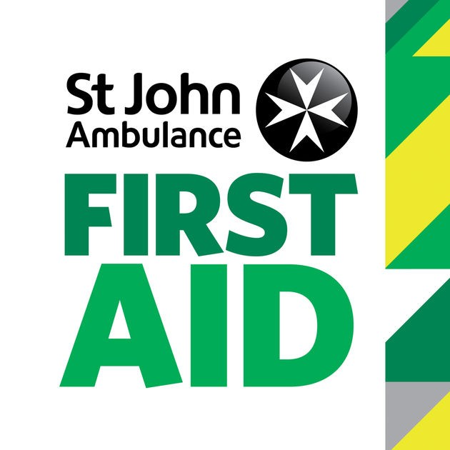

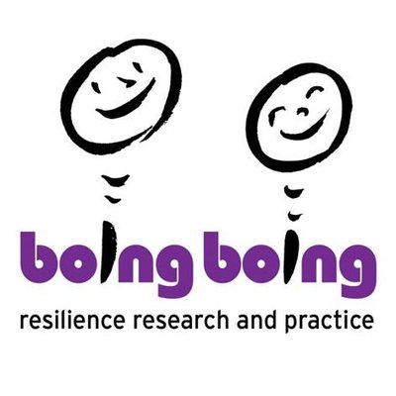
As with social skills, the detailed planning and delivery of life skills lessons is at the discretion of class teachers (in consultation with SLT). Staff are provided with the medium term objectives which fit within a wider progression of skills, but this needs to be adapted to meet the needs of class groups and individuals. Staff carefully select and use the resources mentioned to plan lessons and follow-up activities for their children. As with social skills, life skills taught are then baited and practised through a wide range of opportunities and contexts. Communication with parents is also vital and opportunities to learn and practise life skills at home are strongly encouraged.
Life skills and social skills lessons both reflect and contribute to the wider SMSC (Social, Moral, Spiritual and Cultural) opportunities of the children at Orrets Meadow. We use a range of teaching and learning styles and place an emphasis on active learning by including the children in discussions, investigations and problem-solving activities. Pupils are prompted to consider and express their attitudes and beliefs surrounding the issues and topics studied. We encourage all of our children to take on the moral responsibilities associated with being a proactive and pro-social citizen of any community - whether local or global. We encourage the children to take part in a range of practical activities that promote active citizenship, e.g. charity fundraising, the leading of special events such as assemblies or theme days, or involvement in community activities. We offer children the opportunity to meet visiting speakers, such as health workers, police, and members of the local church, whom we invite into the school to talk about their role in creating a positive and supportive local community. Our children also study aspects of life and culture in other countries, draw comparisons and empathise with others. They evaluate living in a parliamentary democracy and investigate British Values.
Access to the curriculum
All children will have access to life skills and social skills but it is at the class teacher’s discretion (in consultation with SLT) how that will be planned and delivered. This ensures that children’s individual needs will be met.
What do we learn about in life skills and social skills?
We learn about the following:
- Self-awareness
- Emotions
- Family and Friends
- Communication skills
- Conversations
- Friendship
- Appropriate and inappropriate behaviour
- Role-play of social settings
- Mindfulness and positive mental health

- Personal Care
- Emotional Literacy
- Resilience
- Relating Basic Information
- Staying Safe
- Citizenship
- Shopping Skills
- Money
- First Aid
- Time Skills
- Public Speaking Skills
- Cookery and Eating Skills
- Healthy Lifestyles
- Animal Care
- Jobs and Careers
- Community Service
- Philosophy
- Transition to High School

Who do we learn about in life skills and social skills?

Staff use storytelling to tell narratives with specific themes such as assertiveness, negotiations, and decision making. Stories help children to identify choices they make on a day to day basis and the consequences of making decisions. We also use role play to explore real-life situations and unfamiliar concepts and develop the skills of negotiation, empathy, assertiveness, communication and self-awareness. We learn about a range of people (both real and fictitious) who help to demonstrate the skills listed above, including:

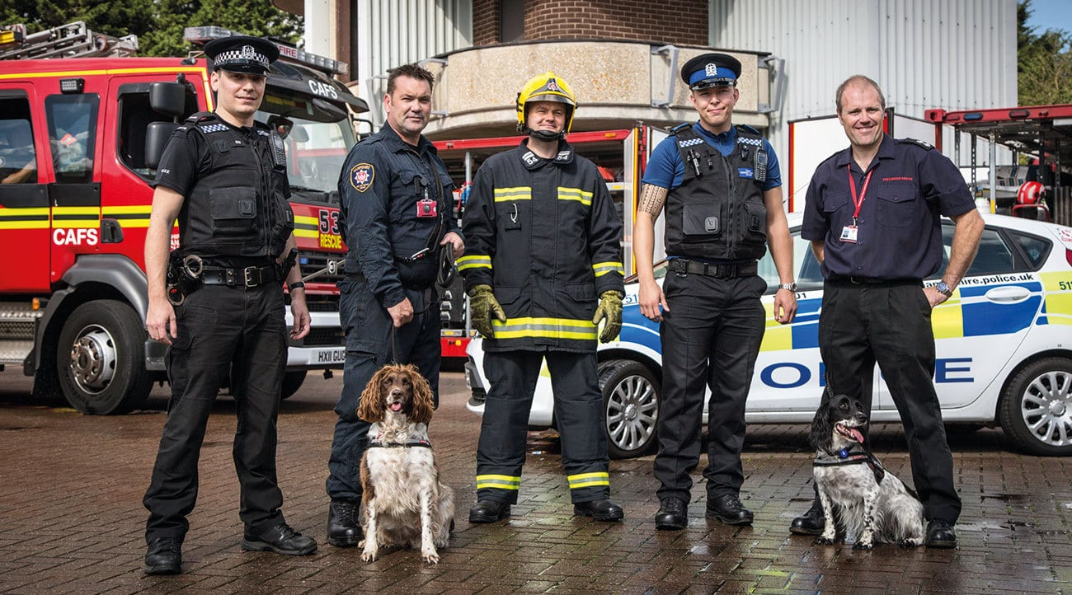

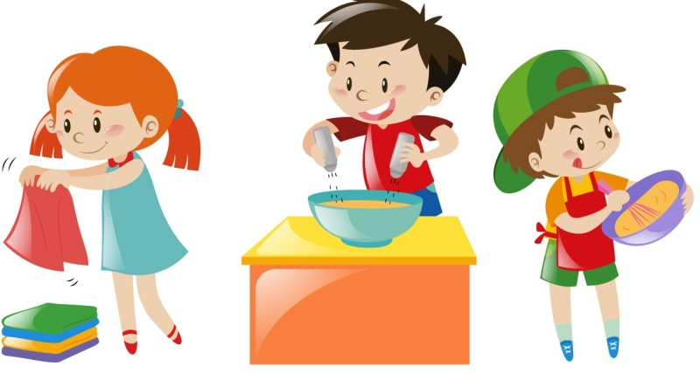

Role-models and future careers
Social stories promoting life skills

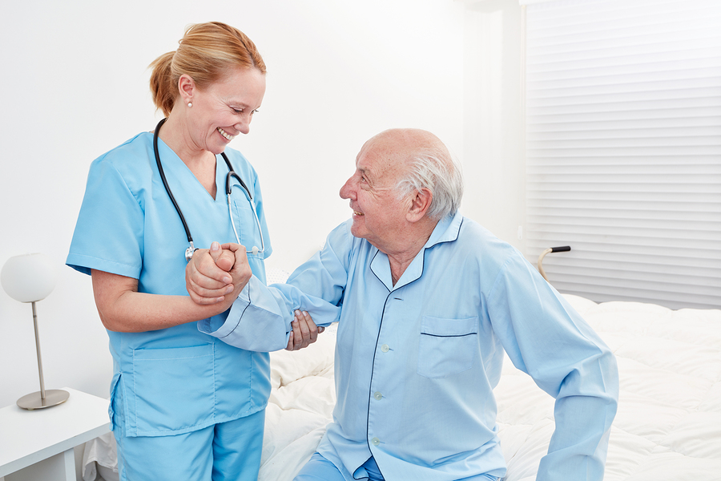
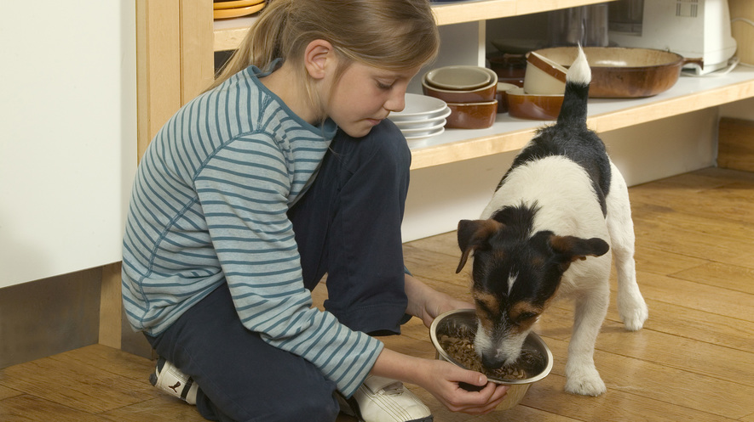

Promotion of caring attitudes and relationships
Promotion of inter-generational relationships


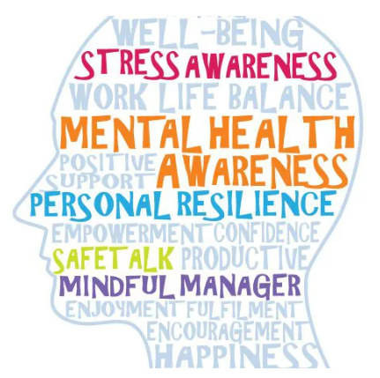

Promotion of physical health and wellbeing
Role-models and advocates for mental health

Life Skills Overview
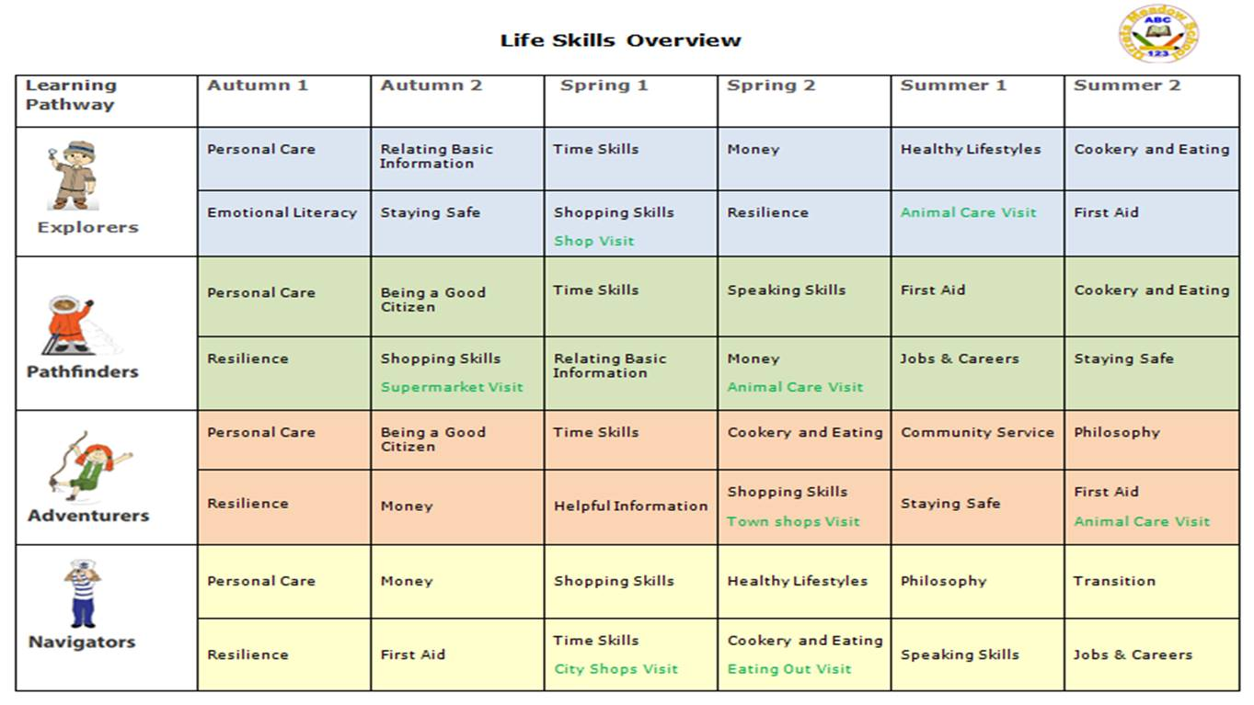

Social Skills Overview

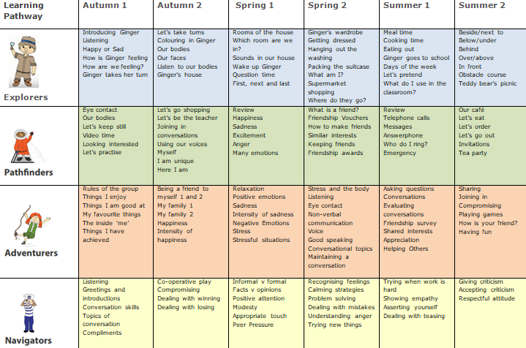

“When words fail, music speaks” Beethoven
Beehoven

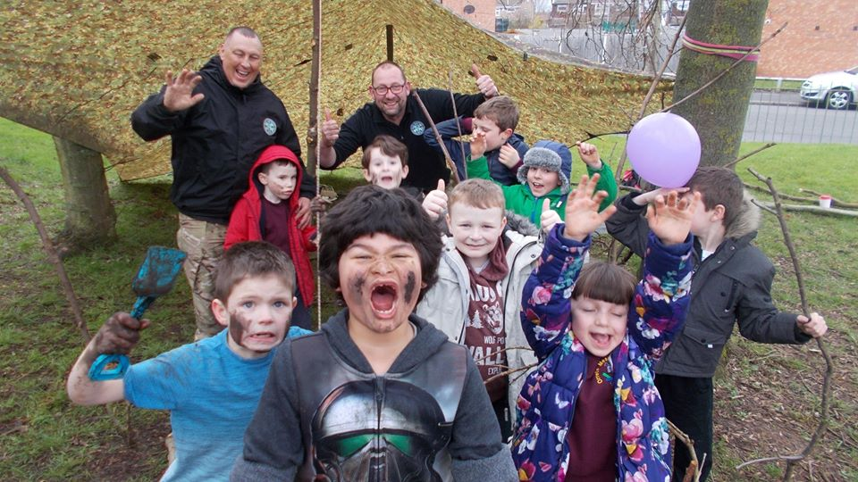

“In today’s world teamwork skills are employability skills” Dr Kagan

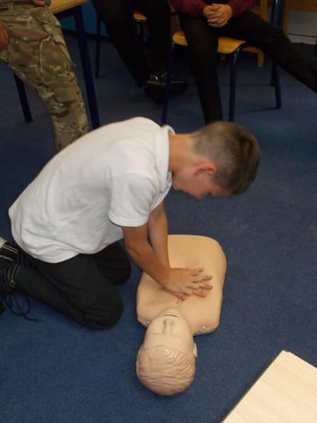
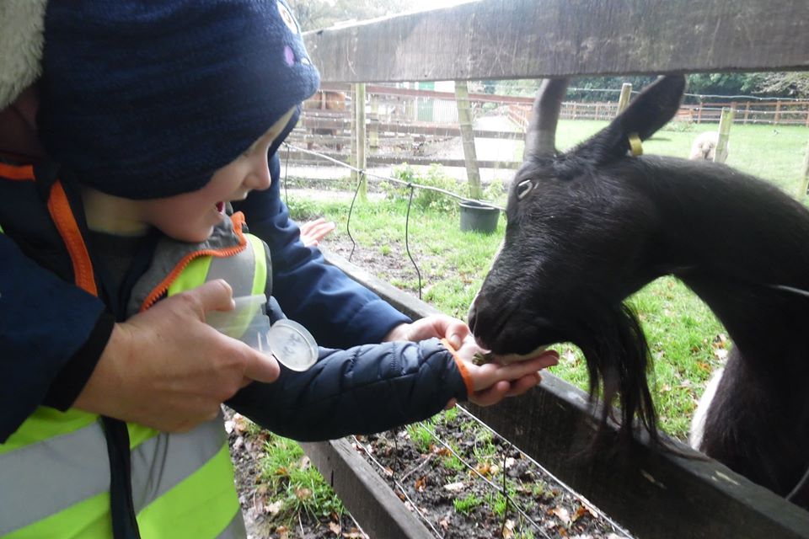
Teaching kids to count is fine but teaching them what counts is best.

To cope with the increasing pace and change of modern life, students need new life skills such as the ability to deal with stress and frustration.

Motivation aside, if people get better at these life skills everyone benefits: the brain doesn’t distinguish between being a more empathetic manager and a more empathetic parent.

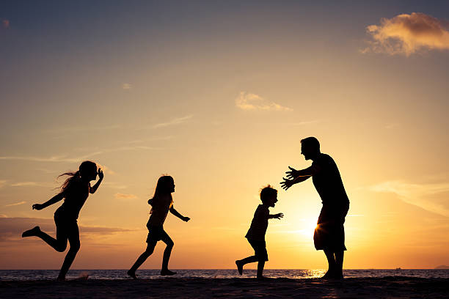

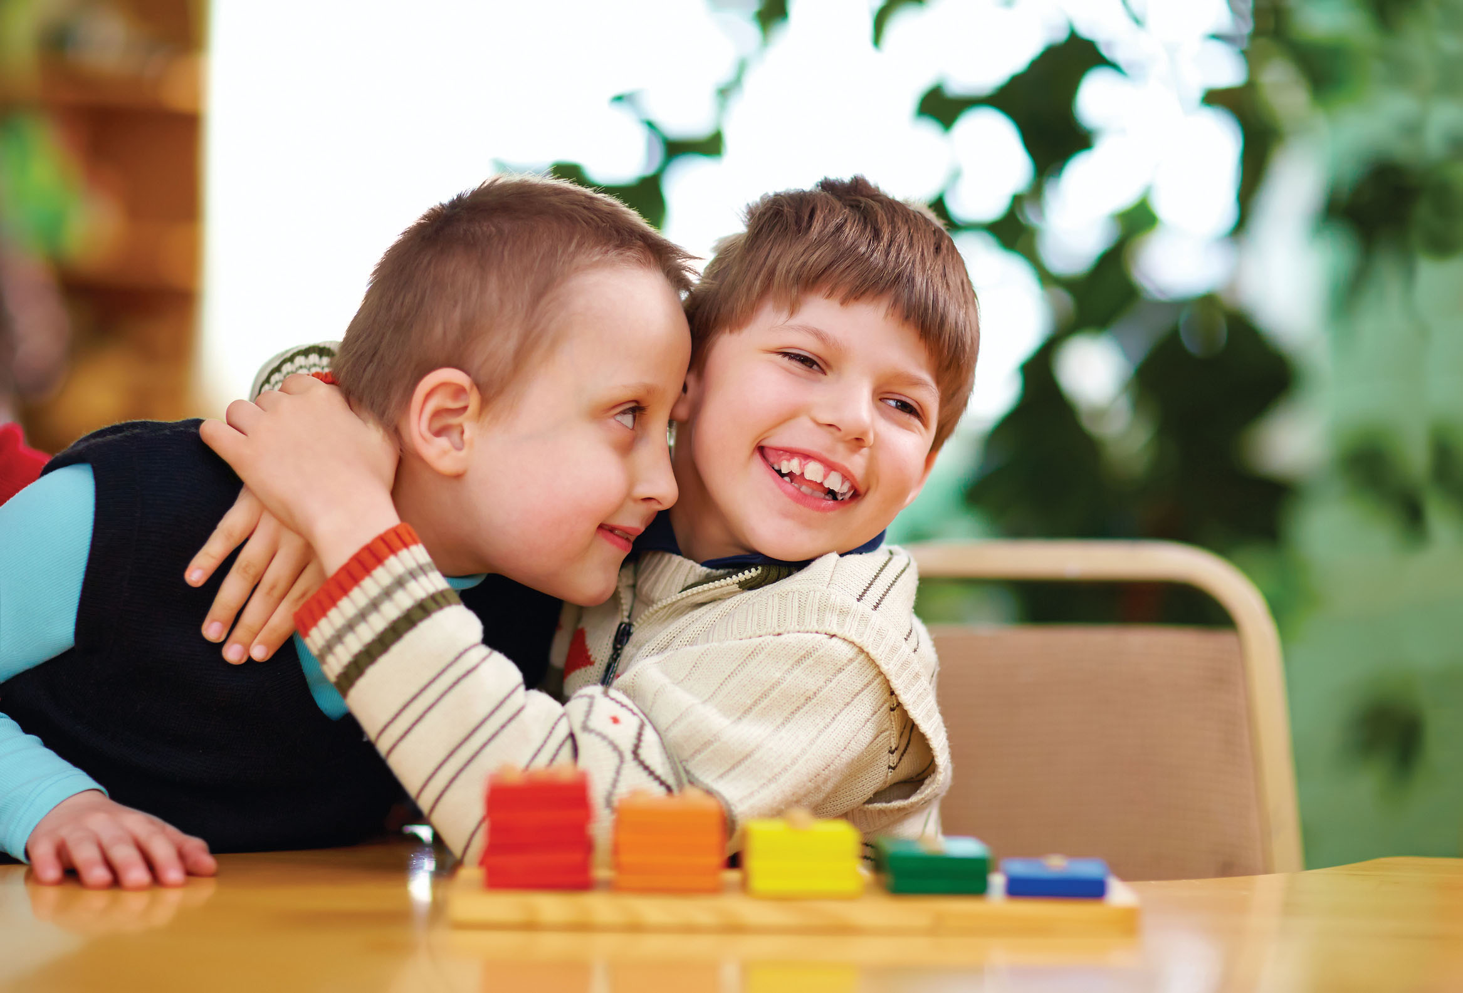

Social thinking skills must be directly taught to children and adults with ASD. Doing so opens doors of social understanding in all areas of life.

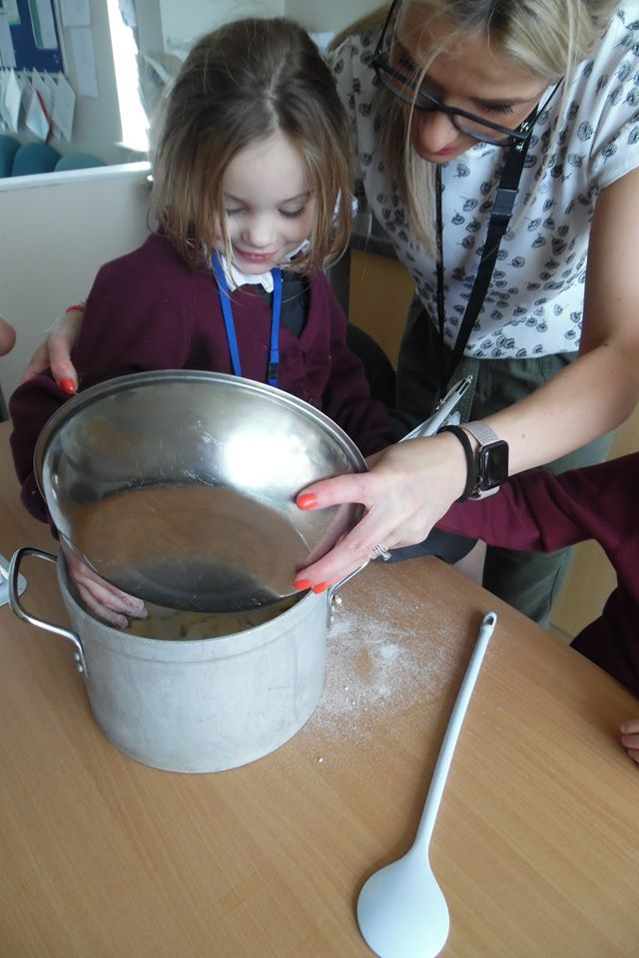
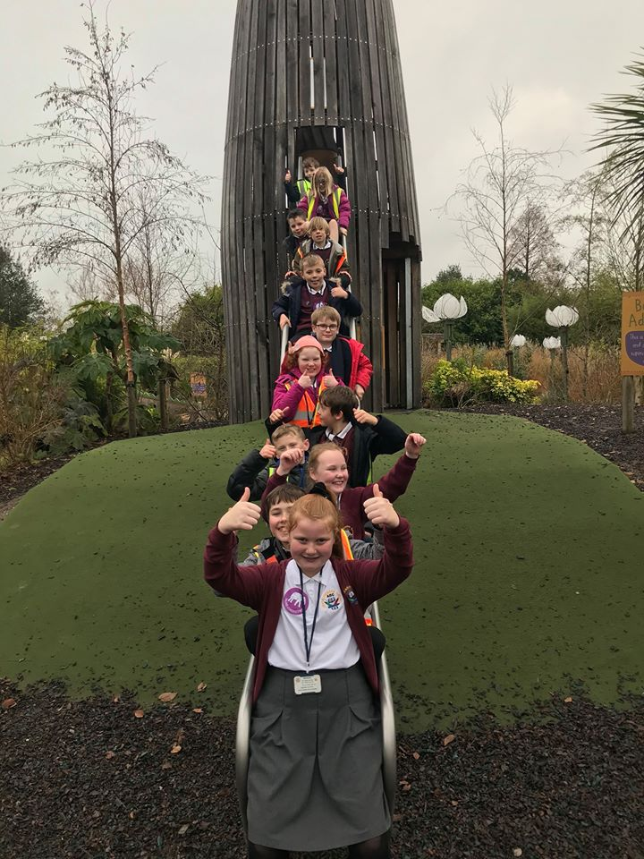

The skills needed to succeed in today’s world and the future are curiosity, creativity, taking initiative and empathy.
Functional life skills improve life chances for young people. They build confidence and independence which in turn lead to the development of positive life-long habits.

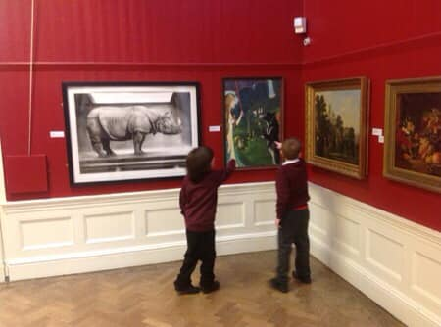
Life is 10% what happens to you and 90% how you respond to it.

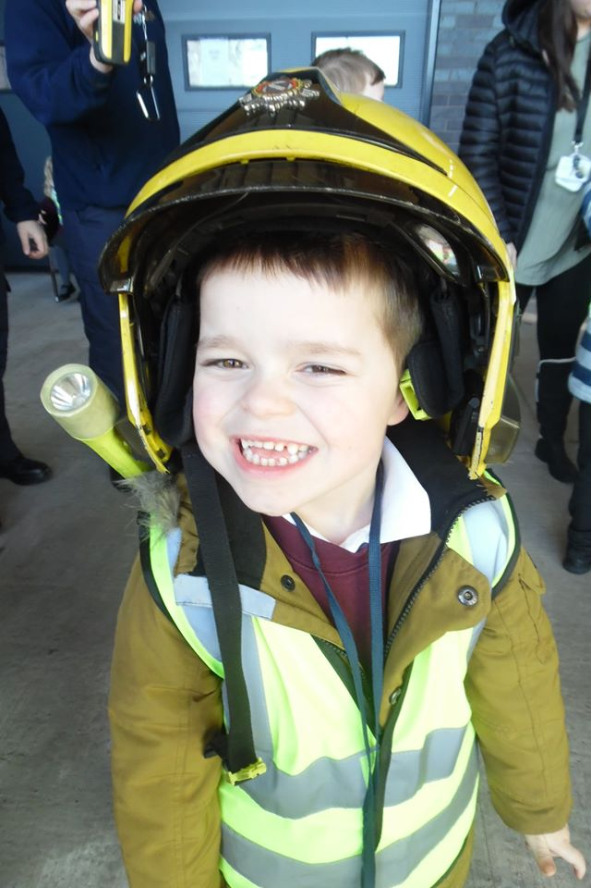
“The most important single ingredient in the formula of success is the knack of getting along with people.” (Theodore Roosevelt)

Life Skills Progression of Skills Examples

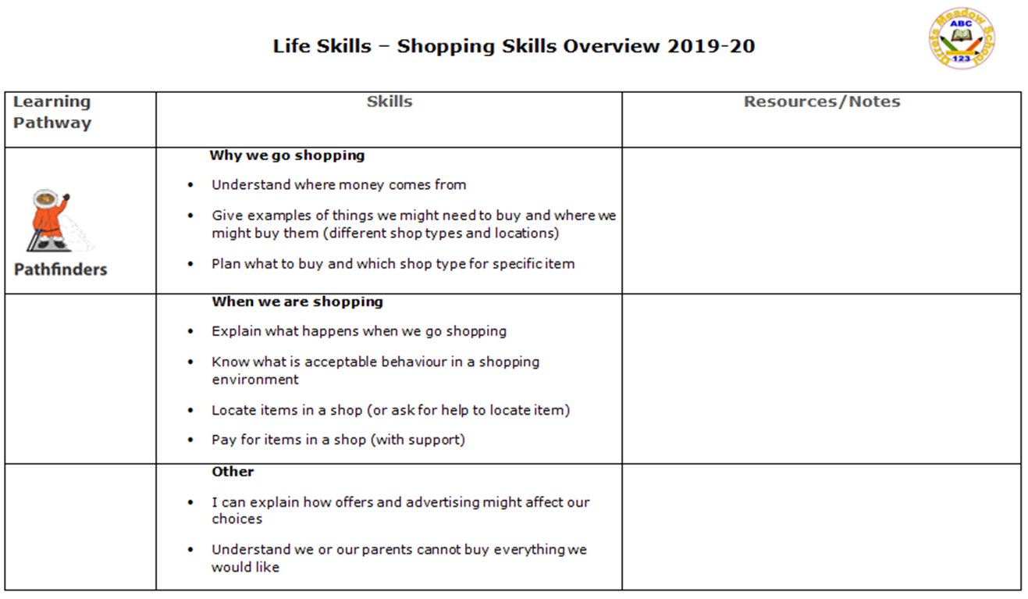

Social Skills – Progression of Skills Examples

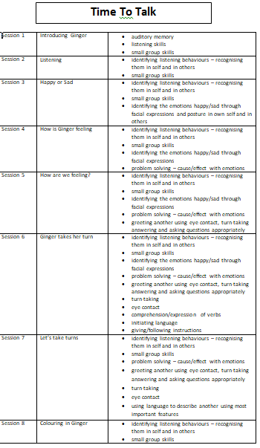

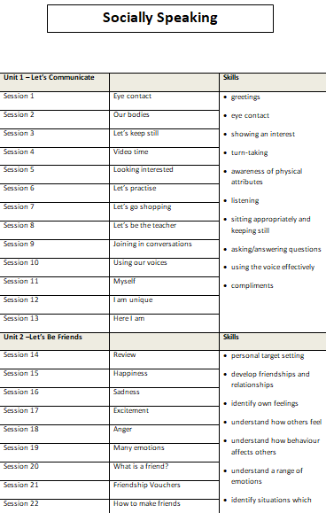

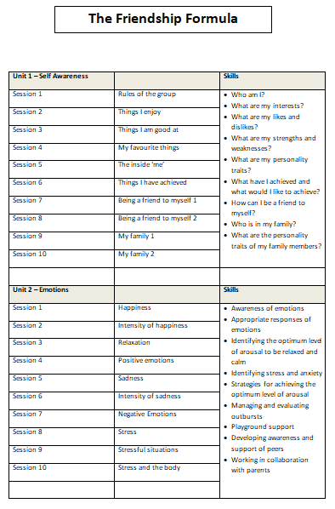

How do we assess and monitor life skills and social skills?

We use the Autism Framework Tracker to track pupil progress in life skills and social skills. Each child has their own individual Autism Framework Tracker booklet which is used throughout their journey at Orrets Meadow School and passed on to their secondary school, to support with transition. The child is given a baseline on entry and then the document is completed on a yearly basis by the class teacher. The data is analysed helping to identify strengths and weaknesses of individual children and of the cohort. It also feeds into the child’s Individual Education Plan (IEP).
SLT, teachers and subject leaders use assessment for learning to inform planning, teaching and learning and CPD opportunities. SLT and subject leaders are continuously monitoring their subject to ensure it meets the needs of our pupils. They monitor using a variety of activities, including:

- Learning walks
- Book scrutiny
- Lesson observations
- Pupil survey and discussions
- Staff survey and discussions

We are excited to teach life skills and social skills and know the programmes will positively impact on our pupils’ lives both in school and outside of school.

