
Governor Report - Summer 2026
Computing
Kathryn Swift
Achievements

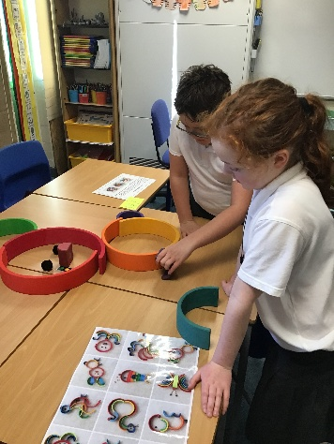
1. Progress Against 2025–2026 Computing Development Targets

a. Embed the new computing curriculum across all phases
The new Computing curriculum has been successfully embedded across all classes. Staff have received training and support to deliver lessons aligned with the revised curriculum, with adaptations made to meet the varying needs of our learners. Monitoring activities, including learning walks, staff voice and pupil voice, demonstrate consistent delivery and clear progression of skills across Computer Science, Information Technology and Digital Literacy. Children are engaging positively with Computing and are increasingly able to apply their skills across the wider curriculum.

b. Design and implement new pre-curriculum computing targets
A bespoke bank of pre-curriculum Computing Steps has been developed and implemented for pupils working below the standard age-related framework. These targets align with the new curriculum and provide clear progression pathways for learners with SEND. The framework has improved consistency in assessment and enabled staff to accurately track and celebrate progress in Computing across all ability levels.

c. Develop a whole-school computing portfolio
A whole-school Computing portfolio has been established to showcase learning and progression across the school. The portfolio includes photographs, pupil work, digital outcomes and assessment evidence from all phases. It provides a valuable record of curriculum coverage, supports subject monitoring and celebrates pupils' achievements in Computing.

d. Provide ongoing CPD through AI-focused drop-In Sessions
A programme of AI-focused CPD has been delivered throughout the year, including drop-in sessions, staff meetings and individual support. Training has focused on the safe and effective use of AI to support planning, resource creation, accessibility and workload reduction. Staff confidence in using AI has increased significantly, with many colleagues now using AI tools regularly to enhance teaching and learning while maintaining appropriate safeguarding and professional standards.

2. Cross curricular Subject Leader support.

Throughout the year, support has been provided to subject leaders to strengthen the use of Computing and AI across the wider curriculum. This has included working collaboratively with leaders to identify practical ways technology can enhance teaching, learning and assessment within their subjects. For example, the History Lead has been supported in using AI tools to generate historically inaccurate resources and images that challenge pupils to identify errors and misconceptions, promoting critical thinking and historical enquiry skills. The Science Lead has received guidance on the effective use of data loggers and digital technologies to improve data collection, observation and analysis within investigations. In addition, ongoing advice and training have been offered to staff to support the use of AI for resource creation, lesson adaptation and accessibility, helping subject leaders explore innovative ways to enrich learning while reducing workload.

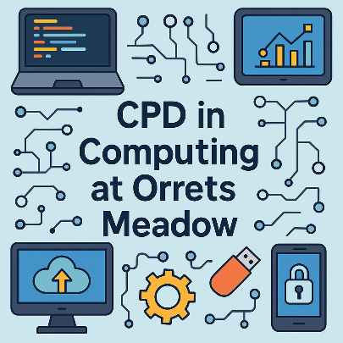
CPD
- 25th September – Use of AI course
- 8th October – Collaborative working with Clare Mount
- 13th November – AI drop in session for staff (Canva)
- 7th January – Unplugged Computing Staff Meeting
- 29th January – MAT AI training
- 15th February – AI drop in for staff (Google Gemini)
- 14th May - AI drop in for staff (Google Gemini prt 2)

Quality of Teaching and Learning

A range of monitoring activities have been used throughout the year to evaluate the quality of Computing across the school. These have included learning walks, informal lesson visits, scrutiny of electronically saved work and class Computing portfolios, alongside the maintenance of a comprehensive subject leader file. Feedback gathered from pupils has been overwhelmingly positive, with children reporting high levels of enjoyment and engagement during Computing lessons. Staff feedback has also been extremely encouraging, highlighting increased confidence in delivering creative and accessible Computing experiences that meet the diverse needs of our children.

Evidence from monitoring demonstrates that Computing is taught effectively across the school, with lessons that are engaging, inclusive and appropriately adapted to meet the needs of our children. Whilst teaching and learning are consistently strong, monitoring identified the need for a clearer progression of the fundamental Computing skills that underpin later digital learning. Staff recognised that children would benefit from a more structured approach to developing key concepts such as logical thinking, sequencing, problem solving, algorithms and debugging. In response, a bespoke ‘Unplugged Computing’ curriculum has been developed which places greater emphasis on these foundational skills through carefully planned unplugged activities alongside the use of technology. This approach enables children to build a secure understanding of core Computing concepts in practical, accessible ways, ensuring that progression is meaningful and matched to their individual developmental needs.
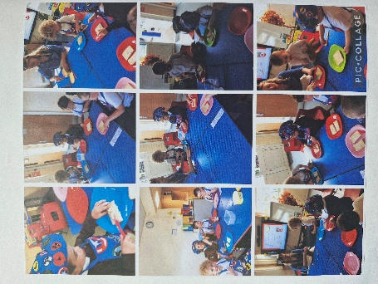

Data Analysis

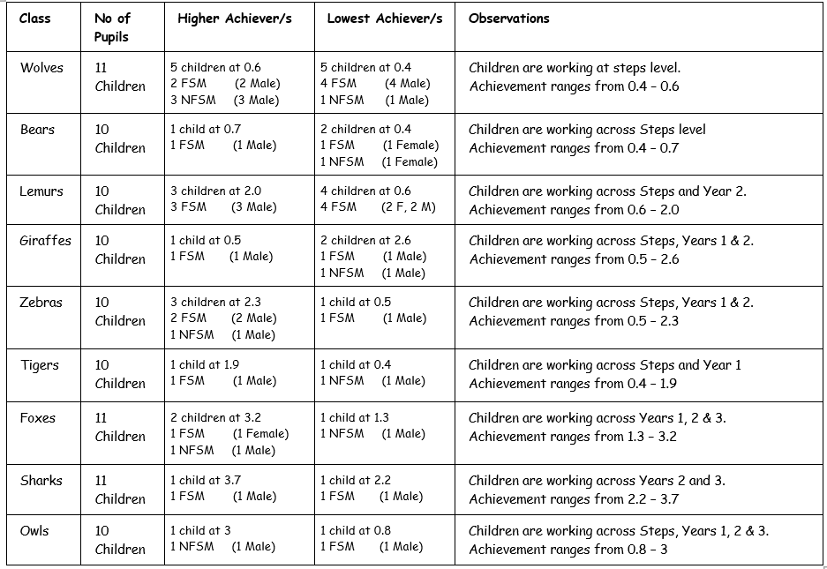

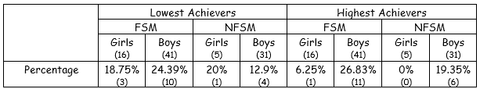

The computing data reflects a wide range of attainment from Steps to Year 3, consistent with our school’s stage-based assessment model. Patterns in attainment across FSM status and gender largely reflect the composition of the cohort rather than indicating clear attainment gaps. Progression across stages is varied and non-linear, which is typical within our SEND setting. A key focus moving forward is supporting more pupils to access higher-level computing skills, where appropriate. Fore a more comprehensive data analysis, see ‘Computing Data Analysis February 2026’.

Strengths

The Computing curriculum at Orrets Meadow has a number of key strengths that reflect the school’s commitment to meeting the diverse needs of its learners.

• Positive steps towards strong foundations through unplugged learning: Children are beginning to develop a more secure understanding of fundamental Computing concepts such as sequencing, algorithms, problem solving and debugging through carefully planned unplugged activities before applying these skills using technology.
• Inclusive and accessible provision: Computing lessons are highly adapted to meet the diverse needs of learners across the school. A combination of practical, visual and hands-on approaches ensures all children can access and achieve within the subject.

• Clear progression for all learners: The bespoke Computing curriculum and pre-curriculum assessment framework provide a coherent pathway of learning, enabling pupils working at all levels to make meaningful progress and build on prior knowledge.

• High levels of engagement and enjoyment: Pupil voice and lesson drop in sessions demonstrate that children are enthusiastic about Computing and actively participate in lessons. Practical activities and real-life contexts help to maintain motivation and curiosity. It has been particularly pleasing when children have asked if they can share their work with me, as Computing Lead. This demonstrates a real sense of pride and achievement in lessons.

• Growing staff expertise: Staff confidence in delivering Computing continues to strengthen through ongoing support, monitoring and professional development. Teachers are increasingly skilled in adapting lessons and using technology effectively to support learning.

• Effective use of technology across the curriculum: Digital tools and Computing skills are embedded across a range of subjects, helping children apply their learning in meaningful contexts. Subject leaders are increasingly exploring the use of technology and AI to enhance teaching and learning within their areas.

• Digital safety embedded throughout school life: Online safety is woven throughout the curriculum and reinforced regularly, helping pupils develop safe, responsible and age-appropriate behaviours when using technology.

• Strong evidence of learning and progression: The whole-school Computing portfolio and foundation assessments provides clear evidence of curriculum coverage, pupil achievement and progression over time, supporting effective monitoring and celebration of success

Ways Forward/ Targets.

Building on the significant progress made this year, the next stage of development will focus on refining and embedding effective practice to further strengthen Computing across the school. Priorities will include deepening pupils’ understanding of core computational thinking skills, enhancing the use of technology and AI across the wider curriculum, and ensuring progression is clearly evidenced for all learners. These targets will support our continued commitment to providing a high-quality, inclusive Computing education that prepares children for an increasingly digital world.

1. Strengthen progression in computational thinking
Target: By July 2027, further develop and refine the progression of core computational thinking skills, ensuring children demonstrate increasing independence in sequencing, problem solving, debugging and logical reasoning through both unplugged and digital activities.

2. Enhance the use of technology across the curriculum
Target: By July 2027, work alongside subject leaders to identify and implement meaningful opportunities for Computing and digital technology to support teaching and learning across a wider range of curriculum subjects, ensuring technology enhances learning rather than simply replacing traditional methods.

3. Develop pupil Digital Leadership opportunities
Target: By Summer 2027, establish a group of Digital Leaders who will promote safe technology use, support peers during Computing lessons and contribute to the development of Computing and online safety initiatives across the school.

4. Further embed AI to support teaching and learning
Target: By July 2027, continue to develop staff confidence in the safe and effective use of AI through ongoing CPD, with a particular focus on supporting accessibility, reducing workload, improving curriculum adaptation and enhancing outcomes for pupils.

5. Refine assessment and evidence of progression
Target: By July 2027, review and further develop Computing assessment systems to ensure progression is clearly evidenced across both curriculum and pre-curriculum pathways, enabling teachers to identify next steps and celebrate achievement effectively.

6. Expand Real-World technology experiences
Target: By July 2027, increase opportunities for pupils to engage with a wider range of technologies, including physical computing, data logging, programmable devices and assistive technologies, helping children understand how Computing supports everyday life and future careers.



