Governor Report – Summer 2026
Geography
Hannah Dunning
- "Continue to embed the Steps Level curriculum to ensure consistency and clarity in progression across all classes." Achieved: This year, we successfully implemented our 'Steps' for geography teaching and learning across all classes, ensuring that all children can fully access the curriculum. This framework allows for robust pre-curriculum assessment prior to National Curriculum indicators, establishing complete clarity and consistency in progression across the school.
- "Create an evidence folder of work for moderation showing progression from Steps to Year 4." Achieved: A comprehensive, central working moderation folder has been created. It showcases high-quality pupil work, photographic evidence that tracks clear skill progression from the initial Steps up to Year 4, successfully supporting internal and cross-school moderation.
- "Maintain successful initiatives such as the Geographical Skills Morning and sponsored walks as annual & biannual events." Achieved & Evolved: We successfully maintained and exceeded this target by expanding the original morning initiative into a comprehensive, full-school Geography Skills Day. This successfully maximised practical fieldwork across all year groups, yielding exceptional pupil engagement. Past sponsored walk frameworks have been kept under positive review for future terms based on receptive staff feedback.
- "Lead a staff meeting refresher to prepare for the next Geographical Skills Morning, ensuring consistency, clarity, and high-quality delivery across all classes." Achieved: Carried out as a core subject leadership CPD milestone, I led a whole-staff refresher briefing prior to our Geography Skills Day. This directly ensured excellent consistency, clarity of learning objectives, and high-quality delivery in every classroom.
- Additional Strategic Achievement: Fully updated the Geography subject policy to include a dedicated statement reflecting our school's new attachment and trauma-informed approach, and finalised updated progression of skills documents across all key stages.
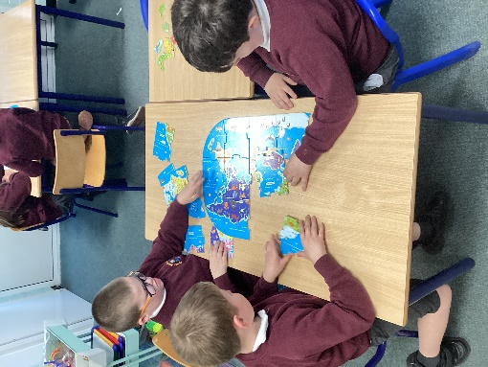
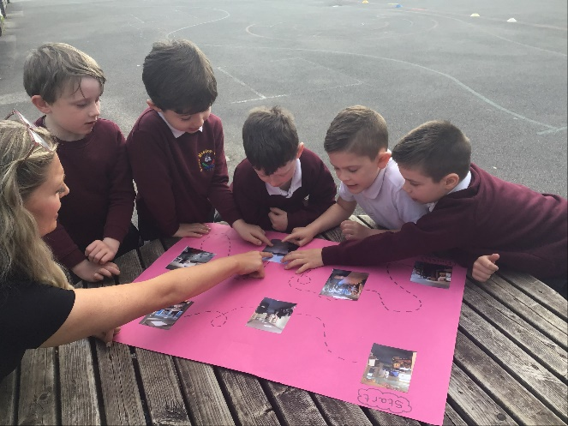
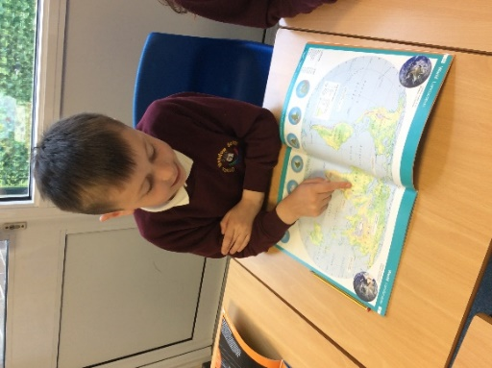

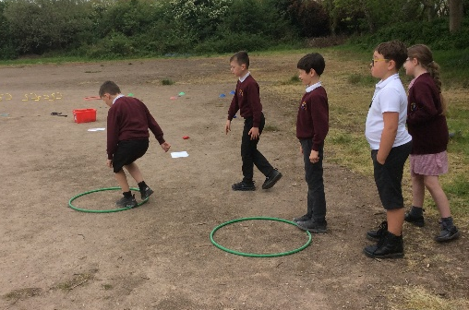
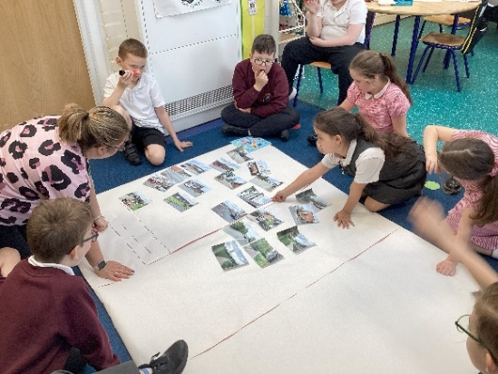
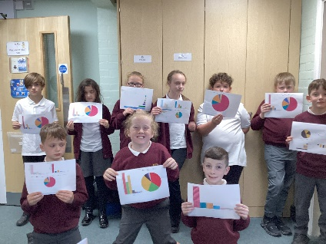

Quality of Teaching and Learning
As subject lead, I have continued to support colleagues across the school in developing their subject knowledge and teaching confidence through shared resources, clear progression frameworks, and ongoing peer support.
Learning walks conducted throughout the year have shown high-quality, adaptive teaching across all key stages. Teachers consistently embrace innovative, immersive methods that engage our diverse learners effectively. Furthermore, a detailed book scrutiny once again revealed beautifully presented, progressive work that reflects our whole-school commitment to maintaining high standards in Geography. Both pupil and staff surveys reinforced a clear preference for these immersive, experiential learning opportunities over traditional written tasks, supporting long-term knowledge retention and student enjoyment.
The expansion to a full Geography Skills Day provided an excellent window into our active teaching quality, with outstanding survey results:
- Staff Voice Insights: 100% of staff rated the day as well or very well organised, unanimously agreeing that activities successfully met learning objectives. Pupil engagement was universally rated as "Engaged" or "Very engaged". Highly effective activities included local community walks integrated with map work, park visits with comparative tasks, physical obstacle courses, Google Earth treasure hunts, utilising Bee-Bots on large-scale UK maps, and surveys at Moreton Cross. Feedback confirmed geography remains modern, relevant, and robustly embedded across the Dimensions curriculum.
- Pupil Voice Insights: Children demonstrated exceptional enjoyment, with the vast majority rating their map-reading confidence as a 4 or 5 out of 5. Pupils clearly articulated new knowledge, including identifying man-made structures (such as red post boxes), studying school ecosystems, locating global cities (like Paris and Venice), conducting vehicle surveys, and exploring how the Wirral has changed. Favourite moments included watching a water race wash away sand and rocks, building 3D Lego maps, coding Bee-Bots, and following treasure hunt clues
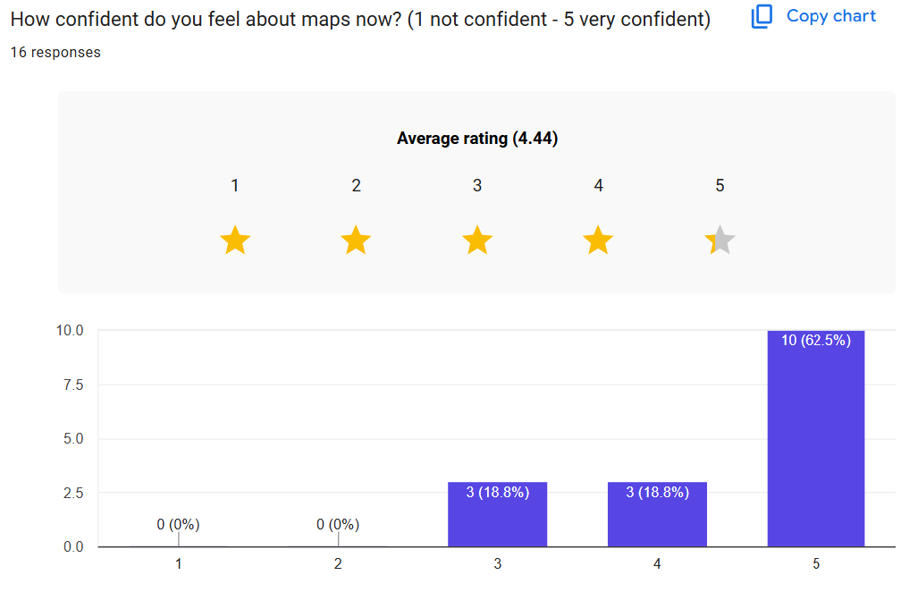

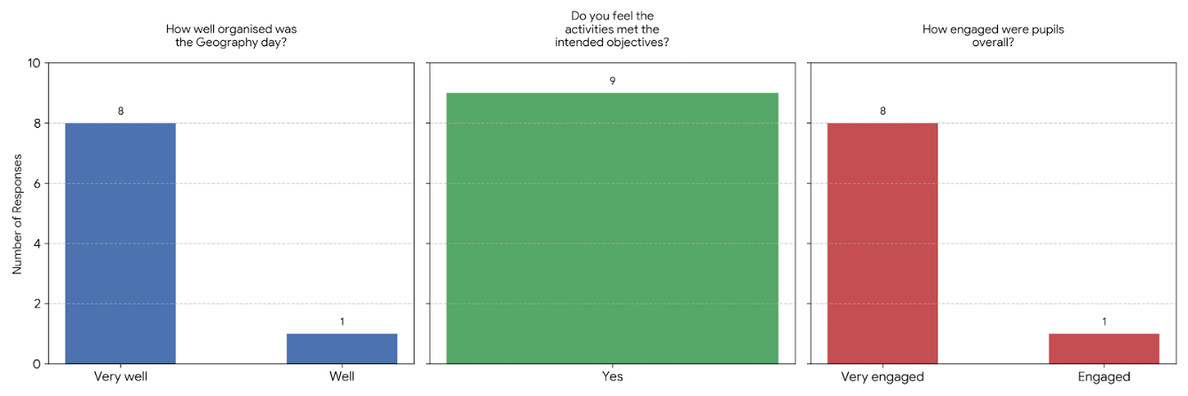

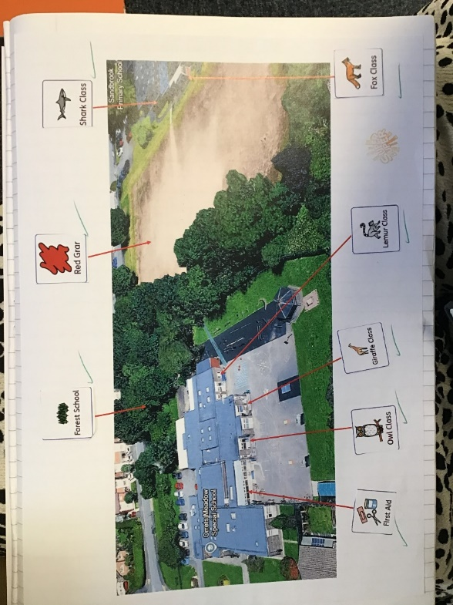
Additionally, we have actively developed our collaborative links with Claremount. Building upon our initial moderation links, we have formally invited Claremount’s Geography Lead to attend our school's Geography Skills Day next school year. Furthermore, we are in the process of organising an enriching class trip to Claremount to utilise their specialised VR headsets. This will bring geography learning to life for our pupils, leveraging modern technology to expand their interactive learning experiences.
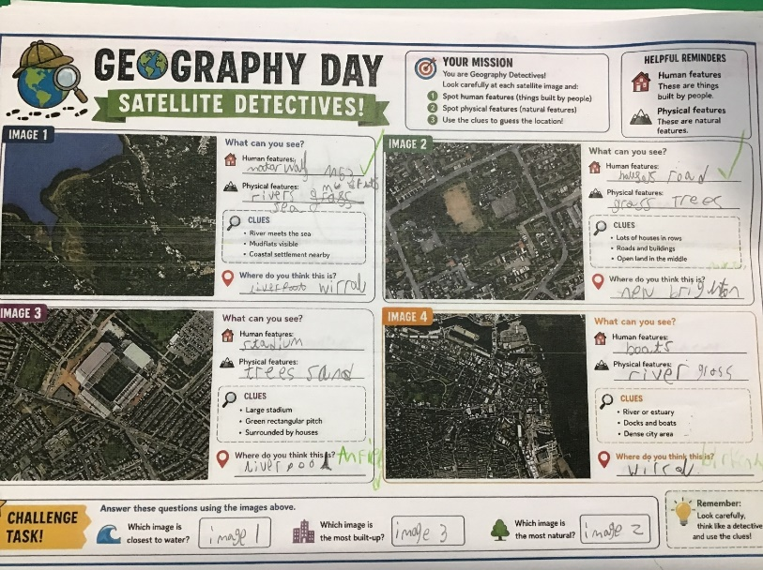

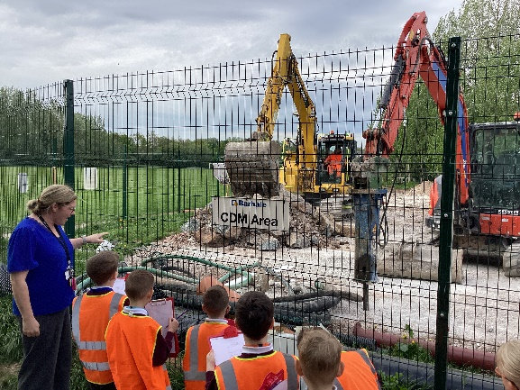

CPD
- Geography Autumn Briefing 2025
- Geography Fieldwork Staff Meeting April 2026
- Geography Spring Briefing 2026
- Clare Mount collaboration meeting Summer 2026

Strengths
- Highly Inclusive Framework: A customised curriculum utilising specialised Steps Level progression to ensure SEN children are accurately assessed and supported prior to National Curriculum markers.
- Immersive Whole-School Enrichment: The successful evolution of subject mornings into full, whole-school enrichment days that optimise pupil engagement and practical spatial skills.
- Authentic Local Fieldwork: Strong use of the school grounds and immediate local community (such as Moreton Cross) to deliver contextualised, real-world fieldwork.
- Rigorous Quality Control: Consistent tracking and cross-moderation supported by regular book scrutinies, learning walks, and a dedicated Steps-to-Year-4 moderation folder.

Ways Forward
- Scale and Solidify Whole-School Enrichment: Capitalise on the success of our geographical days by refining the full-school Skills Day, building on good practice like integrating community walks with immediate classroom map work.
- Enhance Resources for Complex Needs: Deepen the impact of our 'Steps Level' framework by introducing tactile resources (e.g., small world resources) to keep the curriculum accessible and sensory for a complex cohort.
- Address Core Equipment Shortages: Resolve resource sharing by auditing and purchasing dedicated, individual class jigsaws and stage-friendly atlases.
- Drive Technological and Collaborative Innovation: Execute our cross-school collaboration plan by hosting Claremount’s Geography Lead at our next Skills Day and coordinating a pupil trip to utilise their VR headsets.

Targets 2026–2027
- Target 1: Explore resources for inclusive teaching tailored for a more complex cohort, and ensure specific teaching resources are readily available e.g., small world resources (Autumn 26)
- Target 2: Organise and lead the whole-school Geography Skills Day (Spring 27)
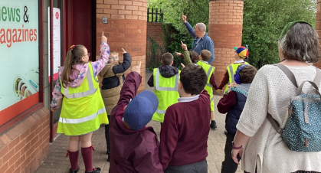
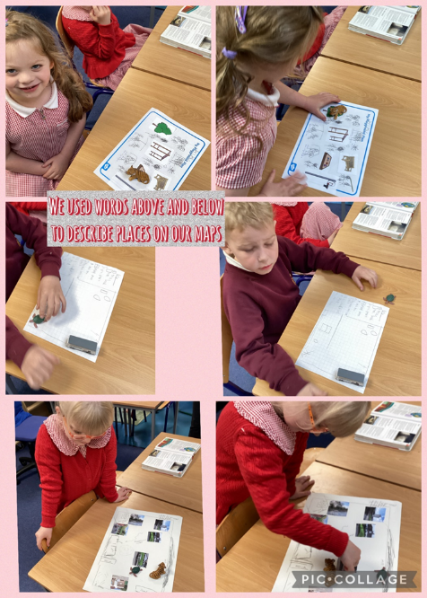
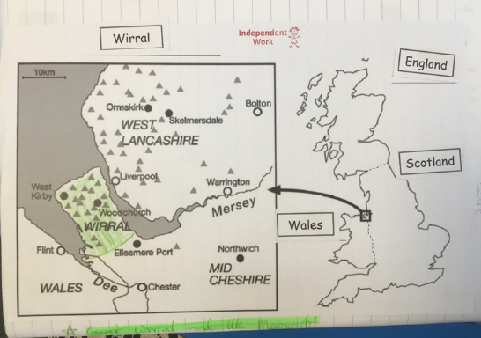
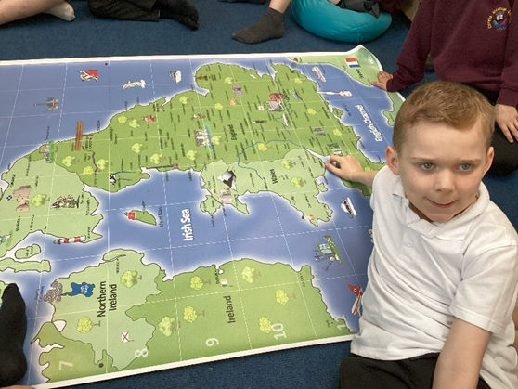
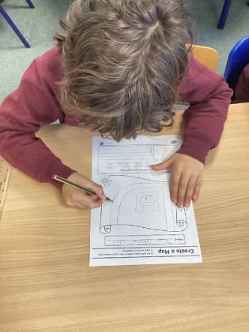
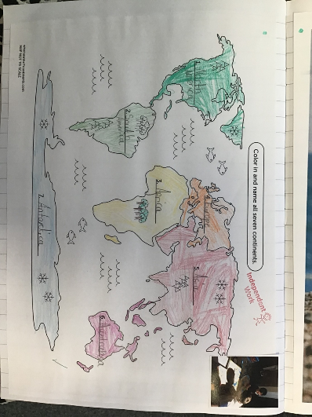
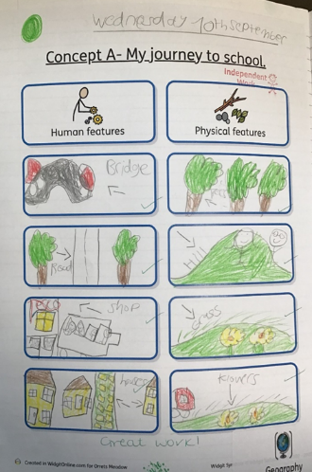
- Target 3: Organise a class trip to Claremount to use VR headsets to expand on geography learning and bring concepts to life through technology (Summer 27)

