Governors’ Report July 2026
Mathematics
Claire Walsh
Overview and main focus for the year:
Based on data from the previous year, a focus for the academic year 2025-26 should be on Early Maths. With the government report ‘Stronger Foundations’ coming out, there is a huge focus nationally on basic skills and closing gaps- Orrets Meadow’s bread and butter. Therefore, consolidating skills and knowledge as well as refreshing ideas and learning new research was thought to be strategically important for all staff.
Mrs Billington took early retirement in February and Mrs Walsh took over her role as Maths Leader.
CPD
Sarah Tennant from Sarah Squared lead staff in three staff meetings, working on counting and the four operations. Staff were lead in sessions using practical ideas as well as research based theories and professional discussions.
It was the first year of using the new steps statements for the whole year. This enabled staff to plan more bespoke lessons for pupils based on their needs. The steps document was and expanded enhanced particularly for the earlier steps, giving staff more ideas for activities and assessments for their children. This document will be used to make final assessments in July.
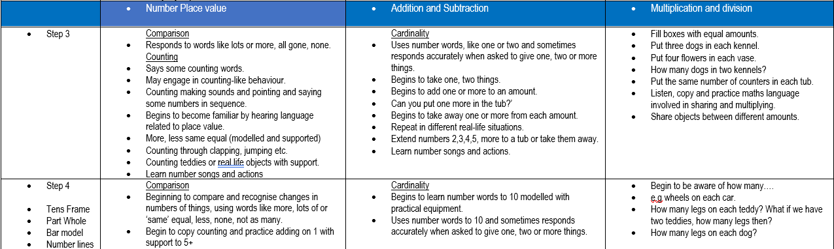
Moderation meetings across the year were successful for Orrets staff and some staff from across the academy trust. Staff felt more confident that they were using the new steps statements correctly to inform their planning and assess outcomes.
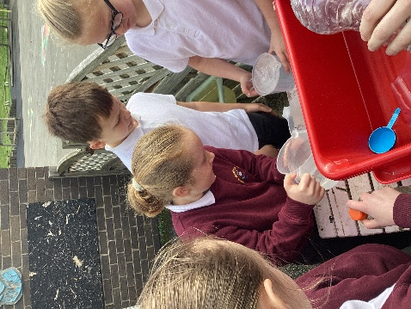
Previous learning walks have suggested that although the main part of the maths lessons are very well structured and delivered, the fluency part of the lesson is not as consistently delivered. Two new progression documents for fluency (multiplication and division, and addition and subtraction) were created and disseminated to staff. A staff meeting delivering the rationale behind fluency and its impact on maths as whole was delivered, and staff were given the documents to trial over the summer term. A new planning document for maths has been created which includes fluency objectives and activities, ensuring staff have a clearer opportunity to teach fluency to all children at the correct level.
Monitoring and Evaluation
In order to get to know the maths curriculum across the school, lesson drops were undertaken from wolves up to sharks. Pupils and staff were really receptive and welcoming and it was a privilege to see maths being taught in a rigorous, creative and consistent way across the school.
Staff voice demonstrated that staff feel more confident teaching maths using early maths strategies.

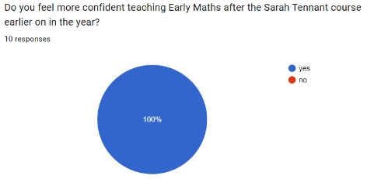
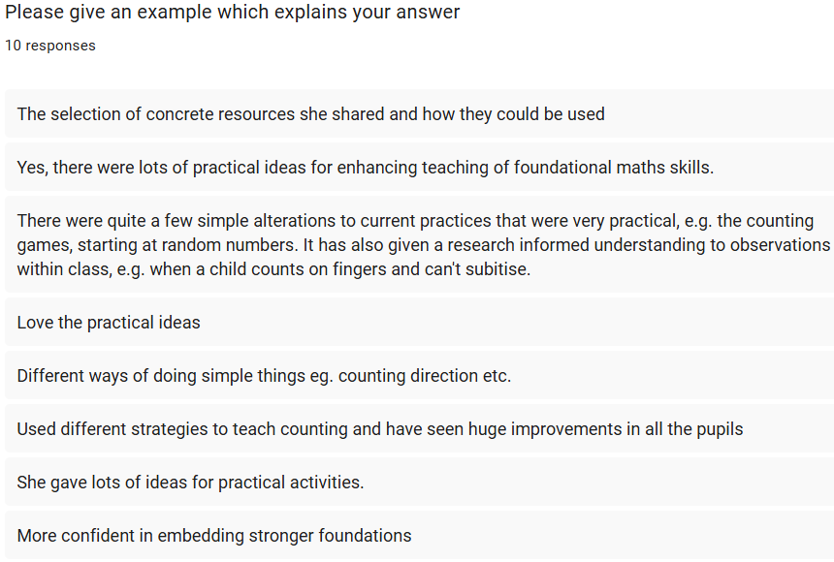

A maths book scrutiny was also undertaken alongside a pupil voice collection. Overall the books were excellent demonstrating a whole school approach consistently using strategies that support early maths teaching.

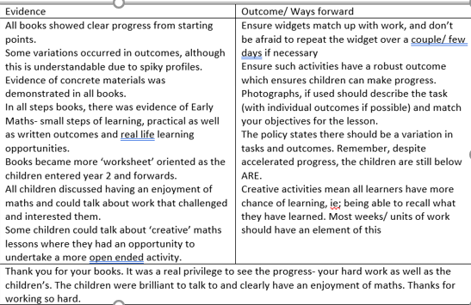

Enrichments
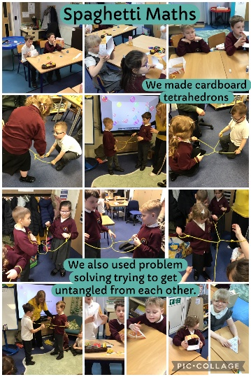
The school won a competition with a company called ‘Spaghetti Maths’. The children were encouraged to create structures using spaghetti and their knowledge of 3D shapes. It was a fantastic enrichment opportunity.

Sharks class had the opportunity as part of their transition and our relationship with our high school, to visit Claremount school. They took part in some active learning about position and direction and learned on the computer programs they will be using when they move to Claremount in September.

Strengths
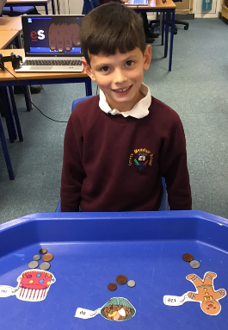
- Staff have enhanced their early maths knowledge
- Steps documents have been enhanced, leading to more rigorous subject knowledge and stronger judgements at the right level in early maths
- A more rigorous approach to fluency has been implemented including a detailed fluency progression document
- Maths lessons and books are of a high standard and show progression and a wide range of early maths and multi sensory practices across the whole school
Ways forward
- Further develop oracy in maths across the school
- Embed early maths practices
- Monitor fluency lessons to ensure consistency
- Attend half termly subject leaders updates with a local cluster of school maths leads to keep up to date with the latest research and

