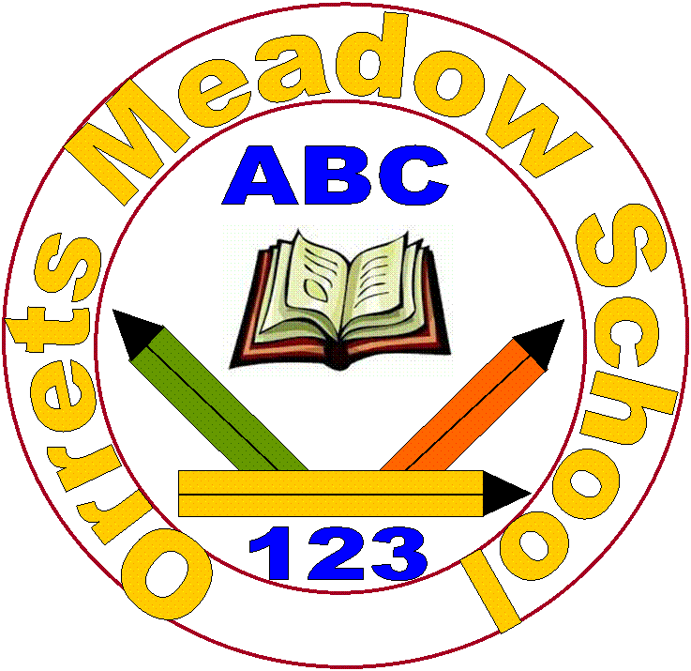

Orrets Meadow PSHE, RSE and Citizenship Policy

September 2026

Aims
The National Curriculum states that ‘all schools should make provision for personal, social, health and economic education (PSHE), drawing on good practice.’

According to the Education Act 2002 and the Academies Act 2010, the PSHE curriculum should be balanced and broadly-based, promoting the spiritual, moral, cultural, mental and physical development of pupils at the school and of society, and preparing pupils at the school for opportunities, responsibilities and experiences of later life.

We use a PSHE Programme - 3D PSHE and Citizenship - through which pupils develop the knowledge, skills and attributes needed to keep themselves healthy and safe, whilst preparing them for life and work.

This policy, provided by Dimensions Curriculum, reflects the 2026 guidance and covers all aspects of Relationships Education and Health and Wellbeing Education in an age appropriate or in our case a stage appropriate way.

There are two underlying core areas taught throughout Dimensions 3D PSHE, plus a section on Citizenship. Within these core areas, there is connection, overlap and flexibility:-

Core 1. Health and Wellbeing (shortened to C1 in lesson references)
Core 2. Relationships (shortened to C2 in lesson references)
Citizenship (shortened to CIT in lesson references)

Pupils are encouraged to participate in a wide variety of activities, enabling them to make significant contributions to both life in school and within the wider community. This allows them to become aware of their skills and talents, develop their self-worth, learn to work as part of a team and take greater responsibility for their own learning. In doing so, they are able to reflect on and evaluate how they are making progress.

Pupils will also learn about how to look after their own health and wellbeing through understanding the need for a balanced diet and regular exercise. They will learn about ways to support their own mental health, as well as physical health, through understanding how different emotions can make them feel. Health and Wellbeing links to Relationships, illustrating how positive relationships can influence mental wellbeing, too.

The 3D PSHE and Citizenship Programme provides pupils with the means to handle many of the social, cultural, spiritual, physical and moral issues that occur throughout life.

3D PSHE and Citizenship helps pupils to develop and demonstrate skills and attitudes that will allow them to participate fully, and contribute positively, to life in modern Britain. Pupils learn to respect similarities and differences between diverse cultures, in order to build successful and meaningful friendships and relationships that are vital to the world we live in.

Dimensions 3D PSHE and Citizenship supports the development of the attitudes, values, skills and behaviour which enable pupils to:-

- Live healthy lifestyles
- Address personal hygiene
- Develop an awareness of changing and growing
- Deal with different emotions in an appropriate way
- Keep safe
- Communicate well with others and work as a team
- Define, identify and know how to respond to bullying
- Know where and how to seek help when needed
- Treat everybody with respect
- Form and build positive relationships
- Understand the reasons for rules, and their responsibility to keep them
- Learn about their responsibility in caring for others
- Be active in their own learning
- Be active within their community
- Manage money well
- Keep safe online
- Self-assess and identify their strengths and weaknesses
- Know how to make emergency calls
- Know basic First Aid
- Work collaboratively and respectfully
- Appreciate diversity
- Empathise with other points of view
- Express opinions clearly
- Understand the changes that occur in puberty
- Develop strategies for managing changing emotions
- Life online, including wellbeing online, online safety and awareness and media literacy

PSHE is delivered through a trauma-informed approach. We prioritise safe relationships, understand behaviour as communication, and support pupils to regulate, engage, and achieve within a consistent and inclusive environment.

Relationships Education (Statutory)
The focus of 3D PSHE and Citizenship in primary school is on teaching the fundamental building blocks and characteristics of positive relationships, with particular reference to friendships, family relationships and relationships with other children and adults.
3D PSHE and Citizenship teaches pupils, in an age (and in our case stage) appropriate way, what a healthy relationship is, enabling them to form a clear understanding of the features of positive relationships that are likely to lead to fulfilment, happiness and security. Pupils learn what friendship is, what family means and who the people are who can support them.
Our school’s careful use of 3D PSHE and Citizenship teaches about families in a well-judged and sensitive way, based on a clear knowledge of the pupils and their circumstances. It reflects the way in which some children have different family structures and supportive relationships.
Pupils also learn how to take turns, how to treat each other with kindness, consideration and respect, the importance of honesty and truthfulness, permission seeking and giving, and the concept of personal privacy. Establishing personal space and boundaries, showing respect and understanding, including the differences between appropriate and inappropriate or unsafe physical and other forms of contact, are the forerunners of teaching about consent, which takes place at secondary.
3D PSHE and Citizenship lessons teach pupils about online safety and appropriate behaviour online, including sharing data and ways in which information provided by users may be used negatively.
3D PSHE and Citizenship’s Relationships Education encourages the development and practice of resilience and perseverance, self-respect and self-worth. Pupils are also helped to develop personal attributes including honesty, integrity, courage, humility, kindness, generosity, trustworthiness and a sense of justice. In 3D PSHE and Citizenship, this is achieved through a plethora of exciting and innovative learning experiences.
Pupils are taught about positive emotional and mental wellbeing, including how friendships can support mental wellbeing.
They also learn about safe relationships, focusing on boundaries and privacy and ensuring that they understand that they have rights over their own bodies. This also covers understanding boundaries in friendships with peers, in families and with others, in all contexts, including online. In 3D PSHE and Citizenship, pupils are clearly taught how to report concerns and seek advice when they suspect or know that something is wrong. Of paramount importance is ensuring the balance between informing children about making sensible decisions to stay safe (including online) without frightening them unnecessarily, whilst also making it clear that it is never the fault of a child who is exploited or abused, and why victim blaming is always wrong.
All Relationships Education in 3D PSHE and Citizenship is in line with the 2026 RSE guidance.
Sex Education
Sex Education is not statutory in primary schools.
The National Curriculum for science includes subject content in related areas, such as the main external body parts, the human body as it grows from birth to old age (including puberty) and reproduction in some plants and animals. Our school has determined (through parent, staff and governor feedback) that we need to cover any additional content on sex education in Year 6 to meet the needs of our particularly vulnerable pupils.
We use the 3D Relationships and Sex Education Unit. This is tailored to the age and physical and emotional maturity of our pupils and supports pupils’ ongoing emotional and physical development effectively. We ensure that both boys and girls are prepared for the changes that adolescence brings and, drawing on knowledge of the human life cycle set out in the national curriculum for science, helps pupils understand how a baby is conceived and born.
We consult parents before their children start Year 6 about the detailed content of what will be learnt through the 3D Relationships and Sex Education unit. We offer parents support in talking to their children about sex education and how to link this with what is being taught in school.
Parents have the right to withdraw their children from our sex education lessons. Our PSHE/RSHE lead R Warren will be available to discuss the request with parents to ensure that their wishes are understood and to clarify the nature and purpose of the curriculum, and a record will be kept of this process. R Warren will discuss with parents the benefits of receiving this education and any detrimental effects that withdrawal might have on the child, for example the likelihood of the child hearing their peers’ version of what was said in the classes, rather than what was directly said by the teacher. These detrimental effects may, of course, be mitigated if the parents propose to deliver sex education to their child at home instead. If a pupil is excused from sex education, our school will ensure that the pupil receives appropriate, purposeful education during the period of withdrawal.
Our 3D Relationships Sex Education teaching and materials are appropriate, having regard to the age and religious backgrounds, and any special educational needs or disabilities of our pupils.
Topic Based Afternoon PSHE
Why did we choose 'Learning Means the World'?
As a school which is majority white British, we want our pupils to fully embrace cultural diversity, learning about, experiencing and celebrating a range of different cultural and faith heritages.
We believe that communication is key to accessing learning and securing pupils’ future success. As many of our pupils have Speech Language Communication Needs it is essential that opportunities are given to develop language for learning across the curriculum. With one of its 4 foci being on communication, this curriculum provides lots of opportunities for pupils to develop expressing themselves in discussion, debate and presentation, as well as enabling them to collaborate and exchange ideas.
We feel our pupils, as the future generation, need a greater awareness and appreciation of local, national and global conservation issues and initiatives. The need to learn that they have an important role to play in sustainability. This curriculum gives pupils opportunities to grow and develop spiritually, emotionally, physically and socially in the natural world around them. Our commitment to nurturing positive attitudes and values and developing life and social skills is promoted throughout the Learning Means the World (LMTW) curriculum.
It is theme based and broken down into the following phases:
- Explorers (Foundation level)
- Pathfinders (KS1 level)
- Adventurers (Lower KS2 level)
We have the freedom to teach the National Curriculum in line with our pupils' specific needs and believe that our whole curriculum meets the values and aims which our stakeholders requested at the start of the consultation.
Pre-curricular PSHE
The pre curriculum for PSHE at Orrets follows a slightly different structure to support the younger cohort. It is based around the 3 areas:
- Managing Self
- Self-Regulation
- Building Relationships
This is to support our younger children getting a solid foundation before moving onto the next phase of the curriculum. We have also matched these across to the strands Relationships, Living in the Wider World and Health and Well Being so the sequence flows across the pre curriculum, KS1 and KS2 PSHE curriculum delivered.
Pre-curricular topic coverage:

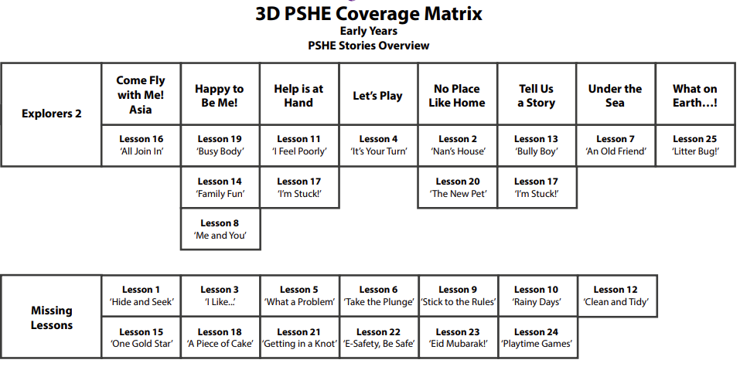

Orrets Meadow Pre-Curricular Discrete Overview
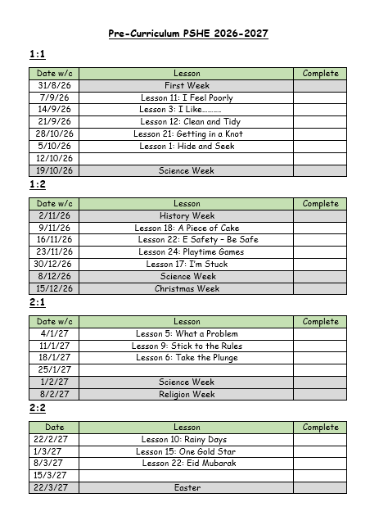
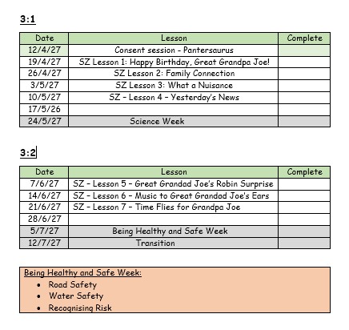
The targeted areas the pre-curriculum looks at are recorded below:

Managing Self | Lessons
Be confident to try new activities and show independence, resilience and perseverance in the face of challenge  (ELG)  It’s all about…taking part! | Lesson 6 ‘Taking the Plunge’  Lesson 15 ‘One Gold Star’
Explain the reasons for rules, now right from wrong and try to behave accordingly  (ELG)  It’s all about… taking part! | Lesson 5 ‘What a Problem’ Lesson 25 ‘Litter Bug’
Manage their own basic hygiene and personal needs, including dressing, going to the toilet and understanding the importance of healthy food choices  (ELG)  It’s all about… being smart! | Lesson 3 ‘I Like...’  Lesson 12 ‘Clean and Tidy’ Lesson 21 ‘Getting in Knot’
Self-Regulation | Lessons
Show an understanding of their own feelings and those of others, and begin to regulate their behaviour accordingly  (ELG)  It’s all about… having heart! | Lesson 2 ‘Nan’s House’ Lesson 13 ‘Bully Boy’  Lesson 20 ‘The New Pet’
Set work towards simple goals, being able to wait for what they want and control their immediate impulses when appropriate  (ELG)  It’s all about… being smart! | Lesson 10 ‘Rainy Days’
Give focused attention to what the teachers says, responding appropriately even when engaged in activity, and show an ability to follow instructions involving several ideas or actions  (ELG)  It’s all about… being smart! | Lesson 18 ‘A Piece of Cake’

Building Relationships | Lessons
Work and play cooperatively and take turns with others  (ELG)  It’s all about… taking part! | Lesson 4 ‘It’s Your Turn’ Lesson 9 ‘Stick to the Rules’  Lesson 24 ‘Playtime Games’
Form positive attachments to adults and friendships with peers  (ELG)  It’s all about… having heart! | Lesson 7 ‘An Old Friend’ Lesson 14 ‘Family Fun’ Lesson 23 ‘Eid Mubarak’
Show sensitivity to their own and to others’ needs (ELG)  It’s all about… being smart! | Lesson 1 ‘Hide and Seek’ Lesson 11 ‘I Feel Poorly!’ Lesson 19 ‘Busy Body’
PSHE Curriculum Year 1 to Year 4:
The Year 1 to 4 PSHE Dimensions Curriculum core theme coverage is divided into three areas; Health and Well Being, Relationships and Citizenship. These areas are colour coded as below:
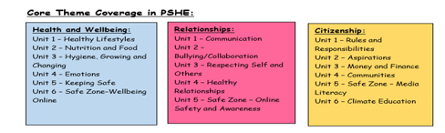
Year 1/Year 2 PSHE coverage including themed units (topic) and additional units taught discretely:
Health and Wellbeing:
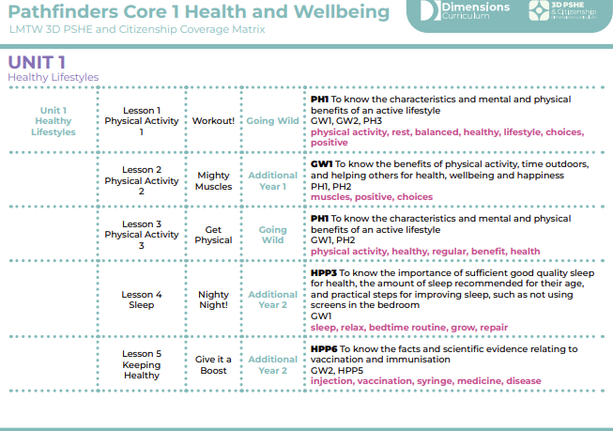
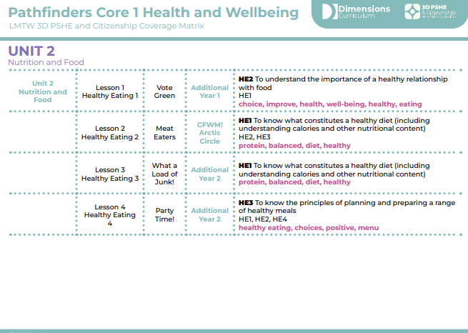
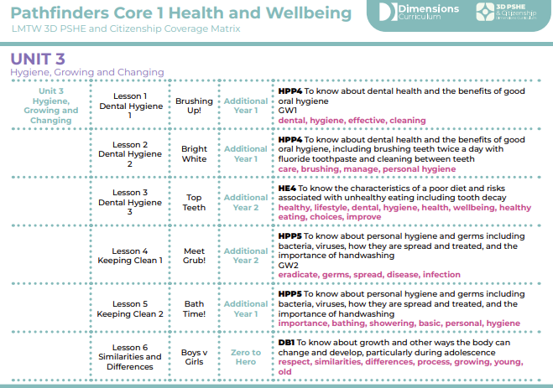
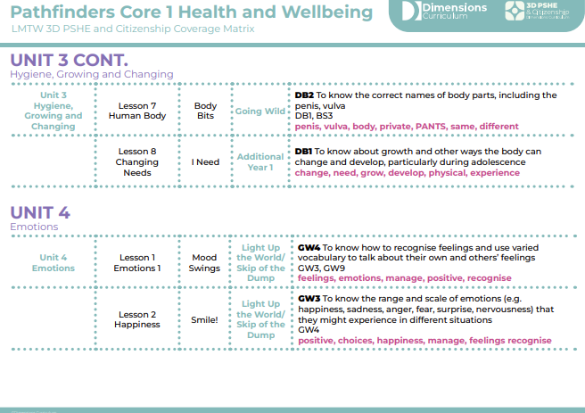
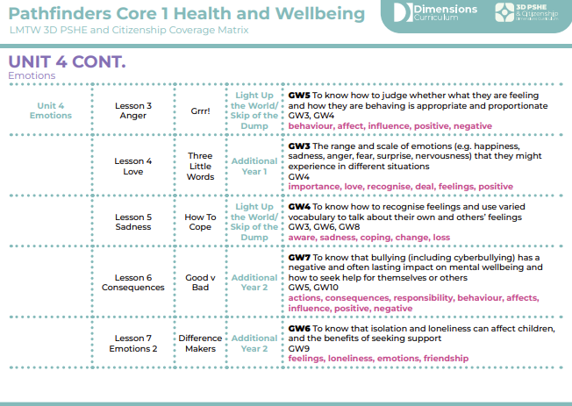
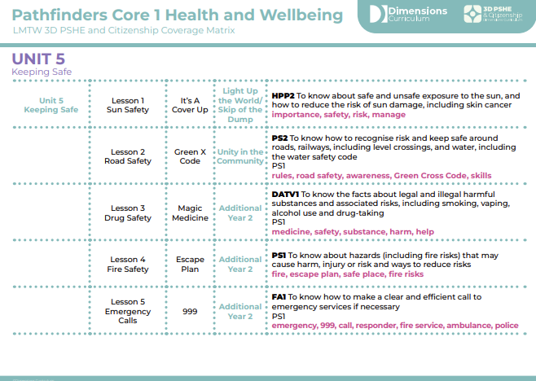
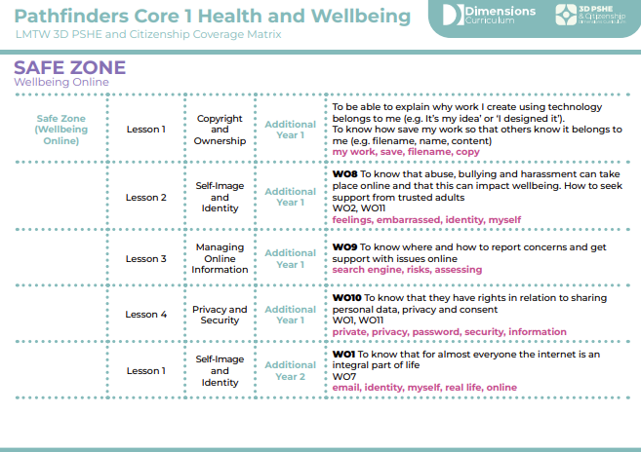
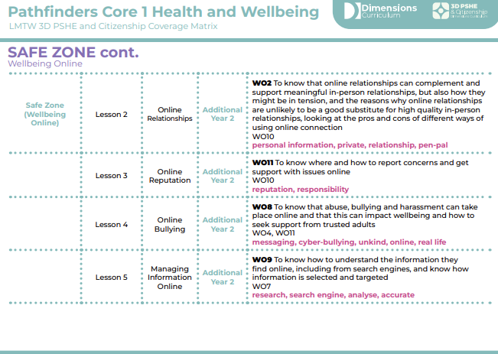
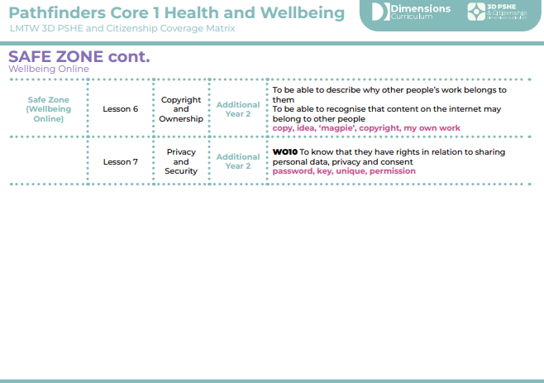

Relationships:
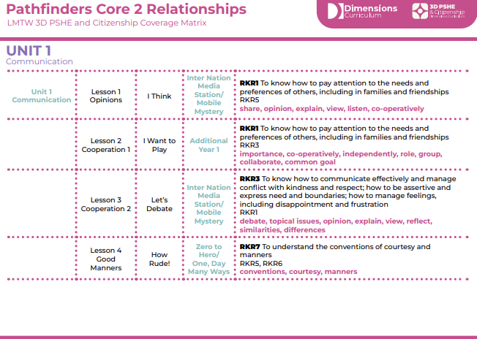
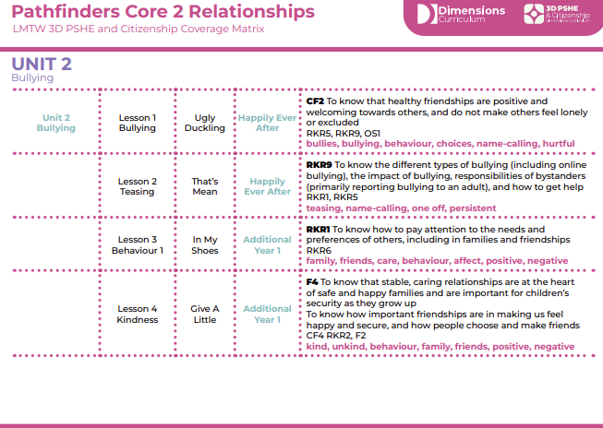
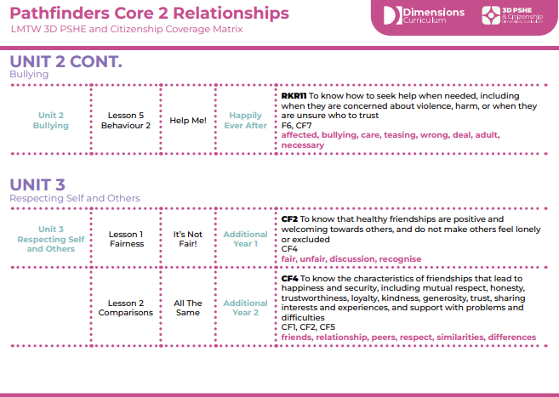
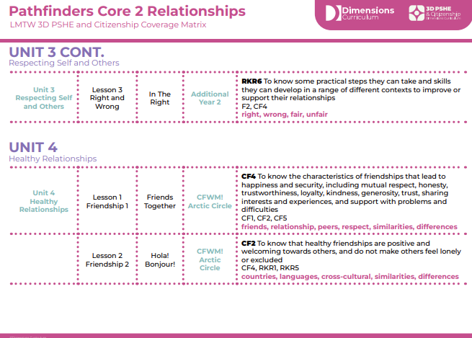
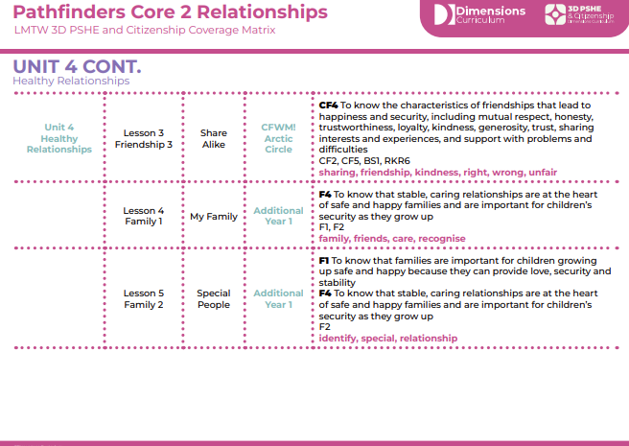
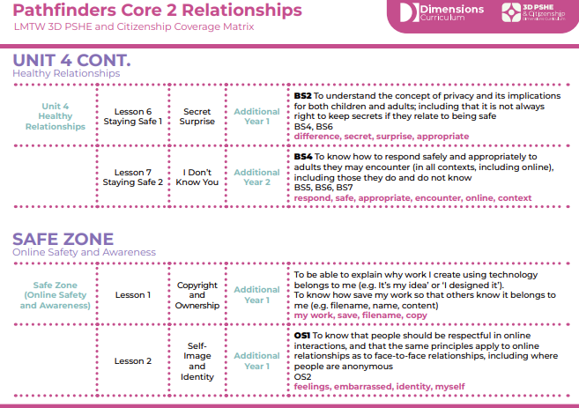
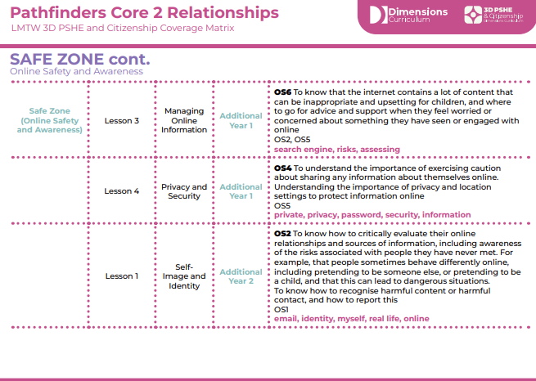
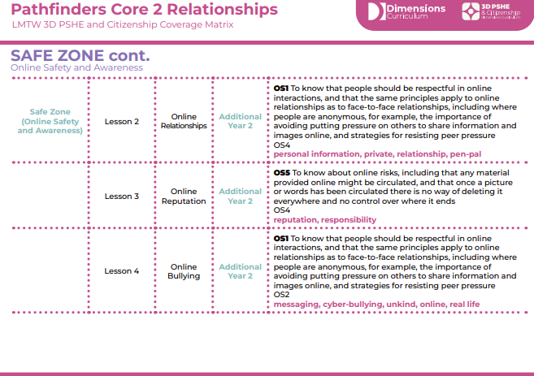
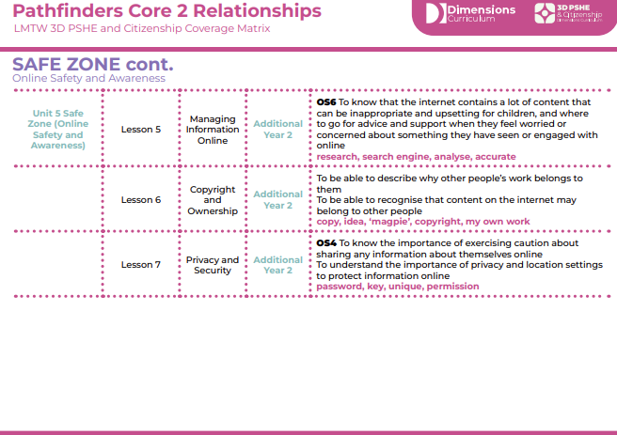
Citizenship
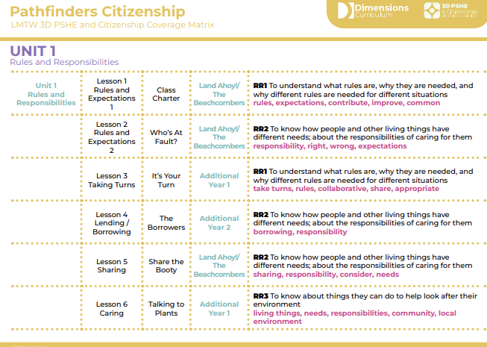
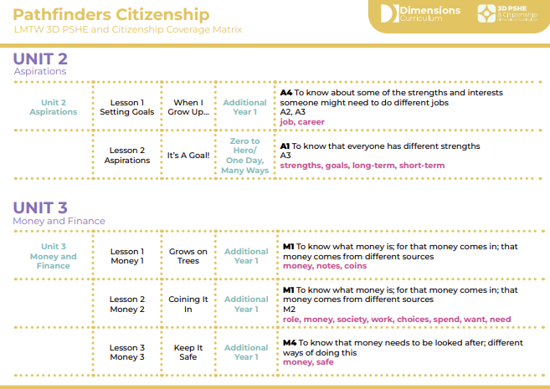
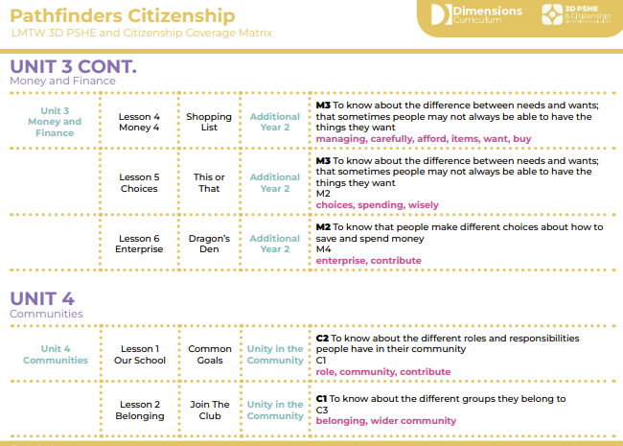
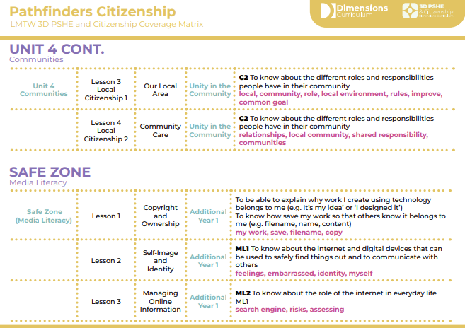
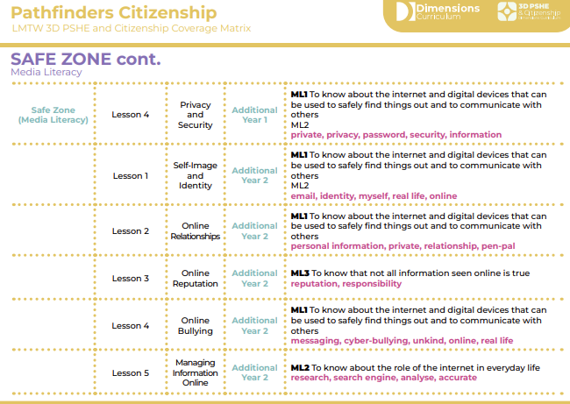
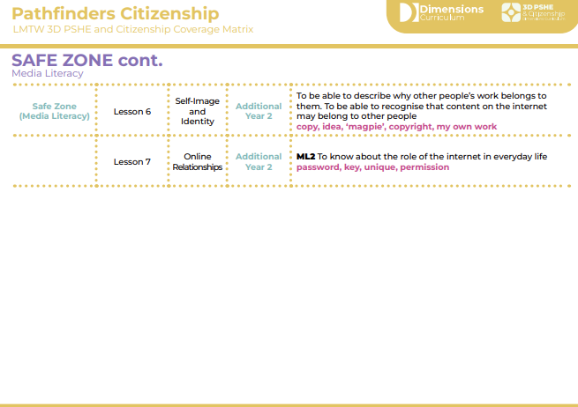
Year One Discrete Overview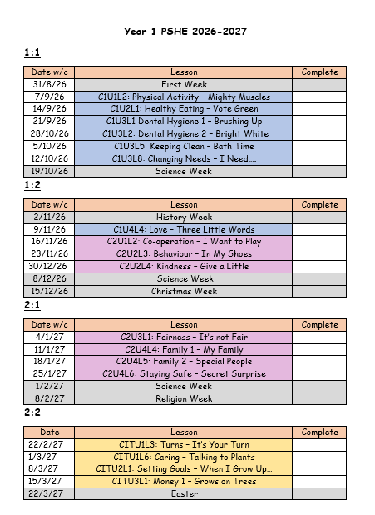
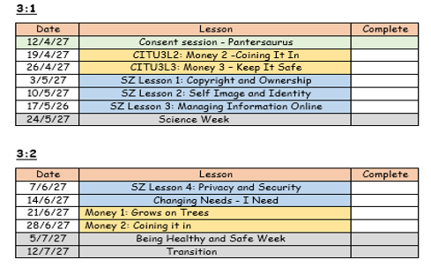
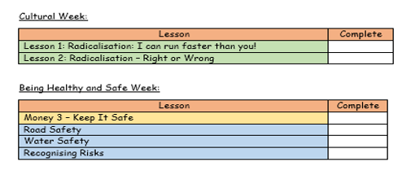
Year Two Discrete Overview
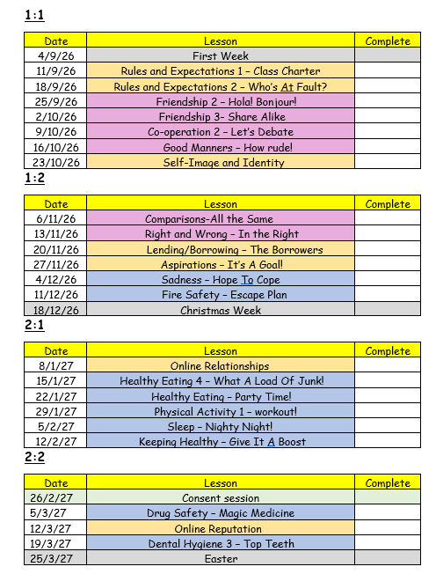
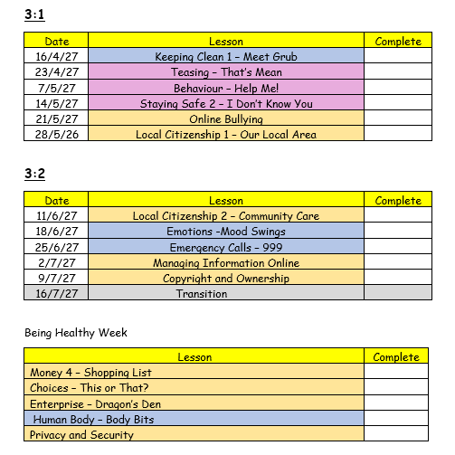

Year 3/Year 4 PSHE coverage including themed units (topic) and additional units taught discretely:
Health and Wellbeing:
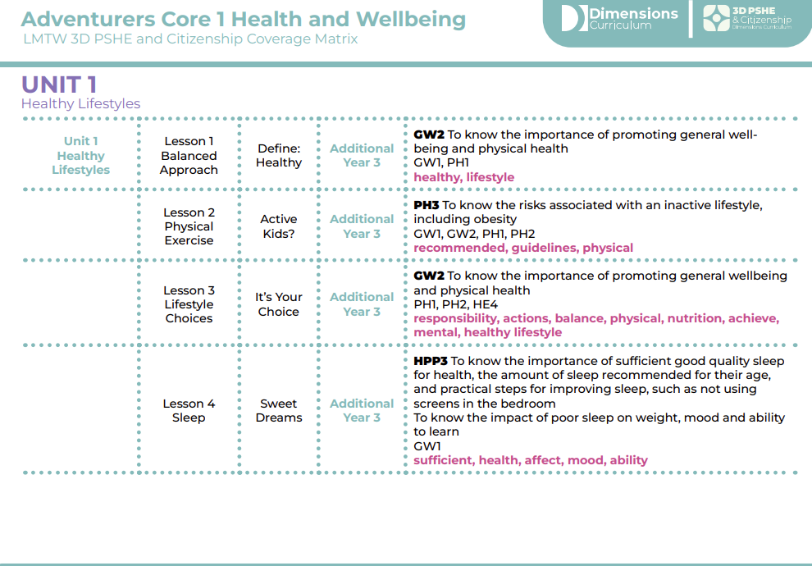
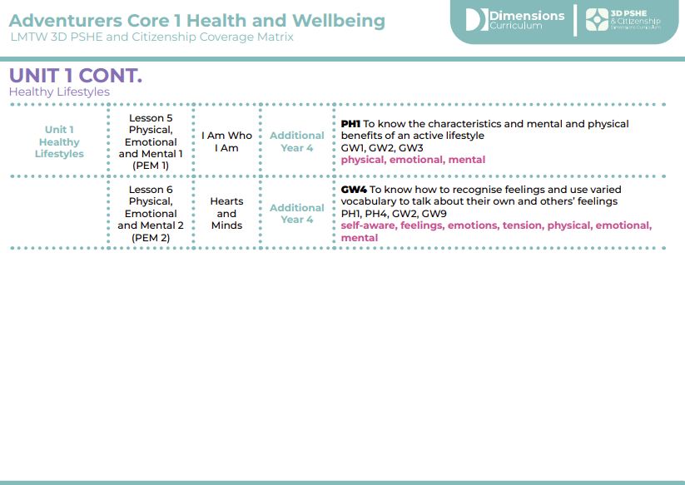
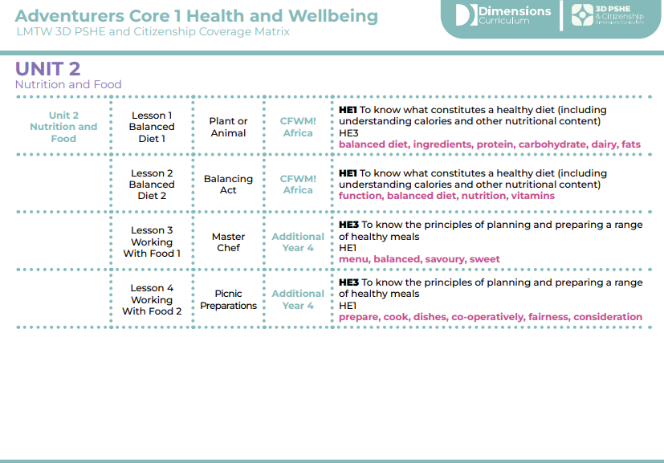
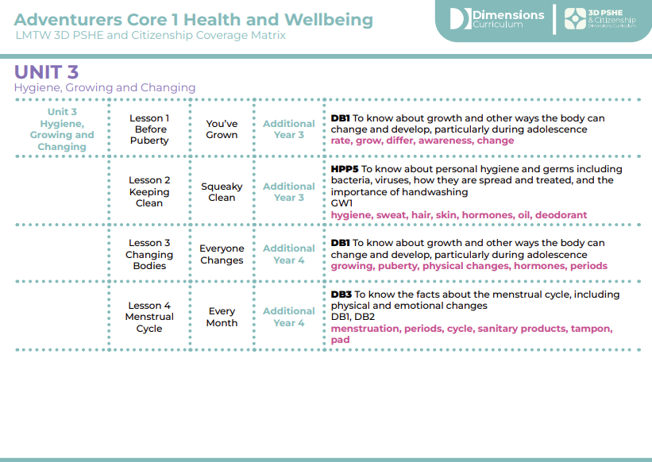
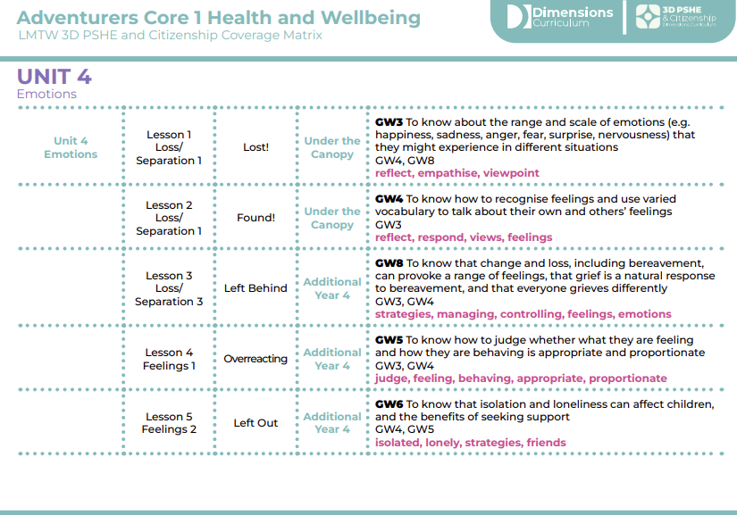
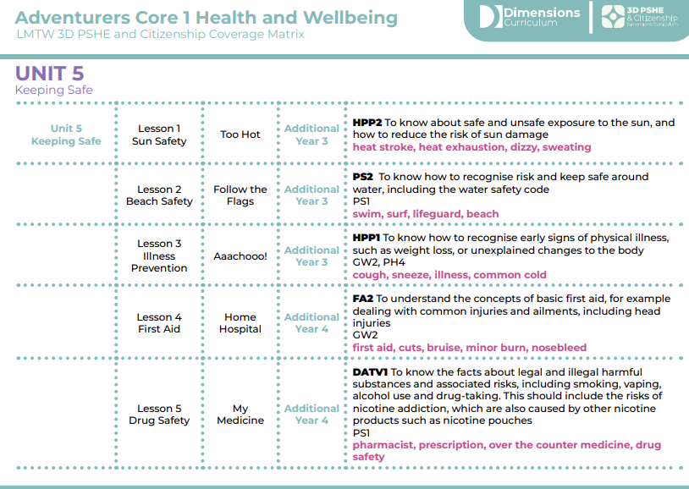
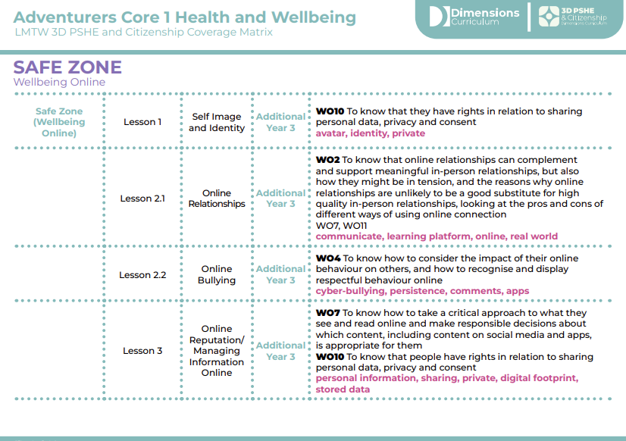
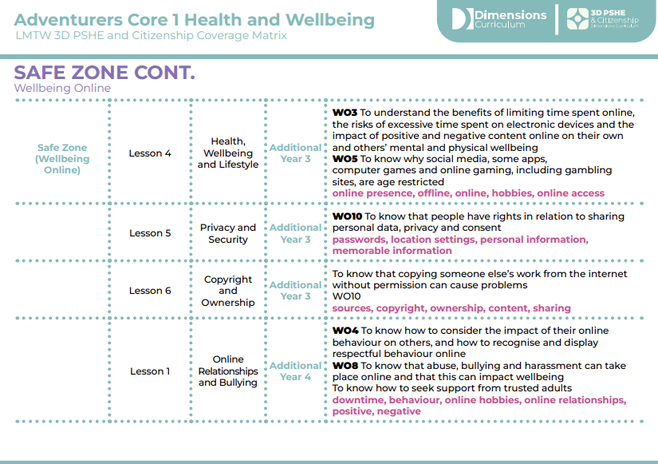
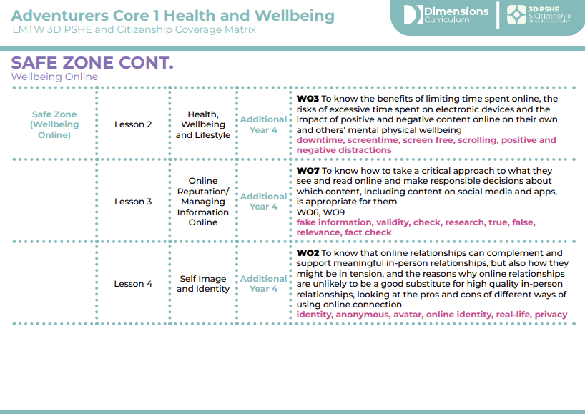
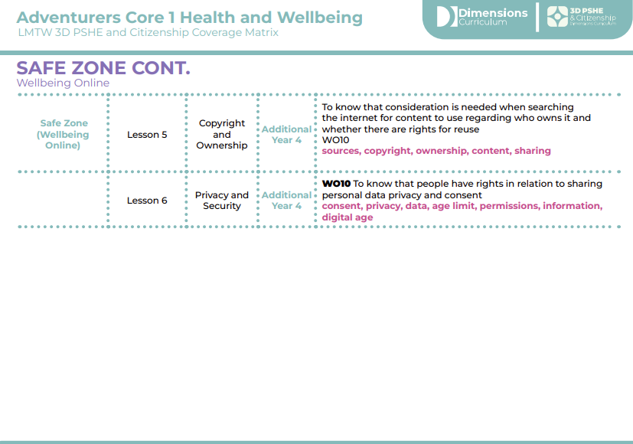

Relationships:
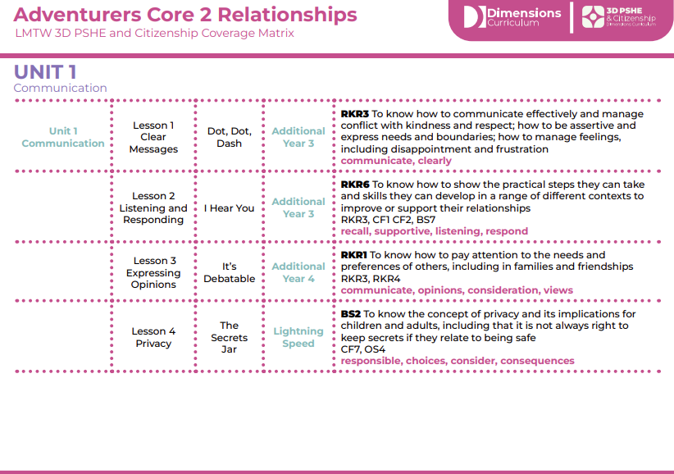
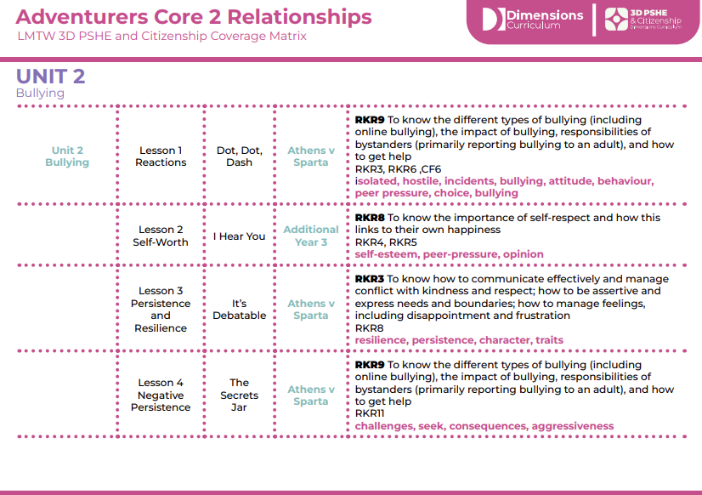
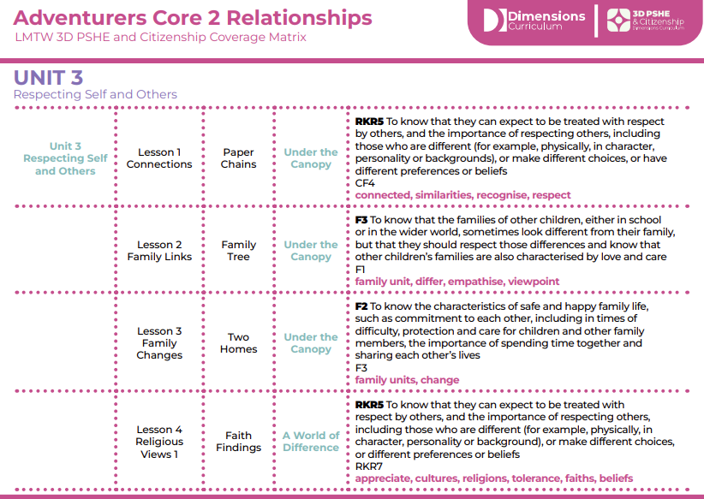
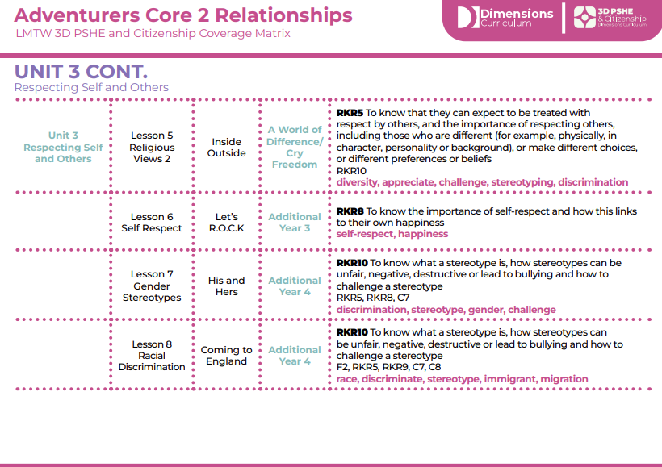
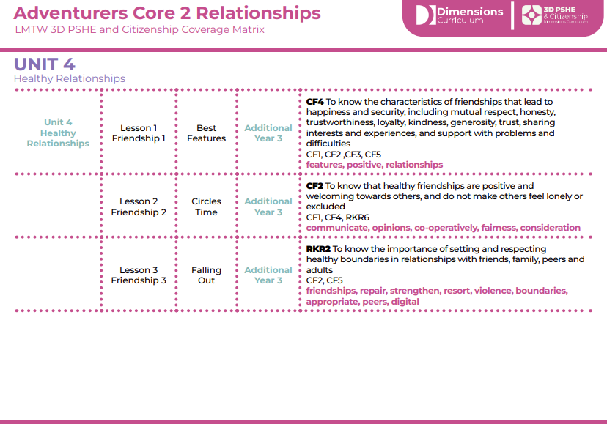
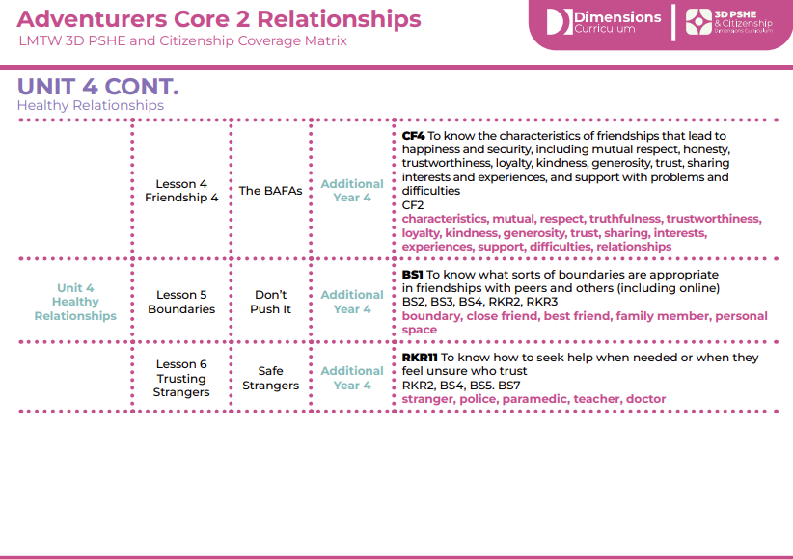
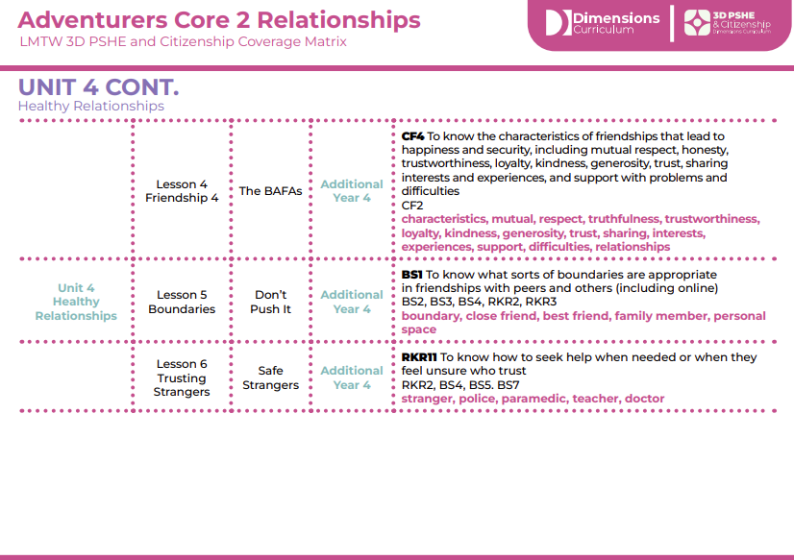
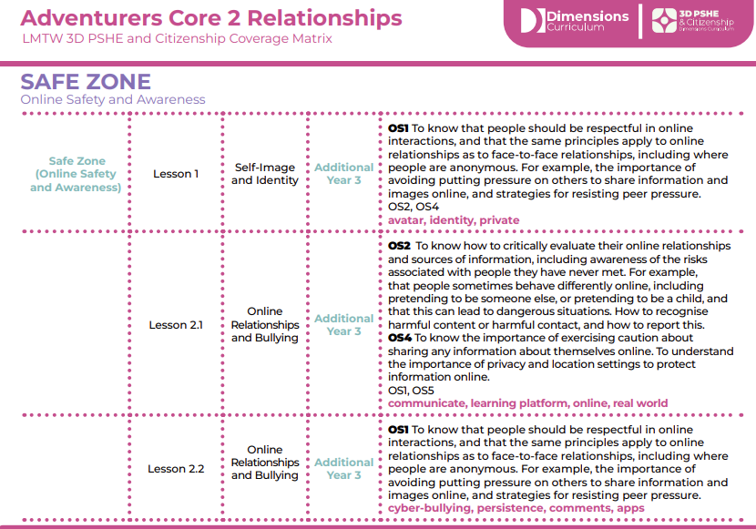
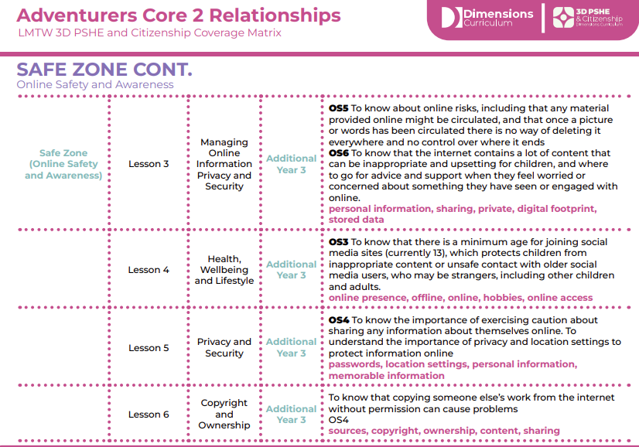
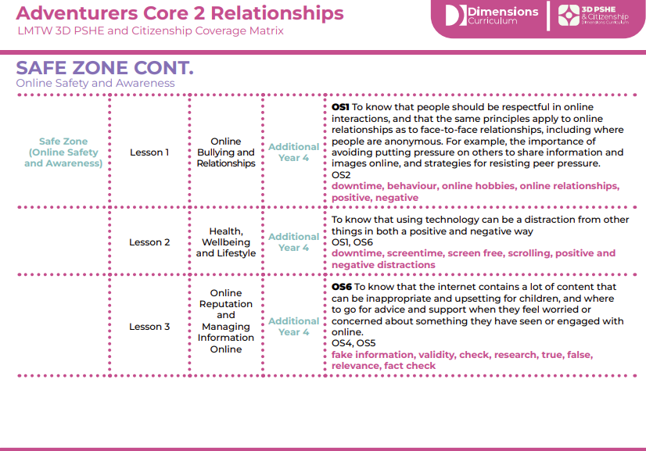
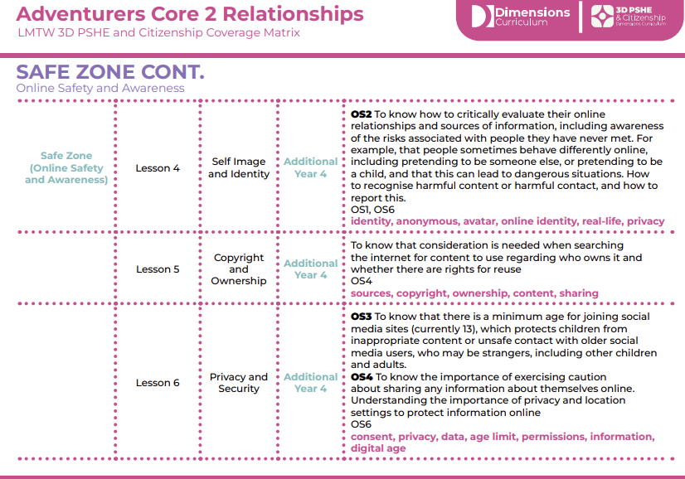

Citizenship:
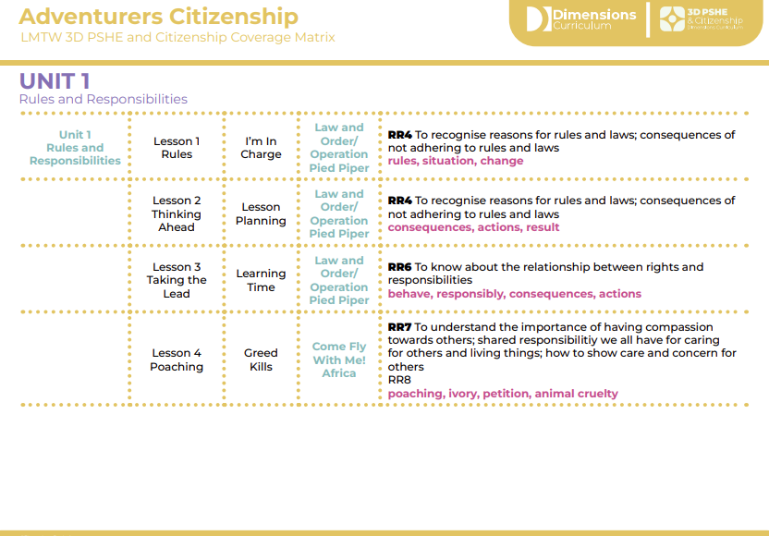
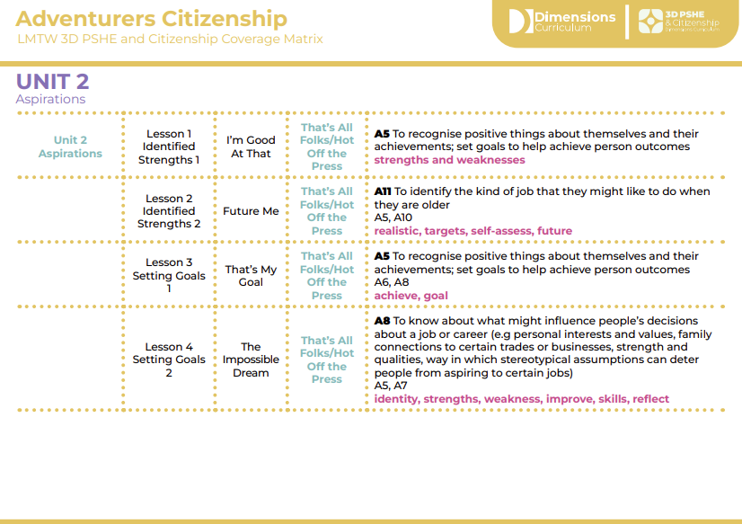
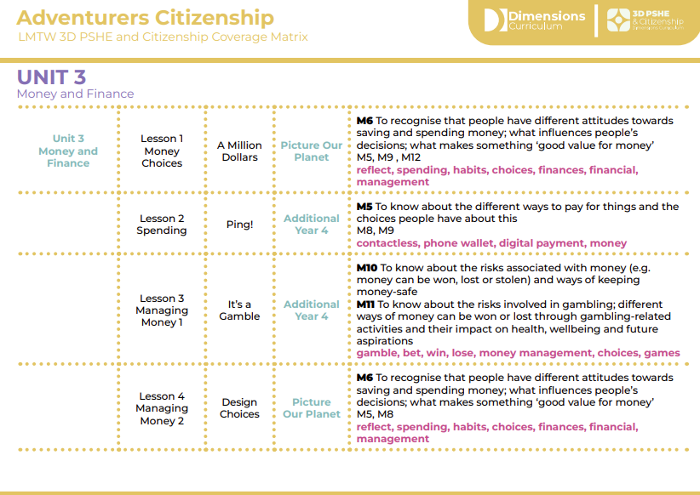
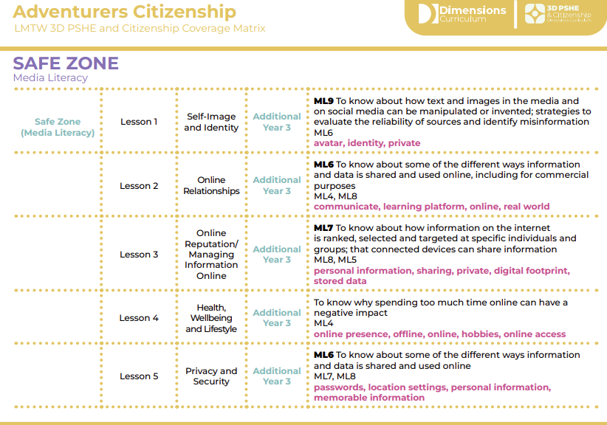
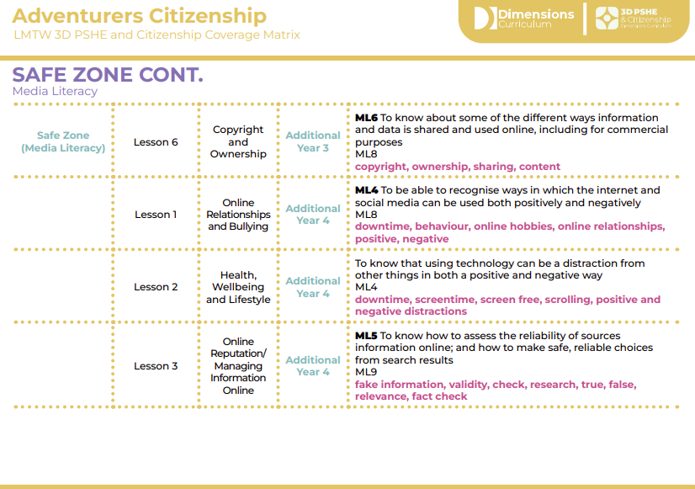
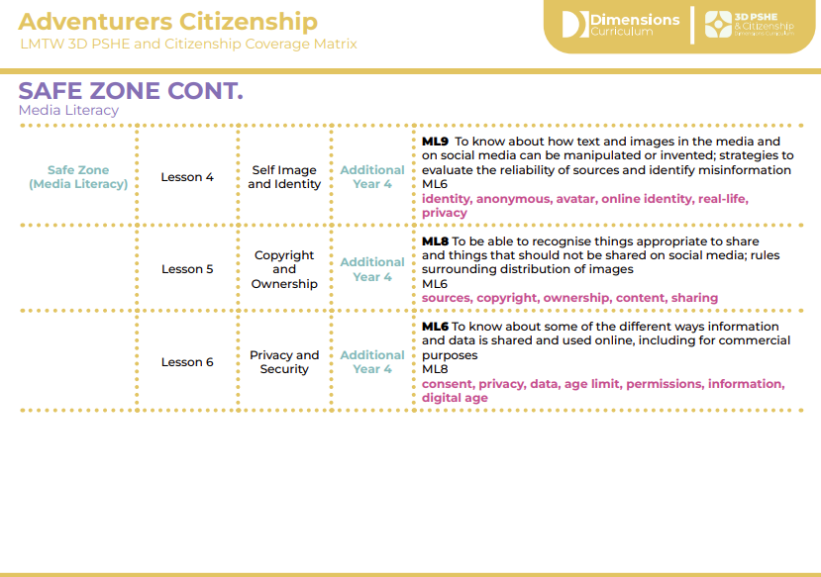

Year Three Discrete Overview
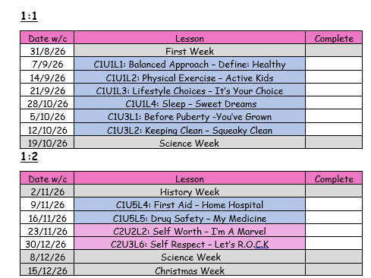
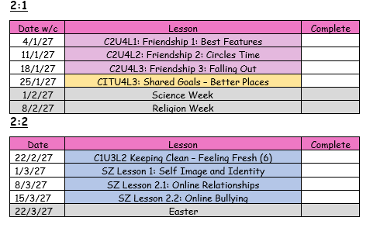
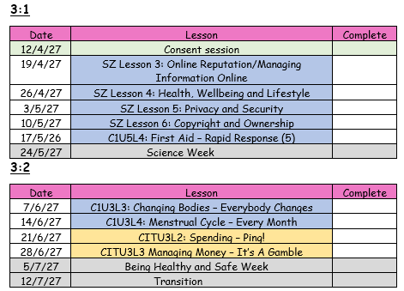

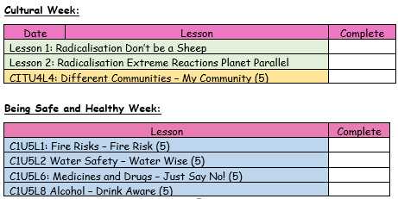

Year Four Discrete Overview
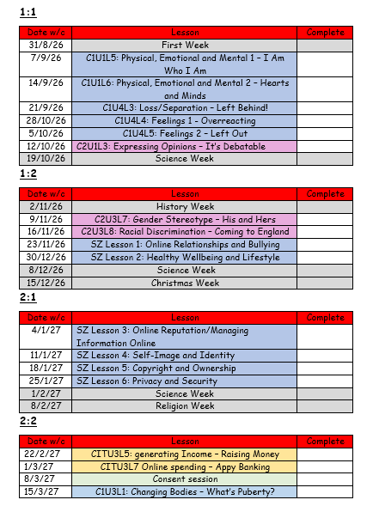
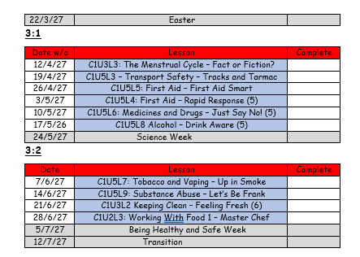
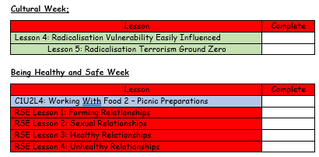
3D PSHE and Citizenship Sex Education Unit
We use the 3D Relationships and Sex Education Unit. This covers close relationships, including friendships, that often form during puberty; the physical, mental and emotional changes that take place during puberty; sexual relationships; busting some myths about sex; the features of healthy and unhealthy relationships.

3D PSHE and Citizenship Extremism and Radicalisation Unit
We use the 3D PSHE and Citizenship Extremism and Radicalisation Units. In KS1 we cover understanding the differences between ‘fact’ and ‘opinion’; recognising and respecting similarities and differences between people; how to deal with confrontation; understanding that difference is a positive feature. In KS2 we look at how to deal with peer pressure; how extremism manifests itself; homophobia and racism as extremist behaviours; terrorism.

3D PSHE and Citizenship Substance-Related Abuse Unit
We use the 3D Substance-Related Abuse Unit. This covers keeping safe;
understanding some of the consequences of risk-taking; knowing some of the different forms addiction can take; the names of the most common drugs; how advertising influences our choices.

3D PSHE and Citizenship Substance Tough Topics
These topics are not planned into our curriculum offer. However, there is opportunities to teach them in the ‘Being Healthy and Safe’ week if the Year 5/6 class teachers feel they have relevance to their current cohort. It covers Female Genital Mutilation (FGM), Child Labour, Knife Crime, Peer-On-Peer Abuse and Self Harm. These topics are challenging, but are addressed in an age-appropriate, creative and thoughtful way. They would be adapted to meet the needs of our children.

Relationships:

Citizenship:

Why is PSHE important?

PSHE teaches us how to make informed choices and be enterprising and ambitious.
Through PSHE education, we focus on achieving our potential by supporting our wellbeing and tackling issues that can affect our ability to learn, such as anxiety and unhealthy relationships. In PSHE, we learn the importance of a healthy lifestyle and positive relationships.
When is PSHE taught?
PSHE is taught both discretely and through thematic units. The attached overview (Appendix 1) maps out which thematic units feature this subject and the coverage overviews (Appendix 2) clearly show the objectives taught. Separate lessons are also planned in across each phase.

How is PSHE taught?
PSHE is taught through a combination of subject knowledge and skill building. Learning takes place both inside and outside the classroom. It is taught discretely but also interweaved throughout our afternoon curriculum.

How do we assess and monitor PSHE?
We use the Autism Framework Tracker to track pupil progress in PSHE. Each child has their own individual Autism Framework Tracker booklet which is used throughout their journey at Orrets Meadow school and passed on to their secondary school to support with transition. The child has a baseline on entry and then the document is completed on a yearly basis by the class teacher. The data is analysed helping to identify strengths and weaknesses of individual children and of the cohort. It also feeds into the child’s Individual Education Plan (IEP).

PSHE is monitored by the SLT and the PSHE lead. It is monitored using a variety of activities, including:

- Learning walks
- Book scrutiny
- Lesson observations
- Pupil survey and discussions
- Staff survey and discussions

Bibliography
This Dimensions 3D PSHE and Citizenship Policy is informed by the following links:-

- Academies Act 2010
- Children and Social Work Act 2017
- Education Act 2002
- Guidance on Relationships, Relationships and Sex Education, and Health Education
- Parliament UK Report 2019
- PSHE Association

Appendices
For further guidance on Relationships Education (Primary), Relationships and Sex Education (RSE – Secondary) and Health Education (Primary and Secondary), please visit the following:
Guidance on Relationships, Relationships and Sex Education, and Health Education

