Governor’s report - Summer 2026
Music
Kate Walsh
Achievements
This year the children have enjoyed a variety of musical experiences. We had a whole school trip to The Liverpool Philharmonic where the children got to experience a concert played by the whole Liverpool Philharmonic orchestra.
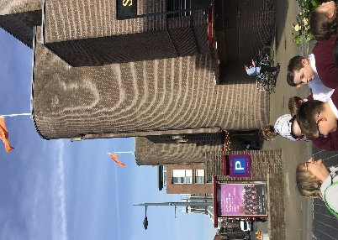
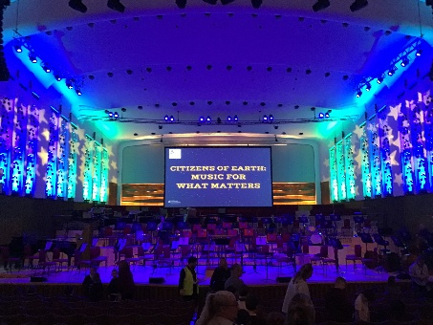
Whole school trip to Liverpool Philharmonic
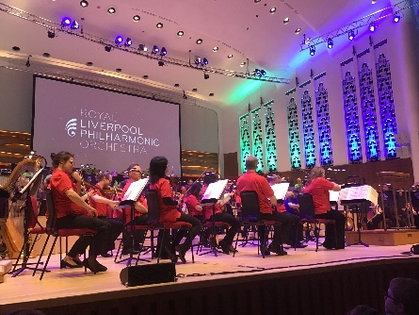

Lemurs enjoyed shared musical experiences at Meadowside and Foxfield schools. They got to sing and play musical instruments as well as socialising with other children from other special schools across the Wirral.
Lemurs enjoying a musical workshop at Foxfield School
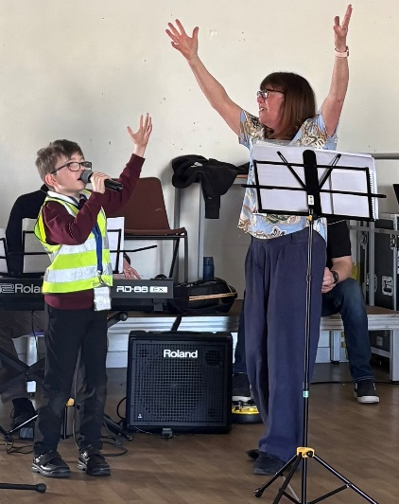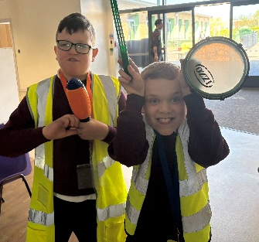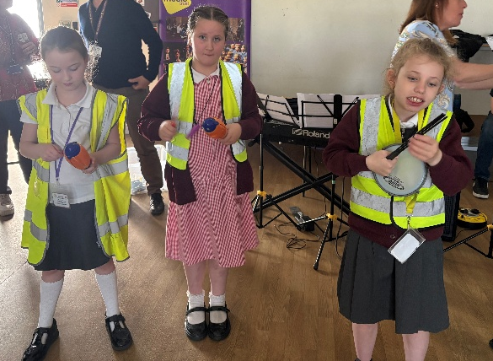
A group of children took part in a musical singing show at Hulme Hall, Port Sunlight as part of an Oak Trees MAT event. The children got up on stage and performed a song from K-pop and they represented our school magnificently.
We have built strong relationships with staff at the music department in Claremount school this year and the year 6 children we lucky enough to take part in a music workshop provided by the staff at Claremount in our school. This was not only an enjoyable experience but also an opportunity for them to begin their transition to secondary school.
Owls and Sharks enjoying a music workshop provided by Claremount staff
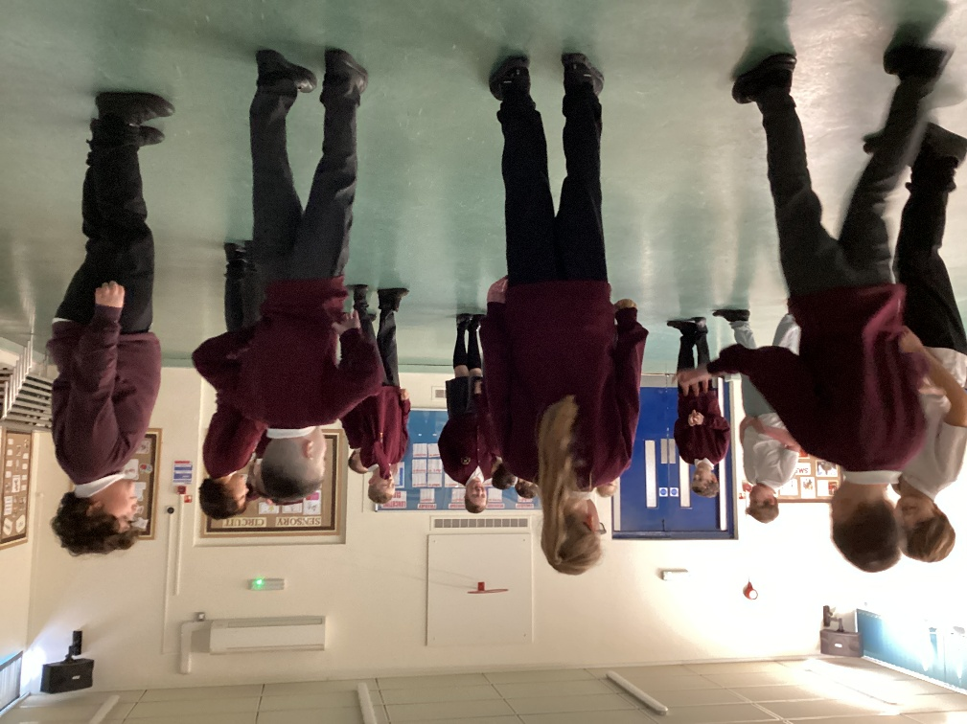
Our younger children were invited to Claremount where they worked with some year 10 pupils on drama and music which resulted in a mini show at the end of the session.
The children have also enjoyed a selection of musical concerts as part of the Musical Mondays. These gave the children the opportunity to experience types of music or instruments they may not normally come across in mainstream commercial music.
Tigers enjoying the zoom concerts
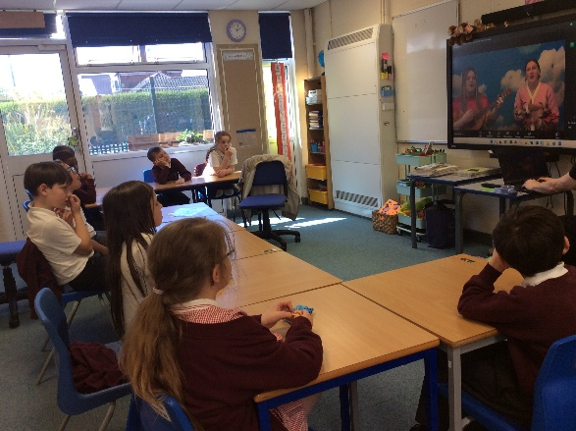

I secured a grant to enable us to enrich our musical offer. We have used this to purchase new keyboards and we have now incorporated music lessons into our additional needs group sessions which the children have really enjoyed as well as given them the opportunity to build musical skills.
The music grant has also given us the opportunity to have professional musician Matt Baker come to school to do singing workshops with the children.
I have developed a moderation model this year that will assist us in assessing and showing progress in music across the school. We are now also fully utilising our music platform – Charanga. We have enjoyed three Charanga afternoons this year and this will increase to six sessions next year which will help build musical skills and knowledge.

Our zoom concert experiences
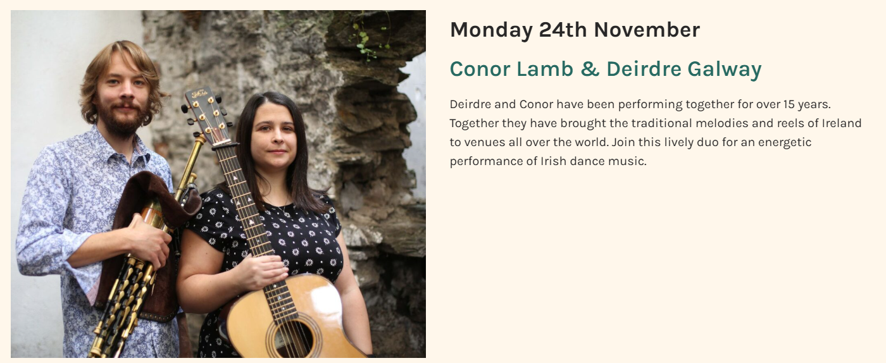
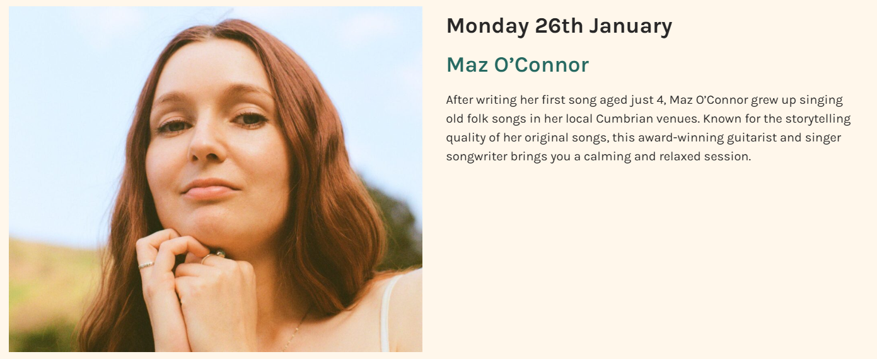
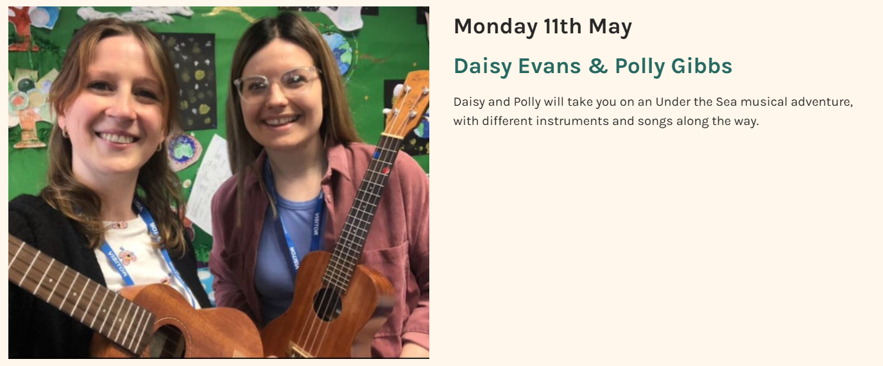
CPD
This year I have attended a training session in the community for our Charanga platform. This enabled me to fully understand how to get the most out of the system and enabled me to create a bespoke music plan for each class in school.
I also attended a session during the evening in Liverpool - The Neuroscience of Music with Professor Lauren Stewart. This was very informative and has allowed me to understand the benefits of music for the brain which will help me better plan music to support our children.
We have also joined Love Music Trust this year. They are an organisation who provide music services to schools. As part of our membership with this trust I have been able to access zoom meeting with other music leads in special schools. This collaboration is great for gaining ideas and addressing any questions that require a specialist answer. I have also been able to join a training session for how to maximise moderation in music. As a result of this I have been able to develop our school moderation plan.
Wolves enjoying a music lesson from Charanga
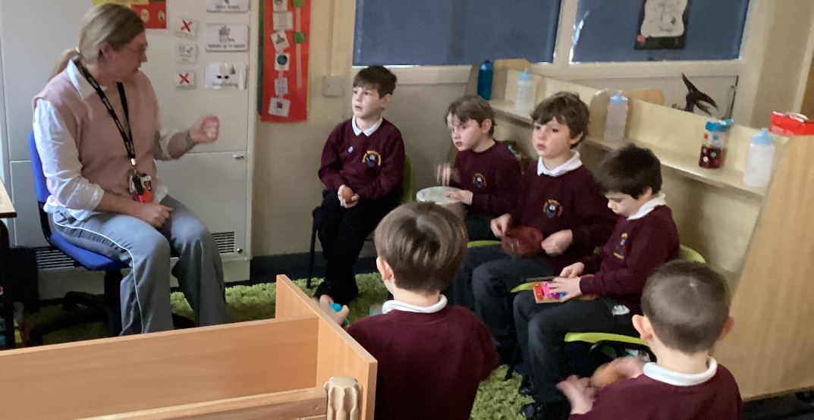

Quality of teaching and learning
To maintain excellence in music education across the school, I regularly evaluate classroom practice and curriculum delivery through formal lesson observations and book scrutinies. Alongside these quality-assurance measures, I designed and analysed comprehensive pupil and staff surveys. This multi-perspective data has provided a robust, evidence-based foundation to guide our strategic planning and drive continuous improvement in music teaching and learning.
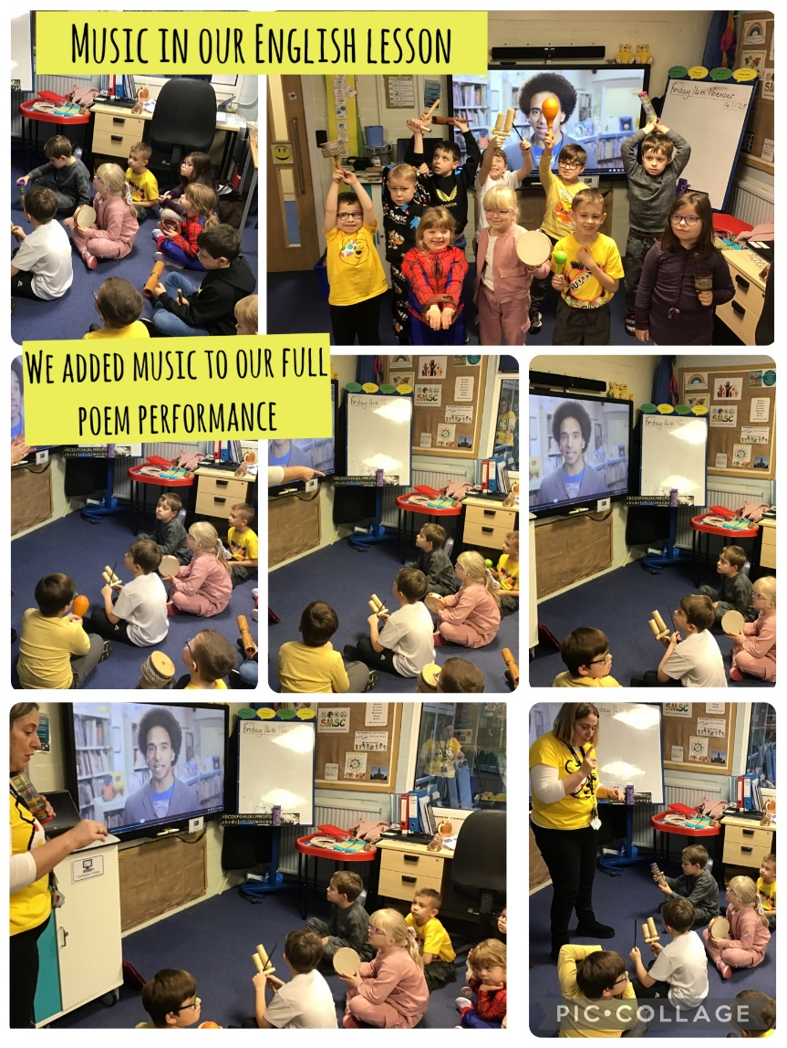
Bears incorporating music into English lessons for a cross-curricular experience.
Strengths
Our music provision demonstrates several key strengths that contribute to a vibrant and inclusive learning environment across the school. Foremost is the widespread enjoyment of music lessons, with pupils actively engaged and enthusiastic about their musical education. This passion is supported by our comprehensive use of the Charanga Music platform, which teachers leverage effectively to enhance learning, build digital confidence, and ensure a high standard of interactive delivery. Furthermore, we pride ourselves on a bespoke music curriculum designed specifically to meet the unique needs and backgrounds of our children, ensuring lessons are both relevant and accessible. These internal successes are greatly enriched by our collaborative work with partnership schools, a strategy that has successfully broadened our pupils' horizons through shared musical experiences, performances, and collaborative learning opportunities.
Ways Forward
To further elevate the profile and impact of music across the school, a robust series of strategic actions has been planned for the upcoming academic year. Beginning in Autumn 2026, we will enhance our inclusive practice by embedding targeted, small-group music sessions within our additional needs provision, while simultaneously enriching our SMSC curriculum through the introduction of live music concerts. Moving into Spring 2027, the focus will shift toward broadening pupils' musical horizons; this will include hosting inspirational visits from professional musicians and fostering external partnerships, specifically through attending music festivals and initiating joint working projects with the Claremount music department. Finally, the Summer 2027 term will focus on rigorous quality assurance and compliance. During this period, I will refine our moderation folder to provide a transparent picture of musical progression across all key stages, support teaching staff in consistently uploading student evidence to the Charanga platform, and publish our updated Music Development Plan on the school website to ensure transparency and celebrate our ongoing progress.

