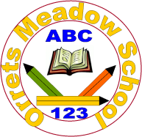
Governors Report – Summer 2026
RE
Subject leader: K Baker
Achievements
The ‘ways forward’ identified last year from this year’s school development plan and the actions taken:
- An evidence folder was created for moderation purposes. Information was carefully collated and showed a variety of activities are utilised to ensure all children are accessing RE and can be effectively assessed.
- Class teachers were encouraged to plan trips to enhance the delivery of RE. Wirral LTLRE hosted a ‘Sense of Belonging’ day which Zebra class attended. They had the opportunity to meet with people from a range of faiths and explore artefacts and ask questions. Owl Class took part in a trip to Thor’s Rock in Thurstaston to provoke awe and wonder in relation to both Christian and Jewish understanding of the creation stories. Bears class visited the Deen Centre as part of their topic on Special Stories.
- Continued to embed the new schemes of work in Explorers and Pathfinders A. Through active collaboration with teaching staff there were a broad range of activities delivered supporting accurate curriculum assessment in these new areas.
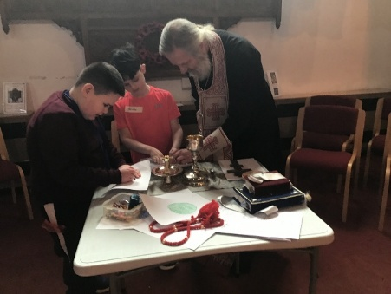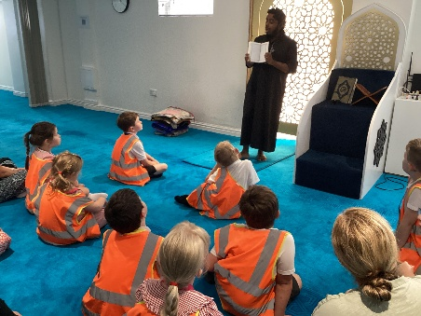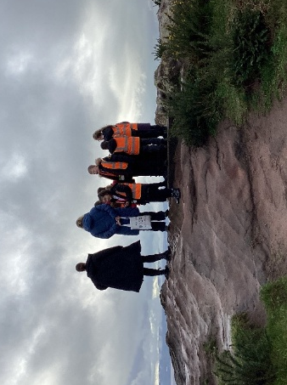

CPD
During my first year as RE Subject Leader, I have developed a deeper understanding of the primary RE curriculum through a range of professional development opportunities and collaboration with colleagues. I have attended a series of online webinars with the Wirral LTLRE HUB which have strengthened my subject knowledge and pedagogical understanding. Additionally, I have worked closely with the previous RE lead, as well as other colleagues, whose guidance and expertise have significantly enhanced my confidence in leading RE.

Quality of Teaching and Learning
As subject lead for RE, I have completed a multitude of monitoring activities to maintain the teaching and learning standards of RE throughout the school. The staff survey noted the confidence and positive approach to the teaching and delivery of the RE scheme, with some suggesting our multicultural links could be strengthened. This is an area I will continue to develop throughout the coming academic year.
I have completed learning walks during our Spring Term religion week. This gave great insight into the variety of religions covered at our school and the wide range of multisensory approaches that are adopted to support learning in RE. The different approaches include using art, listening to music, completing role play and engaging in stories.
Pupil voice further highlighted the successes in the implementation of RE. It was evident that all children enjoy their lessons. All children shared areas that they had learnt this year, highlighting their understanding of the Easter Story and key facts about World Religions. The children particularly enjoy the multisensory approaches to learning in RE, highlighting an enjoyment for drawing, painting and crafting.
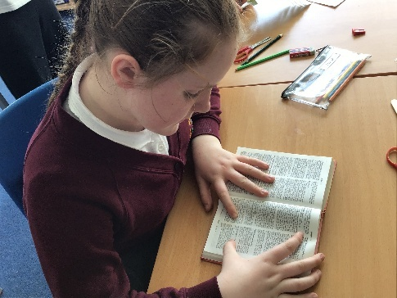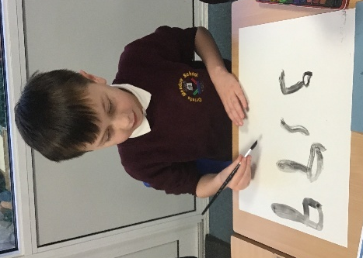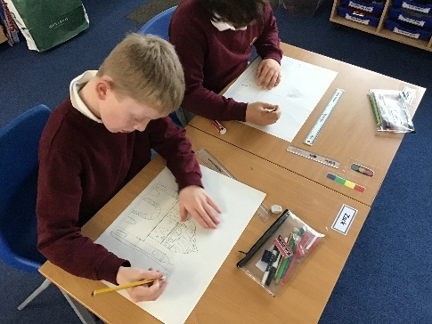
Strengths
From observations and book scrutinies it is evident that RE lessons are meaningfully adapted to ensure engagement with RE lessons for all learners with a range of needs. The staff and pupil surveys evidenced strong engagement in the subject, with children sharing their reflections and enthusiasm. Additionally, I have collated and analysed RE data which gave valuable insights into the subject progression throughout the school.
In collecting evidence of work for moderation purposes, it is evident that teaching and learning is consistent with learning objectives. There is evidence of lessons being tailored to ensure children working at different levels within the same classroom are able to achieve their individual targets.
Ways forward
- Strengthen evidence to incorporate children’s responses and/or reflections. Autumn 2
- Continue to build moderation folder for celebrations, rituals and expression. Spring Term 2
- Continue to develop early curriculum to reflect our expanding diversity of need. Ongoing

