**Governor’s report - Summer 2025**

**Music**

**Kate Walsh**

**Achievements**

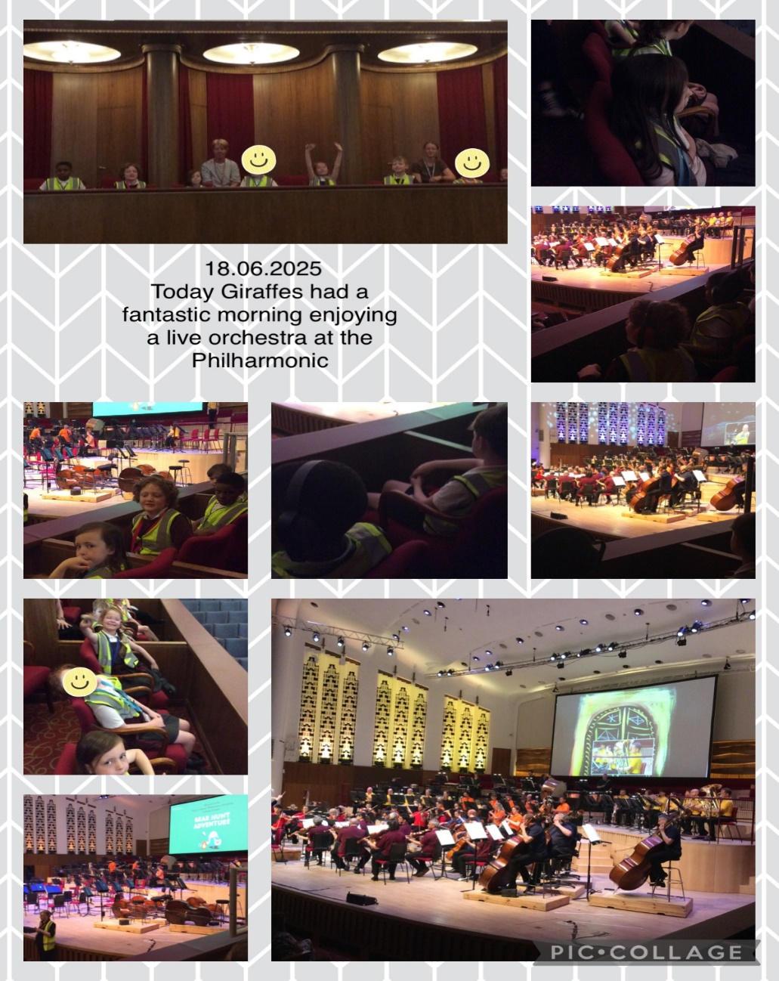This year, we have embedded Musical Mondays to provide the children with targeted teaching using the Charanga scheme, enhancing their musical skills in a structured way. Additionally, the children have enjoyed a varied repertoire of Zoom concerts from the Musical Hub, broadening their musical experiences remotely. We have successfully introduced the first Access Drumming project for Zebra and Tiger classes, which they thoroughly enjoyed, culminating in an impressive final performance. Furthermore, we arranged and took Lemur and Giraffe classes to an orchestral concert at the Liverpool Philharmonic, offering them an inspiring live music experience.

**Giraffes Enjoying a trip to the Liverpool Philharmonic**

We have developed and introduced a tailored set of music curriculum steps specifically designed to assess children working below the National Curriculum level. This framework supports teachers by providing clear, accessible benchmarks that guide both teaching and assessment, ensuring that all children’s musical progress is accurately tracked and effectively supported.

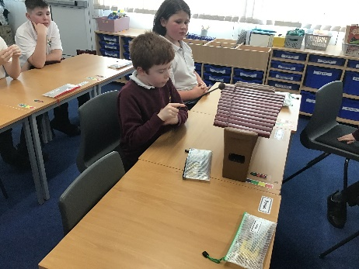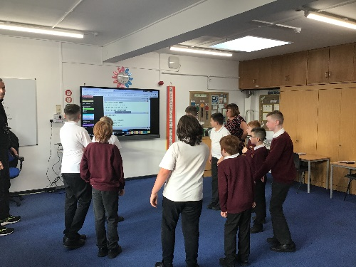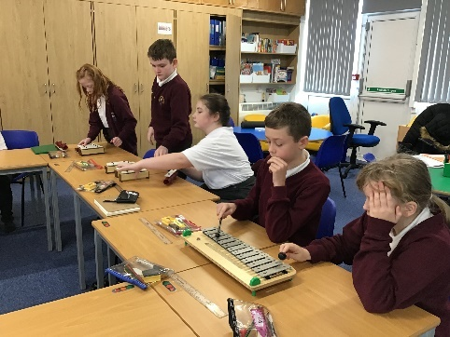**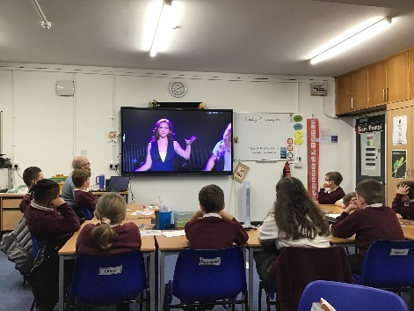Foxes – learning about body percussion and performing during a Charanga lesson**

**Sharks playing and singing during a Charanga session**

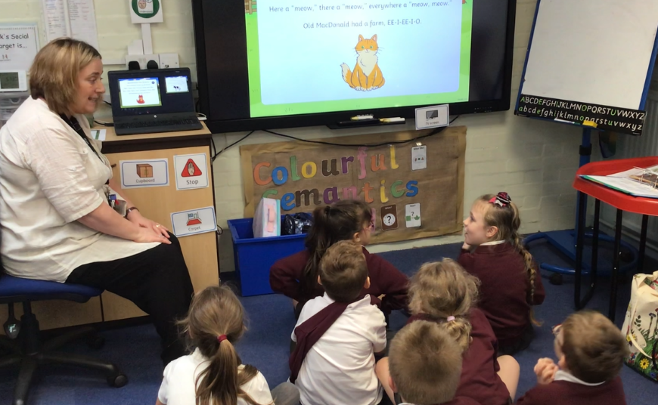

**Bears enjoying a music lesson in their Dimensions Curriculum topic**

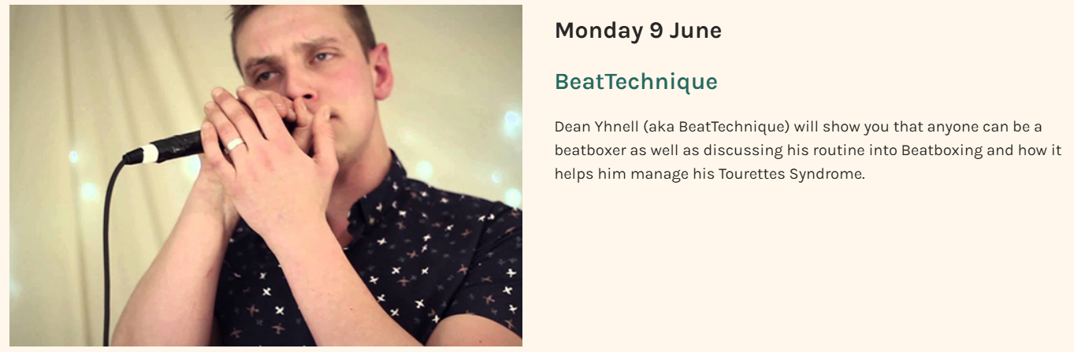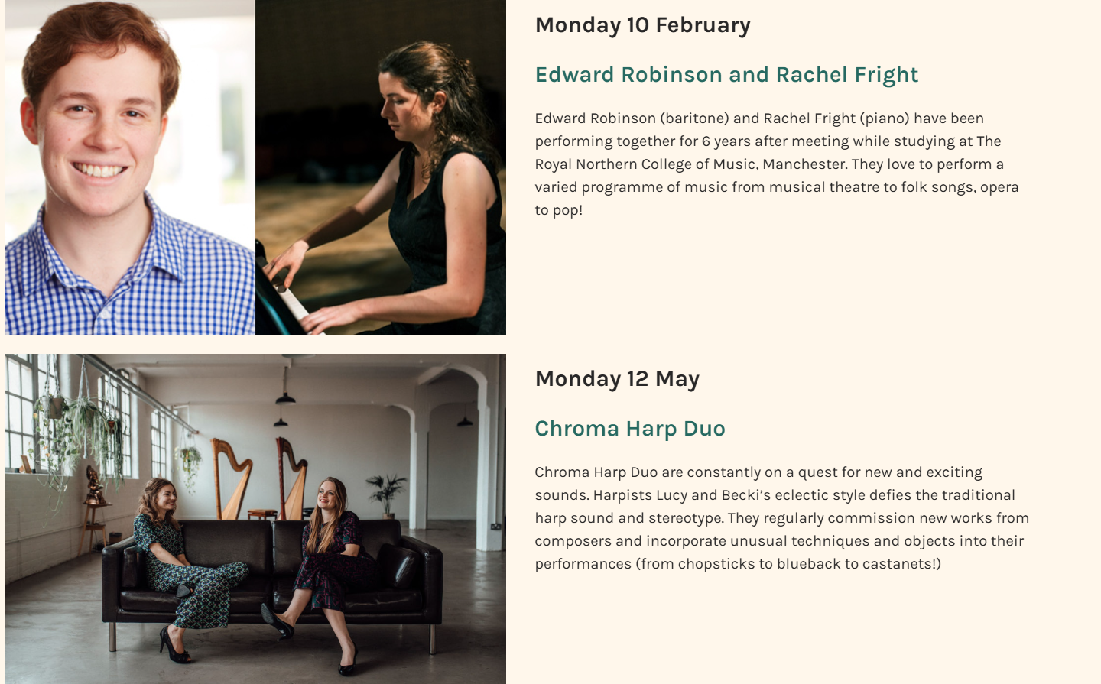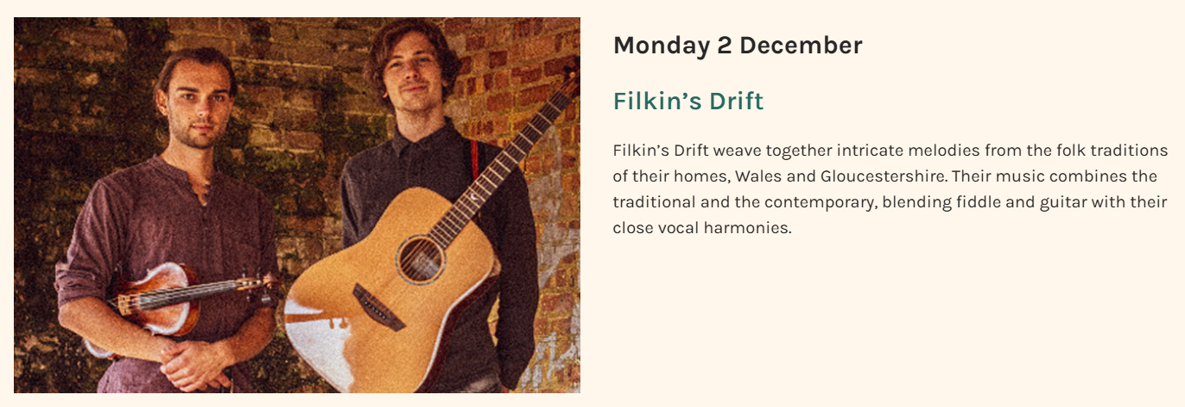   
**Our zoom concert experiences**

**CPD**

Over the past year, I have developed my understanding of the primary music curriculum through a combination of professional development and collaborative learning. I have engaged with a range of online webinars, which have deepened my knowledge of effective music teaching strategies and curriculum design. Additionally, I have benefited greatly from a close working relationship with the previous music lead, whose guidance and shared expertise have helped me build confidence and understanding in delivering and leading music across the school.

**Quality of teaching and learning**

To ensure a high standard of teaching and learning in music across the school, I have conducted lesson observations and book scrutinies to monitor the consistency and quality of music provision. These activities have allowed me to identify strengths and areas for development within classroom practice and curriculum delivery. In addition, I have produced, collated, and analysed data from both pupil voice and staff voice surveys, gaining valuable insights into the effectiveness of our music curriculum from multiple perspectives. This evidence-based approach has informed strategic planning and supported continuous improvement in music teaching and learning throughout the school.

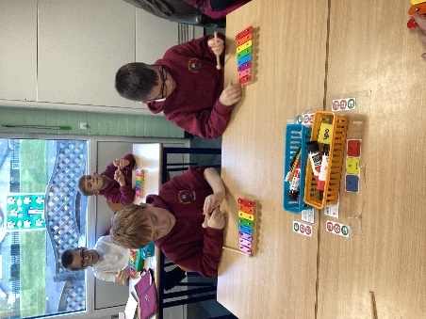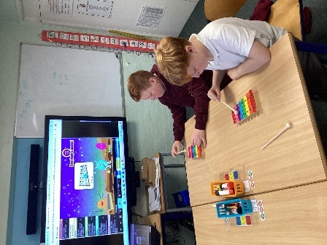

**Owls working on improvisation**

**Strengths**

Engagement and enjoyment of the music curriculum are clearly evident during learning walks around the school, with children actively participating and showing enthusiasm in their music lessons. The Musical Monday experiences are now firmly embedded into the curriculum, providing a consistent and structured approach to music teaching. Teachers have grown in confidence when delivering lessons, particularly when using the Charanga scheme, and this is reflected in the quality of teaching and the positive learning atmosphere in classrooms. Overall, music is becoming a valued and vibrant part of the school’s routine.

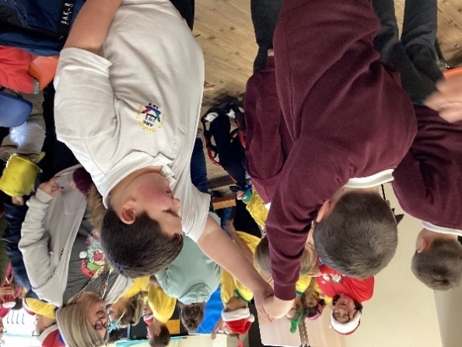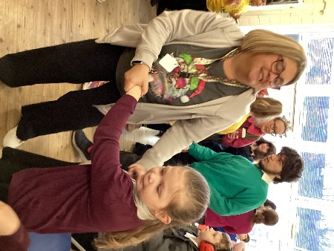   
 **Lemurs enjoying the Christmas singalong at Meadowside School.**

**Wolves singing the One World song.**

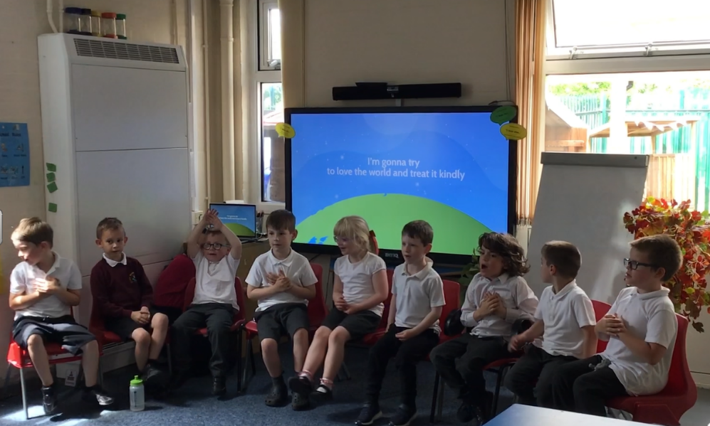

**Zebras and Tigers in their Djembe drumming sessions.**

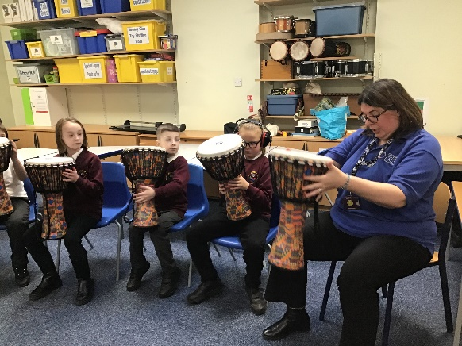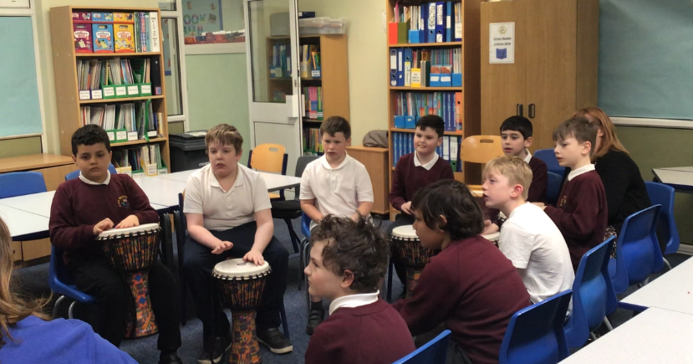

**Ways Forward**

In the coming year, I plan to build on our music curriculum through a range of exciting developments. I will continue to develop our music assemblies on Musical Mondays, focusing on Charanga afternoons to deepen students’ engagement. I am exploring the possibility of incorporating musical instrument lessons into the timetable to offer more hands-on learning. To support staff, I will arrange CPD sessions focused on the Charanga curriculum and musical notation, ensuring confident and effective teaching. I also intend to analyse the skills embedded within Charanga to ensure alignment with the Dimensions curriculum, strengthening the overall learning journey. To support assessment and moderation, I will create a comprehensive Music Evidence Folder, compiling pupil work, photos, assessment notes, and key musical vocabulary from Steps to Year 4. Throughout the year, I plan to arrange live music concerts accessible to the whole school, alongside visits from professional musicians, enriching the cultural experiences available to our students. Additionally, I will explore local music festivals, including opportunities for joint work with Claremount, to broaden students’ musical horizons and community connections.