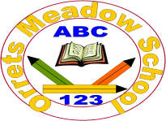

Orrets Meadow Special School
Register of Governors Interests 2025/2026

Governor Attendance 2025-26

Key P: Present, Ap: Apologies, Ab: Absent, R: Resigned

Date | Carolyn Duncan | Ian Patten | Cindy Cooper | Gail Keville | Michelle Blakemoore Irving | Julie Merry | Catherine Welch | Claire Walsh | Callum Kinch | Cathy Cotgrave
LGC  11.09.25 | P | P | P | P | P | P | P | P | P | P
LGC  04.12.25 | P | P | P | Ap | P | Ab | Ap | P | Ap | P
LGC  12.03.26 | P | P | P | P | Ap | P | P | A | P | Ap
LGC  02.07.26 | P | P | P | P | P | P | Ap | P | P | P

