

**Governor Report - Summer 2025**

**Computing**

**Kathryn Swift**

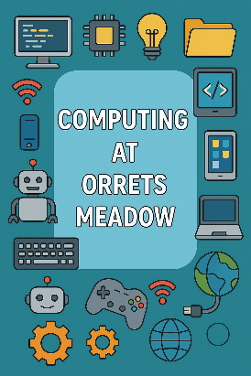**Achievements**

Throughout this academic year, I have taken on the responsibility of leading Computing at Orrets Meadow. In taking on this role, I have made notable progress in understanding how **Computing** is currently delivered at Orrets and constructed clear strategies to elevate its impact across the curriculum. Following the **DfE’s Key Stage 1 Computing Programme of Study** and the areas of learning within the EYFS curriculum that pertain to developing computing skills, I have begun embedding the key strands of Computing:

* **Computer Science**: Helping our children grasp what algorithms are and how programs execute precise, unambiguous instructions; guiding them to create and debug simple sequences and predict program behaviours.
* **Information Technology**: Ensuring children use technology purposefully to create, organise, store, manipulate, and retrieve digital content—recognising everyday uses beyond school.
* **Digital Literacy & E‑Safety**: Teaching respectful and responsible technology use; emphasising privacy, safe online behaviours, and identifying when and where to seek help.

This academic year, I have audited our current Computing provision and pinpointing strengths and gaps against these core strands, mentioned above. I’ve begun weaving **unplugged activities** to deepen algorithmic thinking without screens, and ensuring **hands-on practice**—from BeeBots and visual programming to digital content creation—is reinforced both within Computing lessons and across cross-curricular themes in Dimensions lessons.

As Computing Lead, I have developed and implemented a bespoke assessment framework (Steps) to support the teaching and learning of Computing for children working below the National Curriculum level. This framework is tailored to meet the needs of our children and breaks down the key Computing concepts into small, achievable steps. This new framework aligns with our curriculum and is designed to capture progress in both computational thinking and practical application through engaging, accessible tasks. Teachers use these ‘Steps’ to inform planning, track individual progress over time, and celebrate success in ways that are meaningful to each child’s learning journey. Early feedback from staff has been positive, with improved confidence in delivering and assessing programming skills across a range of abilities.

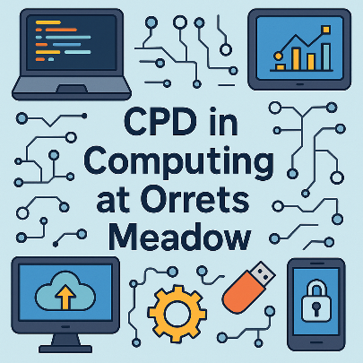**CPD**

* July 24 prior to starting role - Primary Computing Subject Leader Briefing (SIL)
* Dec 24 - Primary Computing Subject Leader Briefing (SIL)
* Feb 25 – Computing Hub Meeting. Jen McCulloch
* Feb 25 – Micro:bit training
* Feb 25 – AI Training for Computing Subject Leaders (SIL)
* June 25 – Hi Impact meeting with Computing curriculum expert to begin to devise new curriculum
* June 25 – Delivered ‘AI to Reduce Workload’ meeting to teaching staff.
* June 25 – Delivered an ‘Introduction to the new Computing Curriculum’ meeting to teaching staff.

**Quality of Teaching and Learning**

The quality of teaching and learning in Computing has been carefully monitored through a range of methods, including a well-maintained Computing Lead folder; learning walks, informal lesson observations; regular reviews of pupil work saved electronically and via class computing portfolios. Pupil voice has provided valuable insight into learners' experiences, with 100% expressing high levels of engagement and enthusiasm for Computing activities. Staff voice has further reinforced the positive picture, with teachers demonstrating growing confidence and creativity in delivering Computing sessions tailored to our children’ needs.

These monitoring activities have confirmed that teaching and learning in Computing is of a consistently high quality across the school. Lessons are engaging, appropriately scaffolded, and accessible for all learners. However, this rigorous approach to monitoring has also highlighted the need for a more structured and progressive computing curriculum as the needs of our children are constantly evolving. While high-quality teaching is evident, teachers reported that they needed a more clearly defined progression of skills and knowledge across year groups as the changing profile of our children has created some inconsistencies in their ability to access particular units of work. As a result, steps have been taken to design and implement a bespoke Computing curriculum that better reflects the needs of our children and ensures a coherent progression of learning throughout the school.

**Strengths**

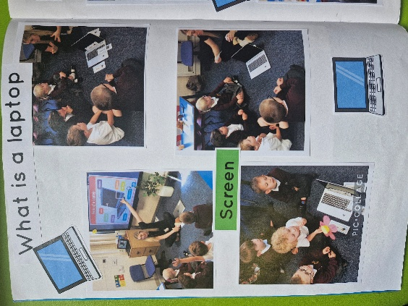The Computing curriculum at Orrets Meadow has a number of key strengths that reflect the school’s commitment to meeting the diverse needs of its learners.

* **Adapted and Tailored Lessons**: Computing lessons are carefully adapted to meet the diverse needs of pupils, ensuring accessibility and meaningful engagement for all learners.
* **High Engagement**: Both staff and pupils demonstrate strong engagement, with teachers confidently delivering computing sessions with a clear passion for developing their own CPD. Children engage in lessons with great enthusiasm and this is also reflected in pupil voice questionnaires.
* **Robust Curriculum**: A newly developed Computing curriculum provides a clear progression of skills and knowledge across all key stages, ensuring continuity and coherence in learning.
* **Effective Assessment and Feedback**: A consistent and structured assessment and feedback format is in place, enabling accurate tracking of pupil progress and informing next steps in teaching.
* **Online Safety and Digital Responsibility**: Safe and responsible use of technology is embedded throughout the curriculum, promoting strong digital citizenship.
* **Cross-Curricular Integration**: Computing is meaningfully integrated across the wider curriculum, supporting the practical application of digital skills in real-life and subject-specific contexts.

**Ways Forward/ Targets.**

As we move forward with the development of computing at Orrets Meadow, the focus will be on fully embedding the newly tailored curriculum and ensuring staff feel confident and well-supported in delivering high-quality computing lessons. The following key actions have been identified to strengthen consistency, deepen staff subject knowledge, and further enhance outcomes for our children:

**1. Embed the New Computing Curriculum Across All Phases**  
***Target:*** By July 2026, fully embed the new Computing curriculum across all key stages, ensuring it is appropriately adapted to meet the needs of each class. This will include introducing age and stage appropriate lesson structures and ensuring all classes are delivering lessons aligned with the updated curriculum.

**2. Design and Implement New Pre-Curriculum Computing Targets**  
***Target:*** By Spring 2026, produce a bank of pre-curriculum Computing Steps aligned with the new curriculum, suitable for learners working below the standard framework.

**3. Develop a Whole-School Computing Portfolio**  
***Target:*** By July 2026, create and maintain a digital and/or physical portfolio of Computing work across the school, showcasing pupil achievements and evidence of skill progression in line with the new curriculum.

**4. Provide Ongoing CPD Through AI-Focused Drop-In Sessions**  
***Target:*** By July 2026, deliver at least three termly after-school or lunchtime CPD drop-in sessions for staff, focused on the safe and practical use of AI tools to support teaching and learning, including accessibility for SEND learners and reducing workload.

