Orrets Meadow School

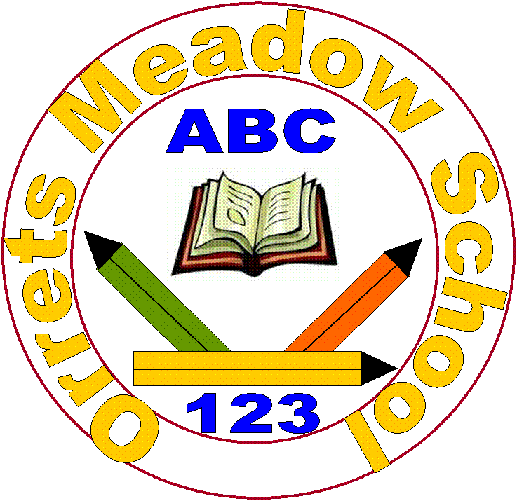

SEND Information Report
2022

“To raise the aspirations of every child and give them confidence to fulfil their potential through positive experiences”

- How does Orrets Meadow know if children need extra help and what should I do if I think my child may have special educational needs?
All pupils that attend Orrets Meadow have an Education Health Care Plan, which describes their individual areas of special needs and informs his/her individual education plan. Orrets Meadow caters for children with Social Communication Difficulties and other associated needs. In May 2019, we achieved Autism Accreditation, which is a nationally recognised award, which shows Orrets Meadow demonstrates high standards of provision to cater for pupils with Autism.
Our classes have between 8 and 12 pupils, a specialist teacher and 2 or 3 Teaching Assistants to support, depending on the needs of the class. As all classes have high staffing ratios each teacher is able to quickly identify any requirements for additional support on an ongoing basis throughout the year and discusses these in pupil progress meeting with senior leaders and parents. The class teacher is the first point of contact for parents who think their child has developed additional needs and so may require alternative support.
- How will Orrets Meadow staff support my child?
Multisensory programmes of study are delivered daily with an emphasis of phonics and basic skills. Each class has a high staff pupil ratio. The classteacher plans for all the pupils in his/her class, differentiates accordingly to suit the pupil’s individual needs and is responsible for the assessment of their progress. Children are taught as a whole class, as groups, or 1:1 by both the class teacher and the teaching assistants. Pupil progress meetings are held each term to discuss the progress of pupils with the Headteacher. The shared discussions will highlight what further support or intervention may be needed to increase progress and bring the child back on track to meet end of year targets. A formal review is held once a year to discuss your child’s progress, their current areas of special needs and any additional needs which have been identified. The additional needs are met through daily intervention groups and are recorded on cohort provision maps. Examples of intervention groups are; Social stories, fine motor skills, co-ordination, memory, speech and language programmes.
Individual Education Plans outline targets from our Autism tracker and copies of these are sent home. Your child’s view is valued and an important part of the process. Orrets Meadow has a Speech and Language Therapist two full days a week who provides 1:1 and group speech clinics, assessments and language support in the classroom. Under her supervision we employ a HLTA to lead speech and language interventions throughout the week, including Talk Boost, social skills, sounds and Lego Therapy.
If your child needs expert support from an outside agency such as Occupational Therapy or a Paediatrician, a referral will be made, with your consent. The Governors at Orrets Meadow are responsible for the overseeing of all procedures in school and are regularly in school.
- How will the curriculum be matched to my child’s needs?
We believe it is important for children to develop relationships with a number of adults at Orrets Meadow and ensure all staff understand a child’s SEN. Our curriculum is based on the National Curriculum and includes all the mainstream subject areas but has been adapted by staff to enable all pupils to access each subject in a meaningful and purposeful way. Phonics is taught discretely and is embedded across the curriculum. Access to the curriculum is important to ensure we get right for children with Literacy and Numeracy difficulties and the school uses a wide variety resources to facilitate access to the curriculum, including: Numicon, Clicker, coloured overlays and ipad apps. Every child is given a laptop to use as they start school and this remains with them until they leave in Year 6.
It maybe your child needs specialist equipment eg. Writing slopes, pencil groups, posture support cushions and chairs and will be provided by school to help your child make progress. Our children are consulted about their preferred learning style and what best supports them in their learning journey. They make progress in many ways not only through academic achievement. We teach using approaches to develop confidence, resilience and independence and offer opportunities for these skills to be transferred across the school setting.
Every classroom has a sensory room attached and children are able to access a sensory circuit which is available throughout the morning in the hall. Our PE assistant has been trained by our ASD lead, Mrs Warren, to lead sensory circuit. All of our TAs have also been trained in sensory circuits. These short sensory breaks have proven success in ensuring the child is ready to learn.
- How will I know how my child is doing and how will you help me to support my child’s learning?
Copies of your child’s IEPs will be sent home when they are reviewed and new targets set. Parents Evenings are held termly for teachers to discuss your child’s progress and assessment data is sent home termly to show progress made. At the end of each year you will receive a written report outlining progress made over the year and targets for your child to aim for the following year. As all our children have Literacy difficulties, including reading and spelling difficulties, it is expected that they will be working outside their age related expectations as they progress through school. Parents are therefore asked to support their child’s learning by completing reading and spelling homework set daily to maximise progress made while at Orrets Meadow.
- What support will there be for my child’s overall well being?
Your child’s well being and emotional health is as important as their academic progress. Teachers plan for the holistic development of each child in his/her class, using their detailed knowledge of each individual to promote their confidence and self esteem. High staffing levels enable additional time as required to support the emotional well being of individual children. Individual behaviour plans are used should there be the additional need. The school offers a wide variety of pastoral support for pupils who encountering emotional difficulties, including:
- Teachers and Teaching Assistants readily available to discuss issues and concerns
- Curriculum is planned with promoting mental health, life skills, social skills and resilience at the heart of it.
• Military Education – a bushcraft programme which boost low self-esteem, emotional difficulties and promotes positive mental health. Each class has a 4 week block across the school year.
• Camhs – we are an Accelerator school so have had full training in all areas of mental health and to lead Next Steps.
• Clubs and extra adult supervision from Teaching Assistants and Senior Leaders at lunchtime to support children who find them challenging.
• Pen Portraits are written with our pupils with social communication difficulties and their parents, to find out more about their views on school and their likes and dislikes. These are shared with adult stakeholders within school to help them support the child’s learning and behaviour in school.
• If a pupil has a medical need then a detailed Health Care Plan is compiled with support from the School Nurse, in consultation with parents/carers.
• All Teaching Assistants are trained in first aid and in agreement with parents/carers medicines are administered in school but only where a signed medical consent form is in place to ensure the safety of both child and staff member.
• All staff are trained on how to use a defibulator and school has one on the premises.
• Teaching Assistants with pupils who are incontinent have been trained by the nurse so are able to support children with toileting needs and follow the school’s intimate care policy.
• All staff have been trained in Team Teach and receive refresher training when needed. Positive handling is used as a last resort to support a child’s behaviour and only when the child is putting themselves or others at risk. We pride ourselves on how we promote children’s well being and emotional health at Orrets Meadow.
- What specialist services and expertise are available at or accessed by the school?
Senior leaders, teachers and teaching assistants are highly skilled in meeting the individual learning, behavioural and social needs of our children.
The school accesses a range of specialist services including:
• School Nurse
• Speech and Language Therapist – two full days a week
• Occupational Therapist
• Educational Psychologist
• Military Education
- Camhs worker
• Physiotherapists
• Educational Welfare Officer
• Vision and Hearing Support
• Social services – Wirral Gateway
• Social Care Family Support Worker
• Paediatricians
• Local Authority EHCP Team
• Wired/Parent Partnership
• Wirral Autistic Society
• Child and Family
• Minority Ethnic Achievement Service (MEAS)
• Special Educational Needs Assessment Advice Team (SENAAT) – Orrets Meadow runs the service
- What training are the staff supporting children and young people with SEND had or are having?
Teachers at Orrets Meadow are specialist in teaching children with SEN and have got qualifications in Dyslexia, Autism or SEN. All staff, both teachers and teaching assistants have received training in Team Teach and mandatory safeguarding , manual handling and fire training.
Different members of staff have received training related to SEND including session on:
• Autism
• Social Communication Difficulties
• Speech and Language
• Dyslexia
- Talk Boost
- Lego Therapy
- Next Steps – mental health
- ADHD training
• Dyscalculia
• Occupational Therapy and strategies to use within the classroom
• Social Emotional Behavioural Needs
• First Aid
• Intimate Care and Toileting
• Inclusive Physical Education from Claremount Sports College
- How will my child be included in activities outside the classroom including school trips?
As a fully inclusive school, all children participate in whole school curriculum and off site activities. The extent to which each child participates and the levels of support received will vary between children, but we differentiate the activities and expectations to enable all children to take part. Parents are asked to give generic permission for their child to participate in activities in support of the curriculum ie. A visit to the local church etc. Orrets Meadow uses the LA’s Evolve system to plan all educational trips and children are risk assessed to enable them all to participate. If it is deemed an intensive level of 1:1 support is required a parent/carer may be asked to accompany their child during the activity.
- How accessible is the school environment?
Orrets Meadow is a single story building and fully accessible. The building is light, classrooms have plenty of access, doors are wide and the site is both safe and secure. Funding from the LA has enabled school to recently fully refurbish all classrooms to make them meet the needs of Autistic pupils. Minimalist and considerate to sensory needs, they have access to their own sensory room, toilets and shower/changing room. Each changing room has toilets and changing facilities for disabled users.
- How will the school prepare and support my child when joining Orrets Meadow School or transferring to a new school?
Parents and children are welcome to look around Orrets Meadow at any time to see what Outstanding (Ofsted October 2017) provision we offer and whether you feel we can meet the needs of your child. Once a place has been confirmed at Orrets Meadow, we will contact your child’s school and find out as much information as possible about your child. Your child if particularly worried or anxious will be offered some transition visits and an opportunity to meet their new class teacher and class mates. Often we find a short transition is most successful. The LA will liaise with the transport department and an official start date will be agreed.
On joining Orrets Meadow children with ASD have a personalised social story about school and the adults/children in their class to ensure a smooth transition. Soon after joining a meeting is set up by the teacher with parents to write a pen portrait, so the needs of the child, what supports them and what upsets them is clear.
Transition to secondary school can be a worrying time for both parents and the child so at Orrets Meadow we do extra transition visits and talk at length to Secondary teachers about the children’s special educational needs. We ensure all paperwork is passed on to them and they are made aware of any special requirements, both educationally and pastorally.
- How are Orrets Meadow’s resources allocated and matched to children’s special educational needs?
Each child receives support matched to their own level of special educational need. This will vary across each day and throughout time in our school, as the level of support is directly related to their needs and circumstances.
- How is the decision made about how much support my child will receive?
On a daily basis the classteacher determines the level of support for individual children within the class. When children whose SEN circumstances or health requirements indicate that additional support may be required, discussions are held between the class teacher and senior leaders to determine what this may be. Typically this support continues to be provided from within the class, but may be targeted at specific times. If evidence suggests that even higher levels of support maybe beneficial this is agreed by senior leaders as the resource is provided within the school. Due to the high levels of staff in each class this is not required very often and only in extreme situations would this additional support be requested from the Local Authority.
- How will I be involved in discussions about and planning for my child’s education?
All parents are encouraged to contribute to their child’s education.
This may be through:
- Discussions with the class teacher
- Annual reviews
- During parents evenings
- Parent workshops
- During discussions with other professionals
- Parent coffee mornings
- Secondary transition meetings
- Who can I contact for further information or if I have any issues or concerns?
The first point of contact for anything related to your child’s education is the class teacher. We encourage parents not to wait for the next formal opportunity to meet but to contact us on an ongoing basis. Home School books can be used for communication or staff are always available to talk outside of teaching hours or an appointment can be made for a mutually convenient time. Please telephone the school office on 678 8070.
For matters not directly related to your child’s progress parents are invited to contact the school office and the Deputy or Headteacher will be available to talk to you. If you feel your matter still has not been dealt with you can follow the procedures outlined in our school complaints policy, which is on our school website under policies. Considering a special school for your child can be a daunting time and we have parents and parent governors who are happy to talk with prospective parents to share their experiences of Orrets Meadow and answer any questions you may have.
Finally if you would like to know what our current parents feel about Orrets Meadow please look at the parent tab on our school website. http://orrets-meadow.eschools.co.uk

