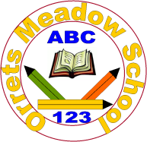
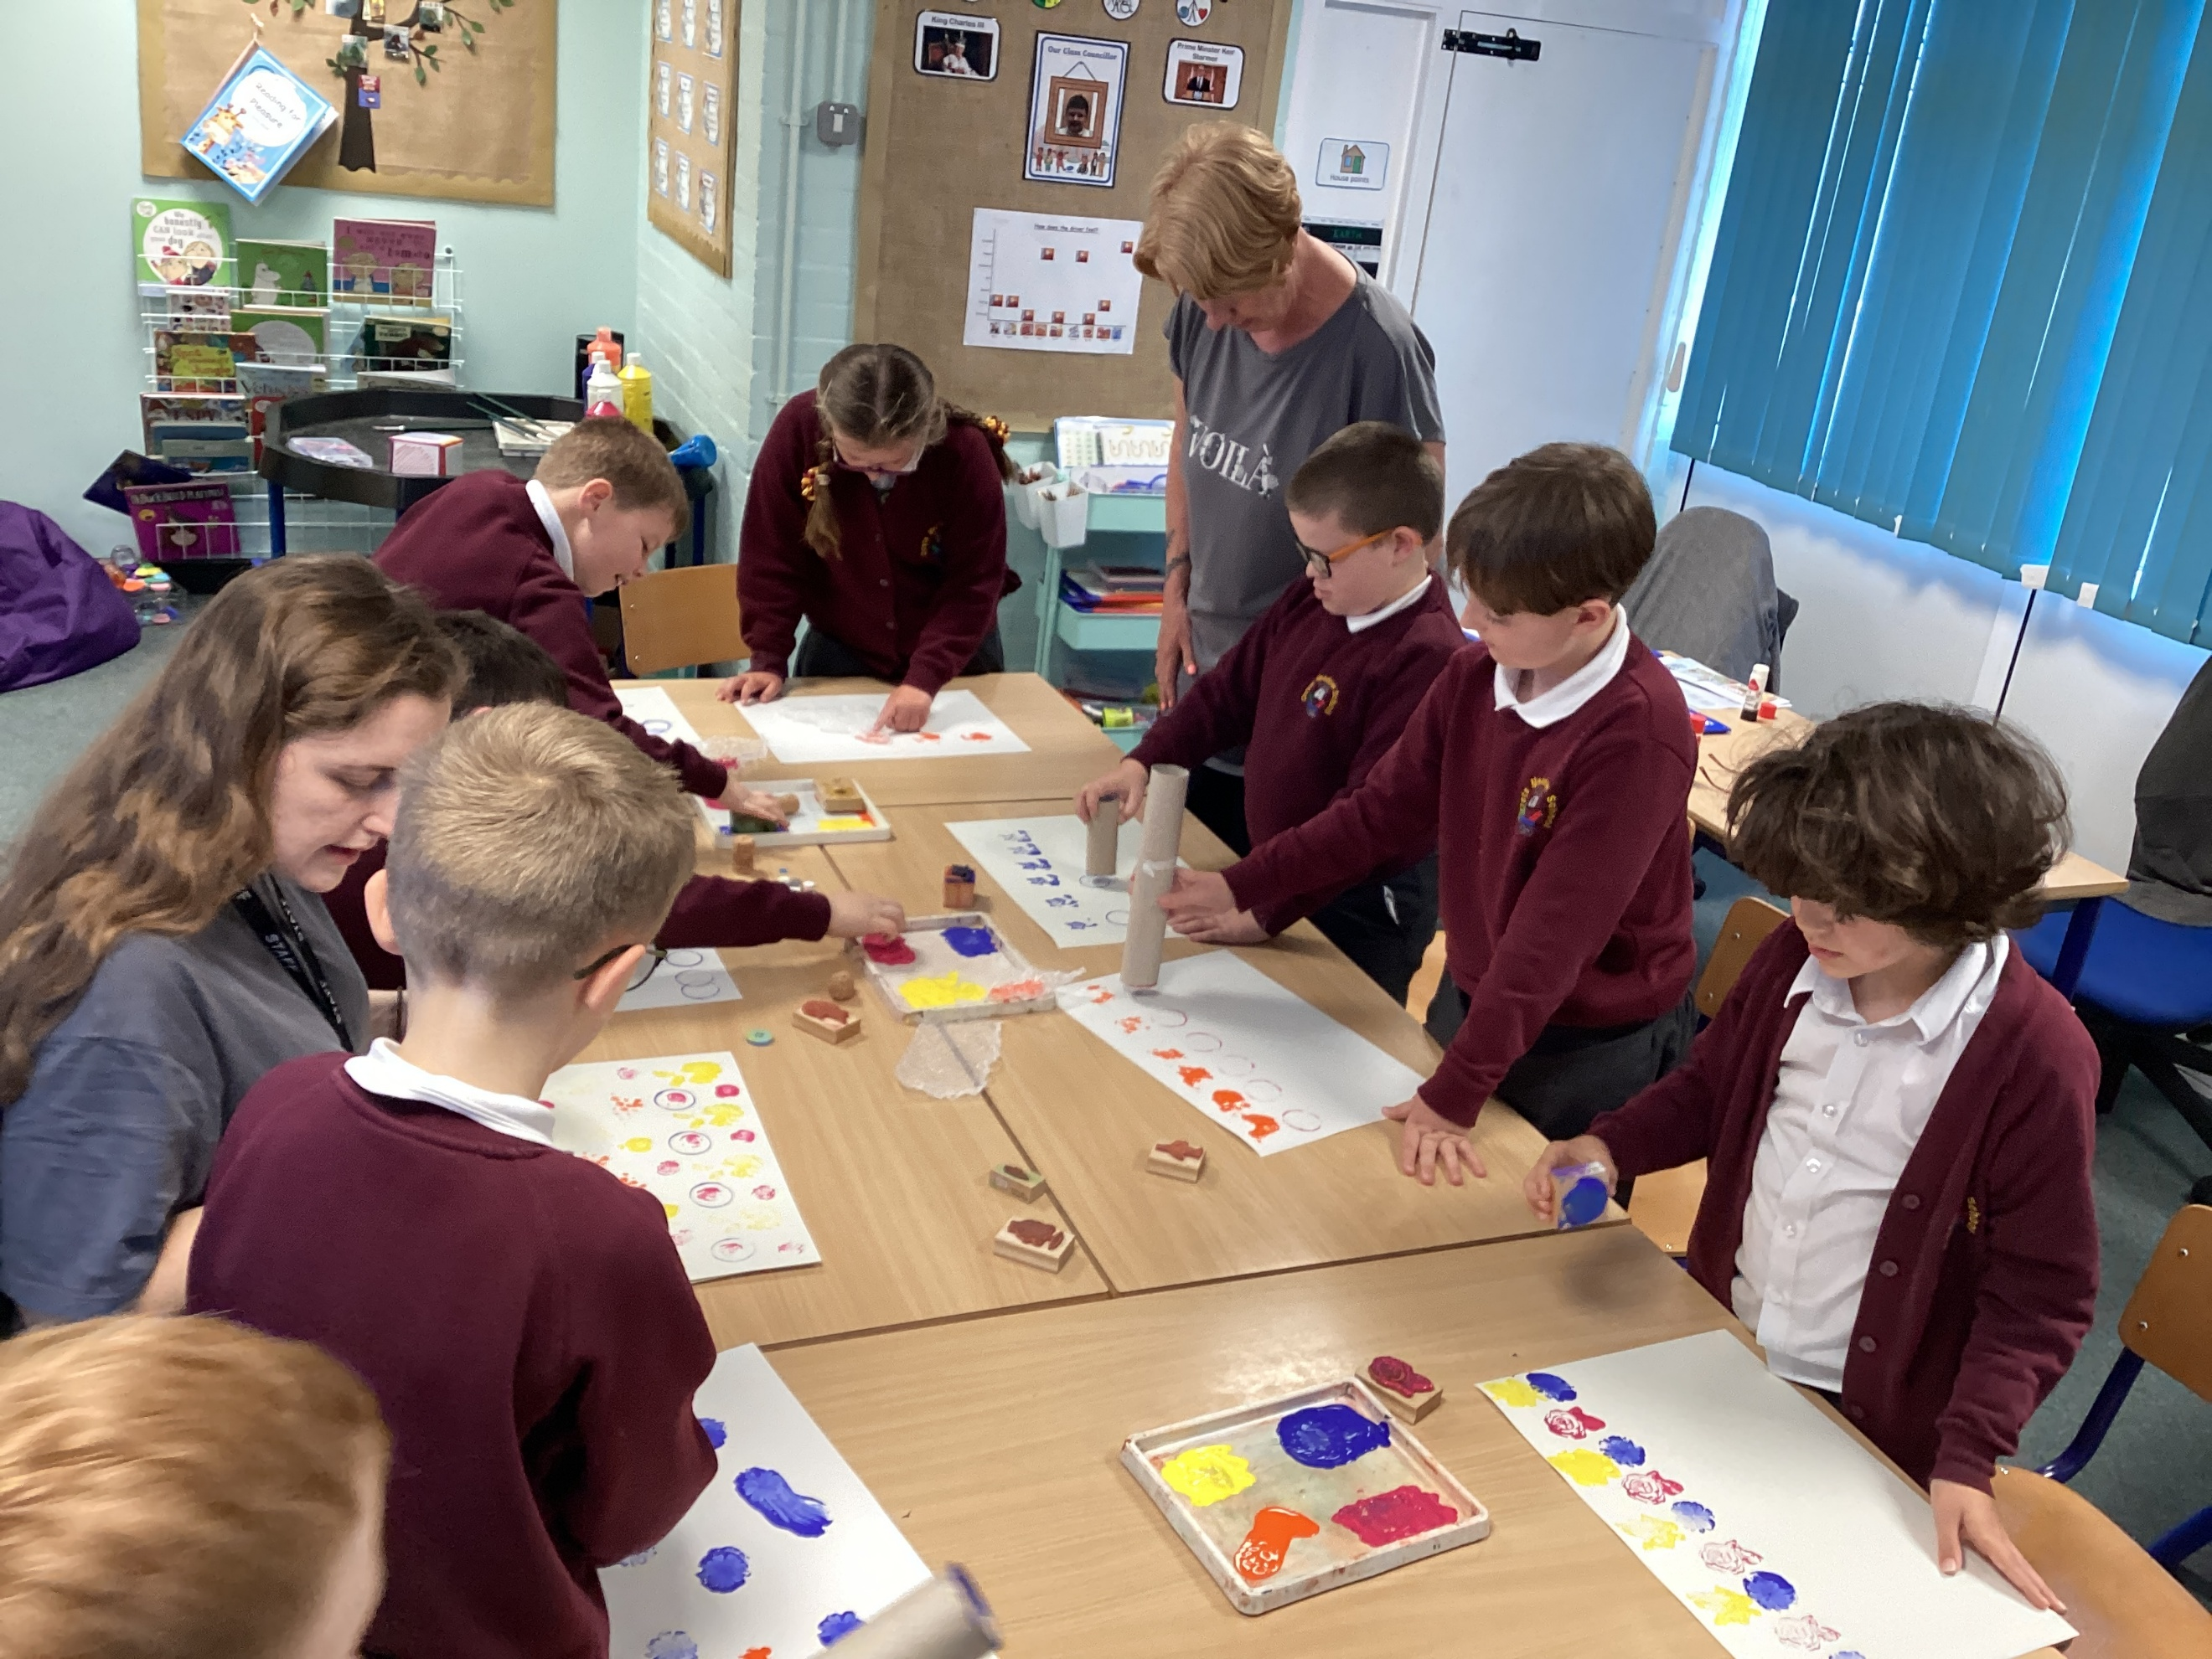

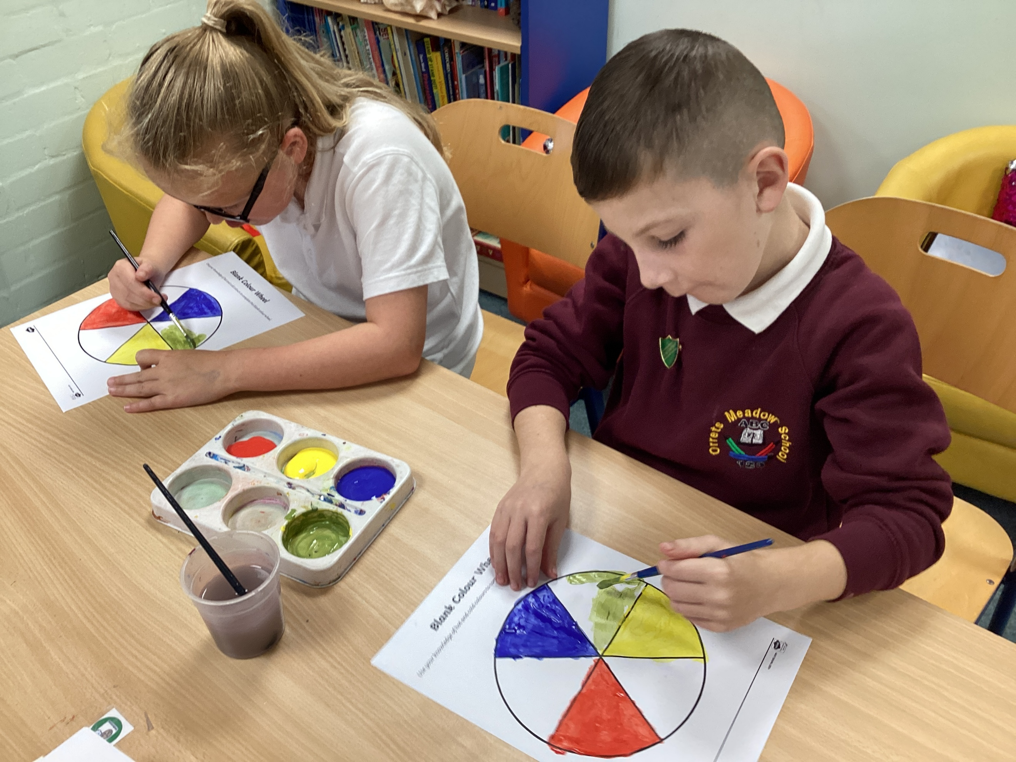
Governors Report – Summer 2026

Art Subject leader: Roz Warren
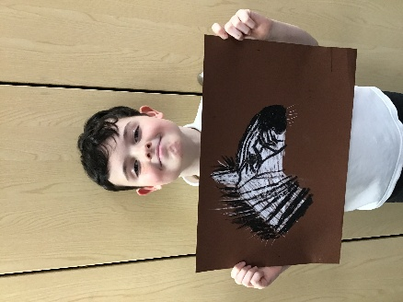
Achievements
The ‘ways forward’ identified last year from this year’s school development plan and the actions taken:
Ways forward
To refine the art pre-curricular skills to ensure that progression from Step 4 to Step 7 is broken down through the different areas of art to support the lower cohort. (Autumn 2)
Pre-curricular art targets have been successfully scaffolded from Step 4 to Step 7. By breaking these down into specific artistic disciplines, we have created a clear, progressive pathway from Step 4 through to Year 5 benchmarks. This clearly determines starting and end points, effectively supporting our pre-curricular cohort as they build toward national curriculum targets.
To produce a moderation file for art to develop consistency in the levels awarded in art. (Ongoing)
Development of the art moderation file is well underway, with the printing sections now fully completed. Moving forward, work from subsequent designated Art Days will be systematically added to the folder until every curriculum area is comprehensively covered.
To ensure an art order is placed in preparation for the designated art days. (Autumn 1/Spring 1/Spring 2)
All required resources were audited and ordered well in advance of the designated Art Days, ensuring that the sessions were highly organized and ran smoothly.
To construct a plan to ensure that all areas of art have a designated art day over a two-year cycle to supplement the Dimensions curriculum. (Autumn 1)
Rather than a two-year cycle, a strategic three-year rolling programme was ultimately implemented to ensure robust, comprehensive coverage of all key artistic areas. (Please see the framework below).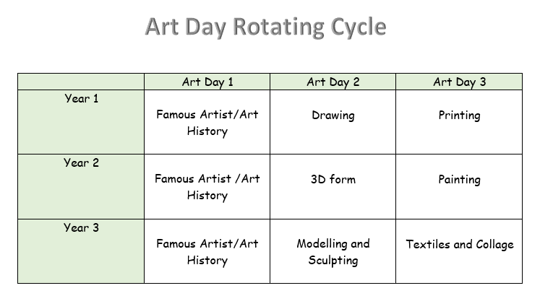
To keep up to date with the requirements, knowledge and skills in Art through the Liverpool School Improvement Art sessions.
R. Warren successfully attended all online art training sessions provided by Liverpool School Improvement. This evidence-based, highly beneficial CPD highlighted the latest developments in art pedagogy. Because the sessions are tailored to our requested cohort needs, they focus on achieving sustainable improvements in outcomes and empowering children to reach their full potential.
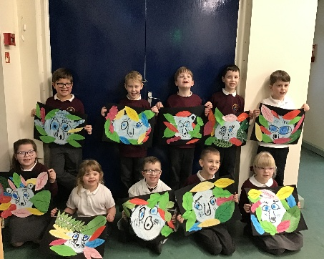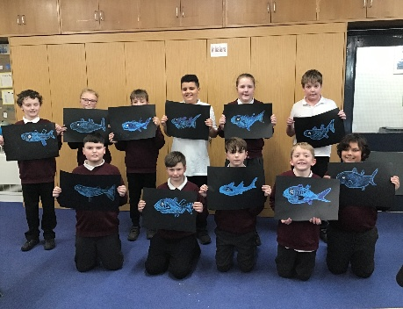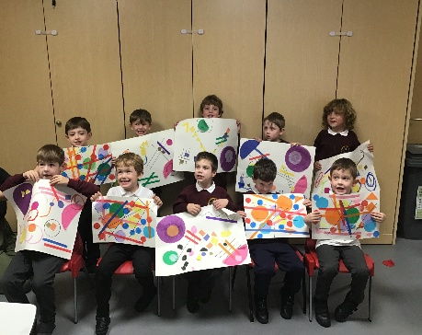

What has happened this year?

Art Days
This year, we successfully held three dedicated Art Days, allowing children to focus on developing their skills, expanding their knowledge, and using sketchbooks to explore new ideas. To support the specific needs and structure of the Wolves class, they participated in a focused art afternoon using a collaborative class sketchbook rather than individual ones. Because the Wolves class curriculum naturally integrates frequent art opportunities, these pupils continue to regularly build their skills and knowledge through daily learning.

Art Day 1 - raise awareness of art history – 3rd October 2026
Art Day 1 was dedicated to art history, with each class researching a unique artist. Pupils then applied these historical styles and techniques to create their own inspired artwork.

Art Day 2 Drawing – 23rd January 2026
Pupils in each class developed their drawing skills by learning to sketch their respective class animals. Following a structured, step-by-step methodology created by artist Katie Lloyd (introduced during our 2023 INSET training), the children sequentially built their techniques to produce their final pieces.

Art Day 3 – Printing 12th June 2026
Art Day 3 focused on the medium of printing, with each class studying a specific artist to inspire their final piece. The day also provided a valuable opportunity for internal moderation, with examples of the pupils' print work collated into a dedicated art moderation file to track progress and standards.
Monitor children’s progress and look for patterns in performance

Art data for 2026:
Class | Class Average | FSM | Non FSM | Girls | Boys
Wolves | 0.5 | 0.5 | 0.5 | N/A | 0.5
Bears | 0.5 | 0.5 | 0.4 | 0.4 | 0.5
Lemurs | 0.8 | 0.8 | 1.0 | 0.8 | 1.4
Giraffes | 1.3 | 1.5 | 1.3 | 1.6 | 1.3
Zebras | 1.8 | 1.8 | 1.8 | 1.9 | 1.5
Foxes | 2.3 | 2.6 | 1.9 | 2.8 | 2.5
Tigers | 1.8 | 2.3 | 2.0 | 2.4 | 1.6
Sharks | 2.7 | 2.5 | 3.2 | 2.9 | 2.6
Owls | 2.0 | 1.8 | 2.6 | 2.1 | 2.2

Across the nine classes, the data demonstrates that FSM pupils are performing broadly in line with, and in several instances outperforming, their Non-FSM peers. There is no systemic, school-wide disadvantage gap favouring Non-FSM pupils. Gender breakdowns show varying patterns, but girls generally edge out boys in higher-year cohorts.
Art comparison data for 2024, 2025 and 2026:
Class | Class Average |  |  | FSM |  |  | Non FSM
Year | 2024 | 2025 | 2026 | 2024 | 2025 | 2026 | 2024 | 2025 | 2026
Wolves | 0.7 | 0.6 | 0.5 | 0.7 | 0.7 | 0.5 | 0.6 | 0.6 | 0.5
Bears | 0.9 | 0.6 | 0.5 | 0.8 | 0.6 | 0.5 | 0.9 | 0.7 | 0.4
Giraffes | 1.4 | 1.1 | 1.3 | 1.3 | 1.2 | 1.5 | 1.4 | 1.0 | 1.3
Lemurs | N/A | 1.0 | 0.8 | N/A | 1.0 | 0.8 | N/A | 1.0 | 1.0
Zebras | 2.2 | 2.0 | 1.8 | 2.1 | 2.0 | 1.8 | 2.2 | 1.5 | 1.8
Foxes | 2.4 | 3.3 | 2.3 | 2.2 | 3.3 | 2.6 | 2.7 | 3.3 | 1.9
Tigers | 2.2 | 1.8 | 1.8 | 2.1 | 1.7 | 2.6 | 2.2 | 1.7 | 2.0
Sharks | 3.7 | 3.1 | 2.7 | 4.0 | 2.8 | 2.5 | 3.5 | 3.1 | 3.2
Owls | 2.5 | 3.0 | 2.0 | 2.3 | 3.3 | 1.8 | 2.7 | 2.6 | 2.6

A review of our three-year data from 2024 to 2026 shows that student performance is generally stabilising across the school. Most classes that previously showed large performance gaps or high peaks have now balanced out. While Free School Meal (FSM) pupils have historically performed as well as—or better than—their peers in several year groups, a clear achievement gap has opened up in our older cohorts (Sharks and Owls).
The table below shows each class’s ability range from lowest to highest data. This shows that particularly in the older classes there is a wider range to cover during lessons.
Ability range per class:
Class | Class Average
Class | lowest | highest
Wolves | 0.4 | 0.5
Bears | 0.4 | 0.7
Lemurs | 0.6 | 2.0
Giraffes | 0.5 | 2.0
Zebras | 0.5 | 2.3
Tigers | 0.5 | 2.4
Foxes | 1.5 | 3.0
Sharks | 2.0 | 3.8
Owls | 0.8 | 3.4
Summary
- Highest Overall Performance goes to our oldest classes: The Sharks achieved the highest overall peak with a maximum class average of 3.8, closely followed by the Owls at 3.4.
- Lowest Overall Performance goes to our youngest classes: The Wolves and Bears share the lowest minimum class average at 0.4. The Wolves also have the lowest maximum cap at just 0.5.
- Most Consistent Group: The Wolves show the least variance in their scores, remaining extremely tight with a tiny range of just 0.1 between their lowest and highest averages.
- Most Variable Group: The Owls show the largest fluctuation in performance, spanning a wide range of 2.6 grade points between their lowest (0.8) and highest (3.4) averages.
CPD
This year, R Warren attended termly School Improvement Liverpool Art and Design Subject Leader Briefings online. These informative sessions offered excellent practical ideas and the latest updates on art education. Additionally, we partnered with the Claremount art lead to analyse progression maps and exchange effective teaching practices across our schools.

Quality of teaching learning
Art Book Scrutiny
The primary focus this year was utilising the Art Day scrapbooks to track skill development and serve as a tool for moderation. The scrap books successfully demonstrated pupil creativity, personal expression, conceptual experimentation, and the scaffolded skills leading up to their final piece. A similar standard of work was evident in the Wolves class floor book, with their topic books containing additional art-focused tasks. The dedicated art days continue to be essential for embedding key skills, deepening subject knowledge, and providing visible evidence of progression.

Learning Walk
Learning walks carried out by R Warren during this year's art days confirmed that high-quality teaching is taking place across the school, resulting in outstanding pupil work. Classrooms maintained a positive, focused learning environment where children were deeply engaged in their tasks and expressed immense pride in what they achieved.

Pupil Voice
Out of the children that were surveyed (survey was based on the moderated child for print):
100% enjoyed art days.
88% could name a famous artist.
100% could talk about their themed art days using their scrap book.
85% could name a famous artist. (The data from the younger classes showed they could not state artists names).
44% have not been to an art gallery. (This will be a focus next year).
Comments:
‘I love art’
‘I would like to do more drawing’
‘I love painting at Orrets’
‘I’d like to be an artist’

Staff Voice
100% of staff commented positively about teaching art.
100% of staff enjoyed teaching the art days.
Modelling and 3D work came out the lowest on the confidence scale (Katie Sheen has been booked in to deliver training on this next year).
Print and Drawing came out high (All staff have received INSET training by Katie Sheen in these areas).

Strengths
What were the strengths in your subject you found this year from all your moderation activities?
- New 3-Year Cycle: Launched a rolling programme for art days to guarantee deep, comprehensive coverage of all art disciplines across the key stages.

- Sketchbook Progression & Independence: Art sketchbooks clearly show the scaffolded growth of skills alongside independent student research, creative exploration, and personal artwork.

- Art Project: Collaborated with artist Katie Sheen on a large-scale art piece during “Being Healthy and Safe" week.

- Professional Development: Attended external School Improvement Liverpool training sessions to enrich subject knowledge and curriculum delivery.
Ways forward
- Plan and organise gallery visits across the school to support art topics and our pledge that every child will access an art gallery during their time at Orrets (Autumn Term)

- Continue to develop the Art Moderation File by gathering student evidence and conducting moderation during each Art Day (Ongoing)

- Co-deliver two staff meetings with Katie Sheen to prepare teachers for new Art Days: 3D Form (6th Jan 2027) and Painting (19th May 2027)

- Purchase all necessary art supplies and place orders well in advance of designated Art Days. (Autumn 1 / Spring 1 / Spring 2)

- Maintain up-to-date subject knowledge and skills by regularly attending the Liverpool School Improvement Art sessions. (Ongoing)

