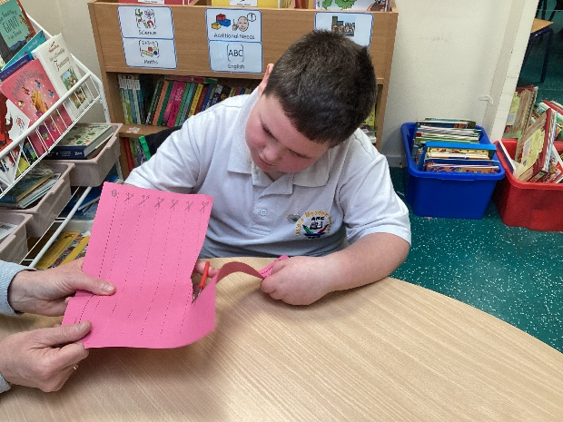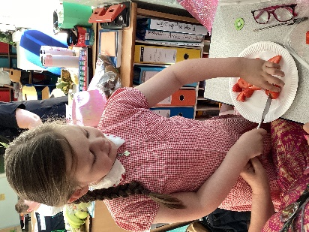

**Governors Report – Summer 2025**

***Design and Technology***

***Subject leader: Jane Gordon***

**Achievements**

The ‘ways forward’ identified last year from this year’s school development plan and the actions taken:

* **Develop Steps levels for Design and Technology progression of skills**

I am pleased to announce the creation of a new steps level assessment tool intended for use across the entire school. This assessment focuses on creating with materials, providing students with the opportunity to explore various technological skills and techniques. It also encourages them to be imaginative and expressive, allowing creativity to flourish within the educational environment. By implementing this tool, we aim to recognise and celebrate the unique talents of each child.

* **Produce and support the use of risk assessments when carrying out DT lessons**

I've had the pleasure of sourcing and implementing risk assessments across the entire school, specifically tailored to our design and technology curriculum. I led a staff meeting to walk through how to access and utilise these assessments during our focus days and Dimension projects. I wanted to make sure that all staff felt confident and equipped to reference these resources in their teaching. It’s essential that we prioritise safety while fostering creativity in our students.

* **Research and cost updated CAD teaching opportunities and training**

This summer term, I undertook a Computer Aided Design CPD course through the Design and Technology Association, and it was truly enlightening! The course enabled me to assess the various CAD opportunities available for our students. I left with a newfound confidence, knowing that the resources and learning experiences we offer are appropriate for our children's age and stage.

* **Research and purchase construction kit opportunities for school**

We're embarking on an exciting journey to enrich our students' learning experiences through the procurement of innovative construction kits! Each class has been tasked with creating a vibrant visual document showcasing their selected construction kits, ensuring there's plenty of choice for all. This initiative not only promotes creativity but also provides an opportunity to enhance our offering further by integrating STEM class activity stations. By combining these elements, we can engage our pupils in hands-on learning experiences that foster collaboration and problem-solving skills.

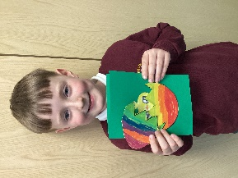 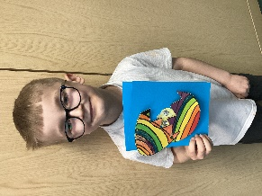   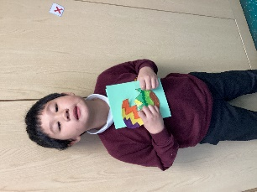

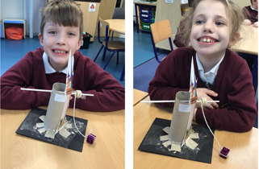 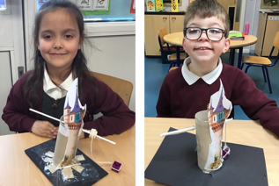

**CPD**

This year, I have engaged in termly online training in Design and Technology through the School Improvement Liverpool Design and Technology Subject Leader Briefing. These briefings have provided valuable insights and up-to-date information on the effective teaching and learning practices in design and technology. Furthermore, my membership in the Design and Technology Association (DATA) has facilitated the continuation of the application process for the design and technology award. As part of our continuous professional development, all teaching staff have access to a range of resources and online training opportunities through DATA to meet their specific teaching and developmental needs. Staff meetings have also emphasised the importance of maintaining standards in Design and Technology throughout the school and ensuring new staff to Orrets Meadow are confident practitioners and have secure understanding of what makes Design and Technology a such a successful subject at Orrets Meadow.

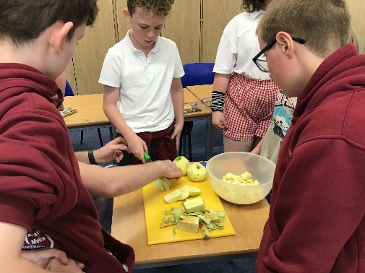

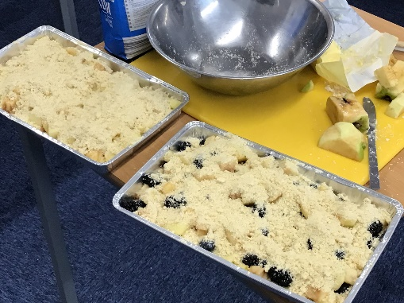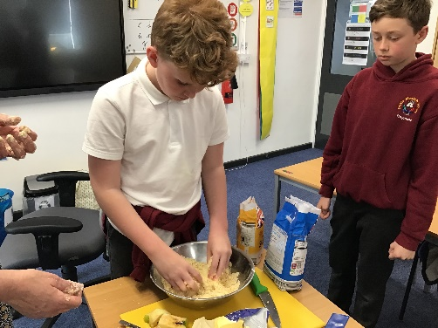

**Quality of teaching learning**

As subject leader, I have conducted various monitoring activities this academic year to uphold the exemplary standard of teaching and learning in Design and Technology. Notably, I undertook a Key Stage 1 lesson observation of the Designing and Making of a Pirate Remote Control who has mobility challenges. It was a wonderful example of the students’ independent skills, ideas and problem-solving abilities. Additionally, throughout DT Focus Days, I conducted learning walks and observed the enhancement of practical skills and building fluency, cultural knowledge, and enrichment activities such as food tasting, understanding food origins, healthy meal concepts, and architectural explorations leading to the construction of personal dens and shelters. The academic year also saw engaging activities such as kite making, puppet designing and sewing, and crafting stuffed animals for sale at the Zoo gift shop. Thorough scrutiny of books, data analysis, as well as surveys involving both pupils and staff were diligently carried out and examined to reinforce the ongoing delivery of excellent teaching practices and effective learning experiences within the classroom.

**What were the strengths in your subject you found this year from all your moderation activities?**

* The DT Focus days show a clear development of children’s designing, making, and evaluating skills, fostering resilience and self-esteem.
* Continued high-quality work in dimensions and class DT floor books.
* Staff are confident in creating opportunities for building fluency in DT and this is now embedded into teaching.
* Staff enthusiasm in delivering Focus days and the Dimensions DT curriculum.
* The creative freedom exhibited in the students designing and making.

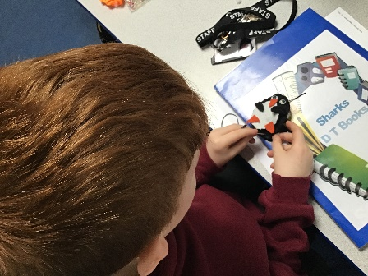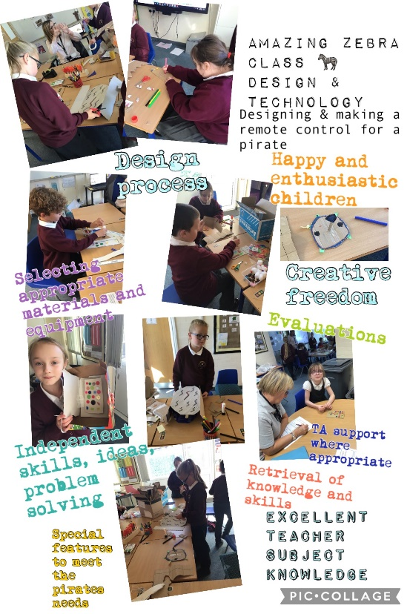

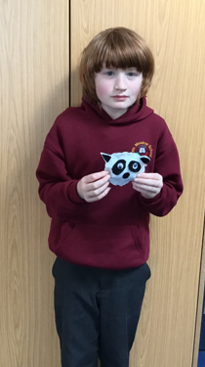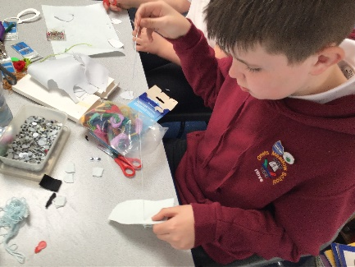

**Ways forward**

* Complete DT Award. Autumn Term 1
* Plan a whole school ‘Scissor-thon’ to promote scissor foundation skills – Staff meeting Autumn Term 1
* Research and promote CPD opportunities for staff through DATA – Autumn Term 1
* To read the findings of the National Curriculum review and be aware of potential changes to the Design and Technology curriculum - Autumn Term 1
* Introduce whole school DT Day focusing on Structures. Autumn Term 2
* Create an evidence folder of DT examples for moderation purposes. Spring Term 2
* Continue to collaborate with Claremount DT department – Summer Term 2