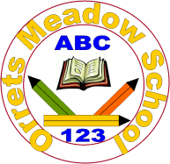



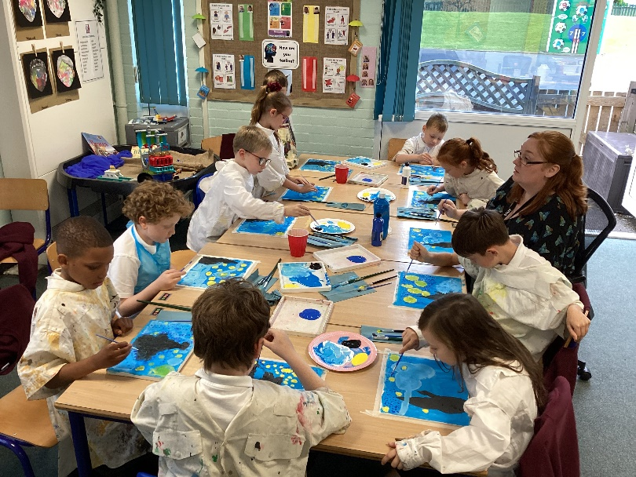

**Governors Report – Summer 2025**

***Art Subject leader: Roz Warren***

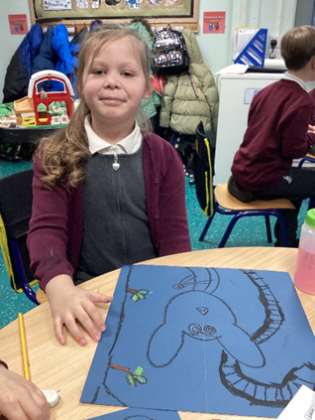

**Achievements**

The ‘ways forward’ identified last year from this year’s school development plan and the actions taken:

**To concentrate on Dimension Art lessons to analyse the effective teaching of art through the thematic afternoon topics. (November ’24)**

RW completed a book scrutiny and learning walk of Dimension art lessons. Some lovely lessons and work were observed however it was difficult to track and see progress of skills and knowledge in discrete Dimensions art lessons due to the limited time dedicated. Therefore, a rotating two-year art day schedule will be mapped out including all areas of art to support the development of skills and knowledge through focussed art days.

**To rewrite pre curricular targets for Art to ensure clear steps of progression for the lower cohort. (January ’25)**

The pre curricular art targets were broken down in steps from step 3 to step 7. This is to enable progression in art for our pre-curricular cohort and support children in building towards the national curriculum targets.

**To book an artist to produce a large-scale art piece which all children contribute to – for collaboration and CPD. (Being Healthy Week – June’25).**

Dani Rain head of art at Claremount School will be supporting our children to create a large-scale art piece during Being Healthy and Safe week.

**To place an art order with the requested resources. (September ’24)**

An order was placed to ensure staff had the resources they needed to support them in Dimensions and Art Day art.

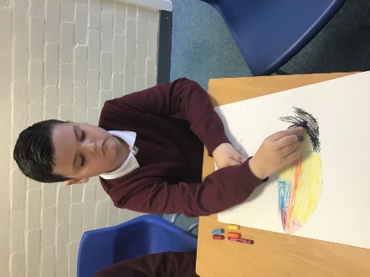 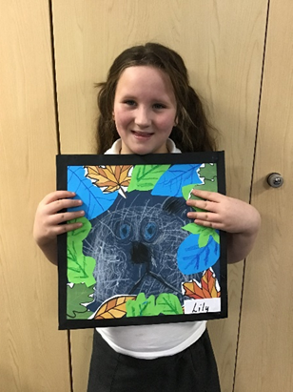 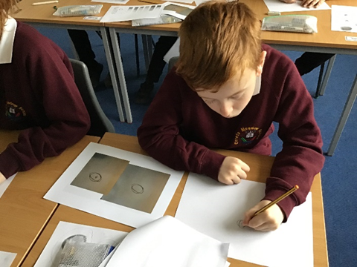

**What has happened this year?**

**Art Days**

We have completed 3 art days again this year to give the children the opportunity to work on their skills and knowledge and use their sketch books to develop ideas during the focused days. This year the Wolves class completed a class sketch book instead of individual ones and took part in an afternoon of art instead of a day to support the class in maintaining structure and supporting the lower cohort. Wolves class curriculum includes many art opportunities so they have lots of chances to build up their skills and knowledge in their day-to-day learning.

**Art Day 1 - raise awareness of art history – 20th September 2024**

Our first art day focused on art history. Each class had a different artist to research and apply their techniques. The following artists were used:

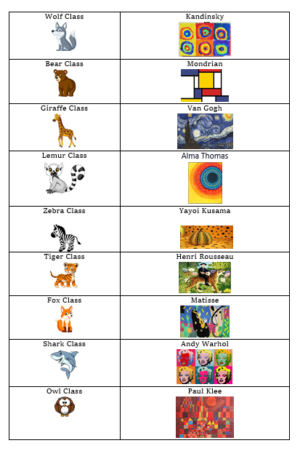

During this day I completed a learning walk round the classes. There was a calm, creative vibe in all classrooms.

**Art Day 2 – Mixed Media Art 10th January 2025**

Art Day 2 focused on Mixed Media. The pictures below show the different artists that the classes focused on for inspiration. Children used a range of collage materials to build up a mixed media creation.

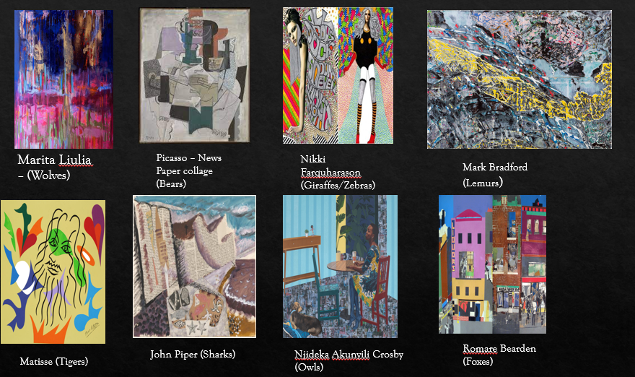

For our ‘mixed media’ art day we thread it through the Dimensions curriculum. The table below shows the topic and skills that will be applied on this day.

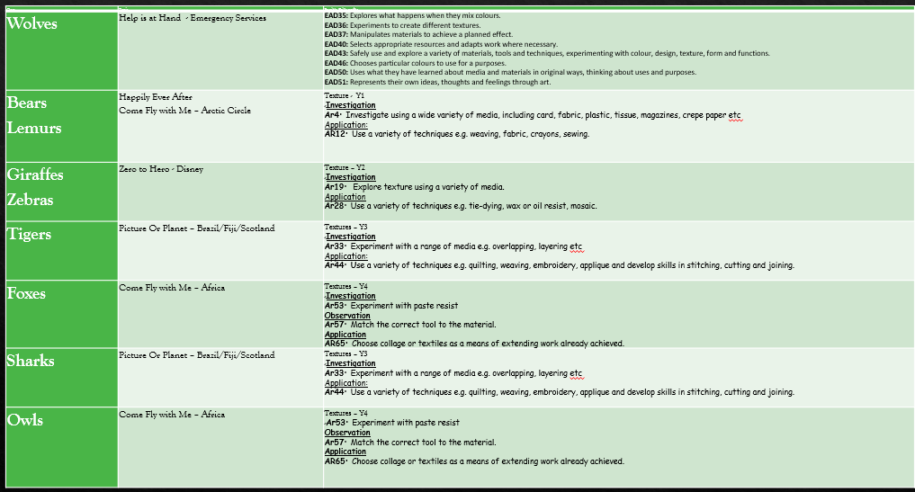

**Art Day 3 Drawing – 24th January 2025**

Katie Lloyd provided another excellent Inset this time with the focus of drawing. She delivered an afternoon of modelling, copying and practicing core skills and knowledge. All teachers and TAs took part and felt confident and prepared to deliver the session to the children. She provided books for each class as a starting point and then step by step power point slides as guidance. Each class drew their class animal the work produced was phenomenal.

**Monitor children’s progress and look for patterns in performance**

Art data for 2025:

|  |  |  |  |  |  |
| --- | --- | --- | --- | --- | --- |
| **Class** | **Class Average** | **FSM** | **Non FSM** | **Girls** | **Boys** |
| Wolves | 0.6 | 0.7 | 0.6 | 0.9 | 0.6 |
| Bears | 0.6 | 0.6 | 0.7 | 0.6 | 0.6 |
| Lemurs | 1.3 | 1.3 | 1.2 | 1.1 | 1.2 |
| Giraffes | 1.1 | 1.2 | 1.0 | 1.2 | 1.0 |
| Zebras | 2.0 | 2.0 | 1.5 | 2.0 | 2.0 |
| Foxes | 3.3 | 3.3 | 3.3 | 3.4 | 3.3 |
| Tigers | 1.8 | 1.7 | 1.7 | - | All boys |
| Sharks | 3.1 | 2.8 | 3.1 | - | All boys |
| Owls | 3.0 | 3.3 | 2.6 | 3.1 | 2.9 |

In comparing this data to the 2024 data it is evident that the school’s cohort is getting lower in art (the green highlights when 2024 data is higher than 2025). 63% of the compared classes showed a drop in class average and FSM and 75% in non-FSM. Therefore, the new art steps will support this transition. Art will also be monitored through learning walks, topic books and art sketch books to ensure the skills being taught match the current cohort.

Art comparison data for 2024 and 2025:

|  |  |  |  |  |  |  |
| --- | --- | --- | --- | --- | --- | --- |
| **Class** | **Class Average** | | **FSM** | | **Non FSM** | |
| **Year** | **2024** | **2025** | **2024** | **2025** | **2024** | **2025** |
| Wolves | 0.7 | 0.6 | 0.7 | 0.7 | 0.6 | 0.6 |
| Bears | 0.9 | 0.6 | 0.8 | 0.6 | 0.9 | 0.7 |
| Giraffes | 1.4 | 1.1 | 1.3 | 1.2 | 1.4 | 1.0 |
| Zebras | 2.2 | 2.0 | 2.1 | 2.0 | 2.2 | 1.5 |
| Foxes | 2.4 | 3.3 | 2.2 | 3.3 | 2.7 | 3.3 |
| Tigers | 2.2 | 1.8 | 2.1 | 1.7 | 2.2 | 1.7 |
| Sharks | 3.7 | 3.1 | 4.0 | 2.8 | 3.5 | 3.1 |
| Owls | 2.5 | 3.0 | 2.3 | 3.3 | 2.7 | 2.6 |

The table below shows each class’s ability range from lowest to highest data. This shows that particularly in the older classes there is a wider range to cover during lessons.

**Ability range per class:**

|  |  |  |
| --- | --- | --- |
| **Class** | **Class Average** | |
| **lowest** | **highest** |
| Wolves | 0.5 | 0.9 |
| Bears | 0.5 | 0.7 |
| Lemurs | 0.4 | 1.4 |
| Giraffes | 0.8 | 1.3 |
| Zebras | 0.6 | 2.6 |
| Tigers | 1.5 | 2.0 |
| Foxes | 2.3 | 3.9 |
| Sharks | 1.9 | 4.2 |
| Owls | 1.8 | 4.3 |

Summary

* Class average in art shows progression in each year group - Wolves being the lowest data and sharks being the highest.
* Children at Orrets Meadow are achieving between Steps and Year 4.
* The majority of classes data shows FSMs data is higher or the same as non-FSMs.
* Girls achieve higher than boys in art.
* Data is lower than 2024 data.

**CPD**

This year I have undertaken termly online training in art through the School Improvement Liverpool Art and Design Subject Leader Briefing. The briefings have been really informative and given lots of ideas and current information on the teaching and learning of art. I also undertook a session at Claremount with Dani Rain the Art lead it was interesting looking at next steps of learning. Dani will be joining us during ‘Being Healthy and Safe week’ to complete a whole school large scale art piece.

**Quality of teaching learning**

**Art Book Scrutiny**

This year the focus was on Dimension Art work found in the children’s topic books. Topic book scrutinises have taken place each term to moderate coverage and skill development. On monitoring the topic books, it became evident that even though from year group to year group there is a clear progression in skills and knowledge there is a limited number of pieces produced and limited time assigned to produce them. Therefore, the art days are essential to secure these skills, knowledge and demonstrating progression in the different art areas.

**Learning Walk**

Mrs Duncan and I conducted learning walks during the art days this year. We both witnessed high quality teaching which resulted in some amazing pieces of art. There was a positive working atmosphere in all rooms, the children were engaged in the activities being taught and were proud of their accomplishments.

**Pupil Voice**

Out of the children that were surveyed (2 children from each class):

100% found art lessons enjoyable.

100% could name some skills they had developed in art.

85% could name a famous artist. (The data from the younger classes showed they could not state artists names).

62% have not been to an art gallery. During Being Healthy Week 3 of our classes will be attending an art gallery so this number should increase.

**Staff Voice**

100% of staff commented positively about teaching art.

100% of staff enjoyed teaching the art days and found it beneficial having time to complete a longer art project.

Suggestions for further development:

‘More art days’

‘More art in afternoon topic’

**Strengths**

**What were the strengths in your subject you found this year from all your moderation activities?**

* The discrete art days continue to be a strength and show clear progression of art skills in the identified areas.
* The art sketch books demonstrate development of skills and knowledge in the areas covered.
* Creating links with the head of art at Claremount School.
* The Liverpool school improvement sessions.

**Ways forward**

* To refine the art pre-curricular skills to ensure that progression from Step 4 to Step 7 is broken down through the different areas of art to support the lower cohort. (Autumn 2)
* To produce a moderation file for art to develop consistency in the levels awarded in art. (Ongoing)
* To construct a plan to ensure that all areas of art have a designated art day over a two-year cycle to supplement the Dimensions curriculum. (Autumn 1)
* To ensure an art order is placed in preparation for the designated art days. (Autumn 1/Spring 1/Spring 2)
* To keep up to date with the requirements, knowledge and skills in Art through the Liverpool School Improvement Art sessions.