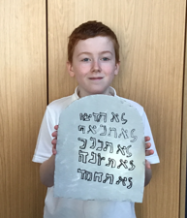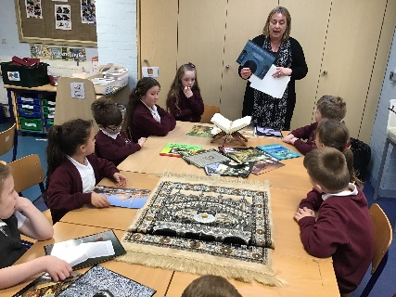

**Governors Report – Summer 2025**

***RE***

***Subject leader: Jane Gordon***

**Achievements**

The ‘ways forward’ identified last year from this year’s school development plan and the actions taken:

* **Monitor And support the implementation of the new schemes of work**

To ensure the successful implementation of the new schemes of work, it was imperative that I actively monitored and supported our colleagues throughout this process. Engaging staff voices during regular meetings allowed us to gather invaluable feedback and insights. Additionally, we utilised monitoring books to gauge the success of each new topic and identify areas for improvement. Learning walks provided an opportunity to observe practical applications in real-time, while structured lesson observations helped refine our teaching practices.

* **Review and create Steps levels for RE**

In our commitment to fostering a comprehensive grasp of Religious Education, I have developed tailored Steps levels that reflect the progression of knowledge and skills across all age groups. It is essential to create a framework that not only addresses the Wirral SACRE but also caters to the diverse needs of our children at every stage of their development. By adopting an inclusive approach, we will enable our learners to engage meaningfully with key concepts, ensuring that each child feels supported and valued. Implementing clear progression pathways will facilitate deeper understanding and enrich their spiritual and moral development throughout their educational journey.

* **Implement new schemes of work for Explorers Curriculum**

As we continue to implement new schemes of work for the Explorers Curriculum, this initiative remains very much a work in progress. Looking ahead to next year, we aim to develop a bespoke Religious Education curriculum tailored specifically to meet the changing needs of our youngest cohort. I am excited to work closely with our dedicated teaching staff to ensure that we create engaging and multisensory experiences for our students. By fostering collaboration and innovative teaching methods, we can enhance our learners' educational journeys and support their holistic development in this vital stage of their education.

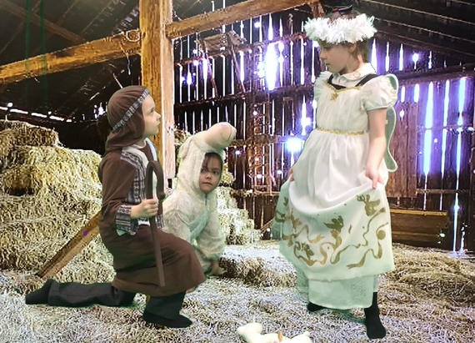 ***CPD***

As a subject leader I place a high value on continued professional development and collaboration with local subject leaders. Being a member of the Wirral LTLRE HUB has provided me with an excellent opportunity to connect with like-minded RE professionals, sharing innovative ideas and best practices. Participating in the regular training meetings organised by Wirral LTLRE HUB has enriched my teaching practices. My RE staff meetings have not only focused on promoting sensory teaching strategies and maintaining quality of work and how it is recorded and presented but have also emphasised the implementation of new schemes of work, long-term planning, and the new Steps assessment document I have written.

***Quality of Teaching and Learning***

As the subject leader for Religious Education in our school, I have been proactive in ensuring the maintenance of exceptional teaching and learning standards throughout the year. My commitment to this has involved a plethora of monitoring activities, aimed at overseeing both the quality of instruction and the progress our students make in their understanding of religious concepts.

From regular classroom observations to collaborative meetings with fellow teachers, I’ve delved into what makes our lessons engaging and effective. I’ve also sought feedback from students, as their voices are invaluable in shaping a curriculum that genuinely resonates with them. By fostering an open and communicative environment, we can explore what works best for our learners.

Additionally, I’ve introduced resources that align with current educational standards whilst being mindful of the diverse beliefs represented in our school community. It’s rewarding to witness our pupils not only grasping the content but also developing critical thinking skills that will serve them well beyond the classroom. I’m excited to continue this journey, ensuring that the quality of teaching and learning in RE thrives, enabling us to produce well-rounded individuals who can engage thoughtfully with the world around them.

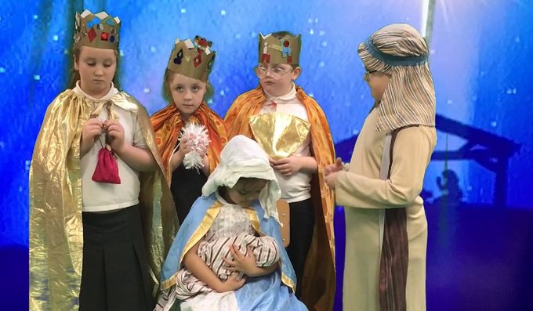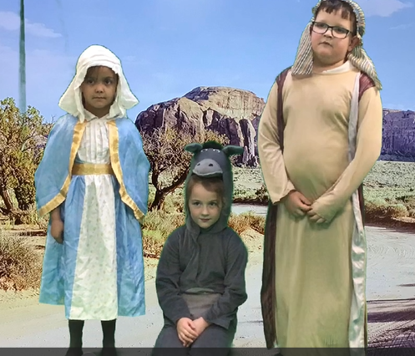

**What were the strengths in your subject you found this year from all your moderation activities?**

Reflecting on this academic year's moderation activities in Religious Education, it’s delightful to see several key strengths coming to the forefront. Firstly, teachers new to Orrets Meadow have noticeably gained confidence and enjoyment in teaching RE. This has largely been to due to ongoing professional development and the benefits of collaborative planning sessions, which have fostered a supportive environment.

Religion Week was a tremendous highlight, allowing students to delve into various faith traditions. It was rewarding to witness the promotion of mutual respect and understanding blossom throughout our school community. Additionally, the involvement of Rector Ron in our assemblies during Christian celebrations added richness to our students’ experiences, enhancing their grasp of Christian beliefs while fostering inclusivity.

Moreover, the comprehensive focus on Christmas and Easter festivities enabled students to explore the historical and cultural significance of these important celebrations in a truly engaging manner. It’s also worth noting how multisensory and creative teaching strategies have made lessons not only interactive but memorable, catering to diverse learning styles.

Finally, the introduction of class floor books across the whole school has been brilliantly visual and creative method for recording learning. This initiative encourages student reflection and self-assessment, empowering them to take pride in their educational journey and boosting overall success.

**Ways forward**

* Encourage class teachers to plan trips to religious buildings/places to enhance the delivery of RE. Autumn Term 2
* Create an evidence folder of work for moderation purposes. Spring Term 2
* Continue to implement and monitor new scheme of work ‘Special Stories’ for Explorers and Pathfinders A alongside class teachers. Summer Term 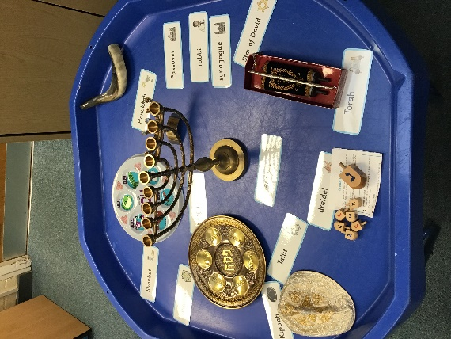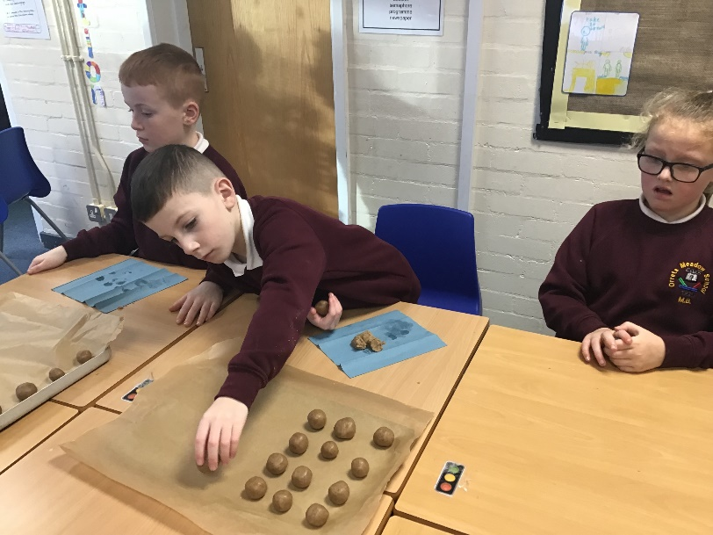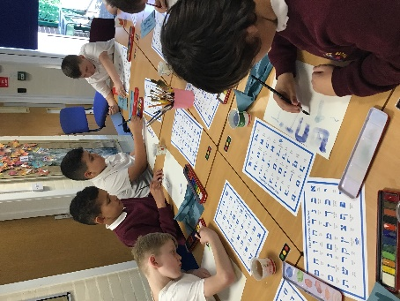2