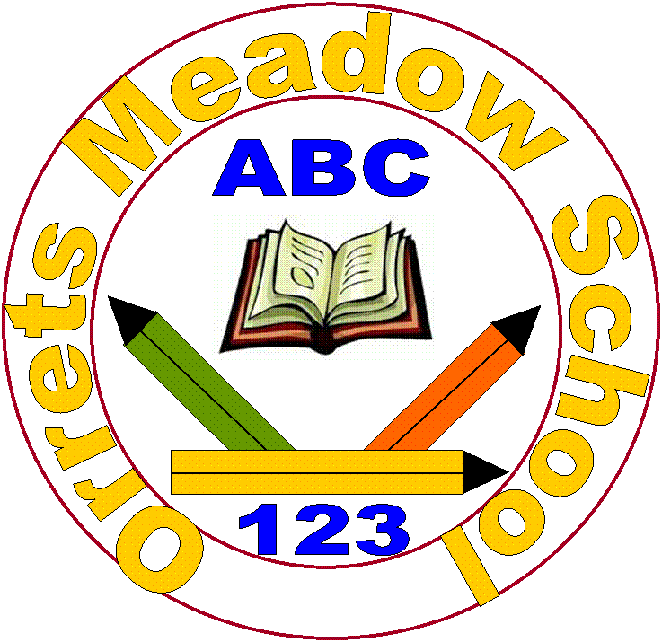
Orrets Meadow School
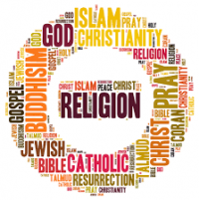
Religious Education Policy

“To raise the aspirations of every child and give them confidence to fulfil their potential through positive experiences”

Orrets Meadow Curriculum Aims and Values
Aims
To ensure all our children are at the centre of a broad, varied and interesting learning experience that is enjoyable and relevant for the future. Our creative, multisensory curriculum will create a sense of awe and wonder and help to inspire a lifelong love of learning. The holistic nature of our practice will promote positive mental health and well-being and will enhance our children’s life skills, social skills and cultural awareness.
Values
Our curriculum will promote a range of values including:
- Respect
- Empathy
- Responsibility
- Equality
- Independence
- Happiness
- Resilience
- Gratitude
- Honesty
- Friendship
Intent
Introduction
Religious Education plays an important role in the curriculum since every pupil in a maintained school has a statutory entitlement to religious education. This entitlement must be for all pupils regardless of their faith or belief. In the teaching of RE and Worldviews, we should ensure that all pupils ensure that all pupils enjoy their learning and have opportunities to succeed, whatever their individual needs or barriers to learning may be. Pupils need to understand the role and significance of religion in the modern world, the important beliefs and values that shape it; and the impact religion has on many people’s lives, and especially on communities.

Aims
- To support the development of children’s own values and to contribute to their spiritual, moral, social and cultural development.
- To encourage interpretation of and response to a variety of religious concepts, beliefs and practice within their own and others cultural and life experiences.
- To encourage the fostering of a responsible and caring attitude towards each other, through an awareness of themselves and their relationships with others in the community.
- To prepare children for the responsibilities, opportunities and experiences of later life.
- To provide equality of opportunity for all children, regardless of age, ability, ethnicity, gender or race.
Implementation

When is Religious Education taught?
Religious Education is taught through discrete weekly sessions every other half term. The Long Term Plan maps out the topics taught in these weekly sessions for each year group. We follow the schemes of work from the Wirral Agreed Syllabus.
World Religions are taught at KS2 through the Dimensions Topic: A World of Difference and every Spring Term each class spends a whole week studying a world religion and experiencing the faith through visits to religious building or welcoming visitors from that faith to their class.
The themed Christmas week is planned to include Christmas around the world where each class learn how Christmas is celebrated in different cultures. The Christian Christmas story is also studied from different perspectives through the classes to enable a progression of understanding through the school.
We enjoy many planned trips to Liverpool Cathedrals, Wirral Deen Centre and other religious buildings to give the children the opportunity to experience different religious buildings and enhance Cultural Capital in RE.

SMSC contributes significantly to the Religious Education curriculum. It promotes spiritual development through discussion and reflections. Moral development is promoted through studying key beliefs and teachings from religion and philosophy, values and ethical codes of practice. Social development is enhanced by investigating social issues from religious perspectives, recognizing the diversity of viewpoints within and between religions. Cultural development by promoting racial and interfaith harmony, respect for all, combating prejudice and discrimination and awareness how interfaith co-operation can support the pursuit of the common good.
Religious Education enhances PSHE, Citizenship and British Values by developing understanding to facilitate discussion
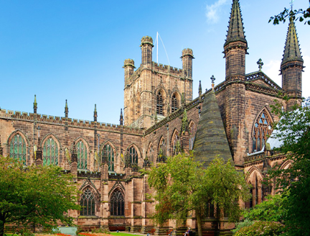
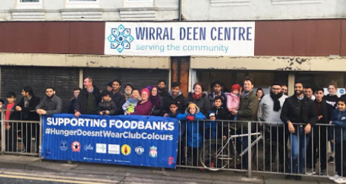

How is Religious Education taught?

Learning about religion from religion
The knowledge, skills and understanding identify the key aspects of learning in Religious Education. These are described as ‘learning about religion’ and ‘learning from religion.’ These two strands are incorporated into the single attainment target in the Wirral Agreed Syllabus for Religious Education.

Learning about religion includes enquiry into the nature of religion, including diverse beliefs, teaching, ways of life, sources, practices and forms of expression. It includes the skills of interpretation, analysis and explanation. Pupils learn to communicate their knowledge and understanding using specialist vocabulary. In the Wirral Agreed Syllabus for Religious Education ‘learning about religion’ covers pupils’ knowledge and understanding of individual religions, and how they relate to each other.

Learning from religion is concerned with developing pupils’ reflection on and response to their own and others’ experiences in the light of their learning about religion. It develops pupils’ skills of application, interpretation and evaluation of what they learn about religion. Pupils learn to develop and communicate their own ideas, particularly in relation to the questions of identity and belonging, meaning, purpose, faith/belief, values and commitments.

Pupils at Orrets Meadow have ASD and additional needs, so consideration needs to be given to how we teach Religious Education. All of our pupils are working at least two years behind their chronological age and so the curriculum is adapted to meet the stage they are working at and strategies are used to best meet their needs.
We acknowledge our children’s different learning styles and encourage learning through active participation in drama, stories, song, video clips, interactive teaching walls, scrap book making, ICT, art and all creative ways which extend and embed RE skills.




“Science without religion is lame,
Religion without science is blind”
Albert Einstein
“I believe that religious education must be the sole concern of religious associations.”
Ghandi

Religious Education Long Term Plan

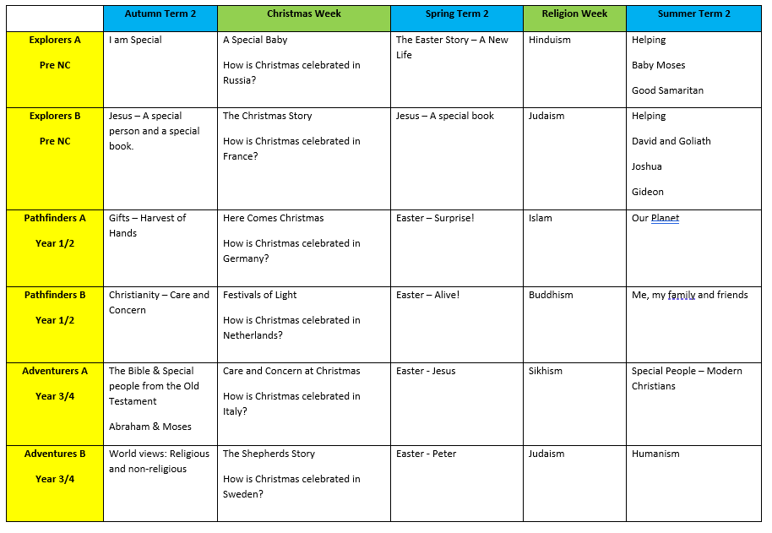

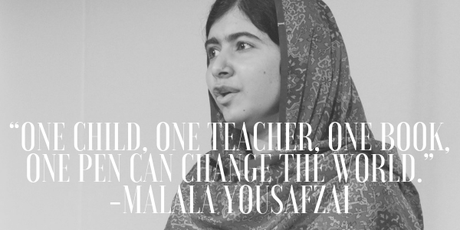

Skills Progression
Pre NC | Year 1 | Year 2 | Year 3 | Year 4 | Year 5 | Year 6
Children begin to understand that they belong to groups beyond the family.  Children show sensitivity to the needs and feelings of others and respond appropriately.  Children recognise that their actions affect themselves and others.  Children begin to understand that Jesus is a special person to Christians.  The children know that the Bible is a special book for Christians.  Children respond to cultural events and show a range of feelings.  Children are able to re-tell the key points in bible stories. E.g. Christmas and Easter  Children become aware of their own identity/  uniqueness.  Beginning to develop a relationship with other children and adults  Children begin to show respect for themselves and for others and for their belongings.  Children begin to understand the word trust and be able to talk about who they can trust.  Children start to view themselves as citizens within their community / school.  Children begin to show an understanding of the responsibility of helping other people. | Children begin to recall and name different beliefs and main festivals associated with religions.  Children begin to explore daily practices and rituals of religions, identifying religious practices and recognising that some are featured in more than one religion.  Children explore a range of sources of wisdom and the traditions they come from.  Children can name religious symbols and meaning of them  Children can learn the name of important religious stories.  Children look at how an appreciation of religion plays an important role in the lives of some people.  Children can identify things that are important in their lives.  Children can ask questions about the puzzling aspects of life.  Children look at and appreciate how people’s values affect a community and individuals.  Children look at religious stories to understand actions and consequences. | Children can describe the main beliefs of a religion.  Children can describe the main festivals of a religion.  Children begin to reflect on their own experiences of attending ceremonies.  Children can explain religious rituals and ceremonies and the meaning of them.  Children can observe when practices and rituals are featured in more than one religion or lifestyle.  Children can retell religious stories and suggest meanings in the story.  Children begin to recognise different symbols and how they express a community’s way of life.  Children can make links to expressing identity and belonging and what is important to them.  Children understand that there are similarities and differences between people.  Children begin to make connections to their own lives, looking at their own actions and consequences and choices they can make.  Children can explain how actions can affect other people.  Children can understand that they have their own choices and begin to understand the concept of morals. | Children can describe the key beliefs and teachings of the religions studied.  Children look at the concepts of belonging, identity and meaning.  Children identify religious artefacts and how they are involved in daily practices and rituals.  Children describe religious buildings and how they are used.  Children explore beliefs through books, scriptures, art and other important means of communication.  Children begin to identify religious symbolism in different forms of art and communication.  Children explore how an appreciation of religion plays an important role in the lives of some people.  Children understand that personal experiences and feelings can influence their attitudes and actions.  Children develop their appreciation of the ways in which people’s values are an important aspect of their lives.  Children make links to responsibility and citizenship and choices they make affecting their lives.  Children make informed choices and understand the consequences of choices. | Children can make some comparisons between religions.  Children begin to compare the main festivals of world religions.  Children refer to religious figures and holy books.  Children begin to discuss and present thoughtfully their own and others’ views.  Children explore pilgrimages as a part of religious life.  Children explain religious ceremonies and rituals and their importance for people’s lives and sense of belonging.  Children can look at holy texts and stories and explain meanings in stories.  Children can express their beliefs in different forms, with respect for others’ beliefs and comparing beliefs.  Children can offer suggestions about why religious and non-religious leaders and followers have acted the way they have.  Children can ask questions that have no agreed answers, and offer suggestions as answers to those questions.  Children understand that there are similarities and differences between people and those differences.  Children describe how shared values in a community can affect behaviour and outcomes.  Children discuss and give opinions on morals, values, including their own. | To explain how beliefs and teachings can make contributions to the lives of individuals and communities.  To look further at the concepts of belonging, identity and meaning. To understand how certain features of religion make a difference to individuals and communities.  To continue to explore the expression of beliefs through books, scriptures, art and any other important means of communication.  To continue to develop understanding how an appreciation of religion plays an important role in the lives of some people.  Make links to expressing identity and belonging and notice and respond sensitively to different views.  Continue to develop appreciation of the ways in which people’s values are an important aspect of their lives. Make links to responsibility and citizenship. | To compare the key beliefs and teachings of various religions, using appropriate language and vocabulary and demonstrating respect and tolerance.  To explore rituals and ceremonies which mark important points in life.  To have the opportunity to explore non-religious ways of life (Humanism.)  To explain the meaning of religious stories, sources of wisdom and the traditions from which they come.  Children can discuss and apply their own ideas about ethical questions, including ideas about what is right and wrong and what is just and fair.  To understand the concept of shared values and how a community can use shared values. To begin to strengthen their capacity for moral judgements.
Impact

How do we assess and monitor Religious Education

Using a simple decimal grading system for our assessment allows staff to record even the smallest steps of progress by our pupils. The first digit in the given number represents the year group that a child is working at and the second is the level at how they are achieving within that given grouping. Teachers can quickly identify where a given student is and how this related to their peerage in each class. This method of assessment is used twice yearly in March and July. It is recorded in the Foundation subject tracker where RE attainment can be assessed and analysed by SLT, subject leaders and teachers.

As many of our pupils have short term memory difficulties, they find retaining knowledge especially difficult, so we use Kahoot quizzes throughout the units to support them remember ‘Sticky Knowledge’. These quizzes make learning fun, engaging and impactful. Teachers can create their own to introduce the topic, review and reinforce knowledge and use the information gained to help them identify which objectives have been achieved.

SLT, teachers and subject leaders use assessment for learning to inform planning, teaching and learning and CPD opportunities.

SLT and subject leaders are continuously monitoring their subject to ensure it meets the needs of our pupils. They monitor using a variety of activities, including:

- Learning walks
- Book scrutiny
- Lesson observations
- Pupil survey and discussions
- Staff survey and discussions

