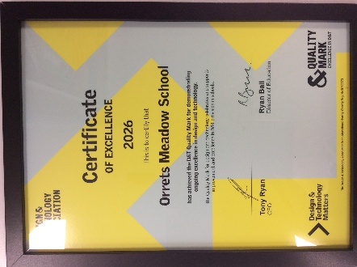



Governors Report – Summer 2026
Design and Technology
Subject leader: Jane Gordon
We are incredibly proud to announce that our school has been officially awarded the prestigious DT Mark by the Design and Technology Association (DATA). This highly regarded national accolade is a major milestone for Orrets Meadow, representing the pinnacle of recognition for schools capable of demonstrating true excellence in Design and Technology education.
The DT Mark is not easily achieved. It requires a rigorous, comprehensive independent assessment that scrutinises every facet of a school's department. During the evaluation, I provided extensive evidence across several core areas, including curriculum planning, the overall quality of teaching, and the subsequent depth of student learning. Furthermore, the assessment evaluated our student tracking and assessment models, the strategic vision of our leadership, and our long-term capacity to innovate. Crucially, the reviewers also thoroughly audited our management of resources and our commitment to health and safety.
Receiving this award validates the passion, hard work, and dedication of our staff, who consistently strive to deliver an inspiring, relevant curriculum. It also celebrates our student’s exceptional creativity and enthusiasm. By achieving the DT Mark, we have proven that our curriculum not only meets rigorous national standards but actively exceed them, fostering a safe and stimulating environment where the next generation of engineers, designers, and innovators can thrive.
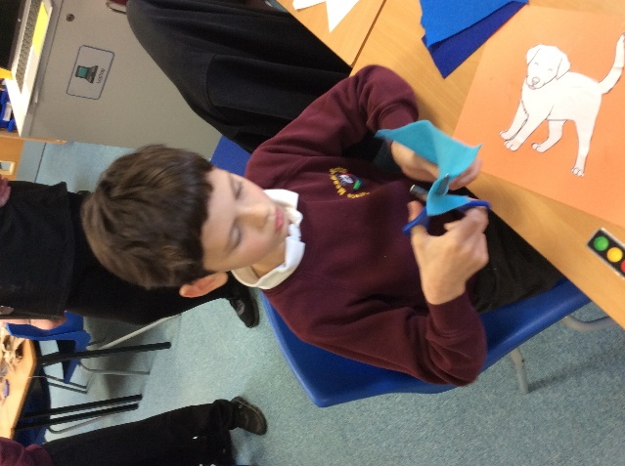
Plan a whole school ‘Scissor-thon’ to promote scissor foundation skills
Responding to a nationwide decline in children's foundational motor skills, Orrets Meadow successfully implemented a whole-school 'Scissor-thon' initiative to explicitly target, develop, and monitor essential scissor proficiency. Recognising that scissor control is a critical precursor to fine motor success, this curriculum outcome bridged targeted staff professional development with high-impact classroom application.
To ensure a cohesive approach, I designed and delivered a staff meeting for teachers. This session deepened their understanding of specific developmental ages and stages of scissor competency. Crucially, teachers directly tried out and tested a range of activities, ensuring they were fully equipped to facilitate three dedicated 'Scissor-thon' afternoons scheduled across the school year.
To secure long-term impact and objective measurement, I devised a bespoke Orrets Meadow Scissor Skills Progression Framework. This structured progression empowers teaching teams to accurately assess baseline abilities, identify fine motor gaps, and systematically monitor individual pupil growth. By blending quality staff training, engaging whole-school events, and a tailored tracking framework, this initiative has successfully elevated the profile of fine motor skills, providing our children with the structural support needed to master this vital life skill.

CPD
Throughout this academic year, my commitment to Continuous Professional Development has focused on driving excellence in Design and Technology through targeted training, professional memberships, and cross-school collaboration.
Engaging in termly online training via the School Improvement Liverpool DT Subject Leader Briefings has provided critical, up-to-date insights into effective teaching and learning practices. A direct success of these briefings was the inception of a new, structures-focused DT Day. Collaboratively developed during staff meetings, this initiative—alongside our whole-school "Scissor-thon" event and ongoing contributions toward the DT Award—has been successfully integrated into our long-term curriculum planning.
To build sustainable, school-wide capacity, I utilised our membership with the Design and Technology Association (DATA). This has granted all teaching staff equitable access to high-quality resources and bespoke online training tailored to their individual developmental needs. Furthermore, establishing collaborative links with Claremount School has allowed us to share innovative ideas and resources, fostering a culture of best practice.
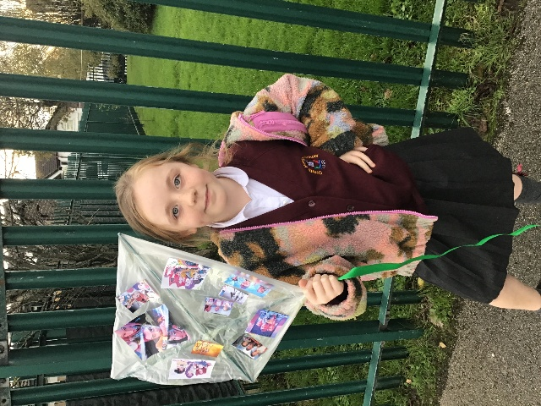
Quality of teaching learning
During the academic year, our primary focus has been to closely oversee the quality of teaching and learning to ensure continuous growth. To achieve this, we implemented a structured framework designed to evaluate both daily instruction and student outcomes.
A central element of this strategy included a targeted learning walk conducted during the Structures Design and Technology day. This provided invaluable, real-time insights into practical teaching methods, collaborative problem-solving, and the effective application of the curriculum in an active environment. To complement these observations, careful book scrutinises were performed across cohorts. This process allowed us to assess the consistency of adaptation to meet children's needs, the pace of learning, and the depth of student progress over time.
Recognising that comprehensive evaluation requires different perspectives, we also deployed pupil and teacher surveys. These forms specifically measured engagement levels and the relevance of current projects to the learners.
The data gathered from these combined activities has now been thoroughly analysed. This evidence provides a clear picture of our current strengths and areas for development, which will directly inform strategic changes and curriculum improvements as we transition into the next academic year.
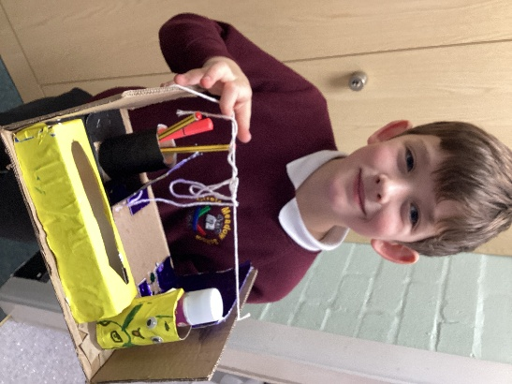
To ensure consistency in our assessments, I have created a school-wide moderation folder for Design and Technology. This folder will serve as a practical benchmark for staff, directly aligning pieces of student work against National Curriculum statements and our Steps progression of skills framework. By compiling clear examples of designing, making, and evaluating from different year groups, we can establish a shared understanding of what age-related expectations look like in practice. This collaborative tool will not only validate teacher judgements during internal moderation but also ensure that the progression of technical skills is built upon as children move through the school.
What were the strengths in your subject you found this year from all your moderation activities?
- The DT Focus days show a clear development of children’s designing, making, and evaluating skills, fostering resilience and self-esteem.
- Continued high-quality work in dimensions and class DT floor books.
- Staff are confident in creating opportunities for building scissor skills.
- Staff enthusiasm in delivering Focus days and the Dimensions DT curriculum.

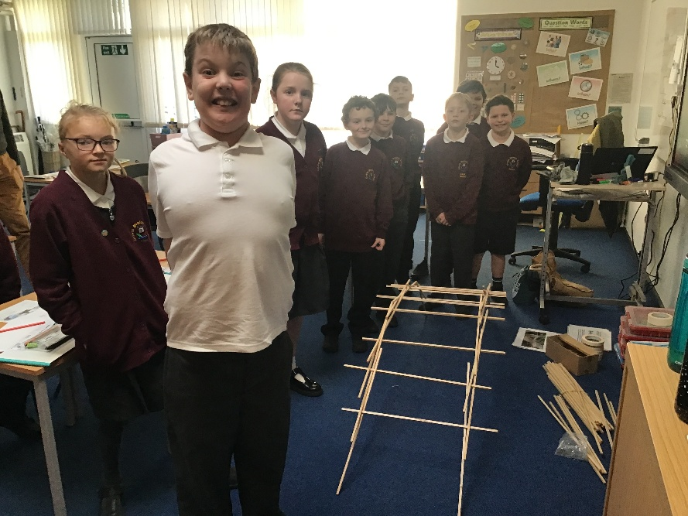
- The creative freedom exhibited in the students designing and making.

Ways Forwards
- Introduce teaching staff to strategies to enable children to engage in an iterative design and make process. Spring Term 1 (30 min slot)
- Explore the suitability of Tinkercad in the DT CAD tool kit for teaching staff.
- Develop oracy in DT through the use of key vocabulary and monitor during DT Focus Days
- Continue to monitor pupil progress in DT
- To keep up to date with the requirements, knowledge and skills in DT through the Liverpool School Improvement DT meetings

