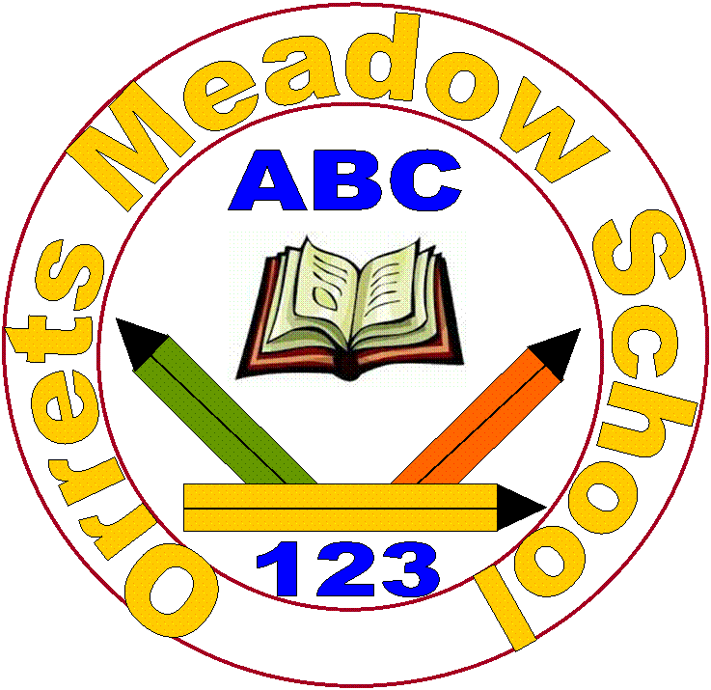
Orrets Meadow School
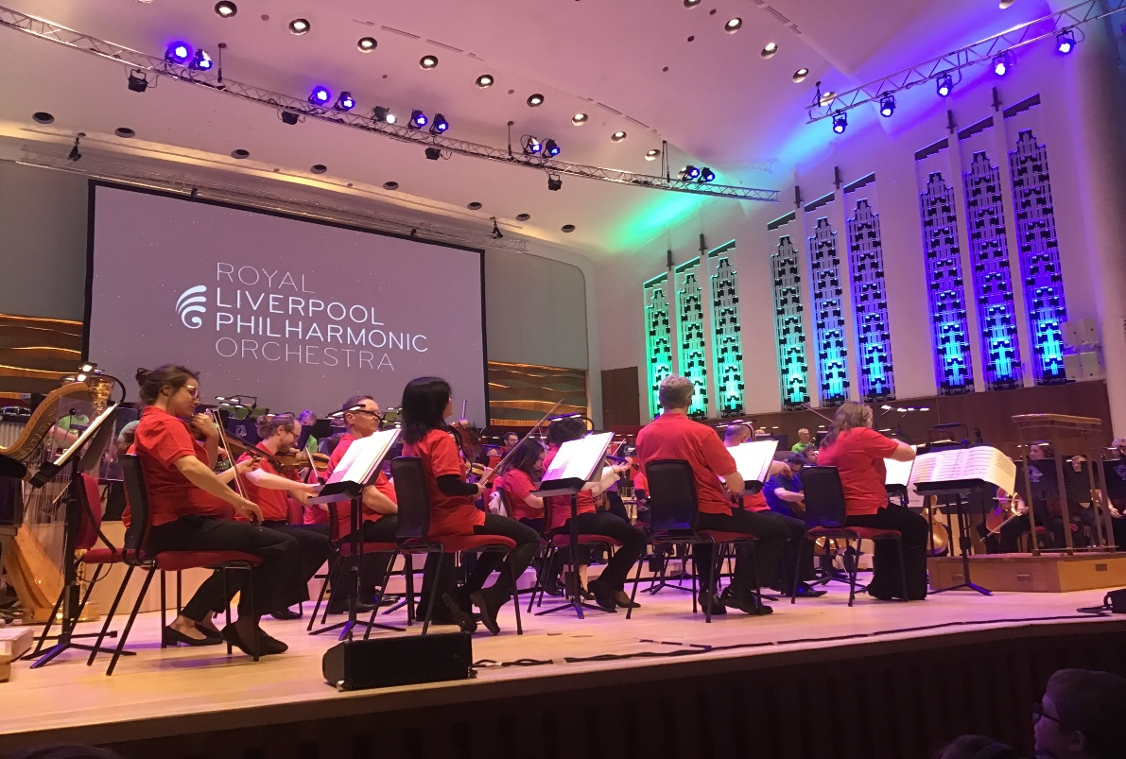
Music Policy

“To raise the aspirations of every child and give them confidence to fulfil their potential through positive experiences”

Orrets Meadow Curriculum Aims and Values
Aims
To ensure all our children are at the centre of a broad, varied and interesting learning experience that is enjoyable and relevant for the future. Our creative, multisensory curriculum will create a sense of awe and wonder and help to inspire a lifelong love of learning. The holistic nature of our practice will promote positive mental health and well-being and will enhance our children’s life skills, social skills and cultural awareness.
This subject is delivered through a trauma-informed approach. We prioritise safe relationships, understand behaviour as communication, and support pupils to regulate, engage, and achieve within a consistent and inclusive environment.
Values
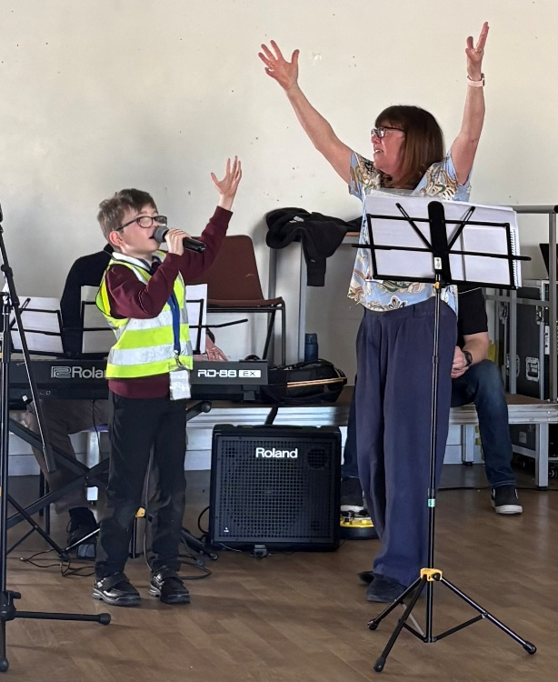
Our curriculum will promote a range of values including:
- Respect
- Empathy
- Responsibility
- Equality
- Independence
- Happiness
- Resilience
- Gratitude
- Honesty
- Friendship
National Curriculum - Music
Purpose of study
Music is a powerful, unique form of communication that can change the way pupils feel, think and act. It transcends different cultures, abilities and generations – stimulating responses on both emotional and intellectual levels. A high-quality music education should engage and inspire pupils to develop a love of music and their talent as musicians, and so increase their self-confidence, creativity and sense of achievement. As pupils progress, they should develop a critical engagement with music, allowing them to compose, and to listen with discrimination to the best in the musical canon.
Aims
The national curriculum for music aims to ensure that all pupils:
♣ perform, listen to, review and evaluate music across a range of historical periods, genres, styles and traditions, including the works of the great composers and musicians
♣ learn to sing and to use their voices, to create and compose music on their own and with others, have the opportunity to learn a musical instrument, use technology appropriately and have the opportunity to progress to the next level of musical excellence
♣ understand and explore how music is created, produced and communicated, including through the inter-related dimensions: pitch, duration, dynamics, tempo, timbre, texture, structure and appropriate musical notations.
In addition, the Model Music Curriculum (MMC) sets out a sequences of learning in the following key areas which, when taken together, all contribute towards the steadily increasing development of musicianship:
- Singing
- Listening
- Composing
- Performing/Instrumental Performance
Within each of these areas are some suggested repertoire choices to support teachers in delivering the curriculum and, in the appendices, suggested approaches to demonstrate the way in which musical listening, meaning, performance and composition are linked.
Orrets Meadow’s Curriculum
We teach a Global Curriculum called 'Learning means the World' (LMTW) for all our afternoon subjects. This curriculum is innovative, forward-thinking and highly relevant to our pupils' needs and thoroughly engages them as they tackle challenging and inspiring topics and issues.
LMTW curriculum has been written with world issues in mind and is centred on 4Cs:-
- Communication
- Conflict
- Conservation
- Culture
Why did we choose 'Learning Means the World'?
As a school which is majority white British, we want our pupils to fully embrace cultural diversity, learning about, experiencing and celebrating a range of different cultural and faith heritages.
We believe that communication is key to accessing learning and securing pupils’ future success. As many of our pupils have Speech Language Communication Needs it is essential that opportunities are given to develop language for learning across the curriculum. With one of its 4 foci being on communication, this curriculum provides lots of opportunities for pupils to develop expressing themselves in discussion, debate and presentation, as well as enabling them to collaborate and exchange ideas.
We feel our pupils, as the future generation, need a greater awareness and appreciation of local, national and global conservation issues and initiatives. The need to learn that they have an important role to play in sustainability. This curriculum gives pupils opportunities to grow and develop spiritually, emotionally, physically and socially in the natural world around them. Our commitment to nurturing positive attitudes and values and developing life and social skills is promoted throughout the Learning Means The World (LMTW) curriculum.

It is theme based and broken down into the following phases:
- Explorers (Foundation level)
- Pathfinders (KS1 level)
- Adventurers (Lower KS2 level)
We have the freedom to teach the National Curriculum in line with our pupils' specific needs and believe that our whole curriculum meets the values and aims which our stakeholders requested at the start of the consultation.
Why is Music important?
Through music, we are provided with a powerful universal language which helps promote unity, enables us to process and express our emotions and fuels our imagination.
Music is important in developing individual discipline, focus and memory.

Whether we are singing, playing, or listening, we develop our aural discrimination through music, which is an important part of communication and literacy.
As a universal language,
music enables children to
break down barriers and
enables communication.

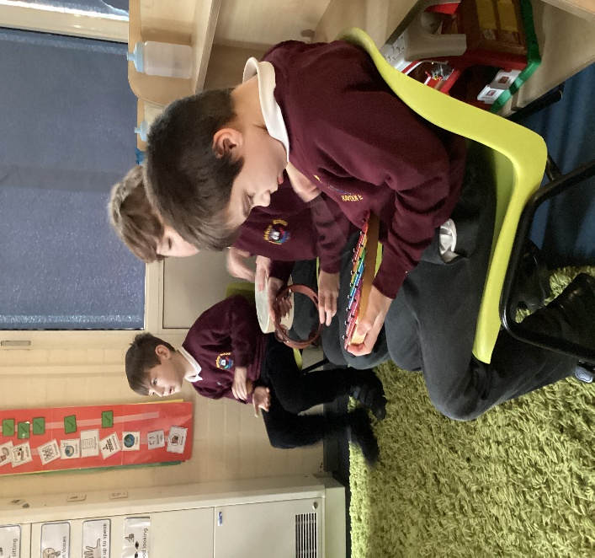

Music helps pupils to appreciate and understand a wide range of traditions and cultures.

Music increases pupils’ confidence through self-expression and performance, as well as providing a sense of achievement.

When is Music taught?
Music is taught through thematic units. The attached overview maps out which thematic units feature this subject and the Long-Term Plan clearly shows the progression of skills across the school.
In addition to the Dimensions Curriculum, we also have six dedicated ‘Musical Mondays’ as blocked afternoons to explore a musical theme using the Charanga Music School.
Our music provision is further enhanced by musicians visiting the school and a yearly trip out to the Liverpool Philharmonic to be a part of the School Concerts. We also work with other schools within our community and we take part in musical workshops and concerts.

How is Music taught?
Music is taught through a combination of subject knowledge and composing, performing, listening and appraising skills. Learning takes place both inside and outside the classroom.
Access to the curriculum
We aim to make an enjoyable learning experience and encourage all children to participate in a wide range of musical activities. Adaptions are frequently made to accommodate the challenging sensory needs of many of our pupils. Specialist items such as noise cancelling headphones and low resonance instruments such as Boom whackers make composition and performance a much less noisy affair for those that prefer it that way.
What do we learn about in Music?
We learn about the following:-

- Graphic scores
- Notation
- Signs and symbols
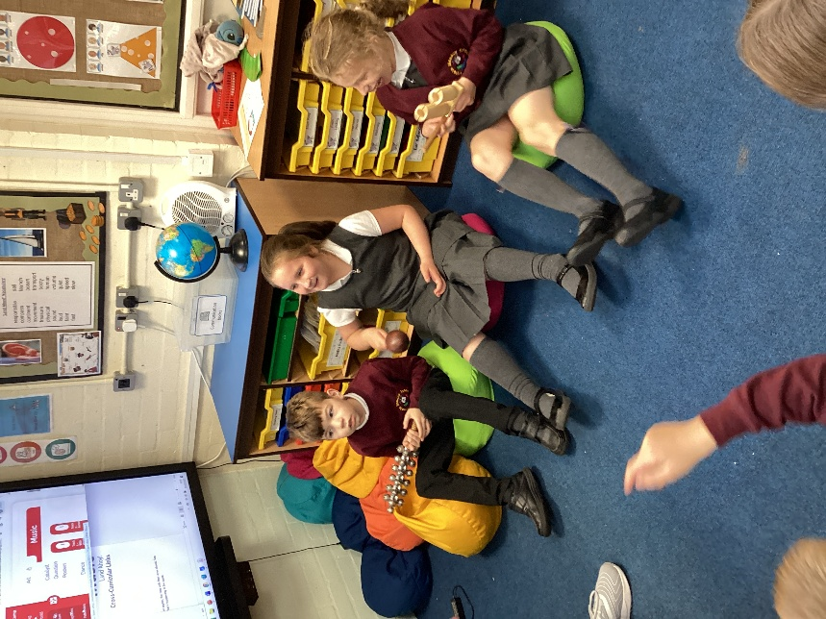
- Soundscapes
- Sound effects
- Singing
- Sea shanties
- Folk songs
- National anthems
- Slave songs
- Battle chants
- War songs
- Cyclic patterns
- Instrument families
- Evolution of instruments
- African music, including drumming
- Celtic music
- Hannukah music
- Jingles
- Film music
- Musicals
- Inuit throat singing

Who do we learn about in Music?
We learn about a range of famous composers from history, such as J.S. Bach, Ludwig Van Beethoven and Rimsky-Korsakov.
We also learn about more contemporary composers, such as Andrew Lloyd-Webber.

Music allows pupils to
express their feelings and
ideas through
composition and
performance.

Music Topic Overview

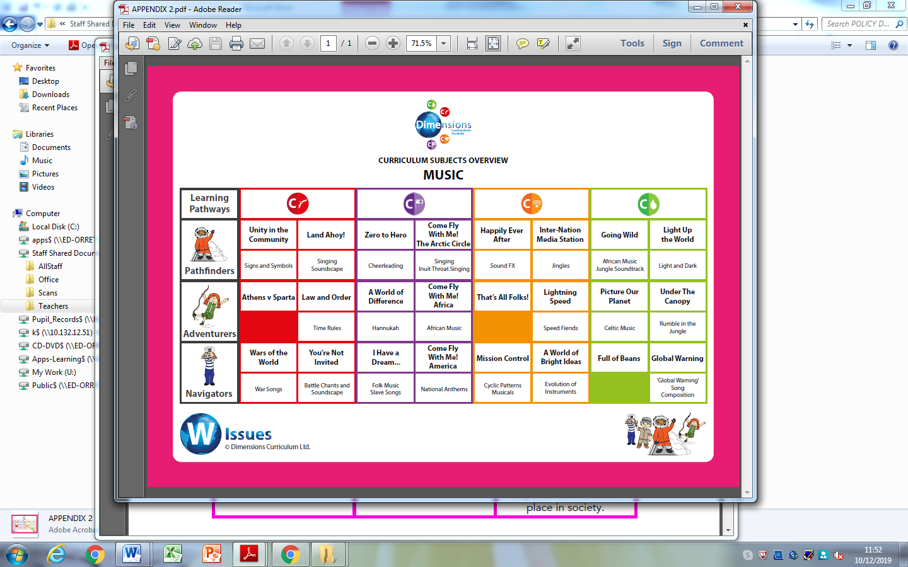

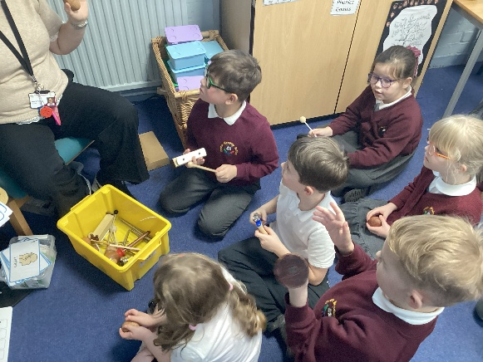

“When words fail, music speaks” Beethoven
Beehoven

Music knowledge builder across the school

Pre – Curriculum

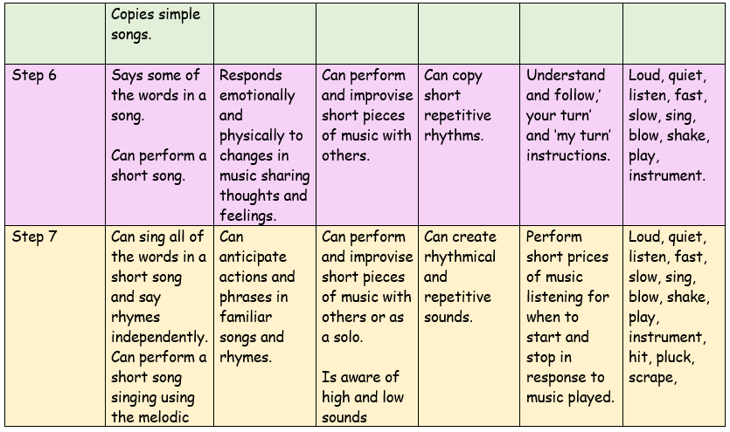
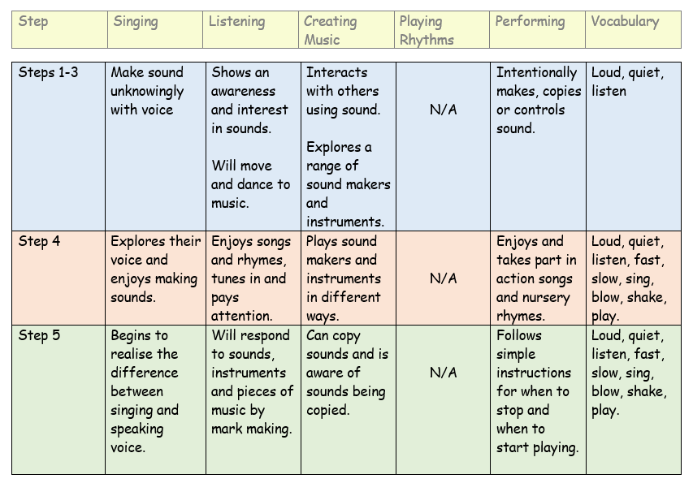

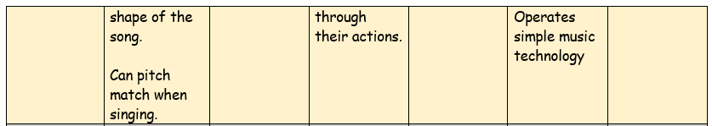

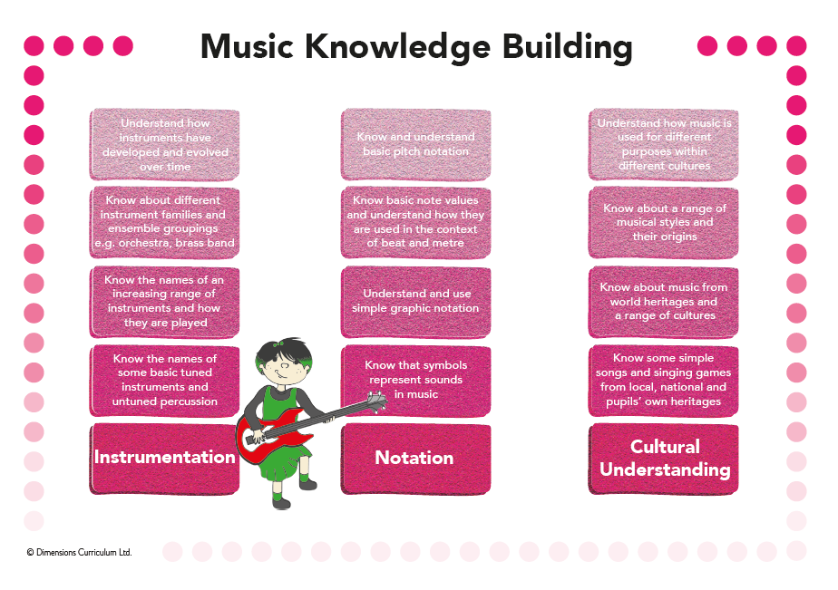

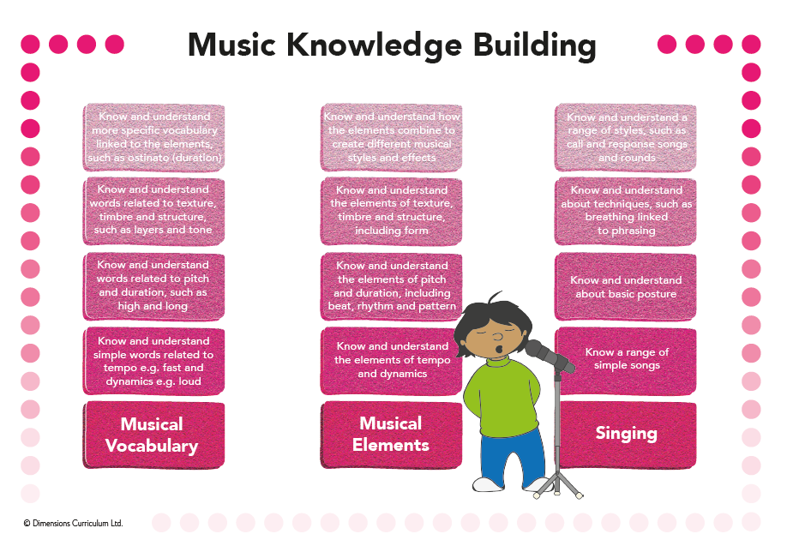

Long Term Plan – Progression of skills
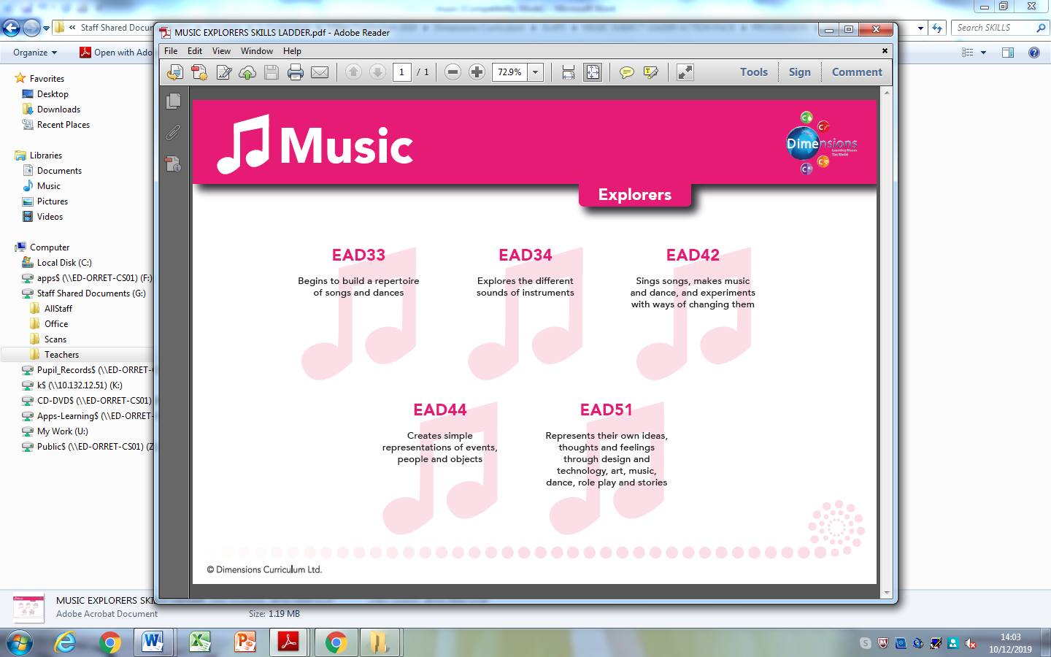

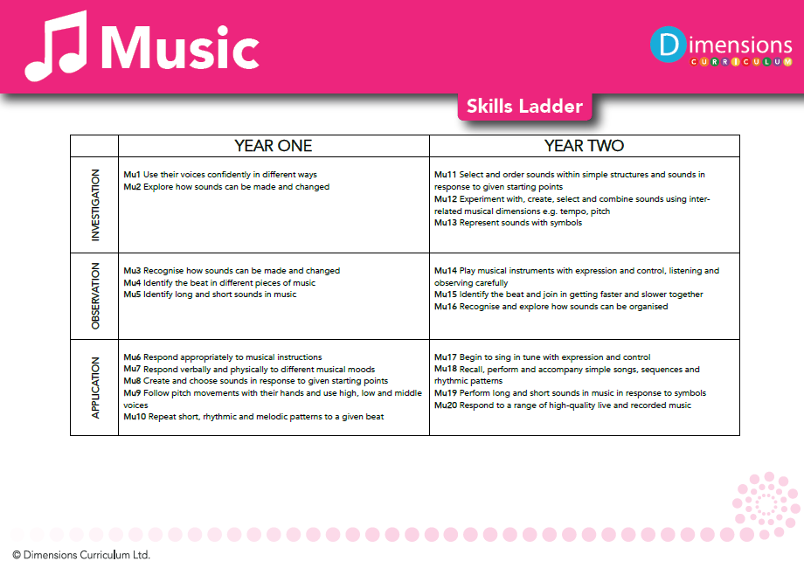

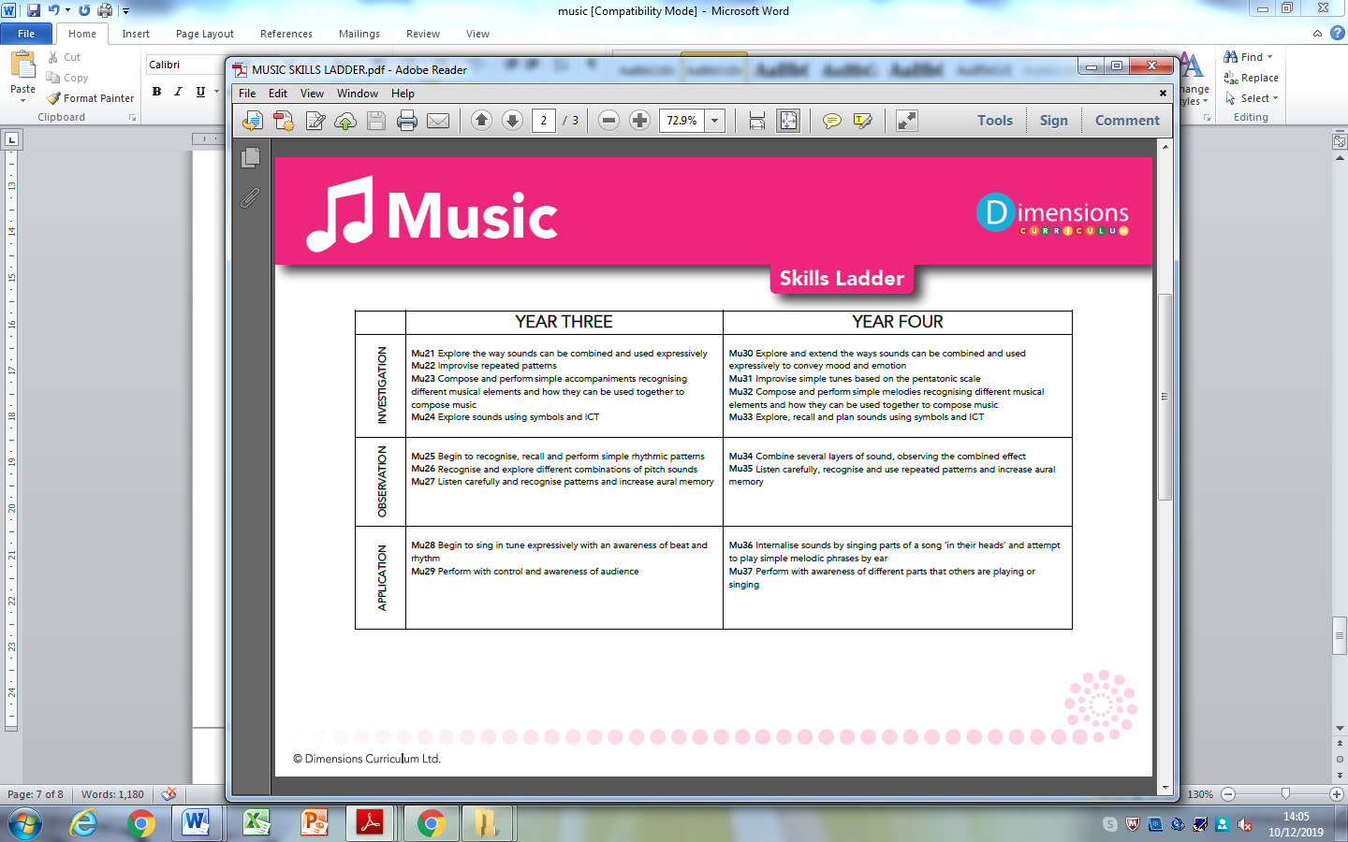

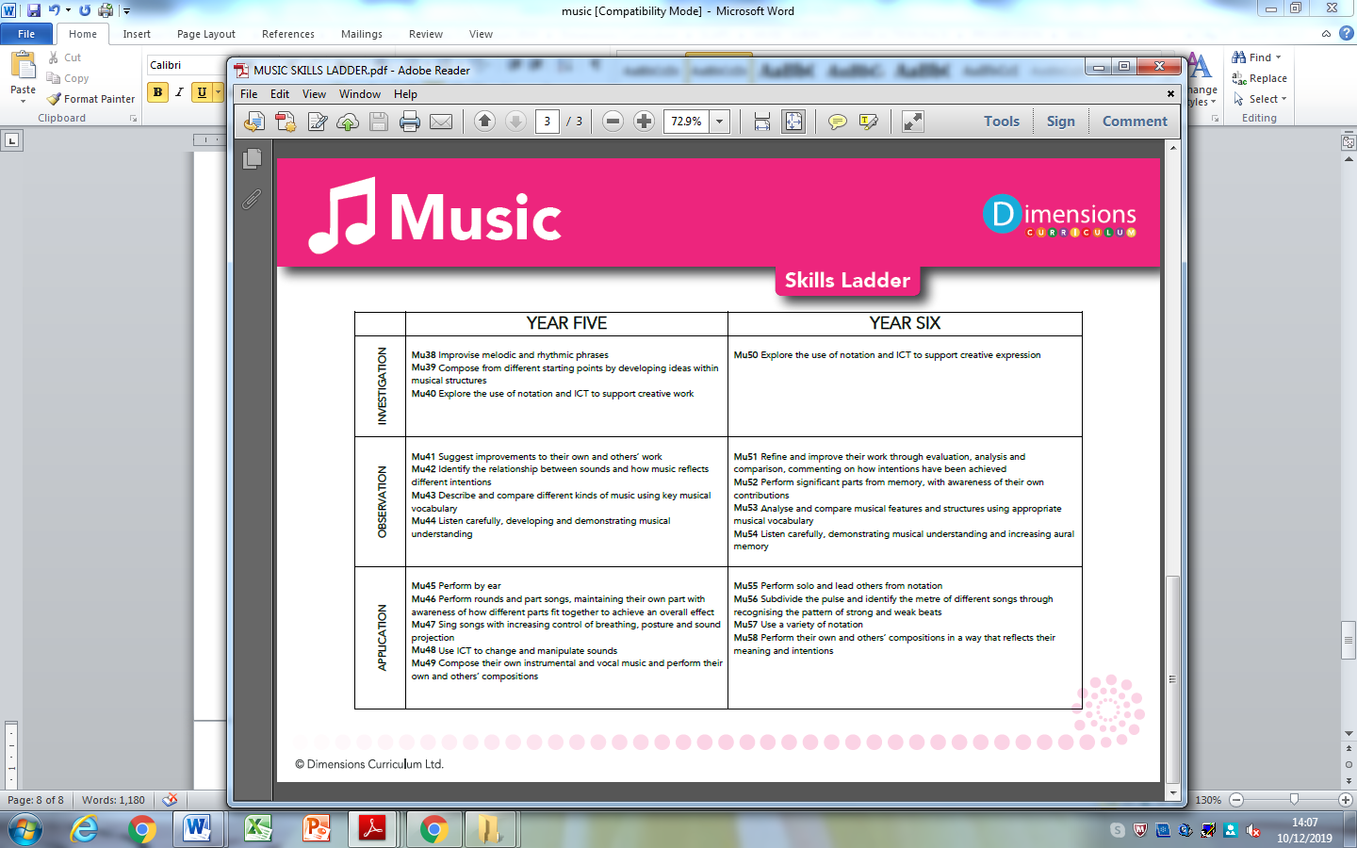

How do we assess and monitor music

Music enables children to develop an understanding of culture and history, both in relation to children individually, as well as ethnicities from across the world. Children are able to enjoy music in as many ways as they choose – either as listener, creator or performer. Children have the opportunity to discuss and share their own thoughts, opinions and ideas, acknowledging and respecting that these may vary and that this is positive. They can dissect music and comprehend its parts.

We measure impact by analysing the whole school data produced twice a year. This allows the Music Lead and Class teachers to identify gaps in learning and any areas for development.

Using a simple decimal grading system of 0-6 teachers make a judgement on each pupil’s progress, taking into account the overall evidence gathered through observation, conversation and examination, using their own professional judgement. Awarding a '4' would indicate a pupil is working within the year 4 skill set and a 4.6 would indicate that they have attained over half of the skills in year 4.

As many of our pupils have short term memory difficulties, they find retaining knowledge especially difficult, so we use Kahoot quizzes throughout the units to support them remember ‘Sticky Knowledge’. These quizzes make learning fun, engaging and impactful. Teachers can use the readymade quizzes created by Dimensions for each unit or they can create their own to introduce the topic, review and reinforce knowledge and use the information gained to help them identify which objectives have been achieved.

Each child’s grade is collected twice a year for SLT, subject leaders and teachers to gain valuable knowledge on how the child, class and school are working in each subject.

SLT, teachers and subject leaders use assessment for learning to inform planning, teaching and learning and CPD opportunities.

SLT and subject leaders are continuously monitoring their subject to ensure it meets the needs of our pupils. They monitor using a variety of activities, including:

- Learning walks
- Book scrutiny
- Lesson observations
- Pupil survey and discussions
- Staff survey and discussions

