**Governor Report - Summer 2025**

**Geography**

**Hannah Dunning**

### ****Achievements****

Develop a structured progression plan for Geography curriculum implementation at steps level (Autumn 2024)

This academic year began with the implementation of a structured ‘**steps Level progression plan**’, a **pre-curriculum framework tailored to meet the diverse needs of our SEN pupils.** This approach ensures that foundational geographical concepts are introduced in a clear, accessible, and sequential manner, enabling all learners to build confidence and understanding from their individual starting points. A key success of this strategy is evident in our **pupil survey results**, with children across the school—from **Wolves to Sharks**—now confidently identifying the **country we live in** and where our **school is located**, demonstrating progress in their locational knowledge and spatial awareness.

Implement a dedicated "Geographical Skills Morning" to hone students' fieldwork, map-work, spatial awareness and analytical abilities (Spring 2025)

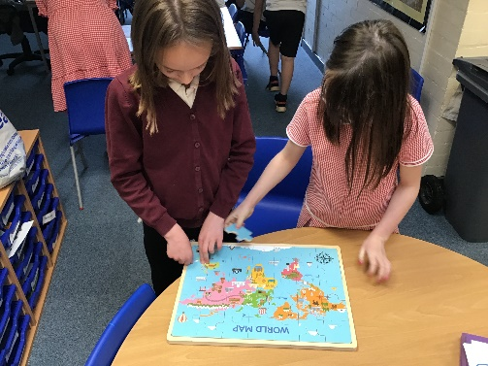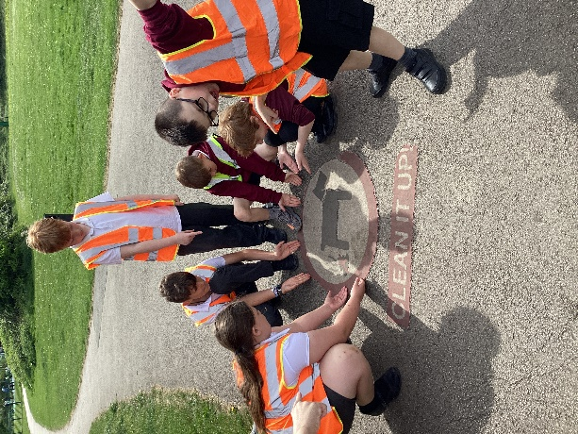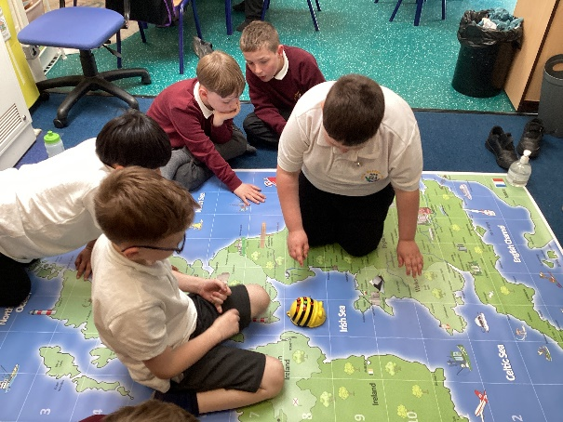Our first Geographical Skills Morning was a resounding success. Pupils engaged in a carousel of interactive activities that developed core geographical skills. Activities were designed to develop **map-reading, orienteering, investigation, observation, and analytical thinking** ina highly practical and immersive format. The event was praised by staff for its creativity, structure, and impact on learning. Feedback included comments such as:  
*“The children were fully immersed and loved the activities.”*  
*“It was fantastic to see Geography come to life in such a hands-on way.”*

The success of this event reinforces the value of dedicated curriculum enrichment days and sets the stage for further development in coming years.

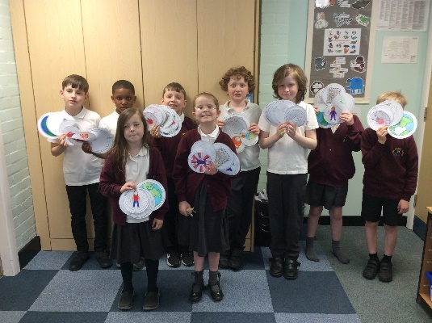

Organise Geography-sponsored walks for each class, focusing on orienteering in the local area throughout the academic year, with proceeds contributing towards school trips (Summer 2025)

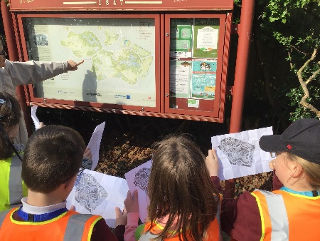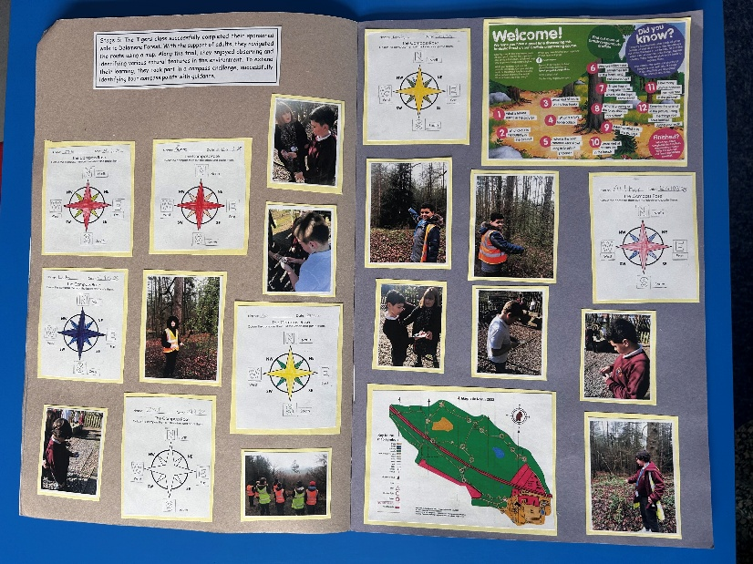The Geography-sponsored walks brought together physical activity, fundraising, and curriculum learning in a powerful way. Each class participated in a **sponsored walk,** using their local environment to apply real-world geographical skills. These included **map reading, compass navigation, sketching, and observation**; giving pupils the chance to engage in authentic fieldwork linked to our progression plan. The walks also provided a platform for orienteering and surveying, sparking discussions about human and physical features of the Wirral area. In addition to curriculum benefits, the walks raised over **£2,100** to support school trips. The blend of purposeful fundraising and curriculum-driven activity made this one of the highlights of the year.

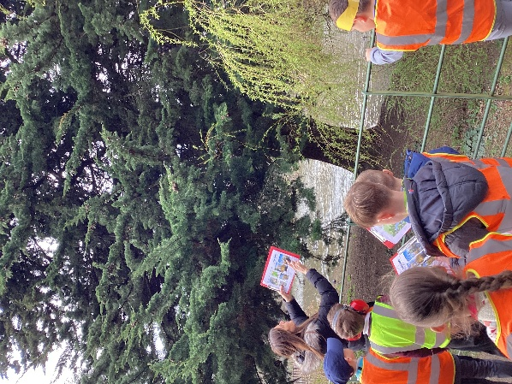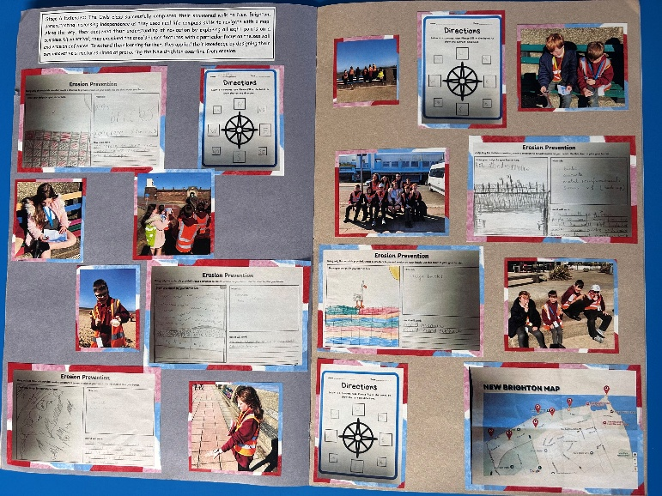

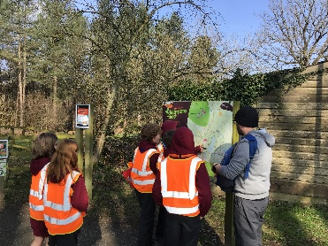

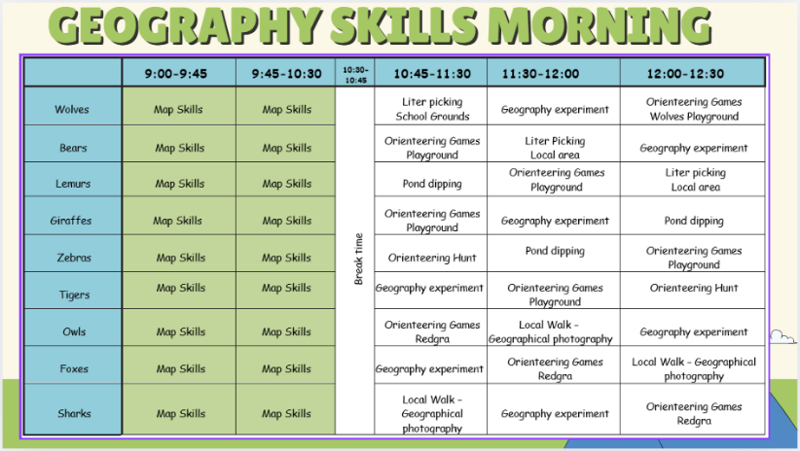

### ****CPD****

* Completion of NPQLT qualification
* Geography Staff Meeting Sept 2024
* Geography Autumn Briefing 2024
* Geography Fieldwork Staff Meeting Mar 2025
* Geography Spring Briefing 2025
* Clare Mount Book Moderation Summer 2025

### ****Quality of Teaching and Learning****

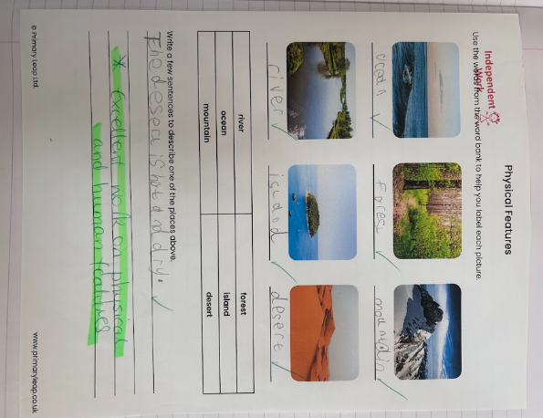As subject lead, I have continued to support colleagues in developing their subject knowledge and confidence through staff meetings, shared resources and an open-door policy offering ongoing support around the teaching and learning of geography.

**Learning walks** conducted throughout the year have shown high-quality, adaptive teaching. Teachers continue to embrace innovative, immersive methods that engage our diverse learners effectively.

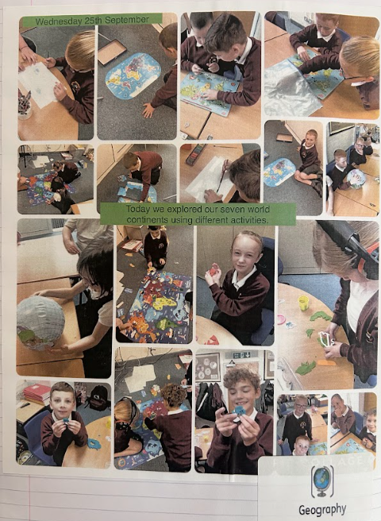A **book scrutiny** once again revealed beautifully presented, progressive work that reflects our whole-school commitment to high standards in Geography. During our **moderation visit from Clare Mount**, we received **positive feedback on the quality of pupils’ work, particularly the Geography Skills book**, which was praised for its clarity, structure, and evidence of progression.

The **pupil and staff surveys** showed a continued preference for immersive learning experiences over traditional written tasks. These findings reinforce our decision to prioritise **interactive, multi-sensory learning approaches** that support retention and enjoyment of geographical knowledge.

This year, Geography has been enhanced through a range of enrichment activities designed to broaden pupils’ experiences and build cultural capital. Pupils engaged in meaningful fieldwork through the sponsored walks and our Geographical Skills Morning, applying key geographical skills in real-world contexts.

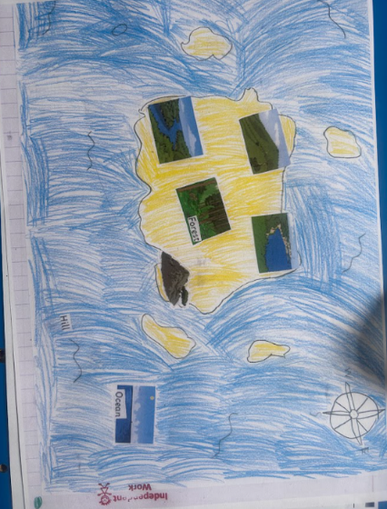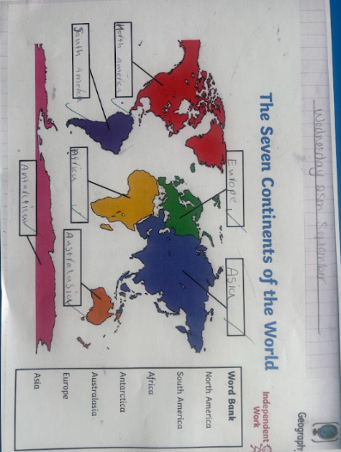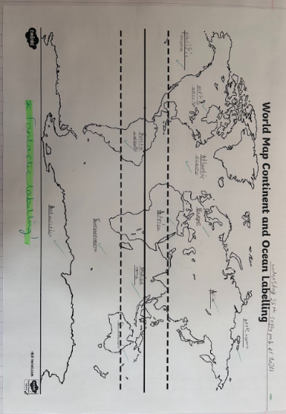We continued to explore and celebrate our local area through the Wonders of the Wirral theme, helping pupils develop a stronger sense of place and community. These opportunities supported pupils’ understanding of both human and physical geography, while also fostering curiosity and global awareness across all year groups.

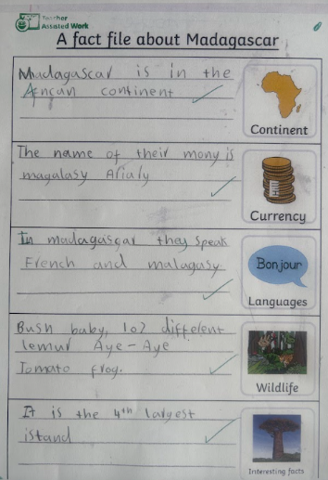

### ****Strengths****

The Geography curriculum at Orrets Meadow continues to flourish through:

* A robust multi-sensory approach to learning that engages all types of learners
* Purposeful and well-sequenced curriculum delivery, including progression at Steps Level for SEN pupils
* Inclusive teaching practices that adapt to the diverse needs of our students
* Excellent use of local learning opportunities, including the *Wonders of the Wirral* theme
* Real-world application of geographical skills through dedicated events such as the Geographical Skills Morning
* High-impact fieldwork experiences, including the Geography-sponsored walks, which combined outdoor learning with curriculum-linked skill development
* A strong emphasis on developing core geographical competencies, including map-work, observation, and orienteering guided by **Ofsted-backed research on the importance of high-quality fieldwork experiences**

### ****Ways Forward****

* **Embed the Steps Level Progression Framework**Continue refining and embedding the structured Steps Level curriculum to ensure consistency and clarity in progression across all classes, supporting staff to confidently implement it in everyday teaching.
* **Consolidate High-Impact Geographical Events**Maintain successful initiatives such as the Geographical Skills Morning and sponsored walks as annual events, focusing on enhancing quality and pupil engagement rather than expanding the programme.
* **Develop Practical, Ongoing Assessment Methods**Introduce manageable assessment tools (e.g., annotated photo evidence, skills passports, pupil observations) that reflect the multi-sensory and practical nature of Geography teaching, ensuring meaningful tracking of pupil progress.
* **Create a Geography Evidence Folder for Moderation**Compile a working evidence folder showcasing progression from Steps to Year 4, including pupil work, photos, assessment notes, and examples of key geographical skills. This will support internal and external moderation and provide a clear picture of curriculum impact.

### ****Targets 2025–2026****

* **Continue to embed the Steps Level curriculum** to ensure consistency and clarity in progression across all classes*.* (Autumn)
* **Maintain successful initiatives** such as the Geographical Skills Morning and sponsored walks as annual & biannual events. (Spring)
* **Create an evidence folder of work for moderation** showing progression from Steps to Year 4. (Spring)
* **Lead a staff meeting refresher** to prepare for the next Geographical Skills Morning, ensuring consistency, clarity, and high-quality delivery across all classes. (Spring)