**Governor Report- Summer 2025**

**Science**

**Charlotte O’Brien**

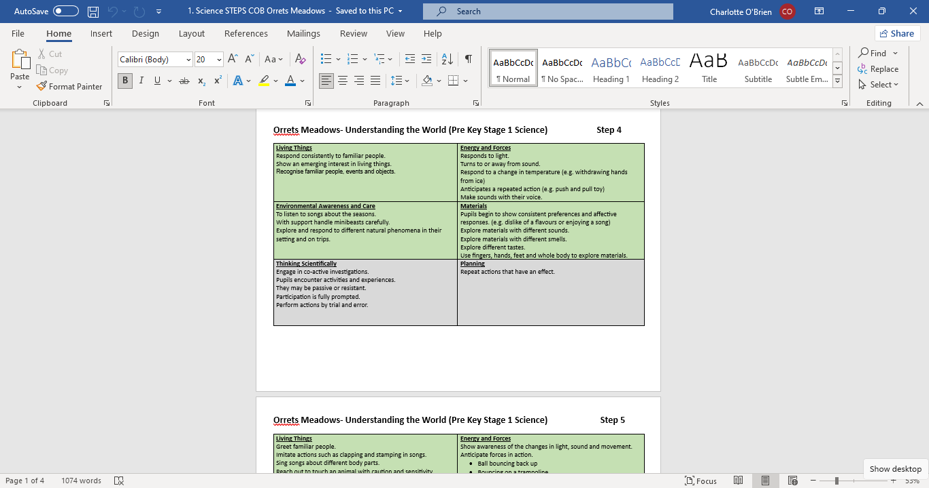**Achievements**

* The Steps for Science were written in the Autumn Term and agreed by the staff in a staff meeting during the Spring Term. They were adapted from the Development Matters (2023) an Early Years document and reflect current practice at Orrets Meadow.
* 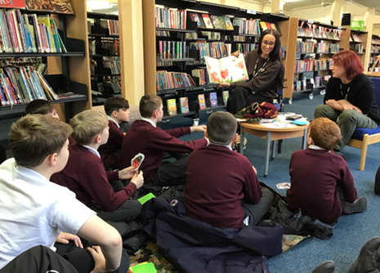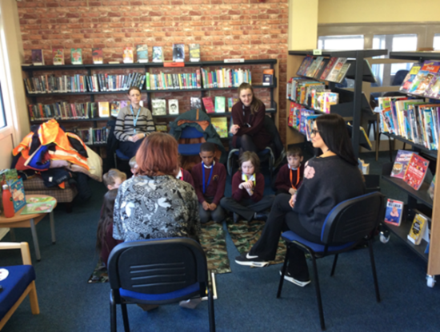Children have continued to develop Science Learning outside the classroom through the visits to Moreton Library. They have taken part in the ‘Wild About’ a programme created by the Rangers Service and Wirral Library Services looking into nature, habitats and food chains. They have explored the library looking at books linked to topics and completed a nature treasure hunt.
* We have continued to improve cultural capital by offering our students the opportunity to meet scientists. During our Science Week in February, we invited parents to talk about how they use science in their career. There were lots of responses and parents arranged to visit their child class.

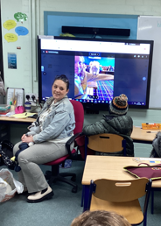

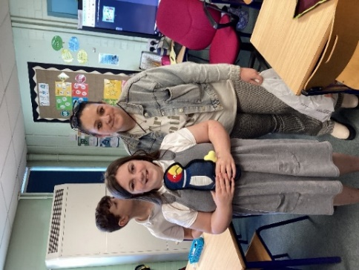

Ms Antley talking to the Owl class about her role as a Veterinary

Care Assistant.

* Classes have continued to make the most of our location to bring science learning to life through trip linked to topics
* 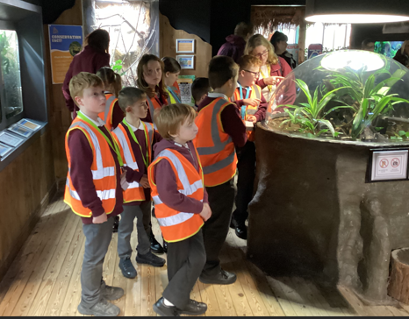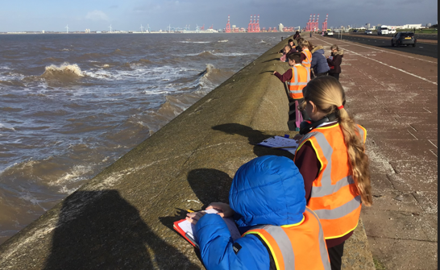

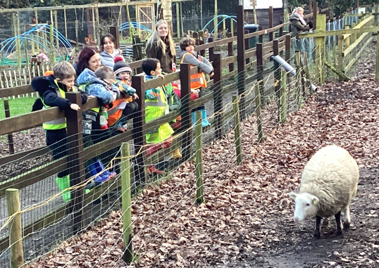

* Later in the Summer Term Year 6 will visit the Science Labs at Clare Mount Specialist School to enhance their transition to secondary school.

**CPD**

* **Eureka! Science + Discovery- Primary Science Conference** 1/7/24

The Primary Science Conference at Eureka Science+Discovery proved useful for ideas to enhance our offer in science.

* **Primary Science Subject Leader Briefing- Autumn Term** 22/11/24
* **Primary Science Subject Leader Briefing- Spring Term** 20/03/25
* **Primary Science Subject Leader Briefing- Summer Term** 26/06/25
* **Primary Science Conference -Ness Gardens** 1/7/25

**Quality of Teaching and Learning**

* 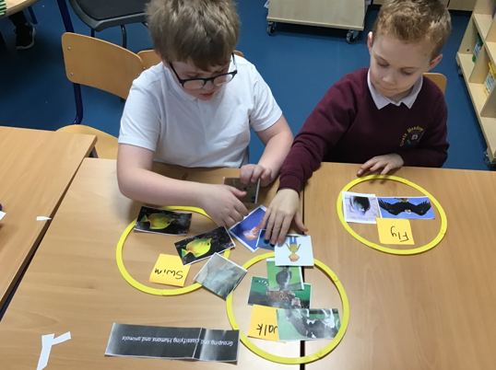**Science Subject Leaders Folder-** To monitor the quality of teaching and learning in Science, a Science Leader’s file is kept updated. All the relevant policies and documents are kept in one central place. The Science policy has been updated to reflect Science teaching and learning at Orrets Meadow.

* **Moderation-** This year we met with teachers from Clare Mount School to moderate our curricula and share best practice in science.
* 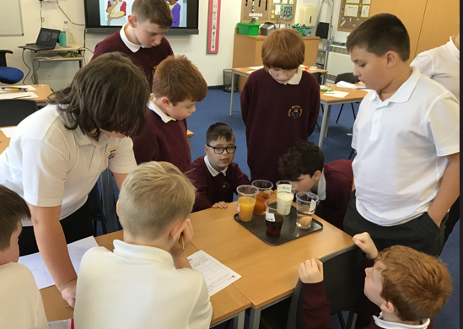A **Learning Walk** in the Autumn Term demonstrated a wide range of activities adapted to for the needs of the children. Progression of skill and knowledge was evident across the school and all children were engaged in their learning.

* The **Children’s Survey** showed that Science is a popular subject across school with 89% of children saying they like science a lot. The children all knew they were doing well and making progress in science and could share fact they knew about science and important scientist.
* The **Teachers Surveys** revealed that 60% of teachers ranked their confidence in teaching science as 9 or 10 at he top of the scale and 40% of the teachers ranked their confidence as a 7 or a 8. Teachers requested CPD for Electricity, Investigations, Data Loggers and Early Years Science which will become part of a staff meeting. Teachers also requested a review of Science APP so that objectives are more precise and less repetitive.
* 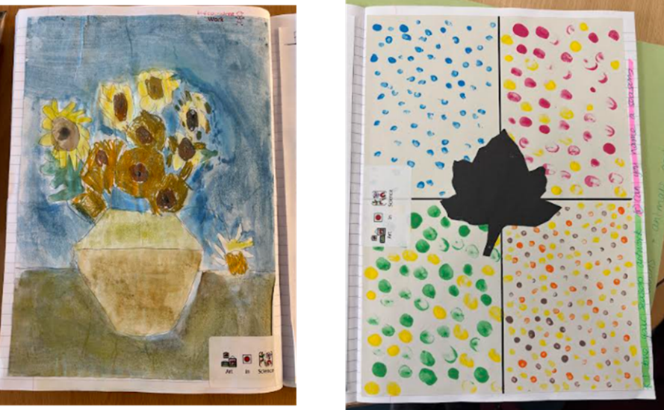**Book Scrutiny**- in November and May book scrutiny’s have shown creativity and progress through the curriculum. Teachers have maintained the high standards and range of curriculum enhancements. Some teachers have embraced Science in Art and encouraged wonderful Scientific themed art to encourage long term recall of science knowledge.

**Strengths**

* We have a robust curriculum that meets all the demands of the National Curriculum and beyond.
* All staff have a clear understanding of the value of science and are confident teaching science.
* We have a wide range of multisensory resources to support skill and knowledge development across the school.
* Children enjoy science a lot at Orrets Meadow. (89%)
* Most children can say who uses science in the real world (83%) with (89%) of children able to name a scientist.
* 100% of children know they are doing well in science.

**Ways forwards**

* Review APP sheets for Y1-Y6 -Autumn Term
* Develop CPD ideas for staff meetings- Spring Term
  + Investigations
  + Electricity
  + Early Years
  + Data Loggers
* Monitor Art in Science-On going
* Create an evidence folder for science- Summer Term

