Subject Report for Governors - History
Mel Pickering
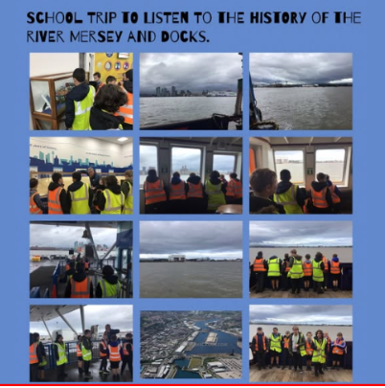
Achievements
Steps Moderation file
All staff are now assessing against the History steps implemented last year and a moderation file to show progression and knowledge acquired has been produced showing a range of multi-sensory learning has been developed. It shows various samples of work across year groups embedded the ‘Golden Thread’ of Never Give Up in some topics.

History Week:
A highly successful History Week took place in the Autumn term, featuring a range of activities across the school designed to engage pupils with key historical themes and periods. Pupils explored local and global history through creative tasks, role-play, and collaborative projects. Pupil and staff voice has shown that everyone thoroughly enjoys this special week. Pupils were able to recall knowledge from the Egyptians through to the Stone Age Era. A variety of work showed achievement of some of the Historical steps being achieved such as how Boudicca didn’t give up when attacking the Roman cities. Moving forwards the theme of the ‘Golden Thread’ has begun to be explored in some classes but has not yet been embedded in all classes. This will be a future target with a staff training ideas session to be planned in the new academic year to share resources and ideas.
Use of AI
Zebra Class visited Clare Mount School to participate in a VR headset experience about the Romans. Staff have gained knowledge on the use of AI and how it can enhance the curriculum.

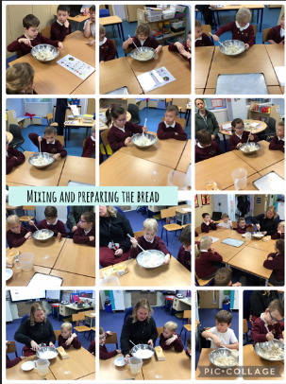
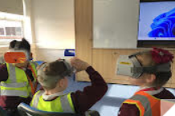
Lots of children explored how to make ‘Viking bread’ and related making bread in ‘Pudding Lane’ in their topic of The Great Fire of London.



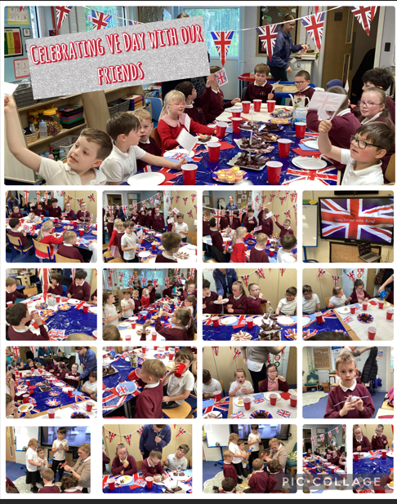
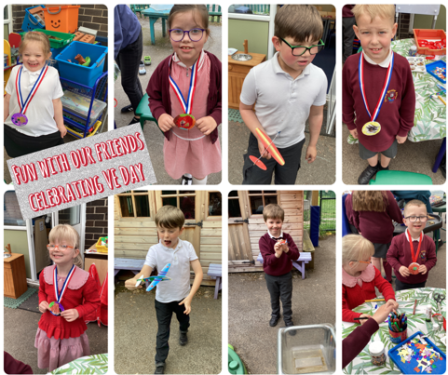
VE Day Celebrations:
The school marked VE Day within their class using cross-curricular activities linking History with English and Art. A special VE day afternoon tea was held in Bears Class who invited the members of Giraffes to achieve a real sense of community on the day. Pupils gained a deeper understanding of World War II and the significance of VE Day in British and global history and lots of lovely cake at the same time. The children listened to the National Anthem and enjoyed creating fun memories with their peers.

CPD
- History Staff Meeting Sept 2025
- History Autumn Briefing 2025
- History Spring Briefing 2026
- Clare Mount AI suite tour Spring 2026
- Clare Mount Book Moderation Summer 2026
Staff Meeting – Focus on The Golden Thread:
The staff meeting this year focused on introducing the Golden Thread of ‘Never Give Up.’ Staff shared ideas how to implement this across their planning and how to ensure that resilience is celebrated. Suggestions were given how to embed significant others in a range of topics and were added to planning.
Collaboration with Clare Mount Staff:
A really interesting afternoon was spent with the Humanities staff at Clare Mount School will hopefully be the beginning of a collaborative partnership, which will hugely benefit Orrets Meadow. We discussed the use of AI and had I was given a tour of their immersive ICT suite. Future events were planned to swap resources and for staff from Clare Mount to visit during our History week to share their knowledge and skills.
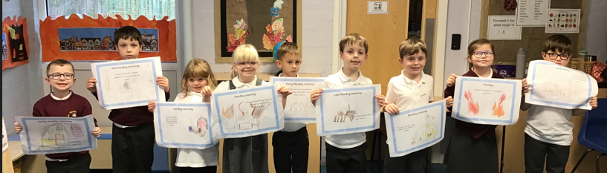
Quality of Teaching and Learning
Observations indicate that History lessons are well-structured, engaging, and effectively adapted. Book scrutiny demonstrated an outstanding range of multi- sensory opportunities for our children, which allowed the children to become fully immersed in their learning, and the daily quizzes ensured the sticky knowledge was embedded, leading to long term retention.
Feedback from staff indicates confidence in teaching their particular units during history week and a clear enjoyment. Staff shared ideas for retention of knowledge which will be shared in the next staff meeting. Pupils report enjoying History lessons, particularly those involving multi-sensory learning- trips out, food tasting and art and craft were mentioned by children as opportunities which help their learning. Enrichment activities have included practicing skills of archaeology of chocolate chip cookies, to trips out to the Liverpool Museum and Liverpool Mersey Docks.
Strengths
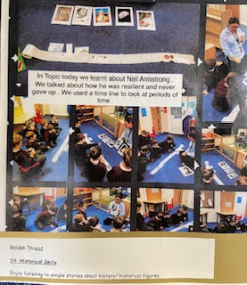
- Staff knowledge is a real strength of the school in history- teachers know their particular subjects really well and understand the importance of chronology and how to teach it to children with additional needs. A key strength is the effective use of timelines. Staff have demonstrated versatility in their approach, utilizing everything from practical, hands-on methods to digital photographic formats.
- Evidence conveys inclusive teaching practices that are adapted to the diverse needs of our students. A key feature of the history curriculum is its diverse, practical approach, which heavily incorporates the use of real-world artifacts to enrich learning
Ways Forward:
- To embed the ‘Golden Thread’ of ‘Never Give Up’ based on one of the school values across all classes (Autumn term)
- Continuing the collaboration with colleagues from Clare Mount, looking to enrich the subject of History through the use of AI. (termly)
- To implement a new History Literacy Spine adhering to The Reflecting Realities framework, pioneered by the Centre for Literacy in Primary Education (CLPE) to increase ‘Oracy’ throughout History week (Autumn term)
- Lead a staff meeting to promote ‘oracy’ within History (Autumn term)

