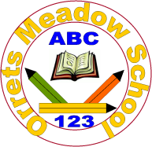
Governors Report – June 2026
English
Matthew Ferris-Rice

Overview & Priority Focus:
This academic year the main focus for English has been to monitor the implementation and impact of the new whole-school writing curriculum. Following the redevelopment work completed during the previous academic year, the priority has been ensuring that the curriculum is embedded consistently across the school and continues to meet the needs of our pupils.
The new writing curriculum is now fully implemented across the school. Throughout the year I have worked closely with staff to monitor its effectiveness, gather feedback and refine elements where necessary. Monitoring activities, pupil outcomes and staff feedback indicate that the curriculum is having a positive impact and is supporting pupils to make strong progress within writing.
Achievements:
There have been some real strengths and highlights throughout English this year. These include:
- Full implementation of the new whole-school writing curriculum.
- Introduction of daily handwriting sessions across the school.
- Foxes Class having their poetry published through the Young Writers competition.
- A successful World Book Day, including a whole-school book treasure hunt and free books for pupils.
- A live online author event with Dame Floella Benjamin, with all classes receiving a copy of Coming to England.
- Internal and Oak Trees MAT moderation events focused on writing progression and independence.
- Continued accelerated progress in reading across the school.
- Positive feedback from governors, the CEO and visitors during learning walks and monitoring activities.
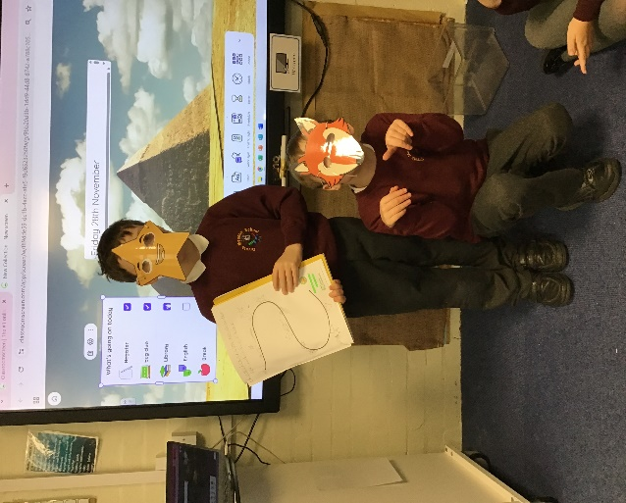
Curriculum Development:
Bears performing their stories
Although the curriculum has now been fully implemented, development work has continued throughout the year. This has included reviewing medium-term plans, literacy spine texts, outcomes documents and progression documents. Staff have played an important role in this process through regular feedback and discussion.
Particular focus has been placed on reviewing the literacy spine and ensuring texts remain engaging, ambitious and appropriate for our pupils. This work will continue next year as part of our ongoing curriculum review cycle.

Staff and Pupil Voice:
Staff and pupil voice have continued to play an important role in curriculum development this year.
Staff were consulted on a range of areas including the implementation of the writing curriculum, outcomes documents and Wonders of Wirral planning. Feedback has been overwhelmingly positive and has helped inform further refinements.
Pupil surveys and discussions during learning walks continue to show high levels of engagement with reading and writing. Pupils are increasingly able to discuss books they enjoy and talk confidently about themselves as readers and writers.
Staff Training and CPD:
Staff development has remained a key priority throughout the year.
Support has been provided in areas including writing, moderation, phonics, handwriting and adapting learning for pupils with a wide range of needs.
Several moderation events took place throughout the year, both internally and across Oak Trees MAT. These sessions focused particularly on writing within the Steps framework and generated valuable discussion around progression and independence.
As subject leader I have continued to attend Sarah Squared English Leader updates throughout the year. I also attended the Oracy North West event at Fender Primary School.
Reading for Pleasure:
Reading for pleasure continues to be a significant strength at Orrets Meadow.
Reading Ambassadors have continued to meet throughout the year and have played an important role in promoting reading across the school. During Spring 2, leadership of the group transitioned to Mrs Walsh, who has continued to build upon the excellent work established previously.
The library continues to be well used by pupils and I have continued to expand and maintain the digital library system.
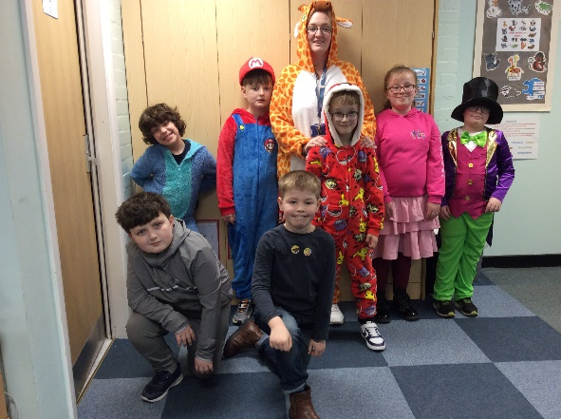
World Book Day was once again a fantastic success. Pupils came dressed as their favourite book characters and took part in a range of reading activities throughout the day. A whole-school book treasure hunt returned by popular demand, with pupils receiving a free book to take home.
Giraffes class ready for World Book Day
Pupils have also benefited from a range of author experiences throughout the year. One particular highlight was a live online session with Dame Floella Benjamin. Following the event, every class received a copy of Coming to England and many classes used the text within their English lessons.
Learning walks have also highlighted the effective use of author videos within lessons. In one session pupils were highly engaged while watching Michael Rosen perform Chocolate Cake, demonstrating the positive impact that authors can have in developing enthusiasm for reading and poetry.
Curriculum Enrichment and Pupil Achievement:
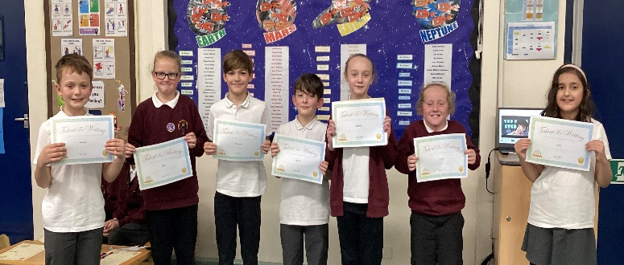
English continues to provide pupils with opportunities to engage with reading and writing beyond the classroom.
Owls class with their Young Writers certificates
Foxes and Owls successfully had their poetry published through the Young Writers competition. This was a fantastic achievement and provided pupils with a genuine sense of pride in their writing.
The continued development of the literacy spine has ensured that pupils are exposed to a wide range of high-quality texts, authors and poets. Combined with author events and reading promotion activities, pupils continue to experience a rich and engaging English curriculum.
Handwriting:
One of the most significant developments this year has been the introduction of daily handwriting sessions across the school.
All classes now participate in a structured fifteen-minute handwriting session each day. Staff received initial training and early monitoring has shown positive engagement from pupils and improving consistency across classes.
Quality of Teaching and Learning:
Monitoring has continued throughout the year through learning walks, book scrutiny, planning reviews, staff voice and pupil voice.
Mr Patten, English Governor, completed a learning walk and book scrutiny during the Autumn Term. In addition, several visits took place with Mr Lacey, CEO of Oak Trees MAT, focusing on phonics, handwriting and English provision.
Learning walks consistently demonstrated high levels of pupil engagement, strong classroom routines and ambitious expectations. Book scrutiny evidence showed clear progression across the school and strong alignment between planning, assessment and work produced by pupils.
Assessment and Impact:
Assessment information, monitoring activities and feedback from staff and pupils continue to demonstrate positive trends across English.
Reading remains a particular strength within the school. Pupils continue to make accelerated progress and assessment information shows increasing numbers of pupils accessing a broader range of curriculum content due to improvements in reading and language skills.
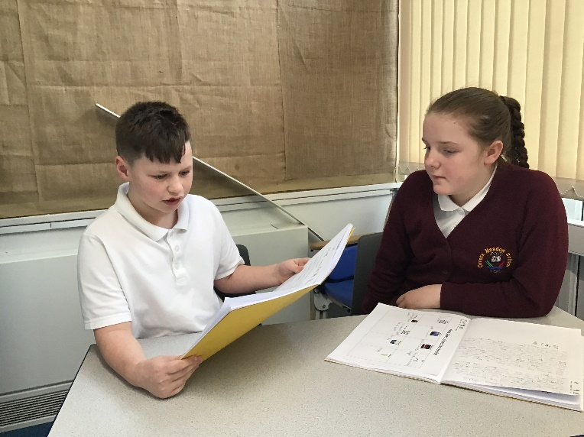
Phonics data remains positive, with pupils continuing to make progress throughout the year. Monitoring identified that some pupils in the lower school required a greater focus on early phonological awareness and sound discrimination. In response to this, the phonics scheme was extended to provide additional opportunities for pupils working at earlier stages of cognitive and language development.
Sharks exploring audience
Writing assessment information, moderation activities, pupil work and monitoring all indicate that the new writing curriculum is having a positive impact on pupil outcomes. Further details can be found within the termly English tracking documents.
Strengths:
Orrets Meadow continues to have a strong and inclusive English curriculum that successfully meets the needs of a diverse range of learners.
Particular strengths this year include:
- Successful implementation of the new writing curriculum.
- Strong reading culture across the school.
- High levels of pupil engagement.
- Improved consistency in writing provision.
- Successful introduction of daily handwriting sessions.
- Continued staff willingness to engage with professional development and curriculum refinement.
Ways Forward:
The priority for English during 2026-27 will be to further develop staff understanding of the Reading and Writing Journey and how it can be adapted to meet the diverse needs of pupils.
This will include:
- Developing staff understanding of adapting the Reading and Writing Journey for different learners.
- Continuing to refine handwriting provision.
- Reviewing literacy spine texts.
- Continuing to develop assessment and moderation practices.
- Maintaining the strong culture of reading for pleasure across the school.
(For full details please see the SDP 26-27)

