**Subject Report for Governors- History**

**Claire Walsh**

**Achievements**

New Steps Statements:  
I have written and implemented new steps statements to bring greater clarity and consistency to assessment. These steps are now being used to track pupil progress more accurately across the whole school and to ensure that pupils’ understanding of key historical concepts is secure and developmental.

****History Week:  
A highly successful History Week took place in the Autumn term, featuring a range of activities across the school designed to engage pupils with key historical themes and periods. Pupils explored local and global history through creative tasks, role-play, and collaborative projects. Pupil and staff voice has shown that everyone thoroughly enjoys this special week and there are plans to introduce new topics and a ‘Golden Thread’ will run through the whole history curriculum going forward.

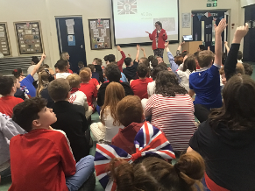

VE Day Celebrations:  
The school marked VE Day with a series of commemorative events, including a special assembly, and cross-curricular activities linking History with English and Art. Pupils gained a deeper understanding of World War II and the significance of VE Day in British and global history. A special VE day picnic was created and served by Kim, our school cook to make this a truly multi-sensory experience for all!

**CPD**

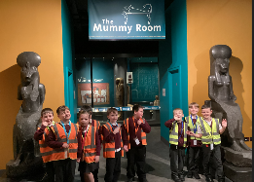Liverpool Partnership – AI in History:  
As part of a new partnership with colleagues in Liverpool, I participated in CPD sessions exploring the use of artificial intelligence in historical research and education. I intend to liaise with the computing lead to collaborate on ways to enhance history teaching across the school.

Staff Meetings – Focus on Recall:  
My staff meeting this year focused on improving pupils’ retention of key historical knowledge through enhanced strategies for recall. Techniques such as retrieval practice, low-stakes quizzing, and timeline work have been consolidated in lessons and have been the focus of learning walks.

Collaboration with Clare Mount Staff:  
A really interesting afternoon was spent with the Humanities staff at Claremount School will hopefully be the beginning of a collaborative partnership, which will hugely benefit Orrets Meadow.

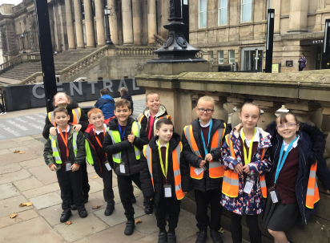Quality of Teaching and Learning  
Observations indicate that History lessons are well-structured, engaging, and effectively adapted. Book scrutiny demonstrated an outstanding range of multi- sensory opportunities for our children, which allowed the children to become fully immersed in their learning, and the daily quizzes ensured the sticky knowledge was embedded, leading to long term retention.  
Feedback from staff indicates confidence in teaching their particular units during history week and a clear enjoyment. Staff shared ideas for retention of knowledge which will be shared in the next staff meeting. Pupils report enjoying History lessons, particularly those involving multi sensory learning- trips out, food tasting and art and craft were mentioned by children as opportunities which help their learning. Enrichment activities have included the Great Fire of London project which the Bears were involved with, and trips out to the Liverpool Museum to see Ancient Egypt and Stone Age exhibitions.

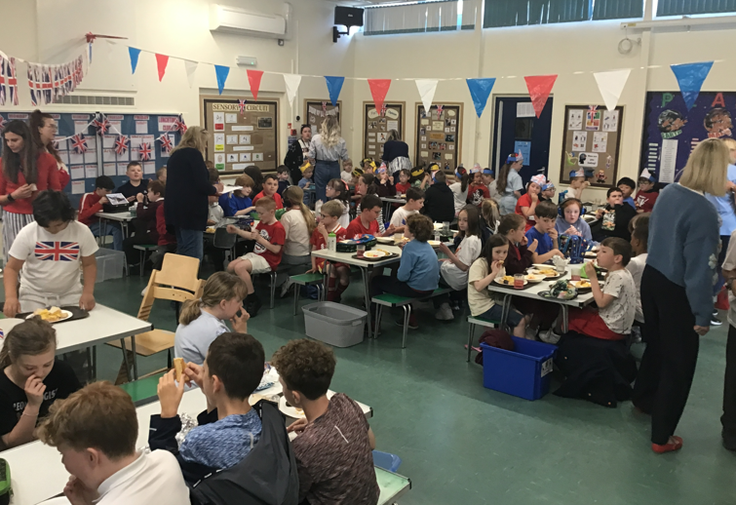**Strengths**

* Staff knowledge is a real strength of the school in history- teachers know their particular subjects really well and understand the importance of chronology and how to teach it to children with additional needs.
* Multi- sensory teaching strategies are used excellently in all lessons. This is enabling all children to access what can be a very difficult subject for children with additional needs.

**Ways Forward:**

* The creation of an evidence folder of work for moderation showing steps to year 4 in History (all year)
* The introduction of a ‘Golden Thread’ of learning in history across the whole school and monitor through learning walks. The Golden thread will be ‘Never Give Up’ based on one of the school values (Autumn then all year)
* Continuing the collaboration with colleagues from Claremount, looking to enrich the Romans topic initially and other topics going forward (termly)

Research and implement historians to study during History Week

* Plan a new Romans topic for the new additions to the curriculum(autumn)
* Liaise with computing lead to research how AI can be used in history teaching and learning in the 2026/27 academic year (spring)