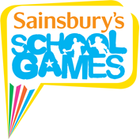
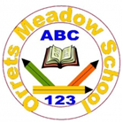

This term Orrets Meadow has taken part in two electrifying house competitions in Boccia and New Age Kurling. They both produced high quality games that went down to the wire!
Boccia
After a series of close knockout games between houses, Earth and Saturn were the only teams standing for the grand finale. Both teams were fighting for one hundred points for their house and the prestige of being Boccia champions! After 5 extremely close rounds Earth started too pulled away due to some excellent teamwork and concentration from those taking part. The final score finished:
Earth 15 – 8 Saturn
Well done to everyone who took part and congratulations to the winners Earth!
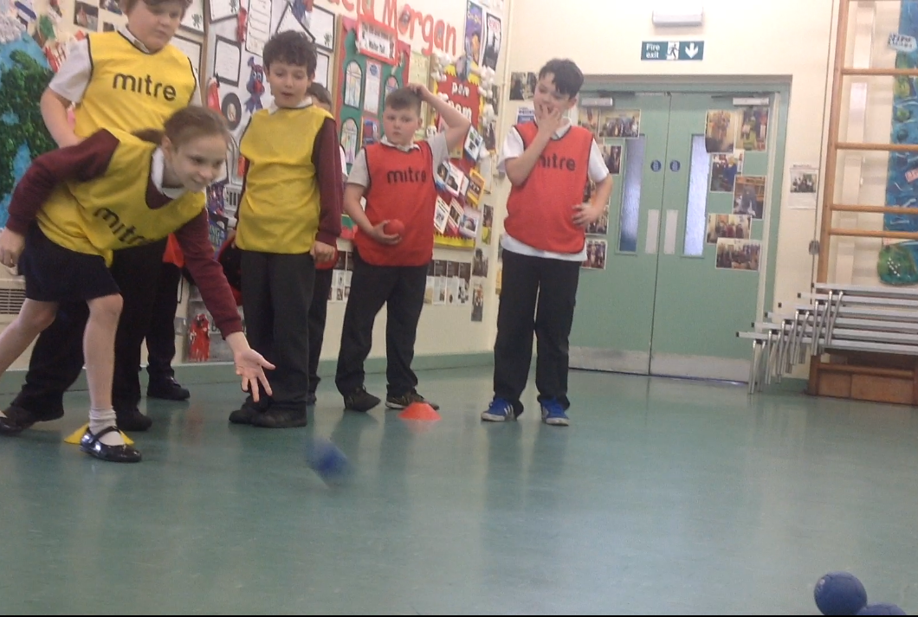

New Age Kurling
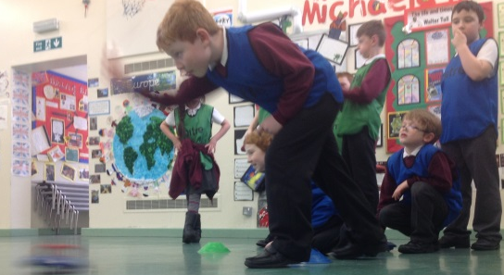
New Age Kurling continued on from the excitement around Boccia and produced the same format of competition. The knockout stage formed two finalists, Neptune and Earth. A simply fantastic display by Earth was too much for Neptune to handle, therefore making them the deserved winners of the Kurling competition.
The final scores finished:
Neptune 8 – 13 Earth
Congratulations to Earth for winning both house competitions and showing sportsmanship throughout.

