Animal Awards Mental Maths

At Orrets Meadow we use ‘Animal Awards’ to assess and support mental maths. This is a fun way to encourage children to progress through a selection of objectives aimed at supporting mental maths application.
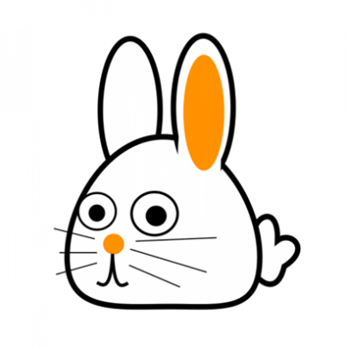
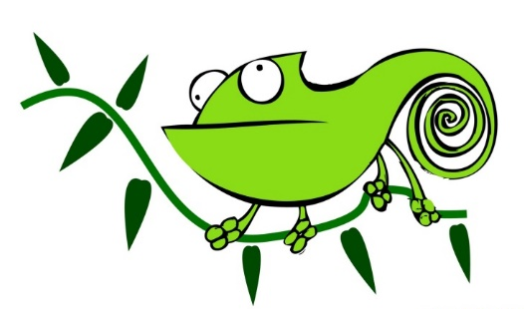

The general aim being that children progress from one animal award to another. Within each animal award there are a number of mental maths objectives. Children, depending on their ability my be awarded a certificate on completion. For children who may work more slowly through each award ‘Mini certificates’ may be given to celebrate achievements along the way.
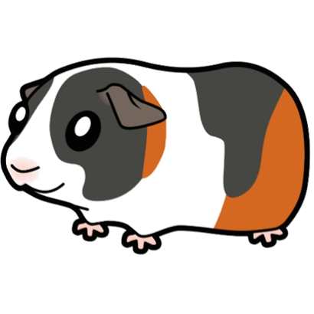

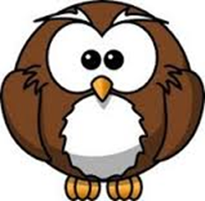
In class animal awards are assessed at regular intervals throughout each term. Children are given the objectives to take home and to work on with family.

