Adopt a Class Visit by Mr Rostance - Governor
Reading – Class 2 (ASD) – Nov. 2014

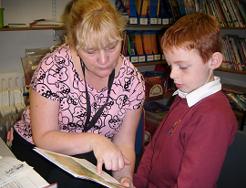
JJ – age 9
Teaching Assistant, Mrs Forshaw, explained that they avoid timing the children as this adds pressure and puts children off their reading.
John enjoyed reading ‘In the Garden’ and gave a descriptive account of the book’s cover. He was able to talk about the long grass and how it got this way! He sounded out words extremely well by breaking them down. By page two he had really grown in confidence and on page three John was quick to point out the cat, Wilma and the Dad. He was particularly good with using the colour of the clothing to point out members of the family.
After this, John got a little distracted and then tried to skip a line. Mrs Forshaw was quick to spot his antics - they both smiled - and John was happy to go back a line and read it well.
John prefers to read a real book so that he can touch, feel and smell it.
John read the probe well after the book.

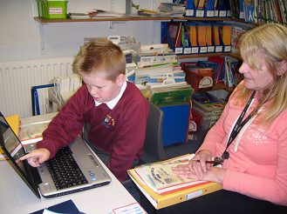
LS – age 8
Teaching Assistant, Mrs Nicholls explained that Lewis loves using computers to read books. In this case ‘Casper’s Scare School’ proved a hit! They use Bugclub – an online reading scheme.
Lewis was able to read the book well. The words seamed to appear randomly across the screen but Lewis was able to read quite well and identify the characters: Ra, Mantha, Thatch and Mr Burns extremely well. He did, however, miss a line out – but this was understandable with the format of the page layout.
Lewis was successful at sounding out the difficult words but then struggled with (the easier) conjunctions. His strategy for not losing his place was to use one of his finger as well as the curser – this worked well as he was familiar with computers. He sounded out the words well. He got coffin correct but struggled with words including: done (said don’t), stink (said sticky, stinky), mend (said make).
Lewis read the probe well after the book.
Interestingly, both boys read the probe after the book. I have tended to find, with my son, that if they read the probe first they gain in confidence and read the book even better!

