Orrets Meadow School
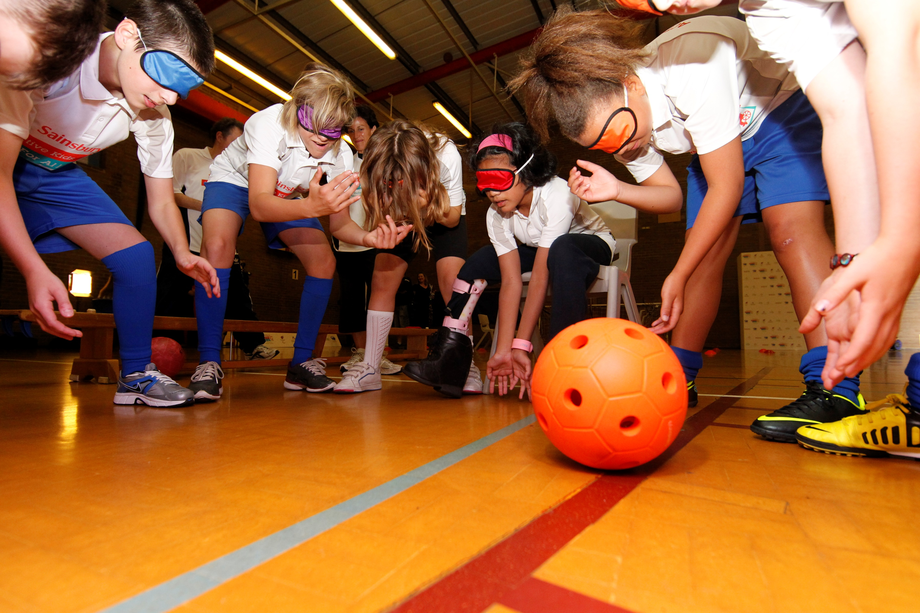

PE Policy

“To raise the aspirations of every child and give them confidence to fulfil their potential through positive experiences.”

Orrets Meadow Curriculum Aims and Values
Aims
To ensure all our children are at the centre of a broad, varied and interesting learning experience that is enjoyable and relevant for the future. Our creative, multisensory curriculum will create a sense of awe and wonder and help to inspire a lifelong love of learning. The holistic nature of our practice will promote positive mental health and well-being and will enhance our children’s life skills, social skills and cultural awareness.
Values
Our curriculum will promote a range of values including:
- Respect
- Empathy
- Responsibility
- Equality
- Independence
- Happiness
- Resilience
- Gratitude
- Honesty
- Friendship
Intent
National Curriculum - PE
Purpose of study
A high-quality physical education curriculum inspires all pupils to succeed and excel in competitive sport and other physically-demanding activities. It should provide opportunities for pupils to become physically confident in a way which supports their health and fitness. Opportunities to compete in sport and other activities build character and help to embed values such as fairness and respect.

Aims
The national curriculum for PE aims to ensure that all pupils:
- develop competence to excel in a broad range of physical activities
- are physically active for sustained periods of time
- engage in competitive sports and activities
- lead healthy, active lives

Why is PE important?

Physical education has much to offer in the development and enrichment of the whole person. Not to have a substantial provision for Physical Education in the curriculum would deny pupils their entitlement to a broad, balanced, progressive and enjoyable education, (BAALPE). It is primarily a practical subject and it is better placed than most to develop physical literacy. Pupils learn best through their experience of movement, although observation and self or peer assessment is an important aspect of their development. This will help to enhance performance, knowledge, understanding and a sense of achievement. PE can also contribute to the social, moral, spiritual and cultural (SMSC) needs of children. In situations that can be both competitive and collaborative, students learn resilience, respect for others and the value of individual effort and teamwork.

Benefits of physical activity in childhood include:
- greater bone strength and positive movement skill development (Bass, 2000; Fisher et al., 2005; Kemper et al., 2000).
- physical activity is linked to better cognitive functioning (Sibley and Etnier, 2003).
- physical activity has a positive effect on mental health in children, including reducing anxiety and depression and improving mood (e.g. Ahn and Fedewa, 2011; Mutrie and Parfitt, 1998).
- however, there is some evidence that for pupils who do not enjoy physical activity it can have a negative impact on self-esteem and mood (Biddle, 1999; Hellison, 1973).
- physical activity is linked to improved concentration and behaviour in the classroom (Budde, 2008; QCA, 2007; Raviv and Low, 1990; Tuckman and Hinkle, 1986).
- development of social, emotional and intellectual skills e.g. leadership, communication and trust, tolerance, independence, co-operation, loyalty, fairness and respect, acceptance of responsibility

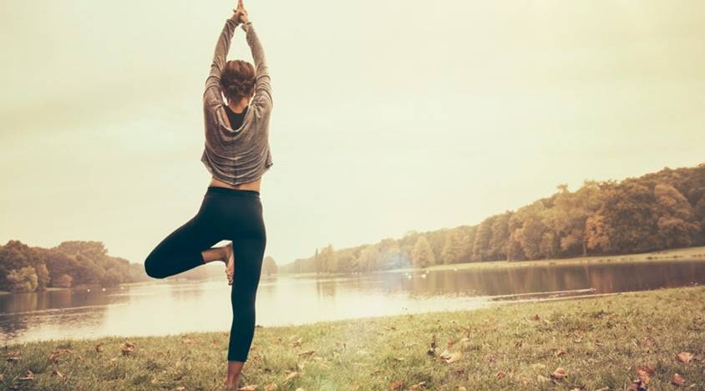
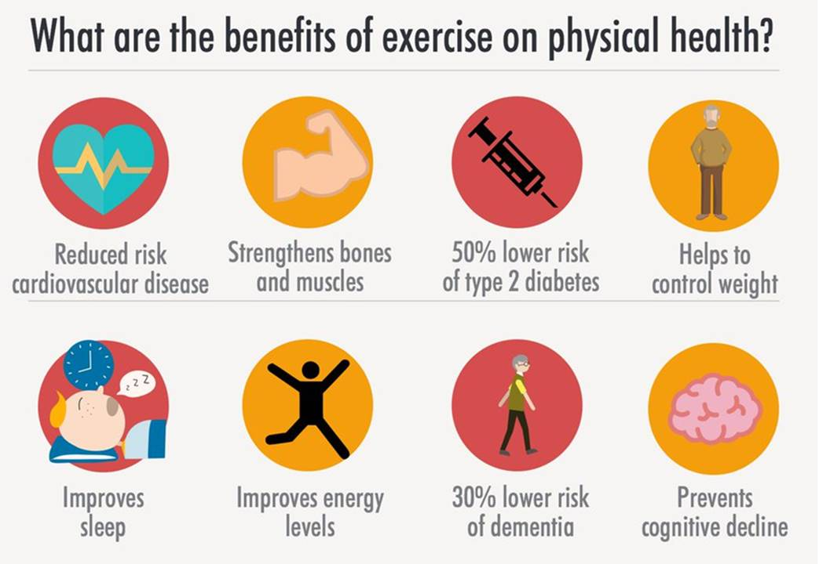

Our objectives:

- To promote life-long participation in physical activity and maintaining healthy lifestyles and well-being

- To promote positive mental health

- To provide high quality inclusive PE for all children

- To ensure pupils are engaged and physically active for sustained periods of time

- To enable pupils to develop physical literacy in a broad range of activities

- To develop problem-solving skills

- To develop children’s character and help to embed values such as fairness and respect

- To develop leadership opportunities for all children

- To develop children’s appreciation of the aesthetic qualities of movement

- To encourage children to engage in competitive sports and activities

- To promote safe practice

Physical education at Orrets Meadow should provide a broad and balanced programme for each individual pupil, taking into account his/her abilities. Along with other subjects, we are concerned with maximising each child’s educational potential. The programme should have a range of experiences with the development of purposeful and skilful performance.

Implementation
When is PE taught?
PE is taught during a minimum of 2 hours per week. The attached overview maps out which areas of PE are taught for each class and the long-term plan clearly shows the progression of knowledge and skills across the school.
How is PE taught?
Planning is mainly guided by the Total PE+ Scheme of Work (Early Years, Key Stages 1 and 2). This scheme was produced by a local CIC (Edsential) in partnership with local schools and PE specialists. Advice is based on current research and good practice in addition to the requirements outlined in the National Curriculum.
Staff are provided with regular INSET for PE with specific focus on applying the Scheme of Work. Planning for learning highlights:
- the activity and theme of the unit
- unit objectives
- differentiated learning expectations (Emerging, Expected, Exceeded)
- links to ICT, English, maths and science and other cross-curricular themes
- links to social, moral, spiritual and cultural development

Staff are provided with medium term plans showing an overview of the unit of work. This includes a number of focuses, suggested teaching activities and the learning objectives and outcomes for the unit. Unit tasks are provided to aid assessment for learning ensuring children are improving, progressing and achieving throughout the units. Short term plans are provided to give a more detailed breakdown of possible activities which could be used to deliver and achieve the particular objectives. Such plans are used to help inform planning and it is the responsibility of the teacher to adapt these to meet the individual and collective needs of pupils.
Opportunities for the development of physical, personal, social and thinking skills are provided under the child-friendly elements of learning ‘Physical Me’, ‘Healthy Me’, ‘Social Me’ and ‘Thinking Me’. Alongside the Wirral Scheme of Work, Orrets Meadow uses a wide range of other resources to support PE lessons. These currently include: Matalan TOPs cards, TOPs Sportsability, Elevating Athletics, Sportshall Athletics, FUNs, Sensory Circuits, AEGON tennis, Bikeability, Change 4 Life Clubs, Project Ability and School Games cards.
Health and Wellbeing
PE forms a part of a wider focus on our children’s overall health and wellbeing. Mental health is closely linked with physical health and so a holistic approach has been taken, making use of some of the PE sport premium funding to help. We use information and data from a range of sources to help inform planning and delivery of activities and education in school. These may include targeted mental health interventions and extra-curricular activities, opportunities for less-active children, health and wellbeing education programmes and work with parents and families.

SHEU Survey

Children from Y3 and above complete an annual bespoke survey carried out in partnership with the Schools Health Education Unit (SHEU) to help gather information about their health and wellbeing. The survey is completed online and questions cover a range of aspects of life including:

- levels of physical activity
- emotional health and wellbeing
- diet
- sleep habits
- levels of worry
- use of technology
- attitudes towards school
- safety and bullying
- leisure time

The data from the survey helps to inform planning of education programmes, identify pupils at risk of mental health difficulties and plan interventions. Some of the data also helps to inform and plan PE and school sport activities and initiatives. For example if children are identified as being less active they may be offered opportunities which match their interests and preferences. If there are barriers to children joining clubs outside of school, then we can work with parents and clubs to help. If there are children who are lacking in confidence they may be encouraged to take part in our numerous leadership opportunities, such as Young Ambassadors Leadership programme or YST Active in Mind (PE and mental health programme). We take a holistic approach to health and wellbeing and ensure that all areas of school life link up to provide the best possible outcomes for our young people and their families.

As with curriculum PE, we strive to include all children in our health and wellbeing strategy, and all children are given curriculum and extra-curricular opportunities regardless of sex, race, ethnicity or disability (see Inclusion and Equality section below). Examples of this include our promotion of disability sports events such as boccia and new age kurling, and our Girls Active Programme (YST) which is planned, organised and led by girls throughout the school with the aim of breaking down barriers of participation in physical activity for girls.

Enrichment and Competition

Also as part of our holistic approach towards wellbeing, children across the school are offered a variety of enrichment activities matched to their individual and collective needs. Examples include judo, taekwondo, fencing, dance club and opportunities for pupils to attend OAA activities at Barnstondale (day visits and residential trips). Our children also benefit from high levels of intra-school and inter-school events, including traditional formal competitive sports or inclusive festivals. Orrets Meadow is a member of PE and sport ‘clusters’ with mainstream and special schools. This helps us to plan and match opportunities to meet the needs of our children. Such events give numerous benefits for our children such as increased confidence and self-esteem, improved social skills and opportunities for social interaction and help to promotes lifelong physical activity.

Inclusion and Equality
Inclusion is about welcoming diversity, benefiting all participants, supporting the excluded and providing equal access to education for all. Inclusion is a positive response to diversity. It identifies and removes barriers, ensures participation for all and actively looks to focus on the achievement of the marginalised and excluded who might be underachieving (UNESCO). The inclusion approach in school sport, community sport and play environments is one entirely based on the Social Model of Disability.

According to the Social Model of Disability, and reflecting human rights, we should value the diversity of the young people we are working with and look for opportunities for them to achieve their goals. As PE and sport leaders, we can positively change their experience by changing our approach. By using our knowledge of the young people (Education and Health Care plans, Social Narratives, Baseline Assessment for Learning, Observation, Environmental or Sensory Audit Wheels), their starting point can be assessed. The Inclusion Spectrum and STEP Model (Stevenson/Black, 2012) is used to help our staff provide inclusive PE and sport.

Differentiation, the Inclusion Spectrum and the STEP model
“Differentiation is the means by which all pupils are enabled to fulfil their potential in PE”. Pupils at Orrets Meadow have a range of additional needs and difficulties. This will impact differently upon their performance in PE. Adaptions and variations are made using the Inclusion Spectrum and the STEP model:

The ‘Change to Include’ approach uses STEP to change the way the activity is delivered in one or more of the STEP areas (Space, Task, Equipment, People).
Space
Examples:
- Increase or decrease the size of the playing area
- Vary the distance to be covered in activities to suit different abilities
- Use zoning e.g. where children are matched by ability and therefore have more opportunity to participate
Task
Examples:
- Ensure that everyone has equal opportunity to participate, e.g. in a ball game, all the players have the chance to carry/dribble, pass or shoot
- Break down complex skills into smaller component parts if this helps players to develop skills more easily
- Ensure there is adequate opportunity for players to practise skills or components individually or with a partner before including in a small-sided team game

Equipment
Examples:
- In ball games, increase or decrease the size of the ball to suit the ability of the children, or on the kind of skill being practised
- Provide options that enable people to send or receive a ball in different ways, e.g. using a chute or gutter to send, a catching mitt to receive
- The use of bell or rattle balls can assist the inclusion of some players

People
Examples:
- Match players of similar ability in small-sided or close marking activities
- Balance team numbers according to the overall ability of the group, i.e. it may be preferable to play with teams of unequal numbers to facilitate inclusion of some players and maximise participation of others

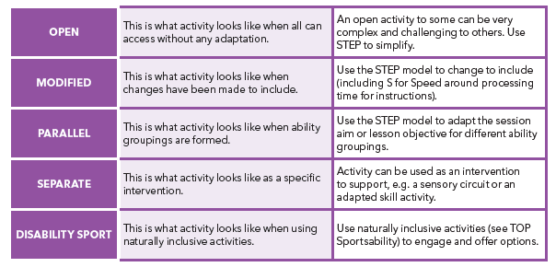

The Inclusion Spectrum is an activity-centred approach to the inclusion of young people of all abilities in physical activity. Inclusion can be achieved by changing the way in which the activity is presented. The Inclusion Spectrum provides physical activity and sport teachers, coaches and volunteers with different methods of supporting inclusion. By delivering activities differently we can balance different needs within the group and so helping to maximise the potential of all young people.
The Inclusion Spectrum Framework
1. Everyone can play – naturally inclusive activities based on what everyone can do with little or no modifications e.g. warm ups and cools downs, where children can find the level of participation that suits them; and/or collecting or gathering games- for example, gathering up objects scattered around the playing area and arranging them into by colour.
2. Change to include – everyone does the same activity using adaptations to provide both support and challenge across a range of different abilities; the STEP model (space, task, equipment and people) can be used to provide a structure for adapting and modifying the activities (see the STEP section for examples).
3. Ability groups – participants are grouped according to ability - each group does a version of the same activity, but at a level which suits the individuals in each group e.g. creating two or more versions of the same activity, (e.g. a standing version and a seated version of volleyball).
4. Alternate or separate activity –individuals work temporarily on specific skills leading to more successful inclusion in the whole group; sometimes, in order to include someone more effectively, they need to practise separately first. Note: this should not be most of the time.
5. Adapted physical activity and disability sport – aspects of physical activity based on adapted physical activity or disability sport programmes can be included in all approaches; this provides specific opportunities for disabled students and a new challenge for non-disabled students - ‘reverse integration’. E.g. children with disabilities teach their non-disabled peers a Paralympic sport activity, like boccia; or as a project, young people can learn the rules, improvise the equipment, and organise and run small competitions based on disability sport.
The Inclusion Spectrum framework can be adapted to support: competition, by providing a range of activities that corresponds to the Spectrum categories; differentiation across any range of abilities, not only where young people with Special Education Needs & Disability are involved; as a basis for inclusion in its widest sense; for example, cultural differences.
It is important to note that young people on the autistic spectrum may still face challenges, even when activities are heavily adapted or differentiated. Each young person on the autistic spectrum is individual and different. Staff at Orrets Meadow use the Inclusion Spectrum planning model, the STEP tool and what we know about the young person in terms of their sensory profile (including sensory diets and circuits) and emotional regulation to make every effort to include them in activity and social experiences.
During wider school life many of our children benefit from structure and routine. This is continued in PE and sport. Visual timetables are created to help give structure to their day - helping with planning, organisation and transitioning from one activity to another. Establishing a clear routine ensures pupils know exactly what they are doing and ensures a high degree of consistency in PE lessons, giving ‘typicality’. Giving young people with ASC a high degree of consistent structure allows them to orientate themselves to the space and environment, as well as the task, which assists them to focus on the activity.
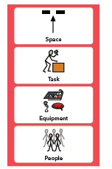

This level of structure gives young people consistent anchors to help them orientate through the lesson and can lead to young people being able to cope with more and more high energy group activities as they grow in confidence, develop higher level skills and flexibility of thought. Further guidance can be found in our All About Autism resource (Youth Sport Trust).

Participation

Participation in PE lessons is expected for all pupils, although matched to meet their individual needs. Non-participants play an important part in lessons in a variety of roles e.g. coaching, officiating, leadership etc. A note signed by the parent/guardian or a phone call is accepted procedure if a pupil is to be excused from physical participation for any reason. If a pupil has no note, yet claims they need to be excused owing to illness/injury, care should be taken before insisting the pupil takes part in the lesson.

Access to the curriculum
In consultation with the PE Leader each teacher/team will have responsibility for mapping the curriculum and ensuring that pupils experience a coherent and progressive curriculum throughout their time at Orrets Meadow. Each team will produce a curriculum map at the beginning of the academic year. This is a working document and provision should be adapted to meet the needs of individual pupils and/or classes. Health and safety guidance for the teams is found in wider school risk assessments and documentation (in the Headteacher’s office) and in good practice guides in PE store (based on BAALPE Safe Practice in Physical Education, 2016). Alongside the curriculum provision there is a wide and varied programme of extra-curricular activities of which all children are encouraged to participate it.
Course information and CPD is co-ordinated by the PE Leader. Regular staff INSET for PE is provided and individual courses are offered to meet CPD needs of staff. This training is largely run in collaboration with our partner high school – Clare Mount Specialist Sports College.

Partner School – Clare Mount Specialist Sports College

Since the advent of the PE and Sport Premium in 2013, we have used some of our funding to access support and services from a local high school – Clare Mount Specialist Sports College. It has been a highly successful partnership with many benefits including:
- specialist CM PE staff to plan and teach units of work (1/2 day per week) for the principle purpose of providing high quality Continuous Professional Development (CPD), coaching and mentoring for OM staff
- provide the highest quality teaching and learning experience for young people at Orrets Meadow
- sharing and modelling of current best practice suitable resources from National Governing Bodies, giving teachers advice and support around monitoring and assessment
- organisation of PE Premium cluster meetings and fostering of positive relationships
- annual calendar of events and competitions for both the cluster and through the school games
- annual calendar of CPD for staff to develop their confidence and knowledge
- development of young leaders
- assistance in applying for kite mark awards and/or funding
- use of Clare Mount Sports College Sports Leaders to help run events
- develop school-club links
PE and Sport Premium

Schools must use the annual funding to make additional and sustainable improvements to the quality of their physical education (PE), physical activity and sport. Since being asked to be a case study of best practice of use of the PE and Sport Premium by HMI in 2014, Orrets Meadow has continued to find innovative ways of using the premium to improve our PE and sport offer and meet our aims.

This means that we should use the premium to:
- develop or add to the PE, physical activity and sport that our school provides
- build capacity and capability within the school to ensure that improvements made now will benefit pupils joining the school in future years

We should use the premium to secure improvements in the following 5 key indicators:

Engagement of all pupils in regular physical activity, for example by:
- providing targeted activities or support to involve and encourage the least active children
- encouraging active play during break times and lunchtimes
- establishing, extending or funding attendance of school sport clubs and activities and holiday clubs, or broadening the variety offered
- adopting an active mile initiative
- raising attainment in primary school swimming to meet requirements of the national curriculum before the end of key stage 2. Every child should leave primary school able to swim

Profile of PE and sport is raised across the school as a tool for whole-school improvement, for example by:
- encouraging pupils to take on leadership or volunteer roles that support sport and physical activity within the school (such as ‘sport leader’ or peer-mentoring schemes)
- embedding physical activity into the school day through active travel to and from school, active break times and active lessons and teaching

Increased confidence, knowledge and skills of all staff in teaching PE and sport, for example by:
- providing staff with professional development, mentoring, training and resources to help them teach PE and sport more effectively to all pupils, and embed physical activity across our school
- hiring qualified sports coaches to work alongside teachers to enhance or extend current opportunities

Broader experience of a range of sports and activities offered to all pupils, for example by:
- introducing new sports and physical activities (such as dance, yoga or fitness sessions) to encourage more pupils to take up sport and physical activities
- partnering with other schools to run sport activities and clubs
- providing more (or broadening the variety of) extra-curricular activities delivered by the school or other local sport organisations

Increased participation in competitive sport, for example by:
- increasing pupils’ participation in the School Games
- organising, coordinating or entering more sport competitions or tournaments within the school or across the local area, including those run by sporting organisations.

Using Pupil Premium and PE funding, children across the school are offered enrichment activities matched to their individual and collective needs. Examples include judo, taekwondo, fencing, dance club and opportunities for pupils to attend OAA activities at Barnstondale (day visits and residential trips).
More information of how we spend the PE and Sport Premium and evidencing the impact of it can be found on our school website under ‘PE and Sport’. This is updated termly and reported to governors.
What do we learn about in PE?
The development of physical, personal, social and thinking skills are provided under the child-friendly elements of learning ‘Physical Me’, ‘Healthy Me’, ‘Social Me’ and ‘Thinking Me’. Using these elements we learn about the following:
- Games
- FUNs (Fundamental Movement Skills)
- Dance
- Swimming
- Athletics
- Outdoor and Adventurous Activities
- Health and Fitness

Key Stage 1

Pupils should develop fundamental movement skills, become increasingly competent and confident and access a broad range of opportunities to extend their agility, balance and coordination, individually and with others. They should be able to engage in competitive (both against self and against others) and co-operative physical activities, in a range of increasingly challenging situations.

Pupils should be taught to:

- master basic movements including running, jumping, throwing and catching, as well as developing balance, agility and co-ordination, and begin to apply these in a range of activities
- participate in team games, developing simple tactics for attacking and defending
- perform dances using simple movement patterns.

Key Stage 2

Pupils should continue to apply and develop a broader range of skills, learning how to use them in different ways and to link them to make actions and sequences of movement. They should enjoy communicating, collaborating and competing with each other. They should develop an understanding of how to improve in different physical activities and sports and learn how to evaluate and recognise their own success.
Pupils should be taught to:

- use running, jumping, throwing and catching in isolation and in combination
- play competitive games, modified where appropriate [for example, badminton, basketball, cricket, football, hockey, netball, rounders and tennis], and apply basic principles suitable for attacking and defending
- develop flexibility, strength, technique, control and balance [for example, through athletics and gymnastics]
- perform dances using a range of movement patterns
- take part in outdoor and adventurous activity challenges both individually and within a team
- compare their performances with previous ones and demonstrate improvement to achieve their personal best.
- Swimming and water safety - all schools must provide swimming instruction either in key stage 1 or key stage 2. In particular, pupils should be taught to: swim competently, and proficiently over a distance of at least 25 metres; use a range of strokes effectively [for example, front crawl, backstroke and breaststroke]; perform safe self-rescue in different water-based situations.

Example Long Term Plan
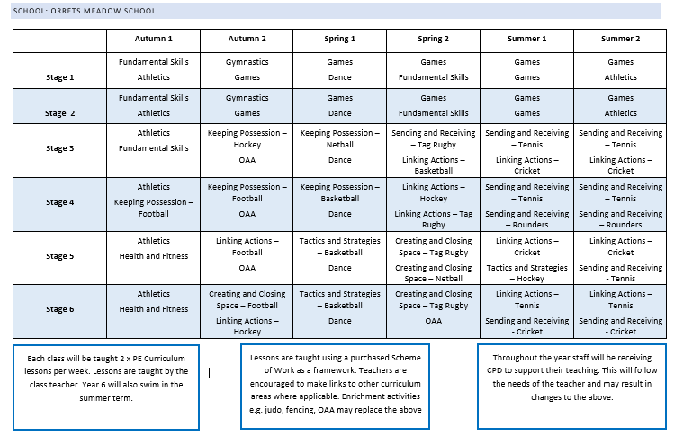

Who do we learn about in PE?

We learn about a range of famous sportspeople who demonstrate our school and sporting values e.g. Mo Farah, Jonnie Peacock, Katrina Johnson-Thompson etc.
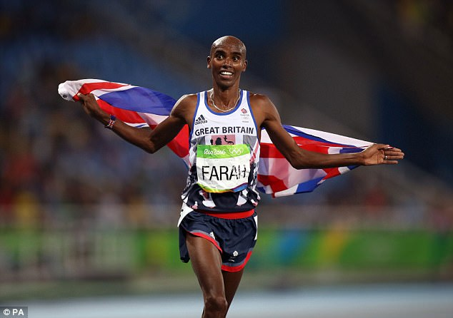
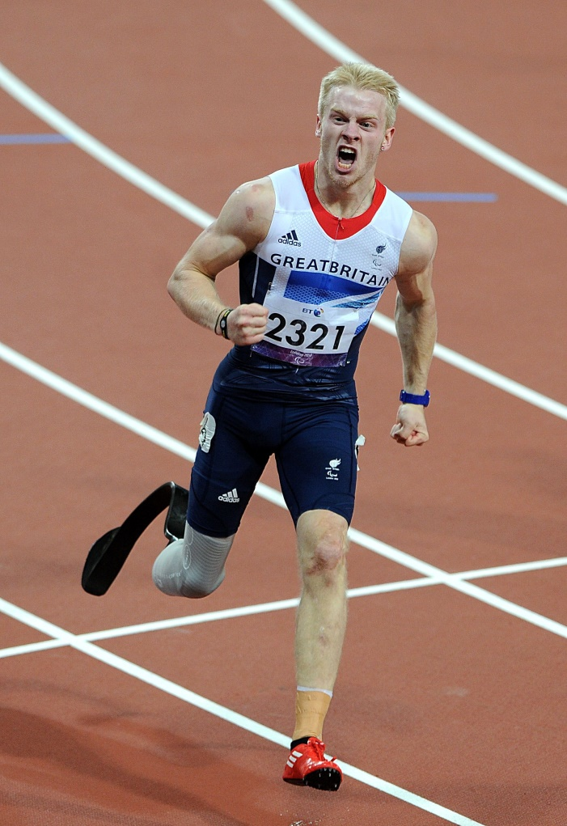

Where possible we provide opportunities for our children to meet inspirational sportspeople and hear their stories or in some cases even receive coaching masterclasses. Examples of previous inspirational figures include: Samantha Quek (Olympic Gold Medallist), Shanaze Reade (3-time World BMX champion), Rachel Brown (England International Goalkeeper) and coaches from teams such as Sale Sharks, St Helens RFC and Everton FC. Orrets Meadow has also been proud to welcome back successful former pupils including an England Disability Cricket Tri-Nations Gold Medallist.

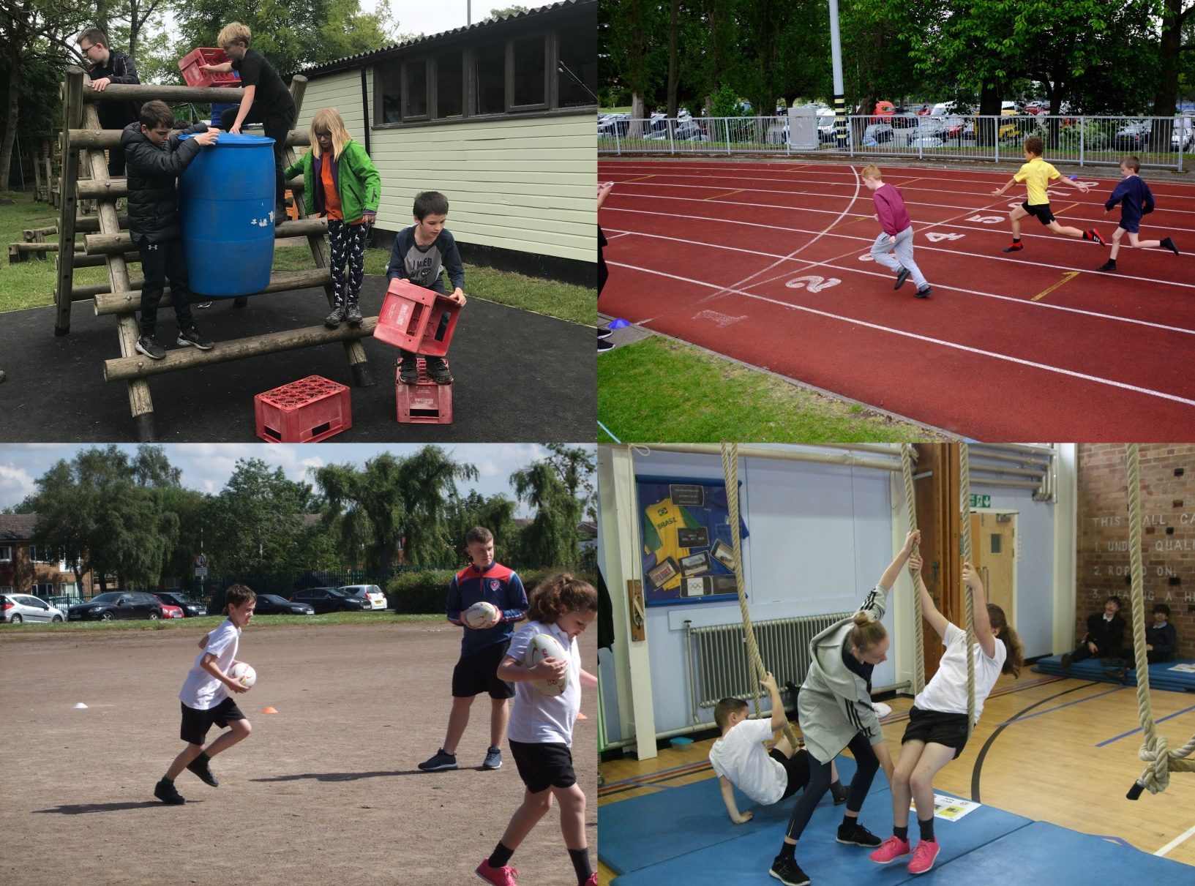
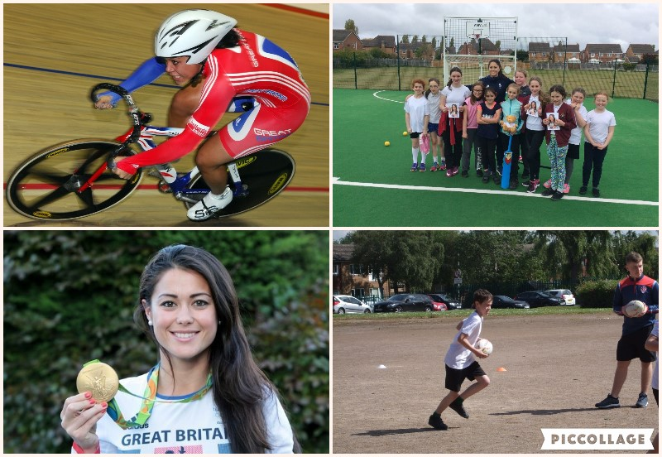

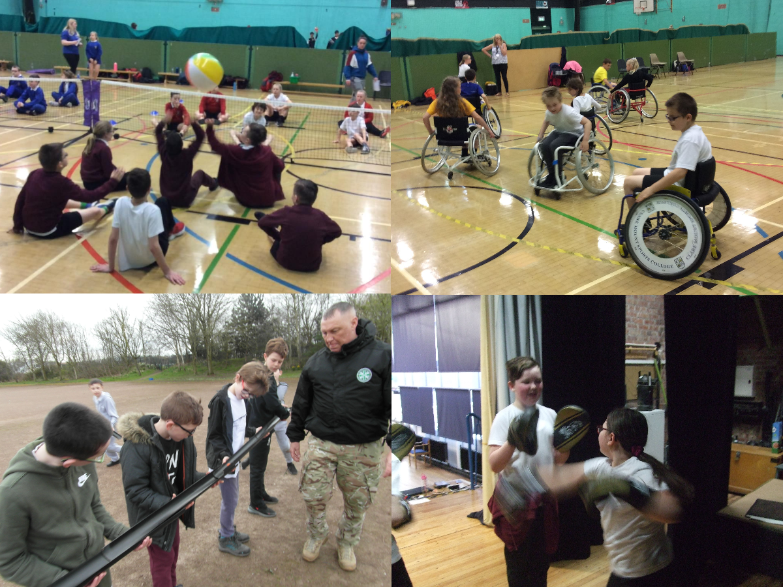

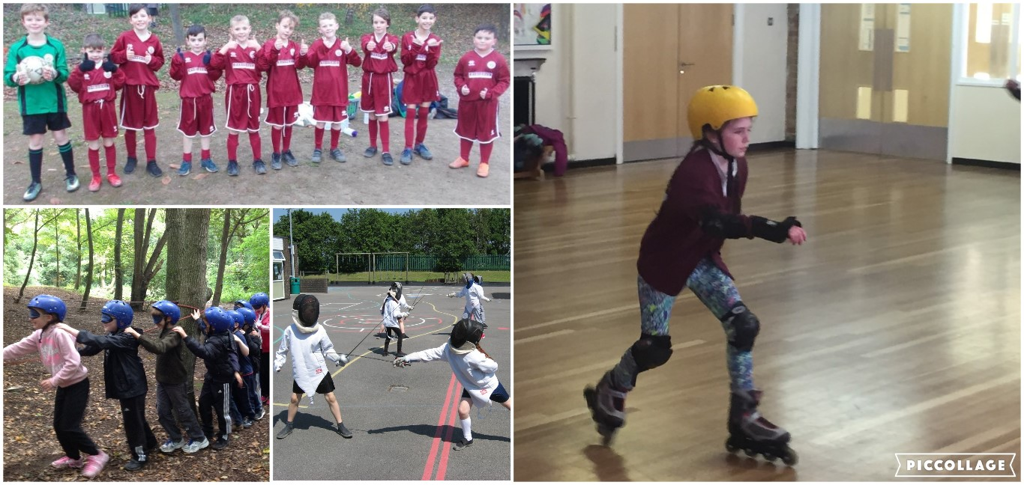
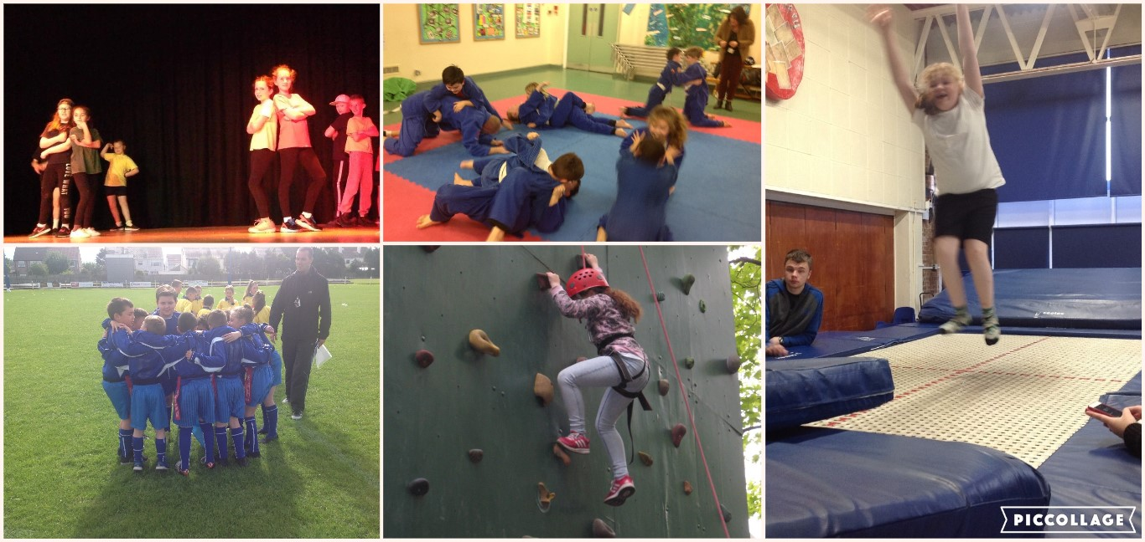

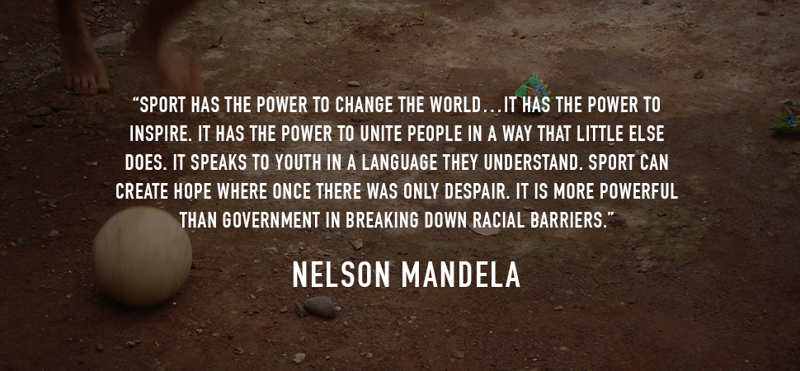

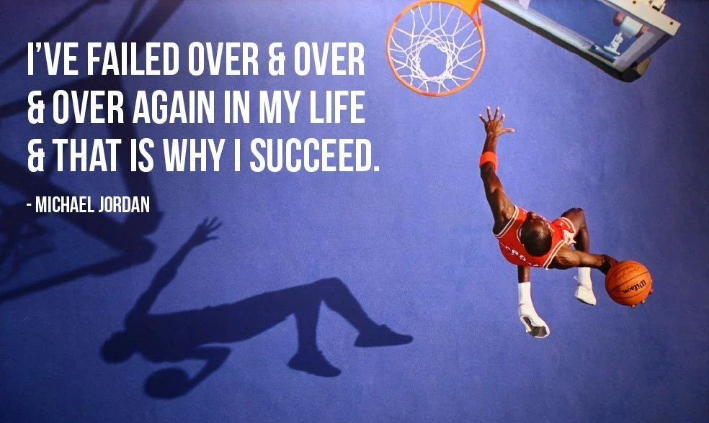

“Sport is something that transcends generations, transcends backgrounds, cultures, races. And so the power of sports is real.”
Malcolm Jenkins

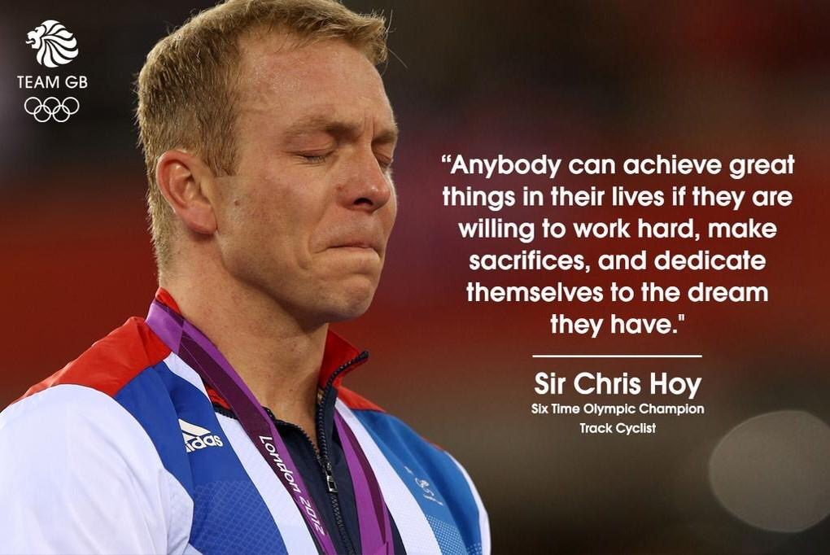

PE Progression of Skills – Example Documents (Full Documents on School Website)

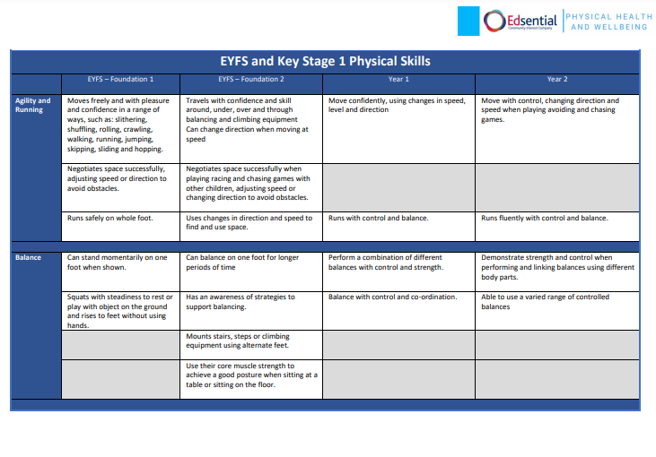

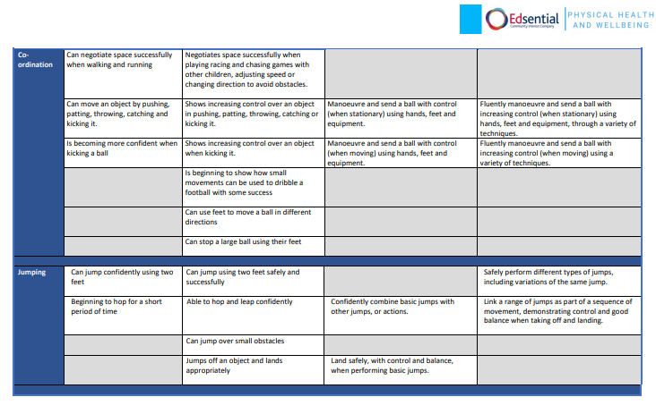

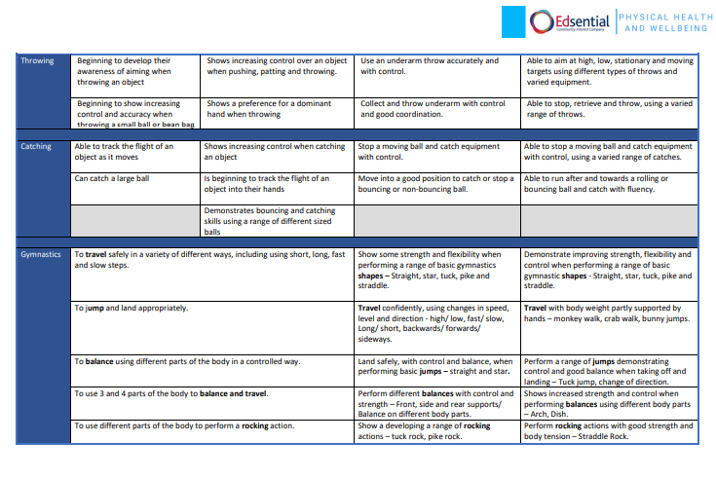

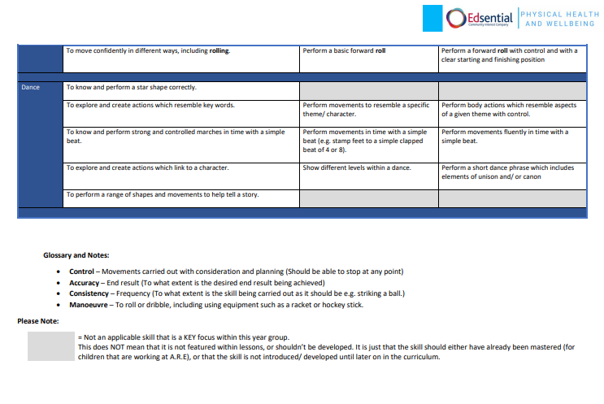

Impact

How do we assess and monitor PE?

The programme of study for PE specifies the core knowledge, skills and understanding for each Key Stage. The National Curriculum states that schools teach the new Programmes of Study and assess progress with reference to the new attainment target which is integral to each Key Stage.
Every child is assessed in Physical Education. Children are assessed against the specific criteria for their ability group i.e. ‘Expected’, ‘Emerging’ and ‘Exceeding’. A sample of evidence is recorded by teachers. If a child is not meeting the criteria within an attainment target teachers will use professional judgement when deciding to continue or lower the attainment target. The assessments are then further broken down into a decimal system e.g. 3.2 (Year 3 emerging), so that a universal language across subjects and moderation can be more effective. Assessment is ongoing but provided to the Headteacher at the end of each academic year. The PE leader will analyse the assessments to ensure high standards of pupil progress.
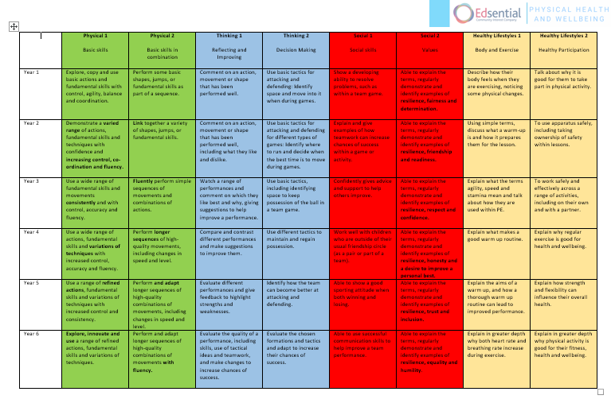

SLT, teachers and subject leaders use assessment for learning to inform planning, teaching and learning and CPD opportunities.

SLT and subject leaders are continuously monitoring their subject to ensure it meets the needs of our pupils. They monitor using a variety of activities, including:

- Learning walks
- Book scrutiny
- Lesson observations
- Pupil survey and discussions
- Staff survey and discussions

Criteria to help such monitoring largely comes from AfPE (Association for PE) which can be seen below. Orrets Meadow was proud to receive the AfPE Quality Mark with Distinction in 2017 and 2022. Aligning with the recent Ofsted framework (2019), there are whole-school guidance criteria from AfPE which we aim to meet:

‘The leadership & management of PESSPA is exceptional. All teachers are engaged, feel effectively and meaningfully supported both in terms of their well-being and opportunities to take part in focused professional development. Those responsible for governance ensure that the school has a clear vision and strategy and that resources are managed well. There is a clear and ambitious vision for high quality PESSPA.

The PE curriculum is well planned, relevant and purposeful and supports the progression of all pupils from their starting points to their end points with the aim that all pupils successfully complete their programmes of study, demonstrating improved skills, competencies and developing at the same time, detailed knowledge, understanding and the cultural capital to succeed in life.

There is a wide and rich range of extra-curricular experiences that enhance and extend pupils interests and talents. Pupils are motivated and engaged and participate willingly and respond positively to the sporting and cultural opportunities on offer. PESSPA contributes exceptionally well to the development of pupils’ character, confidence, resilience and independence and supports their persistence in the face of challenges and difficulties. Pupils know how to eat well, maintain an active lifestyle and keep physically and mentally healthy.

Pupils appreciate how PESSPA can make a difference to their attitudes and behaviour across the school and how to be responsible, respectful and active citizens. They feel safe in PESSPA and there is a culture of safeguarding that supports effective arrangements. There is a positive climate for learning where low level disruption and bullying is not tolerated. Pupils’ behaviour and attitudes in PESSPA are exemplary.

PESSPA provision contributes strongly to the spiritual, moral, social and cultural development of pupils and effectively meets different pupils’ needs, including pupils with SEND.’

The impact of PE and sport is monitored and shared by termly written reports from the PE Lead. These reports are presented at governors’ meetings. More details can be found on the Orrets Meadow website under ‘PE and Sport’.

