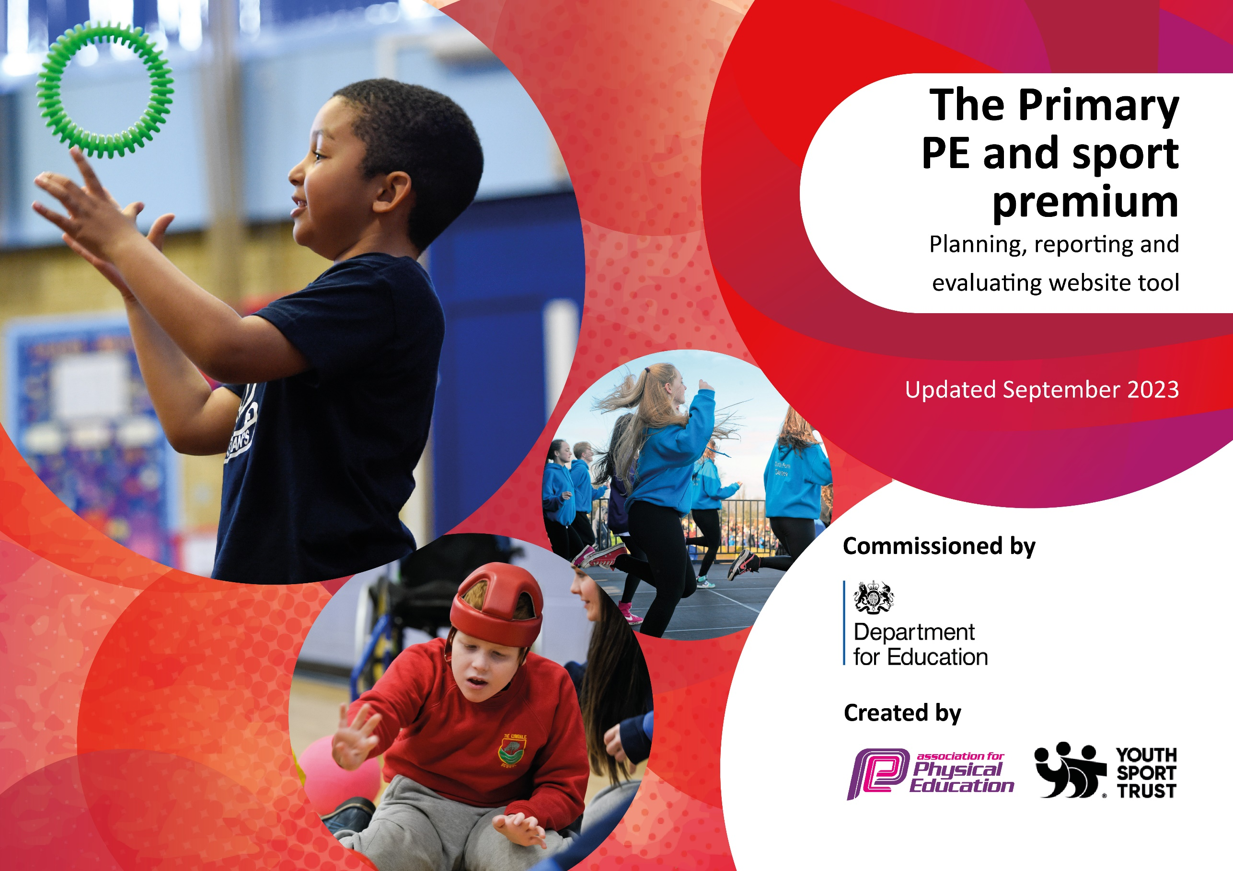

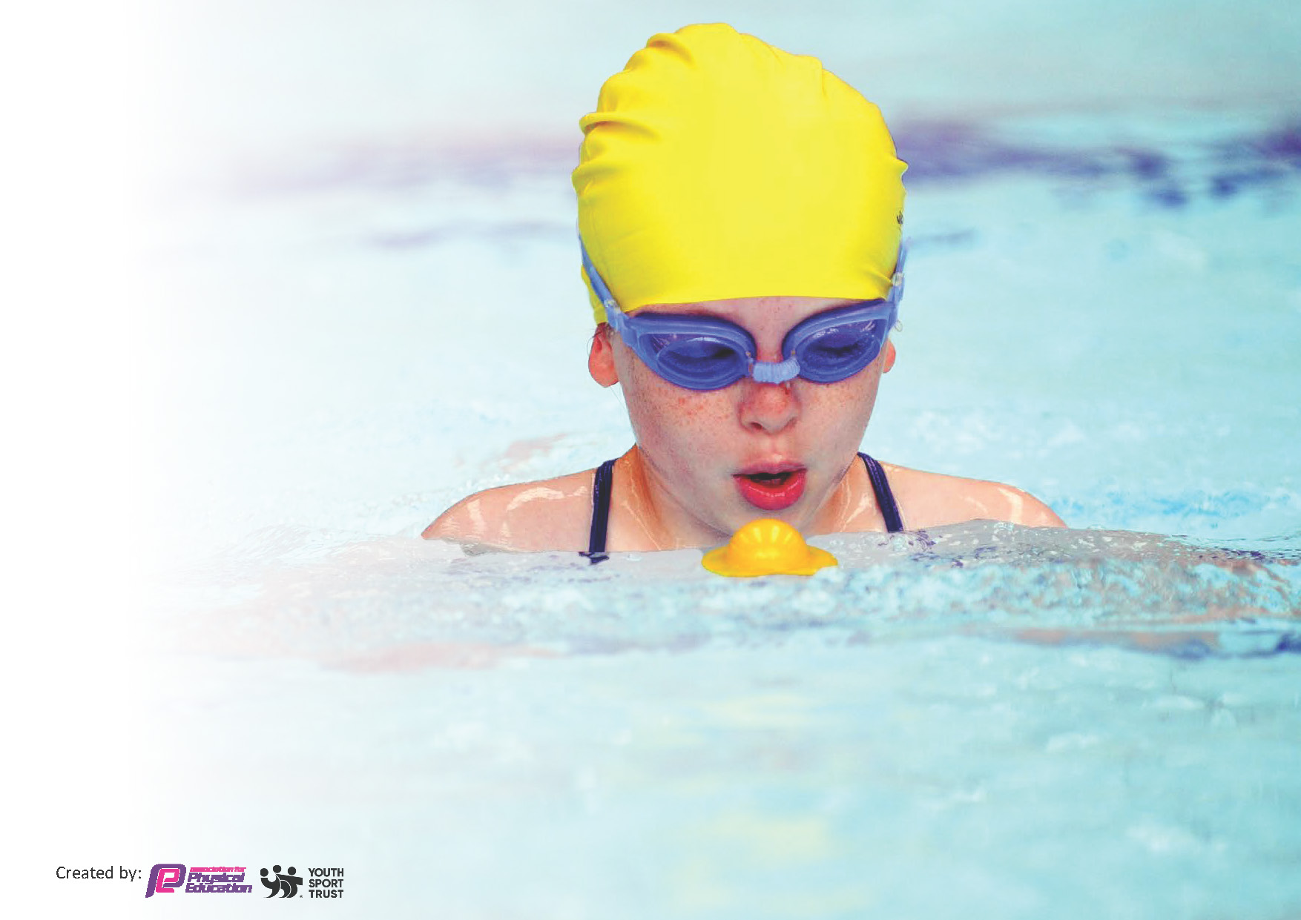
This template can be used for multiple purposes:
by:
- It enables schools to effectively plan their use of the Primary PE and sport premium
- It helps schools to meet the requirements (as set out in guidance) to publish information on their Primary PE and sport premium
- It will be an effective document to support Ofsted inspections enabling schools to evidence progress in Physical Education (PE) and evidence swimming attainment, which forms part of the PE National Curriculum. We would recommend schools consider
the Intent, Implementation and Impact of any spend, as examined within the Education Inspection Framework.

It is important that your grant is used effectively and based on school need.

Schools must use the funding to make additional and sustainable
improvements to the quality of the PE, School Sport and Physical Activity (PESSPA)
they offer. This means that you should use the Primary PE and sport premium to:

- Build capacity and capability within the school to ensure that improvements made now will benefit pupils joining the school in future years
- Develop or add to the PESSPA activities that your school already offers.

The Primary PE and sport premium should not be used to fund capital spend projects; the school’s core budget should fund these. Further detail on capital expenditure can be found in the updated Primary PE and sport premium guidance.

The Primary PE and sport premium guidance, outlines 5 key priorities that funding should be used towards. It is not

necessary that spending has to meet all the key priorities, you should select the priorities that you aim to use any funding towards.

Although completing this template is not a requirement for schools, schools are required to publish details of how they spend this funding. Schools must also outline what the impact this funding has had on pupils’ PE and sport participation and attainment and how any spending will be sustainable in the future. All funding must be spent by 31st July 2024.

The Department for Education has worked closely with the Association for Physical Education (afPE) and the Youth Sport Trust (YST) to develop this template and encourages schools to use it. This template is an effective way of meeting the reporting requirements of the Primary PE and sport premium.
Review of last year’s spend and key achievements (2022/2023)

We recommend you start by reflecting on the impact of current provision and reviewing your previous spend.

Activity/Action | Impact | Comments
- Inclusion and Fit Fun Fest  - Magic Mile  - 60 second challenges  - Physical Activity and Sport Project – DfE  - Intra-school Football  - PE and Mental Health Interventions  - CPD  - Healthy and Safe Week  - Active in Mind  - Golf Foundation Project  - Enrichment Activities | - Fit Fun Fest October 2022: 10 children enjoyed a rugby festival - a carousel of inclusive activities with Rugby World Cup theme. The activities on offer supported personal development through exploring communication, confidence, self-esteem and resilience.  - Fit Fun Fest December 2022: 15 children enjoyed a carousel of inclusive activities with a Christmas theme. Children were highly engaged and physically active.  - Ten Pin Bowling Panathlon event provided children with experience of inclusive, competitive ten pin bowling. High pupil engagement and enjoyment. Increased confidence.  - ‘Magic Mile’ – children and staff taken part in minimum of 15mins walk/run x3 per week. Positive feedback from children and staff. Evidence of improved fitness and wellbeing.  - 60 second challenges introduced by PE TA. Used in a variety of ways e.g. sensory breaks, interventions, warm-ups, gross motor groups etc.  - School council have offered pupil voice on physical activity and sport (Feb 23) which feeds into future projects e.g. exercise and healthy eating posters created for display around school, new extra-curricular sports clubs, class hydration plan etc.  - Intra-school house football competition has seen over 30 children participating across several fixtures. Other sports/activities to follow.  - Lunchtime Clubs, PE interventions and PSHE week (Spring/Summer 2023) have helped to encourage less active children to become more active:  - 93% enjoyed the physical activity intervention sessions  - 100% enjoy PE and sport  - 100% feel more confident in PE  - 93% think they are now physically fit  - 100% feel they are better at physical activity  - 100% now feel PE and sport are important  - JW and DS led staff CPD on the ‘Orrets Meadow PE ethos and culture’ - best practice (November 2022). Re-cap on planning, resourcing and adapting learning (using STEP, inclusion spectrum etc.) JW and DS led staff CPD on assessment for learning and the new Edsential Total PE+ scheme of work. New staff more knowledgeable about schemes of work, planning and inclusion. Staff also know what priorities for OM are and signposted to resources.  - Keep Healthy and Safe Week saw positive feedback and reported increases in wellbeing. As a result of sessions such as Soul Sanctuary, Yoga, Reflexology, Active in Mind etc.  - Children have been so positive about Active in Mind and Neil Danns’ story. They report feeling inspired and that you should ‘never give up’. Some have taken up skateboarding out of school as a result.  - Zebras class have enjoyed a 6 week block of golf lessons as a result of CPD. Children have loved experiencing something new and have developed physical skills.  - Judo – Year 6 children enjoyed a 6 week block of Judo with expert coach. Extremely positive feedback. Children displayed confidence, respect and responsibility.  - Bikeability: Y6 children received cycling tuition teaching practical cycling skills and road safety. Majority of Y6 children attained Level 2 qualification.  - Fencing (May 23) Y5 have enjoyed 6 weeks of fencing, learning discipline, respect and responsibility.  - Barnstondale Residential Trip (June 23). 20 Y6 children enjoyed OAA opportunities building confidence, resilience, teamwork etc.  - Children dancing at Wirral School Games Dance Festival showed great courage and passion as they performed in front of a huge crowd. They performed brilliantly as a team.  - Little Hobbits: 4 classes so far have had opportunity for OAA sessions including activities such as: sensory play, messy play, tree climbing, bug hunting, wood carving , campfire cooking , water play and tool use.

Key priorities and Planning
This planning template will allow schools to accurately plan their spending.

Action – what are you planning to do | Who does this action impact? | Key indicator to meet | Impacts and how sustainability will be achieved? | Cost linked to the action
- Introduce new scheme of work (Total PE+)  - Support teaching of new scheme of work  - Coach and mentor teaching staff and teaching assistants  - Staff meetings to be led with Clare Mount each term linked to PE and school sport e.g. Total PE+, STEP, autism in PE etc.  - Provide sports-specific CPD opportunities for staff from recognised National Governing Bodies  - Implement and monitor new digital assessment evidence space on network  - Further collaborate and moderate with other schools on new scheme of work  - Year 6 Mental Health Champions – online and full day training for pupils  - SHEU online survey: pupils to be surveyed on their mental and physical health and well-being  - Wellbeing interventions – linked to SHEU survey  - Update Pyramid of Need  - Active in Mind – Neil Danns (YST) Mental health programme including mentoring  - Extend Disney Shooting Stars Programme to wider teaching staff  - Pitch Hire | Teaching staff, support staff, children: new curriculum PE lessons  Teaching staff, support staff, children.  Increase in staff knowledge, confidence in PE and specific areas such as autism in PE, leadership etc.  Teachers, support staff, children: increased subject knowledge will improve quality of delivery and allow more staff to offer a variety of extra-curricular clubs  Improved evidence in a central location will allow more accurate assessment and moderation. Teachers will improve assessment skills due to better opportunity for moderation. Children can learn from videos and enjoy photos and videos as celebration.  Improved teacher moderation skills. Sharing of good practice will enhance learning for all.  Mental health training for Y6 children will allow them to improve their own mental health but also to support their peers around school.  Children will be signposted to their favourite activities and help design programme of events.  Children will receive targeted support e.g. more physical activity, improved confidence, health and fitness education etc.  Mental health risk will be assessed and children who need mental health support will be identified.  Promotion of positive mental health among Year 5 and 6 children. Focus on resilience, determination etc.  Engagement with autistic children (particularly girls) in both PE and reading.  Appropriate space allows children to access 2 hours plus high quality PE and School Sport. | Key indicator 3: Increased confidence, knowledge and skills of all staff in teaching PE and sport  Key indicator 3: Increased confidence, knowledge and skills of all staff in teaching PE and sport  Key indicator 3: Increased confidence, knowledge and skills of all staff in teaching PE and sport  Key indicator 2: The profile of PESSPA being raised across the school as a tool for whole school improvement  Key indicator 2: The profile of PESSPA being raised across the school as a tool for whole school improvement.  Key Indicator 4: Broader experience of a range of sports and activities offered to all pupils  Key indicator 5: Increased participation in competitive sport  Key Indicator 1: The engagement of all pupils in regular physical activity  Key Indicator 5: Increased participation in competitive sport  Key Indicator 1: The engagement of all pupils in regular physical activity  Key Indicator 4: Broader experience of a range of sports and activities offered to all pupils  Key Indicator 5: Increased participation in competitive sport | Increased teacher and support staff subject knowledge, skills and confidence. Up-skilling of staff leaves legacy of high quality PE for years to come.  Up-skilling of staff leaves legacy of high quality PE and extra-curricular sport for years to come. | £375 per year for Total PE+  TLR payment/release time (£3000); SLA with Clare Mount School (£3750).  £1000 for 23/24  £500  £150  TLR payment/release time (£3000)  and SLA with Clare Mount School (£3750).  £500  TLR payment/release time (£3000); SLA with Clare Mount School (£3750).  £1800

Key achievements 2023-2024
This template will be completed at the end of the academic year and will showcase the key achievements schools have made with their Primary PE and sport premium spending.

Activity/Action | Impact | Comments

Swimming Data
Meeting National Curriculum requirements for swimming and water safety.
Priority should always be given to ensuring that pupils can perform safe self-rescue even if they do not fully meet the first two requirements of the National Curriculum programme of study

Question | Stats: | Further context  Relative to local challenges
What percentage of your current Year 6 cohort can swim competently, confidently and proficiently over a distance of at least 25 metres? | %
What percentage of your current Year 6 cohort can use a range of strokes effectively [for example, front crawl, backstroke, and breaststroke]? | %

What percentage of your current Year 6 cohort are able to perform safe self-rescue in different water-based situations? | %
If your schools swimming data is below national expectation, you can choose to use the Primary PE and sport premium to provide additional top-up sessions for those pupils that did not meet National Curriculum  requirements after the completion of core lessons. Have you done this? | Yes/No
Have you provided CPD to improve the knowledge and confidence of staff to be able to teach swimming and water safety? | Yes/No

Signed off by:

Head Teacher: | C Duncan
Subject Leader or the individual responsible for the Primary PE and sport premium: | D Saul
Governor: | C Cooper
Date: | 6/12/23

