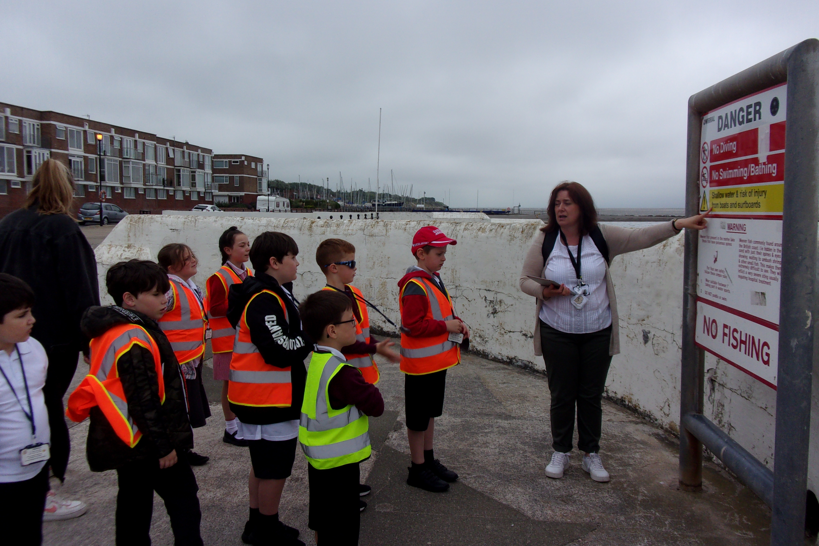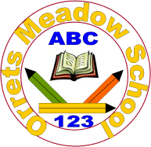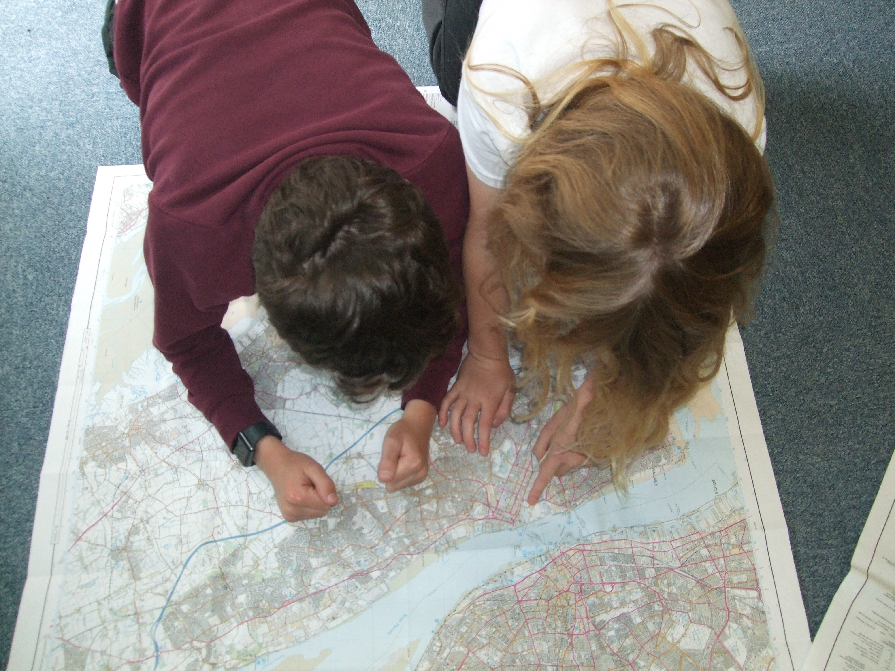
Governors Report – Summer 2021
Geography
Mr Eóin M Campbell

Achievements
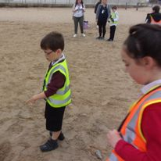
Despite the interference of the Covid pandemic, school persevered with our new Dimensions curriculum which presents Geography in a more holistic, blended manner. The themes delivered across the school have been wide and varied and all have opportunities to explore geographical content and in many cases, subject matter that would not normally be broached. In virtually every Dimensions theme there is Geography.
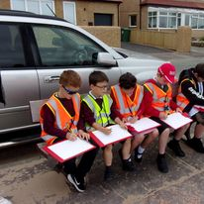
Geography is a very popular subject with Orrets pupils and given the major change from autonomous, stand-alone subject delivery to themed topics, this trend has continued. Staff stated unanimously that they enjoy the numerous opportunities in delivering and developing concepts.
The attainment analysis demonstrates clear achievement and progression in Geography skills and knowledge.

CPD
I have been fortunate to have been offered a number of courses, originally group sessions in various locations over the Mersey and since the advent of covid, I’ve been able to continue SL (Subject Leader) courses via Zoom and other social/digital portals.
Although the last Zoom course was largely geared towards a recovery curriculum, I still managed to extract many ideas and initiatives to help me plan for ways forward for Geography as a subject at Orrets.

Quality of teaching & learning
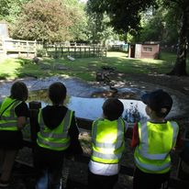
During peer observations and book scrutiny, it’s abundantly clear that we have gifted, enthusiastic, resourceful and highly motivating teachers and teaching assistants at Orrets. Geography is popular with our students precisely because the subject is delivered in an innovative and enthusiastic fashion. Pupils feel fully supported, they know what to do when they ‘hit a brick wall’ and are challenged to an appropriate level for their ability. Differentiation is a key part of lesson planning and delivery and each class’ team of staff are distributed well to provide for their group. Consequently, pupils make steady, measured progress with regard to NC levels of attainment. Students expressed an interest in sharing their new knowledge. They are keen debaters and rather driven to learning about new countries, cultures and locating these on both maps and globes.
I have had the pleasure of peer observing colleagues and experienced first-hand the multifaceted array of skills, expertise and resources. Staff are immensely resourceful and imaginative, which positively impacts the enrichment of lessons.

Reviews and survey samples
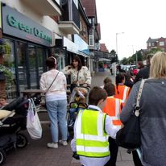
Through discussion with colleagues, staff and pupil voice survey samples and staff meetings, it’s evident that Geography has a higher appreciation status at Orrets than is perceived nationally. It is believed that Geography does not attract as much interest in pupils and is in some cases marginalised in many schools. Not so here! Pupils enjoy practical, hands-on sessions, trips linked with our ‘cultural capitol’ and even maps. On the whole, it is believed that we are reasonably well resourced and there were a number of positive, proactive suggestions for ways to improve our inventory of stock. It also emerged that students are more likely to return home and discuss or relay the subject material they have learned from that day’s session.
Staff found the new Dimensions Trackzone assessment tool straightforward and useful in recording skill progression. Even at the lower end of the attainment scale, students can still be seen to achieve well and make steady progress.

Strengths in Geography
On sampling staff on their perceived strengths in teaching, Geography factored high in both subject knowledge and enjoyment. From my observations and indeed the progress made by our student population, this is evidently the case. Teaching staff are enthusiastic about researching newer material to complement their base knowledge on given topics and many expressed great energy in doing so. Resourcefulness in providing opportunities for drama, computing, fieldwork, trips, multi-sensory provision to supplement their delivery are ever-present and the is a wealth of evidence in our students books and in both photographic and video format kept securely on the school’s bank.

Ways forward
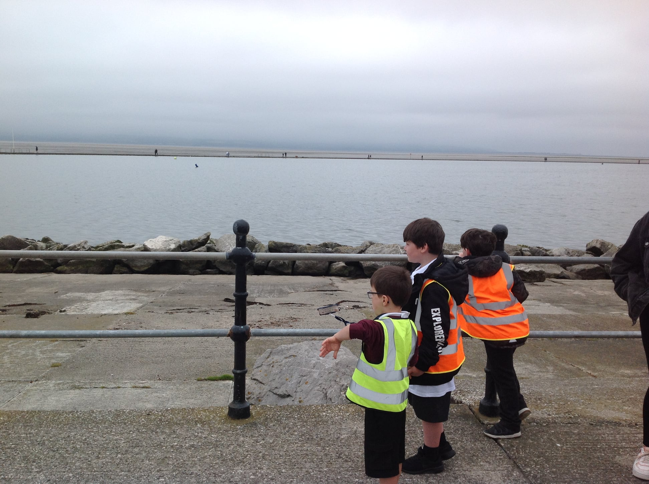
As Geography lead, I intend reviewing the school’s Geography inventory. We are limited by space more than most other schools and this is therefore a premium. I’m conscious that we have specific resources that are no longer required so an audit and reorganisation will take place.
I intend continuing my own CPD and I have already enrolled on further courses in the Autumn and Spring terms for next academic year.
Since the staff and pupil surveys took place this year, some of the proposals have already been addressed/implemented. Each class now has its own globe, which permits staff to demonstrate, spatially, where certain countries or regions are (sub-Saharan Afirca, Southern Hemisphere, etc.) and school renewed its subscription to Ordnance Survey Maps, which is a digital version of its entire mapping of the UK. Staff can print any region in all available scales for specific lessons or even fieldwork.
It is intended that an inventory be produced which will classify certain websites for specific types of lesson presentation. National Geographic and The British Geographical Society are two aimed at the adults/staff but provide great resources and information to increase staff knowledge. I intend to seek sites which provide more online, interactive resources.
Trips have been very difficult due to Covid, yet school have still been able to visit Tam O’Shanter, Parkgate, West Kirby, Hoylake and Birkenhead Park as part of their Wonders of Wirral topics. These visits brought their topic alive and they were able first hand to see the features they talked about in the classroom.
Finally, staff also expressed they would like ‘awe and wonder’ boxes for History. These would be furnished with specific objects for specific themes. Given the wide variety of themes and the entire globe being researched over the time a student may be at Orrets, this would prove to be an on-going way forward.

Targets for 2021-2022
- Purchase more globes (multisensory) [Jan 2022]
- Greater use of maps – OS Maps (expressed by many pupils sampled) [Aut 21/Spring 22]
- Purchase Class atlases – Oct 2021
- More ‘real-life’ resources (link with history) – awe and wonder - staff meeting 9/3/2022
- Geography computing programs – staff meeting – 1/12/21
- More fieldwork trips (cultural capitol) [throughout 21-22]
- More regular collaboration & sharing of resources [throughout 21-22]
- Purchase large scale wall map – Jan 2022

