23rd November 2016
Dear Parents/Carers

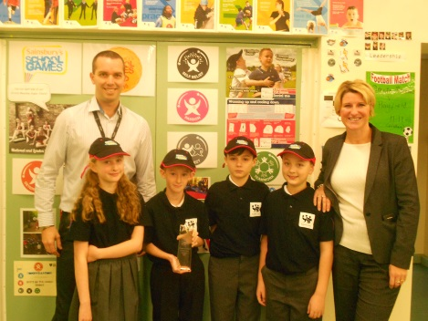
Wow what a term we are having! On Friday we were awarded ‘Primary School of the Year’ at the Merseyside Sporting Awards.

We also gained the Esafety Mark last week and we were one of the first Primary Schools on the Wirral to do so. Thanks to all the parents, pupils and staff who were interviewed by the assessor for the Award.

Anti-Bullying Charter
Michelle is our Anti-bullying lead person and recently she sent out a questionnaire for parents to complete to capture their views on Orrets Meadow’s anti bullying policy and practice. 100% said their child feels safe from bullying whilst in school and 100% felt any bullying incidents were dealt with quickly and effectively in school.

The Anti- bullying policy is on the website in two places- in the behaviour section and in the school policy section. The policy is updated annually and shared with all staff and Governors. Currently parents are not involved in adapting the policy and all returned questionnaires stated you would not like the opportunity to be involved.

All pupils have attended an Anti-bullying assembly by Bullybusters and they are taught about all forms of bullying and how to deal with it, if it happens, in lessons. All pupils when questioned felt there is no bullying at Orrets and if there was they would know what to do and who to tell. Michelle has created an anti-bullying board in the foyer and there is ‘young person friendly’ guide on it.

Art Sale
On Friday 9th December we are having a whole school art day. The theme is Happiness. Each child will produce a piece of fabric art which will be framed. Parents will then have the opportunity to buy the framed piece of Art for £5. All money raised will go towards enrichment activities for the pupils. Please sure your child is in school on the 9th December to create the art work.

End of term arrangements
Please look carefully below for activities taking place in the last week as there is a lot going on. On Wednesday 21st December children will be dropped off at Christchurch Church, Moreton by the taxis at 8.50am. Parents who bring their children to school will also need to drop off at church by 8.50. (It is the church off Moreton roundabout, on the right heading towards Upton).

Parents/carers, grandparents etc are invited to attend our Christmas service, which normally runs for about an hour. After the service the pupils walk back to school with their teachers and teaching assistants. Pupils must not leave with their parents as we will not know where they are.

Parents will drive back to Orrets Meadow for the end of term achievement assembly. Tea/coffee and mince pies will be on sale. There will be a bottle and chocolate tombola and an auction of various items/experiences. All money raised will go to the pupils, so please bring lots of money with you! Raffle tickets for a Christmas hamper will go on sale in the week before the assembly.

The end of term assembly is an opportunity for pupils and parents to celebrate progress made at Orrets. Prize Cups are also given out for various things eg. Art, PE, Kindness etc. Please try to attend as it means a lot to school and the children.

Christmas Dinner
This year Christmas dinner will be held on Friday 16th December. Letters will go out this Monday for you to return if you would like your child to have it. The dinner will be roast turkey with all the trimmings and Christmas pudding. (Other options are available on the menu). If your child wants their packed lunch that is fine. It is traditional at Orrets Meadow for the teachers to serve the pupils their Christmas dinner! The cost is the normal £2.30.

Wind in the Willows
Orrets Meadow’s Christmas treat to the children is for them to go see the Wind in the Willows play at the Williamson Art Gallery. Pupils will be transported in the school minibus. Half the school will go on the 19th December and the rest on the 20th December.

Dates for the Diary
30th Nov Flu Immunisations – Y1, 2, 3 pupils
1st Dec PTA meeting @ 4pm
2nd Dec Liscard v OM Football match 1.30pm (minibus)
2nd Dec Non Uniform day – chocolate for Xmas tombola
9th Dec Whole School Art Day – Happiness through fabric
9th Dec Non Uniform day – bottles for Xmas tombola
12th Dec Class 7 trip to Liverpool
14th Dec Signalong - Meadowside
16th Dec Save the Children – Wear a Xmas jumper day - £1
16th Dec Christmas dinner
19th Dec Wind in the Willow play @ Williamson Art Gallery (half the school)
20th Dec Wind in the Willow play @ Williamson Art Gallery (half the school)
21st Dec End of term assembly and church service @ 9am – details above
22nd Dec AM - House reward – Cinema trip to the Light Cinema (winners announced 16th)
22nd Dec PM – Class Christmas parties – Come in party clothes. Father Xmas is visiting!
22nd Dec School finishes for half term @ 3.30pm

Tuesday 10th January – school reopens for the Spring Term

Thanks for your continued support

Mrs Duncan

