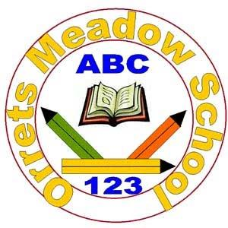

Orrets Meadow

Literacy Spine

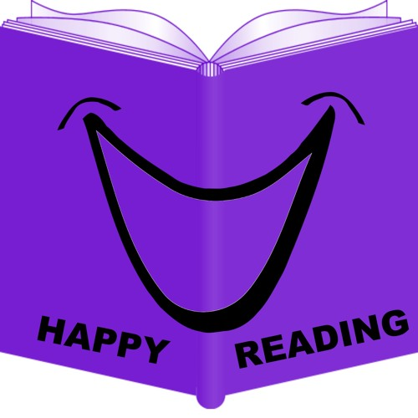

**Explorers (Cycle A)**

|  |  |
| --- | --- |
| **Curriculum Texts** | **Class Readers** |
| Funny Bones (Allan Ahleberg) | Where’s Spot? (Eric Hill) |
| Peace at Last (Jill Murphy) | Dear Zoo (Rod Campbell) |
| Farmer Duck (Martin Waddell) | You Choose (Pippa Goodhart & Nick Sharratt) |
| Barry the Fish with Fingers (Sue Hendra) | Brown Bear, Brown Bear, What Do You See? (Bill Martin Jnr. & Eric Carle) |
| Pirates Love Underpants (Claire Freedman & Ben Cort) | Jasper’s Beanstalk (Nick Butterworth & Mick Inkpen) |
| All Ears, All Eyes (Richard Jackson) | The Very Hungry Caterpillar (Eric Carle) |
| The Three Little Pigs | Hairy Maclary from Donaldson’s Diary (Lynley Dodd) |
| Can’t you Sleep Little Bear? (Martin Waddell) | Each Peach Pear Plum (A & J Ahlberg) |
| The Rainbow Fish (Marcus Pfister) | Hug (Jez Alborough) |
| Pete the Cat and the Treasure Map (James Dean) | The Train Ride (June Grebbin) |
| Ears, Eyes and Toes | Come on, Daisy! (Jane Simmons) |
| The Singing Mermaid (Julia Donaldson) |  |
| The Colour of Us (Karen Katz) |  |
| Perfect Pet (Margie Palatini) |  |
| Nugget and Fang (Tammi Sauer) |  |
| Goldilocks |  |
| We’re Going on a Bear Hunt (Michael Rosen) |  |
| I Forgot |  |
| Commotion in the Ocean (Giles Andreae) |  |
| How to Babysit a Grandma (Jean Reagan) |  |
| All Join In (Quentin Blake) |  |
| The Lonely Lobster (Beth Costanzo) |  |

**Explorers (Cycle B)**

|  |  |
| --- | --- |
| **Curriculum Texts** | **Class Readers** |
| Jack and the Beanstalk – Twinkl | Owl Babies (Martin Waddell) |
| I am Josephine and I am a living thing (Jan Thornhill and Jacqui Lee) | The Gruffalo (Julia Donaldson) |
| The Gingerbread Man - Twinkl | Handa’s Surprise (Eileen Browne) |
| Where’s my Teddy? (Jez Alborough) | Mr Gumpy’s Outing (John Burningham) |
| Pretty (Canizales) | Rosie’s Walk (Pat Hutchins) |
| Should I Share my Ice-cream? (Mo Willems) | Six Dinner Sid (Inga Moore) |
| Snow White – Twinkl | Mrs Armitage on Wheels (Quentin Blake) |
| The Rhyming Rabbit (Julia Donaldson) | On the Way Home (Jill Murphy) |
| The Smartest Giant in Town (Julia Donaldson) | Goodnight Moon (Margaret Wise Brown) |
| All About India (Shalu Sharma) | Shhh! (Sally Grindley) |
| Superworm (Julia Donaldson) |  |
| Cinderella - Twinkl |  |
| Mr Small (Roger Hargreaves) |  |
| Diwali Holidays Around the World (Lisa J Amstutz) |  |
| Old Bear (Jane Hissey) |  |
| The New Baby (Anna Civardi) |  |
| How the Camel got his Hump (Rudyard Kipling) |  |
| Whatever Next (Jill Murphy) |  |
|  |  |

**Pathfinders (Cycle A)**

|  |  |
| --- | --- |
| **Curriculum Texts** | **Class Readers** |
| The Ugly Duckling (Lynne Bradbury)/ Twinkl | The Elephant and the Bad Boy (Elfrida Vipont & Raymond Briggs) |
| Little Red Riding Hood - Twinkl | Avocado Baby (John Burningham) |
| Cinderella - Twinkl | The Tiger Who Came to Tea (Judith Kerr) |
| The Three Little Pigs - Twinkl | Lost and Found (Oliver Jeffers) |
| Where the Wild Things Are (Maurice Sendak) | Knuffle Bunny (Mo Willems) |
| The Polar Bear Son – An Inuit Tale (Lydia Dabcovich) | Beegu (Alexis Deacon) |
| We’re Going on a Bear Hunt (Michael Rosen) | Cops and Robbers (A & J Ahlberg) |
| Not Now Bernard (David McKee) | Elmer (David Mckee) |
| Man on the Moon (Simon Bartram) | The Twits (Roald Dahl) |
| The Garden (Dyan Sheldon) | The Water Horse (Dick-King Smith) |
| Dogger (Shirley Hughes) | Blob (David Walliams) |
| The Zoo (Anthony Browne) |  |
| Little Beauty (Anthony Browne) |  |
|  |  |

**Pathfinders (Cycle B)**

|  |  |
| --- | --- |
| **Curriculum Texts** | **Class Readers** |
| The Owl Who Was Afraid of the Dark (Jill Tomlinson) | Meerkat Mail (Emily Gravett) |
| Traction Man is Here (Mini Grey) | Amazing Grace (Mary Hoffman) |
| Dino Danger (Mortimer Keene) | Pumpkin Soup (Helen Cooper) |
| The Lighthouse Keeper’s Lunch (Ronda and David Armitage) | Who’s Afraid of the Big Bad Book? (Lauren Child) |
| The Runaway Iceberg (Twinkl) | Dr Xargle’s Book of Earthlets (Tony Ross) |
| The Snail and the Whale (Julia Donaldson) | Tuesday (David Wiesner) |
| The Secret of Spiggy Holes (Enid Blyton) | The Flower (John Light) |
| Jake’s First Day - Twinkl | Gorilla (Anthony Browne) |
|  | Emily Brown and The Thing (Cressida Crowell) |
|  | Frog and Toad Together (Arnold Lobel) |
|  | The Giraffe, the Pelly and Me (Roald Dahl) |
|  | Fantastic Mr Fox (Roald Dahl) |
|  | The Hodgeheg (Dick King-Smith) |
|  | Flat Stanley (Jeff Brown) |
|  | Willa and old Miss Annie (Berlie Doherty) |
|  |  |

**Adventurers (Cycle A)**

|  |  |
| --- | --- |
| **Curriculum Texts** | **Class Readers** |
| Greek Myths (Marcia Williams) | The Iron Man (Ted Hughes) |
| The Orchard Book of Greek Myths (Geraldine McCaughrean) | Cat Tales: Ice Cat (Linda Newberry) |
| Nessie, the Loch Ness Monster (Richard Brassey) | The Sheep-pig (Dick King-Smith) |
| Loch Ness Monster (James Carney) | The Abominables (Dick King-Smith) |
| Firework Maker’s Daughter (Phillip Pullman) | The Battle of Bubble and Squeak (Philippa Pearce) |
| The Chronicles of Harris Burdick (Chris Van Allsburg) | The Diary of a Killer Cat (Anne Fine) |
|  | How to Train your Dragon (Cressida Cowell) |
|  | Charlie and the Chocolate Factory (Roald Dahl) |
|  | The Secret Seven (Enid Blyton) |

**Adventurers (Cycle B)**

|  |  |
| --- | --- |
| **Curriculum Texts** | **Class Readers** |
| Hansel and Gretel (Anthony Browne) | Bill’s New Frock (Anne Fine) |
| Little Red Riding Hood/Rapunzel (Bethan Woollvin) | Charlotte’s Web (EB White) |
| Cinderfella (Malachy Doyle and Matt Hunt) | Why the Whales Came (Michael Morpurgo) |
| The Great Kapok Tree (Lynne Cherry) | The Snow Walker’s Son (Catherine Fisher) |
| The Vanishing Rainforest (Richard Platt) | Perry Angel’s Suitcase (Glenda Millard) |
| Tales From Africa (Kathleen Arnott) | Voices in the Park (Anthony Browne) |
| Journey to Jo’burg (Beverly Naidoo) | Kensuke’s Kingdom (Michael Morpurgo) |
| The Suitcase Kid (Jaqueline Wilson) | Gangsta Granny (David Walliams) |
| The Lion, The Witch and The Wardrobe (C.S. Lewis) | The Enchanted Wood (Enid Blyton) |
| The Secret World of Polly Flint (Helen Cresswell) | The Famous Five (Enid Blyton) |
| Anna and the Land of Clocks |  |
|  |  |