ORRETS MEADOW SCHOOL
2019/20
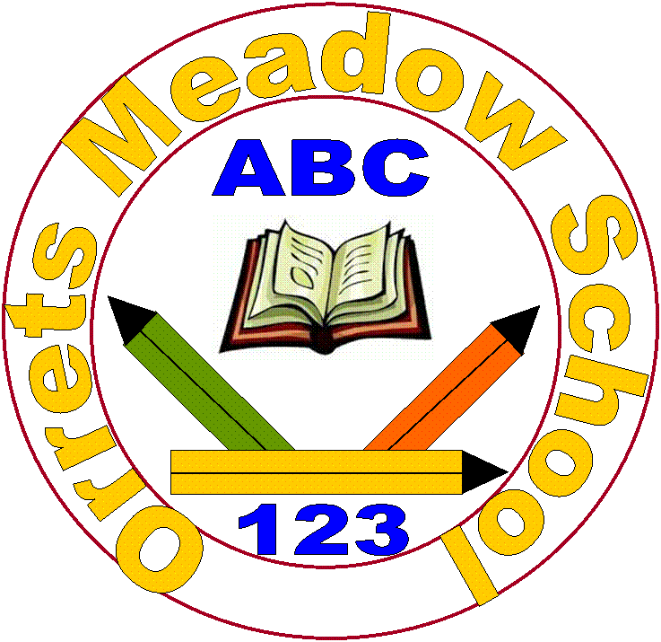

“To raise the aspirations of every child and give them the confidence to fulfil their potential through positive learning experience”

Orrets Meadow School
Chapelhill Road
Moreton
Wirral
CH46 9QQ

Tel no. 0151 678 8070
Email: schooloffice@orretsmeadow.wirral.sch.uk
School website: http://orrets-meadow.eschools.co.uk
https://www.facebook.com/orretsmeadow/

Dear Parents

"To raise aspirations of every child and give them confidence to fulfil their potential through positive experiences"
Welcome to Orrets Meadow's Website! Our most recent Ofsted report, October 2017, found Orrets Meadow for the fourth consecutive time to be an 'Outstanding' school.
We are a special school for children aged 5-11, who have an EHCP for Social Communication Difficulties including Autism. All of our children are working below age related expectation and have difficulties in reading and spelling. They may also have specific difficulties with maths, attention, social skills, speech and language, organisational skills, spatial awareness and fine/gross motor skills.
Orrets Meadow offers children; specialist teachers in Autism, Dyslexia and Dyscalculia, small classes of 8-12 pupils, tuition using multi-sensory techniques and a carefully structured approach with opportunities for reinforcement and revision. Our learning programmes and methods are tried and tested but are flexible and adapted to suit the needs of the individual. Positive mental health, developing resilience and building a love of school and learning, are at the forefront of everything we do. The 3 values for all our staff and pupils are; Work Hard, Be Nice and Never Give up!
All of our classrooms are ‘ASD’ friendly. Each class uses visual timetables, emotional thermometers to gauge mental health, has access to a sensory room and their own toilet and changing facilities. Sensory circuit runs every morning from 9-12 so the children can have as many sensory breaks as they require to help them regulate and be ready to learn. Each child has a pen portrait and a sensory diet profile.
Our policy is to re-awaken interest in learning, to restore the child’s confidence and self-esteem and to help every pupil reach his or her potential. At the same time, we provide a broad and balanced curriculum relevant to the pupil’s needs and abilities. Progress is carefully monitored in a variety of ways, including standardised diagnostic reading and spelling tests. At all time the pupil's mental health is paramount and this remains a relentless focus for the school and all its stakeholders.
We work with many professionals to help remove barriers to learning including; School nurse, Educational Psychologist, Occupational Therapist and Camhs. We use our Pupil Premium to fund both a Speech Therapist on site two days a week and weekly visits from Thumbs Up. We will also have our own full time Home School Worker. We have regular coffee mornings with a wide range of courses and visitors. Parents describe Orrets Meadow as being like their family.
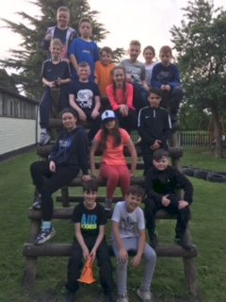
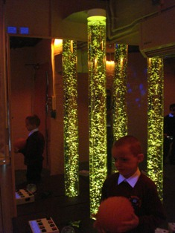
Orrets Meadow also provides a number of traded services. A traded outreach service is available to mainstream schools for Literacy and Numeracy. Training for Teachers and Teaching Assistants can be provided, as well as advice and assessment expertise from a specialist team (SENAAT).

We hope that if your child joins us he or she will be happy and make excellent progress and will continue on to Secondary School with the skills and confidence to succeed.
If you have any further queries, or if you would like to visit Orrets Meadow, please do not hesitate to contact me.
Mrs Duncan - Headteacher

1. Who will come to our school?

All of the children at Orrets Meadow have an Education Health Care Plan, naming this school.

2. What will happen if my child has additional needs?

If you are concerned that your child may have additional needs please raise these concerns with the class teacher or with the headteacher or deputy.

We work in partnership with many agencies and are able to access support from the ASD team, Behaviour Support, Vision and Hearing Impaired Services, Clinical Psychologist, Occupational Health, Educational Psychology Service. Using our Pupil Premium funding we buy in our own Speech & Language therapist, Bethany, who visits 2 days a week. We also have a full time Home School Link Worker, called Michelle and Thumbs Up Education, Sue, on site half a day a week, working with classes, groups and individuals.

There is full wheelchair access to the school, changing room/shower facilities and a disabled toilet.

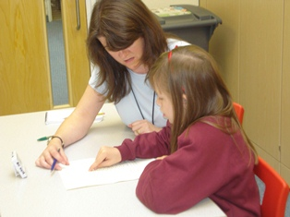
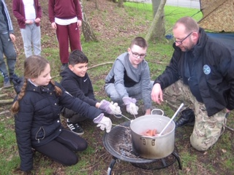

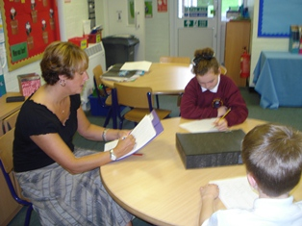
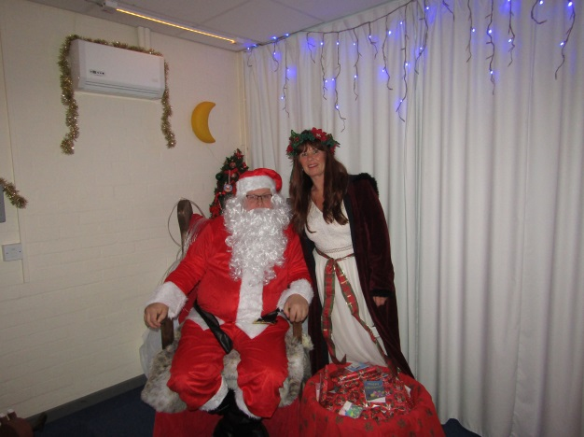

Michelle and Father Christmas

3. Who are the staff at Orrets Meadow?

Staffing Plan 2019/2020

Class/Year | Teacher | Teaching Assistant
Class 1 - Y1/2 | Mrs Wright (ASD Leader) | Miss Delamare  Mrs Mervyn  Miss Harris  Miss Pownall Jones
Class 2 – Y3/4 | Mrs Billington ( SpLd leader) | Miss Johnson  Mrs Forshaw
Class 3 – Y4/5 | Miss MacGregor/Mrs Gordon | Mrs Amer  Miss Deer
Class 4 –Y4/5 | Mr Ferris | Mrs Doyle  Mrs Nicholls
Class 5 – Y5/6 | Mr Saul | Mrs Ward  Mrs Maddocks
Class 6 – Y5/6 | Mrs Tunna | Mrs Wynne  Mrs Bridson
Class 7 – Y6 | Miss O’Brien | Mrs Walsh  Mrs Binnell
Mr Campbell, Mrs Williams and MrsGordon and cover PPA. Mrs Williams leads Speech and Language and Lego Therapy sessions each week.
Admin Midday Supervisors
Miss A Griffiths Mrs Welch
Mrs J Santangeli Mrs Simon

ICT Technician Kitchen
Steve Roberts Mrs Cleverley

Cleaning/Caretaker Home School Worker
Mr Connor/ Mrs Winson Michelle King

Speech and Language Therapist Chair of Governors
Bethany Ian Patten

Safeguarding Lead = Mrs Duncan Deputy – Mrs Wright/Mrs King
Health and Safety Lead = Mrs Duncan Deputy – Mrs Wright
Safeguarding/H&S Governor – Mrs Cindy Cooper

4. Is the curriculum different at Orrets Meadow?

The school’s curriculum covers all the subjects your child will have studied in their mainstream school. The difference is in the balance and the emphasis on teaching literacy and numeracy skills. We also hope to teach the children to recognise their difficulties and to develop strategies to cope with them, thus becoming increasingly independent.

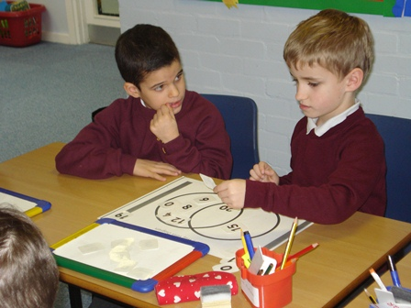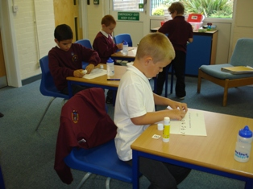

The afternoon curriculum has more of a focus on social and life skills as well as teaching all the usual foundation subjects. We have designed an exciting afternoon curriculum for Sept ’19.Our aim is that your child makes progress in all areas and continues to Secondary School with a passion for learning and increased confidence in themselves and their learning.

Multi-sensory Learning
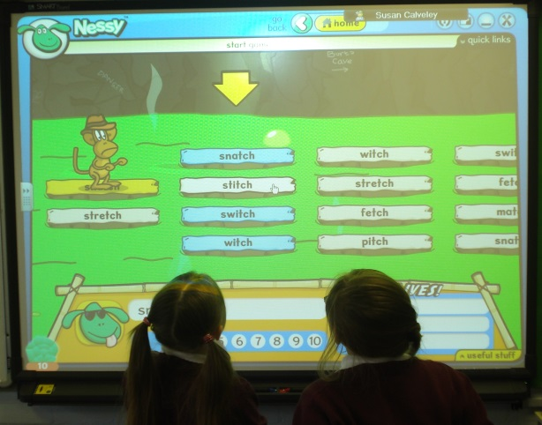
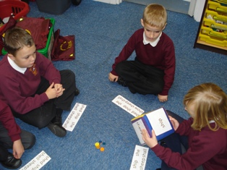

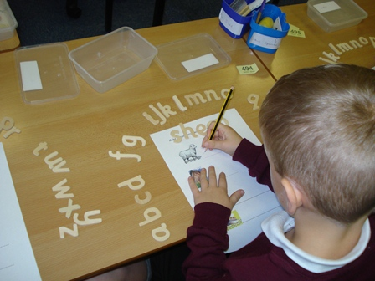
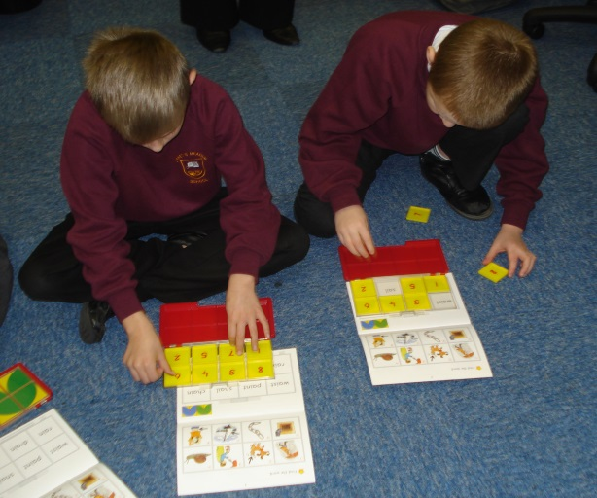

5. Will my child do PE?

Orrets Meadow was awarded ‘Primary School of The Year’ and is very fortunate to have a specialist lead PE teacher who has helped the school gain the Sainsbury’s Gold School Games Award and the prestigious AfPE Award, which is the highest accolade a school can gain in PE. All our teachers have had specialist PE mentoring to deliver lessons covering a wide range of sports and activities. Visiting coaches also offer extended activities such as Dance, Taekwondo, Archery, Judo and Fencing. We offer the children football, rugby, boccia, cycling, volleyball, gymnastics, rounders, table tennis, cricket, hockey and athletics. Swimming is available every year for two weeks during the summer term for Year 6. Opportunities for outdoor and adventurous activities such as climbing and orienteering are also provided at Barnstondale for the older pupils in the annual residential. Year 6 also take part in Bikeablilty, which ensures children are safe to cycle on the road. With the PE funding given to every school, we have Clare Mount Sports Specialist College come in once a week to coach the children and professionally develop the teachers. Working with Clare Mount has led to us accessing many inspirational talkers and professional sports people, including Olympians.

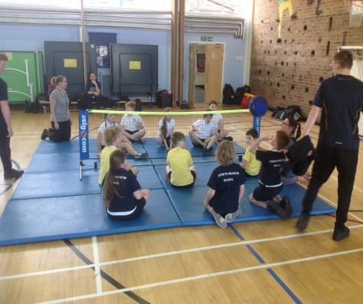
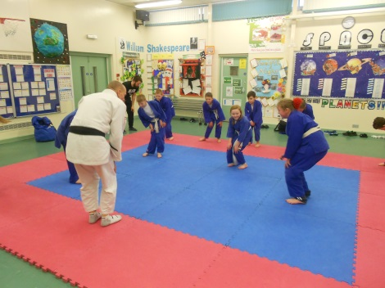
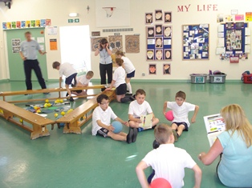

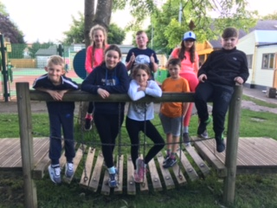

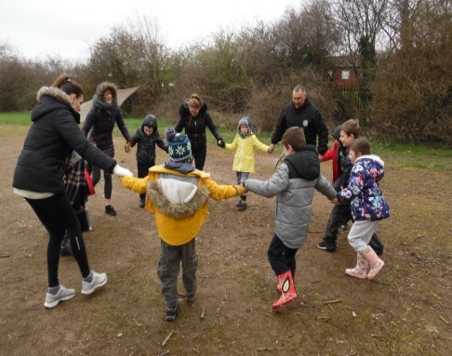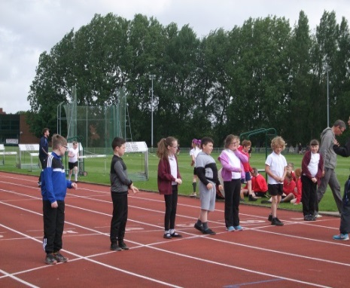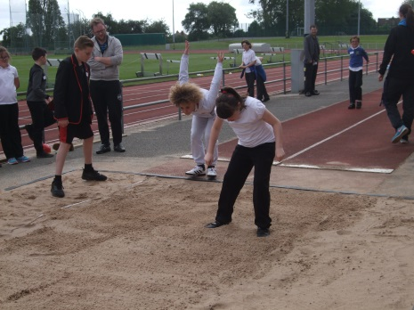

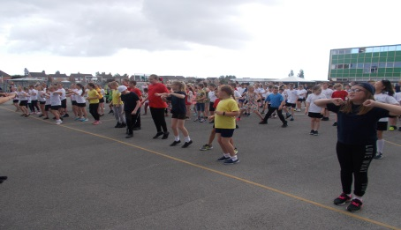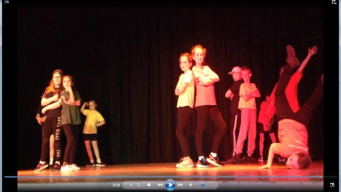
Our playground has a number of climbing frames and balancing equipment to make playtimes fun or children can play football on the large pitch. Orrets Meadow frequently enters teams into local sporting competitions and plays football matches against the local mainstream school.

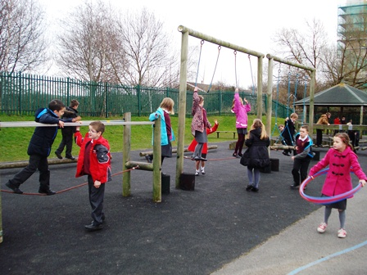
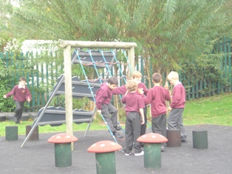

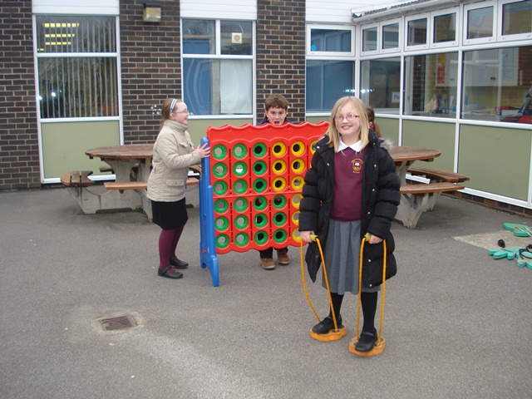
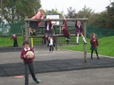

6. Is there a Sex Education Policy?

There is and it is available for parents at school and on the school website. Sex education is taught in terms of relationships and emotional development and forms part of the Dimensions PSHE curriculum, under the theme ‘relationships’. Should any parent wish to withdraw their child from any aspect, they should request this in writing. It is usually taught during the summer term and parents and carers are invited in to see and discuss materials used in this work.

7. Does the school teach RE?
The children are taught about cultural and moral aspects of a variety of religions. The school is not affiliated to any one religion. Children can be withdrawn from RE and the collective act of worship. These children will sit in the Library to read quietly.

.

8. Does the school have a Behaviour Policy?

Yes, and it is available at the school and on the school website. We use our own behaviour system based on the planets and this is consistently applied across the school day. Details of this system can be found on the website. Positive behaviour is actively rewarded and children are made clear about the consequences of making poor choices. There is a Code of Conduct which is agreed with children each year. There is also an Anti-Bullying Policy and we have several incentives to encourage good behaviour. Orrets Meadow has achieved the Anti Bullying Charter.

Pupils are divided into four Houses, and can win points for their House via various sports tournaments, good behaviour on school transport and earning class prizes in the weekly Rewards Assembly. At the end of each term a treat is organised for the winning House, such as: Bowling, Laser Quest or the Cinema.

More serious incidents are recorded and persistent poor behaviour may result in parents being contacted to discuss possible causes and ways to improve future conduct. It may be decided to place the child on a behaviour chart where the child’s behaviour will be monitored and recorded throughout the day.

School rules are kept to the minimum and are written in a positive way – Be Nice, Work Hard and Never Give Up. The aim is for all children to develop self-discipline. Rules are discussed at the beginning of each year, with regular reminders throughout the year. They are also displayed around the school.

All staff are trained in Team Teach and this is only used as a last resort, to keep the child from hurting themselves or others. All Team Teach and behaviour incidents are recorded and kept in the Headteacher’s office. Parents are asked to sign a consent form for Team Teach in their induction pack and parents are always informed if it has been used. Our policy on Team Teach is on the school website.

Each teacher rewards one or two pupils in their class at our Friday Assemblies. This may be for good work, thoughtfulness or kindness etc.
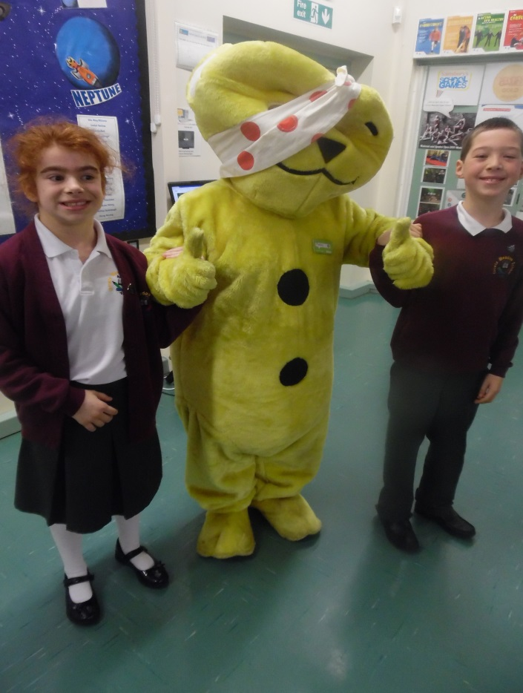
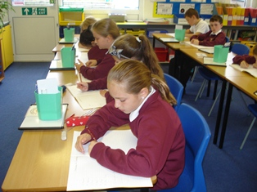

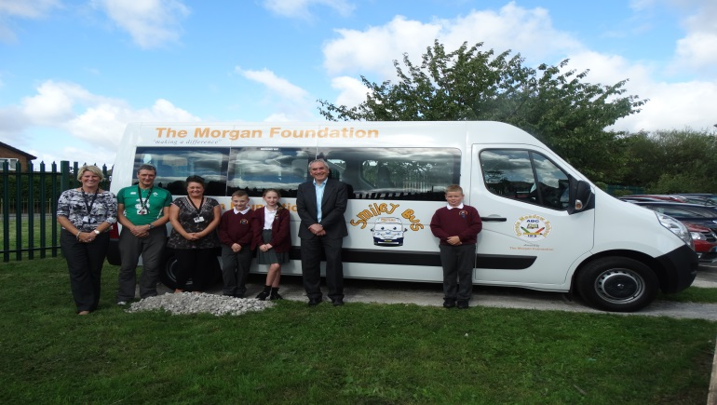

9. What will my child’s day be like?

The children arrive at school by bus or taxi at about 8.50am. They are met by our Teaching Assistants who remain with them until 9.00am. During this time they may buy toast or fruit and/or a drink (fruit juice, milk, hot chocolate). All items cost 20p. This includes milk for those pupils who want it and for those children entitled to free milk. .

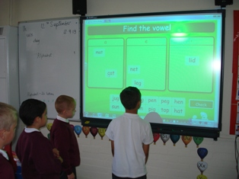
9.00 – 9.45 Phonics

9.45 – 10.30 English

10.30 – 10.45 Break

10.45 – 11.00 Mental Maths

11.00 -12.00 Maths

12.00 – 12.30 Groups time – meeting the child’s additional needs

12.30 – 1.30 Lunch

1.30 – 1.45 Assembly (Mondays)

1.45 – 3.30 Lessons – Dimensions curriculum, PE, RE, Computing, life & Social Skills

On a Fridays children are asked to join Mrs Duncan on the Special Table for lunch. This rewards good behaviour and attitude towards learning.
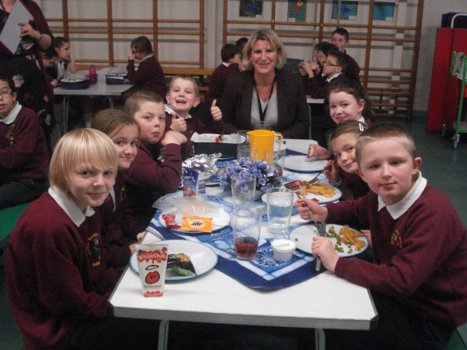

Parents and friends will be informed of special achievement assemblies as they arise.

10. Will my child have Homework?

Your child will get homework and we would ask you to support this work. If children receive support at home, they usually make greater progress and children love being able to achieve!

Homework is set each day and we ask parents to check that it has been completed to a reasonable standard. It will comprise about 10 minutes reading, probe and spelling. However if this is causing issues at home it can be completed at catch up club. Maths will usually be set once a week. Early September, we hold a Meet the Teachers meeting and all parents are advised to attend as homework is discussed and explained. Catch up club is at lunchtime each day for any child who can’t do their homework at home. If for some reason difficulties arise from the homework, please contact the school and we may be able to suggest some alternatives.
11. What happens if my child is unhappy?

We work hard to create a warm and caring environment in which your child will feel secure. We are aware that many of our pupils have had unhappy experiences in their education and it is our aim to ensure that these are not repeated here.

With this in mind, we are always ready to listen to our pupils and their parents and to do our best to sort out any problems or difficulties that may arise. We would therefore urge you to contact school if you are aware of anything which is causing your child distress. Usually the staff are able to put the child’s mind at rest and to deal with the problem immediately. Wherever possible, staff will always contact parents to inform them of the outcome.

Occasionally a problem will arise which staff feel unable to deal with without the advice or guidance of an outside agency, possibly the school nurse or Social Services.

You will appreciate that if a child raises an issue with a member of staff, or if a member of staff has concerns for a child’s welfare, it is imperative that all steps are taken to ensure the safety and well-being of the child. Such occasions occur rarely. However if it should involve you and your child, we hope you will realise that our first responsibility is to the child. In such circumstances we would ask for your co-operation and understanding.

12. What do I do if I have a complaint?

Speak to someone as soon as possible, either the class teacher or the Headteacher. On our website there is a copy of our complaints policy.

13. Can we keep our child off school for a holiday?

The Headteacher is unable to authorise Holidays in school time, except in exceptional circumstances.

14. Is attendance important?

Regular attendance is very important, especially for those with learning difficulties. With regular attendance, your child will be more settled in their new school and will certainly progress. They will also gain and keep friendships. Each child with 100% attendance receives an end of term certificate. We aim for 96% and above, if a child’s attendance falls below 95% a letter of concern is sent home and if it falls below 90% the Headteacher will ask parents to attend a meeting to explain why this pattern has arisen.

Currently attendance is 97% at Orrets Meadow, which is higher than the national average.

You must inform school before 9am if your child is unwell and not coming into school. Michelle King, Home School Link Worker, will ring any parents who we have not heard from.

15. Are there any charges made by the school?

The Governors have adopted the Authority Policy on charging for activities. A copy is available from school. We will charge for:

Materials provided for practical sessions, tuition provided by the Authority’s Music Service and board and lodging for residential trips.

Any costs linked to repair or replacement of materials or fabric of the building damaged by your child.

You will be asked for a voluntary contribution towards:

School trips or visits – no child will be excluded from such trips for non-contribution.

We will pay for: materials, books, and equipment used during school hours.

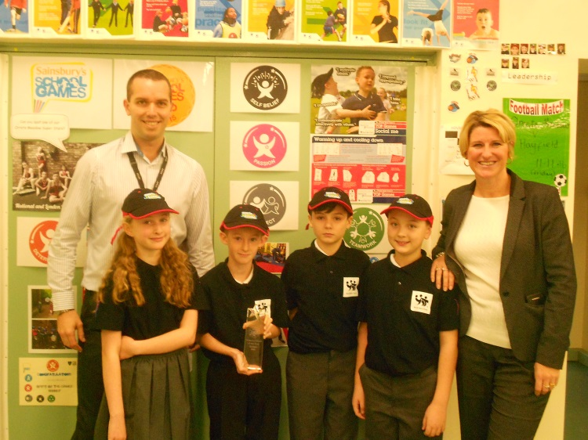
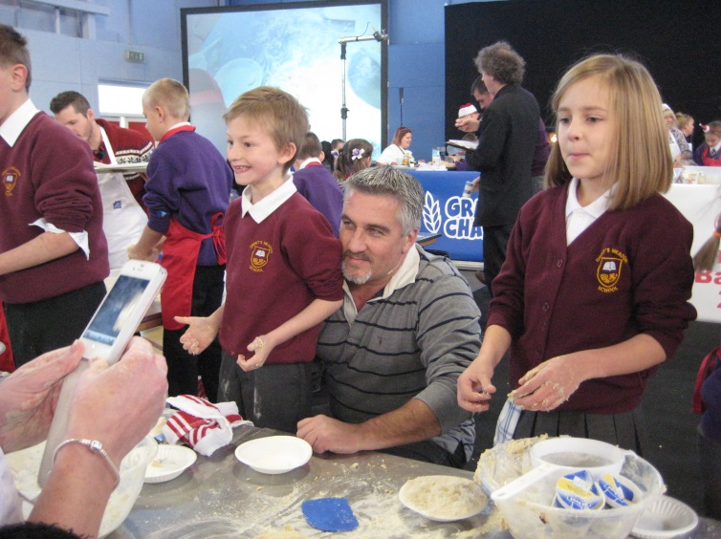
Residential Trips

Year 6 children take part in a residential trip to Barnstondale. The children get the opportunity to do lots of activities such as: kayaking, rock climbing, orienteering, river crossing, archery etc. All children are encouraged to go and we some of our PE funding to subsidise the cost.

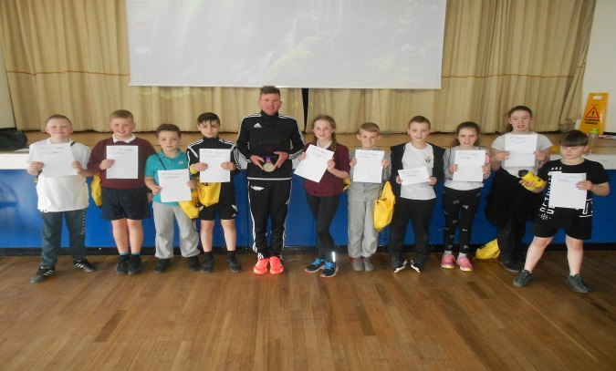

Orrets Meadow School – Term Dates 2019/2020

Autumn Term 2019

Monday 2nd September – Inset Day – School closed.
Tuesday 3rd September – Inset Day – School closed.
Wednesday 4th September – School re-opens for pupils.

Friday 25th October – School closes at 3.30pm
Half Term – Monday 28th October to Friday 1st November
Monday 4th November – School re-opens for pupils

Friday 20th December - School closes at 3.30pm
Christmas Break – Monday 23rd December to Friday 3rd January

Spring Term 2020

Monday 6th January – Inset Day – School closed.

Tuesday 7th January – School re-opens for pupils.

Friday 14th February – School closes at 3.30pm
Half Term – Monday 17th February – Friday 21st February
Monday 24th February – School re-opens for pupils.

Friday 29th March – School closes at 3.30pm
Spring Break – Monday 6th April – Friday 17th April

Summer Term 2020

Monday 20th April – School re-opens for pupils
May Bank Holiday – Friday 8th May
Thursday 21st May – school closes at 3.30pm

Friday 22nd May - Inset Day – School closed.

Half Term – Monday 25th May – Friday 29th May.
Monday 1st June – School re-opens for pupils

Friday 17th July – School closes at 3.30pm
Monday 20th July Inset Day – School closed.

Autumn Term 2020 – School opens Tuesday 1st September 2020

16. What do the children wear?

We have an Orrets Meadow Sweatshirt, which can be bought from school.
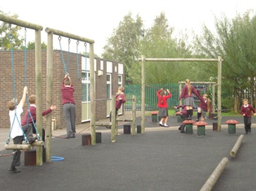
We ask that the children wear the following:

Boys Plain, dark coloured trousers, plain shirt or polo shirt, sweatshirt and sensible shoes.

Girls Dark skirts, pinafores or trousers, plain blouses or polo shirts, cardigan or sweatshirt and sensible shoes. In the Summer term school dresses can be worn – red gingham. Long hair should be tied back.

PE White t-shirt or vest and dark shorts, pumps or trainers.

17. Is there anything they are not allowed to wear?

Children should not wear denim jeans. For reasons of safety, no jewellery is allowed in school except for wrist watches. Appropriate hair cuts are also requested.
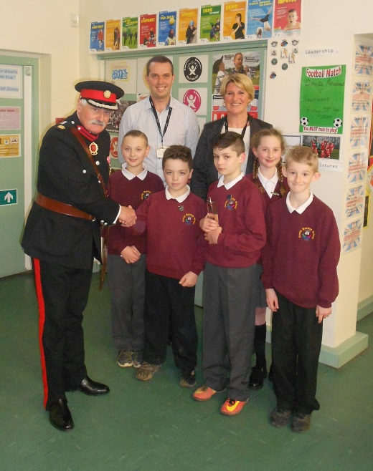
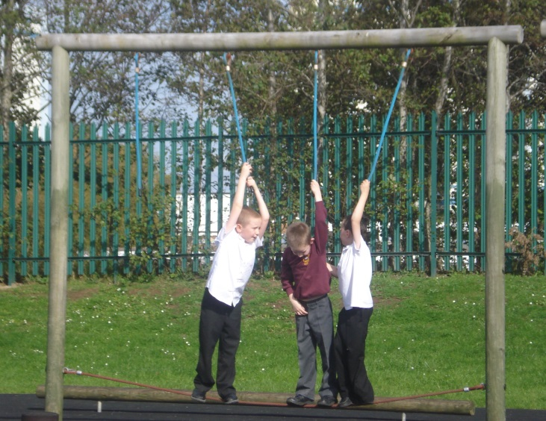

18. What happens about food during the day?

As children leave home early in the morning, we run a breakfast club. Children can buy toast or fruit, fruit juice, milk or hot chocolate. All items cost 20p each and money should be brought to school each morning. This is when milk is available for those who wish to buy it and for those children entitled to free milk.

Lunches are prepared in our kitchen each day. There is a choice of a hot meal or wrap/sandwich each day. Meals currently cost £2.30 per day, and should be paid weekly by sending £11.50 each Monday into school via the escort. Children can also choose to have school meals on particular days, then money must be paid on the day. Parents can also pay half termly or termly if preferred.

If your child is entitled to a free school lunch, this will continue in this school. Children in KS1 receive free school meals.
If your child prefers to bring a packed lunch, please send it in packed securely in a container with the child’s name on. Fizzy drinks are not allowed and all drinks should be in a plastic bottle or carton.

Fruit and breadsticks are on sale at break times for 20p a piece of fruit (breadsticks 10p for 2).

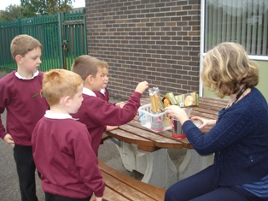
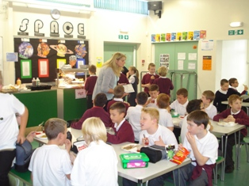

19. Can my child get drinks through the day?

All children are provided with sports bottles for water, which can be filled at the chilled water fountain.

Milk is available at a cost of 20p per day. The milk is available when they arrive at school. Children entitled to a free school meal can receive free milk also.

20. Is there anything children should not bring to school?

We ask that children do not bring in sweets or chocolate for break times as we are a ‘Healthy School’. Valuable items such as mobile phones, tablets etc, for use on the bus, should be given to a member of staff on arrival at school and any cameras on them must be covered up. The internet must not be enabled on all devices in line with our safety policy.

21. Does Orrets Meadow have a football team?

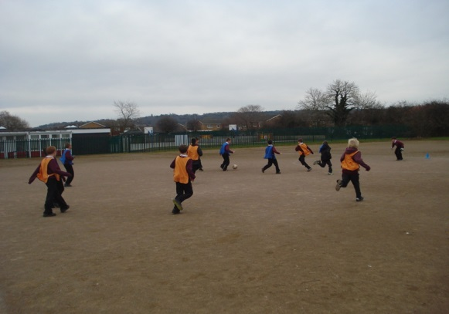
We do not have a team which regularly plays against other schools, mainly due to the distances our children travel, however we do play against our local mainstream school every term. Our PE teacher coaches the pupils who want to play and the chosen players take part in tournaments whenever possible. Matches with other schools are arranged. The children also play organised matches each break-time and lunch time. They are supervised and organised by an adult and are purely optional. The children play on an all-weather pitch which we share with an adjacent school.

22. Are there any after school clubs?

Because of the distances our children travel, we hold most extra-curricular clubs at lunchtimes. This year the children have access to reading, football, lego, dance, minecraft, model making, gardening, computer, Art, sewing and Wii clubs, tennis, ECO, bike, school magazine, leadership clubs, plus many more over the year.

23. How will our child get to school?

School transport is provided by the Local Authority. Each bus has an Escort, who is your direct link with the school.

Please have your child ready before the Escort calls, and remember to let the Escort know if your child will not be attending school due to illness or other reason. When your child is well enough to return, let the Escort know to call again. You must phone school to inform us your child is off school too before 9am.

If you have any queries, or need to make any changes to where your child is collected or dropped off, please phone transport on 666 4213/4212.

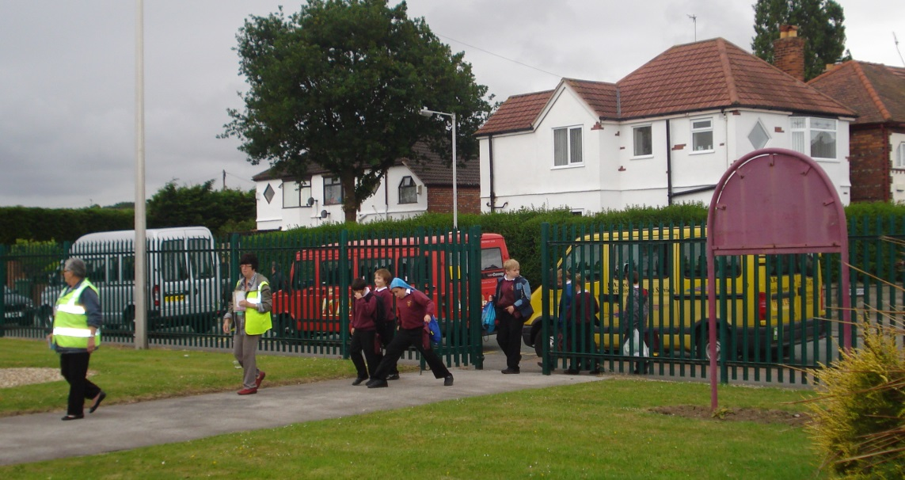

24. Can my child be given medication in school?

Prescribed medicines can be given to your child in cases where they are well enough to return to school after a short-term illness, or where chronic illness such as asthma or epilepsy needs to be controlled. We ask parents to complete a medicine form or asthma card. We can give paracetamol but not ibuprofen for a short term if medicine forms are completed.

All medicines should be sent to school in original packaging, clearly labelled with the child’s name, dosage and timings. Medicines should be transferred by adults only.

We cannot accept responsibility in cases where timing and the nature of administration are of vital importance, or where technical or medical knowledge is required or where intimate contact is necessary.

25. What will happen if my child has an accident in school?

Bumps and grazes do occur from time to time and are dealt with as you would at home. If the injury is to the head, we will inform you by telephone if possible and by letter via the Escort.

If your child suffers a more serious injury in school, we will make every effort to contact you. If the injury requires emergency treatment then appropriate action will be taken immediately. It is very important we have working telephone numbers to get hold of you at all times in case of an emergency.

25. What does school need from you?

Please:

Take an active and supportive interest in your child’s work;

Support your child with their daily homework;

See that your child attends school regularly;

See that your child has adequate sleep so that s/he is ready to learn the next day;

Support the school in terms of discipline – this will help your child to achieve maturity, self-discipline and self control.

Keep us up to date with changes in telephone numbers etc so that we can reach you in an emergency.

26. How do the Governors support Special Needs?

Governors regularly monitor the school’s success in meeting the needs of our pupils as well as their progress. This may be by formal reports and through Governors’ visits to the school. Funding is allocated to meet the school’s aims and its Development Plan, which is updated according to the changing needs of our pupils.

27. ICT Provision

We are well resourced at Orrets Meadow. Every child is given a laptop when they join Orrets, which they use until they leave the school. We have a top of the range computer suite with 15 computers. We also have 15 ipads to facilitate our IT and cross curricular subjects. Wireless is installed across the school and each classroom has the latest panel screens to enhance the children’s teaching and learning experiences. We also have a huge table top tablet in class 1.

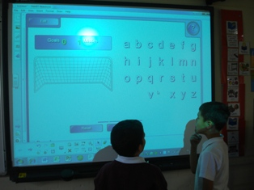
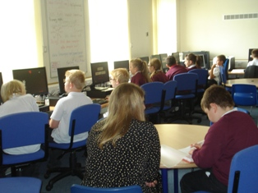

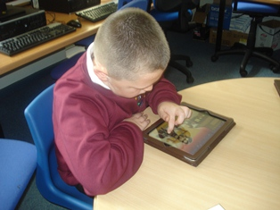
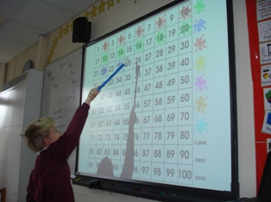

28. Collaborative Learning

We encourage team work whenever possible and give the children a sense of belonging to a community with our Planets System. Each child belongs to a planet: Earth, Saturn, Mars or Neptune and earns points for their house team.

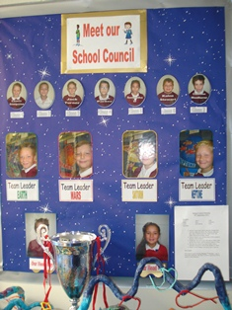
Points can be gained by:

- good attendance
- good behaviour on the transport
- good work
- acts of kindness
- inter house team competitions

The winning team is announced in our achievement assembly each Friday and the coloured ribbons on the House cup changed by the House Captain.

The winning team has a special treat at the end of each term, such as the cinema, bowling or lazor quest.

Pupil Voice - Each class is represented in School Council. This meets half termly to discuss issues raised by the children. Recently school council have voted on a new dinner menu.

Attendance

13/14 | 14/15 | 15/16 | 16/17 | 17/18 | 18/19
96.2% | 96.3% | 96.6% | 96.9% | 97.5% | 97.4%

Attendance at 96.6% is well above average and has an attendance grade indicator of HIGH.

Exclusions

2013-2014 | 2014-2015 | 2015-2016 | 2016-2017 | 2017-2018 | 2018-2019
0 fixed term | 0 fixed term | 0 fixed term | 0 fixed term | 0 fixed term | 0 fixed term

Over the school year there have been no fixed term exclusions.

If you have any further questions please look at the school website on
http://orrets-meadow.eschools.co.uk

We have a Twitter account where you can read all the latest tweets about things
happening at Orrets Meadow. Just search for Orrets Meadow.

We also have Facebook account – please search for our Orrets Meadow page.

Or you can always phone Mrs Duncan, Michelle King (Home School Link Worker) or the school office on 678 8070.

Please spend some time reading the parent survey from 2017.
Orrets Meadow School
Parents and Carers Survey 2019 – 64 out of 70 returned

Question/Statement | Strongly agree | Agree | Disagree | Strongly disagree | Don’t know
1. My child is happy at this school. | 52 | 11 |  |  | 1
2. My child feels safe at this school. | 56 | 8
3. My child makes good progress at this school. | 58 | 5 |  |  | 1
4. My child is well looked after at this school. | 59 | 5
5. My child is taught well at this school. | 60 | 4
6. My child receives appropriate homework for their age. | 54 | 10
7. The school make sure its pupils are well behaved. | 58 | 6
8. The school deals effectively with bullying. | 46 | 9 |  |  | 8
9. The school is well led and managed. | 59 | 4 |  |  | 1
10. School responds well to any concerns I raise. | 56 | 8
11. I receive information from school about my child’s progress. | 58 | 6
12. I would recommend this school to another parent. | 62 | 1 |  |  | 1
Any other comments about your child’s experience of Orrets Meadow?

- Very pleased with his progress and very happy he attends OM.
- Wonderful school and wonderful staff!
- She has made lots of progress and seems happy and excited to go to school every day. She has settled well into her new setting. We have less tears and upset since moving here! Well done to the staff for their amazing support!
- This place is amazing and we are very lucky to have got a place here!
- I am very happy he attends OM as I know it offers the best education that he needs.
- She transitioned to OM from another specialist school and is doing excellently. The school have been very flexible in meeting her needs. Perfect placement!
- I have never experienced a bullying situation in OM, hence the don’t know.
- Fantastic school and staff.
- Very good school.
- He really enjoys coming to school each day and we are so happy with the fab progress he has made since starting in Sept 2018.
- Amazing school. We are happy with OM and would highly recommend. Teachers and TAs give great support, second to none.
- My child’s confidence has grown due to the surroundings and fantastic support from his staff, this has resulted in him wanting to come to school to learn and make great progress. We can’t thank you enough OM – You have been fantastic!
- We are very impressed with the progress she has made during the 6 months she has been at OM.
- Since she has been at the OM her confidence is unbelievable. Her reading and writing is fantastic. She has made lots of friends. Thank you for making her happy and safe.
- We couldn’t be happier about how he has progressed at OM.
- His anxiety has significantly improved since starting OM. He is also talking and communicating more at home.
- I could not recommend this school strongly enough. The teachers are absolutely wonderful and supportive. I literally couldn’t ask for anything more. Thank you!
- He is so happy at this school. We feel very lucky that he is attending OM. The progress he has made is unbelievable and the support we receive as parents is invaluable!
- He loves his rainbow school. We are very happy with his progress. Thank you to everyone, keep up the good work!
- Brilliant school. The staff are fab, They have worked wonders with my son.
- Thank you for all your ongoing support. You are all amazing!
- She loves this school as well as all the teachers and staff. She is very happy here and will miss everyone when she leaves in September.
- Since joining the school he has made amazing progress and looks forward to going to school. There is no better place he could be that provided everything for his needs.
- He has never been happier. He has come on in leaps and bounds. Thank you so much.
- My daughter has thrived at OM and is extremely happy at the school. I would 100% recommend the school to anyone!
- Both our son and family could not be happier as to his progress and how happy he is at the school. We cannot speak highly enough of the school and staff collectively.
- This school is amazing to think how much my son has achieved in one year of being here is unbelievable!
- We are really pleased with all the support he has received and can’t believe how much progress he has made in a short time. Thank you!
- We can’t thank the staff at OM enough for all they do. What it has done for our son is beyond words!
- Overall she has had a very positive experience and really enjoyed her time here.
- I cannot say enough good things about OM – it has changed all our live for the better beyond belief.
- OM has helped our son so much, all we can say if thank you so much!
- Moving our son to this school was the best decision we ever made!
- He often comments that he loves this school! We think it’s the best school ever! Thank you for being so amazing!
- My son has made excellent progress at OM in all areas. Great staff – amazing school!
- We would love a high school just like OM. He has progressed massively since starting OM. Thank you all!
- Our child continues to make great progress at OM. It is an excellent school in every way!
- Since starting in September our child has settled in well and is really happy at OM. She had made great progress in her reading and writing.
- His confidence within himself and his learning has had a significant boost since joining OM. Thank you!
- He has come on really, really well at OM. I can’t thank the teachers enough. Brilliant school!
