 | RA 043 Rapid Testing School staff in primary schools & nurseries v1 Jan 2021 | RISK ASSESSMENT  RECORDING FORM

Location or School  Address: Orrets Meadow School | Date assessment  Undertaken Jan 19th 2021 | Assessment undertaken  By: Jeanne Fairbrother AND C Duncan
Activity or  situation Rapid LFD Testing of Staff in primary schools & nurseries | Review  date: ongoing | Signature: C Duncan

Background

This risk assessment is required by all schools who are participating in self-testing prior to starting testing.

DfE Helpline
Schools and colleges in England can raise questions specific to the Department for Education, via the DfE coronavirus helpline: 0800 046 8687 (Mon-Fri 8am-6pm; Sat-Sun 10am-6pm) or at RapidTesting.SCHOOLS@education.gov.uk
For clinical concerns by calling 119 in England and Wales and 0300 303 2713 in Scotland and Northern Ireland. Clinical incidents should be reported to testing.incidents@dhsc.gov.uk

Additional guidance:

DfE guidance below is on their Google drive available form Wednesday 20th

- NHS ‘How to guide’ - Rapid testing of primary nursery workforce.
- NHS Your step-by-step guide or COVID 19 self-testing
- YouTube video – ‘Step-by-step guide to COVID 19 self-testing

DfE Guidance - Rapid asymptomatic coronavirus (COVID-19) testing for staff in primary schools, school-based nurseries and maintained nursery schools
Published 18 January 2021

1) Hazard / Activity | 2) Who can be harmed and how? | 3) What controls exist to reduce the risk?  Have you followed the hierarchy of controls (eliminate, substitute etc)? | Risk Score  Consequence  X Likelihood | 4) Any further action.  This should be included in the action plan on overleaf
Communication | Staff pupils – lack of information about testing process/. Lack of buy in | - School has explained to staff what rapid testing is and communicated Rapid LFD Testing of Staff in primary schools & nurseries with all staff, governors and other relevant stakeholders.  - Staff have all read the privacy notice and understand what will happen to their data.  - All staff have all read this risk assessment.  - COVID Coordinator/ and Registration Assistant to communicate with all staff collecting kits  - Staff who decline to take part in testing will follow national guidelines on self -isolation and will book a PCR test if they start to experience symptoms | 1x4
Contact between appointed roles - the COVID Coordinator and Registration Assistant (can eb same person) and members of staff picking up test kits - increasing the risk of transmission of COVID19 | Staff, pupils -Transmission of the virus leading to ill health or potential death | - All colleagues are to be advised in advance not to attend if:  - they have any symptoms of COVID 19,  - live with someone who is showing symptoms of COVID 19,  - if they have returned within 10 days from a part of the world affected by the virus  - have been contacted by track and trace.  - All colleagues must always adhere to the hand hygiene expectations on site.  - Member of staff responsible for handing out LFTs will:  - Sanitise hands before handling each new batch of tests per adult.  - Ensure that areas are cleaned down between different colleagues.  - Two metre social distancing to be maintained between subjects with verbal reminders where required.  - Regular cleaning of the site including wipe down of all contact points in accordance with PHE guidance. | 1X 4 = 4
Contact between appointed roles - the COVID Coordinator and Registration Assistant (can be same person) and members of staff picking up test kits - increasing the risk of transmission of COVID19 -Welcome & Registration | Staff, pupils -Transmission of the virus leading to ill health or potential death | - Room identified for collection of tests – CD office  - Staff given time slots to collect their tests  - Staff to sanitise hands on entry into the Room.  - to sanitise hands after each member of staff has collected their batch of test.  - Staff to collect their batch of tests and complete log sheet. | 1X 4 = 4
Use of shared equipment | Staff, pupils -Transmission of the virus leading to ill health or potential death | - Staff signing for kits will bring their own pen | 1X 4 = 4
Workforce, inadequately trained -unaware of how to complete test | Staff, pupils -test used incorrectly inaccurate result | - All staff who are opting in to take the self-test must complete:  - NHS ‘How to guide’ - Rapid testing of primary nursery workforce.  - NHS Your step-by-step guide or COVID 19 self-testing  - YouTube video – ‘Step-by-step guide to COVID 19 self-testing  - All staff opting in will receive New Instructions for use – plain blue cover printed 15th January 2021 v1.3.2  - And agree to record their test results in the Test Kit Log  - COVID Coordinator/ and Registration Assistant to communicate with all staff collecting kits. | 1X 4 = 4
Damaged barcode, lost LFD, failed scan of barcode | Orphaned record on registration portal & No result communicated to individual | - Subjects are called for a retest | 1X 4 = 4
Failure of school to keep records | Headteacher/SLT unable to react or provide details of which staff have tested | - School will use DFE templates to maintain:  - Test kit log of details of staff member/date/ID of test kit  - Register of staff results | 1X 4 = 4
Positive test result | Staff, pupils -Transmission of the virus leading to ill health or potential death | - Anyone with a positive result will need to leave school/college, take a confirmatory Polymerase Chain Reaction (PCR) test and follow the self-isolation guidelines (currently 10 days). | 1X 4 = 4
Non-reporting of test results | Headteacher/SLT unable to react swiftly to prevent potential spread. | - School has provided all staff with access to NHS/DFE training materials and guidance  - Staff all have access to latest instructions to accompany test kits with clear reporting details. New instructions – plain blue cover printed 15th January 2021 v1.3.2  - Staff all know they are required to report the results of their test online , every time they take a test even if the result is negative or invalid  - (Headteacher) to identify which staff are testing each week and hold a register of information.  - Staff to message me their test result by 12pm on Sunday mornings and Wednesday by 8.30pm.  - Staff to phone (Headteacher) if their result is positive and text me if void and repeating test.  - (Headteacher) initiates local authority and PHE protocols around reporting and track/trace. | 1X 4 = 4
LFD test - COSHH | Staff at home or school staff exposed to chemicals in the test kits during testing or dealing with damaged test kits | - Very low quantities in kit low risk  - If large quantity spillage of multiple damaged kits f  - Spillages: wipe surfaces which the solution has been spilt on and dispose of cleaning material in line with the site waste disposal procedures  - Material Safety Data Sheet supplied with kits has been read | 1X 4 = 4
Equipment | Staff, pupils -Transmission of the virus leading to ill health due to | - Initial test kits arrive at schools from 8am on Monday 18th January.  - New instructions – plain blue cover printed 15th January 2021 v1.3.2  - Testing kits stored securely.  - Storage of kits to be maintained 2°C to 30°C  - Kits should be tested at room temperature >15° C | 1X 4 = 4
Shortage of LFD tests in school | Staff, pupils -Transmission of the virus leading to ill health or potential death | - Staff working from home due to COVID 19 National Lockdown guidance who are not mixing with other staff and pupils will not be offered testing  - Student teachers working in school will be offered test kits  - COVID Coordinator/ and Registration Assistant manage stocks and reorder kits | 1X 4 = 4
Incidents | Staff, pupils -Transmission of the virus leading to ill health or potential death | Schools –  - Any repeated or similar issues experienced by staff will be reported to DfE Helpline (see above)  Individuals testing at home:  If an individual experiences a:  - Clinical issue – broken swabs, bleeding or an allergic reaction they will report to https://coronavirusyellowcard.mhra.gov.uk  - Non-clinical issue – missing or damaged kit items, they will report this to 119 and to school in case of a trend. | 1X 4 = 4
Waste disposal of kits by staff at home | Staff, others in the home -Transmission of the virus leading to ill health or potential death | - Staff have received training and will follow all information in the accompanying instructions.  - Test kit placed in waste bag provided with kit and placed in household waste. | 1X4= 4
Consumption of food or drink prior to testing | Staff, others in the home -failing to prepare for test may void process | - No food or drink should be consumed a minimum of 30 minutes prior to test | 1X4= 4
Staff who are pregnant | Staff who are pregnant side effects of test | - Pregnant staff can administer the test. No ill effects | 1X 4 = 4
Staff with underlying health conditions | Staff with underlying health conditions - side effects of test | - Staff can administer the test. No ill effects  - Staff who have experienced a recent nosebleed should test the other nostril or wait 24 hours | 1X 4 = 4
Staff with allergies | Staff with allergies - side effects of test | - Staff can administer the test. No ill effects  - Rapid LFD test does not contain latex. | 1X 4 = 4
Staff with nose piercing | The impact of nasal jewellery on testing on individual | - If one nostril pierced use the opposite one  - If both pierced then remove piercing to complete test | 1X 4 = 4
Materials | Staff, pupils -Transmission of the virus leading to ill health or potential death | - Storage of liquid testing solution to be maintained 2°C to 30°C | 1X 4 = 4
Manual handling | Staff moving and handling equipment, test materials – musculoskeletal injuries, sprains, strains | - Premises team move and handle large stocks as required  - Access to trolleys to move and handle large stocks of supplies  - Basic manual handling training provided to team | 1X4= 4 | Use Toolbox Talk Manual Handling from JFA website as refresher

Risk Rating | Action Required
17 - 25 | Unacceptable – stop activity and make immediate improvements
10 – 16 | Tolerable – but look to improve within specified timescale
5 – 9 | Adequate – but look to improve at review
1 – 4 | Acceptable – no further action but ensure controls are maintained
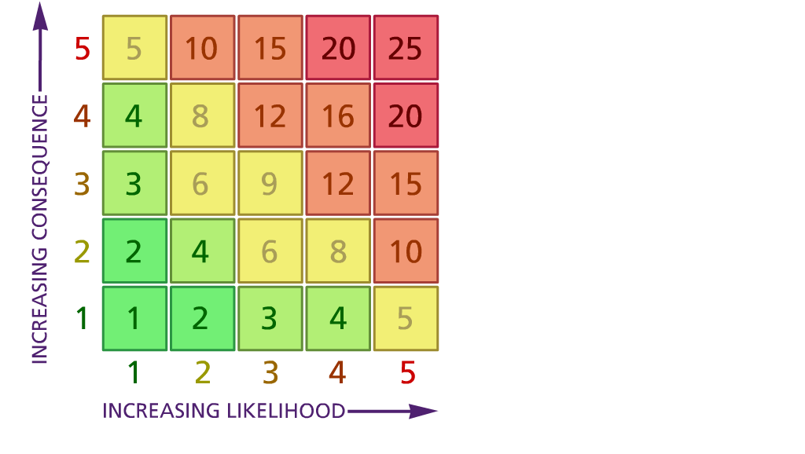

(1) List hazards something with the potential to cause harm here
(2) List groups of people who are especially at risk from the significant hazards which you have identified
- List existing controls here or note where the information may be found. Then try to quantify the level of risk the likelihood of harm arising that remains when the existing controls are in place based on the number of persons affected, how often they are exposed to the hazard and the severity of any consequence. Use this column to list the controls that you might take and develop all or some of that list into a workable action plan. Have regard for the level of risk, the cost of any action and the benefit you expect to gain. Agree the action plan with your team leader and make a note of it overleaf. If it is agreed that no further action is to be taken this too should be noted.

Likelihood: Consequence:

5 – Very likely 5 – Catastrophic

4 – Likely 4 – Major
3 – Fairly likely 3 – Moderate

2 – Unlikely 2 – Minor

1 – Very unlikely 1 – Insignificant

ACTION PLAN
Action required: | Responsible person | Completion date
Appoint Team leader | C Duncan | 19/1/2021
Action plan agreed with (signature) C Duncan Date - 25/1/2021

