 | RA 029B Contingency Plan V4 Feb 2022 | RISK ASSESSMENT  RECORDING FORM

Location or School  Address: Orrets Meadow School | Date assessment  Undertaken 14th March 2022 | Assessment undertaken.  by: Jeanne Fairbrother AND C Duncan
Activity or  situation Contingency Plan School opening | Review  date: Weekly review or as appropriate for the activity | Signature: 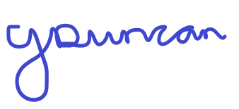

Background information

Contingency Plan COVID 19 V4 February 2022
On 21 February the Prime Minister set out the next phase of the Government’s COVID19 response. COVID-19 continues to be a virus that we learn to live with, and the imperative is to reduce the disruption to children and young people’s education. The contingency framework describes the principles of managing local outbreaks of coronavirus (COVID-19) (including responding to variants of concern) in education and childcare settings, covering:
- good baseline infection prevention and control which can provide protection against infection and associated education disruption
- the types of measures that settings should be prepared for
- who can recommend these measures and where • when measures should be lifted
- how decisions are made Local authorities, directors of public health (DsPH) and their teams, and the UK Health Security Agency (UKHSA) health protection teams should follow the principles and can recommend measures described in this guidance in individual education and childcare settings as part of their outbreak management responsibilities. Where there is a need to address more widespread issues across an area, ministers will take decisions on an area-by-area basis.

Guidance
DfE guidance states that schools should have an ‘outbreak management plan’, this is the same as the contingency plan outlining how they would operate if any of the measures described in the document were recommended for their setting or area. It clearly states what a good contingency plan should cover:
• roles and responsibilities
• when and how to seek public health advice
• details on the types of control measures you might be asked to put in place

For each control measure you should include:
• actions you would take to put it in place quickly.
• how you would ensure every child, pupil or student receives the quantity and quality of education and support to which they are normally entitled.
• how you would communicate changes to children, pupils, students, parents, carers and staff.
See Guidance: Contingency framework: education and childcare settings
This risk assessment applies to:
- primary schools
- secondary schools (including sixth forms)
- special schools, special post-16 providers and alternative provision
- 16 to 19 academies
- infant, junior, middle, upper schools
Please note that this risk assessment has been created in line with the current government guidance. It contains sample control measures that fit with the system of controls contained in Government guidance. One size does not fit all, and schools should make this model risk assessment their own and reflect specifics of what they are doing and any local guidance, particularly from local HPT’s in line with DfE expectations.

Control measures in purple indicate different measures are in place for different settings. Please choose the setting that applies and delete the others to make this reflect your school/setting:
- All settings
- Early years
- Primary schools
- Secondary Schools & post 16 settings
- Special schools
- Wraparound and out of school providers

Legislation and guidance
Health and Safety at Work Act etc. 1974
Management of H&S at Work Regulations 1999
Workplace (Health, Safety and Welfare) Regulations 1992
DfE Actions for schools plus associated COVID 19 Guidance
Public Health England Guidance

1) Hazard / Activity | 2) Who can be harmed and how? | 3) What controls exist to reduce the risk?  Have you followed the hierarchy of controls (eliminate, substitute etc)? | Risk Score  Consequence  X Likelihood | 4) Any further action.  This should be included in the action plan (5), below
Collaboration with local authorities during localised outbreak of COVID 19 cases  All settings unless indicated | Staff, pupils, visitors, contractors increased risk of transmission of COVID 19 | - Local authorities, directors of public health (DsPH) and PHE health protection teams (HPT’s) are responsible for managing localised outbreaks.  - School liaises and responds to guidance from DsPH& local HPT’s | 3X2=6
Failure to assess the risks of COVID 19 transmission in school.  All settings unless indicated | Staff, pupils, visitors, contractors increased risk of transmission of COVID 19 | - School has assessed the reasonably foreseeable risks of transmission of COVID 19. See latest RA 029A School opening COVID 19  - The risk assessment is regularly reviewed as circumstances in school and the public health advice changes.  - School monitors whether the controls in place are effective and working as intended. | 3X2=6
Failure to have adequate baseline measures in place |  | - Schools /Settings latest RA 029A School opening COVID 19 sets out the infection prevention and control measures that all education and childcare settings should have in place as good practice.  - This includes:  - Pupils, staff and other adults with COVID-19 symptoms, a positive test result, or who are a close contact of a case should follow the guidance for people with COVID-19 and their contacts.  - Pupils and staff should return to school as soon as they can, in line with the above guidance.  - School/setting is prepared to implement high-quality blended learning arrangements so that any child or student who is well enough to learn from home can do so.  - School/setting continues to follow the latest RA 029A School opening COVID 19 to ensure good hygiene for everyone, maintain appropriate cleaning regimes, keep occupied spaces well ventilated, and follow public health advice on testing, self-isolation and managing confirmed cases of COVID-19.  - School/Setting continues to encourage (COVID-19) vaccination uptake for eligible students and staff.
Failing to have adequate outbreak management plans to allow for stepping measures up and down.  All settings unless indicated | Staff, pupils, visitors, contractors increased risk of transmission of COVID 19 | - School has latest RA 029A School opening COVID 19  risk assessment for following the latest guidance.  - School has this contingency plan risk assessment with measures it will use if staff or pupils test positive for COVID 19 or, to step measures up or down, if required by local DsPH in the event of a local outbreak. | 3X2=6
Communication  All settings unless indicated | Staff, pupils, visitors, contractors increased risk of transmission of COVID 19 | - School will communicate its plan for addressing any imposed restrictions with parents, staff, pupils and other relevant parties regarding:  - opening arrangements.  - access for specific targeted groups where applicable, such as certain year groups, vulnerable pupils and children of critical workers.  - any reviews of the school’s protective measures as part of school’s risk assessments.  - any arrangements for remote working  - School will keep all relevant parties up to date with the circumstances of any imposed restrictions and how these affect the school as the situation develops. | 3X2=6
Testing | Staff, pupils, visitors, contractors increased risk of transmission of COVID 19 | All settings  - Increased testing - this may temporarily be advised for an individual setting or in areas of high prevalence by DsPH as part of their responsibilities in outbreak management.  - School/setting contingency plans reflect the possibility that a DPH or HPT might advise rapid lateral flow device (LFD) testing by some staff.  - Any additional testing measures would need to be agreed with settings and DsPH will consult settings and work with them to identify what support may be needed to do this, including test kit supply.  - DsPH should keep DfE and UKHSA informed of all cases where they are considering recommending onsite LFD testing for an education setting, via their RPT and RSC. Pupils, staff and other adults with a positive test result should follow UKHSA guidance on whether to stay at home and avoid contact with other people.  Secondary schools and FE colleges  - School/setting contingency plans reflect the possibility that a DPH or HPT might advise rapid lateral flow device (LFD) testing by some staff, pupils and students (secondary age and above).  Special schools/settings  - DsPH advice may also include the temporary reintroduction of onsite LFD testing for specialist education and childcare settings across areas that have been designated as enhanced response areas where settings and DsPH decide it is appropriate. | 3X2=6
Thresholds for extra action | Staff, pupils, visitors, contractors increased risk of transmission of COVID 19 | For most education and childcare settings  The thresholds, detailed below, will be used by school/setting as an indication for when to seek public health advice if they are concerned:  - a higher than previously experienced and/or rapidly increasing number of staff or student absences due to COVID-19 infection  - evidence of severe disease due to COVID-19, for example if a pupil, student, child or staff member is admitted to hospital due to COVID-19  - a cluster of cases where there are concerns about the health needs of vulnerable staff or students within the affected group .  For special schools, alternative provision, SEND/AP units within schools and colleges, open and secure children’s homes and settings that operate with 20 or fewer children, pupils, students and staff at any one time:  - 2 children, pupils, students and staff, who are likely to have mixed closely, test positive for COVID-19 within a 10-day period and/or there are concerns about the health needs of vulnerable individuals within the affected group  All settings  - School/setting will seek public health and operational advice by phoning the DfE helpline (0800 046 8687, option 1),  - School/setting will work to contain any outbreak by following local HPT’s advice  Insert details of school’s local PH Helpline phone number to contact i.e.  - Cheshire & Merseyside PHE contact 0344 225 0562  - Greater Manchester Health Protection Unit 0844 225 1295  - Wirral schools contact Wirral LA covid helpline 0151 666 3600. Email: covidschoolsupport@wirral.gov.uk | 3X2=6
Close contacts  All settings unless indicated | Staff, pupils, visitors, contractors increased risk of transmission of COVID 19 | All settings  - From 24 February, routine contact tracing will end. Contacts will no longer be required to self-isolate or advised to take daily tests.  - School will no longer ask fully vaccinated close contacts and those under the age of 18 to test daily for 7 days  - Close contacts who are unvaccinated are no longer required to self-isolate.  - Children and young people who usually attend an education or childcare setting and who live with someone who has COVID-19 should continue to attend the setting as normal.  - Contacts are advised to take precautions to reduce risk to themselves and other people:  - minimise contact with the person who has COVID-19  - work from home if you are able to do so  - avoid contact with anyone you know who is at higher risk of becoming severely unwell if they are infected with COVID-19, especially those with a severely weakened immune system  - limit close contact with other people outside your household, especially in crowded, enclosed or poorly ventilated spaces  - wear a well-fitting face covering made with multiple layers or a surgical face mask in crowded, enclosed or poorly ventilated spaces and where you are in close contact with other people  - pay close attention to the main symptoms of COVID-19. If you develop any of these symptoms, order a PCR test. You are advised to stay at home and avoid contact with other people while you are waiting for your test result  - Follow this advice for 10 days after the day the person you live or stayed with symptoms started (or the day their test was taken if they did not have symptoms). | 3X2=6
Positive case - staff  All settings unless indicated | Staff, pupils, visitors, contractors increased risk of transmission of COVID 19 | All settings  - School continues to advise adults and children who test positive to stay at home and avoid contact with other people. After 5 days, they may choose to take a Lateral Flow Device (LFD) followed by another the next day - if both are negative, and they do not have a temperature, they can safely return to their normal routine.  - School will encourage those testing positive for COVID-19 to inform their close contacts so that they can follow new guidance.  - School advises those who test positive should avoid contact with anyone in an at-risk group:  - older people  - those who are pregnant  - those who are unvaccinated  - people of any age who have a severely weakened immune system  - people of any age with certain long-term conditions  - Positive cases who need to leave home while still infectious, should take the following steps to reduce the chance of passing on the infection to others:  - wear a well-fitting face covering made with multiple layers or a surgical face mask  - avoid close contact with anyone you know who is at higher risk of becoming severely unwell if they are infected with COVID-19, especially those with a severely weakened immune system  - avoid crowded places. If you need to take public transport, avoid busy times, for example by using off peak services  - avoid large social gatherings and events, or anywhere that is poorly ventilated, crowded, or enclosed  - limit close contact with other people outside your household as much as possible. Meet outside and try and stay at least 2 metres apart from them  - take any exercise outdoors in places where you will not have contact with other people  - be especially careful with your hand and respiratory hygiene | 3X2=6
Actions to consider once a threshold is reached  All settings unless indicated | Staff, pupils, visitors, contractors increased risk of transmission of COVID 19 | - If school reaches a threshold for extra action (See Thresholds for extra action above) school will:  - contact local the DfE helpline & HPT  - review and reinforce the testing, hygiene and ventilation measures already in place. And will consider:  - whether any activities could take place outdoors, including exercise, assemblies, or classes  - ways to improve ventilation indoors, where this would not significantly impact thermal comfort  - one-off enhanced cleaning focussing on touch points and any shared equipment. | 3X2=6
Face coverings | Staff, pupils, visitors, contractors increased risk of transmission of COVID 19 | Face coverings  In England, face coverings are no longer required by law. In education and childcare settings, face coverings are not advised for pupils, staff and visitors in communal areas, or classrooms and teaching spaces.  - Face coverings in communal areas may temporarily, and exceptionally, be advised by DsPH:  - for an individual setting, as part of their responsibilities in outbreak management  - for settings across areas where DfE and public health experts judge the measure to be proportionate, based on the evidence public health experts share with the DFE and specific local public health concerns. For example, where the area has been designated as an enhanced response area, and where COVID-19 risk may put exceptional local pressure on the healthcare system. This is a temporary measure.  - Face coverings in classrooms and teaching spaces may temporarily, and exceptionally, be advised by DsPH for an individual setting, as part of their responsibilities in outbreak management.  - Face coverings in classrooms and teaching spaces should only ever be recommended across an area if it has been designated as an enhanced response area by the Local Action Committee command structure.  - No pupil or student should be denied education on the grounds of whether they are, or are not, wearing a face covering.  - Any guidance should allow for circumstances where people are not able to wear face coverings.  - In all cases any educational and wellbeing drawbacks in the recommended use of face coverings should be balanced with the benefits in managing COVID-19 risk.  - Where recommended, the use of face coverings should be kept under regular review and lifted as soon as the evidence supports doing so | 3X2=6
CEV staff & pupils, pregnant staff  All settings unless indicated | Staff, pupils, visitors, contractors increased risk of transmission of COVID 19 | - Individuals previously identified as CEV are advised to continue to follow the same guidance as the general public on how to stay safe and help prevent the spread of COVID-19.  - Individuals with a weakened immune system should follow DHSC and UKHSA advice for people whose immune system means they are at higher risk from COVID-19.  - All previously identified CEV & pregnant staff have individual risk assessments detailing the measures the setting has put in place to reduce risks to these staff, including how these protective measures have been reviewed as part of an updated workplace risk assessment. | 3X2=6
Education workforce | Staff, pupils, visitors, contractors increased risk of transmission of COVID 19 | - School contingency plans include details if it is appropriate for some staff to work remotely if restrictions are imposed. Insert details | 3X2=6
Transport  All settings unless indicated | Staff, pupils, visitors, contractors increased risk of transmission of COVID 19 | - Transport services to education settings should continue to be provided as normal where children are attending education settings. The guidance on transport to schools and colleges during the COVID-19 pandemic remains in place. | 3X2=6
Residential educational visits  All settings unless indicated | Staff, pupils, visitors, contractors increased risk of transmission of COVID 19 | - All visits are risk assessed and include current local restrictions.  - School will consider carefully if the educational visit is still appropriate and safe.  - Only pupils who are attending the setting will go on an educational visit. | 3X2=6
School failing to plan:  - Open days  - Transition & taster days  - Parental attendance  - Performances  All settings unless indicated | Staff, pupils, visitors, contractors increased risk of transmission of COVID 19 | - All such events are risk assessed and include current local restrictions.  - School will consider carefully if the event is still appropriate and safe.  - Insert details of any contingency plans in place. | 3X2=6
Attendance restrictions - increased COVID infections | Staff, pupils, visitors, contractors increased risk of transmission of COVID 19 | High-quality face-to-face education remains a government priority. Attendance restrictions should only ever be considered as a short-term measure and as a last resort:  - for individual settings, on public health advice in extreme cases of operational disruption to staffing or where other recommended measures have not mitigated against risks to face-to-face education  - across an area, on government advice in order to suppress or manage a dangerous variant and to prevent unsustainable pressure on the NHS  - School will continue to give priority to vulnerable children and young people and children of critical workers to attend school undertaking their normal timetables.  School contingency plans cover measures that include attendance restrictions, and if the DfE advises on any other groups that should be prioritised. | 3X2=6
Food provision  All settings unless indicated | Staff, pupils, visitors, contractors increased risk of transmission of COVID 19 | - School will provide meal options for all pupils who are attending.  - Schools should also continue to provide free school meals support in the form of meals or lunch parcels for pupils who are eligible for benefits related free school meals and who are not attending school because they have had symptoms or a positive test result themselves. | 3X2=6
Safeguarding  All settings unless indicated | Staff, pupils, visitors, contractors increased risk of transmission of COVID 19 | - School will review the child protection policy so that it reflects the local restrictions and remains effective. | 3X2=6
Vulnerable pupils & young people | Staff, pupils, visitors, contractors increased risk of transmission of COVID 199392 | - Where vulnerable children and young people are absent, school will work with the local authority and social worker (where applicable), to explore the reason for absence and discuss their concern. | 3X2=6
Teaching & learning  All settings unless indicated | Staff, pupils, visitors, contractors increased risk of transmission of COVID 19 | - High-quality remote learning will be provided for all pupils and students if:  - they have tested positive for COVID-19 but are well enough to learn from home; or  - attendance at the setting has been temporarily restricted  - On-site provision is retained for vulnerable children and young people and the children of critical workers.  - If school has to temporarily stop onsite provision on advice of the local HPT, the school contingency plans include alternative arrangements for vulnerable children and young people, this includes google classroom. | 3X2=6
Exams & assessments  Secondary & FE colleges | Staff, pupils, visitors, contractors increased risk of transmission of COVID 19 | - Two-metre spacing between all desks, where directed  - CEV candidates take an exam separately. | 3X2=6

Risk Rating | Action Required
20 - 25 | Unacceptable – stop activity and make immediate improvements
10 - 16 | Urgent action – take immediate action and stop activity, if necessary, maintain existing controls vigorously
5 - 9 | Action – Improve within specific timescales
3 - 4 | Monitor – but look to improve at review or if there is a significant change
1 - 2 | Acceptable – no further action but ensure controls are maintained & reviewed
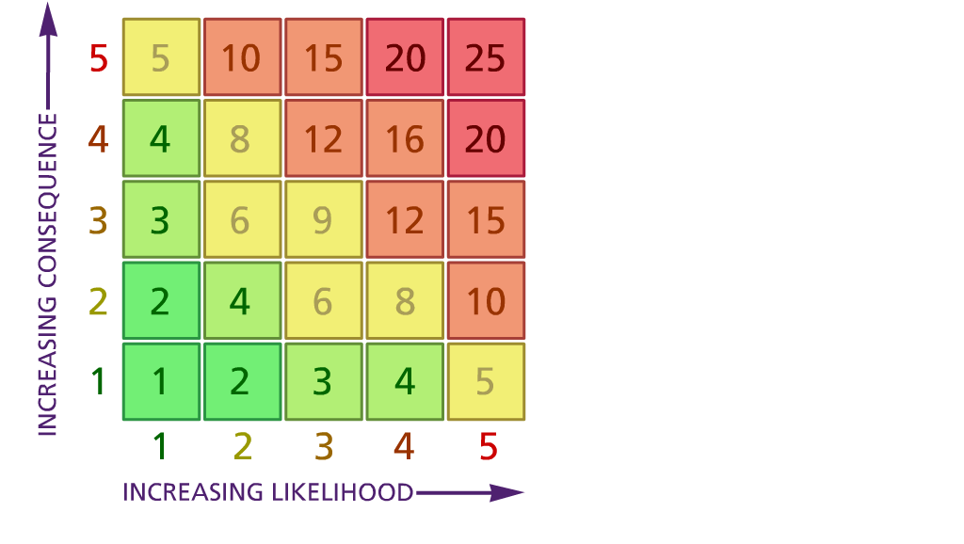

(1) List hazards something with the potential to cause harm here
(2) List groups of people who are especially at risk from the significant hazards which you have identified
- List existing controls here or note where the information may be found. Then try to quantify the level of risk the likelihood of harm arising that remains when the existing controls are in place based on the number of persons affected, how often they are exposed to the hazard and the severity of any consequence. Use this column to list the controls that you might take and develop all or some of that list into a workable action plan. Have regard for the level of risk, the cost of any action and the benefit you expect to gain. Agree the action plan with your team leader and make a note of it overleaf. If it is agreed that no further action is to be taken this too should be noted.
Likelihood: Consequence

5 – Very likely 5 – Catastrophic

4 – Likely 4 – Major
3 – Fairly likely 3 – Moderate

2 – Unlikely 2 – Minor

1 – Very unlikely 1 – Insignificant

 | 5. Action plan | Responsible | Completed
1
2
3
4
5
6
 | Action plan agreed by (NAME & DATE)

