 | RA 029 – Schools (Primary & Secondary) Tier 3 Addendum v1 | RISK ASSESSMENT  RECORDING FORM

Location or School  Address: | Date assessment  Undertaken INSERT DATE | Assessment undertaken  by : Jeanne Fairbrother AND C Duncan
Activity or situation:  Schools (Primary & Secondary) – Tier 3 31st December 2020 | Review  date : Weekly review or as appropriate for the activity | Signature:

These are a temporary set of measures which sit alongside your latest version RA 029 Full opening of school.

Liverpool, Merseyside & Wirral were put into Tier 3: Very High Alert restrictions which came into force on Thursday 31stDecember 2020.

This addendum reflects any additional control measures in Schools -Primary & Secondary which will be affected during the period in Tier 3:
- staff who are pregnant
- use of face coverings
- clinically extremely vulnerable pupils
- clinically extremely vulnerable staff
- wraparound provision and extra-curricular activity
- physical activity in schools
Background
The DfE has published actions for schools during the coronavirus (COVID-19) outbreak .Schools should continue to review their full opening of school risk assessments and implement the system of controls set out in this guidance. These measures provide a framework for school leaders to put in place proportionate protective measures for pupils and staff. If schools follow the guidance and maximise control measures, they can be confident they are managing risk effectively.

1) Hazard / Activity | 2) Who can be harmed and how? | 3) What controls exist to reduce the risk?  Have you followed the hierarchy of controls (eliminate, substitute etc) | Risk Score  Consequence  X Likelihood | 4) Any further action;  This should be included in the action plan on overleaf
Returning to school – primary schools | Staff, pupils, parents, visitors increased risk of transmission of Coronavirus (COVID 19) | - Primary schools resume on-site provision from their advertised first day of term and allow all pupils to attend.  - Orrets Meadow will allow only key worker and vulnerable pupils to return to school for the first two weeks to reduce numbers of pupils and adults in the school. | 3X2=6
Returning to school – special schools increased risk of transmission of coronavirus- COVID 19i | Staff, pupils, parents, visitors increased risk of transmission of Coronavirus (COVID 19) | - All specialist settings and alternative provision schools or settings should plan for provision for pupils from the start of term.  - Special schools and colleges have some flexibility on face-to-face attendance of pupils and students in the first week of term to enable them to mobilise the testing programme. | 3X2=6
Staff working across tiers – increased risk of transmission | Staff, pupils, parents, visitors increased risk of transmission of Coronavirus (COVID 19) | - Public sector employees working in essential services, including childcare or education, should continue to go into work in Tier 3 & 4  - Tier 4 Staff can leave home for work purposes  - Staff can travel form Tier 4 into other tiers for work | 3X2=6
Face coverings – failure of visitors, staff to wear a face covering according to guidance | Staff, pupils, parents, visitors increased risk of transmission of Coronavirus (COVID 19) | Primary schools and education settings teaching year 6 and below,  - no change to the existing position. It is not mandatory for staff and visitors to wear face coverings.  - In situations where social distancing between adults in settings is not possible (for example when moving around in corridors and communal areas), settings have the discretion to recommend the use of face coverings for adults on site, for both staff and visitors.  - At Orrets Meadow staff wear masks at all times when outside of their bubble classroom. | 3X2=6
Transport- increased risk of transmission failing to follow guidance | Staff, pupils, parents, visitors increased risk of transmission of Coronavirus (COVID 19) | - Children and young people aged 11 and over must wear a face covering on public transport. Face coverings should also be worn by pupils in year 7 and above when travelling on dedicated school transport to secondary school or college. This does not apply to those who are exempt.  - School will promote the use of face coverings on school transport and resolve any issues of non-compliance  - Travel in or out of local areas should be avoided, and parents, carers and staff should look to reduce the number of journeys they make - but travelling to deliver and access education is still permitted.  - Staff, children and their parents and carers are encouraged to walk or cycle when travelling to and from school where this is possible, and to plan ahead and avoid busy times and routes on public transport. This will allow social distancing to be practised. | 3X2=6
Visitors to the setting increasing the risk of transmission | Staff, pupils, parents, visitors increased risk of transmission of Coronavirus (COVID 19) | - The setting will restrict all visits to the setting to those that are absolutely necessary.  - Visits that allow a vulnerable child to meet a social worker, key worker or other necessary support will continue on site. | 3X2=6
Clinically extremely vulnerable Children at increased risk of contracting COVID 19 | Staff, pupils, parents, visitors increased risk of transmission of Coronavirus (COVID 19) | - Tier 3 - All pupils and students should continue to attend education settings at tiers 1, 2,3 unless they are one of the very small number of pupils or students under paediatric or other NHS care and have been advised by their GP or clinician not to attend an education setting.  - Tier 4 - Shielding advice is currently in place in Tier 4, so all children still deemed clinically extremely vulnerable are advised not to attend school.  - Children and young people whose parents or carers are clinically extremely vulnerable should also continue to attend education settings. | 3X2=6
Clinically extremely vulnerable CEV  staff at increased risk of contracting COVID 19 | Staff, pupils, parents, visitors increased risk of transmission of Coronavirus (COVID 19) | - Employees working in essential services, including childcare or education, should continue to go into work.  - School will discuss flexibilities that support CEV staff, such as staggered start times to reduce travel during rush hour.  - All other staff continue to attend work, including those living in a household with someone who is clinically extremely vulnerable.  - First two weeks CEV member of staff to work from home.  - Tier 4- staff who are clinically extremely vulnerable are advised to work from home and where this is not possible, they should not go into work.  - Staff in this group will have been identified through a letter from the NHS or from their GP and may have been advised to shield in the past, most recently in November 2020. | 3X2=6
Clinically vulnerable staff and children at increased risk of contracting COVID 19 | Staff, pupils, parents, visitors increased risk of transmission of Coronavirus (COVID 19) | - Staff and children who are clinically vulnerable or have underlying health conditions but are not clinically extremely vulnerable should continue to attend school in line with current guidance.  - School will carry out a risk assessment on each member of staff identified as clinically vulnerable  - Staff should follow all measures in pace in school for their safety. | 3X2=6
Pregnant employees at increased risk of contracting COVID 19  Pregnant women are considered ‘clinically vulnerable’ or in some cases ‘clinically extremely vulnerable’ to coronavirus (COVID-19) and therefore require special consideration as set out in the guidance for pregnant employees. | Staff, pupils, parents, visitors increased risk of transmission of Coronavirus (COVID 19) | - School will carry out a risk assessment to follow the Management of Health and Safety at Work Regulations 1999 (MHSW). See RA 009 New & expectant mother v5 Jan 2021 risk assessment  - Pregnant women of any gestation should not be required to continue working if this is not supported by the risk assessment.  - Women who are 28 weeks pregnant and beyond,or are pregnant and have an underlying health condition that puts them at a greater risk of severe illness from COVID-19 at any gestation, should take a more precautionary approach.  - School will ensure pregnant staff are able to adhere to any active national guidance on social distancing and/or advice for pregnant women considered to be clinically extremely vulnerable
Out-of-school activities and wraparound childcare increased risk of contracting COVID 19 | Staff, pupils, parents, visitors increased risk of transmission of Coronavirus (COVID 19) | - Out-of-school settings and wraparound childcare should continue to operate for face-to-face provision between 4 and 18 January 2021 for children who eligible to attend school for full-time on-site provision  - School has worked closely with our external wraparound providers to ensure as far as possible; children can be kept in a group with other children from the same bubble they are in during the school day.  - The provider will seek to keep children in small, consistent groups with the same children each time, as far as this is possible. | 3X2=6
Sport and physical education Increased risk of transmission from not following guidance | Staff, pupils, parents, visitors increased risk of transmission of Coronavirus (COVID 19) | Tier 3  - School has the flexibility to decide how physical education, sport and physical activity will be provided whilst following the measures in their system of controls.  - Only sports whose national governing bodies have developed guidance under the principles of the government’s guidance on team sport and been approved by the government are permitted.  - School will only provide team sports listed on the return to recreational team sport framework.  - Pupils will be kept in consistent groups and sports equipment thoroughly cleaned between each use by different individual groups.  - Schools can hold PE lessons indoors, including those that involve activities related to team sports, for example practising specific techniques, within their own system of controls.  - Outdoor sports are prioritised where possible, and large indoor spaces used where it is not, maximising natural ventilation flows (through opening windows and doors or using air conditioning systems wherever possible), distancing between pupils and paying scrupulous attention to cleaning and hygiene.  - External facilities will be used in line with government guidance for the use of, and travel to and from, those facilities.  - School will work with external coaches, clubs and organisations for curricular and extra-curricular activities where they are satisfied that it is safe to do so.  - School has considered carefully how such arrangements can operate within our wider protective measures.  - School refers to:  - guidance on grassroot sports for public and sport providers, safe provision and facilities, and guidance from Sport England  - advice from organisations such as the Association for Physical Education and the Youth Sport Trust  - guidance from Swim England on school swimming and water safety lessons available at returning to pools guidance documents  - using changing rooms safely  Tier 4  - PE, sport and physical activity provided by schools to their own pupils under their systems of control can continue. This includes sports clubs or activities before or after school, in addition to their regular PE lessons.  - Pupils are kept in consistent groups and sports equipment thoroughly cleaned between each use by different individual groups.  - Competition between different schools is cancelled in line with the local restrictions on grassroots sport.  - Schools can hold PE lessons indoors, including those that involve activities related to team sports, for example, practising specific techniques, within their own system of controls.  - School can continue to offer those team sports, with approved guidance listed in the DCMS return to recreational team sport framework, offering the activity in line with guidance.  - Outdoor sports will be prioritised where possible, and large indoor spaces used where it is not, maximising natural ventilation flows (through opening windows and doors or using air conditioning systems wherever possible) distancing between pupils and paying scrupulous attention to cleaning and hygiene.  - Where open, external facilities, including other schools’ facilities, can also be used in line with government guidance for the use of, and travel to and from, those facilities and schools’ own systems of controls. | 3X2=6

Risk Rating | Action Required
17 - 25 | Unacceptable – stop activity and make immediate improvements
10 – 16 | Tolerable – but look to improve within specified timescale
5 – 9 | Adequate – but look to improve at review
1 – 4 | Acceptable – no further action but ensure controls are maintained
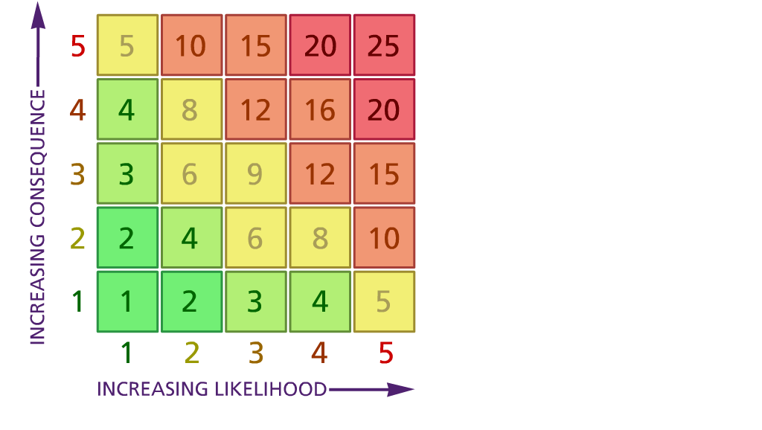

(1) List hazards something with the potential to cause harm here
(2) List groups of people who are especially at risk from the significant hazards which you have identified
- List existing controls here or note where the information may be found. Then try to quantify the level of risk the likelihood of harm arising that remains when the existing controls are in place based on the number of persons affected, how often they are exposed to the hazard and the severity of any consequence. Use this column to list the controls that you might take and develop all or some of that list into a workable action plan. Have regard for the level of risk, the cost of any action and the benefit you expect to gain. Agree the action plan with your team leader and make a note of it overleaf. If it is agreed that no further action is to be taken this too should be noted.

Likelihood: Consequence:

5 – Very likely 5 – Catastrophic

4 – Likely 4 – Major
3 – Fairly likely 3 – Moderate

2 – Unlikely 2 – Minor

1 – Very unlikely 1 – Insignificant

(5) ACTION PLAN
Action required: | Responsible person | Completion date
Action plan agreed with (signature) Date

