
Orrets Meadow School

Computing Policy

“To raise the aspirations of every child and give them confidence to fulfil their potential through positive experiences”

Orrets Meadow Curriculum Aims and Values
Aims
To ensure all our children are at the centre of a broad, varied and interesting learning experience that is enjoyable and relevant for the future. Our creative, multisensory curriculum will create a sense of awe and wonder and help to inspire a lifelong love of learning. The holistic nature of our practice will promote positive mental health and well-being and will enhance our children’s life skills, social skills and cultural awareness.
Values
Our curriculum will promote a range of values including:
- Respect
- Empathy
- Responsibility
- Equality
- Independence
- Happiness
- Resilience
- Gratitude
- Honesty
- Friendship

Intent
National Curriculum - Computing
Purpose of study
A high-quality computing education equips pupils to use computational thinking and creativity to understand and change the world. Computing has deep links with mathematics, science, and design and technology, and provides insights into both natural and artificial systems. The core of computing is computer science, in which pupils are taught the principles of information and computation, how digital systems work, and how to put this knowledge to use through programming. Buildings on this knowledge and understanding, pupils are equipped to use information technology to create programs, systems and a range of content. Computing also ensures that pupils become digitally literate – able to use, and express themselves and develop their ideas through, information and communication technology – at a level suitable for the future workplace and as active participants in a digital world.
Aims
The national curriculum for computing aims to ensure that all pupils:
♣ Can understand and apply the fundamental principles and concepts of computer science, including abstraction, logic, algorithms and data representation
♣ Can analyse problems in computational terms, and have repeated practical experience of writing computer programs in order to solve such problems
♣ Can evaluate and apply information technology, including new or unfamiliar technologies, analytically to solve problems
♣ Are responsible, competent, confident and creative users of information and communication technology.
Orrets Meadow’s Curriculum
We teach a Global Curriculum called 'Learning means the World' (LMTW) for all our afternoon subjects. This curriculum is innovative, forward-thinking and highly relevant to our pupils' needs and thoroughly engages them as they tackle challenging and inspiring topics and issues.
LMTW curriculum has been written with world issues in mind and is centred on 4Cs:-
- Communication
- Conflict
- Conservation
- Culture
Why did we choose 'Learning Means the World'?
As a school which is majority white British, we want our pupils to fully embrace cultural diversity, learning about, experiencing and celebrating a range of different cultural and faith heritages.
We believe that communication is key to accessing learning and securing pupils’ future success. As many of our pupils have Speech Language Communication Needs it is essential that opportunities are given to develop language for learning across the curriculum. With one of its 4 foci being on communication, this curriculum provides lots of opportunities for pupils to develop expressing themselves in discussion, debate and presentation, as well as enabling them to collaborate and exchange ideas.
We feel our pupils, as the future generation, need a greater awareness and appreciation of local, national and global conservation issues and initiatives. They need to learn that they have an important role to play in sustainability. This curriculum gives pupils opportunities to grow and develop spiritually, emotionally, physically and socially in the natural world around them. Our commitment to nurturing positive attitudes and values and developing life and social skills is promoted throughout the Learning Means The World (LMTW) curriculum.
It is theme based and broken down into the following phases:
- Explorers (Foundation level)
- Pathfinders (KS1 level)
- Adventurers (Lower KS2 level)
We have the freedom to teach the National Curriculum in line with our pupils' specific needs and believe that our whole curriculum meets the values and aims which our stakeholders requested at the start of the consultation.

SMSC

An important aspect of our curriculum at Orrets Meadow is the incorporation of all things SMSC. All staff in all subjects take any and every opportunity to humanise and contextualise aspects and issues of social, moral and other intrinsic events or concepts, be they past, present or potentially pending. We see the promotion of discussion and debate as a healthy part of life in school.


Why is Computing important?

Through computing, we not only learn to use technology purposefully and effectively, but become aware of the underlying processes involved, helping us to understand how best to apply skills safely and ethically. Learning about control systems and robots increases awareness of many of the operating systems we use to manage our everyday lives.
Through computing, pupils
are more able to actively
participate in a rapidly
changing technological
world.

internet helps us to rapidly access ideas and experiences from a wide range of individuals, communities, countries and cultures.
Computing makes it possible for pupils to explore real-world situations that would be too difficult, too expensive or too dangerous to create in real life.

In computing, we develop essential skills for life in a digital age, learning to apply critical thinking and problem-solving skills.
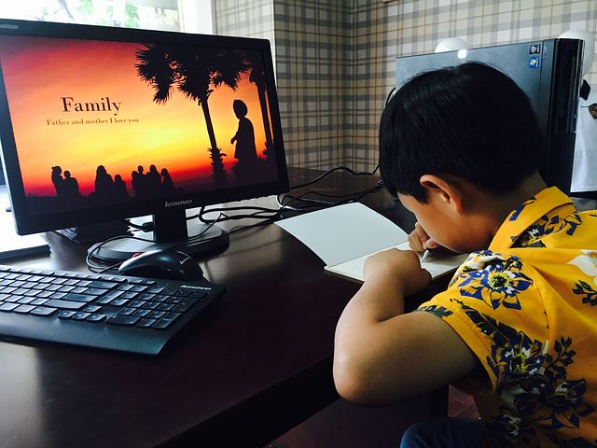
SMSC
An important aspect of our curriculum at Orrets Meadow is the incorporation of all things SMSC. All staff in all subjects take any and every opportunity to humanise and contextualise aspects and issues of social, moral and other intrinsic events or concepts, be they past, present or potentially pending. We see the promotion of discussion and debate as a healthy part of life in school.
Computing teaches pupils how to flourish in a connected world, developing their sensitivity to others online, treating them with respect, and showing respect for their
privacy.

Implementation
When is Computing taught?
Computing is taught discretely in weekly sessions every other half term, but also it is taught linked to thematic Dimension units. The attached overviews show the discrete lessons topics and the thematic units which feature this subject. The Long-Term Plans clearly shows the objectives and skills taught.

How is Computing taught?
Computing is taught through a combination of subject knowledge and development of specific skills and competencies. Learning takes place mainly inside the classroom. Outside of discrete computing lessons pupils work towards earning certificates in computing (appendix 1) which are uniquely designed to enable our pupils to develop their basic user skills in order to help them to become competent end users of computers with a secure knowledge of how to protect themselves whilst accessing the internet. For pupil working Pre National-Curriculum these certificates inform their computing lessons in order to help them develop towards accessing the national curriculum.

What do we learn about in Computing?

We learn about the following:-
Programming
Networking
Sequencing
Multimedia
Data Handling
Presentations
Word Processing
Staying Safe online
Basic Skills
Digital communication
Computing helps pupils to express themselves and develop their ideas through information and communication technology, at a level suitable for the future workplace and as active participants in a digital world.

Computing Topic Overview

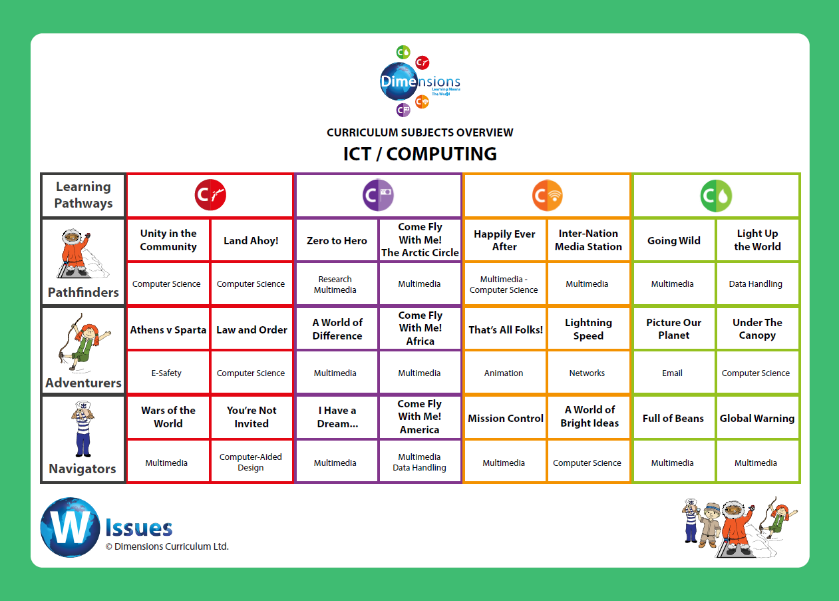

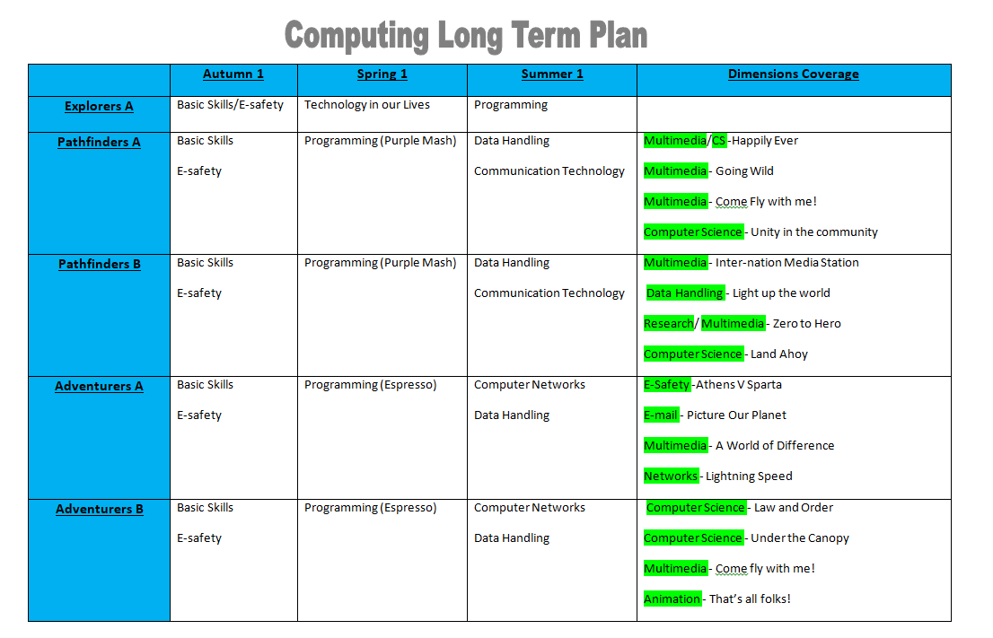
Discrete Computing lessons

Computing knowledge builder across the school

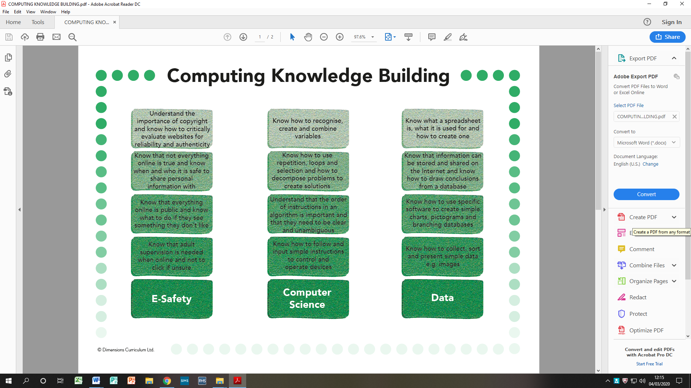

Long Term Plan – Progression of skills – Discrete lessons
Year Group | E-Safety | Multimedia | Programming | Technology around us | Computer networks
1 | -I know my personal information (and who to tell it to).  -I know who I should ask for help if I feel unsafe online.  -I know how to ask for help in school and at home. | -I can use an iPad to capture images.  -I can create a picture using a paint programme.  -I can add text using a computer.  -I can open and save my work. | -I can sequence a set of instructions.  -I can give a person a set of instructions to complete a task.  -I can follow a set of instructions to complete a task.  -I can give a sequence of instructions (algorithm) to a floor bot.  -I can identify if an algorithm is incorrect and begin to debug. | -I can recognise technology I use in school.  -I can recognise technology I use at home.  -I can say what I like to use technology for.
2 | -I know to keep my personal information safe online.  -I communicate respectfully online.  -I can explain how to get help from an adult if I feel unsafe online. | -I can use a range of picture creating programmes and discuss which one I prefer.  -I can copy images from the internet and add them to a working document.  -I can save and open my work and retrieve saved pictures.  -I can move pictures around a document to improve the layout. | -I can create an algorithm for a digital programme (A.L.E.X, beebot, etc.).  -I can predict the behaviours of simple programs, e.g. knowing where the will character end.  - I can debug algorithms for a digital programme.  -I can explain why instructions need to be clear. | -I can recognise technology beyond school and home.  -I can identify benefits of technology in the wider world.  -I am aware of positive and negative impacts technology has had on the world.
3 | -I know what behaviour is acceptable and unacceptable online.  -I know not to meet people from the internet.  -I can recognise facts and opinions online. | -I can capture and manipulate images. (iPad)  -I can create a PowerPoint presentation by adding pictures and text.  -I can add sound into a PowerPoint.  -I can present information using simple graphs. (Purple Mash) | -I can use algorithms to create a programme to meet a specific goal.  -I can solve problems by decomposing them into smaller parts.  -I can debug a programme by looking for errors in the algorithms. |  | -I can find information using a search engine.  -I understand how the internet can be used to communicate with others.  -I am beginning to understand which websites would be a reliable source.
4 | -I am aware of how to block or report inappropriate content online.  -I know that some information online is unreliable, or not accurate.  -I know not to accept friend requests or messages from strangers online. | -I can capture images and use these on the computer.  -I can create simple tables to show information.  -I can add slide transitions in order to improve a presentation.  -I can improve a presentation by changing the background and slide layout. | -I can create algorithms involving sequence, selection and repetition.  -I can create algorithms that can control or simulate physical systems.  -Use logical reasoning to predict the outcome of simple programmes. |  | -I can use advanced internet search features.  -I understand how the internet can be used in order to collaborate.  -I can collaborate through online systems to work on shared documents.
5 | -I am aware of copyright and that content online belongs to someone.  -I can identify features of a computer that make it possible to communicate with people.  -I can use a range of online messaging tools. | -I can record sounds and use them alongside text and images.  -I can present data that I have collected using tables and graphs.  -I can present data using a spreadsheet. | -I can create programmes that use a range of input and output devices.  -I can create programmes that involve variables.  -Use logical reasoning to debug programs involving repetition, and variables. |  | -I can explain that computers can be connected using networks.  -I can draw simple network maps.  -I can refine internet searches to improve the relevance of results.
6 | -I can explain the benefits and risks of communicating online.  -I am aware of how to enable security settings to keep myself safe online. | -I can add hyperlinks into a PowerPoint.  -I can create and share mixed media presentations online for a specific audience. | -I can solve more complex problems by decomposing them into small parts.  -I can create and debug programmes that involve multiple variables. |  | -I understand how search engines results are selected and ranked.  -I can communicate and collaborate through online systems.

Skills Ladders in the thematic units

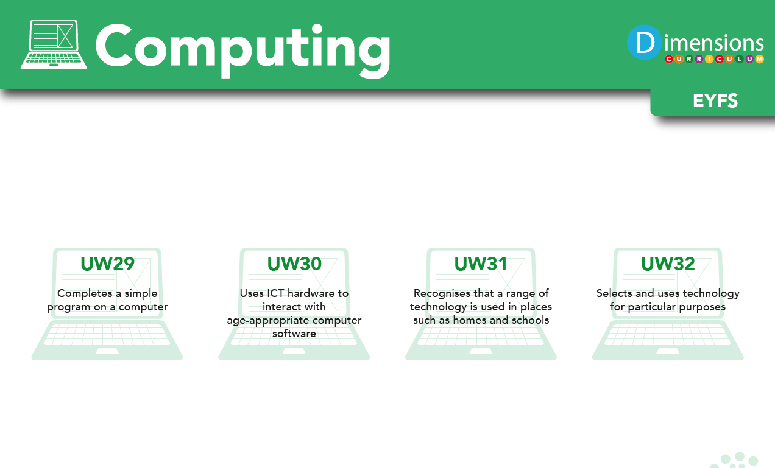

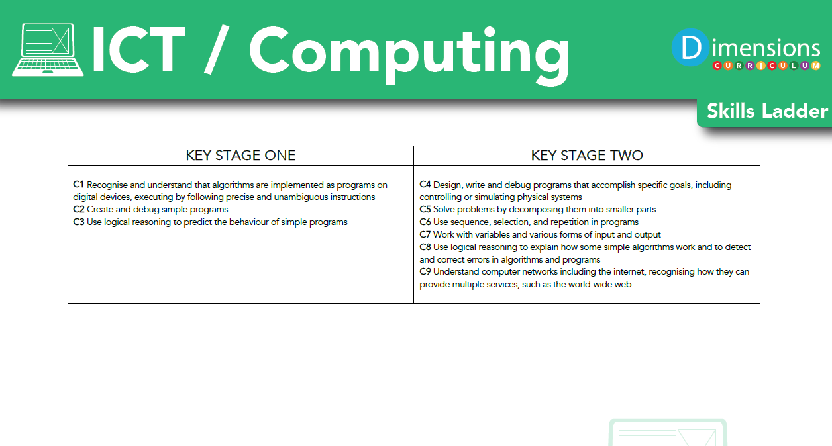

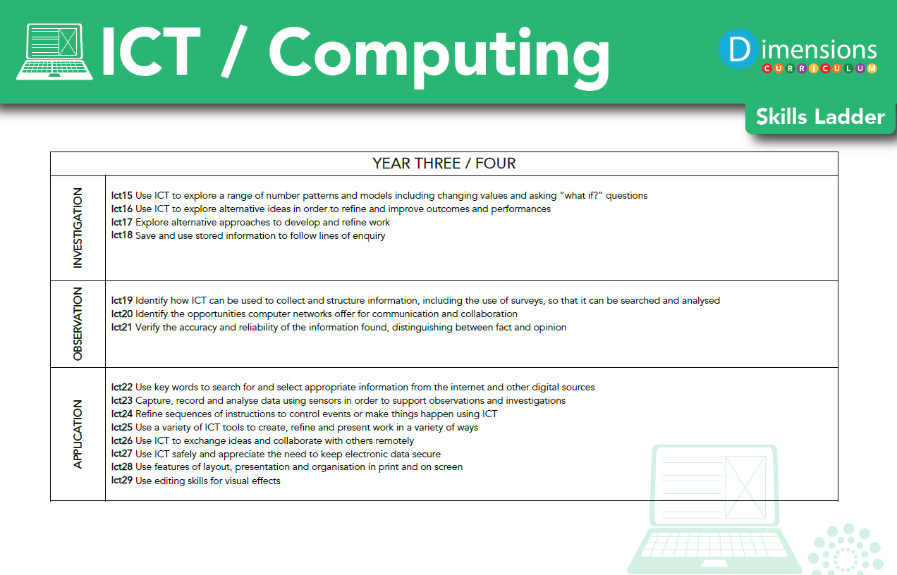

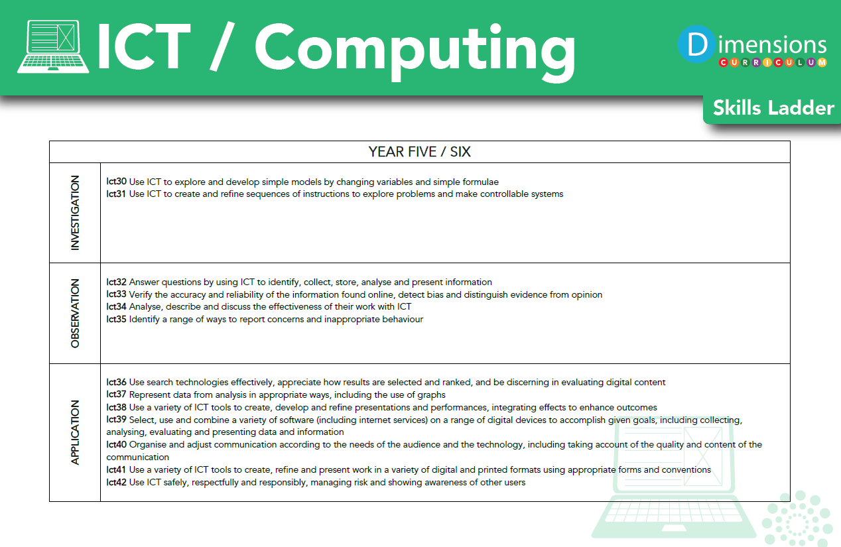

Impact

How do we assess and monitor Computing

Learning Means the World
We use Trackzone which is an online tracking programme to assess computing embedded within ‘Learning Means the World’ global topic. This enables teachers to easily record, monitor and update their assessments in real-time. It makes data analysis at pupil, class and subject level possible, helps identify gaps in learning and any areas for development.

Using a simple grading system of 1-5 (U = Unassessed), teachers are able to make a judgement on each pupil’s progress, taking into account the overall evidence gathered through observation, conversation and examination, using their own professional judgement. Awarding a '4' would indicate a pupil is working at age-related expectation, '5' would be linked to mastery or exceeding expectation and ‘1-3’ would be grades indicative of partial knowledge / achievement.

As many of our pupils have short term memory difficulties, they find retaining knowledge especially difficult, so we use Kahoot quizzes throughout the units to support them remember ‘Sticky Knowledge’. These quizzes make learning fun, engaging and impactful. Teachers can use the readymade quizzes created by Dimensions for each unit or they can create their own to introduce the topic, review and reinforce knowledge and use the information gained to help them identify which objectives have been achieved in Trackzone.

Each child’s average grade (1-5) is collected twice a year for SLT, subject leaders and teachers to gain valuable knowledge on how the child, class and school are working in each subject.

SLT, teachers and subject leaders use assessment for learning to inform planning, teaching and learning and CPD opportunities.

Discrete Computing Lessons
In order to assess the progress pupils have made within their discrete computing lessons teachers use the Orrets Meadow foundation+ assessment tool. This system is set up similarly to Trackzone. For each strand of discrete computing that is taught teachers assess the pupils from 1-5 using the progression of skills map in order to inform their assessments.
These can then be viewed by class teachers, subject leaders and SLT to gain a whole school overview of the discrete subjects within the school.

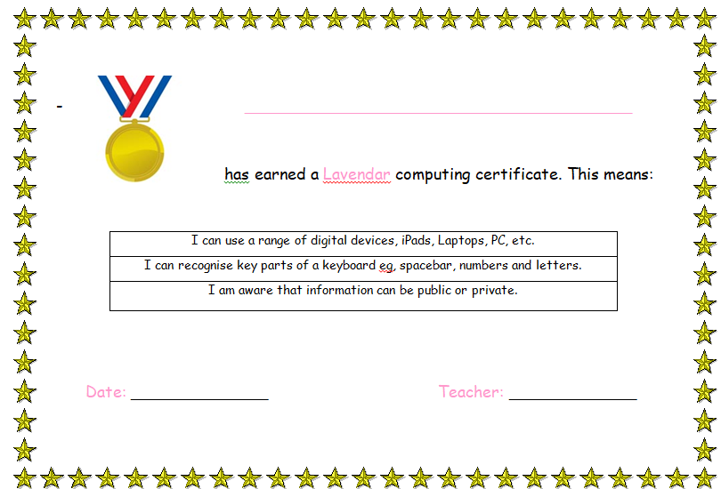

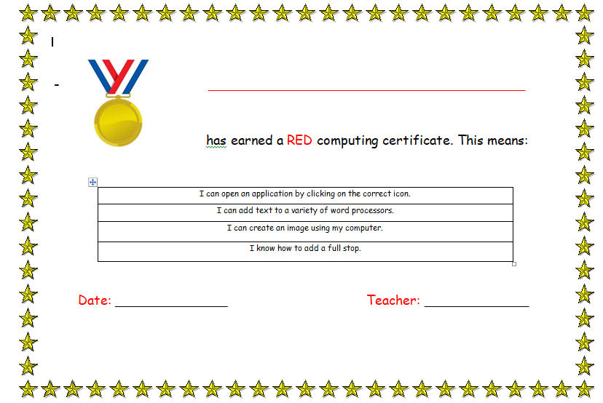

Computing Certificates
Pupils also work towards earning a range of computing certificates. Teachers report back at the end of each term to the computing lead where pupils are up to with these computing certificates. This ensures that computing skills continue to develop outside of computing lessons.



SLT and subject leaders are continuously monitoring their subject to ensure it meets the needs of our pupils. They monitor using a variety of activities, including:

- Learning walks
- Book scrutiny
- Lesson observations
- Pupil survey and discussions
- Staff survey and discussions

We are excited to teach our Learning Means the World curriculum and know it will positively impact on our pupils’ academic and whole well-being.



