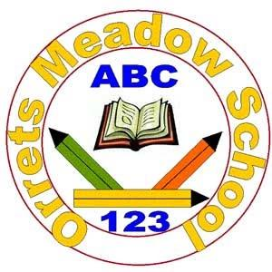

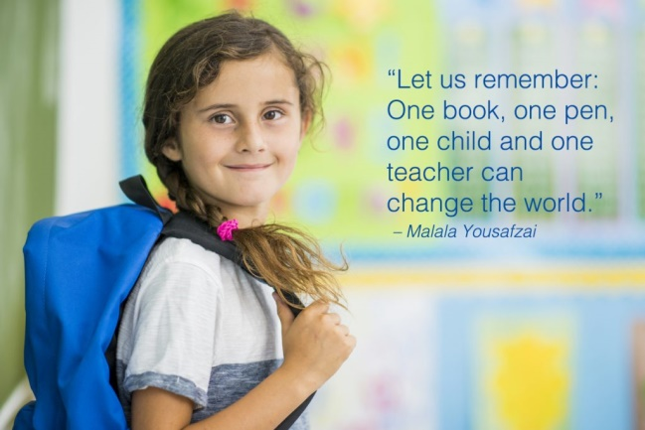**Orrets Meadow School**

**English Policy**

**“To raise the aspirations of every child and give them confidence to fulfil their potential through positive experiences”**

**Orrets Meadow Curriculum Aims and Values**

**Aims**

To ensure all our children are at the centre of a broad, varied and interesting learning experience that is enjoyable and relevant for the future. Our creative, multisensory curriculum will create a sense of awe and wonder and help to inspire a lifelong love of learning. The holistic nature of our practice will promote positive mental health and well-being and will enhance our children’s life skills, social skills and cultural awareness.

**Values**

Our curriculum will promote a range of values including:

* Respect
* Empathy
* Responsibility
* Equality
* Independence
* Happiness
* Resilience
* Gratitude
* Honesty
* 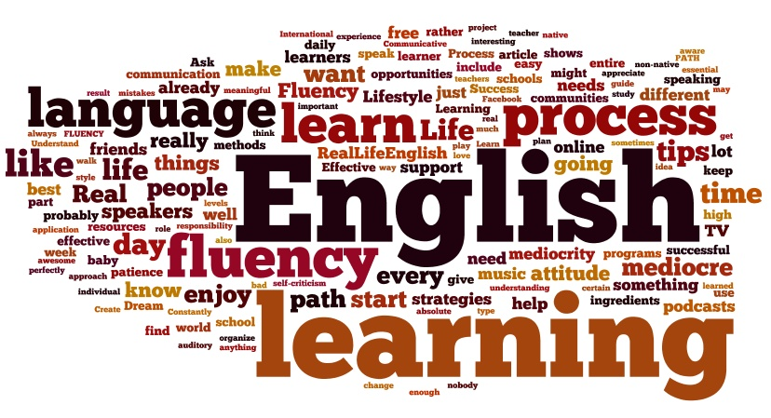Friendship

**Intent**

**National Curriculum – English   
  
Purpose of Study**

English has a pre-eminent place in education and in society. A high-quality education in English will teach pupils to speak and write fluently so that they can communicate their ideas and emotions to others, and through their reading and listening, others can communicate with them. Through reading in particular, pupils have a chance to develop culturally, emotionally, intellectually, socially and spiritually. Literature, especially, plays a key role in such development. Reading also enables pupils both to acquire knowledge and to build on what they already know. All the skills of language are essential to participating fully as a member of society; pupils who do not learn to speak, read and write fluently and confidently are effectively disenfranchised.

**Aims of the Orrets English Curriculum**

Through the teaching of English at Orrets Meadow we aim to help pupils to achieve a range of skills that will become transferable in order to help them to succeed. The aims for are English curriculum are for pupils to;

* Listen attentively, paying attention to detail, to process the information and retain aurally as much detail as they are able.
* Speak confidently with intonation, clear diction, accurate grammar and style with regard for their listener.
* Read fluently with good comprehension, which is reflected in appropriate expression and intonation, from a wide variety of text, at their own level, for pleasure, relaxation, and investigation.
* Develop their cognitive skills, imagination and personal expression through a range of writing tasks using clear, concise language with accurate punctuation and grammar, in a style appropriate for the purposes.
* Make progress along the continuum to become a competent speller.
* Use neat legible cursive handwriting.
* Make fair critical responses about their own language work, that of their peers and that of a variety of authors and poets.

**English Curriculum at Orrets Meadow**

The English curriculum at Orrets Meadow has been integrated with our Global Curriculum called ‘Learning Means the World’. This allows pupils to acquire secure knowledge of topics through their afternoon curriculum that can then be used and applied throughout English lessons. Our curriculum promotes a mastery of English by following ‘The Reading and Writing Journey’ as well as providing purpose for writing during themed weeks throughout the year, such as report writing linked to science investigations.

Pupils at Orrets Meadow also develop their phonetic awareness and spelling skills through a multi-sensory daily programme of study following the Orrets Meadow Core Curriculum.

**Why Is English Important?**

English is both a subject in its own right and the medium for teaching; for pupils, understanding the language provides access to the whole curriculum. Fluency in the English language is an essential foundation for success in all subjects. English is an essential subject that allows pupils to engage with the world around them. Through English lessons pupils will learn;

* 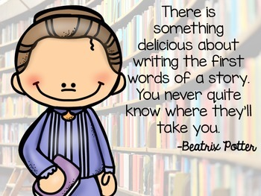Spoken Language
* Writing Composition
* Writing Transcription
* Word Reading
* Reading Comprehension
* Handwriting
* Vocabulary, Grammar and Punctuation

All of these elements of English allow pupils to process and determine meaning from both spoken and written English. It enables pupils to be able to express their own needs in an articulate manner as well as providing transferable skills that can be used later in life in real life contexts.

**Implementation**

**When is English Taught?**

Children at Orrets Meadow spend an extended time allocation on English. In our younger classes this is a 45 minute phonics session and a 45 minute English lesson daily. As pupils become more proficient with their phonetic knowledge they will partake in a 30 minute phonic and spelling session and an hour long English lesson daily. This ensures that each child can have a daily spelling lesson, read with an adult, as well as experience high quality English teaching in classes or group sessions.

**What do we learn about in English?**

We learn about a range of text genres and styles, as well as writing for different purposes. We learn about;

* Spoken Language
* Writing Composition
* Writing Transcription
* Word Reading
* Reading Comprehension
* Handwriting
* Vocabulary, Grammar and Punctuation

Each section of English has a progression of skills which teachers expertly use in order to cater to the learning needs of pupils within their classes. These progressions of skills can be found in the appendices of this document along with the long term plans for English.

**Daily Core Curriculum**

In order to meet the needs of our pupils, we continue to follow a highly structured cumulative phonic and key word programme for reading and spelling as our ‘Core Curriculum’. This programme originally followed Hickey Multisensory Language Course (2000), but has been adapted and developed for group and class work. Teachers use their expertise, to plan and deliver multisensory experiences with great scope for overlearning, based on rigorous assessment and tailored to the needs of the child or group.

Daily activities include:

* Alphabet- ordering and sequencing letters and words
* Auditory Discrimination/Phonemic Awareness
* Memory- auditory and visual
* Revision of key words and known phonics for reading and spelling
* New Learning of key words and phonics for reading and spelling
* Daily reading, with a Teacher or Teaching Assistant
* PROBE (Precise Recording of Objective Based Education)
* Homework linked to phonics or keywords
* Dictionary and thesaurus activities

This structure allows children to develop the transferable basic skills necessary to access the wider curriculum. In small achievable steps, they experience success and build confidence.

**English Mastery at Orrets Meadow**

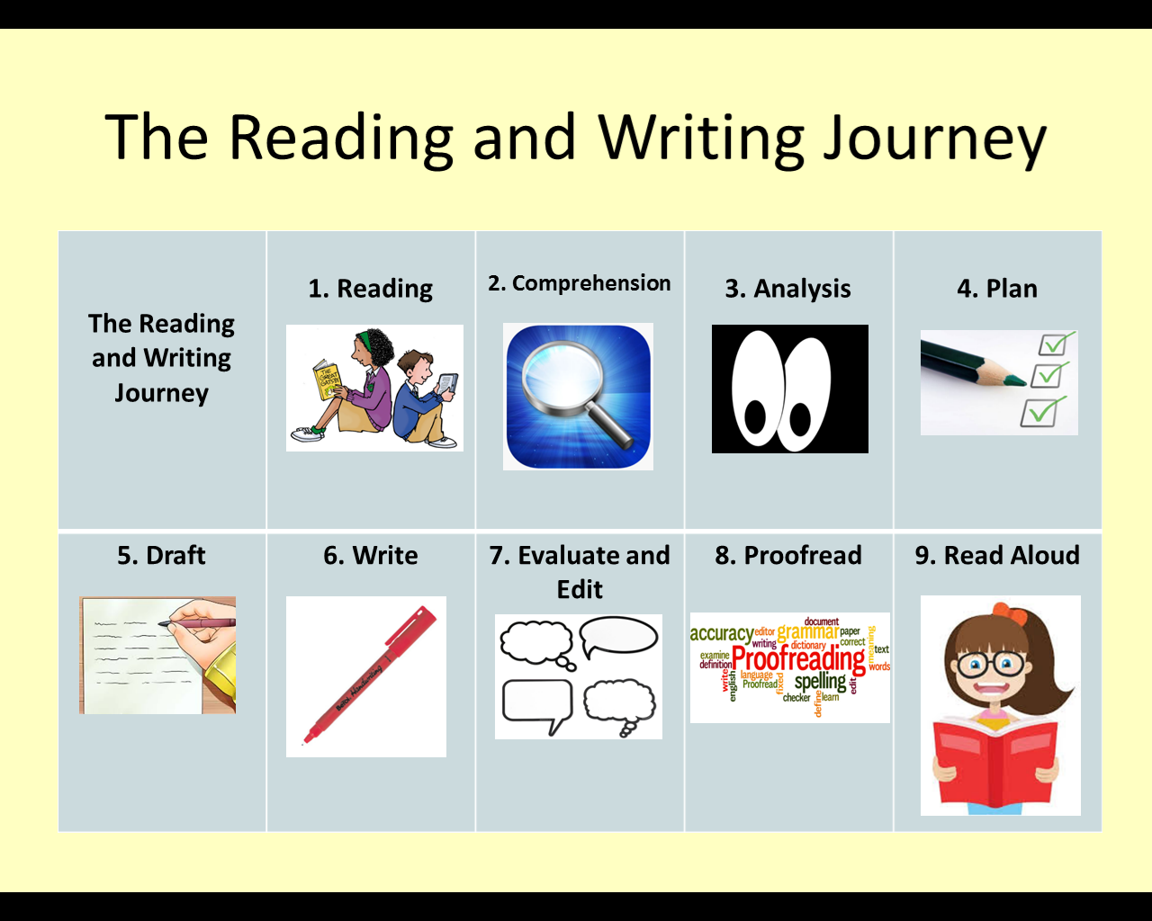‘The Reading and Writing Journey’ illustrated below is the key feature of the Mastery curriculum at Orrets Meadow.

By ensuring each of these elements are taught explicitly children will master the skills needed to become confident readers and writers. Following our new English long term plan (Appendix 1-6), which is linked to our Global Curriculum allows pupil to have a greater comprehension of topics. This allows pupils to focus on the individual writing styles and skills to be used in the area of English they are currently studying.

**How is English Taught?**

English is taught through a combination of subject knowledge, comprhension of differnet genres of wiritng and the development of specific skills along a continuum. Teachers use their expertise in order to deploy a range of teaching and learning strategies that best meet the needs of the pupils within their classrooms. These teaching and learning strategies include;

* Multisensory activities
* Visual, auditory and kinaesthetic
* Overlearning
* 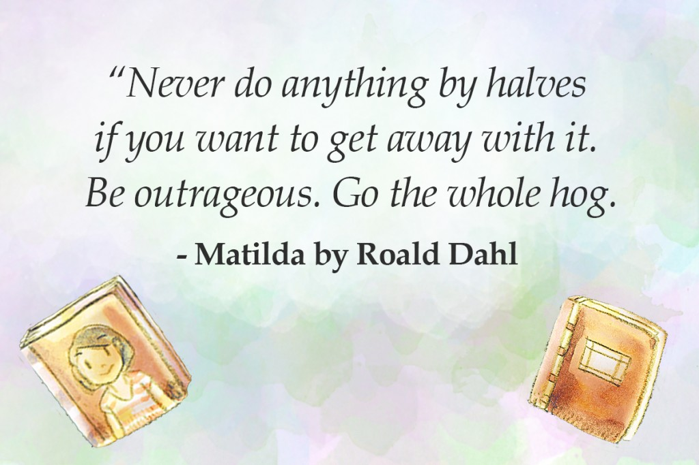Structured and scafolded practical and written activities
* Drama activities for character exploration
* One to one proof reading and editting prior to final drafts of pieces of work.
* Guided reading and writing
* Modelling
* Sight reading
* Probes
* One to one reading
* Small group work and strategic deployment of teaching assistants
* Opportunities to incorporate technology.

**Orrets Meadow Literacy Spine**

Throughout the school pupils are exposed to range of appropriate books covering a range of topics. The Orrets Meadow Literacy Spine (Appendix 7) shows a list of recommended books that are used to broaden pupils’ knowledge of different stories with significant social, moral and cultural impact, which foster an enjoyment of reading and learning. The Literature spine is composed of two elements for each year group; Curriculum Texts and Class Reading. Texts under ‘Curriculum Texts’ are a mixture books that have been recommended through our Global curriculum and other stories that the school team have found to link closely with the areas covered.

Class readers are books not linked to the curriculum that teachers can share with their classes in order to promote a lifelong love of reading and reading for pleasure. These texts have been informed by Pie Corbett as well as recommended texts from the teaching staff. Books selected by teaching staff are books that teachers know are appropriately pitched for our pupils as well as being stories that staff love and are enthusaistic to share.

**Specific Additional Curriculum Needs**

A Speech Therapist assesses and provides group and individual programmes for children with Speech Language and communication needs. These programmes are delivered in Additional Needs Group sessions by a group of three Specialist Teaching Assistants.

**Computer Literacy**

The use of computers permeates all areas of modern life, it is essential we equip our pupils with skills for computer literacy so they are able to fully participate in an ever changing world.

The use of technology is embedded in teaching and learning practices across the English Curriculum. Orrets Meadow is fortunate to have a great variety of laptops, PCs and iPads available for children and teachers to access in order to support the development of skills such as spoken language, composition and writing for different purposes. Some of the software used include;

* Clicker 6 – This features predictive text to enable pupils to explore a wider range of vocabulary that can be used. It also has the capability to read text back to pupils, which helps to develop their proof reading and editing skills.
* Clicker Sentences – This enables pupils to develop their sentence composition by ordering words into the correct order. This can be used at different levels to incorporate a progression of punctuation and range of sentence structures. This application also reads back sentences for pupils to listen for corrections.
* Purple Mash – Purple mash has a range of elements that can help pupils with organisational, layout features and writing for a range of purposes.
* Bug Club - The school has invested in an ICT based programme called Bug Club, which allows pupils to access a range of fiction and non-fiction books at their levels from home. This programme not only helps with word reading, but also comprehension through targeted questioning.

**SMSC in English**

The English curriculum at Orrets Meadow provides many opportunities for pupils to reflect on Spiritual, Moral, Social and Cultural factors. During English lessons pupils can explore the lives of others from history and around the world through stories. Pupils are exposed to each of these elements in a range of ways including the following;

|  |  |  |  |
| --- | --- | --- | --- |
| **Spiritual** | **Moral** | **Social** | **Cultural** |
| Imagery | Right and wrong | Instructional writing | Stories from other cultures |
| Sharing Ideas | Conscience Alley | Role Play | Famous author studies |
| Text and Poetry | Persuasive Writing | Talking Partners | Researching other countries |
| Curiosity | Debating | Working in Pairs | Fact Sheets |
| Imaginative writing | Relationships | Peer Writing of stories | Travel agents and brochures |
| Greek Myths | Fables | Acting | Chinese New Year |
| Legends | Fairy tales | Researching | Kensuke’s Kingdom |

**Home-School partnership**

Although much has been said in the media regarding homework for Primary age children, we have found that the support of our parents is invaluable in children making progress. Fostering a close link with home encourages active generalisation of the new skills and is another opportunity to reinforce new learning.   
Homework is set Monday to Friday, which the exception of big events or specific holidays.

Children are set:

1. Reading
2. PROBE
3. Spelling, writing or maths task.

Home work should not take longer than 10-15 minutes to complete.

**Impact**

**How do we assess and monitor English?**

**Assessment Activities**Throughout the year the impact of the teaching English is closely monitored and assessed using a range of strategies to acquire both staff and pupils views on their success in English. These include

* Learning walks by the English Lead.
* A Learning walk with the English Lead and the Head of Governors
* Book Scrutiny
* Lesson Observations carried out by the Head teacher and the English Lead.
* Pupils’ surveys and discussions.
* Staff surveys and discussions

**Assessment for learning**

**Assessment Cycle**

The Core curriculum is assessed each term, which provides teachers with the detail needed to plan their programmes and identifies children in need of additional provision and support.

**Assessing Pupils Progress(APP)**

Children will be assessed using APP sheets devised from the objectives given in the English programme of study. Assessments will indicate whether a child attains ‘Beginning’, ‘Developing’ or ‘Secure’ against the objectives being studied. Children will be awarded appropriate ‘Steps’ (1-6) when working towards the curriculum and levels A1-C6 when working within the curriculum.

**Tracking and reporting**

**Termly Data Report**

At the end of each term, parents are supplied with an update on their child’s progress, in the form of a Data Report. This shows progress through the year and against curriculum objectives.

**Pupil Progress Meeting**

Pupil Progress Meetings are held each term to identify children not making expected progress. Additional support and group interventions are put into place to promote progress.

**End of year report**

All children receive an end of year report summarising and highlighting the progress they have made in the English curriculum**.**

**Standard Attainment test (SATs)**

Children who are working on the KS2 curriculum will sit the SAT test each May. For some children taking the SATs would have a negative impact on mental health. In such instances careful consideration is made as to which assessments they will take. Individuals unable to access the SATs are awarded a teacher assessment, based on their class work.

**Pupil Self-Assessment**

Children make a summative assess their own progress over an English lesson, by marking their work with a green, orange or red circle. Green meaning the child is secure in their progress and red meaning they are in need of more reinforcement. Additionally children are encouraged to make on going running assessment at appropriate times during the lesson, with coloured circle or traffic lights on their desks

When the children are sufficiently skilled and mature, they will be encouraged to make peer assessment and set targets for their peers.

**Marking & Feedback (Academic Guidance)**

The Academic Guidance Policy sets out the philosophy, standards and marking codes to be used by teachers. Whenever possible, feedback is given orally at the earliest opportunity. A marking code is displayed at the front of each book.

Additionally teachers mark work with a star (green highlighter) and a target (pink highlighter), indicating the next steps a child needs to take to make progress.

**English Policy Appendices**

**Long term plans for English:**

1. **Pre National Curriculum (Cycle A)**
2. **Pre National Curriculum (Cycle B)**
3. **Pathfinders Cycle A (Year 1)**
4. **Pathfinders Cycle B (Year 2)**
5. **Adventurers Cycle A (Year 3)**
6. **Adventurers Cycle B (Year 4)**

**Other Appendices**

1. **Literacy Spine**
2. **Progression of Grammar**
3. **Progression of Reading**
4. **Progression of Writing**

Appendix 1: Pre-National Curriculum Cycle A Long Term Plan

|  |  |  |  |  |  |
| --- | --- | --- | --- | --- | --- |
| **Fiction** | **Dimensions Theme 1**  **Happy to be me!** | **Dimensions Theme 2**  **No Place Like Home** | **Dimensions Theme 3**  **Help is at Hand** | **Dimensions Theme 4**  **Under the Sea** | **Wonders of Wirral Theme 5**  **Pirates and Mermaids**  **New Brighton**  **Fairy Tales** |
| **Whole Class shared Text - Novel** | | | | | |
| **Week 1** | **Funny Bones**  Repetitive Language  Writing fact files | **Peace at Last**  Re-telling stories  Describing rooms | **Farmer Duck**  Making sentences  Writing Captions | **Barry the Fish with Fingers**  Rhyming words  Labelling the fish | **Pirates Love Underpants**  Describes main story settings,  events and principal characters. |
| **Week 2** | **All Ears, All Eyes**  Non-fiction books  Sound walk | **The Three Little Pigs**  Comparing stories  The Fourth Little Pig-writing | **Can’t you Sleep Little Bear**  Non-fiction books  Recount | **The Rainbow Fish**  Telling stories with puppets  The shiny scale | **Pete the Cat and the Treasure Map**  Design treasure maps  Design and label a sea monster |
| **Week 3** | **Ears, Eyes and Toes**  ‘All about me’ books  Senses and food | **The Three Little Pigs**  Matching words to pictures | **Chinese New Year/**  **Police Ambulance and Nurses**  Reading signs Writing captions | **Sharks, Whales and Dolphins**  Matching sentences to pictures  Writing descriptions | **The Singing Mermaid**  Rhyming words  Follow instructions to make mermaid biscuits |
| **Week 4** | **The Colour of Us**  Characteristics  Class book | **Perfect Pet**  Similar Stories  Rory the Tiger | **Doctors and Nurses**  Labelling body parts  Get well cards | **Nugget and Fang**  Rearranging letters  Shark food | **Brochures and Posters**  Design posters/brochures to promote New Brighton. |
| **Week 5** | **Goldilocks**  Family stories  Making books | **We’re Going on A Bear Hunt**  Unusual Home stories  Who lives in a house like this? | **I Forgot**  Labelling and writing captions.  Making sentences  Writing statements | **Crazy Crustaceans**  Find the rhyme  Guess the crustacean |
| **Week 6** | **All Join In**  Performing stories  Writing statements. | Stories with props  Writing messages | **How to Babysit a Grandma**  Instructions | **The Lonely Lobster**  Rhyming strings  Adventure writing |
| **WHOLE SCHOOL THEMED WEEK** |  | **Christmas Around the World**  Sequencing  Retelling the Christmas story.  Role Play parts of the Christmas story. | **Religion Week**  **Hinduism**  Labelling and writing captions.  Sequencing the stories | **Language and Cultural Week**  Learn and write simple facts.  Promoting speaking and listening of another language |  |
| **SCIENCE WEEK** | **Humans, Growing and Changing**  Labelling/Caption writing | **Animals and Caring**  Instructions | **Materials**  Labelling/Caption writing | **David Attenborough**  **Animals and Life Cycles**  Non Fiction information | **My local environment, Habitats, Plants**  Instructions |
| **Grammar – Word, Sentence, Text, Punctuation and Handwriting** | | | | | |

Appendix 2: Pre-National Curriculum Cycle B Long Term Plan

|  |  |  |  |  |  |
| --- | --- | --- | --- | --- | --- |
| **Fiction** | **Dimensions Theme 1**  **Tell Us a Story!** | **Dimensions Theme 2**  **Let’s Play** | **Dimensions Theme 3**  **What on Earth?** | **Dimensions Theme 4**  **Come Fly With Me!** | **Wonders of Wirral Theme 5**  **Swamps and Ice creams Parkgate**  **Fantasy (4 wks)** |
| **Whole Class shared Text - Novel** | | | | | |
| **Week 1** | **Jack and the Bean Stalk**  Comparing Versions of Stories Writing a Letter to the Giant. | **Non Fiction Toy book**  Toy Alphabet Writing Stories. | **I am Josephine and I am a living thing**  Naming Living Things ‘I am...” Sentences. | **‘A Kids Guide to China’**  Fact Books Chinese Letter Writing. | **Shrek**  Describes main story settings,  events and principal characters. |
| **Week 2** | **The Gingerbread Man**  Comparing Stories ‘Lost’ Posters | **Where’s My teddy**  **Jez Alborough**  Listening to Stories Describing Teddy | **Pretty by Canizales**  ‘Pretty’ Story Writing Letters | **Story of Chinese New Year Animals**  Writing Letters to China | **Should I Share My ice cream**  Recipes  Ice cream Sundae design  Invitation |
| **Week 3** | **Snow White**  Comparing Stories Invent a New Dwarf | **The Rhyming Rabbit – Julia Donaldson**  Rhyming Words Describing Movements | **The Smartest Giant in Town**  Giants’ Catalogue | **All About Indian by Shalu Sharma**  Indian Fact Books Making a Holiday Brochure | **Superworm**  Letter to one of the characters. |
| **Week 4** | **Cinderella**  Flashcards Writing Wishes | **Toy Story**  Reading Key Words Writing Stories | **Mr Small Story**  Menu for Mr Small | **Diwali Holidays Around the World by Lisa J Amstutz**  Diwali Fact Books Story Maps | **Poems about senses**  Explore the senses through poetry. |
| **Week 5** | **Cinderella**  Flashcards Writing Wishes | **Whatever Next!**  **Non Fiction Space.**  Words in the Stars Space Ranger Descriptions | **Old Bear by Jane Hissey**  Rhyming Words Matching Initial Sounds | **Non Fiction Information on Russia.**  Russian Alphabet Writing Captions |
| **Week 6** | **Learning to Listen**  Re-telling Stories What Happens Next? | Ordering Instructions | **The New Baby by Anna Civardi**  Writing Some News | **How the camel got his hump by Rudyard Kipling**  Rhyming Words Writing names in Hieroglyphics |
| **WHOLE SCHOOL THEMED WEEK** |  | **Christmas Around the World**  Children are able to retell the key point of the Christmas story.  Children know this story comes from the bible. | **Religion Week**  **Hinduism**  Labelling and writing captions.  Sequencing the story of Rama and Sita. | **Language and Cultural Week**  Learn and write simple facts.  Promoting speaking and listening of another language |  |
| **SCIENCE WEEK** | **Humans, Growing and Changing**  Labelling/Caption writing | **Animals and Caring**  Instructions | **Materials**  Labelling/Caption writing | **David Attenborough**  **Animals and Life Cycles**  Non Fiction information | **My local environment, Habitats, Plants**  Instructions |
| **Grammar – Word, Sentence, Text, Punctuation and Handwriting** | | | | | |

Appendix 3: Pathfinders Cycle A (Year 1) Long Term Plan

|  |  |  |  |  |  |  |  |  |  |  |  |  |  |  |
| --- | --- | --- | --- | --- | --- | --- | --- | --- | --- | --- | --- | --- | --- | --- |
| **‘Happily Ever After’**  **Fairy Tales**  **All About Me (6 Wks)** | **Science**  **Week (1 wk)** | **‘Going Wild’**  **All about Animals**  **(6 wks)** | | **Science**  **Week (1 wk)** | **Xmas around the World (1 wk)** | **‘Come Fly With Me!’**  **Arctic Circle**  **(6 wks)** | **Religion Week (1 wk)** | **Science Week (1 wk)** | **Language & Culture Week (1 wk)** | **Science Week (1 wk)** | **‘Unity in the Community’**  **Where I Belong**  **(6 wks)** | **Science Week (1 wk)** | **West Kirby & Hilbre Island (4 wks)** | |
| **Whole Class shared Text - Novel** | | | | | | | | | | | | | | |
| **Fiction (4 wks)** Traditional Stories and Fairy Tales  **Texts** The Ugly Duckling Little Red Riding Hood Cinderella Three little Pigs  **Outcome** Retell stories Sequence events. Write descriptions. Write own versions of story. Repetitive phrases. |  | **Fiction (3 wks)** Author Study  **Texts** Anthony Browne story books  **Outcome**  Retell stories orally using narrative language. Make predictions about events in a story. Write a retell of a story. | |  | **Fiction (1 wk)**  Here Comes Christmas  **Outcome**  Children know that Advent is preparation time for the Christian festival of Christmas  Recount, retell and re-act the Christmas story in the correct sequence. | **Fiction (3 wks)**  Stories from other cultures  **Texts** The Polar Bear Son – Inuit Tale – L Dabcovich An Eskimo Tale - Chunks of light  **Outcome** Retell story, character, settings, create class storybook. |  |  |  |  | **Fiction (4 wks)** Stories with predictable/ Patterned language.Fantasy Stories  **Texts**  We’re going on a bear hunt – M Rosen Not now Bernard – D McKee Man on Moon – S Bartram The Garden – D Sheldon  **Outcome** Create a story with predictable language linked to a theme. Write a story in a fantasy neighbourhood. |  | **Fiction (2 wks)**  Stories with a moral.  **Texts** “Dogger” – S Hughes  **Outcome** Discuss giving up things for others and the ups and downs of the characters. Feelings and emotions. Write a thank you letter to Bella from Dave. | |
| **Grammar – Word, Sentence, Text, Punctuation and Handwriting** | | | | | | | | | | | | | | |
| **Non Fiction (1 wk)**  Letter  **Texts**  Invitations postcards  **Outcome** Write a postcard and letter to a character | **Non Fiction (1 wk)**  Instruction writing  **Outcome**Write up Science experiment | **Non Fiction (2 wks)**  Explanations  **Texts** Where the Wild Things Are – M Sendak  **Outcome** Features, discuss presentation, purpose and audience. Produce clear diagrams/charts to show process. Create glossary of words for living things. | **Non Fiction (1 wk)**  Info texts  **Outcome**Write labels and sentences on Chris Packham (animals) | |  | **Non Fiction (2 wks)**  Instruction  **Text** Image of Inuit snow goggles to prevent snow blindness.  **Outcome** Follow instruction, sequence, write instructions on how to make something for a friend. | **Non Fiction (1 wk)**  Report Writing  **Outcome**Write non chron report on an element of Islam. | **Non Fiction (1 wk)**  Instruction writing  **Outcome**Write up Science experiment | **Non Fiction (1 wk)**  Non Chron Report  **Outcome**Write a simple non- fiction report on an aspect of their country. | **Non Fiction (1 wk)**  Explanation texts  **Outcome**Write an explanation of a process linked to Plants | **Non Fiction (1 wk)**  Persuasion  **Outcome** Create an advert persuading people to visit your fantasy neighbourhood. | **Non Fiction (1 wk)**  Explanation texts  **Outcome** Write an explanation of a process linked to every day materials. | | **Non Fiction (2 wk)**  Recount  **Outcome** Write a simple, person recount based on their visit to West Kirby. |
| **Poetry (1 wk)** Songs and repetitive poems  **Outcome**  Join in with repeated phrases and patterns |  | **Poetry (1 wk)** Poems about nature.  **Outcome** Write and perform own nature poem. |  | |  | **Poetry (1 wk)** Humorous Poems, inc riddles. **Outcome** Create a riddleand express poems like and dislike. |  |  |  |  | **Poetry (1 wk)** Rhyme and Pattern  **Outcome** Recite a familiar poem off by heart. |  | |  |

Appendix 4: Pathfinders Cycle B (Year 2) Long Term Plan

|  |  |  |  |  |  |  |  |  |  |  |  |  |  |  |  |  |  |  |  |  |
| --- | --- | --- | --- | --- | --- | --- | --- | --- | --- | --- | --- | --- | --- | --- | --- | --- | --- | --- | --- | --- |
| **‘Inter-Nation Media Station’**  **Media Broadcasting**  **(6 Wks)** | **Science**  **Week (1 wk)** | | **‘Light up the World’**  **The Sun – light & Heat**  **(6 wks)** | **Science**  **Week (1 wk)** | **Xmas around the World (1 wk)** | | **‘Zero to Hero’**  **Inspirational figures, past and present**  **(6 wks)** | | | **Religion Week (1 wk)** | **Science Week (1 wk)** | | **Language & Culture Week (1 wk)** | | **Science Week (1 wk)** | **‘Land Ahoy!’**  **Pirates**  **(6 wks)** | **Science Week (1 wk)** | | **Hoylake & Moreton (4 wks)** | |
| **Whole Class shared Text - Novel** | | | | | | | | | | | | | | | | | | | | |
| **Fiction (3 wks)** Narrative Writing  **Film Clips** Meet Top Dollar Nan on the phone Radio interviews  **Outcome**  Use adjectives to describe Top Dollar. Write story about Norman and nan’s big day out. Write and read out ‘Thank you’ speech for Top Dollar. Prepare an interview script with questions and answers for Top Dollar. |  | | **Fiction (3 wks)** Author Study  **Texts** The Owl is afraid of the Dark – J Tomlinson  **Outcome** Discuss author style, character descriptions, hot seating. Write a dialogue between characters. Plan and write a story using a character from a book and take them on a different adventure. |  | **Fiction (1 wk)**  Festivals of Light  **Outcome** Recall and retell the story of Hannukah and offer simple explanations why the Menorah is important to Jews. | | | | **Fiction (3 wks)** Adventure Stories  **Texts**  Traction Man is Here – M Grey Dino Danger – M Keene  **Outcome** Discuss sequence of events in books and how they relate to each other. Write own adventure story with a beginning, middle and ending. |  |  | |  | |  | **Fiction (3 wks)**  Stories with familiar settings  **Texts** Stories set at sea or the seaside.  **Outcome**  Re-enact stories, retell stories, sequence pictures, scenes and sentences. Describe a pirate. Write a diary entry for a pirate captain. |  | | **Fiction (2 wks)** Traditional Tales - Fables  **Texts** Collection of simple fables  **Outcome** Children to write a short fable with a moral behind it. | |
| **Grammar – Word, Sentence, Text, Punctuation and Handwriting** | | | | | | | | | | | | | | | | | | | | |
| **Non Fiction (2 wks)**  Persuasion/ Fact and Opinion  **Outcome**  Is watching too much TV good for you? Discuss and debate. Create a poster persuading people either way.  Create fact and opinion sentences about Top Dollar. | | **Non Fiction (1 wk)**  Inform -ation texts  **Outcome**  Research and produce a fact sheet on Charles Darwin (Living things and habitats) | **Non Fiction (2 wks)**  Recount  **Outcome**  Share and write about family news. Sequence events and use time connectives to write a personal recount. | **Non Fiction (1 wk)**  Instruction writing  **Outcome**  Write up Science experiment | |  | | **Non Fiction (2 wks)**  Information Texts  **Texts** Range of non- fiction books on famous people. Diary entries/ famous diary writers. Blogs  **Outcome**  Hot seat and interview famous people. Choose a famous person and write factual sentences on them. Use secondary sources to create pages for a non- fiction book called “Zero to Hero.” Pupils to create own personal diary. Write own blog entry. | | **Non Fiction (1 wk)**  Report Writing  **Outcome**  Write non chron report on an element of Buddhism | | **Non Fiction (1 wk)**  Instruction writing  **Outcome** Write up Science experiment | | **Non Fiction (1 wk)**  Non Chron Report  **Outcome**Write a simple non- fiction report on an aspect of their country. | **Non Fiction (1 wk)**  Explanation texts  **Outcome**Write an explanation of a process linked to Animals survival and growth | **Non Fiction (2 wks)**  Recount/ Dictionary  **Outcome**  Write a recount on a pirate party day. Make a dictionary of pirate words and write them in alphabetical order. | | **Non Fiction (1 wk)**  Explanation texts  **Outcome**Write an explanation of a process linked to Animals and how we grow | | **Non Fiction (1 wk)**  Recount  **Outcome** Write a simple, 1st person recount based on their visit to Hoylake. |
| **Poetry (1 wk)**  Calligrams  **Outcome** Write and present creatively single word calligrams. Write and present as a poster own shape poems. | |  | **Poetry (1 wk)**  Poetry Appreciation  **Outcome** Talk about favourite words and phrases in poems. Make a response to a poem. Recite a familiar poem by heart with intonation. |  | |  | | **Poetry (1 wk)**  Riddles  **Outcome** Write riddles in the first or third person. Write a rhyming class riddle about a famous person. | |  | |  | |  |  | **Poetry (1 wk)**  Songs and repetitive poems  **Outcomes** Identify repeated patterns in poem. Read and write own list poems. | |  | | **Poetry (1 wk)**  Traditional Poems  **Outcomes** Read, write and perform free verse. |

Appendix 5: Adventurers Cycle A (Year 3) Long Term Plan

|  |  |  |  |  |  |  |  |  |  |  |  |  |  |  |  |
| --- | --- | --- | --- | --- | --- | --- | --- | --- | --- | --- | --- | --- | --- | --- | --- |
| **‘Athens V Sparta’**  **Conflict in Ancient Greece**  **(6 Wks)** | **Science Week (1 wk)** | **‘Picture our Planet’**  **Photo Stories**  **(6 wks)** | **Science Week (1 wk)** | **Xmas around the World (1 wk)** | **World of Difference**  **Religious Festivals**  **(6 wks)** | | **Religion Week (1 wk)** | | **Science Week (1 wk)** | **Language & Culture Week (1 wk)** | **Science Week (1 wk)** | **‘Lightning Speed’**  **The World Wide Web**  **(6 wks)** | | **Science Week (1 wk)** | **Birkenhead Park & Docks (4 wks)** |
| **Whole Class shared Text - Novel** | | | | | | | | | | | | | | | |
| **Fiction**  Myths and Legends (3 wks)  **Texts**  Greek Myths – Marcia Williams  The Orchard Book of Greek Myths – G McCaughrean  Romulus and Remus  **Outcome**  Write a Greek myth |  | **Fiction**  Folklore (2 wks)  **Texts**  Nessie – the Loch Ness Monster –R Brassey  Loch Ness Monster – J Carney  **Outcome**  Make a judgement using evidence on whether the folklore story is true or not. |  | **Fiction**  Care and Concern (1 wk)  **Outcome**  Learn the Innkeeper’s story.  How do charities show care at Christmas? | | **Fiction**  Adventure Stories (3 wks)  **Texts**  Firework Maker’s Daughter – Phillip Pullman  **Outcome**  Write an adventure story | |  |  | **Fiction**  Plays/ Stories from different countries (1 wk)  **Texts**  Play scripts  Story from country  **Outcome**  Write a simple play based on the story from a different country. |  | | **Fiction**  Mystery Stories (3 wks)  **Texts**  The Chronicles of Harris Burdick – Chris Van Allsburg  **Outcome**  Write a short mystery story based on the ‘Evil Genius’ character for the DT project |  | **Fiction**  Plays (2 wks)  **Texts**  Familiar story Play scripts  **Outcome**  Write a play based on a familiar story. Infer character’s thoughts, feelings and motives based on their actions. |
| **Grammar – Word, Sentence, Text, Punctuation and handwriting** | | | | | | | | | | | | | | | |
| **Non Fiction (2 wks)**  Recount - Newspapers/ Magazines  **Outcome**  Write a newspaper article recounting a Greek event. | **Non Fiction (1 wk)**  Instruction writing  **Outcome**  Write up Science experiment | **Non Fiction (3 wks)**  Persuasion  **Outcome**  Write a persuasive letter to parents asking them to move to Scotland, Brazil or Fiji. | **Non Fiction (1 wk)**  Instruction writing  **Outcome**  Write up Science experiment |  | **Non Fiction (2 wks)**  Information texts  **Outcome**  Research and produce information sheets on different religions. | | | **Non Fiction (1 wk)**  Report Writing  **Outcome**  Write non chron report on an element of Sikhism. | **Non Fiction (1 wk)**  Inform -ation texts  **Outcome**  Research and produce a fact sheet on Thomas Young (light) | **Non Fiction** | **Non Fiction (1 wk)**  Explanation texts  **Outcome**  Write an explanation of a process linked to plants | | **Non Fiction (2 wks)**  Formal & Informal Writing  **Outcome**  Write a formal invitation to launch of new technology.  Write letter to a friend about new technology they have been bought. | **Non Fiction (1 wk)**  Explanation texts  **Outcome**  Write an explanation of a process linked to animals – skeletons and movement | **Non Fiction (1 wk)**  Persuasion  **Outcome**  Create a leaflet to persuade people to visit your place. |
| **Poetry (1 wk)**  Creating Images  **Outcome**  Write poems using adjectives and perform. |  | **Poetry (1 wk)**  Poems from around the World  **Outcome**  Read, compare and perform poetry from different countries. |  |  | **Poetry (1 wk)**  Narrative Poetry  **Outcome**  Read and retell stories from narrative poems | | |  |  |  |  | | **Poetry (1 wk)**  Limericks  **Outcome**  Read poems aloud and write simple pattern poems. |  | **Poetry (1 wk)**  Performance Poems  **Outcome**  Perform poems showing understanding through intonation, tone, volume and actions. |

Appendix 6: Adventurers Cycle B (Year 4) Long Term Plan

|  |  |  |  |  |  |  |  |  |  |  |  |  |  |  |  |
| --- | --- | --- | --- | --- | --- | --- | --- | --- | --- | --- | --- | --- | --- | --- | --- |
| **‘Law and Order’**  **Rules And Rights**  **(6 Wks)** | | **Science Week (1 wk)** | **‘Under the Canopy’**  **Rainforests**  **(6 wks)** | **Science Week (1 wk)** | | **Xmas around the World (1 wk)** | **‘Come fly with Me!’**  **Africa**  **(6 wks)** | | **Religion Week (1 wk)** | **Science Week (1 wk)** | **Language & Culture Week (1 wk)** | **Science Week (1 wk)** | **‘That’s All Folks!’**  **Film & Animation**  **(6 wks)** | **Science Week (1 wk)** | **Port Sunlight (4 wks)** |
| **Whole Class shared Text - Novel** | | | | | | | | | | | | | | | |
| **Fiction**  Traditional Tales – alternative Fairy Tales Writing and performing a play (4 wks)  **Texts**  Hansel and Gretal  Little Red Riding Hood/Rapunzel – B Woollvin  Cinderfella – M Doyle & M Hunt  Play scripts  **Outcome**  Write a traditional tale from a key character perspective. Predict what might happen from details read.  Write and perform a play based on a traditional tale. |  | | **Fiction**  Adventure stories (3 wks)  **Texts**  “The Great Kapok Tree” – L Cherry  **Outcome**  Role play animal conversations, hot seating. Use drama to act out the story and perform. Rewrite the final part of the story with a different ending. | |  | **Fiction**  The Shepherd’s Story (1 wk)  **Outcome**  What was the life of a shepherd like?  Why were the shepherds chosen to witness this spectacular event?  Write a playscript of a shepherd talking to his friend about what they have seen. | | **Fiction**  Traditional stories (3 wks)  **Texts**  ‘Tales from Africa’ – K Arnott  **Outcome**  Compare different versions of the same story. Dramatise a scene – explore motive, feelings and plot. Create own African short story. |  |  | **Fiction**  Traditional tales – fables (1 wk)  **Texts**  Collection of short fable stories  **Outcome**  Using features identified, write own short fable conveying a moral. |  | **Fiction**  Stories set in Imaginary Worlds (3 wks)  **Texts**  Comics, cartoons, picture books, fantasy stories  **Outcome** Compare settings, how author creates mood and atmosphere in settings. Write an imaginary world story, relating to animated character who is out of place there. Use photography to enhance the writing. |  | **Fiction**  Diaries (2 wks)  **Texts**  The Suitcase Kid – J Wilson  Diary extracts  **Outcome**  Write sections of the suitcase kid in the form of a diary. |
| **Grammar – Word, Sentence, Text, Punctuation and Handwriting** | | | | | | | | | | | | | | | |
| **Non Fiction (1 wk)**  Letters Points of view  **Texts**  Letters written for different purposed eg. Postcards, historical letters etc.  **Outcome**  Consider points of view for and against a community issue eg dog fouling on pavements. Write a letter to a local councillor putting their view point forward. | **Non Fiction (1 wk)**  Inform -ation texts  **Outcome**  Research and produce a fact sheet on Albert Einstein (Sound) | | **Non Fiction (2 wks)**  Persuasion  **Texts**  “The Great Kapok Tree” – L Cherry  “Hymn to the rainforest” video clip  “Vanishing Rainforest” – R Platt  **Outcome**  Persuade the logger not to cut down the tree – debate, drama and write a persuasive letter. | | **Non Fiction (1 wk)**  Instruction writing  **Outcome**  Write up Science experiment |  | **Non Fiction (2 wks)**  Report  **Texts** The Lion King film  **Outcome** Identify organisational features. Write a report in the form of an informational leaflet on some aspects of African culture, wildlife and landscape. | | **Non Fiction (1 wk)**  Report Writing  **Outcome**  Write non chron report on an element of Judaism. | **Non Fiction (1 wk)**  Instruction writing  **Outcome**  Write up Science experiment |  | **Non Fiction ( 1 wk)**  Explanation texts  **Outcome**  Write an explanation of a process linked to Materials | **Non Fiction (2 wks)**  Playscripts  **Texts**  Cartoons scripts  **Outcome** Write own script for a dialogue between two animated characters. Perform the script. | **Non Fiction (1 wk)**  Explanation texts  **Outcome**  Write an explanation of a process linked to Electricity | **Non Fiction (2 wks)**  Autobiography and Biography  **Texts**  Extracts from autobiography and biography  **Outcome**  Write their autobiography |
| **Poetry (1 wk)**  Creating Images  “If I were King” by A A Milne  **Outcome**  Explore use of similes and imagery language and write own verse about being King/Queen using poetic features studied. |  | | **Poetry (1 wk)**  Express Emotion  **Outcome**  Write and perform poetry expressing emotion about the rainforest being cut down. | |  |  | **Poetry (1 wk)**  Choral and Performance  Poems by Niyi Osundare  **Outcome**  Features of performance poetry. Write and perform own poems, including alliteration, rhyming sentences, onomatopoeia. | |  |  |  |  | **Poetry (1 wk)**  Narrative  **Outcome**  Discuss words and phrases the writer uses engage and impact the reader. Read and respond to narrative poems. |  |  |

Appendix 7: Orrets Meadow Literacy Spine

Explorers (Cycle A)

|  |  |
| --- | --- |
| **Curriculum Texts** | **Class Readers** |
| Funny Bones (Allan Ahleberg) | Where’s Spot? (Eric Hill) |
| Peace at Last (Jill Murphy) | Dear Zoo (Rod Campbell) |
| Farmer Duck (Martin Waddell) | You Choose (Pippa Goodhart & Nick Sharratt) |
| Barry the Fish with Fingers (Sue Hendra) | Brown Bear, Brown Bear, What Do You See? (Bill Martin Jnr. & Eric Carle) |
| Pirates Love Underpants (Claire Freedman & Ben Cort) | Jasper’s Beanstalk (Nick Butterworth & Mick Inkpen) |
| All Ears, All Eyes (Richard Jackson) | The Very Hungry Caterpillar (Eric Carle) |
| The Three Little Pigs | Hairy Maclary from Donaldson’s Diary (Lynley Dodd) |
| Can’t you Sleep Little Bear (Martin Waddell) | Each Peach Pear Plum (A & J Ahlberg) |
| The Rainbow Fish (Marcus Pfister) | Hug (Jez Alborough) |
| Pete the Cat and the Treasure Map (James Dean) | The Train Ride (June Grebbin) |
| Ears, Eyes and Toes | Come on, Daisy! (Jane Simmons) |
| The Singing Mermaid (Julia Donaldson) |  |
| The Colour of Us (Karen Katz) |  |
| Perfect Pet (Margie Palatini) |  |
| Nugget and Fang (Tammi Sauer) |  |
| Goldilocks |  |
| We’re Going on a Bear Hunt (Michael Rosen) |  |
| I Forgot |  |
| Crazy Crustaceans |  |
| How to Babysit a Grandma (Jean Reagan) |  |
| The Lonely Lobster (Beth Costanzo) |  |

Explorers (Cycle B)

|  |  |
| --- | --- |
| **Curriculum Texts** | **Class Readers** |
| Jack and the Beanstalk | Owl Babies (Martin Waddell) |
| I am Josephine and I am a living thing (Jan Thornhill and Jacqui Lee) | The Gruffalo (Julia Donaldson) |
| The Gingerbread Man | Handa’s Surprise (Eileen Browne) |
| Where’s my Teddy? (Jez Alborough) | Mr Grumpy’s Outing (John Burningham) |
| Pretty (Canizales) | Rosie’s Walk (Pat Hutchins) |
| Should I Share my Ice-cream? (Mo Willems) | Six Dinner Sid (Inga Moore) |
| Snow White | Mrs Armitage on Wheels (Quentin Blake) |
| The Rhyming Rabbit (Julia Donaldson) | Whatever Next (Jill Murphy) |
| The Smartest Giant in Town (Julia Donaldson) | On the Way Home (Jill Murphy) |
| All About India (Shalu Sharma) | Goodnight Moon (Margaret Wise Brown) |
| Superworm (Julia Donaldson) | Shhh! (Sally Grindley) |
| Cinderella |  |
| Mr Small |  |
| Diwali Holidays Around the World (Lisa J Amstutz) |  |
| Old Bear (Jane Hissey) |  |
| The New Baby (Anna Civardi) |  |
| How the Camel got his Hump (Rudyard Kipling) |  |
| Whatever Next (Jill Murphy) |  |
|  |  |

Pathfinders (Cycle A)

|  |  |
| --- | --- |
| **Curriculum Texts** | **Class Readers** |
| The Ugly Duckling | Where the Wild Things Are (Maurice Sendak) |
| Little Red Riding Hood | The Elephant and the Bad Boy (Elfrida Vipont & Raymond Briggs) |
| Cinderella | Avocado Boy (John Burningham) |
| The Three Little Pigs | The Tiger Who Came to Tea (Judith Kerr) |
| Where the Wild Things Are (Maurice Sendak) | Lost and Found (Oliver Jeffers) |
| The Polar Bear Son – An Inuit Tale (Lydia Dabcovich) | Knuffle Bunny (Mo Willems) |
| We’re Going on a Bear Hunt (Michael Rosen) | Beegu (Alexis Deacon) |
| Not Now Bernard (David McKee) | Cops and Robbers (A & J Ahlberg) |
| Man on the Moon (Simon Bartram) | Elmer (David Mckee) |
| The Garden (Dyan Sheldon) | The Twits (Roald Dahl) |
| Dogger (Shirley Hughes) | The Water Horse (Dick-King Smith) |
| The Zoo | Blob (David Walliams) |
| Little Beauty (Anthony Browne) |  |

Pathfinders (Cycle B)

|  |  |
| --- | --- |
| **Curriculum Texts** | **Class Readers** |
| The Owl Who Was Afraid of the Dark (Jill Tomlinson) | Meerkat Mail (Emily Gravett) |
| Traction Man is Here (Mini Grey) | Amazing Grace (Mary Hoffman) |
| Dino Danger (Mortimer Keene) | Pumpkin Soup (Helen Cooper) |
| The Lighthouse Keeper’s Lunch (Ronda and David Armitage) | Who’s Afraid of the Big Bad Book? (Lauren Child) |
| The Runaway Iceberg (Twinkl) | Dr Xargle’s Book of Earthlets (Tony Ross) |
| The Snail and the Whale (Julia Donaldson) | Not Now Bernard (David McKee) |
| The Secret of Spiggy Holes (Enid Blyton) | Tuesday (David Wiesner) |
| Journey to the River Sea (Eva Ibbotson) | The Flower (John Light) |
|  | Gorilla (Anthony Browne) |
|  | Emily Brown and The Thing (Cressida Crowell) |
|  | Frog and Toad Together (Arnold Lobel) |
|  | The Giraffe, the Pelly and Me (Roald Dahl) |
|  | Fantastic Mr Fox (Roald Dahl) |
|  | The Hodgeheg (Dick King-Smith) |
|  | Flat Stanley (Jeff Brown) |
|  | Willa and old Miss Annie (Berlie Doherty) |

Adventurers (Cycle A)

|  |  |
| --- | --- |
| **Curriculum Texts** | **Class Readers** |
| Greek Myths (Marcia Williams) | The Iron Man (Ted Hughes) |
| The Orchard Book of Greek Myths (Geraldine McCaughrean) | Cat Tales: Ice Cat (Linda Newberry) |
| Nessie, the Loch Ness Monster (Richard Brassey) | The Sheep-pig (Dick King-Smith) |
| Loch Ness Monster (James Carney) | The Abominables (Dick King-Smith) |
| Firework Maker’s Daughter (Phillip Pullman) | The Battle of Bubble and Squeak (Philippa Pearce) |
| The Chronicles of Harris Burdick (Chris Van Allsburg) | The Diary of a Killer Cat (Anne Fine) |
|  | How to Train your Dragon (Cressida Cowell) |
|  | Charlie and the Chocolate Factory (Roald Dahl) |
|  | The Secret Seven (Enid Blyton) |

Adventurers (Cycle B)

|  |  |
| --- | --- |
| **Curriculum Texts** | **Class Readers** |
| Hansel and Gretel (Anthony Browne) | Bill’s New Frock (Anne Fine) |
| Little Red Riding Hood/Rapunzel (Bethan Woollvin) | Charlotte’s Web (EB White) |
| Cinderfella (Malachy Doyle and Matt Hunt) | Why the Whales Came (Michael Morpurgo) |
| The Great Kapok Tree (Lynne Cherry) | The Snow Walker’s Son (Catherine Fisher) |
| The Vanishing Rainforest (Richard Platt) | Perry Angel’s Suitcase (Glenda Millard) |
| Tales From Africa (Kathleen Arnott) | Voices in the Park (Anthony Browne) |
| Journey to Jo’burg (Beverly Naidoo) | Kensuke’s Kingdom (Michael Morpurgo) |
| The Suitcase Kid (Jaqueline Wilson) | Gangsta Granny (David Walliams) |
| The Lion, The Witch and The Wardrobe (C.S. Lewis) | The Enchanted Wood (Enid Blyton) |
| The Secret World of Polly Flint (Helen Cresswell) | The Famous Five (Enid Blyton) |
| Anna and the Land of Clocks |  |
|  |  |

Appendix 8: Progression in Grammar

|  |  |
| --- | --- |
| **Pre NC** | **Sentence**   * Combining words to make labels, captions, lists, phrases and short sentences. * Joining words using and joining words and clauses using ‘and’   **Text**   * Sequence spoken sentences to form short narrative orally. * Help retell stories orally by * Using repeated story language * Using time adverbials eg. First, then, next, suddenly   **Punctuation**   * Letter formation * Separation of words with spaces * Personal pronoun I * Capital letters * Full stops * Capital letters for names |
| **Y1** | **Sentence Structure**   * How words can combine to make sentences * Joining words and joining sentences using and   **Text Structure**   * Sequencing sentences to form short narratives   **Punctuation**   * Separation of words with spaces * Introduction of capital letters, full stops, question marks and exclamation marks to demarcate sentences. * Capital letters for names and the personal pronoun I |
| **Y2** | **Sentence Structure**   * Subordination (using when, if, that, because) and co-ordination (using or, and, or but). * Expanded noun phrases for description and specification * How the grammatical patterns in a sentence indicate its function as a statement, question, exclamation or command.   **Text Structure**   * Correct choice and consistent use of present tense and past tense throughout writing. * Use of the progressive form of verbs in the present and past tense to mark actions in progress   **Punctuation**   * Use of capital letters, full stops, question marks and exclamation marks to demarcate sentences. * Commas to separate items in a list. * Apostrophes to mark where letters are missing in spelling and to mark singular possession in nouns. |
| **Y3** | **Sentence Structure**   * Expressing time, place and course using conjunction, adverbs or prepositions   **Text Structure**   * Introduction to paragraphs as a way to group related material * Headings and sub-headings to aid presentations * Use of the present perfect form of verbs instead of the simple past   **Punctuation**   * Introduction to inverted commas to punctuation direct speech |
| **Y4** | **Sentence Structure**   * Noun phases expanded by the addition of modifying adjectives, nouns and preposition phrases (e.g. the teacher expanded to: the strict maths teacher with curly hair). * Fronted adverbials (e.g. Later that day, I heard bad news).   **Text Structure**   * Use paragraphs to organise ideas around a theme. * Appropriate choice of pronoun and noun within and across sentences to aid cohesion and avoid repetition.   **Punctuation**   * Use of inverted commas and other punctuation to indicate direct speech. * Apostrophes to mark plural possession. * Use of commas after fronted adverbials. |

Appendix 9: Progression of Reading

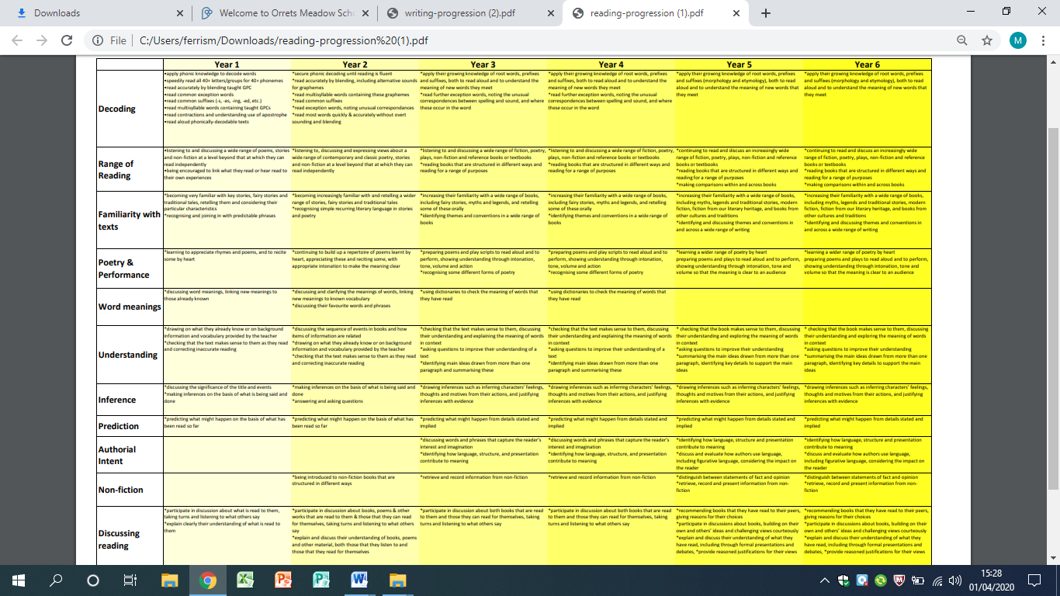

**Appendix 10: Progression of Writing**

