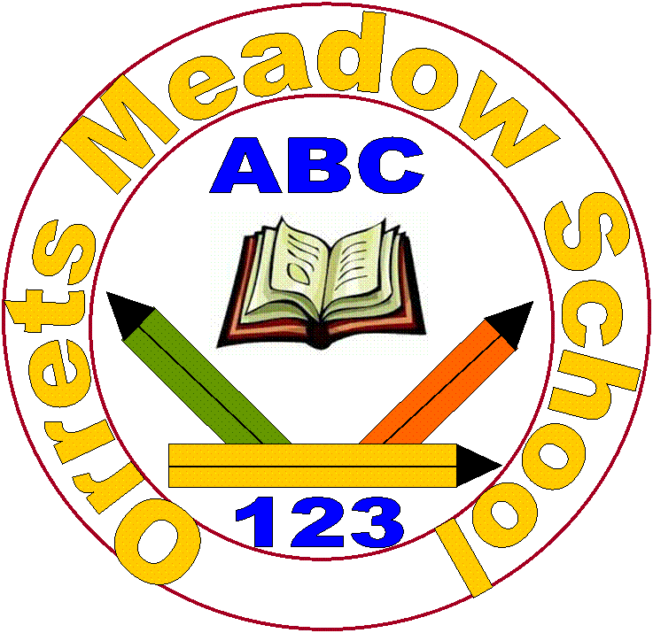

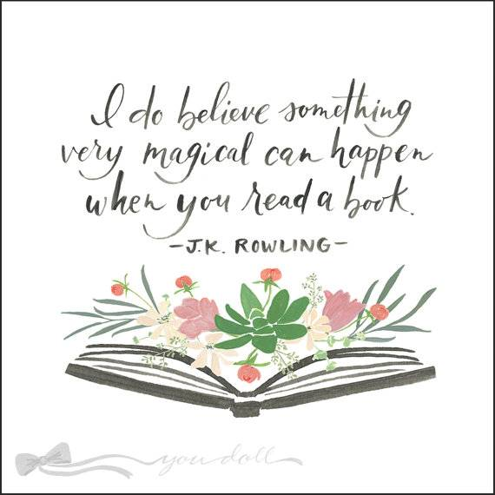Orrets Meadow School

Reading for Pleasure Policy

**“To raise the aspirations of every child and give them confidence to fulfil their potential through positive experiences”**

**Orrets Meadow Curriculum Aims and Values**

**Aims**

To ensure all our children are at the centre of a broad, varied and interesting learning experience that is enjoyable and relevant for the future. Our creative, multisensory curriculum will create a sense of awe and wonder and help to inspire a lifelong love of learning. The holistic nature of our practice will promote positive mental health and well-being and will enhance our children’s life skills, social skills and cultural awareness.

**Values**

Our curriculum will promote a range of values including:

* Respect
* Empathy
* Responsibility
* Equality
* Independence
* Happiness
* Resilience
* Gratitude
* Honesty
* Friendship

**Intent**

At Orrets Meadow School we want to not only equip pupils with the necessary skills to read and understand texts, but also to establish a lifelong love of reading. This Reading for Pleasure Policy is an addendum to the whole-school English Policy outlining our approach to promoting lifelong reading skills.

Aims

This Reading for Pleasure Policy aims to:

* 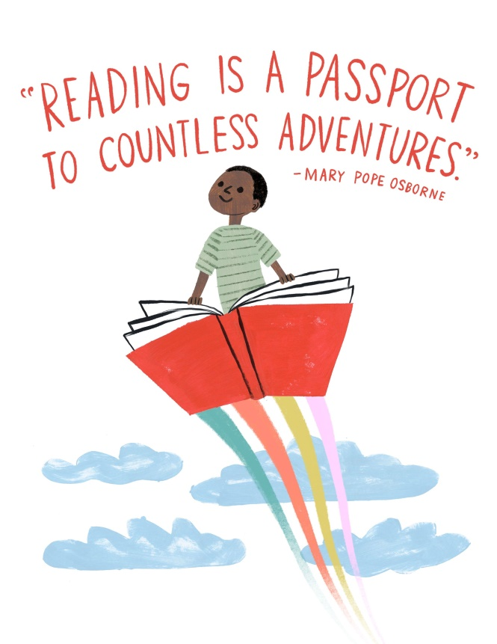Foster and instil a lifelong enjoyment for reading amongst the whole school community.
* Encourage independent and creative thinking.
* Enable pupils to reflect on stories and genres of stories that they enjoy.
* Promote shared enjoyment of reading.
* Develop an appreciation of different cultures and values.
* Develop a wider knowledge of the world.
* Create empathetic, caring and confident citizens.
* Foster relaxation and concentration.
* Enhance social, emotional and economic development.

Why is reading for pleasure important?

Much research has been conducted into the long term benefits of reading for pleasure for children. Research carried out by The Reading Agency found that there is;

* Strong evidence links reading for pleasure and improved educational outcomes.
* Evidence to show a correlation between reading for pleasure regularly and lower levels of stress, anxiety and depression.
* Links to a reduction in the risk of dementia, with frequent readers having lower incidence of dementia in later life.

In addition to the health benefits, reading for pleasure has social benefits and can improve our sense of connectedness to the wider community. Reading increases our understanding of our own identity, improves empathy and gives us an insight into the world view of others.

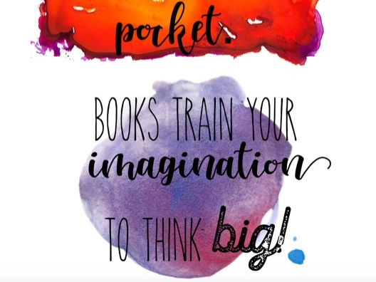

**Implementation**

Orrets Meadow Literacy Spine

Throughout our curriculum there is a range of texts that raise the exposure of pupils’ to texts that they may not be able to independently access. Our Literacy Spine (appendix 1) is broken into two categories for each year group; curriculum texts and class readers.

Curriculum texts link to the topics will be learning as part of their Global and English curriculum. The new long term English plan (revised 2020) ensures a breadth of author and a balance between classic and modern literature to be studied by children in English lessons. Many of these texts have been suggested in our Dimensions Global Curriculum, with others being suggested by teaching staff in order to ensure the correct pitch and story complexity for each class.

Class readers are books that teachers will share with their class in order to promote a love of reading. These stories are a combination of those suggested by Pie Corbett’s literacy spine as well as stories that staff enjoy and are enthusiastic to share with their classes. By teachers sharing stories that they enjoy pupils’ will be able to see first-hand how people can enjoy stories.

Bug Club

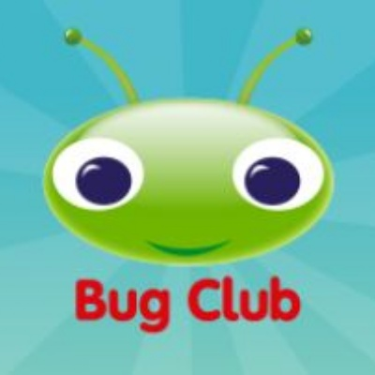The school has invested in an ICT based programme called Bug Club, which allows pupils to access a range of fiction and non-fiction books at their levels from home. This programme not only helps with word reading, but also comprehension through targeted questioning. Pupils can enjoy books and are rewarded with coins that they can use to play literacy games on the Bug Club website.

World Book Day Celebrations

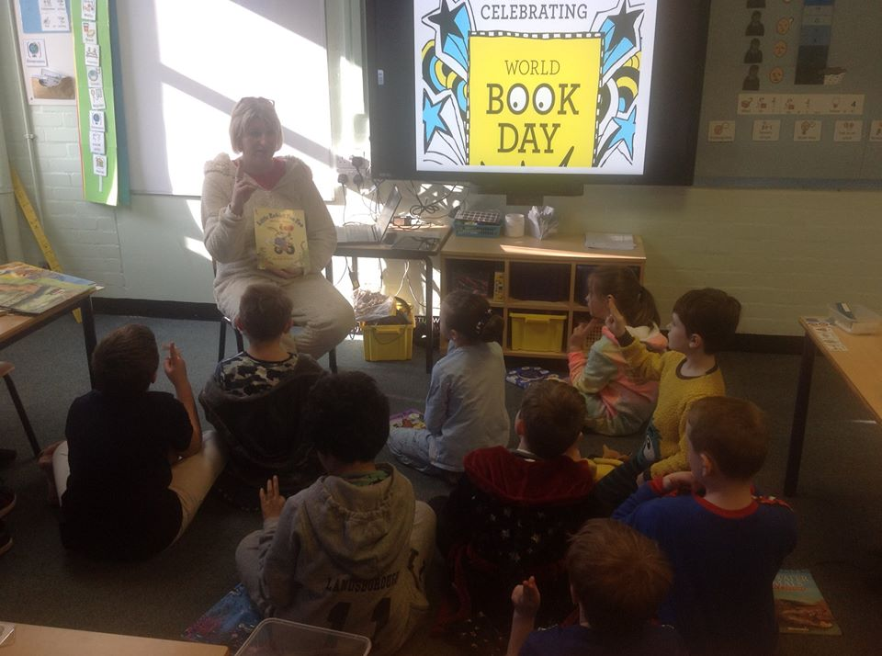The school takes part in the national world book day celebrations as this is a key opportunity for pupils to enhance their love of reading. During this day pupils and staff can share the stories that they enjoy with others. Famous Authors have visited the school, including Michaela Morgan and Natalie Davies, who have shared their stories and personal journeys with books.

Visits from Authors

When possible at Orrets meadow we get authors to visit the pupils. This could be local authors, nationally acclaimed authors, or other professionals who write for a living, e.g. reporters, etc. These visits not only let the children discover how their English skills could lead to a future career, but it also creates a positive discussion environment.

The School Library

Within Orrets Meadow we are privileged to have our own library. Pupils’ have access to the library throughout the year with class slots once a week. The books in the library reflect a wide range of both classic and modern literature. There are books for all of our learners in the library with varying degrees of challenge. The library is well organised to help pupils to discern fiction and non-fiction titles. There is a digital system in place in the library that allows for quick checking of authors works or individual book titles. All pupils are issued a library card which they can then use in order to check books in and out of the library.

Pennac’s Inviolable Rights of the Reader

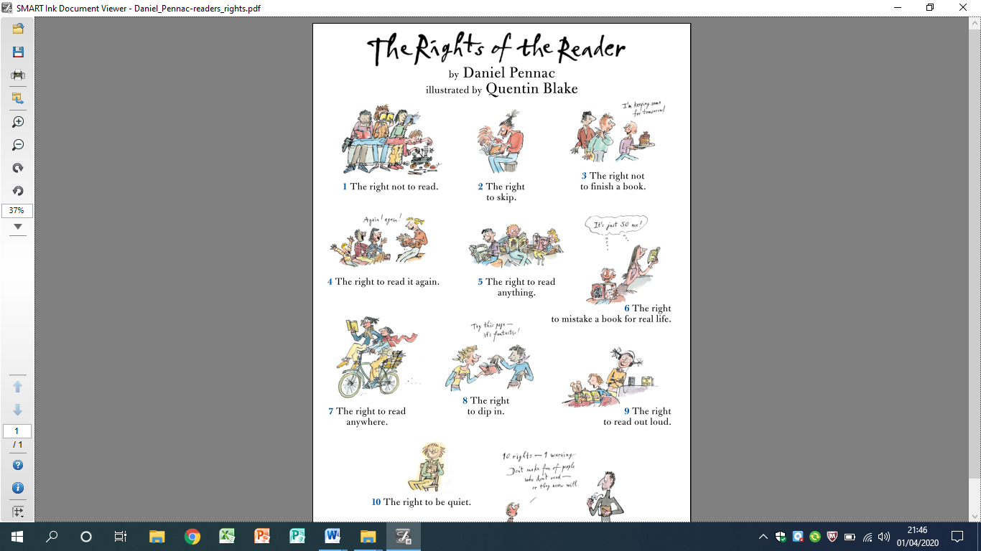Famous French author Daniel Pennac outlines that there are 10 ‘inviolable’ rights of the readers. These are shared with our pupils as they progress throughout the school and become more articulate in their choice of reading. These ten rights are as follows;

Whole Class Novels

As previously discussed there is a list of class readers for each year group throughout the school. These range in genre, length and composition in order to familiarise pupils with a range of authors as well as different genres of stories. Each day teachers lead a ten/fifteen minute class reading slot in order to share these stories and recap over the story so far in order to support recall and comprehension. Each class displays the book that they are currently reading on their classroom door in order to promote peer lead discussions about the books that are being read.

The Foxes are currently reading

[](#'Computing Option 2'!A1)

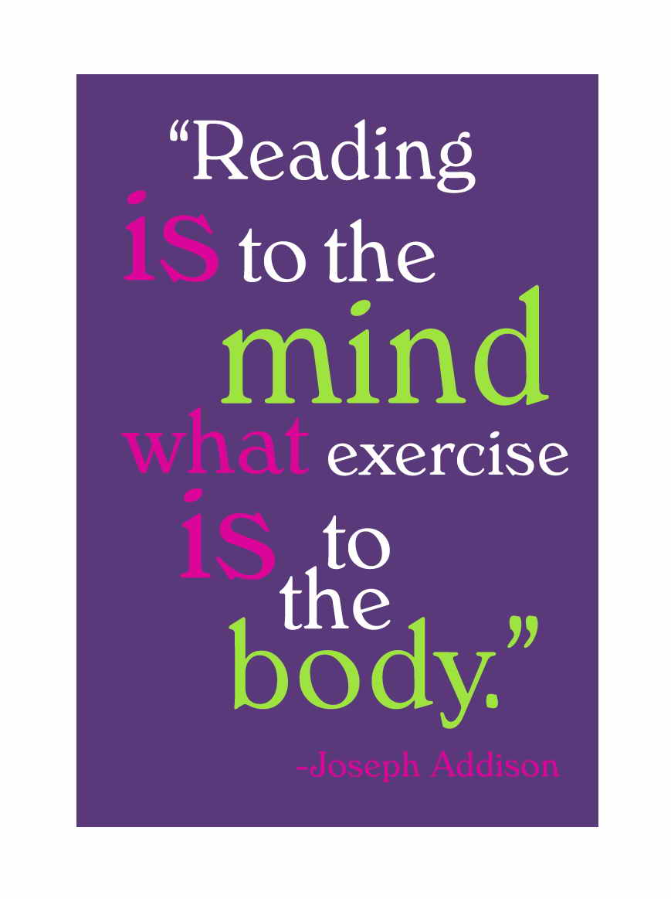

Other strategies to promote reading for pleasure within Orrets Meadow:

* Parents ‘Reading Workshop’
* TA reading updates
* Reading display in the school library
* Reading recommendations and book reviews.
* Pennac’s Inviolable Rights of the Reader

**Impact**

The impact of Reading for Pleasure will be measured by qualitative means. Pupils’ will be better equipped to discuss the stories and authors that they enjoy and give reasons for these. Through the whole class readers pupils will gain exposure to a range of authors which will inform the basis for pupils’ growing knowledge of the stories that interest them.

This will continue to be monitored throughout the year by ways of pupil and staff surveys as well as informal discussions with pupils from around the school. The impact on pupils’ should reflect the initial aims in this policy:

* 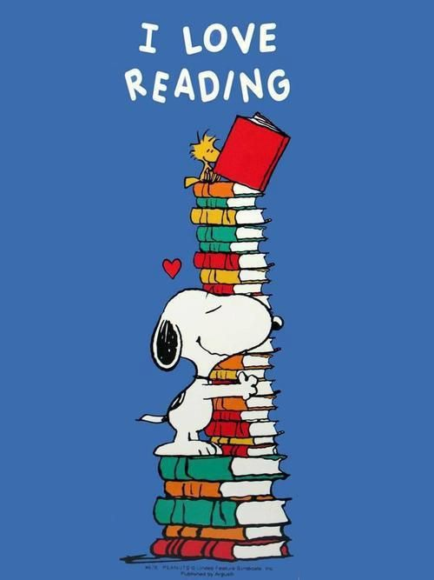Foster and instil a lifelong enjoyment for reading amongst the whole school community.
* Encourage independent and creative thinking.
* Enable pupils to reflect on stories and genres of stories that they enjoy.
* Promote shared enjoyment of reading.
* Develop an appreciation of different cultures and values.
* Develop a wider knowledge of the world.
* Create empathetic, caring and confident citizens.
* Foster relaxation and concentration.
* Enhance social, emotional and economic development.

**Appendix 1: Orrets Meadow Literacy Spine**

Explorers (Cycle A)

|  |  |
| --- | --- |
| **Curriculum Texts** | **Class Readers** |
| Funny Bones (Allan Ahleberg) | Where’s Spot? (Eric Hill) |
| Peace at Last (Jill Murphy) | Dear Zoo (Rod Campbell) |
| Farmer Duck (Martin Waddell) | You Choose (Pippa Goodhart & Nick Sharratt) |
| Barry the Fish with Fingers (Sue Hendra) | Brown Bear, Brown Bear, What Do You See? (Bill Martin Jnr. & Eric Carle) |
| Pirates Love Underpants (Claire Freedman & Ben Cort) | Jasper’s Beanstalk (Nick Butterworth & Mick Inkpen) |
| All Ears, All Eyes (Richard Jackson) | The Very Hungry Caterpillar (Eric Carle) |
| The Three Little Pigs | Hairy Maclary from Donaldson’s Diary (Lynley Dodd) |
| Can’t you Sleep Little Bear? (Martin Waddell) | Each Peach Pear Plum (A & J Ahlberg) |
| The Rainbow Fish (Marcus Pfister) | Hug (Jez Alborough) |
| Pete the Cat and the Treasure Map (James Dean) | The Train Ride (June Grebbin) |
| Ears, Eyes and Toes | Come on, Daisy! (Jane Simmons) |
| The Singing Mermaid (Julia Donaldson) |  |
| The Colour of Us (Karen Katz) |  |
| Perfect Pet (Margie Palatini) |  |
| Nugget and Fang (Tammi Sauer) |  |
| Goldilocks |  |
| We’re Going on a Bear Hunt (Michael Rosen) |  |
| I Forgot |  |
| Commotion in the Ocean (Giles Andreae) |  |
| How to Babysit a Grandma (Jean Reagan) |  |
| All Join In (Quentin Blake) |  |
| The Lonely Lobster (Beth Costanzo) |  |
| Dodo Ice Age |  |
| Mr Gumpy’s Motor Car (John Burningham) |  |
| The Train Ride (June Grebbin) |  |
| Captain Flinn and the Pirate Dinosaurs (Giles Andreae) |  |

Explorers (Cycle B)

|  |  |
| --- | --- |
| **Curriculum Texts** | **Class Readers** |
| Jack and the Beanstalk – Twinkl | Owl Babies (Martin Waddell) |
| I am Josephine and I am a living thing (Jan Thornhill and Jacqui Lee) | The Gruffalo (Julia Donaldson) |
| The Gingerbread Man - Twinkl | Handa’s Surprise (Eileen Browne) |
| Where’s my Teddy? (Jez Alborough) | Mr Gumpy’s Outing (John Burningham) |
| Pretty (Canizales) | Rosie’s Walk (Pat Hutchins) |
| Should I Share my Ice-cream? (Mo Willems) | Six Dinner Sid (Inga Moore) |
| Snow White – Twinkl | Mrs Armitage on Wheels (Quentin Blake) |
| The Rhyming Rabbit (Julia Donaldson) | On the Way Home (Jill Murphy) |
| The Smartest Giant in Town (Julia Donaldson) | Goodnight Moon (Margaret Wise Brown) |
| All About India (Shalu Sharma) | Shhh! (Sally Grindley) |
| Superworm (Julia Donaldson) |  |
| Cinderella - Twinkl |  |
| Mr Small (Roger Hargreaves) |  |
| Diwali Holidays Around the World (Lisa J Amstutz) |  |
| Old Bear (Jane Hissey) |  |
| The New Baby (Anna Civardi) |  |
| How the Camel got his Hump (Rudyard Kipling) |  |
| Whatever Next (Jill Murphy) |  |
| Zoom Rocket Zoom (Margaret Mays) |  |
| Alien’s Love Underpants (Claire Freedman) |  |
| Welcome to Alien School (Caryl Hart) |  |
| Star in the Jar (SamHay) |  |
| Kipper’s Snowy Day (Mick Inkpen) |  |
| Sun and Moon (Lindsey Yankey) |  |
| The Wizard of Oz (Joshua George) |  |

Pathfinders (Cycle A)

|  |  |
| --- | --- |
| **Curriculum Texts** | **Class Readers** |
| The Ugly Duckling (Lynne Bradbury)/ Twinkl | The Elephant and the Bad Boy (Elfrida Vipont & Raymond Briggs) |
| Little Red Riding Hood - Twinkl | Avocado Baby (John Burningham) |
| Cinderella - Twinkl | The Tiger Who Came to Tea (Judith Kerr) |
| The Three Little Pigs - Twinkl | Lost and Found (Oliver Jeffers) |
| Where the Wild Things Are (Maurice Sendak) | Knuffle Bunny (Mo Willems) |
| The Polar Bear Son – An Inuit Tale (Lydia Dabcovich) | Beegu (Alexis Deacon) |
| We’re Going on a Bear Hunt (Michael Rosen) | Cops and Robbers (A & J Ahlberg) |
| Not Now Bernard (David McKee) | Elmer (David Mckee) |
| Man on the Moon (Simon Bartram) | The Twits (Roald Dahl) |
| The Garden (Dyan Sheldon) | The Water Horse (Dick-King Smith) |
| Dogger (Shirley Hughes) | Blob (David Walliams) |
| The Zoo (Anthony Browne) |  |
| Little Beauty (Anthony Browne) |  |
|  |  |

Pathfinders (Cycle B)

|  |  |
| --- | --- |
| **Curriculum Texts** | **Class Readers** |
| The Owl Who Was Afraid of the Dark (Jill Tomlinson) | Meerkat Mail (Emily Gravett) |
| Traction Man is Here (Mini Grey) | Amazing Grace (Mary Hoffman) |
| Dino Danger (Mortimer Keene) | Pumpkin Soup (Helen Cooper) |
| The Lighthouse Keeper’s Lunch (Ronda and David Armitage) | Who’s Afraid of the Big Bad Book? (Lauren Child) |
| The Runaway Iceberg (Twinkl) | Dr Xargle’s Book of Earthlets (Tony Ross) |
| The Snail and the Whale (Julia Donaldson) | Tuesday (David Wiesner) |
| The Secret of Spiggy Holes (Enid Blyton) | The Flower (John Light) |
| Jake’s First Day - Twinkl | Gorilla (Anthony Browne) |
|  | Emily Brown and The Thing (Cressida Crowell) |
|  | Frog and Toad Together (Arnold Lobel) |
|  | The Giraffe, the Pelly and Me (Roald Dahl) |
|  | Fantastic Mr Fox (Roald Dahl) |
|  | The Hodgeheg (Dick King-Smith) |
|  | Flat Stanley (Jeff Brown) |
|  | Willa and old Miss Annie (Berlie Doherty) |
|  |  |

Adventurers (Cycle A)

|  |  |
| --- | --- |
| **Curriculum Texts** | **Class Readers** |
| Greek Myths (Marcia Williams) | The Iron Man (Ted Hughes) |
| The Orchard Book of Greek Myths (Geraldine McCaughrean) | Cat Tales: Ice Cat (Linda Newberry) |
| Nessie, the Loch Ness Monster (Richard Brassey) | The Sheep-pig (Dick King-Smith) |
| Loch Ness Monster (James Carney) | The Abominables (Eva Ibbotson) |
| Firework Maker’s Daughter (Phillip Pullman) | The Battle of Bubble and Squeak (Philippa Pearce) |
| The Chronicles of Harris Burdick (Chris Van Allsburg) | The Diary of a Killer Cat (Anne Fine) |
|  | How to Train your Dragon (Cressida Cowell) |
|  | Charlie and the Chocolate Factory (Roald Dahl) |
|  | The Secret Seven (Enid Blyton) |
|  | The Invisible (Tom Percival) |
|  | The Lost Homework (Richard O’Neill) |

Adventurers (Cycle B)

|  |  |
| --- | --- |
| **Curriculum Texts** | **Class Readers** |
| Hansel and Gretel (Anthony Browne) | Bill’s New Frock (Anne Fine) |
| Little Red Riding Hood/Rapunzel (Bethan Woollvin) | Charlotte’s Web (EB White) |
| Cinderfella (Malachy Doyle and Matt Hunt) | Why the Whales Came (Michael Morpurgo) |
| The Great Kapok Tree (Lynne Cherry) | The Snow Walker’s Son (Catherine Fisher) |
| The Vanishing Rainforest (Richard Platt) | Perry Angel’s Suitcase (Glenda Millard) |
| Tales From Africa (Kathleen Arnott) | Voices in the Park (Anthony Browne) |
| African Tales: A Barefoot Collection (Gcina Mhlophe) | The Forgettery (Rachel Ip) |
| Journey to Jo’burg (Beverly Naidoo) | Kensuke’s Kingdom (Michael Morpurgo) |
| The Suitcase Kid (Jaqueline Wilson) | Gangsta Granny (David Walliams) |
| The Lion, The Witch and The Wardrobe (C.S. Lewis) | The Enchanted Wood (Enid Blyton) |
| The Secret World of Polly Flint (Helen Cresswell) | The Famous Five (Enid Blyton) |
| Anna and the Land of Clocks | It’s a No-Money Day (Kate Milner) |
| Leon and the Place Between (Grahame Baker-Smith) |  |