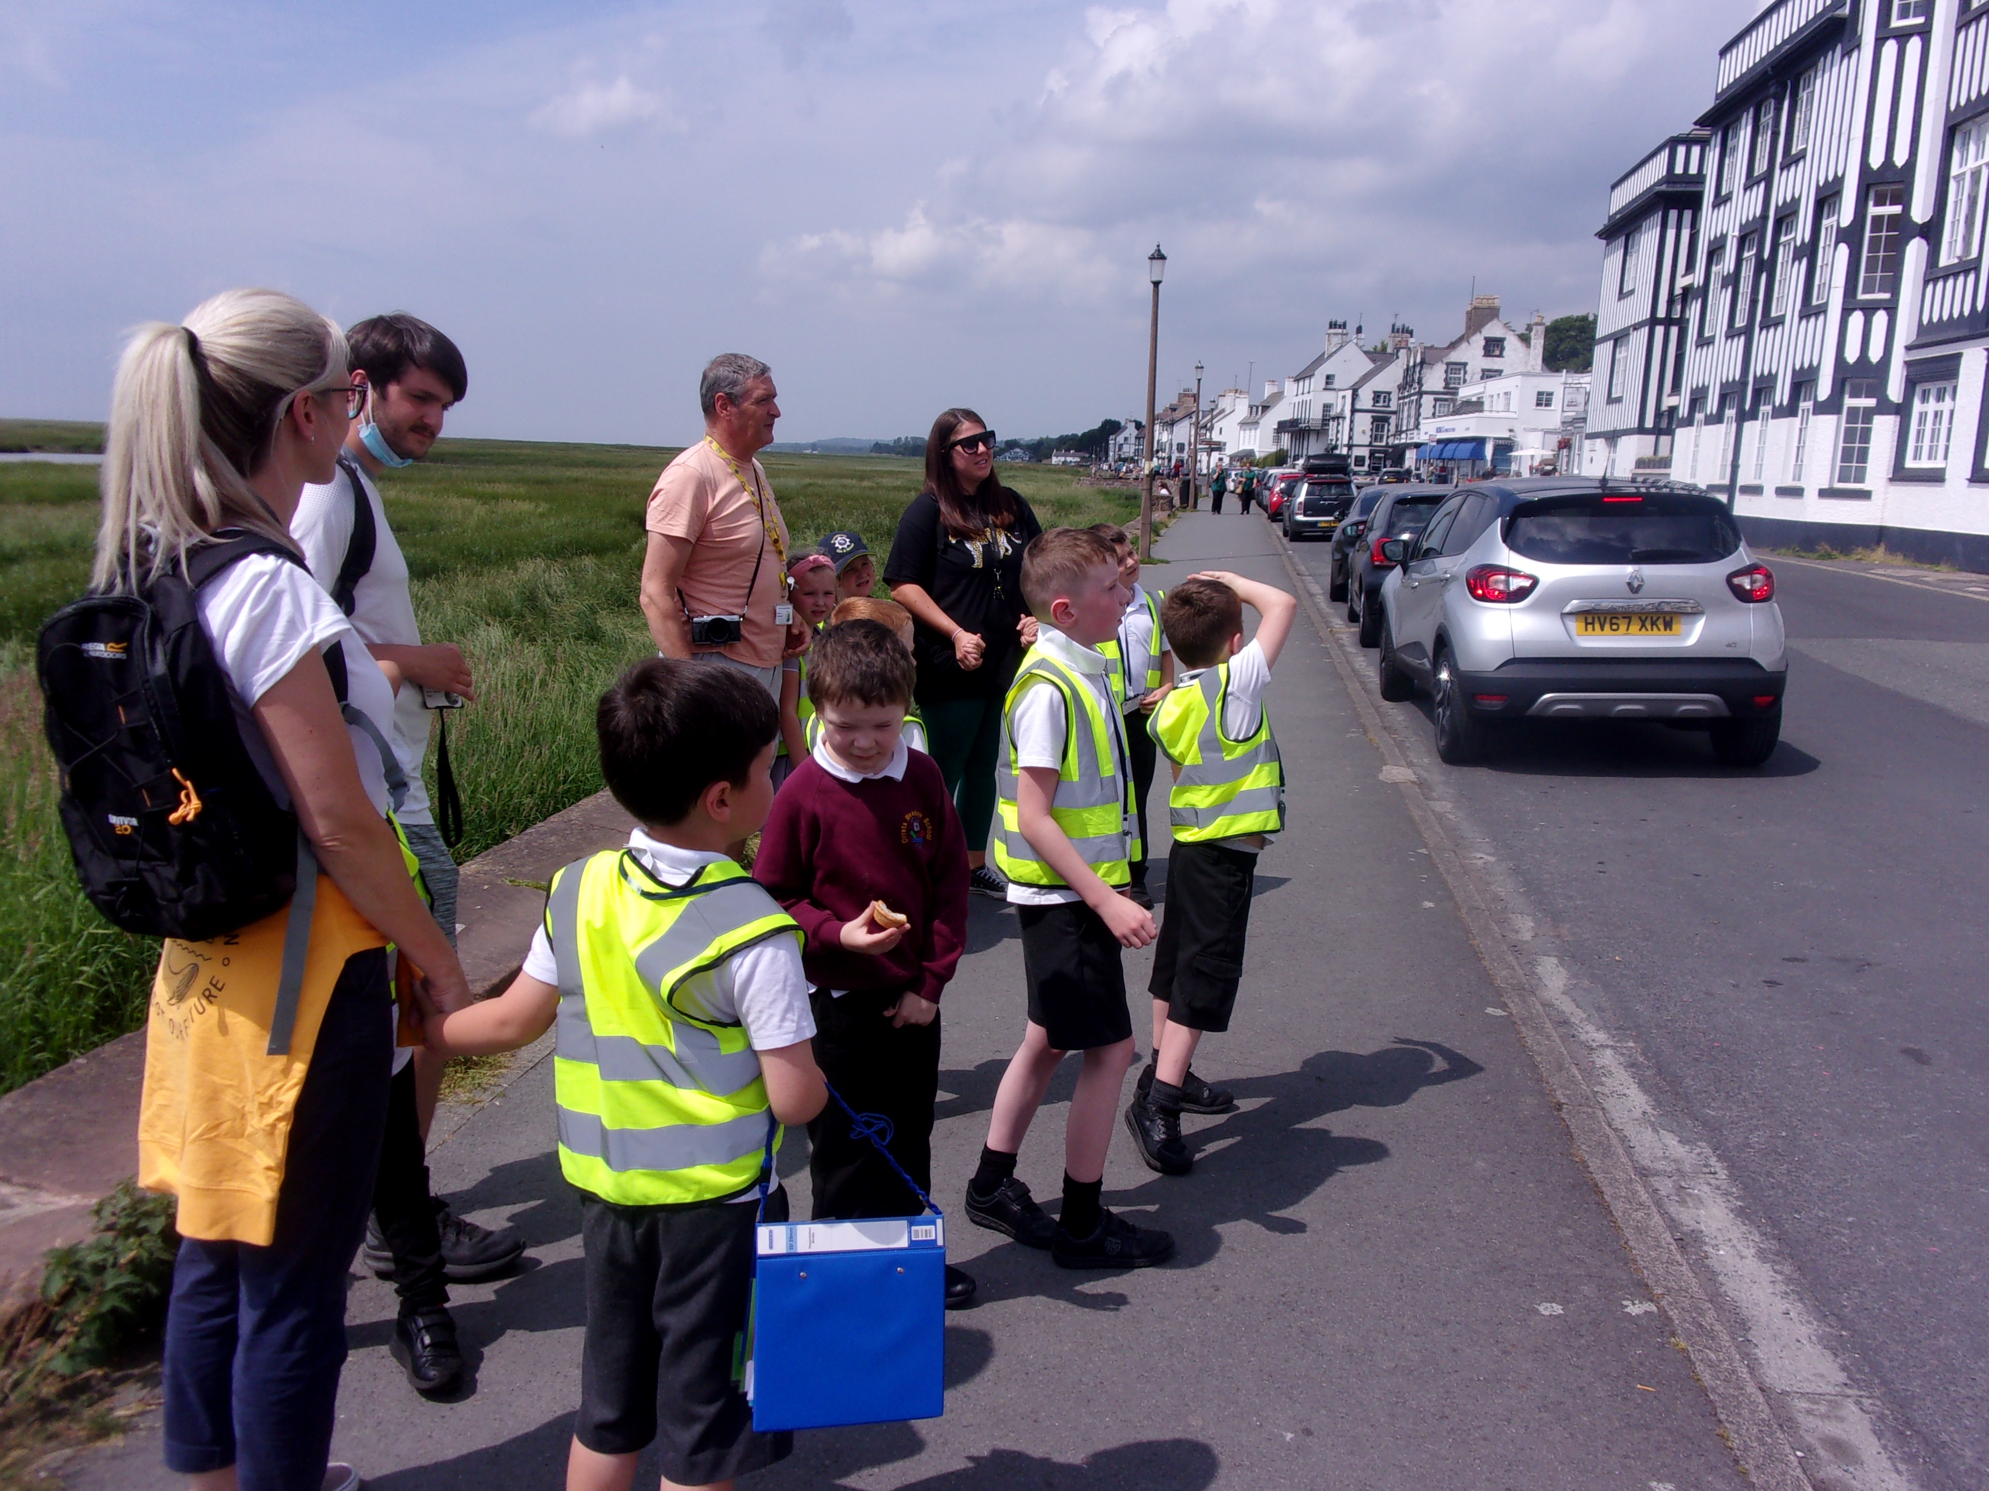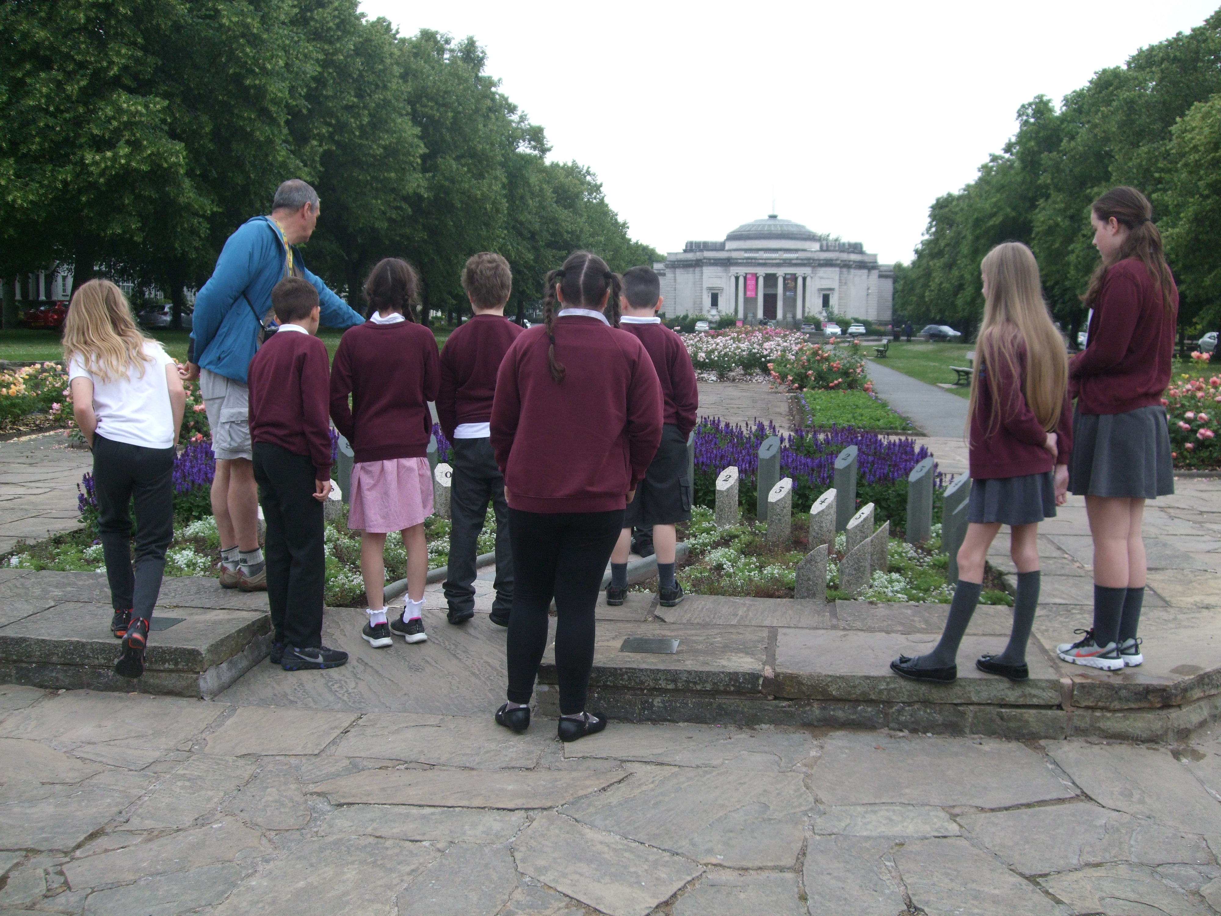
Governors Report – Summer 2021
History
Mr Eóin M Campbell

Achievements
Despite the interference of the Covid pandemic, school continued with our new Dimensions curriculum which presents History in a more holistic, blended fashion. The themes delivered across the school have been wide and varied and all have opportunities to explore Historical content and in many cases, subject matter that would not normally be broached. Although Dimension appears to be more Geography weighted, there is still much in its content and plenty of scope which is History heavy.
Orrets pupils have traditionally enjoyed History as a subject and yet, given the major change from autonomous, stand-alone subject delivery in this subject in afternoon Topic sessions, this popularity of History has not diminished. Teaching staff and Teaching Assistants have indicated that they continue to enjoy preparing and presenting History sessions and find pupils continue to be enthusiastically engaged.
Samples from surveys and subject analysis data demonstrate that the level of achievement in History in our school continue to be very encouraging.

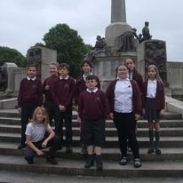
CPD
I have been fortunate to have been offered a number of courses, originally group sessions in various locations over the Mersey and since the advent of this terrible pandemic, I’ve been able to continue SL (Subject Leader) courses via Zoom and other social/digital portals.
Although the last Zoom course was largely geared towards a recovery curriculum, I still managed to extract many ideas and initiatives to help me plan for ways forward for History at Orrets.

Quality of teaching & learning
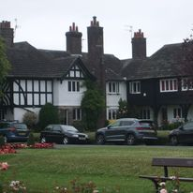
It’s abundantly clear that we have gifted, enthusiastic, resourceful and highly motivating teachers and teaching assistants at Orrets, during peer observations and book scrutiny. History is popular with our students precisely because the subject is delivered in an innovative and enthusiastic fashion. Pupils feel fully supported, they know what to do when they become stuck. They are challenged to an appropriate level for their ability. Differentiation is a key part of lesson planning and delivery and each classes’ team of staff are distributed well to provide for their group. Consequently, pupils make steady, measured progress with regard to NC levels of attainment. What must also be factored in is that students are working below their chronological age and yet OFSTED recognised that progress made by pupils from the time of their entry is ‘nothing more than staggering’. Students expressed an interest in sharing their new knowledge. They are keen debaters, enjoy acting out historical events and exploring the ‘what if’ scenarios in given epochs.
I have had the pleasure of peer observing colleagues and experienced first-hand the multifaceted array of skills, expertise and resources. Staff are immensely resourceful and imaginative which all adds up to the enrichment of lessons.

Reviews and survey samples
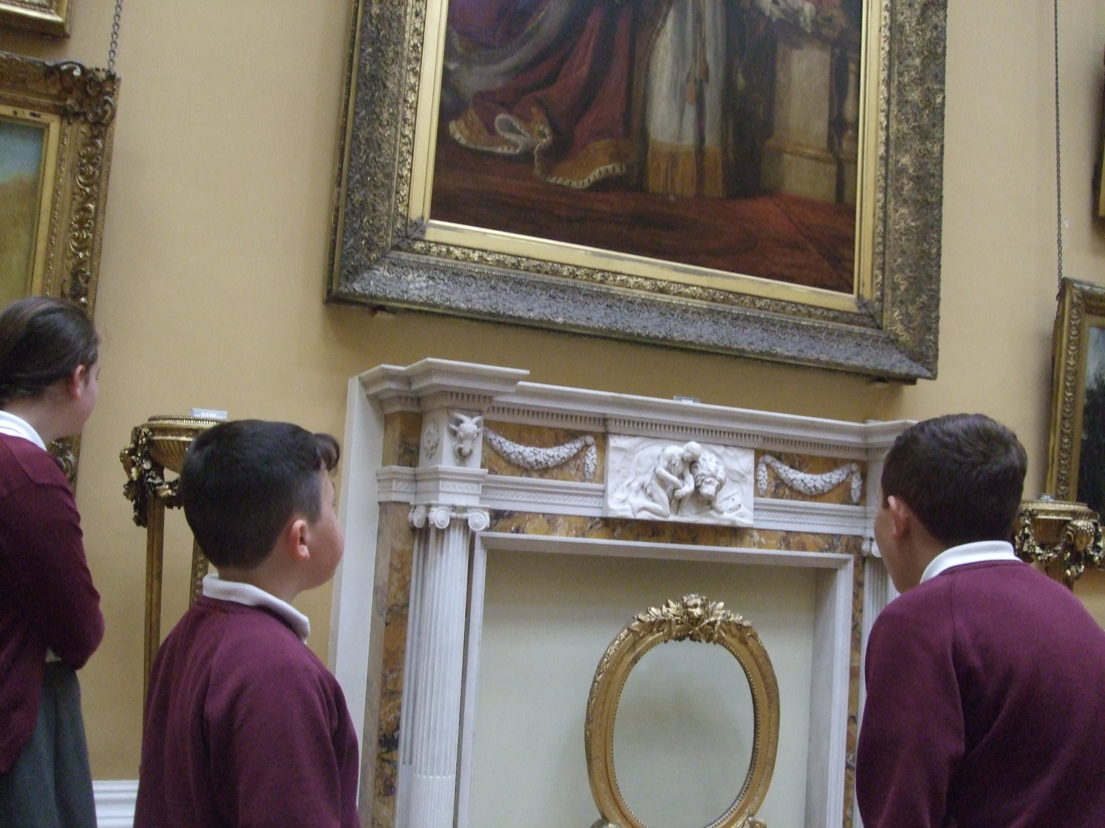
History has a very high standing at Orrets and this notion is confirmed through discussion with colleagues, staff and pupil voice survey samples and staff meetings. There is also the perception that the new Dimensions curriculum we have embarked on is more Geography weighted than it is in terms of History. History and Geography are intrinsically linked and on studying the global Dimensions themes and coverage it becomes clear that this perceived disparity is balanced out over the course of these themes. As previously stated, there is plenty of scope to inject historical content in any themes, even when there is none specifically prescribed in the theme’s schedule. Pupils enjoy practical, hands-on sessions, trips linked with our ‘cultural capital’ and seeing actual sites of historical value. We are well resourced and there were a number of positive, proactive suggestions for ways to improve our inventory of stock. It also emerged that students are more likely to return home and discuss or relay the subject material they have learned from that day’s session.
Staff found the new Dimensions Trackzone assessment tool quite straightforward and useful in recording skill progression. Even at the lower end of the attainment scale, students can still be seen to achieve well and make steady progress.

Strengths in Geography
On sampling staff on their perceived strengths in teaching, Geography factored high in both subject knowledge and enjoyment. From my observations and indeed the progress made by our student population, this is evidently the case. Teaching staff are enthusiastic about researching newer material to complement their base knowledge on given topics and many expressed great energy in doing so. Resourcefulness in providing opportunities for drama, computing, fieldwork, trips, multisensory provision to supplement their delivery are ever-present and the is a wealth of evidence in our students’ books and in both photographic and video format kept securely on the school’s bank.

Ways forward
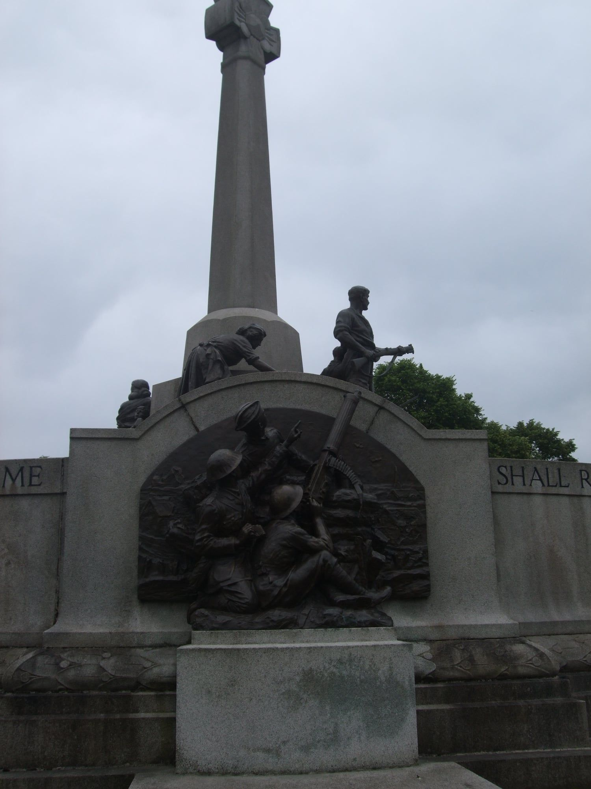
As History lead, I intend reviewing the school’s History inventory. We are limited by space more than most other schools and this is therefore a premium. I’m conscious that we have specific resources that are no longer required and will most likely never be required again, so a ‘cull’ is in order.
I intend continuing my own CPD and CD has already enrolled me on further courses in the Autumn and Spring terms for next academic year.
On examining the ‘Ways forward’ section above, since the survey some of these proposals have already been addressed/implemented. We have sessions, sporadically throughout the year in order to provide teaching staff the opportunity to revise, cover or fill gaps they perceive to be necessary.
It is intended that an inventory be produced which will classify certain websites for specific types of lesson presentation. The Historical Society and the BBC’s own History sites are good starting points and are two aimed at the adults and students alike. I intend to seek sites which provide more online, interactive resources.
Trips have been very difficult due to Covid, yet school still managed to visit Tam O’Shanter, Parkgate, West Kirby, Hoylake and Birkenhead Park. These trips hit both History and Geography curriculum areas and we are spoiled for choice here on the Wirral.
Finally, staff expressed they would like ‘awe and wonder’ boxes for both History and Geography. These would be furnished with specific objects for specific themes. Given the wide variety of themes and the entire globe being researched over the time a student may be at Orrets, this would prove to be an on-going way forward.

Targets for 2021-2022
- Revision of our History artefact boxes (linked to themes) – Spring 2022
- Promote greater use multisensory resources in a staff meeting, including history computer programs – 24th November 2021
- More ‘real-life’ resources – awe and wonder boxes – staff meeting - 9/3/2022
- More historical fieldwork trips (cultural capital)
- More regular collaboration & sharing of resources
- Reviewing the classroom timeline charts – staff meeting – 9/3/2022

