1st December 2021
Dear Parent and Carers

We are in the final weeks of term before we break up for Christmas and I can’t believe how quick the time has passed. The children are beginning to get excited for Christmas which is a lovely thing.

Please can you make sure you check your emails daily as this is the quickest way I can communicate with you. I also post important messages on Facebook.

Unfortunately, Covid is still around and last week we had several positive cases across 3 classes. All close contacts were sent letters advising them to get a PCR test. The rules state that children can continue to attend school while they wait for their results so long as they do not have symptoms.

Please continue to support us by monitoring your child carefully and if you suspect they are not well, keep them off school until they are well again and if they show Covid symptoms get them tested. Children will get sore throats, sneezes, runny noses and colds at this time of year. We can give Calpol if you send it in and sign the form, however we are unable to give Ibuprofen.

The Government has stated that masks must be worn in schools by staff unless exempt. Therefore, if parents need to enter the building they must wear a mask going forward.

Christmas Assembly
Due to rising Covid numbers, schools have been advised not to have events in schools, so unfortunately this means parents will not be able to attend the end of term assembly. We will record the children who are chosen to receive a cup or certificate and I will send the link out to you via email. It is a shame as we were hoping we would be back to normal!

Christmas Dinner
Letters have been sent home outlining the Christmas dinner menu. If your child would like a Christmas dinner simply let the office know and send in £2.30. If you are entitled to free school meals then you will automatically be offered one if you normally have a school dinner. Christmas dinner will take place on Wednesday 15th December.

Christmas Secret Auction and Raffle tickets for Christmas Hamper
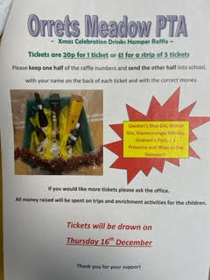
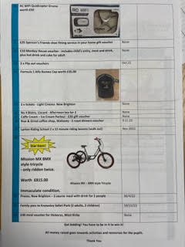
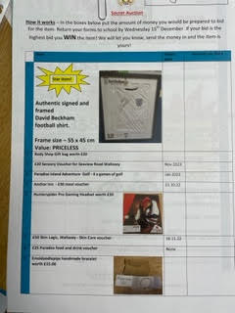
Letters for the secret auction have gone home. Simply bid on an item and if you are the highest bidder we will be in touch in the last week for payment and the item is yours! Ask family and friends do they want to bid on items too! There are lots of items including a framed, signed David Beckham top, a drone and a tricycle. There are also lots of vouchers for meals and day trips. Get bidding and win some lovely prizes. All money raised goes towards the pupils and experiences for them.

Raffle tickets are also going home for our Christmas drinks hamper. Each strip of 5 tickets is £1. You keep one half of the strip and send back to us the other half and we will draw the winner in the last week and share the video on Facebook of it being drawn.

Amazon Christmas Wish List
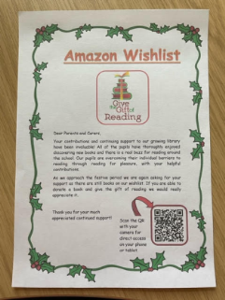
We have had an amazing response to our reading book wish list on Amazon, but we still have lots of books we need to complete our library. Letters were sent home and if you can support us by buying a book from the wish list then add a message and we will stick it in the inside cover. You can choose to have the book delivered straight to school. Thank you everyone who has already bought us a book.

Christmas Jumper Day
On Friday 10th December we are having a Christmas Jumper Day in return for £1 for Save the Children. If your child does not have a Christmas jumper then they can come to school in non-uniform.

Secret Visit
In the last week we have a special visitor coming to school to deliver a present to each child off school. Please keep it a secret from them. Father Christmas will keep socially distanced from them and they will visit him a class at a time in the hall.

Final Day of term – Friday 17th December 1.30pm
Children may wear non uniform. School closes for Christmas on Friday 17th December at 1.30pm. The children will eat lunch before setting off home on transport as usual. Parents who usually pick up are requested to do so at 1.30pm.

School opens on WEDNESDAY 5th January and transport will pick up as usual.

Dates for the diary

Mon 6th Dec Science Week – Whole School
Thurs 9th Dec Michelle’s Coffee Morning – on Zoom
Fri 10th Dec Christmas Jumper Day - £1
Jinny Morgan - author visit
Mon 13th Dec Christmas around the World Week – Whole school
Vicar joining us for a Christmas assembly on Zoom
Wed 15th Dec Christmas Dinner
Wed 15th Dec Parent coffee meeting with Michelle 10am – could be on Zoom
Thurs 16th Dec Our special visitor!
Fri 17th Dec Non uniform day - School finishes at 1.30pm, after lunch
Data reports to parents with progress made this term.

Wednesday 5th Jan School opens for Spring Term

Please look at our school website at http://orrets-meadow.eschools.co.uk for other information on school.

Please follow us on Facebook by searching for Orrets Meadow

Thanks for all your support.
If you have any questions about any of the above, please contact me.

Mrs Duncan

