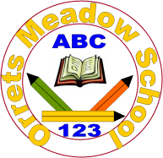
Governors Report – Summer 2022
History
Mr Eóin M Campbell

Achievements
At last, we have experienced a full academic year delivering Dimensions Curriculum in the History field of study. The last year was punctuated with tail-end lockdowns as a consequence of the Covid pandemic. It has permitted groups to really get ‘stuck in’ to the themes scheduled throughout the year and the holistic nature of Dimensions, far from presenting a barrier or hindrance to subject specialist input, indeed opens many more doors to providing a healthy, balanced and holistic educational experience for Orrets pupils.
History, as in last year’s report, remains a very popular aspect of Topic at our school. Staff have become adept at isolating historical exposure in lessons and content is marked out by labels to provide both students and adult viewers a clear indicator within their exercise books. It must be said that teaching and support staff enjoy the history content in our Dimensions themes and although there may be gap windows in specific historical content, over the academic year, this is being bridged. Furthermore, staff take any and all opportunities to relate cross curricular links, when the occasions arise. The evidence of the success of this approach bears fruit when one examines this teacher assessment scores in this school year.
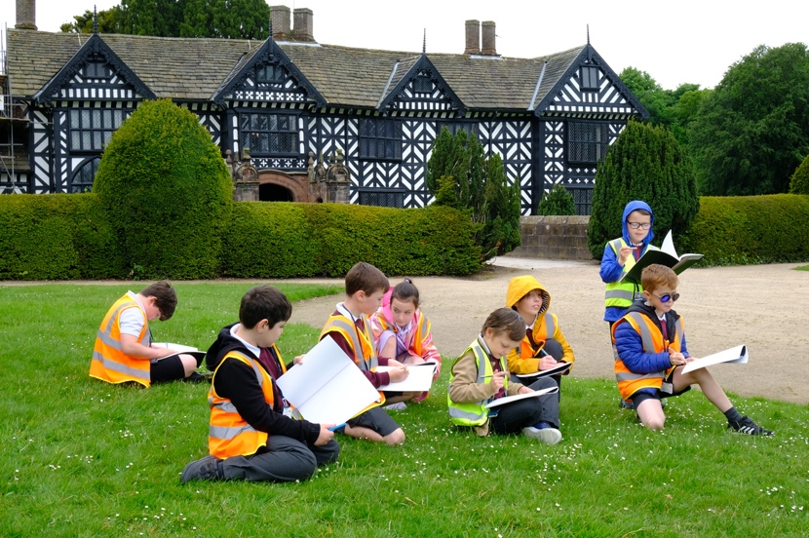 | 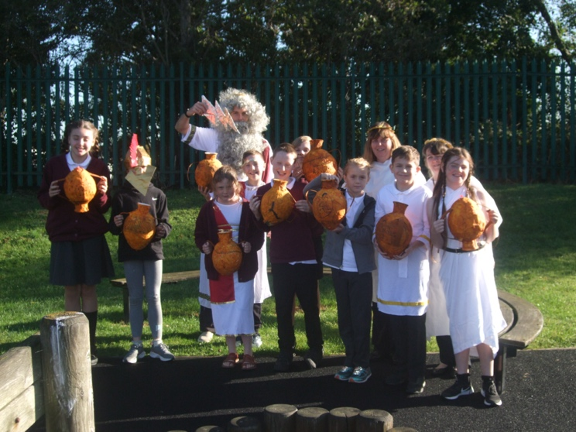

CPD
This year has seen me attend more professional Zoom meetings in the History field. It would appear that this is becoming the norm, nowadays as it involves less time away from school/class and is ultimately convenient, negating the need to travel to Liverpool. I’m now able to attend between two and three courses per academic year and I have the opportunity to discuss issues or topics and pose questions to my subject coordinator either while online or post presentation. The courses are very useful in keeping me up-to-date with policy, practice and resource shares with fellow practitioners.

Quality of teaching & learning
This year’s peer observations and book scrutinies have again demonstrated that we have gifted, enthusiastic, resourceful and highly motivating teachers and teaching assistants at Orrets. History is becoming more popular with our students precisely because the subject is delivered in an innovative and enthusiastic fashion. Pupils feel fully supported, they know what to do when they ‘hit a brick wall’ and are challenged to an appropriate level for their ability. Adaptation is a key part of lesson planning and delivery and each classes’ team of staff are distributed well to provide for their group. Consequently, pupils make steady, measured progress with regard to NC levels of attainment. Students expressed an interest in sharing their new knowledge.
I have been able to attend peer observations with the following colleagues; Mrs Fleming, Ms O’Brien, Ms MacGregor, Mrs Walsh and Mr Saul and experienced first-hand the variety of skills, expertise and resources in the inventory of our staff. Orrets’ staff continue to provide immensely resourceful and imaginative sessions which help to enrich a subject which is already a firm favourite among students.
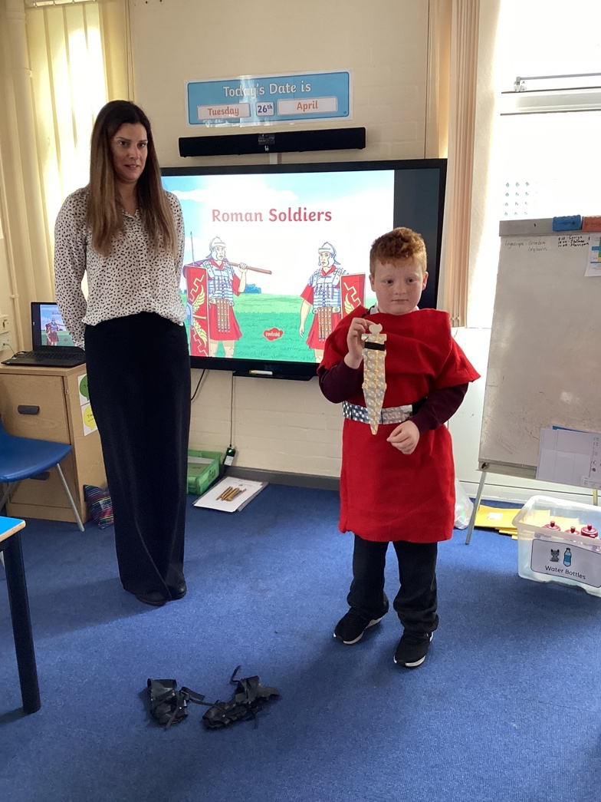 | 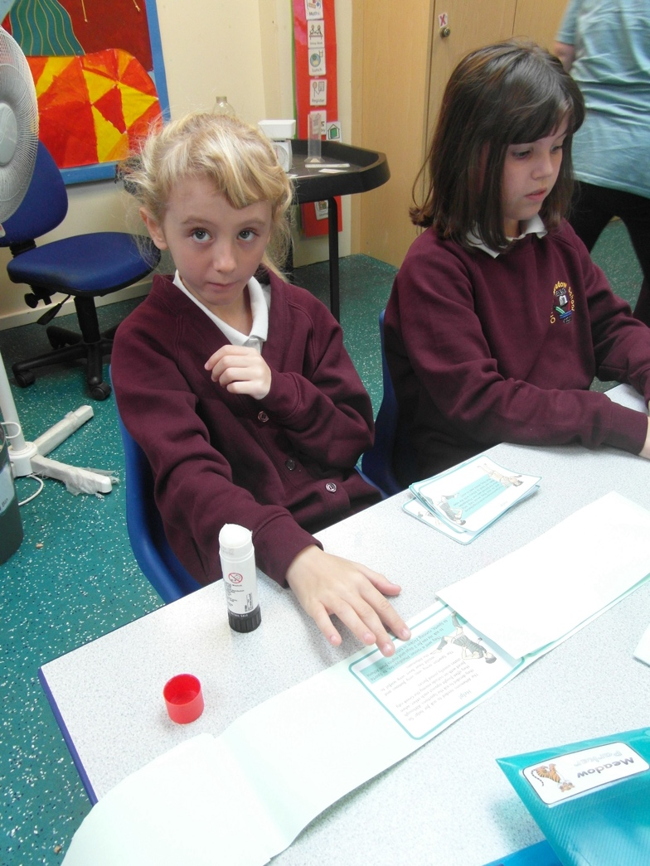

Reviews and survey samples
History continues to be a very popular subject domain for students at Orrets Meadow. This is evidenced through both pupil and staff voices and surveys. Given that we’ve had a full year to deliver the whole Dimensions Curriculum to our pupils, the balance between the ‘sister’ subjects of History and Geography appears to have levelled out. As stated in last year’s report, History is intrinsically linked to Geography and visa-versa, therefore practical sessions and ‘cultural capital’ trips permit the cross-linking of the two domains. This is a notion that is shared and indeed endorsed by colleagues. Colleagues take every opportunity to incorporate knowledge and skills related to History whenever the occasion allows as I’ve witnessed in my peer observations over the past academic year.

History artefact boxes have been reviewed and linked to themes wherever appropriate and colleagues are employing these in a more multisensory manner. Given that themes do not tend to adhere to a traditional, autonomous subject perception, staff now are more reliant on their own personal resourcing. The more ‘real life’ props and resources have been almost entirely focused on fulfilling our cultural capital pledges. More trips are planned for this summer term to National Trust venues around the region. Sites such as Speke Hall, Chirk Castle and Styal Mill are on the agenda and although these may initially appear not to link directly into our Dimensions themes, they are easily spliced with Historical and even Geographical knowledge content and skills. This provides us with an extra opportunity to plug any knowledge and skills gaps, should this be required. Furthermore, cultural capital experiences are wholly cross curricular and fully engaging for our pupils.

Strengths in History
Orrets’ staff continue to enjoy the delivery of Dimensions lessons in the History field. The enthusiasm demonstrated by colleagues while teaching historical content can never be overstated. From epochs such as The Great Fire of London to the tenacity and bravery of Rosa Parks non-aggressive fight against racial prejudice, the noticeable interest in our student population and the motivation and hunger to learn more; to pose questions and enquire as to ‘what, where, when, why, how’ is palpable and for us as educators, thoroughly rewarding! Provision, creation and imagination in resourcing our History content has always been a high priority with colleagues, too. It should be noted that Orrets has a population of educational staff with a disparate array of experience and even former professional careers which allow for even greater enrichment of lessons. This provides greater experience in content as regards discussion and debate and our pupils are highly adept at probing for more detail and clarity in History sessions.
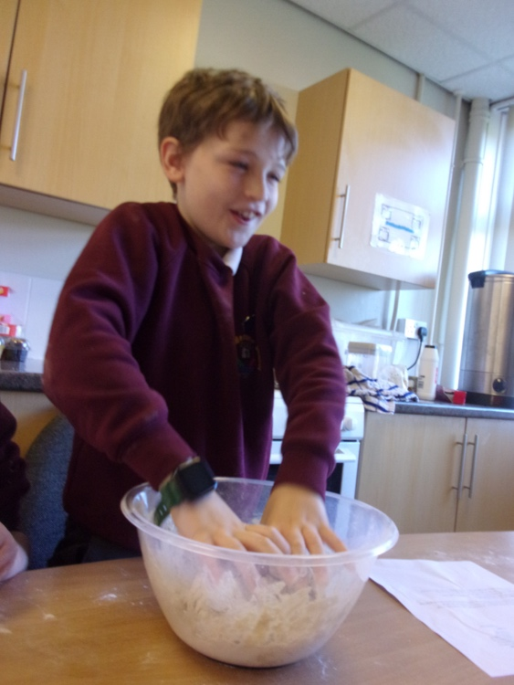 | 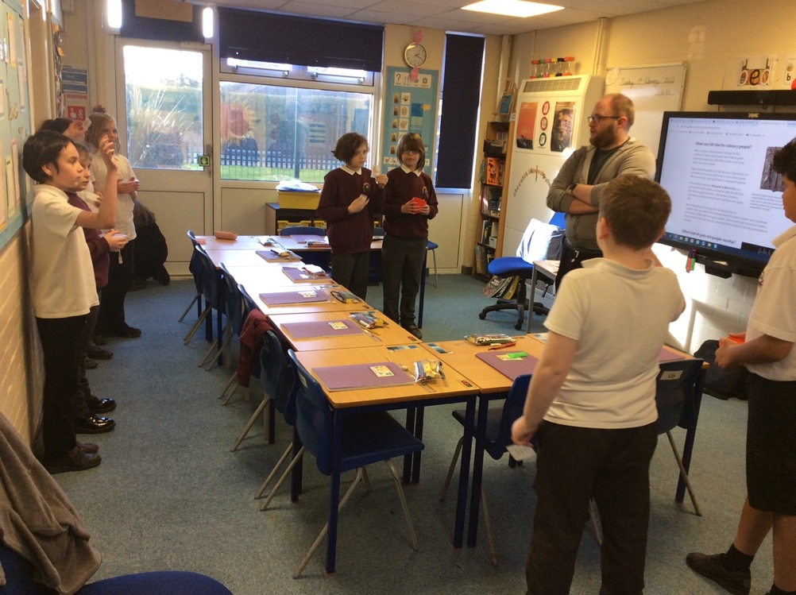

Ways forward
The staff survey samples provided a healthy, productive insight into how the teaching team understood they could move forward in Geography.

Given the large and varied number of resources we have amassed at Orrets, I intend continuing my revision and in some cases cull of useful and no longer relevant material. Space has always been a deciding factor for resources in all areas of the curriculum and the school, in physical terms. Online sites have seen more use by colleagues both for classroom intervention or delivery and simply for resourcing. The Dimensions site has plenty of support but the opportunities for stretching pupils’ engagement and knowledge is augmented greatly when sites are utilised to supplement the proscribed content in our Dimensions Curriculum schemes of work and plans. This not only increases the likelihood of enriching ‘sticky knowledge’ but furthermore gives more autonomy to the learners.

As previously mentioned, it is intended that school trips become a more regular staple in our pupils’ educational diet. With the production of educational packs for various venues added to the more traditional Wonders of Wirral locations such as West Kirby, Birkenhead Park & Docks, Port Sunlight etc. Orrets’ pupils will finish each subsequent academic year with the anticipated skills and knowledge and an equally important catalogue of memories that will remain and even enrich their interest in History, post school.

Targets for 2022-2023
- Encourage greater use of National Trust membership with a Historical focus (Autumn & Summer)
- Produce ‘education packs’ for cultural capital venues (Spring 2)
- Continue to improve and promote use of online History resources (Spring 1)
- Continue to promote greater sharing and use of resources (Spring 2)
- Produce proposed whole school classroom timeline charts (Autumn 2)
- Attend more CPD courses in History (Throughout 2022-23)

