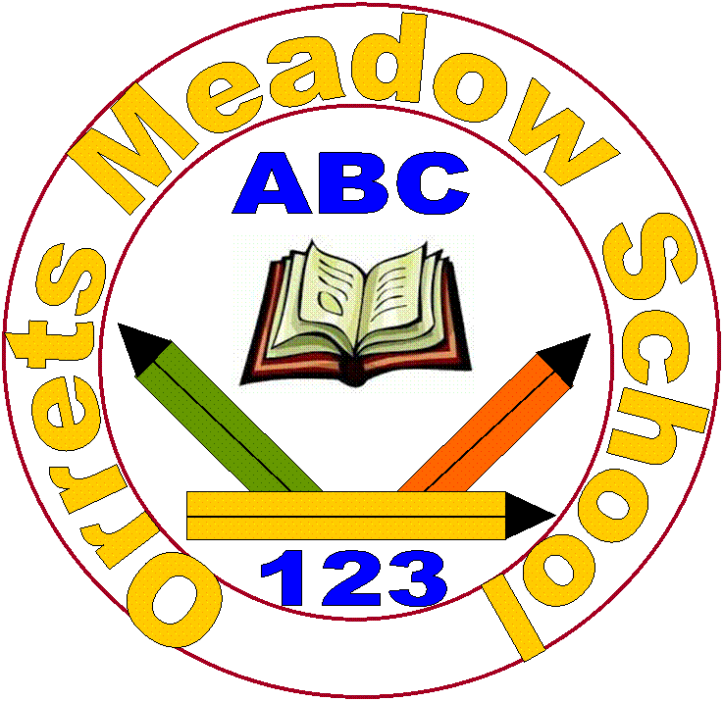
Orrets Meadow School

Writing Policy

“To raise the aspirations of every child and give them confidence to fulfil their potential through positive experiences”

Orrets Meadow Curriculum Aims and Values

Aims
To ensure all our children are at the centre of a broad, varied and interesting learning experience that is enjoyable and relevant for the future. Our creative, multisensory curriculum will create a sense of awe and wonder and help to inspire a lifelong love of learning. The holistic nature of our practice will promote positive mental health and well-being and will enhance our children’s life skills, social skills and cultural awareness.
Values
Our curriculum will promote a range of values including:
- Respect
- Empathy
- Responsibility
- Equality
- Independence
- Happiness
- Resilience
- Gratitude
- Honesty
- Friendship

Intent

Children attending Orrets Meadow face many barriers to learning. Becoming a writer is one of the biggest hurdles they face because of the complex demands needed to control a pencil; while remembering to sequence their thoughts; punctuate sentences and spell words. Through the objectives in this policy we aim to equip children with lifelong writing skills that will enable them to communicate for enjoyment and for work. This Writing Policy is an addendum to the whole-school English Policy outlining our approach to promoting progression in writing.

Aims
This Writing Policy aims to:

- For writing to be seen as purposeful and enjoyable.
- For each child to see themselves as a confident and successful writer.
- For each child to achieve the level of writing of which they are capable.
- For writing to be developed across a range of meaningful contexts.
- For there to be a broad curriculum offering the full spectrum of writing genres.
- For each child to develop the necessary writing skills to be a competent writer.
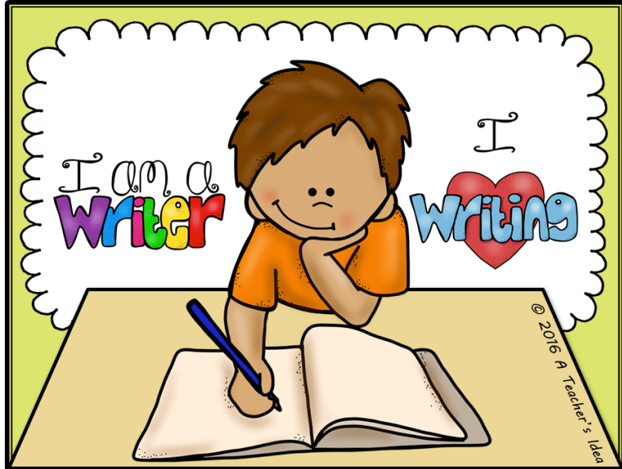
- For writing to be seen as an essential life skill.

Why is writing important?
Much research has been conducted into the long term benefits of writing progression for children. Writing is used in many areas of our lives.
- Writing is critical to becoming a good reader.
- Writing is an essential job skill.
- Writing equips us with communication and thinking skills.
- Writing expresses who we are as people.
- Writing makes our thinking and learning visible and permanent.
- Writing fosters our ability to explain and refine our ideas to others and ourselves.
- Writing preserves our ideas and memories.
- Writing allows us to understand our lives.
- Writing allows us to entertain others.

Implementation

In order to develop pupils’ abilities to construct and record their writing the staff at Orrets Meadow use a wide range of strategies in order to meet the changing needs of pupils’ within the school and promote a mastery of writing.

English Mastery at Orrets Meadow

‘The Reading and Writing Journey’ illustrated below is the key feature of the Mastery curriculum at Orrets Meadow.
The Reading and Writing Journey
1. Reading | 2. Comprehension | 3. Analysis | 4. Plan
5. Draft  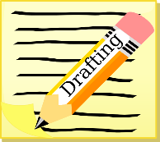 | 6. Revise  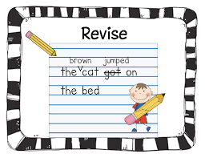 | 7. Edit  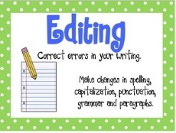 | 8. Publish

By ensuring each of these elements are taught explicitly along with the development of skills from the wiriting progression, appendix 1, pupils’ will master the skills needed to become confident writers. It promotes the development of becoming reflective writers as well as increasing confidence in their own work. This allows pupils to expand their knowledge of the individual writing styles and skills to be used in the area of English they are currently studying.

In order to achieve this we use the following strategies for teaching writing:
- Consistent Language approach-all teachers use the same language to describe different genres of writing
- High quality texts are used to challenge, enthuse and engage children.
- There is a clear progression in the teaching of writing which includes the familiarisation of the text type through reading, the identification of structure and language features, modelled writing, shared writing, supported composition, guided writing and independent writing.
- Progression of teaching writing includes exploring features, planning, drafting, assessing and editing.
- Talk into writing strategies are used at all stages of teaching writing.
- Use of drama in English sessions to improve speaking and listening skills and build confidence and self-esteem.
- Prominent displays of children’s writing.
- Word banks and word mats
- English packs
- Invite Authors and Poets to visit the school and work with children and staff.
- Reduce barriers to writing through use of technology.
- Teach neat cursive handwriting regularly.

Shared Writing
This is a collaborative approach; pupils contribute their ideas and thoughts for the teacher to select the most appropriate. The teacher needs to give reasons for the choices made.

Supported Composition
The children work in pairs to provide the next sentence of the text. This may follow from either modelled or the shared writing process. This may be part of a TPS activity (Think, pair and share).

Guided Writing
Pupils are grouped by writing ability according to their levels and/or target needs. The teacher works with each group in rotation. The task is carefully selected to provide an appropriate level of challenge and will focus on a particular aspect of the writing process as opposed to writing a complete piece. Tasks may include the processes of planning, drafting and editing pieces of writing. Teachers choose a target for each group to work on based on an assessment of their individual needs and previous writing. TAs are also expected to take guided writing groups when appropriate.
Independent Writing
All children are given opportunities to apply their understanding of the text type in their own writing. This is vitally important if children are to develop their skills as writers within different genres.
Talk for writing
- Talk for Writing involves making explicit the processes and thinking involved in the writing process so that ultimately they can be internalised and applied by children in their own writing. Talk for Writing will be embedded in every phase of the ‘Writing Sequence’. The main principles of talk for writing are;
- Book-talk ‘Book-talk’ is the extended opportunity to use talk to explore children’s personal and collective responses to a text as readers.
- Writer-talk ‘Writer-talk’ is the articulation of the thinking and creative processes involved in all stages of the act of writing; talk that helps children to think and behave like a writer (and consider themselves to be one).
- Storytelling and story making, this involves the learning and repeating of oral stories, building children’s confidence to develop them through telling and then extending that development into writing; later creating ‘new’ stories orally as a preparation and rehearsal for writing. The sequence being imitation, innovation and invention.
- Word and Language games Talk games and activities are used to:
  - stimulate and develop vocabulary (VCOP)
  - ‘warm up’ the imagination, stimulate creative thinking ( VCOP, Story starters)
  - Orally develop a character
  - Orally develop a setting
- Role-play and drama Techniques from the Primary Framework are used- ‘hot seating’, ‘conscience alley’etc...

Computer Literacy
The use of computers permeates all areas of modern life, it is essential we equip our pupils with skills for computer literacy so they are able to fully participate in an ever changing world.
The use of technology is embedded in teaching and learning practices across the English Curriculum. Orrets Meadow is fortunate to have a great variety of laptops, PCs and iPads available for children and teachers to access in order to support the development of skills such as spoken language, composition and writing for different purposes. Some of the software used include;
- Clicker 6 – This features predictive text to enable pupils to explore a wider range of vocabulary that can be used. It also has the capability to read text back to pupils, which helps to develop their proof reading and editing skills.
- Clicker Sentences – This enables pupils to develop their sentence composition by ordering words into the correct order. This can be used at different levels to incorporate a progression of punctuation and range of sentence structures. This application also reads back sentences for pupils to listen for corrections.
- Purple Mash – Purple mash has a range of elements that can help pupils with organisational, layout features and writing for a range of purposes.
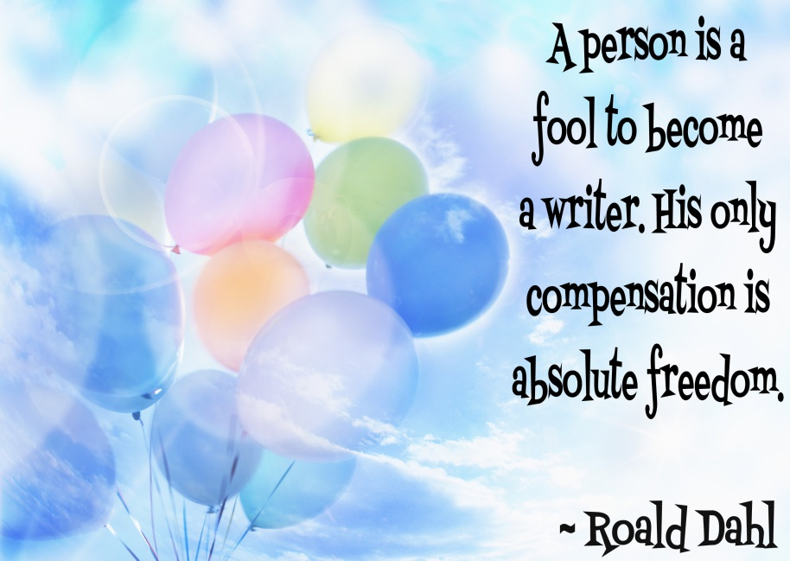

Impact

How do we assess and monitor Writing?

Assessment Activities
Throughout the year the impact of the teaching writing is closely monitored and assessed using a range of strategies to acquire both staff and pupils views on their success in writing. These include
- Learning walks by the English Lead.
- A Learning walk with the English Lead and the Head of Governors
- Book Scrutiny
- Lesson Observations carried out by the Head teacher and the English Lead.
- Pupils’ surveys and discussions.
- Staff surveys and discussions

Assessment for learning
Assessing Pupils Progress(APP)
Children will be assessed using APP sheets devised from the objectives given in the English programme of study. Assessments will indicate whether a child attains ‘Beginning’, ‘Developing’ or ‘Secure’ against the objectives being studied. Children will be awarded appropriate ‘Steps’ (1-6) when working towards the curriculum and levels A1-C6 when working within the curriculum.

Tracking and reporting
Termly Data Report
At the end of each term, parents are supplied with an update on their child’s progress, in the form of a Data Report. This shows progress through the year and against curriculum objectives.

Pupil Progress Meeting
Pupil Progress Meetings are held each term to identify children not making expected progress. Additional support and group interventions are put into place to promote progress.

End of year report
All children receive an end of year report summarising and highlighting the progress they have made in the English curriculum.

Standard Attainment test (SATs)
Children who are working on the KS2 curriculum will sit the SAT test each May. For some children taking the SATs would have a negative impact on mental health. In such instances careful consideration is made as to which assessments they will take. Individuals unable to access the SATs are awarded a teacher assessment, based on their class work.

Pupil Self-Assessment
Children make a summative assessment of their own progress over an English lesson, by marking their work with a green, orange or red circle. Green meaning the child is secure in their progress and red meaning they are in need of more reinforcement. Additionally children are encouraged to make on going running assessment at appropriate times during the lesson, with coloured circle or traffic lights on their desks
When the children are sufficiently skilled and mature, they will be encouraged to make peer assessment and set targets for their peers.

Marking & Feedback (Academic Guidance)
The Academic Guidance Policy sets out the philosophy, standards and marking codes to be used by teachers. Whenever possible, feedback is given orally at the earliest opportunity. A marking code is displayed at the front of each book.
Additionally teachers mark work with a star (green highlighter) and a target (pink highlighter), indicating the next steps a child needs to take to make progress.
After completing a first draft of a piece of writing staff will sit with pupils’ in order proof read and edit the work in order to help pupils’ identify areas that could be improved for their final draft.

What will this achieve?
Our goal for the children of Orrets Meadow is for them to be confident and enthusiastic enough to write in a range of genre at the best level they are capable of before moving onto the next stage in their education.

